Classification of Online Toxic Comments Using Machine Learning Algorithms

Now-a-days many peoples are using digital world data from various online applications such as social media post, online product reviews, health reviews and many more but while writing such reviews some users may use abnormal comments which may disturb normal users and to avoid such comments or reviews all online application applying Spam detection technique, sentiment detection and many more but this techniques are not accurate. So author of this paper is using 6 different machine learning algorithms such as SVM, Logistic Regression, Naïve Bayes, Random Forest, Decision Tree and KNN and then evaluating their performance in terms of accuracy and loss. The higher the accuracy and the lower the loss will make ML better prediction algorithm.

To implement this project we are using KAGGLE TOXIC Comments dataset which contains comments and class label as normal or toxic contents. This dataset is saved inside ‘Dataset’ folder and below is the dataset screen

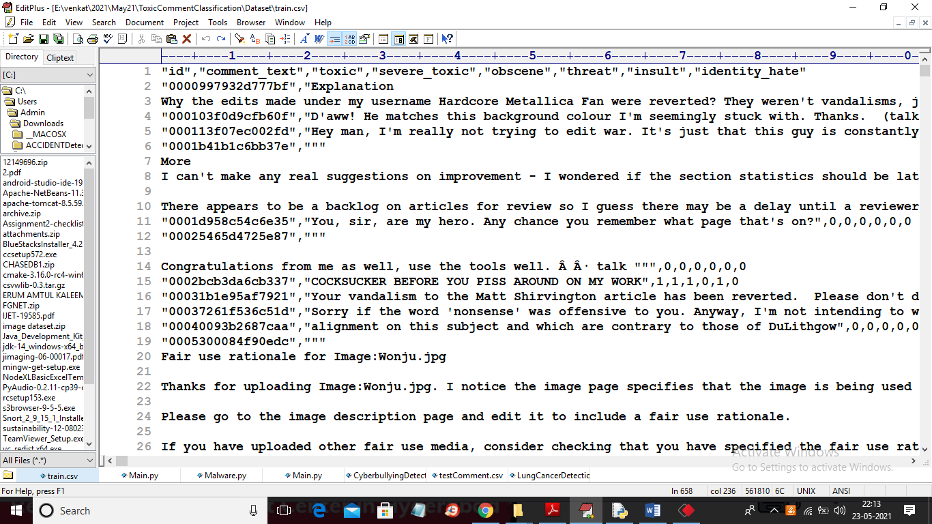

In above screen first row contains dataset column names and remaining rows contains dataset values and each comment will have label as 0 or 1 where 0 means comment is normal and 1 means comment is TOXIC. After training model we will upload test comments then ML will predict whether uploaded test comment is normal or toxic. Below is the test comment

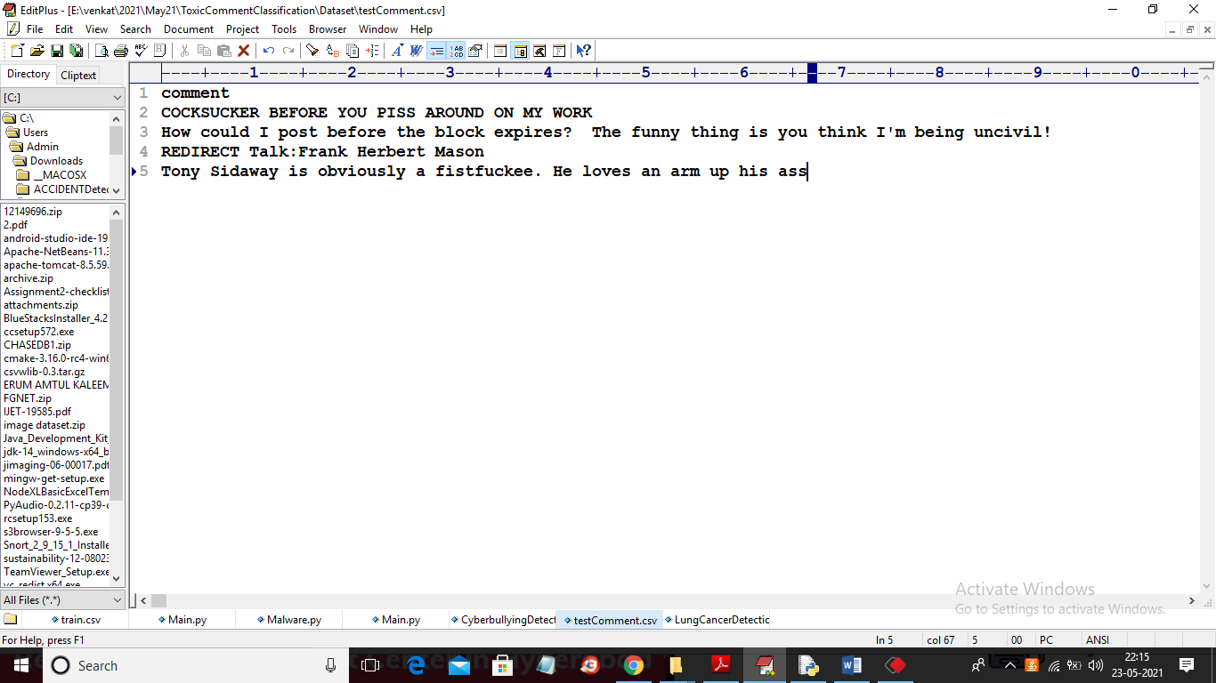

In above screen in test data only comments are there and we will apply ML algorithms on above test data to predict whether test data is normal or toxic.

To implement this project we have designed following modules

1. Upload Toxic Comments Dataset: Using this module we will upload dataset to application
2. Preprocess Dataset: using this module we will read each comments and then remove stop words and special symbols and make all comments clean
3. Apply Count Vectorizer: Using this module we will count occurrence of each words and then find average and then build count vector and this vector will be trained with all algorithms
4. Run SVM Algorithm: Using this module we will split dataset into train and test where application used 80% dataset to Train ML and 20% dataset to test ML and then calculate accuracy of test data prediction
5. Run Logistic Regression: Similar to previous module but here we will use Logistic Regression to train ML.
6. Run Naïve Bayes: will use Naïve Bayes
7. Run Random Forest: will use Random Forest algorithm and calculate accuracy
8. Run Decision Tree: will use decision tree algorithm
9. Run Random Forest: will use Random Forest algorithm
10. Run KNN: will use KNN algorithm
11. Accuracy Graph: Using this module we will plot accuracy and loss comparison between all algorithms
12. Predict Toxic Comments from Test Data: Using this module we will upload test data and then ML will predict whether test data is normal or contains any toxic comments

SCREEN SHOTS

To run this project double click on ‘run.bat’ file to get below screen

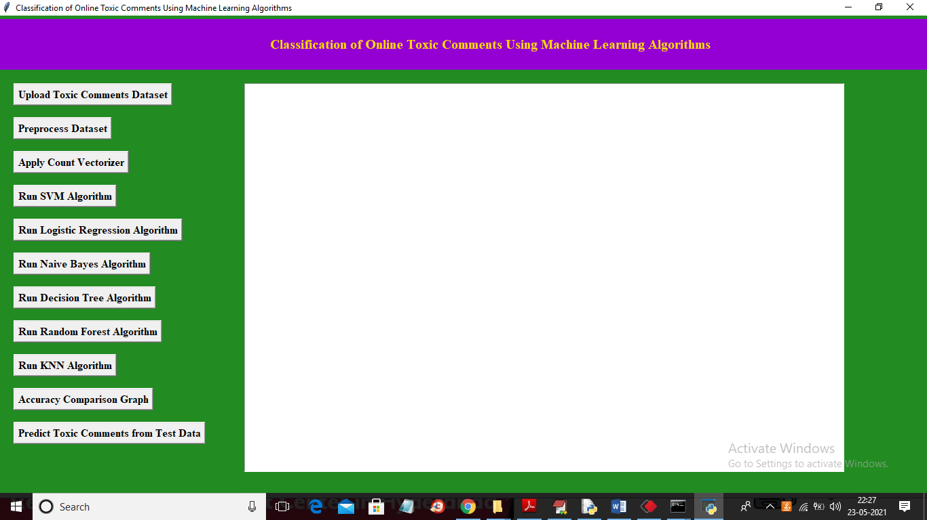

In above screen click on ‘Upload Toxic Comments Dataset’ button to upload dataset

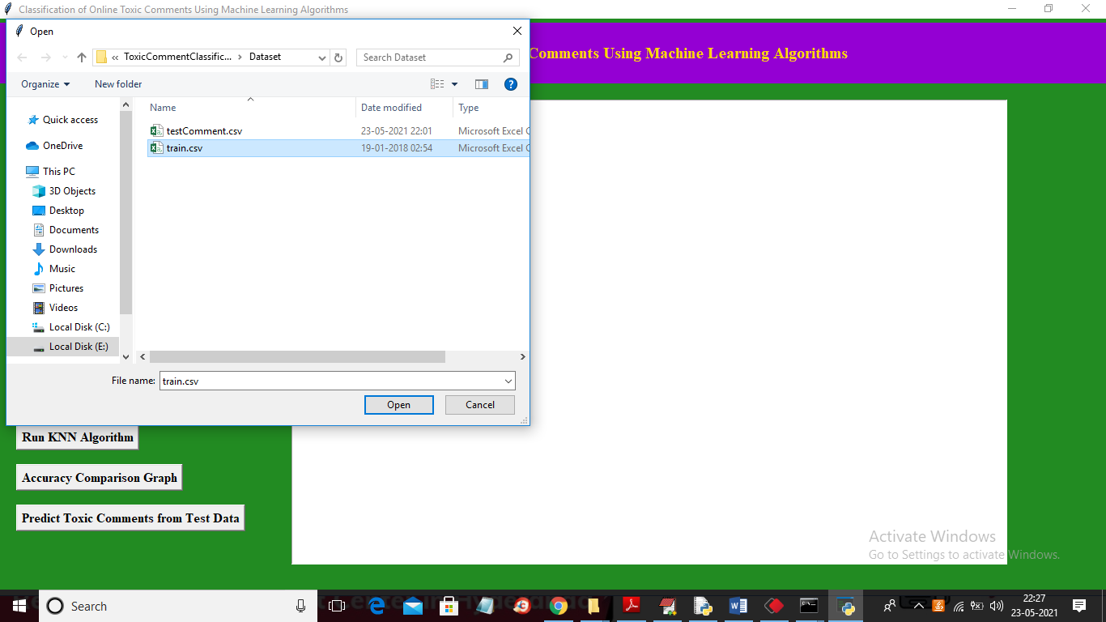

In above screen selecting and uploading ‘train.csv’ file and then click on ‘Open’ button to load dataset and to get below screen

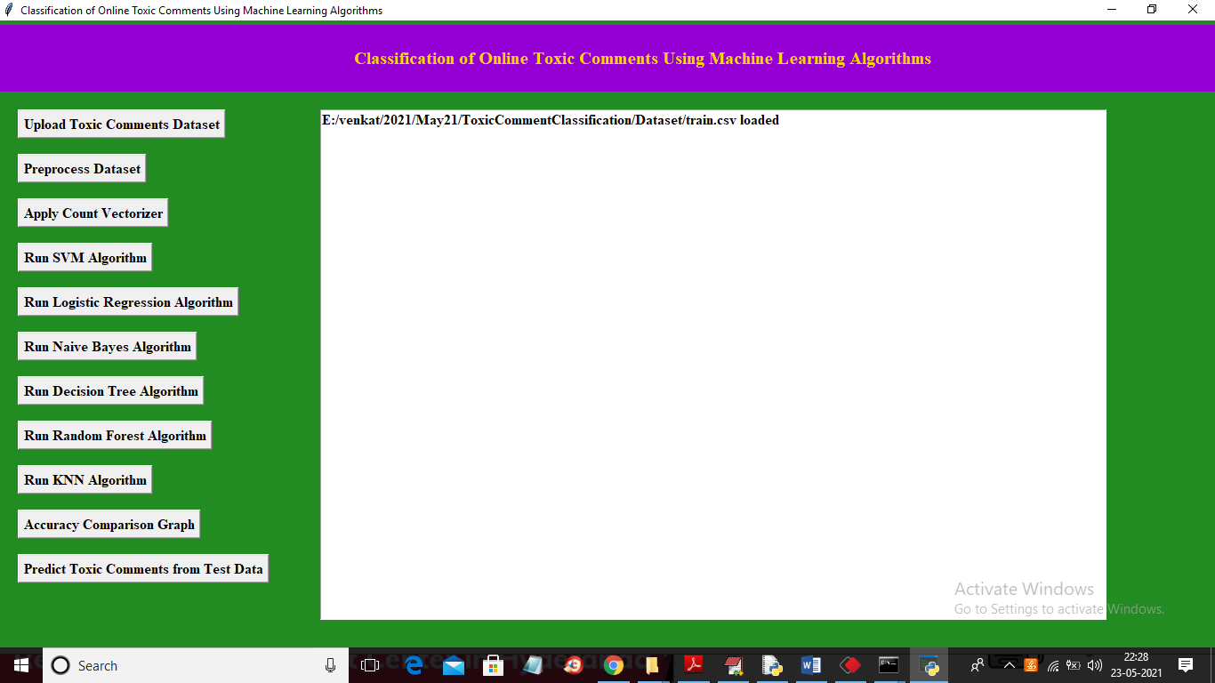

In above screen dataset loaded and now click on “Preprocess Dataset” button to read dataset and then clean it.

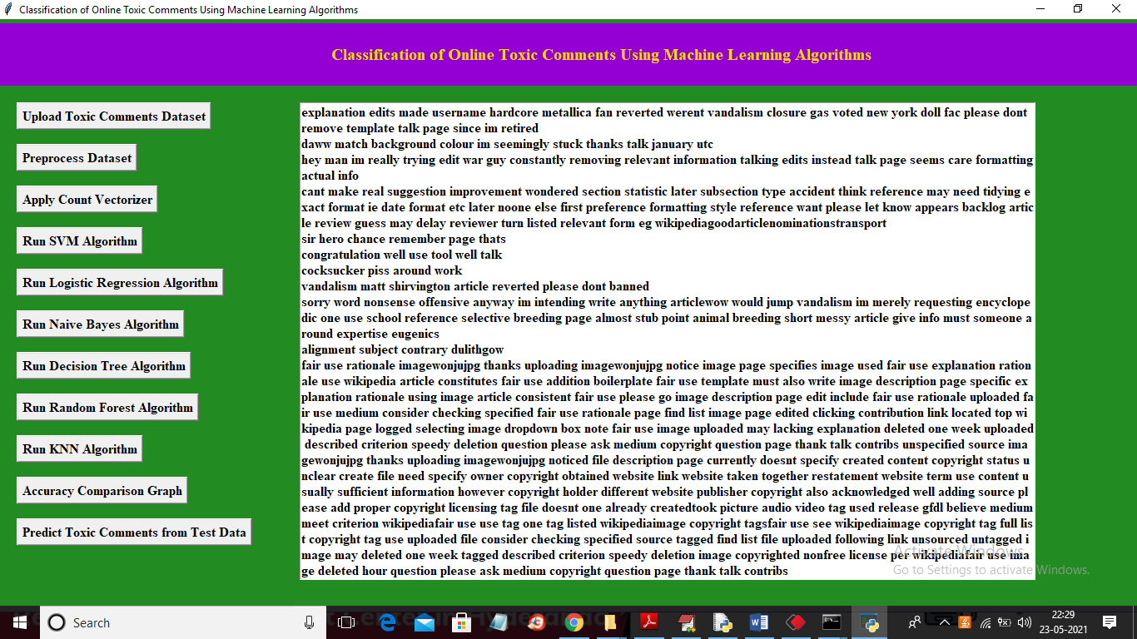

In above screen in text area we can see all comments are read and then clean and displaying them and now click on ‘Apply Count Vectorizer” button to count each word and build a vector

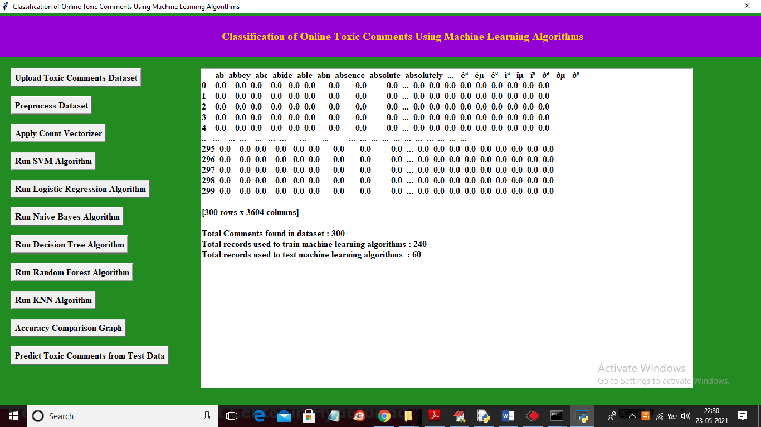

In above screen we can see vector is generated and in first row we can see words names and in remaining rows we can see their count and if word not appear in comments then 0 will be put. Now in above screen we are displaying only few records. Now train vector is ready and now click on ‘Run SVM Algorithm’ button to train SVM with above dataset and in above screen we can see application using 240 records for training and 60 records for testing

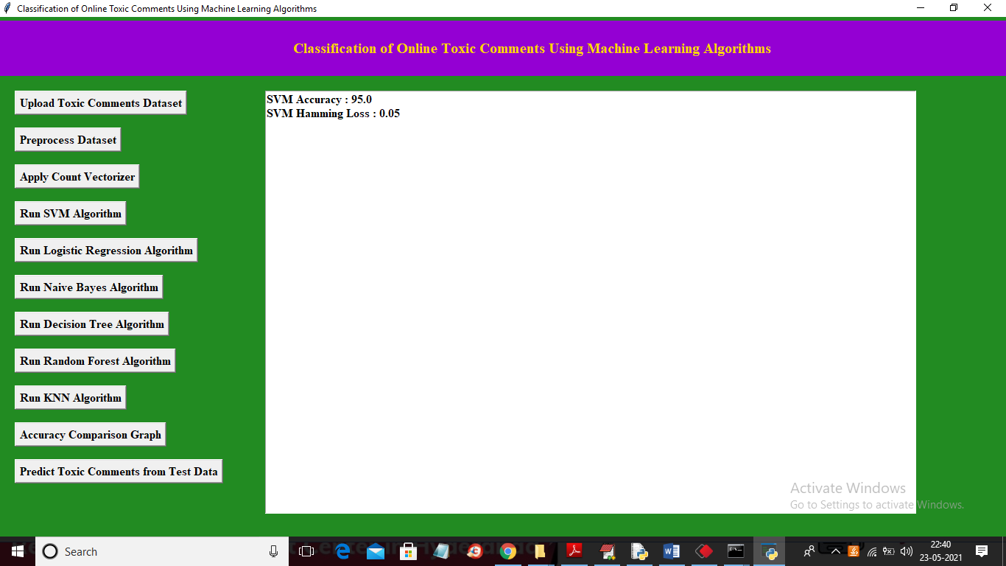

In above screen SVM ML model build with accuracy as 95% and loss as 0.05% and similarly click all algorithms button to train ML model for each algorithm

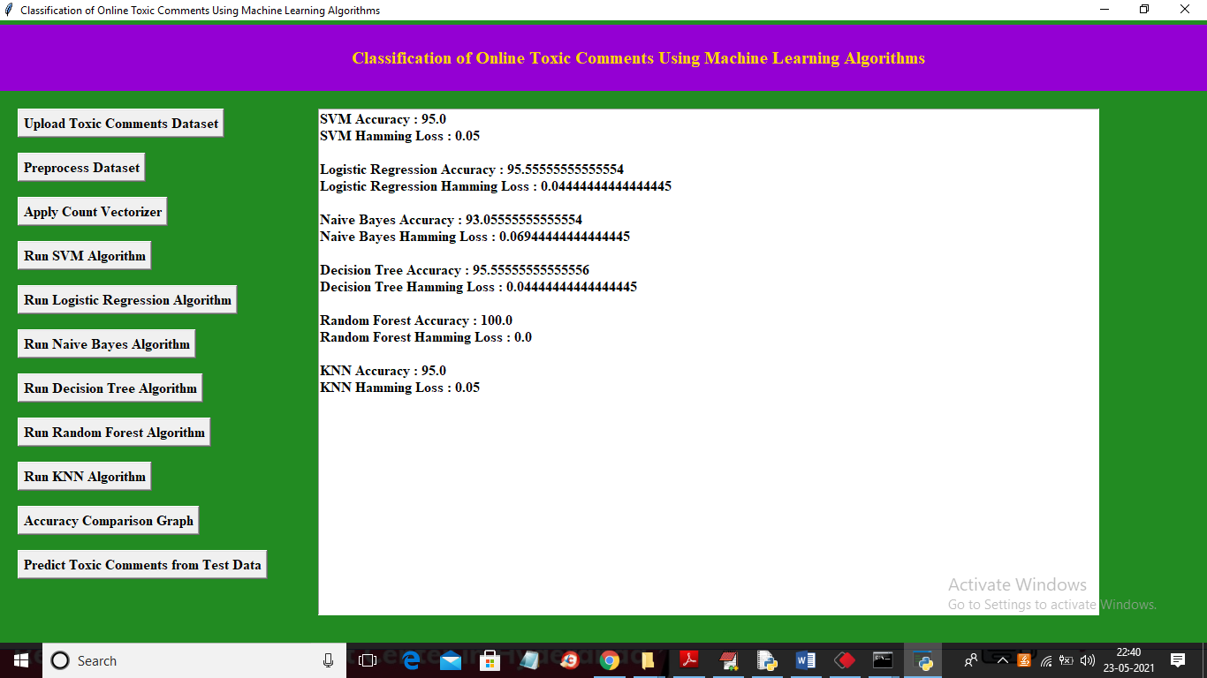

In above screen we can see accuracy and loss value for all algorithms and in above screen random forest gave 100% accuracy with 0% as loss and now click on ‘Accuracy Comparison Graph’ button to get below graph

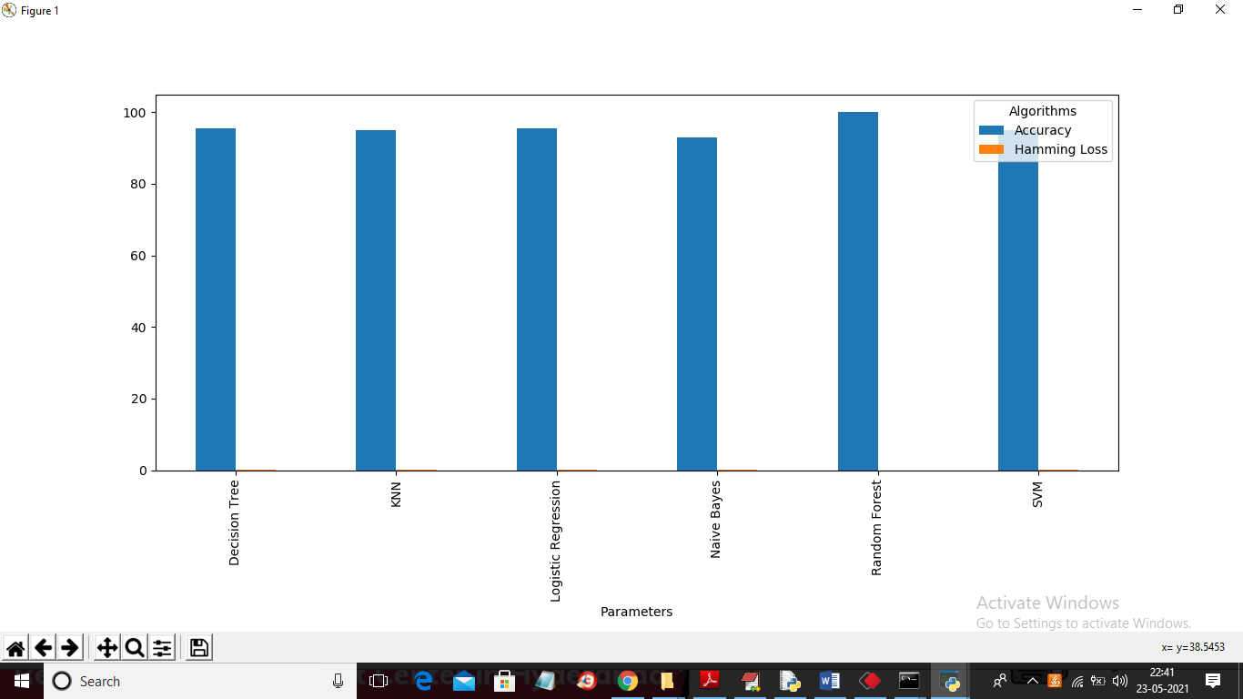

In above graph x-axis represents algorithm name and y-axis represents accuracy and loss value and in above graph all algorithms gave accuracy closer to 100% with minor loss value so loss is not plotting in graph. Now click on ‘Predict Toxic Comments from Test Data’ button to upload test data and then ML will predict comments are toxic or non-toxic

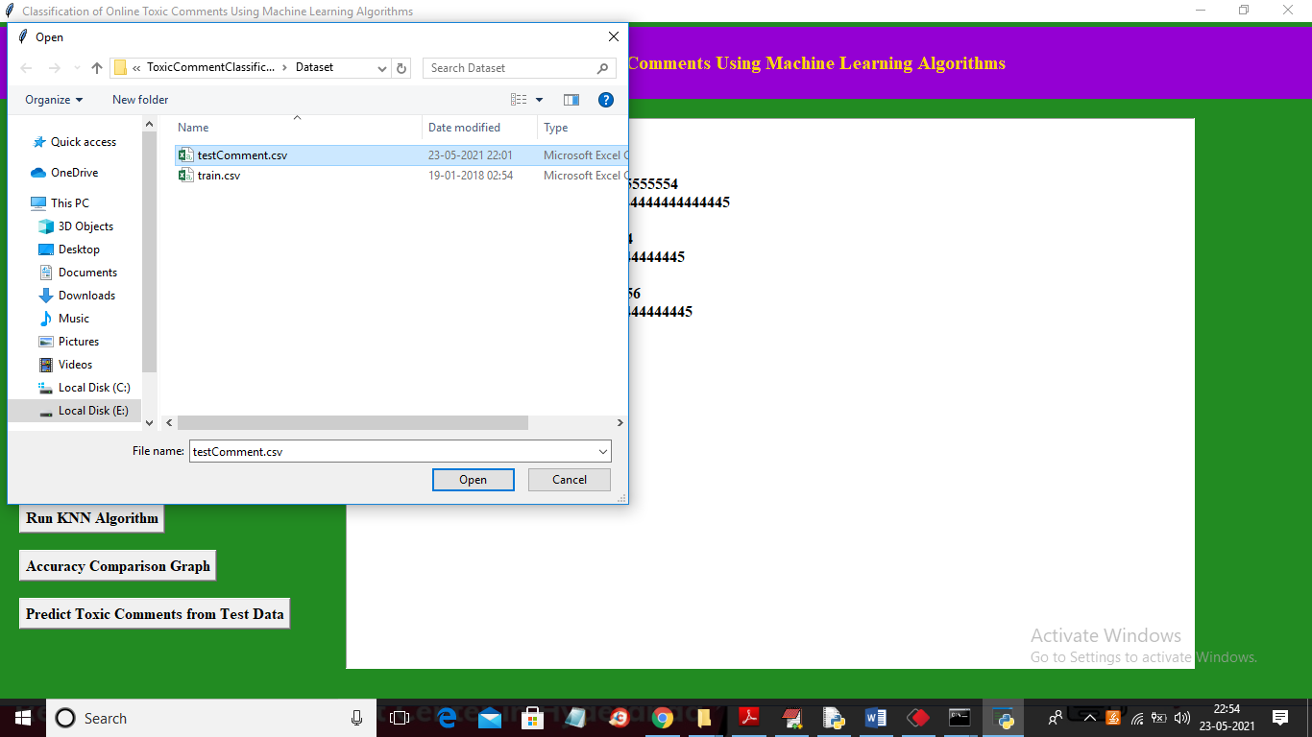

In above screen selecting and uploading ‘testComment.csv’ and then click on ‘Open’ button to get below prediction output

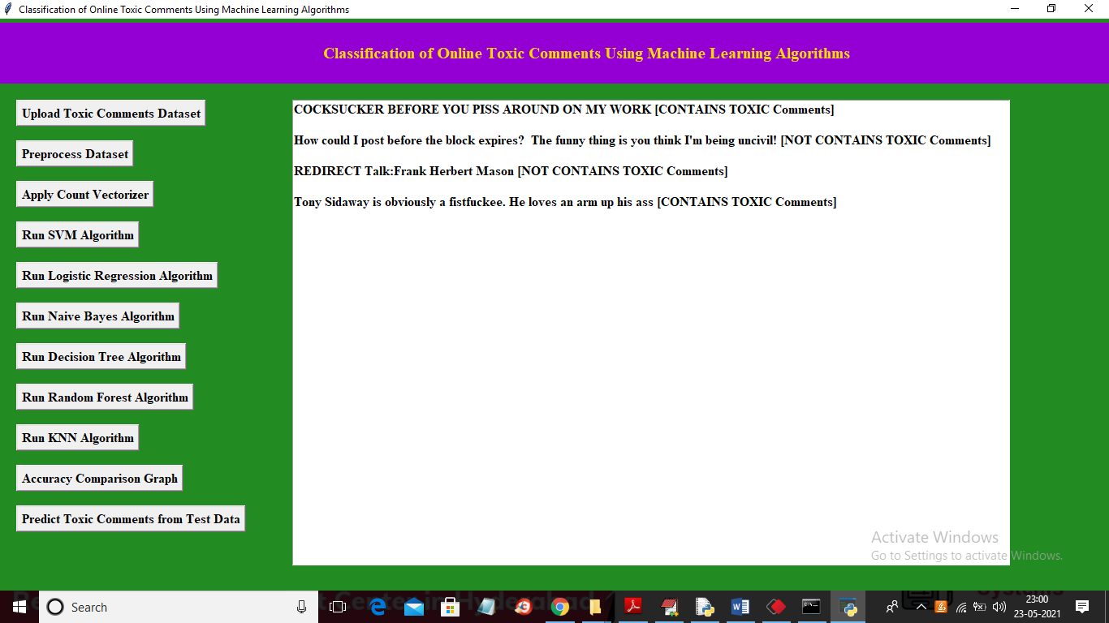

In above screen first we are displaying comments and then in square bracket we are displaying predicted result as ‘[Contains TOXIC Comments]’ or ‘[NOT CONTAINS TOXIC Comments’