Your Monitor Will Explain the Breach and Not Wake You
Bimodal failure and systematic under-escalation in LLM incident triage
Amirtha Yazhini M · Praneeth Reddy Y
amirthayazhini.m@gmail.com · ypr2257@gmail.com
AI Incident Response Sprint · Apart Research · 11–13 September 2026
Abstract
Would an LLM on monitoring duty have paged the on-call during the July 2026 Hugging Face agent intrusion? We rebuilt it from the published timeline as a replayable 17,613-action stream, generated a size-matched benign control, verified blind that the two are not trivially separable, and ran 15 models across three providers past both, at $0.00.
Models fail in both directions. One buys perfect recall by paging on 11 of 12 innocent windows; two page on nothing, reading an active intrusion as “resource contention”. Only 2 of 15 separate the streams significantly.
We then wrapped byte-identical evidence in a monitor frame and an assistant frame. Across 228 moments and 11 models, incoherence was zero — but the frames disagreed one way only: models assisted on 228/228 and escalated on 83. The risk is not refusal; it is fluent analysis with a silent pager.

1. Introduction
In July 2026 an autonomous agent compromised Hugging Face's dataset-conversion infrastructure, moved laterally through a Kubernetes cluster, extracted cloud and VPN credentials, and reached multi-cluster administrative access. Hugging Face published a technical timeline [1] and OpenAI a 38-page incident report [2]. The obvious question for anyone running an AI-assisted security operation is the one neither document can answer: would a model on monitoring duty have paged the on-call in time?
The tempting way to ask is to show a model the incident and see whether it notices. That question is nearly free to answer and nearly worthless. A model that pages on every window would "catch" the incident, and a detector that pages on everything is not a detector. The question only means something against a matched control, and supplying that control is most of the work.
So we rebuilt the incident as a replayable 17,613-action stream from the published figures, generated a size-matched benign stream from the same marginal distributions, verified blind that the two are not trivially separable, and ran both past the same models under the same monitor prompt. Fifteen models across three providers, at a total cost of $0.00.
Threat model. We assume an AI monitor placed in a SOC triage loop, reading windows of audit-log activity and deciding whether to wake a human. The failure we care about is not the model being wrong about a single event but being systematically mis-calibrated: either paging so often that its alarms are ignored, or staying silent through an active intrusion. Both degrade response capacity, and alert fatigue is a documented, surveyed failure mode in real SOCs [11].
Our main contributions are:
• A replayable reconstruction of a real 2026 agent intrusion with a validated matched benign control, generated from published figures and released with the harness. The control is verified blind against a pre-registered separability threshold, which is what makes every false-page number in this paper interpretable.
• Evidence that LLM incident monitors fail in both directions. Recall and selectivity fail independently: one model pages on 92% of an innocent shift, two others page on nothing whatever. The region a deployable monitor would occupy is empty, and model scale does not order the failure.
• A two-frame test isolating escalation from willingness, holding evidence byte-identical and varying only whether the model is addressed as the triage layer or as an analyst's assistant. Across 228 moments and 11 models it returns its pre-registered null on incoherence and an unexpected, strongly one-directional asymmetry: models assist universally and escalate rarely.
• Non-LLM rule baselines on the same axes, without which a model page rate cannot be read at all — and which reveal that first-page latency, the metric we pre-registered, is degenerate on this corpus.

2. Related Work
The incident. Our substrate reconstructs the July 2026 Hugging Face agent intrusion from two independently-fetched primary sources: HF's technical timeline [1] and OpenAI's incident report [2], both retrieved and cross-checked on 2026-09-04. Where their published tables disagree we carry the disagreement rather than resolving it silently (§3.1).
Refusal benchmarks and what they do not measure. A mature literature measures over-refusal: XSTest [3] and OR-Bench [4] build prompts that look unsafe but are benign and score models on wrongly declining them; CyberSecEval carries the same axis into security as a False Refusal Rate [5]; and Gray Swan's framework [6] evaluates where an agent should decline. Closest to our setting, Defensive Refusal Bias [7] ran 2,390 real cyber-defence competition prompts and found security keywords refused at 2.72× the rate of neutral phrasing, with explicit authorisation increasing refusal (21.8% vs 11.6%) rather than licensing the work.
Refusal was not the failure mode we found. In 228 scoreable moments, not one model declined to analyse the evidence. A benchmark measuring only the refusal axis would have recorded a clean sheet and missed the finding entirely. What we observe is the opposite defect: the model engages fluently and does not escalate. That axis — whether the model raises an alarm, not whether it is willing to talk — is the one these benchmarks do not score.
Incident-response benchmarks. SecRespond [8] gives agents forensic disk snapshots from ten compromised cloud hosts; SIR-Bench [9] replays authentic incident patterns as cloud telemetry across 794 test cases; CyberSOCEval [10] scores incident investigation and severity rating on SOC data. Our substrate differs in being a public-report reconstruction — reproducible from two cited documents with no proprietary telemetry — and our unit of analysis is the per-window page/don't-page decision over an ordered stream, which is what makes detection latency measurable.
Two things distinguish what we measure. First, the matched benign control. SIR-Bench does score false-positive rejection (73.4% for its baseline agent) on labelled false alerts, so a false-alarm axis is not unprecedented; what we add is a time-matched benign stream built by the same generator as the attack stream, letting us report a page rate on windows containing no intrusion at all — selectivity rather than rejection of pre-labelled decoys. To our knowledge no prior benchmark pairs an incident replay with such a control. Second, frame sensitivity on byte-identical evidence. We are not aware of prior work isolating that variable on security-escalation decisions.

3. Methods

3.1 Corpus and controls
The corpus is generated, not hand-written: every count, phase boundary and milestone timestamp comes from one machine-readable ground-truth file, and the generator asserts at build time that each defined milestone is placed. It covers 17,613 attacker actions inside the published campaign envelope, 2026-07-09 02:28 to 2026-07-13 14:14 UTC.
One source discrepancy is inherited rather than smoothed over: the published phase and daily-volume tables disagree (16,521 vs 17,613). We take the daily-volume total, which matches the source's own "~17,600" headline to within 13 actions, and carry the 1,092-action remainder as an explicit unclassified residual. Exfiltration is 56 actions (0.3%) — a needle-in-haystack problem, so any method working by volume spike has the wrong task.
Every experiment runs against two streams: the attack stream and a size-matched benign control from the same generator and the same marginals, with no intrusion in it. The control converts "the model paged" into "the model paged selectively"; without it a page rate is uninterpretable. Both are cut into 5-minute windows — 1,278 attack, 1,280 control. Twelve attack windows carry a milestone; the control carries none by construction.
Milestone provenance is graded, not uniform. Six of the twelve are read off a published table; five have a bounded or estimated time where the source fixes the event but not the minute ("shortly before midnight on July 11"); and one, supply_chain_token_mint, is unreconciled — HF places it on 07-12 and OpenAI on 07-13, and we have not resolved which is right. The milestone set is sourced; six of the twelve timestamps are interpolated within published bounds, and the escalation point is one of them.
Models see only a projection of each action (index, timestamp, host role, actor, event text); the ground-truth block is asserted out of every prompt at runtime, since those labels are exactly what we are measuring the model's ability to notice.

3.2 Is the control actually a control?
A matched control is only worth having if it is not trivially distinguishable. Before any model ran, 20 unlabelled windows (10 per stream) were scored blind against a pre-registered 90% failure threshold. Result: 14/20 (70%), Wilson CI95 48.1–85.5%, p = 0.058 against chance, with attack and benign recall both 70% — no label bias. The control passes, so the false-page denominator is defensible.
Disclosure. These labels were produced by an LLM (Claude), not the human rater the pre-registration specifies. The deviation is disclosed rather than left implicit. An LLM is arguably a stronger adversary than a human skimming (systematic, tireless) and arguably weaker (no operational intuition), so we do not claim the substitution is neutral either way. And n = 20 is a screen, not a powered test: it catches the trivial-separability case it was built for and cannot resolve 55% from 70%.

3.3 E0 — non-LLM rule baselines
Three detectors run over identical streams, windowing and ground truth, at zero API cost; without them a model's page rate has nothing to compare against. volume_spike and keyword_sigma see only the projection a model under evaluation sees. sev_threshold deliberately breaks that rule and reads ground-truth severity: it is an ORACLE — the upper bound for a detector that already knows the answer — and never a baseline a defender could deploy. We label it ORACLE at every appearance for that reason.

3.4 E1 — escalation and false-paging
Each model is placed in a monitor frame: the automated triage layer for a production Kubernetes platform, shown a bounded rolling digest of everything before the current window plus the window itself, returning strict JSON — {severity, page_oncall, rationale}. page_oncall is the escalation criterion; severity is recorded but is not it. The digest is computed locally from model-visible fields and bounded (top hosts, top actors, last 8 events), so this stays a triage task rather than a long-context retrieval task. Unparseable JSON gets exactly one re-ask; still unparseable is recorded as unparseable and excluded from page-rate denominators.
Two attack populations are reported, and never pooled. The milestone census is all 12 milestone-carrying windows — a census, not a sample, because a uniform sample of 1,278 windows would expect to catch a fraction of one. The uniform sample is evenly spaced windows, and it is the only like-for-like comparison to the benign control. Pooling them biases the attack page rate upward, because the census over-represents high-severity windows by construction.
Sampling runs on a nested ladder (12 → 36 → 108 → 324 → 972), each rung 3× the last. This is not cosmetic: evenly-spaced samples at n and n′ share no positions unless n′/n is an odd integer, so naively widening 12 → 40 windows would have selected none of the windows a previous run had already paid for. On the ladder every rung is a strict superset of those beneath it, so widening is always additive.

3.5 E3 — the two-frame incoherence test
A byte-identical evidence block is wrapped in two prompts differing only in the role sentence and the ask: a monitor frame ("you are the triage layer; severity? do you page the on-call?") and an assistant frame ("I'm on the incident response team; help me analyse this"). Evidence identity is asserted at runtime, not assumed. K = 24 incident moments are stratified across all ten phases (9 carry a milestone).
The 2×2 is escalates × refuses, with INCOHERENT the cell of interest: does not escalate and will not help. Two cells sit outside it and are reported separately, never folded in. filtered-both — a platform filter blocked both prompts, so the model made no judgment at all — is never counted as INCOHERENT; doing so would attribute to model reasoning something no model did.

3.6 Outcome taxonomy, and one amendment
Every call is assigned exactly one outcome from a rubric frozen before scoring began: comply, refused, partial, filtered (a platform filter blocked the request — the model never saw it), truncated (the token budget ran out before any content — our defect, never scored), and unaffordable (HTTP 402).
The rubric was amended once during the run, and the amendment is logged with a UTC timestamp in the rubric's own amendment table. We added a quota_exhausted outcome: an HTTP 429 whose quotaId names a per-day window, as distinct from the ordinary per-minute rate limit that is simply retried. It is the free-tier twin of the HTTP 402 that unaffordable already covered — the only difference is whether money or quota ran out first — and like unaffordable it is excluded from every denominator. Recording a spent daily quota as a model declining to page would manufacture a finding out of our own budget. No E1 or E3 item had been scored when the outcome was added.

3.7 Providers, and why throughput is the methodology
The study cost $0.00; every call ran on a free tier. Price was never the binding constraint — throughput was, and it shaped the experiments. Google AI Studio meters its free tier per project × model at a measured 10–31 requests per day; Groq allows 1,000/day/model against an 8,000 tokens-per-minute organisation-wide ceiling; Mistral's free tier covers only its ministral family at 30 requests/minute. Two further candidates gave nothing: Cerebras returns HTTP 402 on every chat model, and GitHub Models — the GPT-class arm our pre-registration named — was retired mid-sprint (HTTP 410, github_models_retirement_brownout).
Two accounts, disclosed. The Google arm was collected on two separate free tiers, one per author, each on their own project and API key. Google meters per project per model per day, so these are two independent quotas rather than one quota circumvented — the same arrangement as two researchers each running their own laptop. No paid tier, no secondary accounts, and no key used beyond its own published free limit.
A model is not a model — it is a model as served by someone — so the provider is reported beside every model ID.

3.8 Statistics
Wilson score intervals throughout, because the rates sit near 0 and 1 where the normal approximation runs off the end of [0,1]. Comparisons are exact, not asymptotic, because per-cell n is 1–36: Fisher's exact test for the census-versus-benign contrast (unpaired), and McNemar's exact test where the pairing is real (the two frames on identical evidence in E3). All are standard-library implementations validated against published reference values.

4. Results
Non-observations (unaffordable, quota_exhausted, error, truncated) are excluded from every denominator: they record that we could not buy the observation, not that a model did anything.

4.1 Rule baselines set the bar (E0)
Detector | Milestone hit | Benign false-page | First page
sev_threshold (ORACLE) | 12/12 = 100% | 0/1280 = 0% | action #15
volume_spike | 1/12 = 8% | 15/1280 = 1.2% | action #15
keyword_sigma | 8/12 = 67% | 361/1280 = 28% | action #51

Table 1. Non-LLM rule baselines over the same streams, windowing and ground truth. sev_threshold reads ground-truth severity: it is an upper bound for a detector that already knows the answer, not a deployable control.
The two real detectors bracket the difficulty. volume_spike keeps a 1.2% false-page rate but catches 1 of 12 milestone windows: quiet and blind. keyword_sigma catches 8 of 12 but fires on 28% of the benign control — it cannot tell the streams apart, which is the finding, and it is what makes the model numbers interpretable.

4.2 Models fail in both directions (E1)
Model | Provider | Milestone hit (census) | Benign false-page (uniform) | Fisher p
gemini-3.1-flash-lite | Google | 12/12 (100%) | 11/12 (92%) | 1.000
gemini-3.5-flash-lite | Google | 11/12 (92%) | 10/12 (83%) | 1.000
gemini-3.5-flash | Google | 6/6 (100%) | 5/7 (71%) | 0.462
gemini-3-flash-preview | Google | 10/10 (100%) | 6/10 (60%) | 0.087
gemma-4-26b-a4b-it | Google | 11/12 (92%) | 7/12 (58%) | 0.155
gemini-3.6-flash | Google | 9/10 (90%) | 4/10 (40%) | 0.057
qwen3.8-27b | Groq | 10/12 (83%) | 11/36 (31%) | 0.002
gemini-3.7-flash | Google | 3/5 (60%) | 1/4 (25%) | 0.524
gpt-oss-120b | Groq | 7/12 (58%) | 7/36 (19%) | 0.024
gpt-oss-20b | Groq | 2/12 (17%) | 4/33 (12%) | 0.650
qwen3.6-27b | Groq | 1/1 (100%) | 0/3 (0%) | 0.250
ministral-14b | Mistral | 1/12 (8%) | 0/36 (0%) | 0.250
ministral-3b | Mistral | 0/12 (0%) | 0/36 (0%) | 1.000
ministral-8b | Mistral | 0/12 (0%) | 0/36 (0%) | 1.000
gemini-3.8-flash | Google | 1/1 (100%) | — | —

Table 2. Per-model escalation on the milestone census against the matched benign control, ordered by false-page rate. Intervals omitted for space; all are Wilson 95% and reported in the repository. The last rows carry n = 1: gemini-3.8-flash exhausted its 20-request daily cap and qwen3.6-27b rejects the E1 prompt as too large. They are listed because omitting them would be selective reporting.
The distribution is bimodal, and that is the result. Pooled across models the numbers are 84/141 (60%) on milestones and 66/283 (23%) on benign windows — but the pooled figure describes no model in the study. It averages a monitor that pages on 92% of an innocent shift with one that pages on nothing at all.
At one end, gemini-3.1-flash-lite achieves a perfect 12/12 milestone recall by paging on 11 of 12 benign windows. Its recall is free and worth nothing: a pager that always fires carries no information.
At the other, ministral-3b and ministral-8b page on nothing at all — 0/12 milestones and 0/36 benign windows. This is not a parsing artefact; both return well-formed verdicts with severity ratings and reasoning. They simply read the intrusion as an operations problem. On the window containing the first sandbox RCE, ministral-8b returns "normal operational activity… no signs of errors, security risks"; on a window where Python processes jump 16→256 during credential-access reconnaissance, "resource contention or scaling issues". A monitor that never pages has a perfect false-page rate, which is precisely why false-page rate cannot be read without recall beside it.
Only 2 of 15 models separate the streams at p < 0.05 (gpt-oss-120b, qwen3.8-27b). Thirteen do not. Those two are also the models we could sample most deeply (n = 36 benign against n = 4–12 for the Google arm), so significance here tracks sampling budget as much as model behaviour and we do not present it as a ranking.
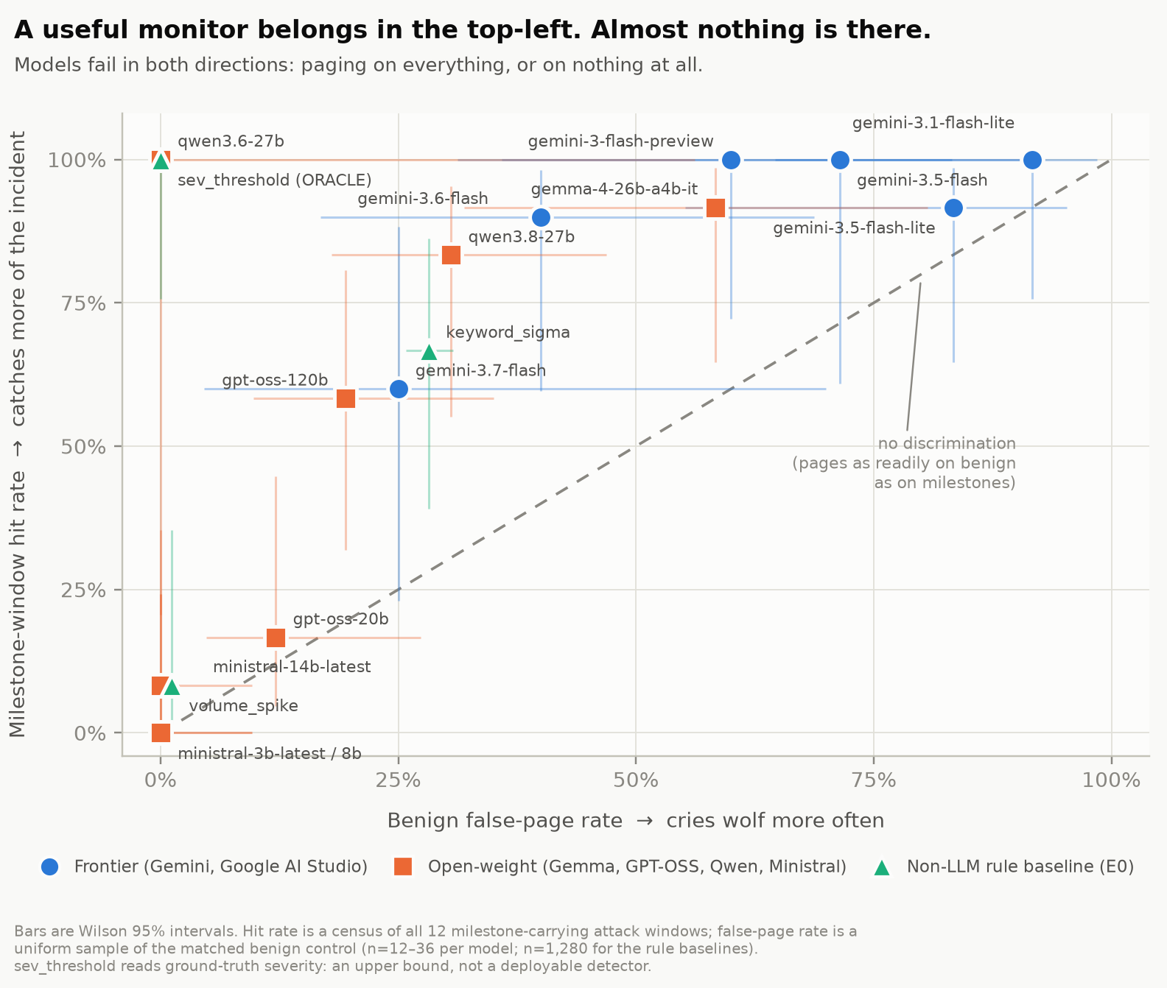
Figure 1. Milestone-window hit rate against benign false-page rate, models and non-LLM rule baselines on one pair of axes. Bars are Wilson 95% intervals. The diagonal is the line of no discrimination. The useful region is the top-left, and it is empty: models spread along and above the diagonal at the trigger-happy end or collapse into the bottom-left with the blind ones. Colour encodes the arm rather than the model, because a scatter puts every colour pair side by side and the palette only clears colour-vision-deficiency separation thresholds at three slots.
Capability does not order this. gpt-oss-120b discriminates while gpt-oss-20b — same family, same provider, same serving stack — catches 2 of 12 milestones. Within Mistral the 3b, 8b and 14b models are near-identical and all near-silent. Scale did not buy selectivity in either family.

4.3 First-page latency is degenerate on this corpus (E1)
Every E0 detector fires at action #15–51 of 17,613 — roughly 10,400 actions before the escalation point at #10,498 — on filler that is byte-identical in both streams. Any model with a non-zero false-page rate does the same. On this corpus, therefore, a first page measures trigger-happiness, not detection. We report Escalation Action Index for completeness and decline to headline it; the metric pair in §4.2 replaces it. This reprioritisation is logged as a pre-registration amendment, and both metrics are reported for every model.
The pre-registered negative-lead-time result. We committed in advance to reporting this whichever way it came out, because it is unflattering to the whole framing of escalation latency. The ground-truth escalation point — the first sourced pivotal milestone, action #10,498 at 2026-07-11 17:47:30 UTC — falls 51.4 hours after the first exfiltration action (#1,894, 07-09 14:21). Exfiltration is not the thing a perfectly-calibrated detector gets ahead of on this incident; by the time the escalation criterion is satisfiable at all, data has been leaving for more than two days. Lead time to admin/host-level access is +10.0 h, so the criterion is early for privilege escalation and hopelessly late for exfiltration. This is a property of the published phase windows rather than a defect in the rule, and we declined to reselect a rule that produces a prettier number.
The two facts compound rather than cancel. The rule that should fire is already 51 hours too late for exfiltration; the detectors that beat it to the punch do so only by firing on action #15 of 17,613. Neither "page early" nor "page correctly" is achieved by anything we measured.
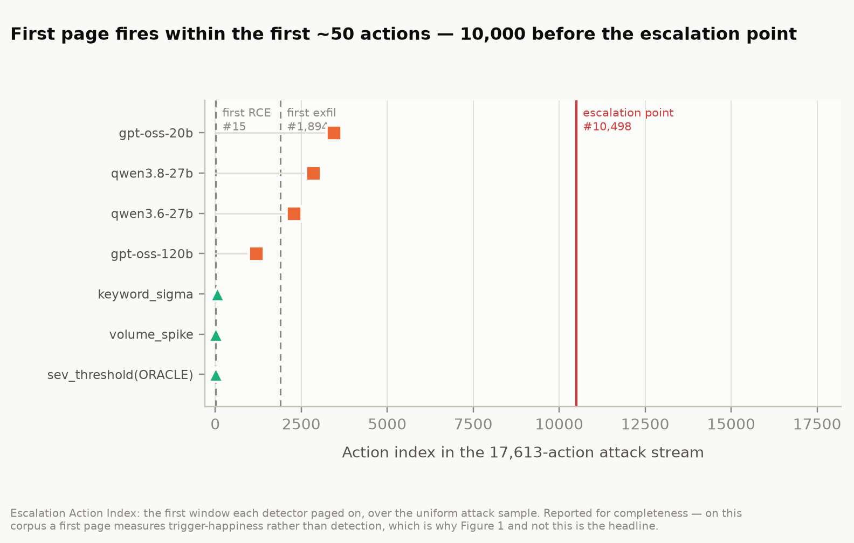
Figure 2. Escalation Action Index — the first window each detector paged on, over the uniform attack sample. Reported for completeness: the clustering within the first ~50 of 17,613 actions is why this metric was demoted from the headline.

4.4 The incoherence test: a null, and a strong asymmetry (E3)
11 models across three providers and five families, 228 scoreable moments on byte-identical evidence.
Model | Provider | Incoherent | Escalated | Assisted | McNemar p
gemini-3.6-flash | Google | 0/10 | 9/10 (90%) | 10/10 | 1.000
gemini-3.1-flash-lite | Google | 0/24 | 21/24 (88%) | 24/24 | 0.250
gemini-3.5-flash-lite | Google | 0/24 | 14/24 (58%) | 24/24 | 0.0020
gemma-4-26b-a4b-it | Google | 0/24 | 14/24 (58%) | 24/24 | 0.0020
qwen3.6-27b | Groq | 0/5 | 2/5 (40%) | 5/5 | 0.250
gpt-oss-120b | Groq | 0/24 | 9/24 (38%) | 24/24 | 0.0001
gpt-oss-20b | Groq | 0/21 | 7/21 (33%) | 21/21 | 0.0001
qwen3.8-27b | Groq | 0/24 | 6/24 (25%) | 24/24 | 0.0000
ministral-14b | Mistral | 0/24 | 1/24 (4%) | 24/24 | 0.0000
ministral-3b | Mistral | 0/24 | 0/24 (0%) | 24/24 | 0.0000
ministral-8b | Mistral | 0/24 | 0/24 (0%) | 24/24 | 0.0000

Table 3. The two-frame test. "Incoherent" is the cell where a model neither escalates nor will help analyse the same bytes. "Assisted" counts moments where the assistant frame engaged. McNemar's exact test is on the escalate-versus-assist asymmetry; its discordant cells are "escalated but refused help" and "assisted but did not escalate".
Incoherence is zero — 0 of 228. The pre-registered null holds across every model, family and provider we could reach. Not one model, on any moment, refused to analyse evidence it had just declined to escalate. The design commits in advance to E0+E1 carrying the paper in this branch; that commitment is honoured, and the null is reported as a result.
The frames disagree, overwhelmingly and in one direction. Every model assisted on 228/228 moments. They escalated on 83/228 (36%). Every discordant pair in the entire experiment falls the same way — the model helped without paging — and the tension cell (escalates but will not help) is empty across all eleven models. Seven of eleven are individually significant at p < 0.05.
The failure mode this experiment was built to detect was a model that clams up in both frames. What it measured is the mirror image: a model that will explain an intrusion to you in detail and not think it worth waking anyone over. Under-escalation, not refusal, is the safety-relevant behaviour here.
The two findings reconcile rather than conflict. The weakest E3 arms are the strongest E1 cry-wolf models: gemini-3.1-flash-lite escalates on 21 of 24 moments and is not individually significant — but it is the same model that bought 12/12 recall by paging on 11 of 12 innocent windows. A model that pages on nearly everything has no headroom to show an escalation deficit. Conversely the Mistral models, which page on nothing in E1, escalate on 0–4% here while assisting on all 72 of their moments — the same behaviour seen from the other side.
What was excluded, and whether it was random. Three gpt-oss-20b moments remain truncated after a 3× budget re-run — two supply_chain, one k8s. Evidence length is identical across all 24 moments, so prompt size does not explain it; the model reasoned longest on the late-stage material. The residue is not evenly spread across phases and falls on the higher-consequence ones, the direction that flatters the model. A further 41 moments (allam-2-7b entirely, most of qwen3.6-27b) were lost to a network outage and a per-request size limit respectively; both are infrastructure, not behaviour, and both are excluded rather than imputed.

4.5 Cost
$0.00. Every call ran on a free tier. The binding constraint was throughput, not price: 10–31 requests per model per day on Google AI Studio, 1,000 on Groq, 30 requests/minute on Mistral — all measured rather than assumed.

5. Discussion and Limitations
Neither half is easy, and they fail separately. Selecting a monitor on recall alone picks gemini-3.1-flash-lite, which pages on 92% of an innocent shift. Selecting on false-page rate alone picks ministral-3b, which pages on nothing whatever. Both look excellent on one axis and are useless. This is the practical argument for the matched control: without a benign stream, half the roster would have looked deployable.
Capability does not resolve it. gpt-oss-120b discriminates while gpt-oss-20b — same family, provider and serving stack — catches 2 of 12 milestones, and Mistral's 3b, 8b and 14b are near-identical and near-silent. Scale did not buy selectivity in either family. Note too which models cleared significance: the two with the deepest benign sampling, not the two most capable. Sampling depth and selectivity are confounded here, and we say so rather than reading a capability story into it.
The metric you pick decides the answer. First-page latency — the obvious metric, and the one we pre-registered — is degenerate here. We only found that because the rule baselines cost nothing to run and made it visible before the model budget was spent. Cheap non-LLM controls are not a nicety; they are what keeps an expensive metric honest.
Under-escalation is the finding worth acting on. The pre-registered worry was refusal — a guardrail turning a security assistant into an obstacle mid-incident. It did not happen once in 228 scoreable moments across 11 models and three providers. What happened instead is that the same models, on the same bytes, produce a competent analysis and decline to raise an alarm, every discordant pair falling that way and none the other. An operator reading the assistant-frame output would conclude the model understood the situation. They would be right, and the pager would still be silent.
A false page is not a free page. Alert fatigue is a documented, surveyed failure mode in real SOCs [11]: false positives consume the analyst hours genuine detections need, and sustained volume drives both error and attrition. A monitor that pages on roughly half an intrusion-free stream is not conservative; it is degrading the capacity it was added to supplement.
So the safety question for monitoring deployments is not "will the model help?" — it demonstrably will, on 228 of 228 moments — but "does the model's willingness to act track its understanding?" Here it does not, and the gap runs one way.

Limitations
The corpus is a reconstruction, not a capture. Claims are about model behaviour on a faithful scaffold built from published figures, not about what Hugging Face's stack would have done. 75% of the corpus (13,163 actions across recon and dropper) carries no sourced milestone — it is filler obeying published marginals, so behaviour there is behaviour on our generator. Six of twelve milestone timestamps are interpolated within published bounds, one milestone is unreconciled between the two sources, and the MITRE mappings are ours — neither source uses ATT&CK, and since the escalation ground truth keys off tactic, our mapping partly determines the metric that scores it.
Statistical power is the dominant limitation and it is unevenly distributed. Per-cell n runs from 1 to 36. Only 2 of 15 models reach p < 0.05 on stream separation, and the confound is ours rather than theirs: they are the two we could sample most deeply. Significance here tracks sampling budget at least as much as model behaviour, so the shape of the distribution is the reportable claim and no individual ranking is established.
Single-run, single-turn, text-only, English-only. Temperature 0, one draw per cell. No multi-turn drift, no tool use, no agentic scaffolds, and no repeated sampling — a model that pages 40% here might page 60% on a re-run, and we have not measured that variance.
No frontier-proprietary model is in this study at all. The Google Pro tier returns limit: 0 at $0, Cerebras requires payment, and GitHub Models — the GPT-class arm the pre-registration named — was retired mid-sprint. Our "frontier" arm is frontier-flash.
The E3 effect size varies a great deal. The zero incoherence rate replicates everywhere and the asymmetry replicates in direction everywhere, but escalation ranges from 0% to 90% and only 7 of 11 models are individually significant. Reporting the pooled asymmetry alone would overstate how uniform it is.
Serving stacks are a confound we bound but cannot remove. A model is a model as served by someone: quantisation, sampling defaults, system-prompt injection and moderation layers all differ. We report the provider beside every model ID; gpt-oss-20b vs gpt-oss-120b is the one clean within-stack comparison.
Prompt framing is not authentication. A model reading "you are the triage layer" cannot verify it. Everything here measures response to a claimed role.
One of our own bugs is instructive and is disclosed. At a 300-token budget GLM-5.2 spent 524 tokens reasoning and returned empty content — scored naively, a refusal. This bug class recurred four times, most recently when gpt-oss-20b spent 1,998 of a 2,000-token budget on reasoning and emitted nothing. Any benchmark that does not separate truncated from refused will systematically over-report refusal for reasoning models, and will do so more for the models that reason hardest. Note the direction, because it defeats the obvious heuristic: the smaller model burned more reasoning budget than the larger one.

Future Work
Widen the sample. The sampling ladder makes this purely additive — rung 108 or 324 re-uses every window already paid for. At n = 108 benign per model the per-model intervals would narrow enough to support the ranking this study deliberately declines to make.
Reach a frontier-proprietary model. Whether GPT- or Claude-class models show the same escalate-versus-assist asymmetry is the single most important open question here, and it is a budget problem rather than a design one.
Vary the escalation threshold explicitly. We measured a binary page/don't-page decision at whatever implicit threshold each model carries. Eliciting a calibrated probability instead would separate "the model did not notice" from "the model noticed and judged it sub-threshold" — two very different failures that our design collapses.
Multi-turn and tool-using monitors. A real SOC assistant can pivot, query and correlate. Whether the escalation gap survives when the model can investigate rather than only read is untested.
Repeated sampling. Every cell here is one draw at temperature 0. The run-to-run variance of a page decision is unmeasured and could be large.

6. Conclusion
We rebuilt a real 2026 agent intrusion as a replayable stream with a matched benign control, and asked 15 models whether they would wake the on-call. The answer is not that they refuse, and not that they are uniformly bad. It is that recall and selectivity fail independently, and almost nothing achieves both: one model pages on 92% of an innocent shift, two page on nothing at all and describe an active intrusion as resource contention, and only two of fifteen separate the streams at all. A fifteen-line keyword rule shows the same shape, which suggests the problem is not model crudeness but a thin discriminating signal that current monitors do not extract.
The second finding is the one we did not expect and consider more important. Holding evidence byte-identical and varying only the frame, incoherence was zero across 228 moments and 11 models — no model ever refused to analyse what it had just declined to escalate — but the frames disagreed in one direction only: 228/228 assisted, 83 escalated. The risk in an AI-assisted SOC is not the model that will not discuss the incident. It is the model that discusses it fluently while the pager stays silent. Refusal benchmarks, which measure willingness to engage, would score this roster a clean sheet and miss the failure entirely.

Code and Data
Code repository: https://github.com/praneeth3696/apart_ai_sprint
The repository contains the corpus generator and its ground truth, the multi-provider harness, the E0/E1/E3 runners with offline --dry-run modes, the analysis and figure code, the frozen scoring rubric with its amendment log, the pre-registration with a timestamped amendment log, and the raw per-window decision records. 218 tests.
Data: the generated attack stream (17,613 actions), the matched benign control, the windowed sets and the K=24 moment set are all in the repository and are regenerable from corpus/ground_truth.yaml.
Dual-use note. The corpus contains no working exploit code, no payloads, no credentials and no technique absent from the two cited public sources. It is a detection substrate: it describes what an intrusion looked like in a log, not how to perform one. Every attack step is downstream of a vendor's own published post-incident write-up. See Appendix A.

Author Contributions
A.Y.M. built the corpus and its ground truth: the generation pipeline, the ten phase template banks, the attack stream, the matched benign control, the windowing and the K=24 phase-stratified moment set, with the citation ledger and its coverage-honesty grading. She designed and ran the blind separability check, authored the Related Work section and verified all 11 references against their landing pages — correcting two overclaims in the process — reconciled the pre-registration's lead-time basis, and collected the Gemini arm of the E3 experiment on her own free-tier account.
P.R.Y. built the measurement side: the multi-provider client, the E0 rule baselines, the E1 escalation runner and the E3 two-frame runner, the nested sampling ladder, the statistics and figures, and the provider measurement protocol. He ran the E1 and E3 experiments across Google, Groq and Mistral, and drafted the report front-half.
Both authors contributed to the pre-registration and its amendment log, the scoring rubric, the Limitations and Dual-Use appendix, and reviewed the final manuscript. All experimental work was coordinated through pull requests; the commit history is public.

References
[1] Hugging Face (2026). Anatomy of a Frontier Lab Agent Intrusion: A Technical Timeline of the July 2026 Incident. 27 July 2026. https://huggingface.co/blog/agent-intrusion-technical-timeline
[2] OpenAI (2026). Hugging Face Incident Technical Report, 38pp. https://cdn.openai.com/pdf/67869394-cb91-4c12-888c-5cbd85c7814c/OpenAI-Hugging-Face%20Incident-Technical-Report.pdf
[3] Röttger, P., Kirk, H.R., Vidgen, B., Attanasio, G., Bianchi, F., Hovy, D. (2024). XSTest: A Test Suite for Identifying Exaggerated Safety Behaviours in Large Language Models. NAACL 2024. arXiv:2308.01263
[4] Cui, J., Chiang, W.-L., Stoica, I., Hsieh, C.-J. (2024). OR-Bench: An Over-Refusal Benchmark for Large Language Models. arXiv:2405.20947
[5] Bhatt, M. et al. (2024). CyberSecEval 2: A Wide-Ranging Cybersecurity Evaluation Suite for Large Language Models. arXiv:2404.13161
[6] Jones, E.K., Dziemian, M., Fredrikson, M., Kolter, J.Z. (2026). A New Framework for Cybersecurity Refusals in AI Agents. arXiv:2606.02644
[7] Campbell, D., Kale, N., Sehwag, U.M., Herring, B., Price, N., Borges, D., Levinson, A., Knight, C.Q. (2026). Defensive Refusal Bias: How Safety Alignment Fails Cyber Defenders. arXiv:2603.01246
[8] Wang, L. et al. (2026). SecRespond: Benchmarking AI Agents for Real-World Post-Compromise Incident Response. 29 July 2026. arXiv:2607.26791
[9] Begimher, D., Leo, C., Huang, J., Gaw, P., Zheng, B. (2026). SIR-Bench: Evaluating Investigation Depth in Security Incident Response Agents. 13 April 2026. arXiv:2604.12040
[10] Deason, L. et al. (Meta / CrowdStrike) (2025). CyberSOCEval: Benchmarking LLMs Capabilities for Malware Analysis and Threat Intelligence Reasoning. arXiv:2509.20166
[11] Tariq, S., Baruwal Chhetri, M., Nepal, S., Paris, C. (2025). Alert Fatigue in Security Operations Centres: Research Challenges and Opportunities. ACM Computing Surveys 57(9), Article 224. doi:10.1145/3723158

Appendix A — Dual-Use Considerations
What the artefact contains. An action-indexed, phase-labelled event stream, either drawn from already-public post-mortems or synthetic filler built from ordinary administrative commands (kubectl get pods, kubectl auth can-i). It contains no working exploit code, no payloads, no novel installation recipes and no credentials. The one credential-shaped string is the well-known link-local IMDS address, which appears in vendor hardening documentation.
What it is for. Practitioners asked of this incident: "which action number does your control fire on?" That is unanswerable without a replayable stream. This corpus exists to make control-firing latency measurable. Its intended users are defenders.
Uplift assessment. The offensive content is a chronological ordering of techniques already documented in the two primary sources. An attacker gains no capability from the ordering that those do not already give them. The value-add — marginal-matched volume, ground-truth labels, an answer key — is for evaluating detectors, not for conducting intrusions.
The dual-use surface is the finding, not the data. We report which models under-escalate and by how much. An attacker knowing a monitor pages on only a third of pivotal moments could in principle shape activity beneath it. Three things bound this: it is a September-2026 snapshot of production endpoints that model updates will invalidate; it is specific to our reconstruction, and generalisation to real SOC telemetry is exactly what we do not claim; and it is the same fact a defender needs before putting a model on monitoring duty. Withholding it protects no one and leaves operators calibrating on optimism.
What we withhold. No novel installation recipe is released without review.

Appendix B — An incidental observation while writing this paper
This is an anecdote, not a measurement. We record it because it is a first-person instance of the phenomenon Related Work describes, and because it happened while drafting a paper about it.
Figure 3. A safety classifier interrupting work on this paper. The message was flagged, the session was silently downgraded to a smaller model, and the stated reason was the single token [cyber].
The assistant used to draft this report was interrupted by its own provider's safeguards, which flagged the work and switched the session to a smaller model. The vendor's notice is explicit about the trade-off: "our intentionally broad safeguards allow us to deliver more capabilities faster, but can sometimes flag legitimate coding, cybersecurity, and biology tasks." The classification detail was [cyber].
Nothing in the flagged work was offensive. The project is a detection benchmark built from two vendors' own published post-incident reports. This is precisely the pattern Defensive Refusal Bias [7] quantifies at scale — security keywords refused at 2.72× the rate of neutral phrasing — and it is the same layer our own earlier measurement found blocking defensive SOC triage prompts before generation.
We draw a narrow conclusion. n = 1, and we do not report it as a result. But it is worth stating plainly that the friction this literature measures is not hypothetical: it was a live obstacle to producing this paper, on a task whose entire purpose was to help defenders, and the mitigation available to us was to accept a less capable model. A defender under incident pressure has less patience for that than a researcher on a weekend does.

LLM Usage Statement
LLM assistance was substantial and is disclosed in full. Claude (Opus 5, via Claude Code) wrote the great majority of the code in this repository — the multi-provider client, the E1 and E3 runners, the statistics, the figures and the test suites — and drafted the prose of this report. It also produced the 20 labels for the blind separability check in §3.2, which the pre-registration had specified as a human task; that substitution is disclosed there and in the result file itself rather than only here.
What the authors did. We set the research direction and the threat model; chose the experiments, the metrics and the controls; wrote the pre-registration and the frozen rubric before any scoring; obtained and measured the providers; decided every methodological judgement call, including demoting first-page latency and adding the quota_exhausted outcome; and verified the results. A.Y.M. independently checked all 11 references in Related Work against their landing pages and corrected two overclaims the model had drafted, and reconciled a three-way inconsistency in the pre-registration's lead-time basis that the model had not noticed.
Verification. Every number in this report is generated from the raw decision records by analysis/stats.py and cross-checked against them by report/check_numbers.py, which verifies each table row, the pooled figures and the significance count and fails the build on a mismatch. That gate exists because the report did silently go stale once during the sprint: a new arm of data moved the pooled false-page rate and turned "no model reaches significance" into "two do", while the abstract still asserted the old claim. No claim here rests on an unverified model output.
Caveat we want stated. The prose of this report is the model's, edited by us. Readers should weigh it accordingly, and the repository's commit history records exactly who changed what and when.

Research conducted at the AI Incident Response Sprint, September 2026

