**Praneeth Reddy K**

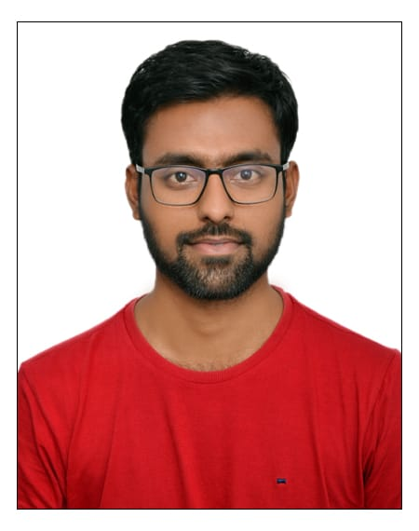

## Quality Engineer Associate Quality Analyst

Worked on 2 Projects in Last 2 Years

Address

Email

Hyderabad, India.

[praneeth.k@kairostech.com](mailto:praneeth.k@kairostech.com)

Phone

+91 9150660240

**I enhance my knowledge and give my best to the organization**.

* Working as Quality Engineer in Kairos Technologies with 2 years’ experience (From Mar 2021 – Till date)
* As a team member I was involved as a Test engineer, the business stories which are provided in the JIRA tool are the inputs for our Test Life Cycle.
* We took the stories and then prepared Test requirements, Test Scenarios, and Test cases for the same.
* Good understanding of Agile software development lifecycle (iterative and incremental)
* Participated in day-to-day stand-up meetings, working in coordination with the development team and on-site team.
* We have updated the bugs in the JIRA bug tracker which was maintained in the Bug life cycle procedure.
* Good exposure to Software development life cycle (SDLC), Software test life cycle (STLC), and Bug Life Cycle.
* Working in sprint model were validating the released software builds meeting the client requirements or not.
* Good knowledge on Sales Cloud, Service Cloud and Admin Activities in the salesforce application

# Employment History

# Associate Quality Analyst – Kairos Technologies

Mar 2021 – Present

Training Period

Mar 2021 – Sep 2021

* I have undergone training on Manual testing, Basics of Core java, and

Automation testing for about 6 months

Project Experience

Kairos website and KLabs Microsite

October2021 – October2022

**Description**: Kairos Technologies is an IT services company and made our own company website with the naming of Kairos Tech Website which describes about the organization and Klabs Microsite which describes about our organization products like KiTAP and DQGateway.

**Roles and responsibilities:**

* As a team member I was involved as Test engineer, the business stories which are provided in JIRA tool are the inputs for our Test Life Cycle.
* Involved in Integration Testing end-to-end scenarios testing by using US & Canada location for testing in HIRS, TSD Rental booking systems.
* We used to maintain the defect report in the Jira tool.

Competency

Associate Quality Analyst

Quality Engineer

## Skills

### Software Testing:

Manual Testing

Automation Testing

### Testing Concepts:

SDLC

Testing Levels

Testing Types

Testing Techniques

**Performed below:**

Smoke Testing, Sanity Testing, Regression Testing, End to End Testing with respect to sprint release timelines.

Computer Languages

Java

C language

## IDE:

IntelliJ

Eclipse

Frameworks

TestNG

Data Driven

Page Object Model

Cucumber BDD

Tools

JIRA

Selenium

## Personal Skills

Result Focused, Adaptability, Collaborator, Problem Solving, Friendly & Approachable.

Project Experience

Frontier Communications(FTR)

December2022-Till date

**Description**: Frontier is a leading communications provider offering gigabit speeds to empower and connect millions of consumers and businesses in 25 states. It is building critical  
digital infrastructure across the country with its 100% fiber-optic network and cloud-  
based solutions, enabling connections today and futureproofing for tomorrow.

**Roles and responsibilities:**

* As a team member I was involved as a Test engineer, the business stories which are  
  provided in the JIRA tool are the inputs for our Test Life Cycle.
* Involved in Mobile App testing end-to-end scenarios in Frontier Applications in  
  Production, Stage Environments.
* As a team We used to create and updated the bugs in JIRA bug tracker which was  
  maintained in the Bug life cycle procedure.
* We used to maintain the defect report in the Jira tool.
* Performed Regression, and exploratory testing for the above-mentioned systems for every sprint.

## Education

### Panimalar Engineering College , Anna University, Chennai, Tamil Nadu.

Bachelor of Engineering (B.E)

With 76% from academic year 2016-2020

### Narayana Junior College, Nellore

Intermediate- MPC

### V.B.R English medium High School

SSC

## Languages

English Telugu Tamil

# Collaboration

