**PROJECT DEVELOPMENT TOOLS:**

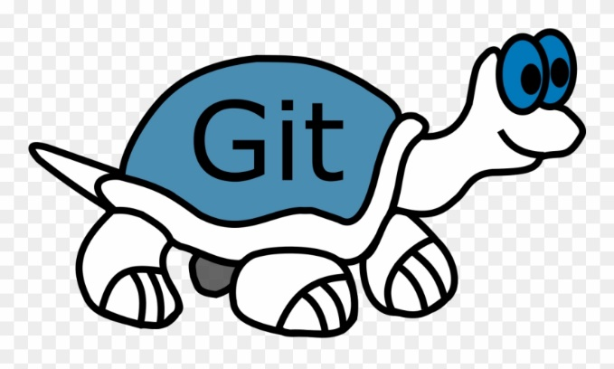**CONFIGURATION MANAGEMENT TOOL: GITHUB**

GitHub is web-based project collaboration tool, which is a distributed computing instrument ordered under Software as a Service (SaaS) class.

Every individual from the group would have allotted certain assignment, pages and capacities to manufacture or refresh, and because the group bunch isn't huge, it is anything but difficult to evade clashes when we consolidate our changes.

For this task, Git would be the form control framework for dealing with its diverse variants. We have picked Git because (git-scm, 2.21.0.1 latest release: 2019) says, it is anything but difficult to learn and claiming is a standout amongst the most famous dispersed adaptation control framework. GitHub would be utilized for the store to help to getting the code in one spot as expressed. Thusly, it is simpler to deal with the difference in all the designer group in one spot and it is anything but difficult to include new Developers. (TortoiseGit, 2015-2019 )

The variety of reason to select tortoise git are stated below:

* Simple to use no need to memorize git bash commands.
* Integrated spell checker for log messages.
* Spell checker.
* Can resolve merge conflicts.
* Conflict numbers are regenerate into links that open the web browser directly on the corresponding issue.
* Shows changes you created to your files.
* Will apply patch files you bought from users while not commit access to your repository.
* TortoiseGitIDiff: to determine the changes you created to your image files (see screenshot)
* TortoiseGit is stable.

**To Setup GitHub Account:**

1. You will need a GitHub account to create a GitHub repository where the revision will be stored.

Go to [https://github.com/join](https://github.com/).

Type a user name, your email address, and a password.

Choose **Sign up for GitHub**, and then follow the instructions.

1. Create a GitHub Repository: You will need a GitHub repository to store the revision.

In the **Repository name** box, enter

1. Upload sample application to GitHub repository

### Install Git and set it up in the project

* Download Git for Windows from <https://git-scm.com/downloads>
* Run Git-2.21.0.1-64-bit.exe
* Click next and when you reach the Configuring the line ending conversions select the first option “Checkout Windows-style …” as the image below:

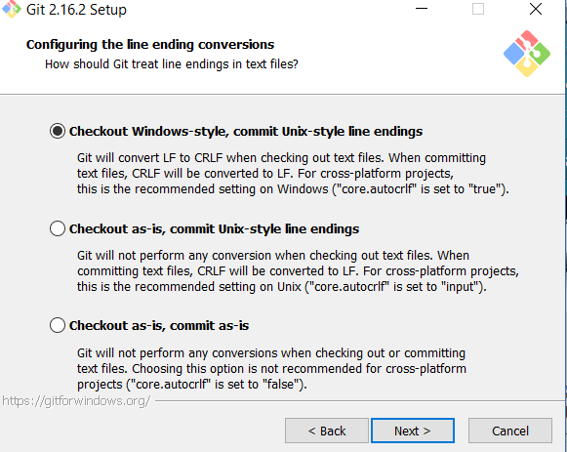

* Click next until finish the installation.
* After installation gets completed we can clone repository in local folder and can add new files, edit files, commit files and push files. (AWS, 2014)

Note: For new members in our team who are not exposed to git commands they use tortoise git instead of Git Bash.