A Real Time Research Project/ Societal Related Project Report

On

**Calorie Counter Application**

Submitted in partial fulfillment of the requirements for the award of the

#### Bachelor of Technology

In

#### Department of Computer Science and Engineering

##### By

**Namala Praneetha Reddy 22241A05G8**

**Nittala Madhu Samhitha 22241A05H0**

**Papineni Divya Sree 22241A05H3**

**Sivapuram Sai Tehya 22241A05J3**

Under the Esteemed guidance of

#### Dr.G.R.Sakthi Dharan

#### Professor



**Department of Computer Science and Engineering**

**GOKARAJU RANGARAJU INSTITUTE OF ENGINEERING AND TECHNOLOGY**

**(Autonomous)**

**Bachupally, Kukatpally, Hyderabad, Telangana, India,500090**

**2023-2024**

I



## GOKARAJU RANGARAJU

**INSTITUTE OF ENGINEERING AND TECHNOLOGY**

**(Autonomous)**

## CERTIFICATE

This is to certify that the Real Time Research Project/ Societal Related Project entitled “**Calorie Counter Application**” is submitted by **Namala Praneetha Reddy (22241A05G8), Nittala Madhu Samhitha (22241A05H0), Papineni Divya Sree (22241A05H3),**

**Sivapuram Sai Tehya (22241A05J3)** in partial fulfillment of the award of a degree in BACHELOR OF TECHNOLOGY in Computer Science and Engineering during the academic year **2023-2024.**

INTERNAL GUIDE HEAD OF THE DEPARTMENT

**Dr.G.R. Sakthi Dharan Dr. B. SANKARA BABU**

**Professor Professor**

II

**ACKNOWLEDGEMENT**

Many people helped us directly and indirectly to complete our project successfully. We would like to take this opportunity to thank one and all. First, we wish to express our deep gratitude to our internal guide **Dr.G.R. Sakthi Dharan**, **Professor**, Department of CSE for his/her support in the completion of our project report. We wish to express our honest and sincere thanks to **Dr.V.Srilakshmi** and **Ms. Ritwika**  for coordinating in conducting the project reviews, **Dr. B. Sankara Babu, HOD,** Department of CSE for providing resources, and to the principal **Dr. J. Praveen** for providing the facilities to complete our Real Time Research Project/ Societal Related Project. We would like to thank all our faculty and friends for their help and constructive criticism during the project completion phase. Finally, we are very much indebted to our parents for their moral support and encouragement to achieve goals.

**Namala Praneetha Reddy 22241A05G8**

**Nittala Madhu Samhitha 22241A05H0**

**Papineni Divya Sree 2241A05H3**

**Sivapuram Sai Tehya 22241A05J3**

**III**

## DECLARATION

We hereby declare that the Real Time Research Project/ Societal Related Project entitled “**Calorie Counter Application”** is the work done during the period from **2023-2024** and is submitted in the fulfillment of the requirements for the award of the degree of Bachelor of Technology in Computer Science and Engineering from **Gokaraju Rangaraju Institute of Engineering and Technology (Autonomous under Jawaharlal Nehru Technology University, Hyderabad).** The results embodied in this project have not been submitted to any other university or Institution for the award of any degree or diploma.

**Namala Praneetha Reddy 22241A05G8**

**Nittla Madhu Samhitha 22241A05H0**

**Papineni Divya Sree 22241A05H3**

**Sivapuram Sai Tehya 22241A05J3**

IV

|  |  |  |
| --- | --- | --- |
|  | **Table of Contents** |  |
| **Chapter** | **Title** | **Page No.** |
|  | Abstract | 1 |
| 1 | Introduction | 2-5 |
| 2 | System Requirements | 6-20 |
|  | 2.1 Software Requirements | 6-8 |
|  | 2.2 Hardware Requirements | 9 |
|  | 2.3 Data Set | 10-20 |
| 3 | Literature Survey | 21-28 |
| 4 | Proposed Model, Modules Description, and UML Diagrams | 29-36 |
|  | 4.1 Modules | 29-32 |
|  | 4.2 UML Diagrams | 33-36 |
| 5 | Implementation, Experimental Results &Test Cases | 37-46 |
| 6 | Conclusion and Future Scope | 47-48 |
| 7 | References | 49-50 |
|  | Appendix   1. Snapshot of the Result 2. Optional (Like Software Installation /Dependencies/ pseudo code) | 51 |

V

|  |  |  |
| --- | --- | --- |
| **LIST OF FIGURES** | | |
| **Fig. No.** | **Title** | **Page No.** |
| 2.31 - 2.3.11 | Dataset | 10-20 |
| 4.3.1.1 | Use Case Diagram | 33 |
| 4.3.2.1 | Class Diagram | 34 |
| 4.3.3.1 | Sequence Diagram | 35 |
| 4.3.4.1 | Component Diagram | 36 |
| 5.1.1.1 | Html code for register page | 37 |
| 5.1.1.2 | Html code for login page | 37 |
| 5.1.1.3 | Html code for user page | 38 |
| 5.1.1.4 | Html code for exercise page | 38 |
| 5.1.1.5 | Html code for food input page | 39 |
| 5.1.1.6 | html code for final result | 39 |
| 5.1.2.1 | code for importing and implementing flask | 40 |
| 5.1.2.2 | Python code for user authentication | 40 |
| 5.1.2.3 | Python code for BMR calculation | 41 |
| 5.1.2.4 | Python code for final result Calculation | 41 |
| 5.1.1 | Register page | 42 |
| 5.1.2 | Login page | 42 |
| 5.1.3 | User details page | 43 |
| 5.1.4 | Exercise Suggestions Page | 43 |
| 5.1.5 | Food item input checkbox | 44 |
| 5.1.6 | Result page | 44 |

|  |  |  |
| --- | --- | --- |
| **LIST OF TABLES** | | |
| **Table No.** | **Table Name** | **Page No.** |
| 1 | Testing | 45-46 |

# VI

# ABSTRACT

# In latest years, there was a growing subject concerning nutritional conduct and their effect on health. With the upward thrust of technology, diverse programs have emerged to help people in coping with their nutritional consumption.

# The device serves as a customized nutritional assistant, able to talking with customers in herbal language to music their calorie consumption. Utilizing AIML, the device employs a rule-primarily based totally method to recognize consumer queries and offer applicable responses. Through a mixture of predefined regulations and device studying algorithms, the device can adapt to customers` possibilities and nutritional necessities over time.

# Calorie counter consist of the capacity to:

# 1. Interpret consumer enter in herbal language, along with queries associated with meals items.

# 2. Retrieve dietary statistics from the database of meals items.

# 3. Calculate calorie consumption primarily based totally on consumer enter and offer real-time feedback.

# 4. Offer personalized pointers and hints for keeping a balanced diet.

# The device targets to empower customers with a handy and sensible device for coping with their nutritional goals. The calorie counter gives a consumer-pleasant interface that simplifies the system of tracking calorie consumption and making knowledgeable nutritional choices. AIML-primarily based totally calorie counter represents a promising method to nutritional assistance, presenting a flexible and adaptive answer for people in search of to enhance their dietary conduct and normal well-being.

# 

**Chapter 1**

**INTRODUCTION**

In today`s fast moving world, keeping a healthy life-style has turn out to be an increasing number of challenging. The upward push in sedentary jobs, clean availability of processed foods, and busy schedules make contributions substantially to negative nutritional conduct and next fitness troubles which include obesity, diabetes, and cardiovascular diseases. To cope with those concerns, virtual fitness tools, specially calorie counter net applications, have emerged as treasured aids for people looking for to control their nutritional consumption and ordinary fitness.

Calorie Counter Application is a complete answer designed to help customers in monitoring and coping with their everyday calorie consumption. This assignment leverages the blended energy of HTML, CSS, JavaScript, and Python to supply a continuing and intuitive consumer experience.

Calorie Counter Application is to file and estimate the variety of energy a consumer consumes and burns every day. The consumer can set the goal of energy for the day. By inputting info of meals fed on and workout accomplished through the consumer, the utility consequently generates an evaluation of the overall energy fed on and overall energy burned, consequently imparting the consumer with a file of what number of energies are left from the goal. This facilitates the consumer to hold song in their ingesting conduct and workout workouts to keep their fitness.

**Project Overview:**

The Calorie Counter Application is a web-primarily based totally utility advanced to assist customers display their nutritional conduct. The number one goal is to offer an easy-to-use platform for logging meals, monitoring dietary consumption, and placing non-public fitness desires. By supplying specific insights and development monitoring, the app objectives to guide customers in reaching their fitness and health objectives.

**Features:**

• User Registration and Authentication: Secure consumer bills with customized dashboards.

• Calorie Tracking: Log every day meals consumption with a complete database of meals an their dietary values.

• Progress Reports: Visual charts and specific reviews to assist customers display their calorie intake and development over time.

• Custom Goal Setting: Personalized desires and reminders to hold customers on song.

**The Significance of Calorie Control**:  
One of the most important components of weight control and general health is calorie management. People can make more educated dietary decisions and improve their health by being aware of the calories in the foods and drinks they consume. Studies have repeatedly shown that keeping an eye on caloric intake is a useful tactic for both weight loss and maintenance. Burke et al. (2011), for example, discovered that people who used digital tools to check their caloric intake shed much more weight than people who did not practice self-monitoring.

Additionally, tracking calories can help prevent and treat chronic illnesses. A study showing the therapeutic effects of such practices was published in the Journal of the American Medical Association. It found that regular calorie monitoring can improve glycaemic control in people with diabetes.

**Evolution of Calorie Counter Application:**  
The introduction of technology has completely changed how we think about calorie control. Sophisticated digital tools have mostly superseded traditional methods, such keeping a handwritten food journal, because they offer better accuracy, convenience, and user engagement. Web programs with calorie counters in particular have become more and more popular because of their extensive functionality and ease of use.  
Simple databases of food items and their corresponding caloric values were the initial iterations of calorie counter programs. Users would manually input how much food they consumed, and the app would calculate the overall number of calories they consumed each day. Although helpful, these apps frequently lacked thorough nutritional information and were difficult to use, which reduced their efficacy.  
These apps have significantly improved as a result of recent technological breakthroughs. These days, calorie counter websites incorporate a wide. Modern Calorie Counter Web Applications' Features

**Entire Food Databases:**  
A crucial component of contemporary calorie counter software is the incorporation of vast food databases. The nutritional data for thousands of food items, including packaged goods, restaurant meals, and home-cooked dishes, can be found in these databases. Regardless of their eating habits, consumers may report their food consumption precisely thanks to this complete coverage.  
  
**Barcode Reading:**  
Barcode scanning is becoming used in calorie counter applications, which significantly simplifies the process of recording food intake. Users can save time and effort by rapidly retrieving nutritional information from packaged food items by just scanning their barcodes, which eliminates the need for manual entry.  
  
**Particularized Suggestions:**

Another important component of modern calorie counter programs is personalization. These programs frequently offer customized.

**1.1 Existing System**

The present device does have an in-depth database of ingredients with dietary data.They take the consumer enter which includes their name, age, weight, height that is utilized in calculating the BMR that is used to calculate whether someone is underweight, obese or obese.

Many features are available in the calorie counter web programs that are currently available to help consumers control their food intake. Well-known programs like MyFitnessPal, Lose It! and Cronometer offer large food databases that let users record their meals along with comprehensive nutritional details. These platforms also include features like personalized recommendations based on user-specific health objectives and barcode scanning, which makes it easier to register packaged goods.  
  
**Modern Calorie Counter Web Application Features:**

**Entire Food Databases**:

A crucial component of contemporary calorie counter software is the incorporation of vast food databases. The nutritional data for thousands of food items, including packaged goods, restaurant meals, and home-cooked dishes, can be found in these databases. Because of its thorough coverage, consumers may record their food intake properly regardless of their dietary habits.

**BarcodeReading:**  
Barcode scanning is becoming used in calorie counter applications, which significantly simplifies the process of recording food intake. Users can save time and effort by rapidly retrieving nutritional information from packaged food items by just scanning their barcodes, which eliminates the need for manual entry.

**Particularized Suggestions:**Another important component of modern calorie counter programs is personalization. Personalized recommendations are frequently given by these apps depending on the user's activity level, age, gender, height, weight, and specific health objectives. This tailored strategy improves the applicability and efficacy of nutritional recommendations, leading to increased adherence to exercise and health regimens.  
  
**Integration with Wearable Devices**  
An important development in the field of digital health is the integration of calorie counter apps with wearable fitness gear. Wearable technology, like fitness trackers and smartwatches track several health data and physical activity continuously. Calorie counter apps that sync with these devices can give users a comprehensive picture of their health by fusing data on physical activity and food consumption to produce more precise and useful insights.

**1.1.1 Limitations in Existing System**

Although there are many advantages to using current calorie counter programs, there are also several drawbacks.

**User Participation and Compliance:**  
Continuing to sustain user adherence and interest over time is one of the fundamental issues. Although many users begin fervently at first, the novelty soon wears off, resulting in lower usage and eventually application discontinuation. A study by Carter et al. (2013) brought this issue to light when they discovered that after the first few weeks of use, adherence to a calorie counter application drastically reduced. User-friendly design, tailored feedback, and ongoing engagement tactics are key to resolving this problem.

**Accuracy of Nutrition Information**:  
 The accuracy of the nutritional data supplied is another drawback. There can be notable differences even though many programs rely on user-reported data or databases from third parties in food's nutritional value, particularly when it comes to restaurant versus home-cooked meals. This error may result in inaccurate counting of calories, which could compromise the app's efficacy. Azar et al.'s (2013) study brought to light differences in the nutritional data offered by various calorie counter applications, highlighting the necessity of standardized and validated databases.

**Privacy and Data Security**:  
Security of data and privacy are also important issues. Because these apps gather private medical data, it is critical to have strong data security protocols in place to preserve user confidence and adhere to legal requirements. There are a lot of risks associated with data breaches and illegal access to sensitive health information. Patil and Seshadri's (2014) research highlight the significance of putting strict security measures in place to protect user data in digital health apps.

**1.2 Proposed System**

Our proposed device makes use of device studying version to expect the calorie content material of meals gadgets, which provides a layer of personalization and adaptability.

We are the use of the Harris-Benedict Equation which makes use of a particular formulation to calculate BMR primarily based totally on consumer enter for age, peak, and weight.

**1.2.1 Advantages of Proposed System**

The dataset used is handy for all of the South Indian customers because it includes all the perfect meals ate up with the aid of using someone in a day. Which consequently enables in calculating the energy in a greater powerful manner.

Our device additionally offers instant comments on whether or not the consumer`s calorie consumption is above or under their BMR, supporting them modify their nutritional conduct accordingly.

# Chapter 2

# SYSTEM REQUIREMENTS

**2.1 Software Requirements**

Software Requirements are specific descriptions of the functionalities, constraints, and goals that a software program product have to achieve. They function a basis for software program development, making sure that the very last product meets the wishes of its stakeholders, consisting of users, developers, and commercial enterprise managers.

* **Operating System:** An Operating System (OS) is device software program that manages laptop hardware, software program resources, and provides common services for laptop programs. It acts as a middleman among customers and the laptop hardware, making sure efficient and fair aid allocation amongst different tasks and customers.

**Key Features of OS:**

1. Process Management: Manages the creation, scheduling, and termination of the process. It also handles multitasking, ensuring that each process gets the necessary CPU time and resources.
2. Memory Management: Manages the system’s memory, including RAM and cache. It also implements virtual memory to extend the apparent memory capacity using disk space.
3. File System Management: Manages files and directories on storage devices. And also provides a way to create, read, write, and delete files.
4. Device Management: Manages device communication via device drivers. And ensures efficient and fair use of I/O devices among multiple processes.
5. User Interface: Provides a user interface, which can be command-line (CLI) or graphical (GUI). This allows the users to interact with the system and execute programs.

Examples of OS: Windows, macOS, Linux, Unix, Android, and iOS.

* **Text Editor:** A textual content editor is a software program utility used for developing and editing undeniable textual content files. Text editors are important gear for plenty pc users, specifically programmers, writers, and administrators. They fluctuate from phrase processors in that they do now no longer commonly encompass formatting functions like bold, italics, or specific fonts. Instead, they consciousness on manipulating the raw textual content.

Visual Studio Code (VS Code) is designed to be fast and responsive, making it suitable for a wide range of development activities. The built-in terminal allows us to run shell commands directly from the editor.

**Key Features of VS Code:**

1. Integrated Development Environment (IDE)
2. Version Control Integration
3. Extensions and Customization
4. User Interface
5. Code Navigation
6. File Management

* **Front-End-Development:**
* **HTML/CSS:** HTML (Hyper Text Markup Language) and CSS (Cascading Style Sheets) are the essential technology used to create and design web pages. HTML provides the shape of the page, while CSS is used to control the presentation, formatting, and layout.

**Key Concepts of HTML:**

1. Elements
2. Tags
3. Attributes
4. Nesting

**Key Concepts of CSS:**

1. Selectors
2. Properties and values
3. CSS Syntax
4. Cascading and Specificity

* **Back-End-Development:**

Programming language used: Python

Python is a high-level, interpreted programming language known for its simplicity and readability, making it a popular preference for each beginner and skilled developers. It helps more than one programming paradigms, together with procedural, object-oriented, and functional programming.

**Key Features of Python:**

1. Readability
2. Interpreted Language
3. Dynamically Typed
4. Cross- Platform

Python`s simplicity, versatility, and extensive ecosystem make it a effective device for a wide variety of applications, from web improvement to data science and beyond.

* **Flask:** Flask is a micro web framework written in Python. It`s designed to be light-weight and easy to use, making it a popular preference for building web applications.

**Key Concepts of Flask:**

1. Flask Application
2. Routing
3. Templates
4. Request and Response
5. Static Files

* **Flask-SQLAlchemy:** Flask-SQLAlchemy is an extension for Flask that provides aid for SQLAlchemy, an ORM (Object Relational Mapper) that lets in you to paintings with databases in an extra Pythonic way. It presents a high-level abstraction over database operations and integrates seamlessly with Flask.
* **Pandas**: Pandas is an effective and widely-used open-supply library in Python for facts manipulation and analysis. It provides data structures and functions needed to manipulate structured data seamlessly**.**

**Key Concepts of Pandas:**

1. Series: A one-dimensional array- like object containing a sequence of values. It can hold any data type and has associated labels.
2. DataFrame: A two-dimensional, size-mutable, and potentially heterogeneous tabular data structure with labeled axes.

* **Jinja2:** Jinja2 is an effective templating engine for Python, extensively utilized in internet improvement to generate HTML dynamically. It is the default templating engine for Flask. Jinja2 permits you to apply templates to split your software common sense out of your presentation common sense, making your code cleanser and extra maintainable.
* **Key Features of Jinja2:**
  + 1. Variables: You can insert dynamic content material into your templates the usage of variables.
    2. Control Structures: Jinja2 helps manipulate systems like loops and conditionals.
    3. Filters: You can apply filters to variables for formatting.
    4. Macros: Reusable blocks of code can be defined and called within templates.
    5. Template Inheritance: Allows you to create a base template and extend it with child templates.

**2.2 Hardware Requirements:**

Hardware requirements confer with the minimal and endorsed physical components wanted for a computer system to run particular software program or carry out positive tasks. These necessities make sure that the software program operates efficiently and provides a very good user experience.

**Architecture:**

Hardware architecture refers back to the layout and organization of the various hardware components in a computer machine. This encompasses the layout, interactions, and capability of the primary additives which includes the CPU, memory, storage, and peripherals. When specifying hardware necessities for a particular machine or application, understanding the underlying structure is critical for most appropriate overall performance and compatibility.

**Memory (RAM):**

Temporary storage that the CPU uses to store data that is being processed.

**RAM: 16.0 GB** of RAM provides ample memory for most modern computing tasks, from basic usage to more intensive applications. A 16.0 GB RAM supports running multiple applications simultaneously without significant slowdowns.

**Processor:** The 11th Gen Intel Core i5-1155G7 provides high performance. The key specifications consist

* + - **Base Frequency:** 2.50 GHz
    - **Cores/Threads:** 4 Cores / 8 Threads
    - **Max Memory Size:** 64 GB
    - **Memory Types:** DDR4-3200, LPDDR4x-4267

**Storage:**

Permanent storage for the operating system, software, and files.

Faster storage solutions improve load times and overall system responsiveness.

The 256GB SSD offers fast and reliable storage, ideal for quick boot times and efficient data access in laptops and desktops.

**Peripherals:**

Input and output devices such as keyboard, mouse, monitors, and printers come under peripherals.

# 2.3 Dataset

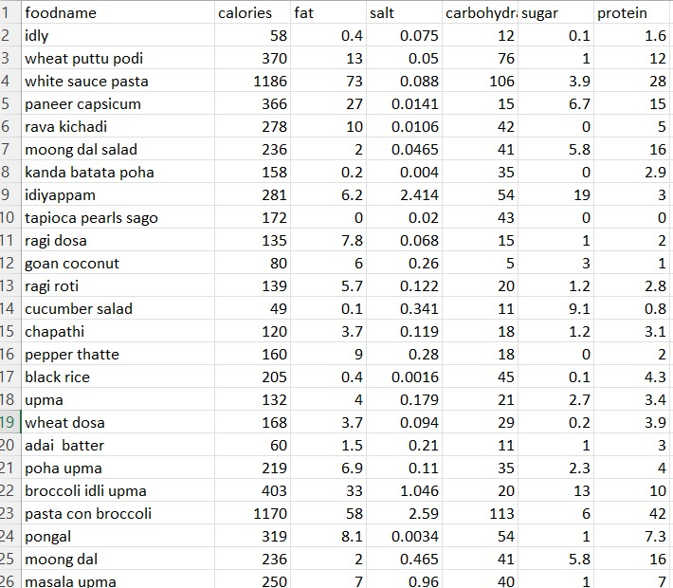

**Fig 2.3.1**

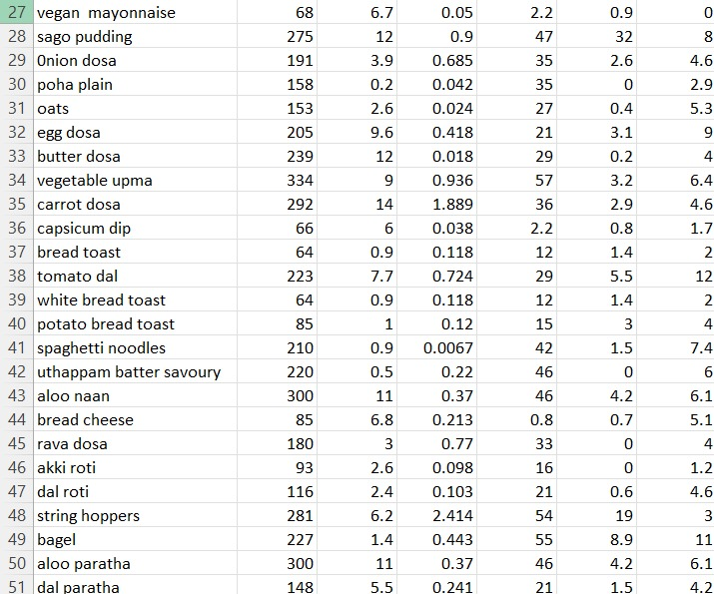

**Fig 2.3.2**

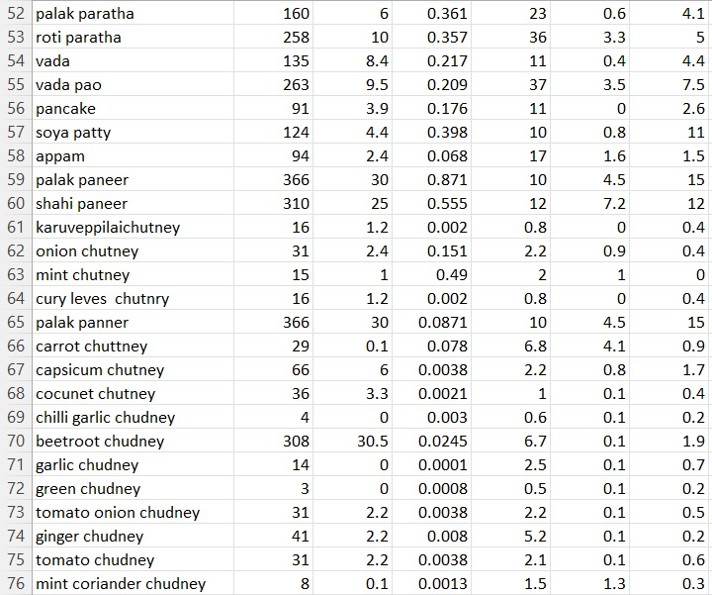

**Fig 2.3.3**

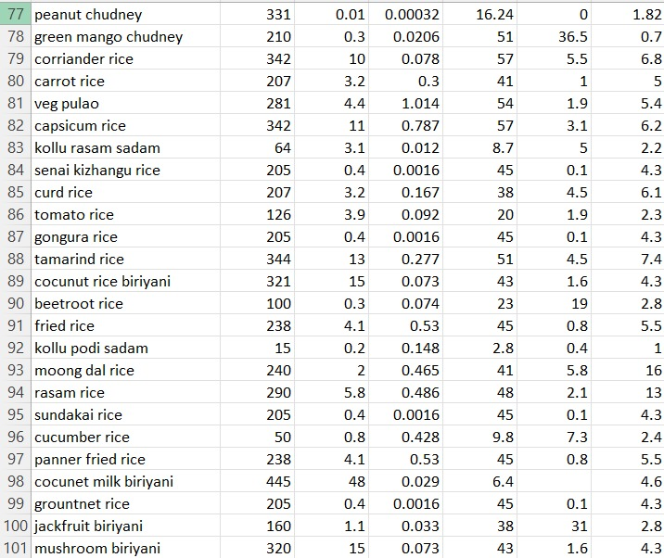

**Fig 2.3.4**

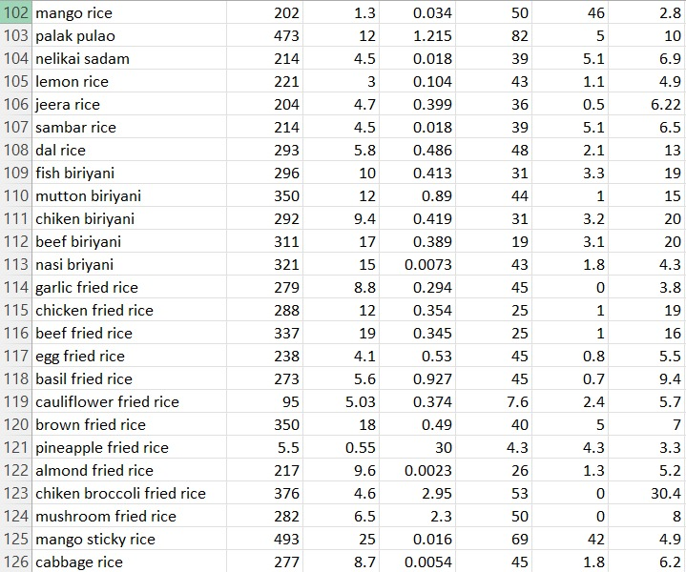

**Fig 2.3.5**

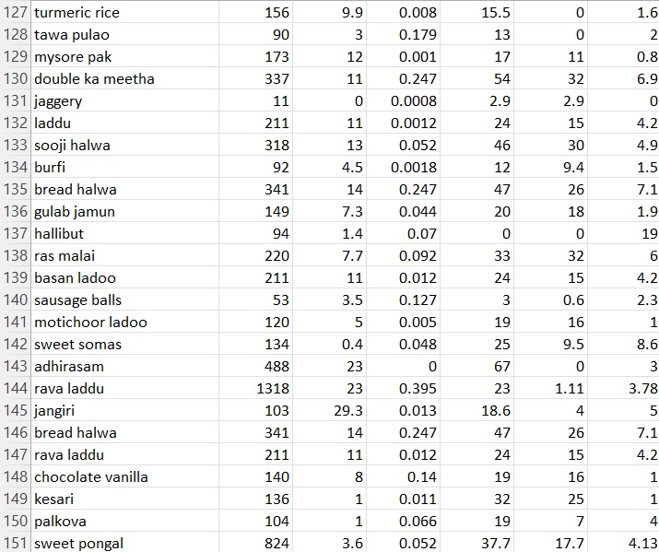

**Fig 2.3.6**

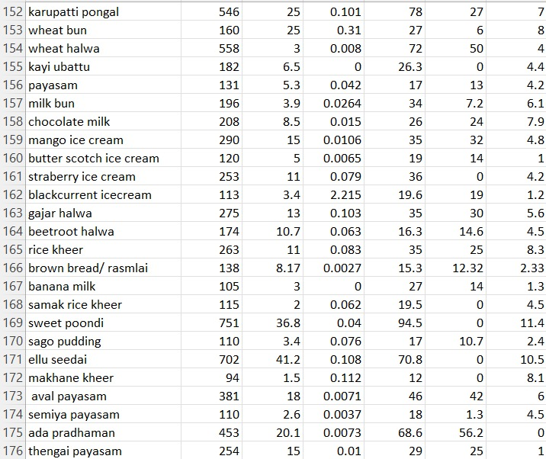

**Fig 2.3.7**

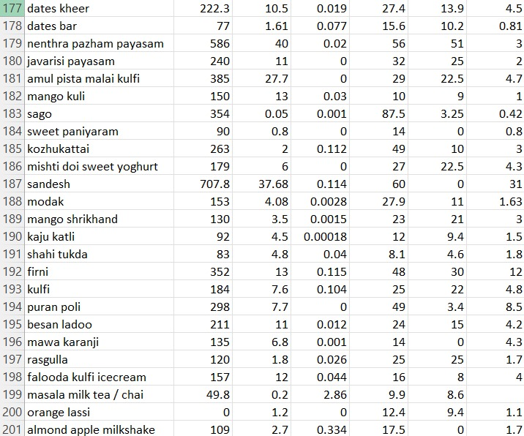

**Fig 2.3.8**

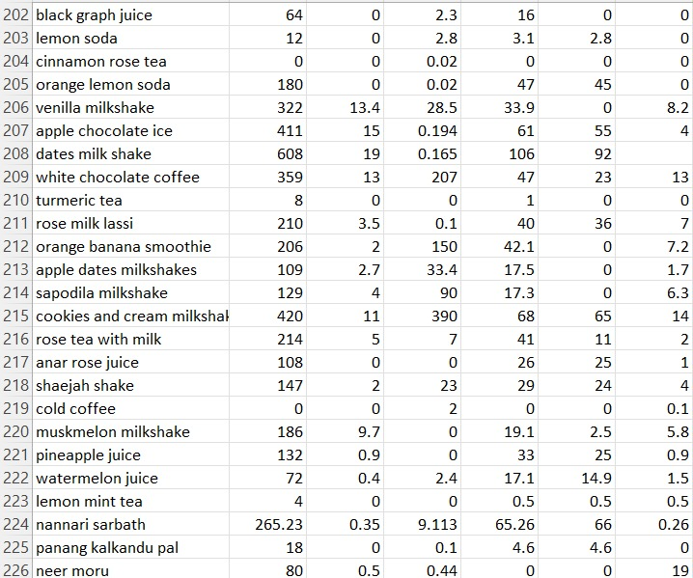

**Fig 2.3.9**

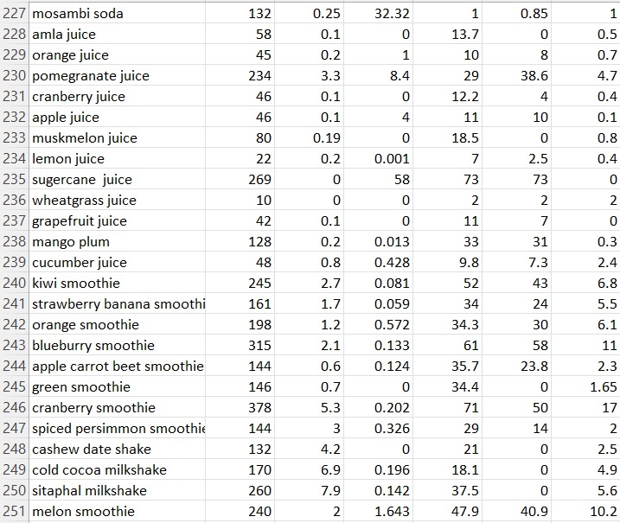

**Fig 2.3.10**

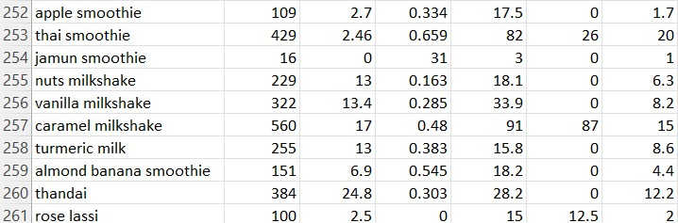

**Fig 2.3.11**

**Chapter 3**

**LITERATURE SURVEY**

# Title: Indian Food Recognition and calorie estimation using YOLOV8

# Authors: V.Gayatri, M.Thanuja

# Year: published in 2023.

# Observations: The creation of a CNN-based model with the goal of identifying food items and estimating their calorie content using YOLOV8 is described in the project paper "Indian Food Recognition and Calorie Estimation Using YOLOV8". A dataset including 5446 photos representing 30 distinct food types is used to train the algorithm. This method provides faster processing speeds and higher accuracy (93.1%), which alleviates the shortcomings of the earlier models. The integration of Streamlit for creating an interactive web application that allows users to input photographs and get estimated calories is highlighted in the article. Notwithstanding its achievements, the study points out that for wider use, more advancements in dataset diversity, real-world testing, and user feedback methods are required. It would also be beneficial for the calorie estimating approach to take into consideration differences in portion sizes and preparation techniques to improve

# Shortcomings: The dataset of 5446 photos representing 30 food classes was used to train the model, although it might not be large enough to capture the wide range of Indian cuisine. This might make it harder for the model to generalise to novel and untested food items. Comprehensive real-world testing or deployment scenarios are not covered in detail in this work. There may be differences in performance between controlled environments and real-world situations due to variations in illumination, occlusions, and food presentation. The calorie estimate is based on a calorie chart and does not take into consideration changes in cooking techniques or portion sizes, which can have a big impact on the number of calories. Despite YOLOV8's efficiency, its high processing power demand may prevent it from being deployed on low-resource devices, such as mobile phones without cloud support. The techniques for user input and mistake correction which are essential for iteratively increasing the model's accuracy based on actual user data are not included in the paper. Although accuracy is the main emphasis of the evaluation, other crucial metrics like recall, precision, and F1 score which are crucial for fully comprehending the model's performance are not fully covered.

# Title: The utilization of Machine Learning for the identification and computation of calories

# Authors: S.Dhanush Hariharan, P.Dinesh, Vivek Chidambaram, G.T Shakila Devi

# Published Year:2023

# Observations: In current years, researchers have explored system getting to know strategies for meals popularity and calorie estimation. One technique includes the use of intensity cameras to seize meals pics at the same time as customers eat. These pics are then processed the use of a YOLOv5 neural network,

# accomplishing a meals popularity fee of over 90%. The calorie estimation mistakess is much less than 10%. This gadget contributes to aged domestic care with the aid of using offering correct nutritional information for tracking and coping with meals intake1. Another look at proposed a framework primarily based totally on AI that routinely categorizes meals pics and estimates meals credits. Their deep getting to know model, which incorporates a convolutional neural network, achieves correct meals classification2. These efforts intention to help people in preserving a balanced eating regimen and coping with calorie intake, addressing fitness worries like obesity.

# Shortcomings: These structures war with as it should be estimating energy whilst element sizes range significantly. A cautiously plated dish may also seem distinctive from the schooling facts, main to errors. Existing fashions frequently lack semantic understanding. For instance, they could confuse a salad with high-calorie dressing as a low-calorie alternative because of visible similarities.Models educated on unique cuisines or cultural ingredients might not generalize nicely to various dishes worldwide. Adapting to nearby versions is a challenge. Real-international implementations need to don't forget consumer interaction. How customers enter facts impacts accuracy.Depth cameras or meals logging apps enhance privateness problems associated with shooting customers` ingesting habits.

# Title: Smartphone Apps for Tracking Food Consumption and Recommendations: Evaluating Artificial Intelligence-based Functionalities, Features, and Quality of Current Apps

# Authors: Sabiha Samad, Fahmida Ahmed, Samsun Naher, Muhammad Ashad Kabir, Anik Das, Sumaiya Amin, and Sheikh Mohammed Shariful Islam

# Year: published in September 2022.

# Observations: This study offers an extensive assessment of smartphone apps that measure food intake and provide dietary advice, with a focus on artificial intelligence (AI)-based features. The writers painstakingly carried out electronic searches through the Google Play, Apple App Store, and Microsoft Store, finding 473 apps at first and reducing them to 80 apps for a thorough examination based on particular inclusion and exclusion criteria. In order to evaluate key features, AI-based functionality, and overall software quality, the article presents a revolutionary app rating tool. The study draws attention to the sophisticated features of some apps, like Foodvisor, which can calculate nutritional values and automatically identify food items. In order to comprehend user expectations and viewpoints, the writers also examined user comments. As a result, they were able to provide insightful analysis on the state and design that was helpful for both researchers and developers.

# Shortcomings: The study has some shortcomings despite its comprehensive methodology. First off, even though the evaluation framework is sound, the paper mainly concentrates on the functional and technical features of the apps, possibly ignoring the larger contextual factors—like cultural variations in eating customs and financial obstacles to healthy eating—that affect app usability. Furthermore, biases may have been created by the original screening process's dependence on app store descriptions and user comments, as these sources might not accurately reflect the app's functionality or user pleasure. The study's exclusion criteria, which eliminated applications pertaining to certain medical problems like diabetes or pregnancy, may have also limited the findings' applicability to a larger user base with a range of medical needs. A more thorough examination of these apps' long-term efficacy in encouraging consistent dietary modifications and enhancing health outcomes would also be beneficial to the paper. Finally, a critical component of user acceptability and trust is the paper's neglect of potential privacy problems around the use of AI and data collecting in these apps.

# Title: Calorie Counter using Django framework

# Authors: Saritha Niranjanrai

# Published Year: July 2021

# Observations:Users can create accounts, log in, and securely control their profiles.The device continues a database of meals objects, consisting of their dietary information (carbohydrates, fats, proteins, etc.).

# Users can upload custom meals objects if they`re now no longer already withinside the database.Based on person enter (height, weight, age, gender), the device estimates the minimal every day calorie requirement.Users can enter their ate up meals objects, and the device calculates the whole calorie

# intake.The app offers pointers for gaining or dropping weight primarily based totally at the person`s

# goals.The UI is constructed the use of HTML, CSS, and Bootstrap, making sure a nice person experience.

# Custom indicators and situations assist customers make knowledgeable selections approximately their meals intake.

# Shortcomings: The challenge`s simplicity won't deal with superior nutritional desires or precise fitness conditions.The accuracy of calorie estimates relies upon at the fine of enter facts (e.g., consumer-stated weight, height, and pastime level). While it gives fundamental calorie tracking, it could lack superior functions like personalised meal making plans or integration with health trackers.The SQLite database used for storing facts won't scale properly for big consumer bases.Remember that this challenge serves as a beginning point, and in addition improvements can deal with those limitations.

# Title: Calorie Counter Information System Development for Weight Loss Program based on Android.

# Authors: Nenny Anggraeni, Nashrul Hakiem, Gerry Widya Ganesha.

# Year: Published on March 2021.

# Observations: System development method that getting used is RAD (Rapid Application Development) This version turned into made with the aid of using James Martin to make the device quicker without compromising quality. The authors carried out a seek of facts with the aid of using spreading the questionnaire, looking for facts from the Internet, the authors additionally do direct statement with the aid of using executing the process of weight loss.

# Shortcomings: The application isn't very interactive with the users and doesn't give them the required exercise suggestions which help the users in controlling their calorie intake and do the minimum required exercise in a day.

# Title: An analysis of calorie estimation accuracy.

# Authors: Hannah Mixon, Matthew E.Davis.

# Published Year: 2020

# Observations: Sharlin Milliard's study "Designing Calorie Counter Smartphone Applications for Effective Weight Loss" outlines the essential components that enhance the efficacy of weight loss apps. It highlights how setting goals, keeping an eye on oneself, and receiving individualized assistance may all help with weight loss. According to the study, calorie counter apps have the ability to provide behavioral therapies outside of clinical settings, providing users with an affordable and practical option. According to the report, which offers a thorough framework for content analysis, many existing apps do not have the necessary elements to maintain user motivation over time and result in noticeable weight loss. The research review emphasizes the significance of ongoing motivation and engagement, which are made possible by attending to users' psychological requirements for relatedness, competence, and autonomy.

# Shortcomings: Notwithstanding the thorough structure and research, there are certain limits to the study. The analysis's biggest limitation is its narrow focus, which may not fully represent the range of calorie counters available, as it only examines a small sample of commercially accessible apps. Additionally, the study makes extensive use of the Self-Determination Theory's theoretical underpinnings, which, while its robustness, might not fully account for all motivating factors pertinent to various user demographics. Furthermore, the study makes the argument that adding features like dietary education and personalized counselling increases the efficacy of calorie counters, but it offers no empirical evidence to back up this assertion from actual program usage. User feedback and longitudinal studies could be incorporated into the study's approach to confirm the usefulness of the suggested design framework.

# Title-Accurate Calorie Counting Algorithm For Carefully Plated Dishes

# Authors: WOON ZHENG LI

# Published Year:30 Dec ,2020

# Observations: The mission employs synthetic intelligence (A.I.) for pervasive and correct calorie estimation. Unlike conventional methods, which cognizance entirely on meals recognition, this set of rules additionally bills for correct meals element detection. The purpose is to create a much better device that helps numerous meals and delicacies types. The set of rules makes use of item detection strategies to perceive meals gadgets on a plate. It then counts the variety of every ingredient, thinking about various sizes, slices, portions, pieces, or units. By doing so, it presents particular calorie estimates primarily based totally at the real composition of the dish.

# Shortcomings: The Accurate Calorie Counting Algorithm for Carefully Plated Dishes targets to cope with the restrictions of current calorie counters. While state-of-the-art calorie counters regularly consciousness on correct meals recognition, they forget particular meals element detection. In this project, the set of rules considers the quantity of elements utilized in a non-occlusive plated environment. It acknowledges that various sizes, slices, portions, pieces, or devices of elements make contributions in another way to universal energy. The final results is a element-conscious calorie counter that estimates energy correctly primarily based totally on the quantity of meals served1. One full-size shortcoming of current packages is the dearth of an item counting set of rules, which can decorate accuracy in counting meals energy with the aid of using incorporating item detection and counting for every component fed on with the aid of using the user.

# Title: Semantics-Based Calorie Counter

# Authors: Sravan Raghu Kumar Narra

# Published Year: August 2020

# Observations: The machine employs tokenization, hashing techniques, and fuzzy matching to extract applicable entities from the recipe. Tokenization breaks down the recipe into significant units. Hashing enables discover comparable substances inspite of moderate versions. Fuzzy matching handles versions in factor names or spellings. After extracting entities, the machine plays unit conversion. It guarantees that measurements (e.g., grams, ounces) are steady for correct calorie calculations. The proposed machine pursuits to decide energy from recipes in numerous formats. Unlike image-primarily based totally approaches, it makes a speciality of textual recipes and leverages semantic understanding.The machine possibly gives an interface wherein customers enter their recipes. It then techniques the recipe text, extracts entities, and calculates energy.

# Shortcomings: The device is predicated completely on recipe textual content, which can also additionally lack unique component portions or serving sizes.Extracting substances and portions as it should be from unstructured textual content may be error-prone.Unlike image-primarily based totally systems, it doesn`t don't forget visible cues (e.g., meals images) for correct calorie estimation. Despite those limitations, in addition studies should beautify its overall performance through combining textual and visible information.

# Title: A study of calorie estimation in pictures of food

# Authors: Jun Zhou, Dane Bell, Sabrina Nusrat, Melanine Hingle, Mahai Surdeanu

# Published Year: November 2020

# Observations: Estimating energy in pix of meals is an critical task, offering information to tell nutrients studies and practice, and supporting people attain optimal, balanced nutritional intakes.

# Researchers have explored gadget mastering strategies for meals reputation and calorie estimation.

# These photographs are then processed the use of a YOLOv5 neural network, attaining a meals reputation fee of over 90%.

# This gadget contributes to aged domestic care via way of means of offering correct nutritional information for tracking and dealing with meals intake.These efforts goal to help people in keeping a balanced food plan and dealing with calorie intake, addressing fitness worries like obesity.

# Shortcomings: A cautiously plated dish may also seem one of a kind from the education data, main to errors. Models educated on unique cuisines or cultural ingredients might not generalize nicely to numerous dishes worldwide. How customers enter data influences accuracy. Depth cameras or meals logging apps enhance privateness troubles associated with taking pictures customers` ingesting habits.

# Title: Deciphering calorie counts to make smarter food choices

# Authors: Santos Lima

# Year: published in 2020.

# Observations: The quick communication "The Nutrition Facts Label: Deciphering Calorie Counts to Make Smarter Food Choices" by Santos Lima provides a useful summary of the significance of using nutrition labels to make better dietary choices. It goes into great detail to describe the composition and elements of nutrition facts labels, highlighting the importance of comprehending calorie counts and their function in daily nutrition. The essay dissects the idea of calories, describing how they are found in proteins, lipids, carbs, and alcohol. It also emphasizes how important calorie monitoring is for maintaining a healthy weight and general wellbeing.It also provides helpful guidance on how to use nutrition information labels to keep a balanced diet, including how to reduce processed foods, emphasize whole foods, pay attention to portion sizes, and be aware of added sugars. The study successfully directs readers toward better dietary practices and nutrient consumption by presenting these tactics. The conclusion restates the importance of nutrition data labels in helping consumers make educated food choices, encourage a well-balanced diet, and maybe lower their chance of developing chronic illnesses.

# Shortcomings: The communication has certain shortcomings, despite its insightful observations. First off, rather than delving extensively into more complex facets of nutrition science, including the effects of various forms of fats or carbs on health, the article mostly concentrates on the fundamentals of calorie counting and broad recommendations for interpreting nutrition labels. This may be an overlooked chance to give readers who are already familiar with the fundamentals of nutrition a more thorough grasp.

# Furthermore, while though the article's advice to prioritize whole foods and minimize processed ones is sound, it ignores possible obstacles to these suggestions, such as financial limitations, the scarcity of fresh produce, or dietary choices related to cultural practices. These elements may have a major impact on a person's capacity to adhere to the recommended standards.Although useful, the explanation of the daily value of nutrients may be improved by elaborating on how these values are calculated and how they might differ for various populations according to factors like age, sex, activity level, and particular medical conditions. This would offer a more tailored approach to dietary guidance. Finally, to help readers better understand the principles covered, the article may include additional visual aids, including sample nutrition labels with highlighted portions. Case studies or actual instances of people utilizing nutrition labels to enhance their health could be included to give the theoretical knowledge more of a practical edge.

# Title: Calorie counting smart phone apps: Effectiveness in nutritional awareness, lifestyle modification and weight management among young Indian adults.

# Authors: Paromita Banerjee, Vishnu Vardhana Rao Mendu, Damayanthi Korrapati, and SubbaRao M Gavaravarapu.

# Year: Published on June 13, 2019.

# Observations: Calorie counting mobile apps declare to help in weight control via way of means of assisting customers monitor their diets and track activity. This examine assessed pleasant and effectiveness of famous calorie counting apps in weight control and behavior change. Anthropometric measurements like height, weight and waist-hip circumference have been measured and BMI become calculated at baseline and endline (8 weeks), the use of standardized equipments.

# Shortcomings: The pattern length on this examine become small, effects cannot be generalized. The inconsistent utilization of the apps via way of means of the participants, abnormal statistics access and faulty calorie estimation via way of means of exceptional apps may also be the feasible motives for the constrained impact of the apps withinside the intervention group.

**Title: Calorie Estimation in Adults Differing in Body Weight Class and Weight Loss Status**

**Authors**: Ruth E Brown ,Karissa L Canning ,Michael Fung ,Dishay Jiandani ,Michael C Riddell ,Alison K Macpherson ,Jennifer L Kuk

# Year: Published on October 2019

# Observations: Individuals with specific frame weight classes (e.g., underweight, everyday weight, overweight, obese) have various calorie requirements. Heavier people usually want extra energy because of their improved frame mass. Caloric wishes fluctuate primarily based totally on weight reduction status. Those actively looking to shed pounds usually create a caloric deficit via way of means of eating fewer energy than their Total Daily Energy Expenditure (TDEE). Individual versions exist past weight, together with muscle mass, genetics, and fitness conditions. Personalized pointers are important for correct calorie estimation.

# Shortcomings: Studies with small pattern sizes might also additionally lack statistical strength and generalizability. Larger, various player companies are vital for sturdy conclusions. Many research depend on self-suggested nutritional intake, which may be misguided because of reminiscence bias or social desirability. Objective measures are preferable. Cross-sectional research seize information at a unmarried factor in time, restricting causal inferences. Longitudinal designs are greater informative for expertise adjustments over time.Factors like bodily activity, genetics, and fitness situations have an effect on calorie wishes. Controlling for confounders is hard however crucial.Caloric wishes are predicted the usage of formulas, which count on uniform metabolic rates. Individual versions are frequently overlooked

# Title: Developing a Calorie Counter Fitness App for Smartphones.

# Authors: Adewole Adewumi, Godwin Olatunde, Sanjay Misra, Rytis Maskeliunas, Robertas Damaševičius.

# Year: Published on January 2018.

# Observations: The existing observe targets to leverage the smartphone platform through growing a clever phone fitness app that tracks the energy burnt through individuals who move about each day sports while wearing their smart phones with them. In order to attain this, the design specification for the utility changed into finished the use of Unified Modeling Language diagrams inclusive of use case diagrams and series diagrams. The initial outcomes display that the app can benefit traction in terms of its adoption given the reality that it's miles less expensive to download the app than purchase a brand-new smart watch for the same purpose.

# Shortcomings: The fitness app is not free to download which makes it very unpopular among the market as there are many free applications out there and the customers would rather choose those applications over this, and not all the individuals can afford to get the app.

# And the app only calculates the number of calories burnt by the user only when their smartphone is with them at all times which is inconvenient to the people who are at the gym for example.

# Title: The Caloric Calculator: Average Caloric Impact of Childhood Obesity Interventions

# Published year: published in 2013

# Authors: Y. Claire Wang, MD, ScD; Amber Hsiao

# Observations: The Caloric Calculator, a web-based tool to calculate the Average Caloric Impact (ACI) of different childhood obesity therapies, is introduced in this study. With the use of this tool, one may analyze the population-level impacts of various interventions that target the energy gap—the discrepancy between calories burned and calories consumed—in an effort to reduce adolescent obesity. A thorough analysis of the literature from 1996 to 2012, which included 15 interventions supported by 29 studies, was conducted in order to construct the Caloric Calculator. These interventions can take many forms, from major policy implementations to small-scale behavioral adjustments. In order to achieve the Healthy People 2020 childhood obesity goals, the study emphasizes the necessity of interventions that can successfully lower the daily energy surplus, with particular targets offered for various age groups.

# Shortcomings: The study has certain limitations, even if the Caloric Calculator is a useful tool for predicting the possible impact of obesity therapies. First off, because the ACI estimates rely on empirical data and existing literature, their correctness is contingent upon the caliber and scope of the research that are already accessible. Since several of the studies that were utilized in the analysis did not provide direct measurements of the caloric impact, analytical models or indirect estimations had to be employed instead. This may cause biases and uncertainty in the impacts that are calculated. Furthermore, the tool makes no assumptions about compensating actions that might not always hold true in real-world situations, such as increased calorie consumption after increased physical activity. Moreover, concentrating only on average impacts could ignore the variation in individual reactions to interventions, especially among various demographic groupings. Additionally, the long-term viability of the interventions and their wider societal and environmental effects are not thoroughly discussed in the research. Lastly, the study's omission of therapies for which there was insufficient data on their caloric impact may have limited the analysis's thoroughness by perhaps leaving out useful tactics whose caloric impact is not well-documented.

**Chapter 4**

**PROPOSED APPROACH, MODULE DESCRIPTION AND UML DIAGRAMS**

**4.1 Proposed Approach:**

The proposed gadget is a complete net software designed to assist customers music each day calorie consumption and manipulate their eating regimen effectively. The software will calculate the user`s Basal Metabolic Rate (BMR) primarily based totally on non-public information along with age, height, weight, and hobby level. It will advise suitable exercises, music the energy ate up thru decided on meals items and offer nutritional suggestions to keep a balanced caloric consumption. To guide customers in attaining their fitness goals, the software will offer customized workout hints primarily based totally at the entered pastime level, providing suggestions that variety from mild sports like strolling and yoga to high-depth exercises like walking and CrossFit. The center capability of the software will consist of a meals choice characteristic in which customers can log their day--by--day meals consumption from a preloaded database of meals items. This database may be controlled the usage of Pandas for green records handling. The utility will verify the overall caloric consumption in opposition to the calculated BMR, figuring out whether or not the consumption is sufficient, in excess, or in deficit, with a ±5% tolerance to offer practical feedback. In instances of caloric deficit, the machine will endorse extra meals gadgets to assist customers meet their everyday caloric requirements, prioritizing ingredients that healthy inside the ultimate calorie allowance. In subsequent versions, the application will incorporate interactive visualizations comprehensive nutritional analysis, and progress monitoring to provide users a comprehensive experience. By using encryption and following best practices, security and data privacy will be given first priority. Using a scalable web server is part of the deployment plan, which guarantees that the application is usable and available even with fluctuating user loads. User feedback will guide ongoing development, guaranteeing that the app continues to be a useful resource for users on their diet and exercise journeys. The Calorie Tracker online application will function as a comprehensive platform that enables users to efficiently manage their health and wellness by merging these functions into a coherent system.

**4.2 Module Description:**

1. **Registration Page:**

At the top, the title "Register" is prominently displayed, indicating the cause of the web page. Below the title, there are enter fields aligned vertically: one for the username, labeled "Username," and every other for the password, labeled "Password." These fields are meant for customers to enter their preferred credentials. Below the enter fields, there's a green "Register" button, which customers can click on to post their registration information. Additionally, at the lowest left of the form, there's a small textual content activate asking, "Already have an account?" accompanied through a link labeled "Login here." This hyperlink presents navigation to the login web page for customers who have already got an account, making sure a continuing transition among registration and login functionalities.

1. **Login Page:**

The title "Login" is focused and prominently displayed, indicating the cause of the web page. Below the title, there are enter fields organized vertically for consumer interaction: one labeled "Username" for customers to go into their username, and every other labeled "Password" for customers to go into their password. Below those enter fields, there may be a green "Login" button designed for customers to post their login credentials.

In the lowest left nook of the web page, there may be a set off that read, "Don`t have an account?" observed through a link labeled "Register here." This hyperlink is meant for customers who do now no longer but have an account and desire to navigate to the registration web page to create one. The typical layout is minimalistic, with masses of white space, making sure that the login shape is the focus of the web page.

**3.Details Page:**

Fields available on the page:

Age: An empty textual content container in which the person can enter their age.

Height (cm): Another empty textual content container for the person`s top in centimeters.

Weight (kg): A 1/3 empty textual content container for the person`s weight in kilograms.

Activity Level: A dropdown menu presently showing the option “Low.”

Button:

Below the enter fields, there`s a inexperienced button labeled “Next.”

This shape seems to be a part of a internet site or software designed to gather non-public fitness or health-associated information. It will be applicable for people searching for music to improve their health progress, obtain personalized exercise plans, or screen their fitness statistics.

**4. Exercise Page:**

The foremost heading reads "Exercise Suggestions," observed via way of means of a subheading that specifies workout suggestions primarily based totally on a low interest level. The listing of counseled sports consists of Walking, Light Yoga, Stretching, and Tai Chi. Additionally, there's a green "Next" button at the left aspect of the page. Overall, the layout is minimalistic and user-friendly.

**5. Food List Page:**

The title "Select Food Items" is focused and prominently displayed, indicating the cause of the web page. In this web page the application focuses on selecting a range of food items that has been consumed by the customer in a day.

The mentioned food items are arranged vertically with a check box which helps the user to choose the food items they have consumed in the day. It further checks the calories from the dataset and calculated the calories consumed by the user to give an efficient final result**.**

**6. Result Page:**

The title says “Calorie Tracker Result” it shows the final result of the applications based on what it has taken from the user as inputs in the earlier steps. The first line shows the BMR of the user which is calculated using algorithms. It is further continued by the Total calories consumed by the user. Comparison of these two values takes place and the result is given whether the user has consumed surplus calories or deficit calories or sufficient calories.

If the calories consumed are deficit or surplus the application also gives the value of difference. If the calories consumed are deficit, then to fulfill the deficit calories the application gives suggestions on what food items the user can consume.

**4.3. System Architecture:**

The diagram outlines a complete device for dealing with eating regimen and exercising, emphasizing customized calorie monitoring to assist customers attain their fitness dreams. The method starts with the Register Page, in which customers enter their username and password, observed via way of means of the User Details web page in which they offer non-public statistics which includes age, weight, height, and hobby level. This statistics is used withinside the information processing level for calculating the Basal Metabolic Rate (BMR), which represents the energy burned at rest. The Exercise Page gives exercising pointers that similarly make contributions to the general calorie price range calculation. An important a part of the device is the Calorie Tracking method, related to an photograph of scrabble tiles spelling `CALORIES', which entails monitoring the person's calorie consumption or consumption. This method is supported via way of means of a Nutritional Dataset, depicted via way of means of a cylindrical database icon with meals images, containing specified meals dietary statistics vital for correct calorie monitoring. Finally, the Output Goal Form shows whether or not the person is in a "Calorie Surplus" or "Calorie Deficit," thereby guiding them closer to their weight benefit or loss dreams primarily based totally on their BMR. This flowchart correctly illustrates a person-pleasant technique to eating regimen and exercising management, supporting customers keep or attain their preferred fitness outcomes.

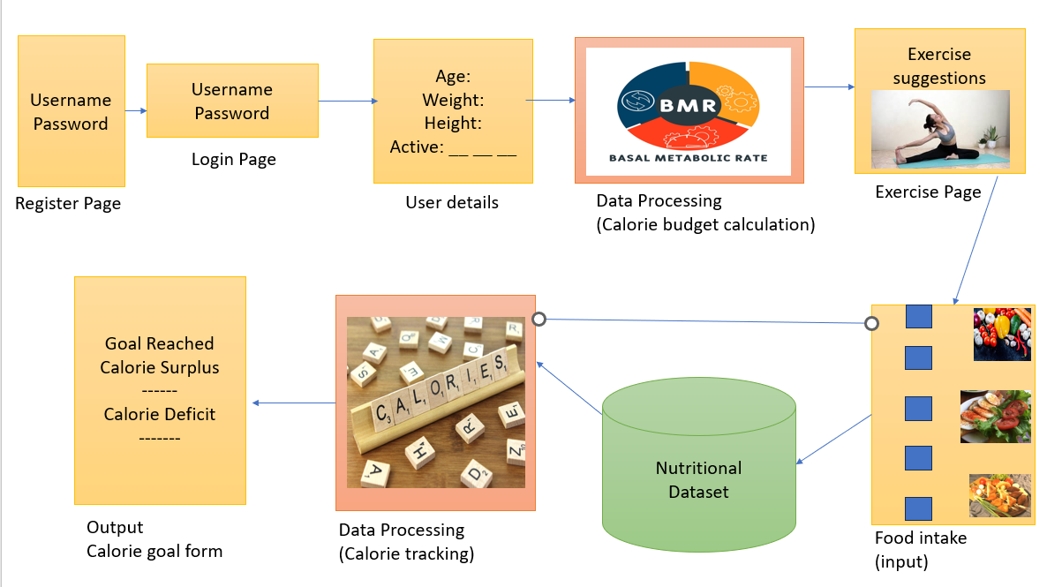

**4.4 UML DIAGRAMS**

**4.4.1 Use Case Diagram:**

A use case diagram allows us to recognize how customers interact with a machine to gain precise goals.

This is an example of a use case diagram showing how a user interacts with a "Calorie Count" application. The components of the use case are broken down into detail below:

* The user is the one who uses the Calorie Count application.
* REGISTER: The Calorie Count application's account-creation process for new users.
* LOGIN: The procedure via which a user who has registered logs into the program.
* INFORMATION ABOUT USERS: This is the area where users may examine or amend their personal data.
* CALORIE INTAKE: This function allows users to record how many calories they consume each day.
* SET GOALS: The feature that allows users to establish their exercise or nutrition objectives.
* VIEW PROGRESS: The function that lets users track their advancement towards objectives.
* LOGOUT: A user's action of logging out from the website.

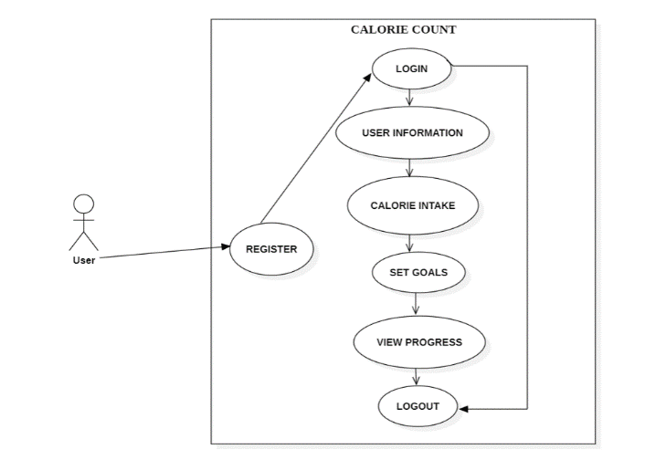

Fig 4.4.1.1 Use Case Diagram

**4.4.2 Class Diagram:**

A class diagram is a kind of static structure diagram that illustrates a system's classes, their properties, methods, and the connections between objects.

**Relationships:**

* There are relationships between the Main and LogList classes and USER_LogEntry:
* This means that these classes have the ability to handle user-created entries.
* Main interacts with Web: This implies that operations in the Web class, like retrieving or displaying BMI and calorie information, can be started by the Main class.
* Additionally, LogList communicates with the Web: This suggests that the Log List class can ask the Web class to perform certain tasks, such as estimating calories or calculating BMI.

**Summary of Responsibilities:**

* USER_LogEntry: Serves as a data structure including age, weight, and calorie information unique to each user.
* Main: Directs the application's flow, starting activities in response to user input.
* Web: Manages computations and data retrieval for the web, including BMI and calorie estimation.
* LogList: Controls the log entries; it can be used to add, remove, load, save, and show entries. It can also issue warnings as needed.

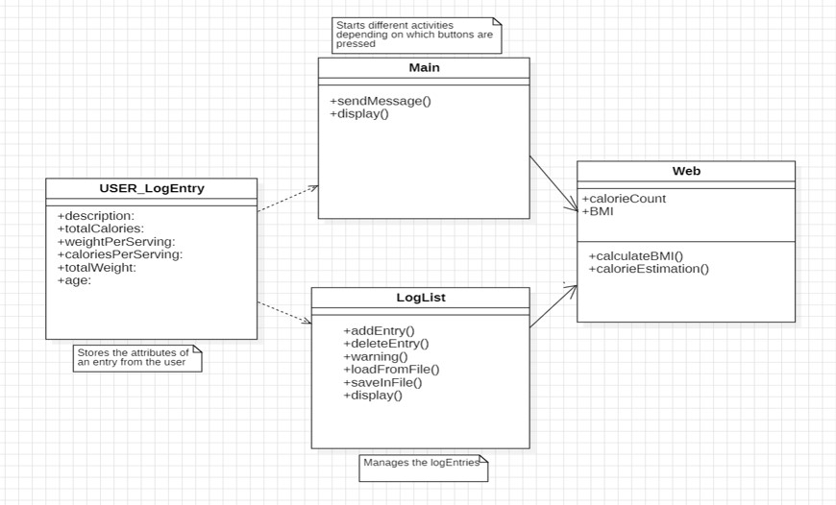

4.4.2.1 Class Diagram

**4.4.3 Sequence Diagram:**

The interactions between the various Calorie Count system components during user login, validation, and data storage are depicted in this sequence diagram. This is a thorough explanation of the sequence diagram:

Customer Logs in on Their Own:

The client selects the login option.

The login request is received by the LOGIN component.

The Login Component Verifies the User.

Passing the User ID and Password, the LOGIN component sends a request to VALIDATE the user.

The supplied credentials are verified by the VALIDATE component.

Successful Login:

The VALIDATE component delivers a confirmation back to the LOGIN component after the credentials have been verified.

The CUSTOMER is notified by the LOGIN component that the login was successful.

Enter the client's information:

The CUSTOMER provides further information such as height, weight, and daily caloric intake after logging in successfully.

These particulars are transmitted to the VALIDATE element.

Information about the Store:

A component called VALIDATE verifies that the data has been successfully stored.

The DATABASE receives the verified data and stores it there.

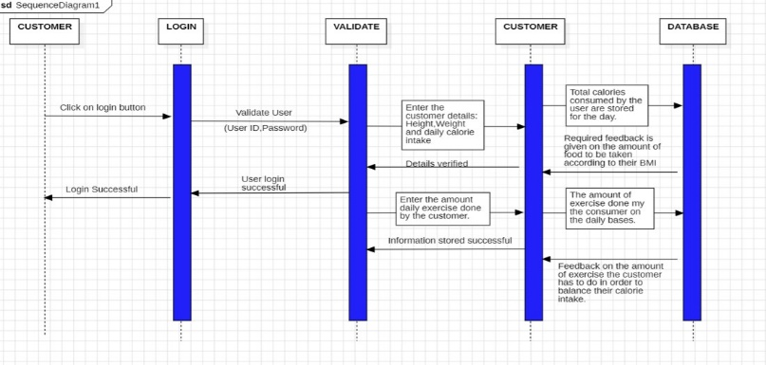

4.4.3.2 Sequence Diagram

**4.4.4 Component Diagram:**

A component diagram is a kind of UML diagram that shows how a system is broken down into its component parts and how these parts are connected.

1. *Web Application*:

- The starting point. Users access the application through a web browser or mobile device

2. *Home*:

- Provides an overview or quick access to essential features

3. *Login*:

- The entry point for existing users.

4. *SignIn*:

- For new users who need to create an account.

- Typically involves providing personal information, setting up a password, and agreeing to terms.

5. *Display Food Log*:

- A critical section where users record their daily food intake.

6. *Update Calorie Goal Form*:

- Enables users to set or modify their daily calorie goals.

7. *Update Weight Form*:

- Allows users to input their current weight.

8. *Total Calories*:

- Aggregates the daily calorie intake from the food log.

9. *Daily Food Log*:

- Users revisit this section to log additional meals throughout the day.

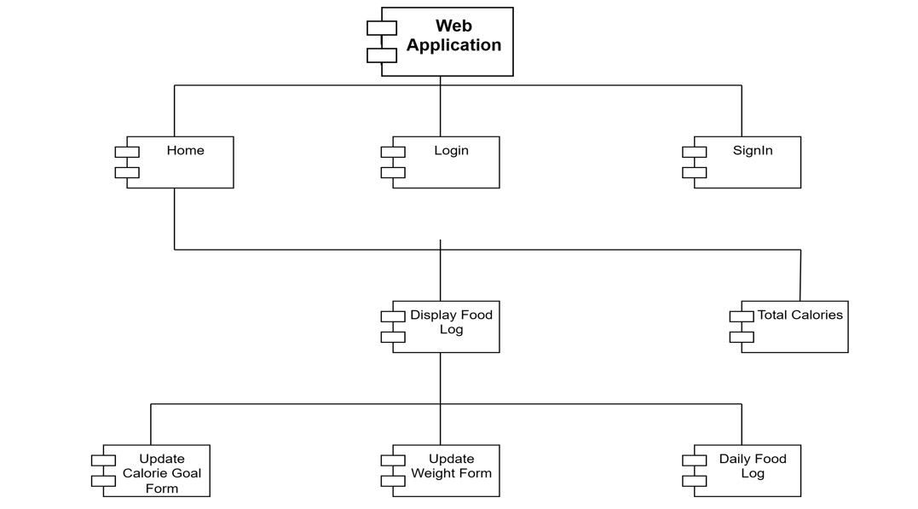

4.4.4.1 Component Diagram

**Chapter 5**

**IMPLEMENTATION, EXPERIMENTAL RESULTS AND TEST CASES**

**5.1 Implementation**

**5.1.1 Frontend Code**

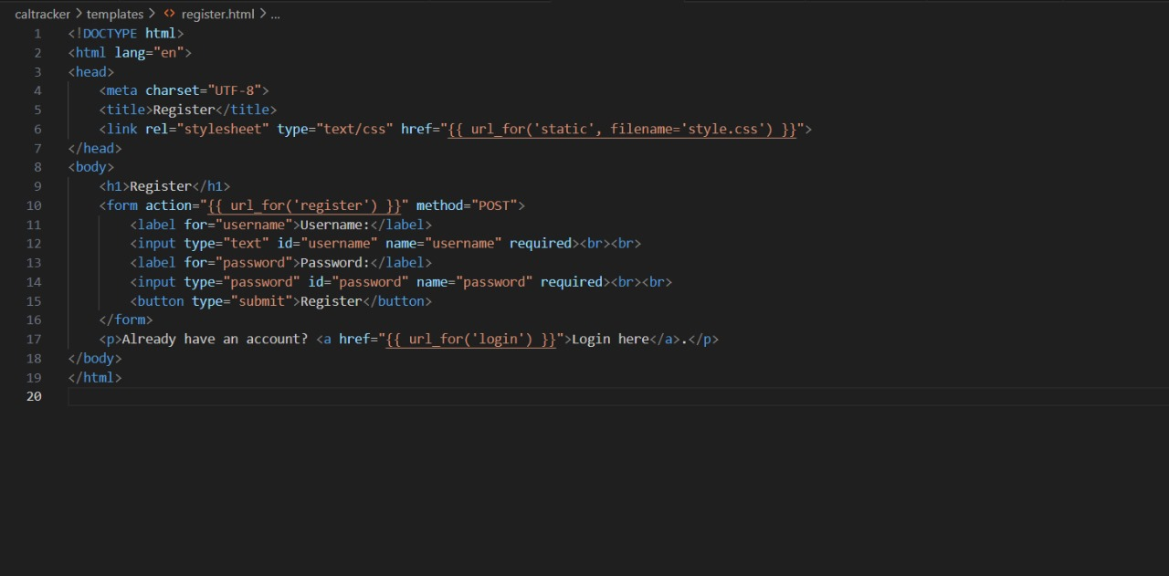

Fig 5.1.1.1 html code for register page

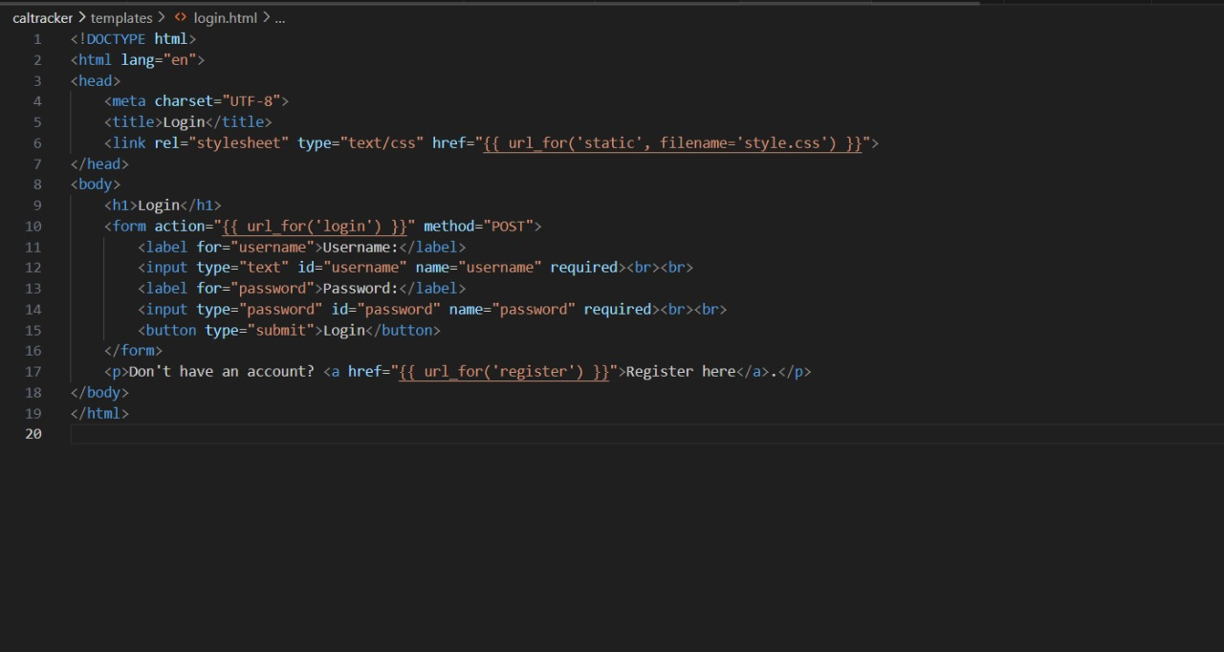

Fig 5.1.1.2 html code for login page

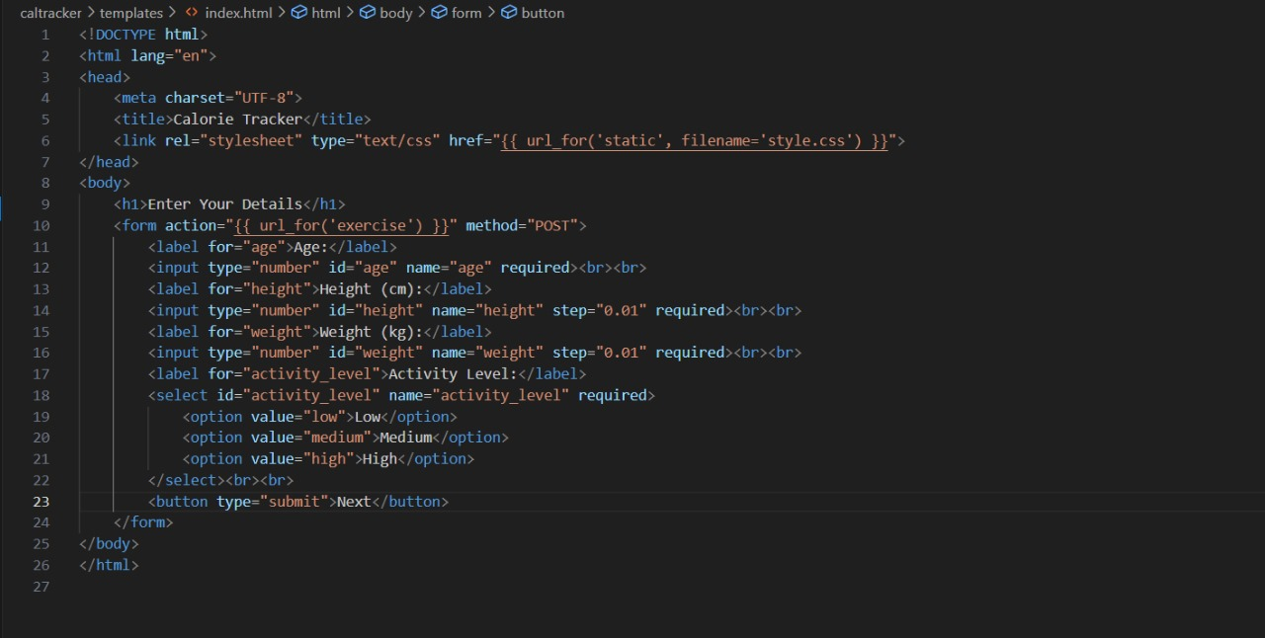

Fig 5.1.1.3 html code for user details

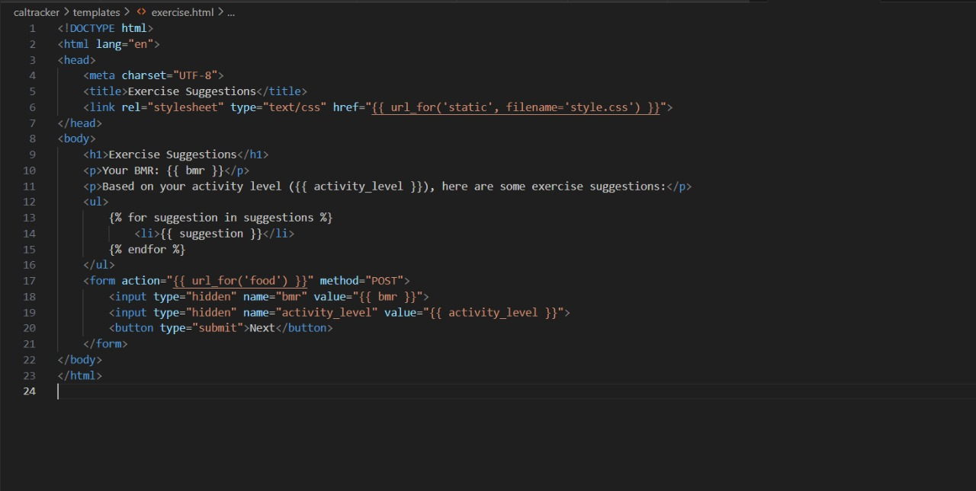

Fig 5.1.1.4 html code for exercise page

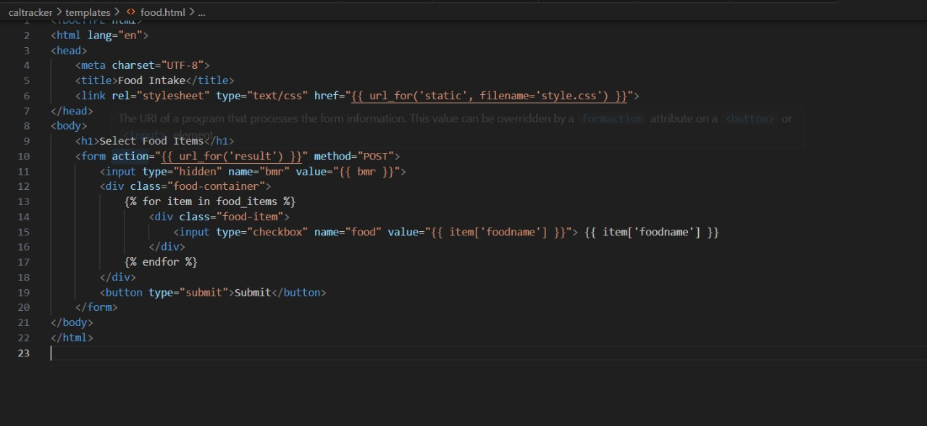

Fig 5.1.1.5 html code for food input page

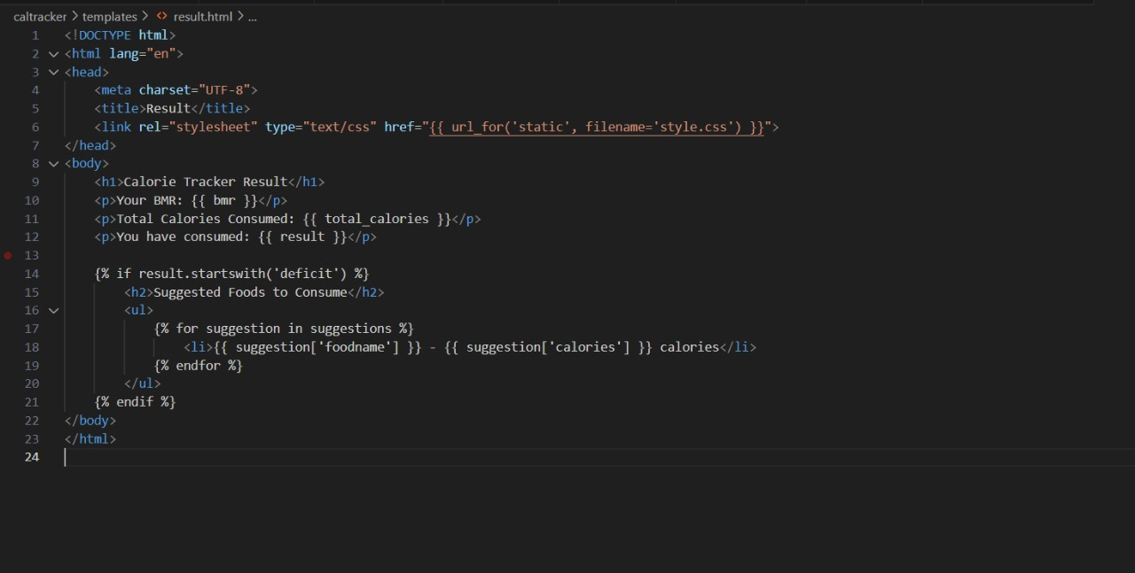

Fig 5.1.1.6 html code for final result

**5.1.2 Backend Code**

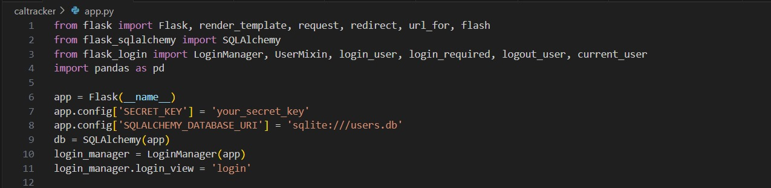

Fig 5.1.2.1 code for importing and implementing flask

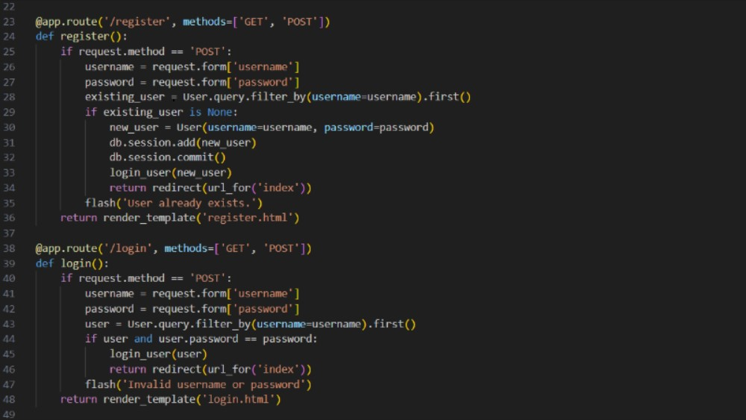

Fig 5.1.2.2 Python code for user Authentication

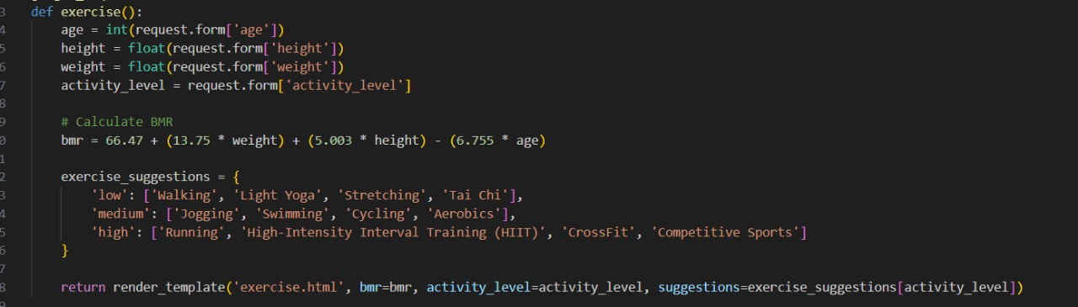

Fig 5.1.2.3 Python code for BMR calculation

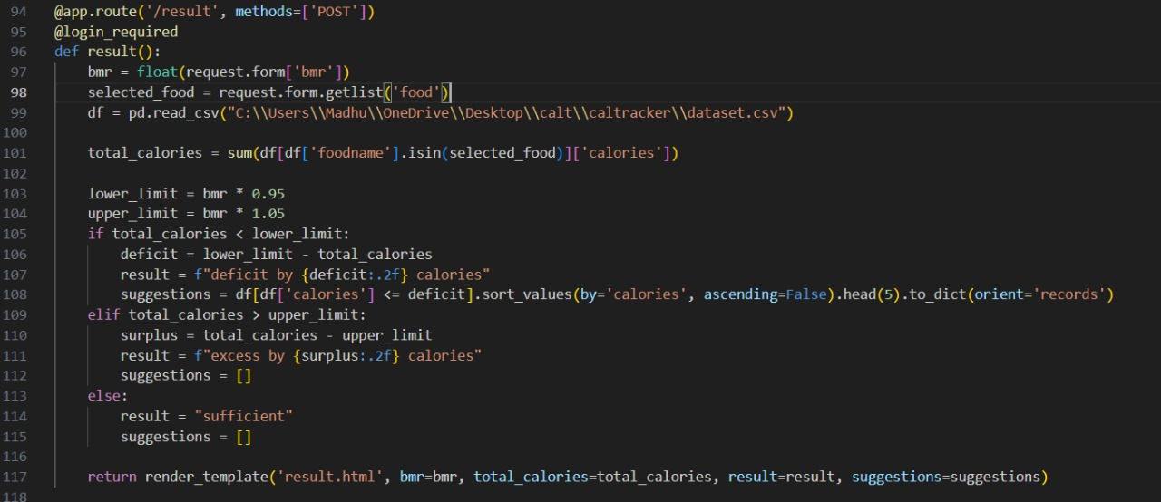

Fig 5.1.2.4 Python code for final result Calculation

# 

# Fig 5.1.1 Register Page

# 

Fig 5.1.2 Login Page

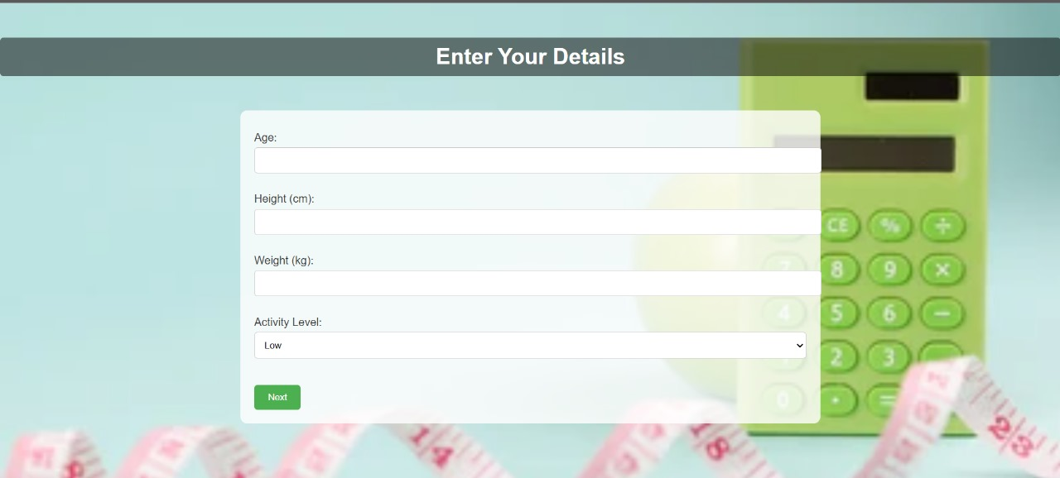

Fig 5.1.3 User Details Page



Fig 5.1.4 Exercise Suggestions Page

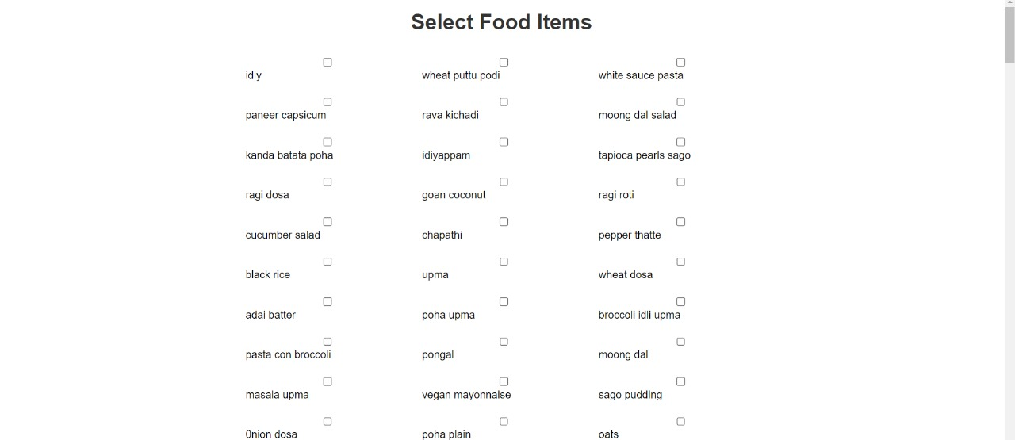

Fig 5.1.5 Food Item Input checkbox

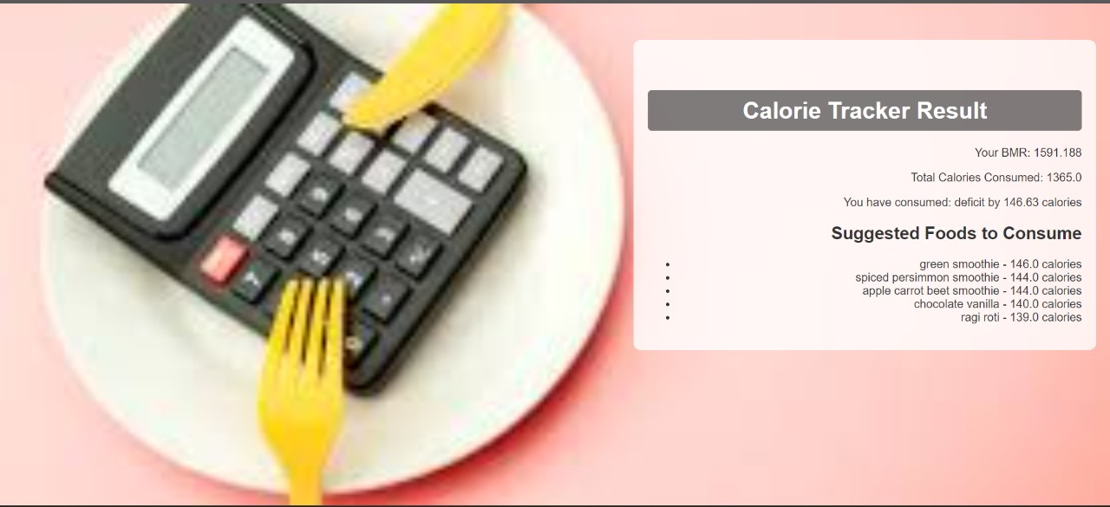

Fig 5.1.6 Result Page

**5.2 Test Cases**

|  |  |  |  |  |  |  |  |  |  |
| --- | --- | --- | --- | --- | --- | --- | --- | --- | --- |
| **S.no** | **Test**  **Scenario** | **Test**  **Case** | **Pre-conditions** | **Test**  **Steps** | **Test**  **Data** | **Expected**  **Results** | **Post-**  **Conditions** | **Actual**  **Results** | **Status**  **Pass/**  **Fail** |
| 1. | Details page of the application | Entering age 30 | The web page is running and user is logged in | Entering inputs in the details page | All the input fields of details page are shown | The inputs are taken and proceeds to next page | The web page is running | Inputs are taken and exercise suggestions page opens | PASS |
| 2. | Details page of the application | Entering age 101 | The web page is running and user is logged in | Entering inputs in the details page | All the input fields of details page are shown | The inputs are taken and proceeds to next page | The web page is running | Invalid input given and takes input again | FAIL |
| 3. | Details page of the application | Entering weight 79 | The web page is running and user is logged in | Entering inputs in the details page | All the input fields of details page are shown | The inputs are taken and proceeds to next page | The web page is running | Inputs are taken and exercise suggestions page opens | PASS |
| 4. | Details page of the application | Entering weight as char | The web page is running and user is logged in | Entering inputs in the details page | All the input fields of details page are shown | The inputs are taken and proceeds to next page | The web page is running | Invalid input given and takes input again | FAIL |
| 5. | Food input page | Selecting 10 checkboxes of food items | The web page is running, user is logged in and details are inputted | Entering input of food items consumed | Checkboxes of various food items available in the dataset are shown | The inputs are taken and gives result | The web page is running with required data | Inputs are taken and calorie result is given | PASS |
| 6. | Food input page | Selecting 21 checkboxes of food items | The web page is running, user is logged in and details are taken as input | Entering input of food items consumed | Checkboxes of various food items available in the dataset are shown | The web page is running with required data | The web page is running with required data | Too many boxes selected takes input again | FAIL |

# Chapter 6

# CONCLUSION AND FUTURE SCOPE

# 

# 6.1 Conclusion:

The Calorie Tracker internet software is designed to be a comprehensive, consumer-pleasant device for dealing with each day caloric consumption and selling a balanced diet. This software leverages contemporary-day internet technology to supply an unbroken and interactive consumer experience. By using the Flask internet framework for strong backend support, alongside HTML, CSS, and Jinja2 for a dynamic front-end, the Calorie Tracker objectives to simplify the manner of tracking and dealing with caloric consumption. Upon registration, customers can securely create money owed and log in, making sure personalised and steady get entry to to their nutritional data. The utility collects private information consisting of age, height, weight, and hobby level, that are used to calculate the Basal Metabolic Rate (BMR) the usage of a scientifically confirmed formula. This BMR calculation serves as the muse for offering tailor-made nutritional and exercising recommendations. The workout inspiration characteristic gives a number of sports primarily based totally at the user`s unique pastime level.

This guarantees that customers obtain applicable and plausible workout hints that align with their health dreams and present-day capabilities. A center factor of the utility is the meals choice and calorie monitoring characteristic. Users can log their everyday meals consumption through deciding on gadgets from a preloaded database of meals gadgets, controlled correctly the use of the Pandas library for information manipulation. This database consists of numerous foods, making sure customers have a complete choice to correctly log their meals. The utility assesses the full caloric consumption towards the calculated BMR, figuring out whether the consumption is sufficient, in excess, or in deficit. A ±5% tolerance variety is carried out to offer sensible and bendy feedback. In instances of a caloric deficit, the gadget now no longer handiest informs the person however additionally shows extra meals objects to assist them meet their every day caloric needs. These recommendations are prioritized primarily based totally at the last calorie allowance, making sure customers acquire realistic and manageable recommendations.

To help ongoing person engagement and effectiveness, the utility plans to consist of destiny upgrades together with development tracking, certain dietary analysis, and interactive visualizations. These functions will permit customers to reveal modifications of their fitness metrics over time, benefit deeper insights into their nutritional habits, and make extra knowledgeable choices approximately their nutrients and workout routines. In summary, the Calorie Tracker net utility gives a complete and person-pleasant platform for coping with each day caloric consumption and selling a balanced diet. By integrating customized capabilities which include BMR calculation, workout suggestions, and precise calorie tracking, the utility pursuits to help customers in accomplishing their fitness and health goals. Future upgrades will recognition on extending functionality, enhancing person experience, and preserving statistics security, in the long run supplying a treasured aid for customers searching for to display and enhance their nutritional behavior and normal well-being.

# 6.2 Future Scope:

# The destiny scope of the Calorie Tracker net software includes a wide variety of upgrades geared toward evolving it right into a complete fitness and well-being platform. One key location is the improvement of cellular packages for Android and iOS, which might offer customers with convenient, on-the-cross get right of entry to and leverage cellular-unique capabilities like push notifications for meal and exercising reminders. Integration with famous wearable health devices, which include Fitbit and Apple Watch, is every other massive enhancement, permitting the automated synchronization of bodily activity, coronary heart rate, and calorie facts to provide greater correct and customized recommendations. Expanding the meals database to consist of particular dietary facts and supplying complete dietary evaluation will assist customers make knowledgeable nutritional choices. Additionally, introducing meal making plans capabilities, entire with a database of wholesome recipes, will help customers in organizing their nutritional consumption effectively.

# Th e software may also gain from social and network capabilities, permitting customers to connect, proportion progress, and take part in challenges, fostering a supportive environment. Leveraging AI and device mastering to offer customized nutritional and exercising recommendations, together with a chatbot for real-time advice, can similarly beautify consumer experience. Progress monitoring capabilities with visualizations, which include charts and graphs, will assist customers display their upgrades over time. Customizable health and nutritional dreams, coupled with particular feedback, will allow customers to tailor the software to their unique needs.

# Moreover, integrating with fitness and well-being APIs will make sure customers have get right of entry to to the present day facts on fitness trends, exercises, and nutritional guidelines. Adding multilingual guide will make the software on hand to a broader audience, whilst culturally applicable meals objects and recipes will cater to various consumer needs. Finally, incorporating gamification elements, which include rewards and challenges, can growth consumer engagement and motivation. These upgrades together intention to convert the Calorie Tracker right into a holistic device for fitness management, supporting customers reap and preserve their health and well-being dreams effectively.

# Chapter 7

# REFERENCES

# Title: Indian Food Recognition and calorie estimation using YOLOV8

# Authors: V.Gayatri, M.Thanuja

# Published Year: 2023

# <https://ijcrt.org/papers/IJCRT2306818.pdf>

# Title: The utilization of Machine Learning for the identification and computation of calories

# Authors: S.Dhanush Hariharan, P.Dinesh, Vivek Chidambaram, G.T Shakila Devi

# Published Year: 2023

# <https://www.eurchembull.com/uploads/paper/4d0ce76f94efc8f3fb94daf38a9ddfd0.pdf>

# Title: Smartphone Apps for Tracking Food Consumption and Recommendations: Evaluating Artificial Intelligence-based Functionalities, Features, and Quality of Current Apps

# Authors: Sabiha Samad, Fahmida Ahmed, Samsun Naher, Muhammad Ashad Kabir, Anik Das, Sumaiya Amin, and Sheikh Mohammed Shariful Islam

# Published Year: 2022

# <https://www.sciencedirect.com/science/article/pii/S2667305322000412>

# Title: Calorie Counter using Django framework

# Authors: Saritha Niranjanrai

# Published Year: 2021

# <https://www.researchgate.net/publication/354381318_Calorie_Counter_using_Django_framework>

# Title: Calorie Counter Information System Development for Weight Loss Program based on Android.

# Authors: Nenny Anggraeni, Nashrul Hakiem, Gerry Widya Ganesha.

# Published Year: 2020

# <https://www.scitepress.org/Papers/2018/99460/99460.pdf>

# Title: An analysis of calorie estimation accuracy.

# Authors: Hannah Mixon, Matthew E.Davis.

# Published Year: 2020

# <https://www.jiss.org/documents/volume_10/JISS%202020%2010(1)%20102125%20Thinking%20About%20Food.pdf>

# Title-Accurate Calorie Counting Algorithm For Carefully Plated Dishes

# Authors: WOON ZHENG LI

# Published Year: 2020

# <http://eprints.utar.edu.my/3768/1/16ACB05571_fyp2.pdf>

# Title: Semantics-Based Calorie Counter

# Authors: Sravan Raghu Kumar Narra

# Published Year: 2017

# <https://library.ndsu.edu/ir/handle/10365/25969?show=full>

# Title: A study of calorie estimation in pictures of food

# Authors: Jun Zhou, Dane Bell, Sabrina Nusrat, Melanine Hingle, Mahai Surdeanu

# Published Year: 2018

# <https://pubmed.ncbi.nlm.nih.gov/30401671/>

# Title: Deciphering calorie counts to make smarter food choices

# Authors: Santos Lima

# Published Year: 2020

# <https://www.alliedacademies.org/articles/the-nutrition-facts-label-deciphering-calorie-counts-to-make-smarter-food-choices.pdf>

# Title: Calorie counting smart phone apps: Effectiveness in nutritional awareness, lifestyle modification and weight management among young Indian adults.

# Authors: Paromita Banerjee, Vishnu Vardhana Rao Mendu, Damayanthi Korrapati, and SubbaRao M G

# Published Year: 2019

# <https://www.researchgate.net/publication/333777044_Calorie_counting_smart_phone_apps_Effectiveness_in_nutritional_awareness_lifestyle_modification_and_weight_management_among_young_Indian_adults>

# Title: Calorie Estimation in Adults Differing in Body Weight Class and Weight Loss Status

# Authors: Ruth E Brown ,Karissa L Canning ,Michael Fung ,Dishay Jiandani ,Michael C Riddell

# Published Year: 2019

# <https://www.ncbi.nlm.nih.gov/pmc/articles/PMC5055397/>

# Title: Developing a Calorie Counter Fitness App for Smartphones.

# Authors: Adewole Adewumi, Godwin Olatunde, Sanjay Misra, Rytis Maskeliunas, Robertas

# Published Year: 2018

# <https://www.researchgate.net/publication/323313861_Developing_a_Calorie_Counter_Fitness_App_for_Smartphones>

# Title: The Caloric Calculator: Average Caloric Impact of Childhood Obesity Interventions

# Authors: Y. Claire Wang, MD, ScD; Amber Hsiao

# Published Year: 2013

# <https://www.ajpmonline.org/article/s0749-3797(13)00269-9/fulltext>

# Title: Health Behavior Theory in Popular Calorie Counting Apps: A Content Analysis

# Authors: Siena F Davis, Marisa A Ellsworth, Hannah E Payne, Shelby M Hall and Amber L

# Published year: 2016

# <https://www.ncbi.nlm.nih.gov/pmc/articles/PMC4795330/>

# APPENDIX