1. Converting the functions into lambda functions

  - Double = lambda num : num * 2
  - Calculate_average = lambda num1,num2,num3 : (num1+num2+num3)/3
  - Check_age = lambda age : “Adult “ if age >= 18 else “ Teenager “ if age >= 13 else “ Child”

2. Virtual environment conflict

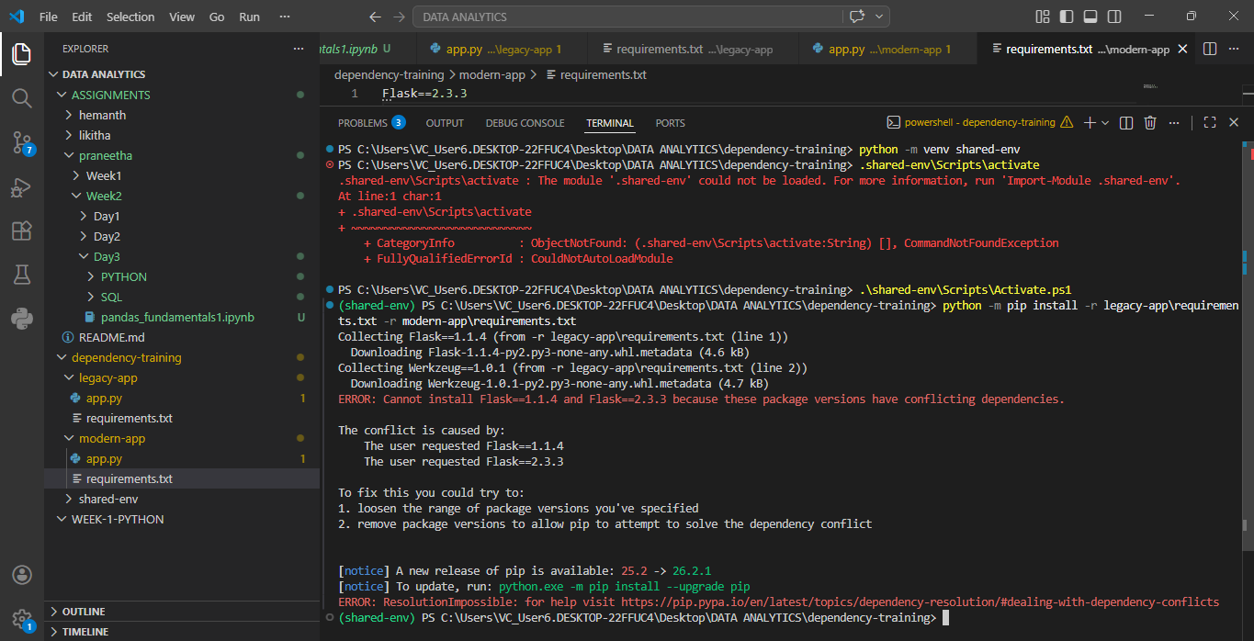

Separate virtual environments

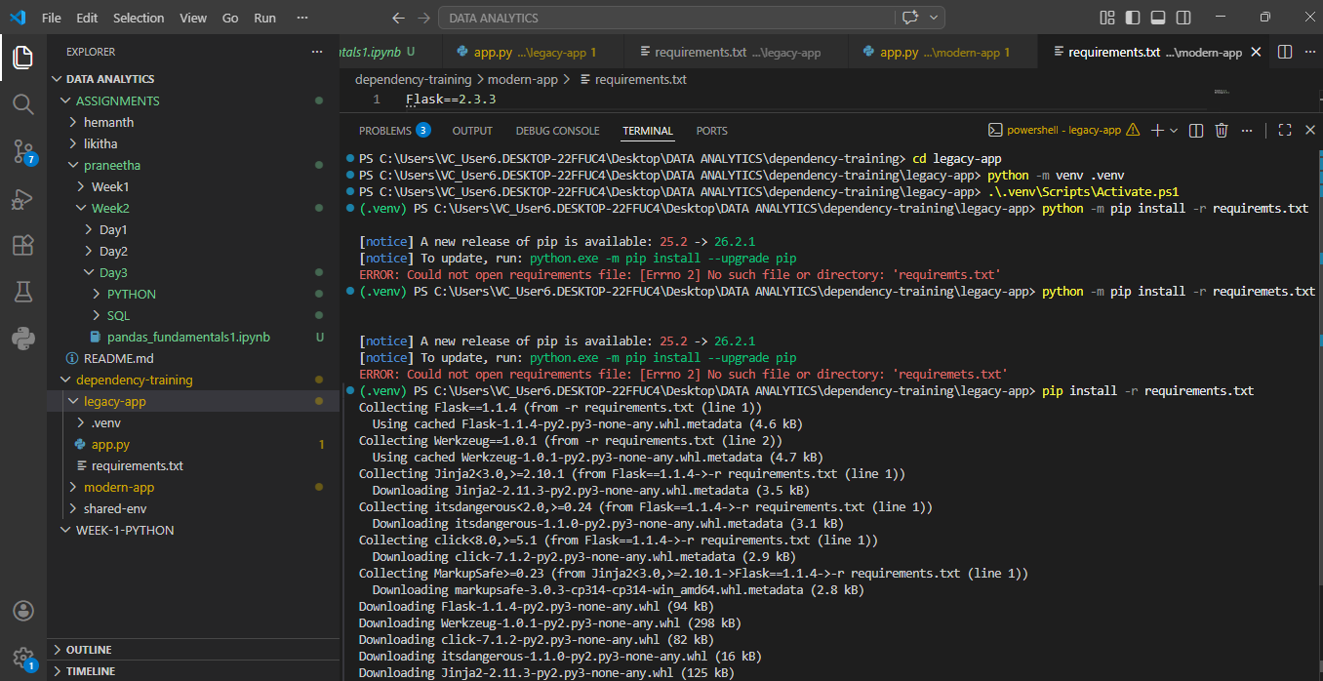

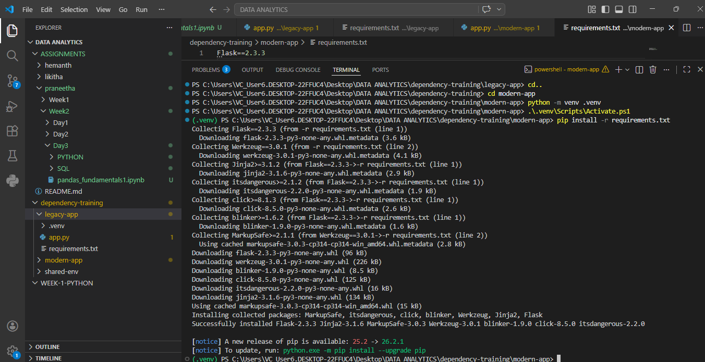

3 A) # code demonstrating global and local varibales scope

# tomato ketchup is a global varible
global_food = "Tomato kechup"

def pizza_hut() :

#pizza is a local variable here
local_food = "pizza"

# here I can access local variable inside the local scope
print(f'I can eat {local_food} inside pizza hut')

# I can also access global variable inside the local scope
print(f'Hurray! I can also eat my {local_food} with my {global_food} inside pizza_hut')

#calling the fxn
pizza_hut()

#here outside the local_scope(i.e inside the global scope)

# I can access my global variable
print(f'I can have my {global_food} outside pizza hut')

# But I cannot access my local_variable outside the local scope
#print(f'Shit ! I cannot have {local_food} outside pizza hut') # will raise an error

I can eat pizza inside pizza hut
Hurray! I can also eat my pizza with my Tomato kechup inside pizza_hut
I can have my Tomato kechup outside pizza hut

B)Study the following Python program and answer the questions:

- Bob
- Alice 25
- Local variable
- It will raise an error
- Becuase name inside the function is a local variable. Its scope is limited to the function and will not effect the global variable.

D)Creative example demonstrating local and global variables with same variable name

# In the real world, our hero is Nani
hero = "Nani"

def eega_transformation():

# Inside this special world, the hero is reborn as a fly
hero = "Eega"

print(f"Inside the transformation world, hero is: {hero}")

print(f"Before transformation, hero is: {hero}")

eega_transformation()

print(f"After returning to the real world, hero is still: {hero}")

Before transformation, hero is: Nani
Inside the transformation world, hero is: Eega
After returning to the real world, hero is still: Nani

4) Colab link : https://colab.research.google.com/drive/13eSy1T0W5xgOziBRnTGBHfI1W0A7acfh?usp=sharing

