**HCI Section: 03**

**Group Number: 3A**

**Team Member Names: Sai Praneetha Jaladanki, Ashok Atkuri, Rahul Reddy Lankala**

**HCI Take Home Exam 3 (30 Points)**

**Directions:**

The last portion of your HCI Exam 3 is a Take Home Exam. This portion of the exam is a group exam to be taken with your final group project team members. This exam will be completed by your entire team and then turned in as a Word document into the course Canvas website by Wednesday, April 18th before midnight. Be certain to name your final take home exam using the following format: Your section number followed by your team name or team number followed by HCIExam3TakeHome. For example, if your team is enrolled in section 2 and your team name is *BlueAngles*, then your take home exam should be named: *Section2BlueAnglesHCIExam3TakeHome.docx*. Another example, if your team is enrolled in section 2 and your team number is 2, then your take home exam should be named: *Section2Team2HCIExam3TakeHome.docx*. Submit your exam to the Exam3TakeHome assignment. Note: Only one person from each group will submit the final project.

Using your final group project, discuss with appropriate screen shots/images what you would need to do to convert your final project into a mobile app. (If your project is a mobile app, discuss the conversion to a web site.) In particular, focus your discussion on the following items:

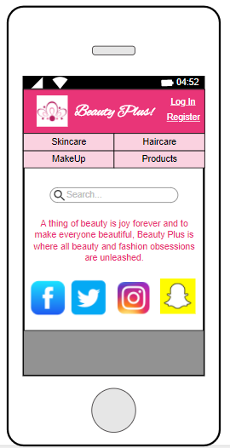 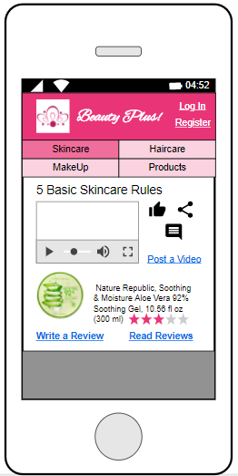 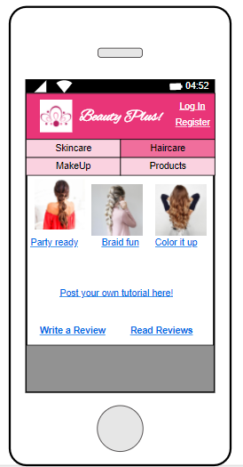 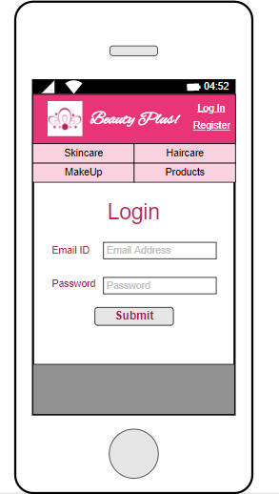

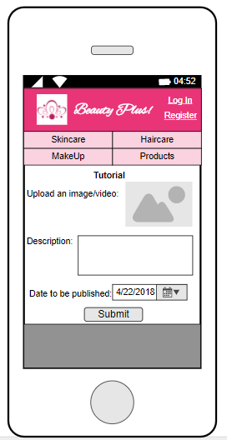 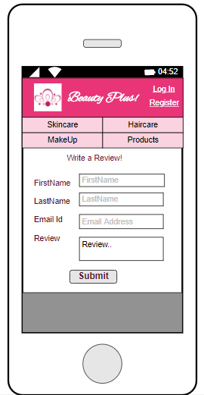

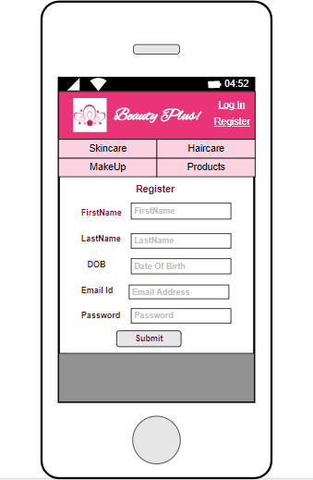 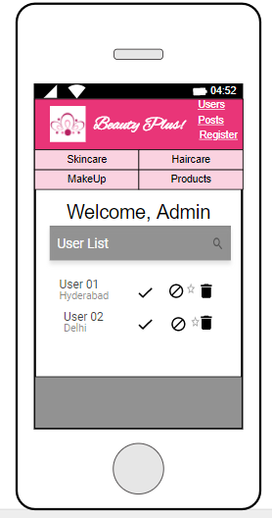 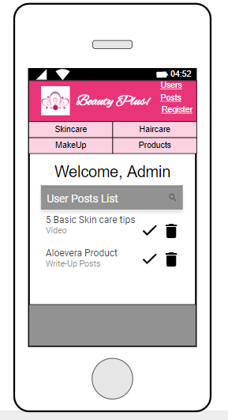

1. Layout changes:

We chose an iOS mobile layout to design our application, keeping in mind that the OS would be more user friendly, easy and popular. There were more number of widgets available to customize the options. We have designed the main menu bar such due to the constraint of the space in a mobile app and hence it is divided into four parts.



1. Control changes:

In the website of our blog, we had a separate button assigned to go to homepage. But in our mobile app, we have changed it. One can traverse to the homepage by clicking on the logo of the blog present on the top right corner of the screen.



1. Content changes:

In the mobile version, we have made the content to minimum by introducing icons for like, comment and share a post instead of having hyperlinks in the website. In the website, we had a separate page where the user could maintain his own posts. But in the mobile, we changed this content so that each category has its own link to post a tutorial or comment from the user.





1. Discuss how fundamental usability issues (small screen, virtual keyboard, slow processor, and unreliable/slow download speed) of mobile app impacted your design.

Fundamental Usability Issues:

1. Small screen – Due to the space constraint, it was very difficult to include all the amount of content in a mobile app that is present in the website.
2. Download speeds – The blog requires a working internet connectivity so as to perform actions. The speed of downloads in an app is less when compared to that of a website. This is due to the lesser bandwidth of the phone.
3. Keyboard – The awkward typing problem arises in case of using the mobile app.

Keyboards that used with the desktop are much easier to type that that of a mobile.

1. Discuss how you are going to address the aforementioned usability issues in your design.

Small Screens: As mobile devices have small screens, we need to include only important relevant content in the application avoiding unnecessary information. We need to take care that the page do not get too clumsy that would make the user distracted. It is better to use bigger target options than the smaller ones, to avoid the “fat finger problem”.

Virtual Keyboard –The speed of typing and the keyboard size are always an issue for the mobile devices. Instead of the text fields, by using the alternative input options such as the drop downs and radio buttons, and through the voice recognition one can reduce the use of virtual keyboards.

Slow processors – If we have more number of widgets and any other options to make the webpage clumsy, the processor will slow down and this would affect the functionality of the website.

Download Speed - The mobile devices always have a less download speed than the desktops. By including too many graphics and templates the memory occupancy of the application would increase, which would directly affect the speed at which the application is downloaded. By addressing these issues, the applications can be much improved.

1. Discuss how you can further improve your mobile app using voice recognition technologies.

* We can add the voice recognition option for Login ad registration page, which helps us to fill in the input fields with ease.
* We can add a voice recognition for opening the application in the mobile.
* The tutorial makeup videos can be uploaded by giving voice commands.
* By giving voice inputs, comments can be made.

1. What is the major challenge that you faced in the conversion of your project?

The major challenge was to implement the website into an app with same amount of information with a different screen size. Using a mobile app is easy but also we have to compromise on the design. The main problems when there are radio buttons and check boxes used to fill a tutorial form. Due to smaller size that the screen, we cannot be able to fill them correctly while choosing. Hence, each of the section has a separate link to post videos so that the part to use those things can be eliminated. challenge is to design with compromising on the quality of the website. In order to make it a better design, we should keep in mind that the content is not messed up on the screen.