S2018 Project 01 – Section 03 Team A - Beauty Blog

Project title – Beauty Plus

Team name – Team Trident

Team member names:

* Ashok Atkuri
* Sai Praneetha Jaladanki
* Rahul Reddy Lankala



**Abstract:**

This project is a beauty blog that lets users know about the latest news and trends in beauty, using the blog to communicate their thoughts and opinions about beauty products and brands. In this website the user can either post, review and comment on the beauty products. We have designed the website in such a way that the novice user can walk through the website easily. To access this website people need to have internet connection. The blog has various categories based on skin care, hair care, make-up and other beauty products.

**Requirement Analysis:**

Ascertain user needs:

The blog allows the user to review and browse through various beauty products all in one place. The user must register first to the blog. This allows the users to post comments under the products and tutorials. The user can also give their own reviews for products based on their experiences. Also, the users should accept the acknowledgement to use the website. The registered users can directly login to access and navigate to give reviews. The beauty blog is categorised into skin care, hair care, make-up and other beauty products for better availability to the user based on their likes.

Ensure Reliability:

The information of the logged in user as well as the credentials are secured. The user cannot comment or review until the user is authorized. The data displayed reflects the actual database. The system is available to the user any number of times.

Promote Standardization, Integrity, Portability, and Consistency:

Consistency makes site easier to use, because visitors don’t have to learn new tricks a they move around. Sites should be internally consistent: standards and conventions should be established and applied throughout all the content. The website follows the portability by being accessible anywhere anytime. The website can be accessed through different software tools and packages. This site is compatible across different product versions. The website has been designed such that it follows the consistency of colors, fonts, texts and navigation through it. The user can find it easy to use.

Within the given Budget and Time:

The final date for the project completion is April 15, 2018.

Cost of the project is approximately 50 dollars.

**Functional Requirements:**

1. User should be able to register to the website to use it if he is first time user.
2. User should be able to login to account if he is existing user.
3. User should be able to search the required information in main page.
4. User should be able to see the information about the skincare, haircare.
5. User should be able to see the different product details.
6. User can provide the reviews about the products.
7. User should be able to logout to account from their account.
8. Admin should be able to login to the website.
9. Admin can view the list of the users.
10. Admin can also view the Posts List of the users.
11. Admin should be able to edit, add, and delete the products of the skincare.

**Task Descriptions:**

**Task Descriptions:**

Task 1: Information about website

**Description:**  On opening the website, it should have home page containing description of website and asks for login or register

Task 2: Search for products

**Description:** User should be able to search the required product.

Task 3: Signup

**Description:** First time user is able to sign up to website free.

Task 4: Login

**Description:** User is able to Login successfully to website. He should be able to retrieve his details when he forget login details.

Task 5: Skin Care

**Description:** User should be able to see the information of the skin care.

Task 6: Skin Care Admin View

**Description:** Admin should be able to Edit, Add and Delete the posts on the site.

Task 7: Reviews

**Description:** User should be able to write the reviews for the products by fillings their details.

Task 8: Logout

**Description:** User should be able to logout from their account.

Task 9: Admin User List

**Description:** Admin should be able to view the List of the Users.

Task 10: Admin User Posts List

**Description:** Admin should be able to view the Posts List of the Users.

Task 11: User Post

**Description:** User should be able to post videos, write posts and update.

Task 12: Admin Track Activities

**Description:** Admin should be able to track the activities of the users.

**Usability Measures:**

Time to learn: Ideally, the time taken by the user to learn from the website even when the user is a first time user should be short. This may typically vary from the average time a typical user takes to learn different tasks in website.

Formula = End Time-Start time

Speed of the performance: The time taken to perform benchmark tasks in the website. The user should be easily able to perform necessary tasks such as review, comment, and post.

Formula = (Number of errors / Time taken to complete the task).

Rate of errors by user: The number of errors performed by a user and at what rate are these errors are being performed is called the rate of errors. The rate of repetition of errors is also monitored. Errors can be occurred during login page, reviewing a product, writing comments for a product and also while posting a tutorial in the blog.

Formula = Use a Likert scale.

Retention over time:Over a period of time, when the user keeps coming back to the blog, the user should be able to remember the navigates so as to save time while using the website. This means that the user has to retain knowledge about using the website. For this website user just need to remember login details.

Subjective satisfaction:The satisfaction of the user while using the website is important. To give feedbacks, the user can contact us back.

**ER Diagram**

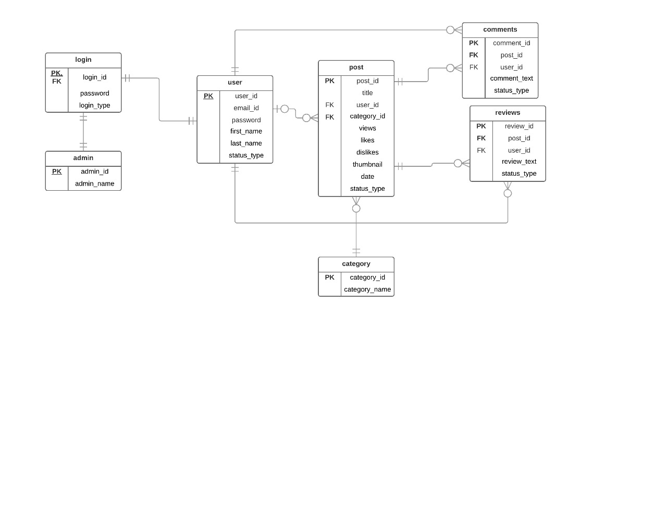

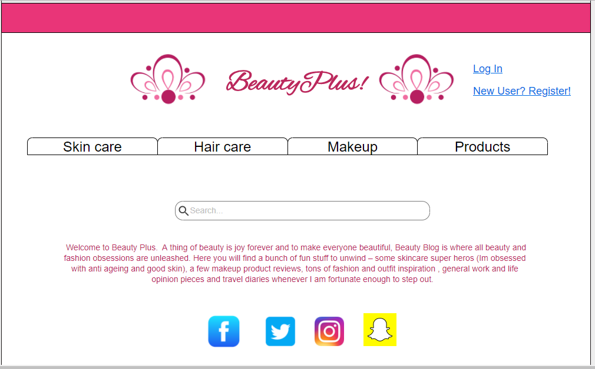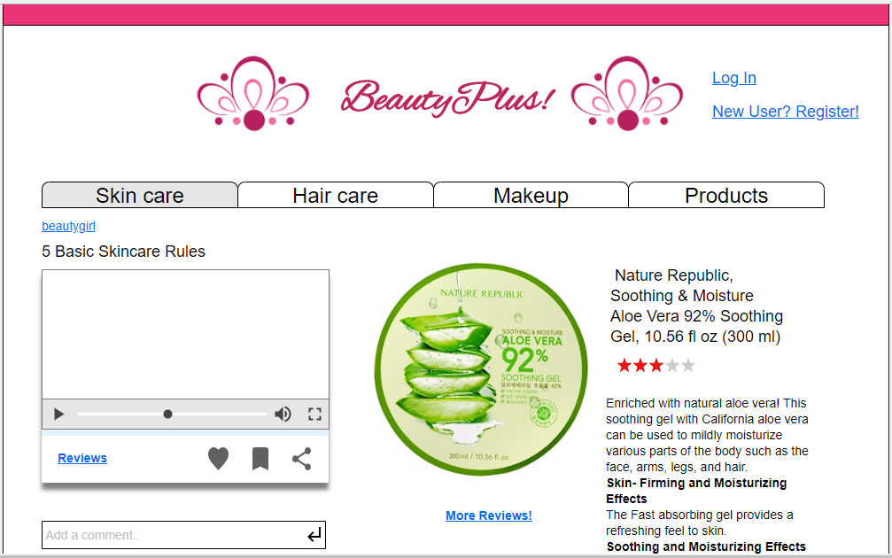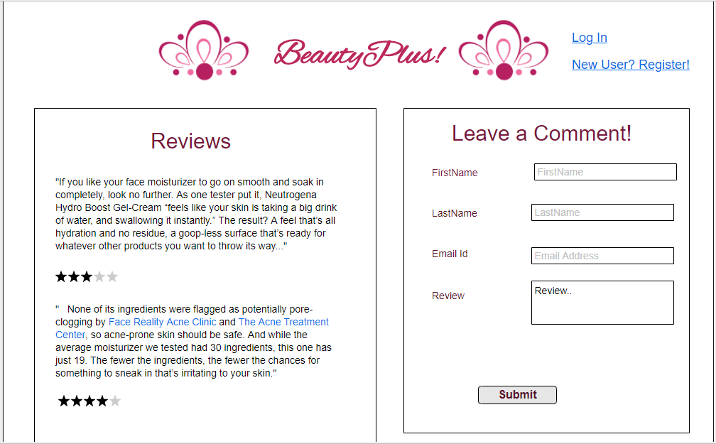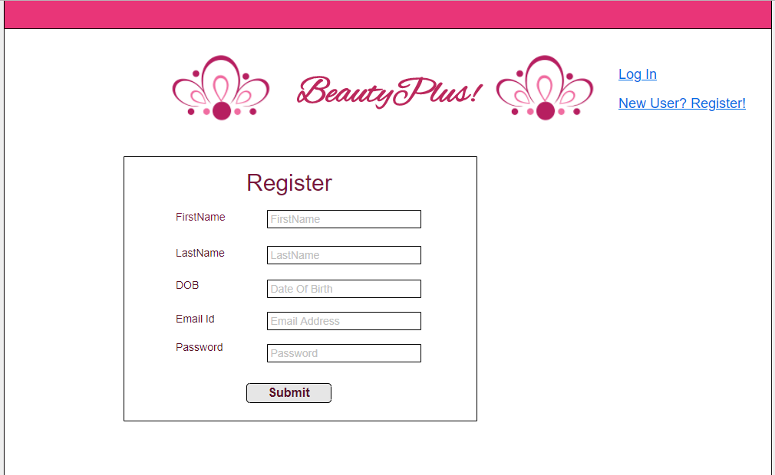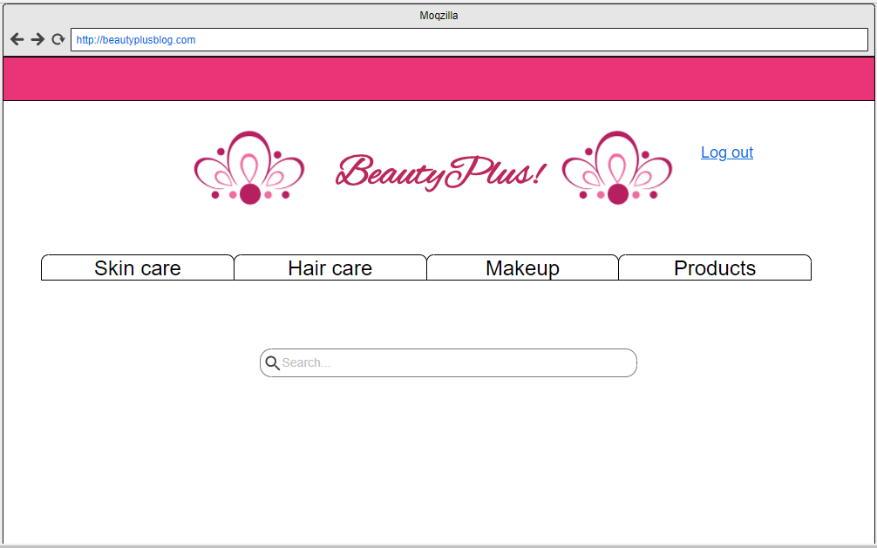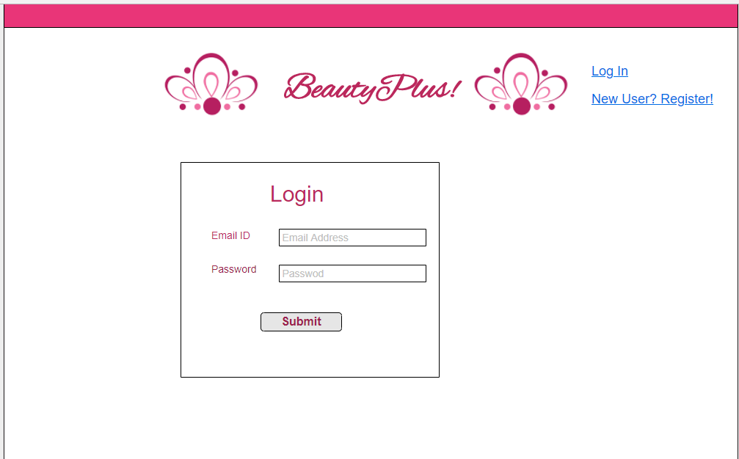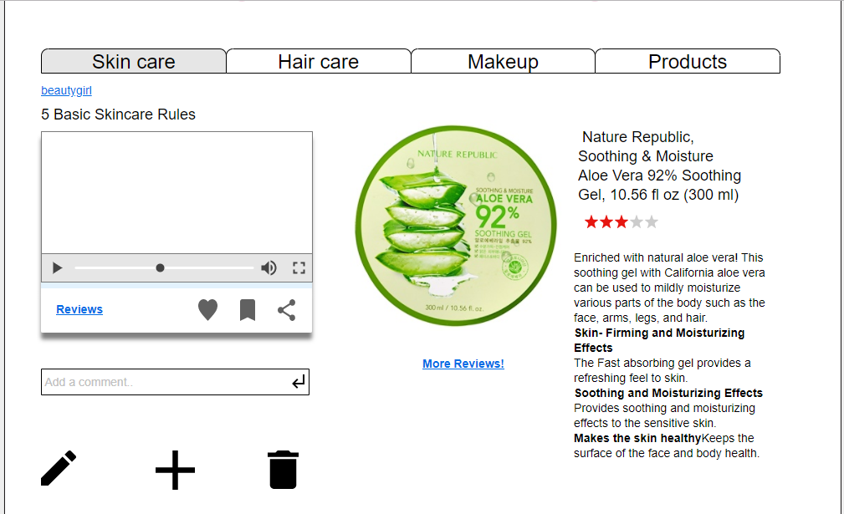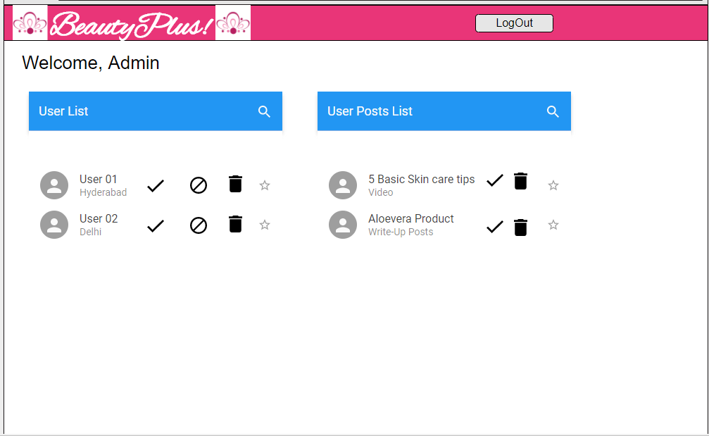

**Informed Consent Form:**

To whomsoever it may concern

1. We have freely volunteered to participate in this project activity.
2. We have been informed in advance, about what my task(s) will be.
3. We have performed the task(s) as per the scheduled procedures.
4. We have been given the opportunity to ask questions before or during the test.
5. We have been told that we have the right to withdraw consent and to abort participation at any time, without prejudice to our future treatment.
6. Our signature below can be taken as affirmation of all the above statements; it was given prior to my participation.

Signature: Ashok Atkuri, Sai Praneetha Jaladanki, Rahul Reddy Lankala

Date: 1st April 2018