**PROJECT REPORT ON**

**EMPLOYEE MANAGEMENT SYSTEM USING SPRING FRAMEWORK AND RESTFUL API**

Submitted in partial fulfillment of the requirements for the degree of

**BACHELOR OF TECHNOLOGY IN**

**COMPUTER SCIENCE AND ENGINEERING**

**OF SASTRA UNIVERSITY**

**Submitted by**

**Kuna Praneetha(117003102)**



**Under the Guidance of**

**B.Ramasubramanian**

**i|Nautix Technologies-A BNY Mellon Company CHENNAI**

**SCHOOL OF COMPUTING**

**SHANMUGHA**

**ARTS, SCIENCE, TECHNOLOGY & RESEARCH ACADEMY**

**(SASTRA UNIVERSITY)**

**(A University Established under section 3 of the UGC Act, 1956)**

**TIRUMALAISAMUDRAM**

**THANJAVUR – 613 401**

**April 2017**

**SCHOOL OF COMPUTING**

**SHANMUGHA**

**ARTS, SCIENCE, TECHNOLOGY & RESEARCH ACADEMY**

**(SASTRA UNIVERSITY)**

**(A University Established under section 3 of the UGC Act, 1956)**

**TIRUMALAISAMUDRAM, THANJAVUR – 613401**



**BONAFIDE CERTIFICATE**

Certified that this project work entitled “Employee Management System using Spring Framework And Restful API” submitted to the Shanmugha Arts, Science, Technology & Research Academy (SASTRA University), Tirumalaisamudram- 613401 by

**Kuna.Praneetha with 117003102**

in partial fulfillment of the requirement for the award of the degree of **BACHELOR OF TECHNOLOGY IN COMPUTER** **SCIENCE AND ENGINEERING** is the original and independent work carried out under my guidance, during the period January2017 - April 2017**.**

|  |  |
| --- | --- |
| **INTERNAL GUIDE** | **ASSOCIATE DEAN** |
| **B.RAMASUBRAMANIAN,** | **Dr. A. UMAMAKESWARI** |
| **i|Nautix Technologies-A BNY Mellon Compnay,Chennai** | **SCHOOL OF COMPUTING** |

Submitted for University Examination held on___________________

**EXAMINER - I** **EXAMINER - II**

**SCHOOL OF COMPUTING**

**SHANMUGHA**

**ARTS, SCIENCE, TECHNOLOGY & RESEARCH ACADEMY**

**(SASTRA UNIVERSITY)**

**(A University Established under section 3 of the UGC Act, 1956)**

**TIRUMALAISAMUDRAM, THANJAVUR – 613401**



**DECLARATION**

We submit this project work entitled **“EMPLOYEE MANAGEMENT SYSTEM USING SPRING FRAMEWORK AND RESTFUL API”** to the Shanmugha Arts, Science, Technology & Research Academy (SASTRA) University, Tirumalaisamudram–613 401, in partial fulfillment of the requirement for the award of the degree of **BACHELOR OF TECHNOLOGY IN COMPUTER SCIENCE AND ENGINEERING** and declare that it is our original and independent work carried out under the guidance of Mr. **B.Ramasubramanian,i|Nautix Technologies-A BNY Mellon Company.**

**Date: 03/4/2017 Name: Kuna Praneetha Signature:**

**Place: Chennai Reg. No: 117003102**

**ACKNOWLEDGEMENT**

It is a great pleasure for us to present this project to all of you. We would like to acknowledge each and every one who had a role to play in making our humble efforts an out-to-out success.

We would like to thank our Honorable **Vice Chancellor (Col.) R. Sethuraman** for providing us with an opportunity and the necessary infrastructure for carrying out this project as a part of our curriculum.

We find very heartening the encouragement and strategic support offered at every step of our college life by **Dr. S. Vaidhyasubramaniam**, **Dean, Planning & Development** and **Dr. V. Badrinath, Dean, Training & Placement and School of Management** and for that we would like to thank them time and again.

We wish to express our gratitude to **Dr. A Umamakeswari**, **Associate Dean**, **and School of computing** for her foresight and guidance, to complete our project in time.

We extend our heartfelt thanks to the **Registrar**, **Dr. G. Bhalachandran**, for providing the opportunity to pursuit this project.

We are very thankful to our internal guide **B.Ramasubramanian**,i|Nautix Technologies, for encouragement, guidance and support throughout the project.

We express our sincere thanks to all the staff of School of computing, for the help throughout the project.

We express our wholehearted gratitude to our parents and friends who kept my spirits high without whose cooperation the completion of the project would not be possible.

**TABLE OF CONTENTS:**

|  |  |  |
| --- | --- | --- |
| **S. no.** | **CHAPTER** | **Page Number** |
| **1** | **Introduction** | **1** |
| **2** | **Statement of the Problem** | **5** |
| **3** | **Objectives of the study** | **6** |
| **4** | **Literature Review** | **7** |
| **5** | **Software, Hardware Requirement Specification** | **9** |
| **6** | **Conceptual Modeling** | **10** |
| **7** | **Interaction Scenario** | **13** |
| **8** | **Methodology and Approach** | **15** |
| **9** | **Output** | **21** |
| **10** | **Steps to develop application** | **27** |
| **11** | **Advance Rest Controller** | **30** |
| **12** | **Conclusion** | **34** |
| **13** | **References** | **35** |

**1. INTRODUCTION**

**1.1 About the Company**

i|Nautix Technologies India Private Limited located in Chennai and Pune in India, is a group company of Bank of New York Mellon-leading financial services provider. Bank of New York is one of the top most and oldest banking corporate in the United States,it is the 20th oldest bank in the world which is established on June 9,1784,by American Founding Father Alexander Hamilton..

i|Nautix provides fields like technology development, business and technology operations and remote infrastructure management services for Bank of NewYork Mellon and its subsidiaries. It also develops and delivers wide ranging technology solutions and products for customers of Bank of New York Mellon. i|Nautix is a essential arm of Client Technology Solutions at Bank of New York Mellon.

i|Nautix provides the following:

* Deliver service excellence and innovative solutions.
* Encourage the development of a collaborative work environment that values inclusion and offers associates, opportunity for growth and recognition.
* Provides support to the local and global communities.
* Provides several insights for shaping the future industry.

i|Nautix provides Cutting Edge Technology Services,availability are some of the important factors for success in evolving the competitive capital field markets. i|Nautix have a expertness in building a wide array of financial systems which includes advisor platforms, broker management systems, asset movement systems, institutional platforms,. Retail client platforms etc.

i|Nautix combines technical expertness with agility, experience, value, integrity and flexibility to deliver wide variety of ranging technological solutions. To make sure of a prompt service response in today’s rapidly changing market situations, the entire i|Nautix team works as a unified team whole from beginning to finish by combine their extensive domain experience and technology expertness to provide an acceptable range of service offerings like Full life cycle Application development, Human factor Engineering etc.

**Company Technologies**

***Nexen Gateway:***

Bank of New York Mellon is always at the dominant level of innovation, with the prominent way of new thinking and also with the new products and services which help the clients of company to get succeed.

In distinct from cloud technology to mobile platforms and also to big data technologies and a lot, Bank of New York Mellon is generating a latest way to develop and deliver the solutions to clients which in turn focus on the access and collaboration in markets, providing a way to increase reliability, flexibility, efficiency. It is also striving for developing stronger risk management.

Bank of New York Mellon is inaugurating one of the biggest technological transformations which are called NEXENSM, which is an open source and cloud based technology platform. It has been designed in such a way that so that it can provide knowledge to the clients so that the clients can change the way of monitoring which will be more efficient fast, flexible etc. This cutting edge technology of BNY Mellon helps the clients at each and every stage of software investment lifecycle.

The main objective of i|Nautix is to create new and original solutions that will position our clients for success which include:

* **Big Data Insights:** Providing digital workspace to make evidences based decisions faster.
* **Cloud Based Platform**: Nexen which is a open source and cloud based technology platform, which is one of the cutting edge technology of financial services.
* **Acquisition Strategy**: The power of advanced investment technology from Bank of NewYork Mellon acquisitions like Eagle,Hedgemark etc.
* Bank of New York Mellon has innovation centers at Silicon Valley, Chennai and Pune

**1.2 BACKGROUND OF THE PROJECT**

Employee management is the management of mates in an organization. Often, large organizations have many problems when storing the details of all the employees and all of these functions are organized by a special team called Human Resource, but managers are still required to supervise and administer the activities of the employees under them, and ensure the well-being, of the employee that report to them.

The current data frameworks depend on the innovation called Database Management, which is an accumulation of consistent and related information. Database Management System fills in as a product framework which permits which permits the clients to characterize, make, keep up and control access to database. To execute this sort of frameworks is very little straightforward and simple. It includes a great part of the shared advancement of use program which is the part of an application engineer and database. The application program is, really the interface between the clients and the database, where the information is put away. Along these lines, an all-around created application program and database are essential for the unwavering quality, adaptability and usefulness of the framework.

The basic idea can be described on Figure below:

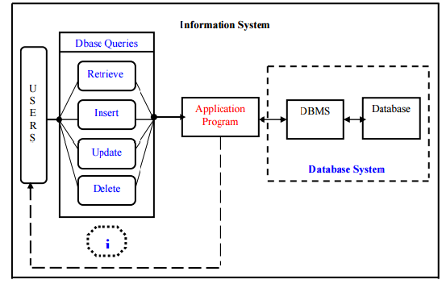

Employee management system suggests advanced technology to be used in order to provide the information to employees in an organization, for the purposes of data transformation into useful information, computer hardware and software are designed and used.

A specific case is that the Human Resources Information System advancement. This sort of frameworks are in charge of putting away information of the representative inside an association and creating reports upon demand. Such sort of framework could be coordinated with different modules like

• Accounting Information System (AIS) which has been intended to change money related information data or

• Management Information System (MIS) which gives choice situated data to chiefs, and so on…

Associations rely on upon Information Systems keeping in mind the end goal to remain focused in a present day advertise. Efficiency, which is essential element for remaining aggressive, can be expanded through better Information Systems.

The End users can insert, delete, update and retrieve the data from the database. The Application program acts as an interface between the database and the user.

**2. PROBLEM STATEMENT**

Management of employee information is very crucial to any organization and it is very important to every organization to have their employee detail record stored. This makes the company very easy to browse about the current employee regarding the ID, place, age and address etc.

Previously the data of the employees was maintained in a excel format but maintaining the data in a excel format will make the date prone to human errors. And such applications would be not fast and efficient in accessing the data. Hence so after the databases were developed the work became much simpler for retrieving, inserting any information about the employee of the organization

This system makes the process of scheduling much easier and computerized. By this system the manager or higher level Designated employee can view the details of any employee working under him,. Thus the higher designation management can easily fix the process of assigning tasks to the employee whenever the employee is free, and also can change the appointment whenever there is a collide with the other meetings and also can avoid the direct contact with the employee..

**3. OBJECTIVE**

The objectives of the system are:

This application will reduce the complexity of employee management.

By using this system one can easily maintain all the records about all the employees of the organization

It will reduce the time to search any record of an employee.

It is easy to handle by any person who have elementary and basic knowledge of computer as it provides a user friendly environment.

**3.1 The Domain**

Employee Management System is one in which it is easy and simpler to maintain the information regarding an employee like the name, year of joining, projects etc. The traditional way of maintaining the details of an employee gets complicated when there is a lot of information to be updated often.

**3.2 Existing System**

. The Existing System is a tightly coupled java application. The Existing System uses servlets and java server page (JSP) technologies for accessing the data from the database. In case of any enhancements the entire code needs to be modified which is a time consuming process. As it is time consuming process, the existing system has been yet to be developed using spring framework and Restful API web services.

**3.3 Proposed System**

The application has been replaced with an interface much better to use and also matching with the current trends. User experience part has been increased with additional options to update any details and view any details of any employee. As the proposed system uses spring technology and if any enhancement is required in the code it can be done just by changing the bean class. Thus it had reduced the complexity and it’s not time consuming.

**4. LITERATURE REVIEW**

This application for managing the employee information uses Java for the server side code and the back end, HTML,CSS for user interface, servlets and jsp for connecting to the database and thus developed a tightly coupled java application. Spring framework and Restful API were used to enhance this application to a loosely coupled.

**4.1 Eclipse**

Eclipse is an open source platform that helps a software developer to create a customized development environment (IDE) from plug-in components built by Eclipse members. Eclipse provides a program (UI) model for operating with tools.  It is designed to run on multiple operating systems while providing robust integration with each underlying OS.  Plug-ins can program to the Eclipse portable APIs and run unchanged on any of the supported operating systems

**4.2Oracle SQL**

Oracle SQL Developer is an incorporated improvement instrument that disentangles the advancement and administration of Oracle Database in cloud stage. SQL Developer offers an entire end-to-end improvement of uses, a workspace for running questions and scripts, a Database Admin reassure for dealing with the database, a report interface, a total information displaying arrangement, and a relocation stage for moving your outsider databases to Oracle. SQL database has been utilized to store the subtle elements of the worker and it does the way toward embedding’s, recovering and refreshing the records of a representative. SQL gives a simple, exquisite, performant design for getting to, characterizing, and looking after information

**4.3Spring**

The Spring Framework is a lightweight framework which is used for building enterprise-ready applications. As the spring framework is flexible it allows to use only the parts which are required and those parts are not needed to bring to the rest. The framework also supports remote access to logic of the code through some web services and also supports transaction management. It also provides many ways to store the persistent data. The framework consists of an container called IOC container, using this one can integrate any framework on the top and also can use the JDBC abstraction layer or Hibernate integration code

Full-featured framework and enables to integrate the Aspect Oriented Programing ([AOP](https://docs.spring.io/spring/docs/current/spring-framework-reference/htmlsingle/#aop-introduction)) transparently into your software. As the spring framework is dependent on java platform, it provides a platform for developing java applications.

**4.4Restful API**

Restful API which is called as Representational state transfer(REST) or Restful web services are one of the way which coalesce the computer system on the internet. REST web services provide access and also help to change the textual representations of web sources using some stateless protocols and operations. Many other forms of web services also exist like Web Service Definition language (WSDL) and Simple Object Access Protocol(SOAP), they provide their own set of arbitrary operations. In a RESTful Web service, requests made to a resource  [URL](https://en.wikipedia.org/wiki/URI)  will receive a response which might be in that may be in [XML](https://en.wikipedia.org/wiki/XML), [HTML](https://en.wikipedia.org/wiki/HTML), [JSON](https://en.wikipedia.org/wiki/JSON) etc.. The response body provides if any alteration is made to the already stored record and also provides methods like GET, PUT, POST,DELETE and also provides some hyperlinks to the other resources which are related or collection of resources. By using  [HTTP](https://en.wikipedia.org/wiki/HTTP), which is one of the most common type of operations available which are predefined by the [HTTP verbs](https://en.wikipedia.org/wiki/HTTP_verbs) are GET, POST, PUT, DELETE etc. By using stateless protocols REST systems are liable for fast performance, reliability and flexibility and as they reuse the components it is easy to manage and update even when the application is running.

**5. SOFTWARE REQUIREMENT SPECIFICATION**

**5.1 Software requirements**

The following are the minimum requirements that the target system (Employee Management System) is expected to satisfy for smooth running of this application.

Operating System: Windows 2007 or above

Eclipse: 3.4 or greater

HTML 5

CSS 3

**5.2 Hardware Requirements**

The following are the minimum hardware requirements that the target system is expected to satisfy for running this program.

Processor: 1 GHz or Higher

RAM: 1GB or higher

Storage Space: 50MB free space

**5.3 Development Specifications**

Technologies used: Java (Eclipse), spring

IDE used: Eclipse, Maven Platform

**5.4 Functional requirements**

The following functional requirements were specified

* The application checks if the entered employee number and PIN are valid.
* The application will allow the Employees to view the projects submitted by them and also the list of ongoing projects and can also view the points the employee earned.
* This application allows the manager or top level designated employee can view the details of any employee working under him, he even can check whether the employee is free in particular time or in other times

**5.5 NON FUNCTIONAL REQUREMENTS**

**5.5.1 Performance requirements**

The user should be able know the next step in the process with certain prompts. This makes the application user friendly. Care should be taken as to observe that no column is filled with erroneous or ghost data. While signing up to the application all the details get stored in the database. The application should be user friendly and it should be faster to access.

**5.5.2 Operational Requirements**

The application should be ready to be deployed in other applications with limited and easy customizations. Such as able to run on any browser and data and can be integrated as a component or plug-in. This makes the application that is to be developed behave as a component in the real world.

**5.5.3Alert Messages**

The user should know the process and must be alerted with accurate error messages and the error codes must be decoded or translated in such a way that the user should know what exactly the error is and what is supposed to be done by the user for the process to be completed successfully.

**6. CONCEPTUAL MODELLING**

**6.1 Use-Case Diagram:**



*Figure 6.1. Use case diagram for various users*

**6.2 Class Diagram**



*Figure 6.2 Class diagram*

**6.3 Activity Diagram**

*Figure* 6.3 *Activity Diagram*

**7. INTERACTION SCENARIO**

**7.1 Sequence Diagram**



*Figure 7.1. Sequence Diagram for All Users*



*Figure 7.2. Sequence Diagram for Checking performance*



*Figure 7.3 Sequence Diagram for any Feedbacks & Suggestion*

**8. METHODOLOGIES AND APPROACH**

**8.1 Design**

**8.1.1 Client-Side Design**

The user interface is kept simple and understandable. The user need not take any additional effort to understand the functionality and navigation in the application. The layouts are chosen in such a way that user can easily understand where the input has to be given. Non mandatory fields are mentioned with required descriptions to help the user in giving the correct input.

The following are the main screens and features in this application.

* Home screen
* Employee interface screen
* Signup Screen

**Home screen:**  
 This is the first screen that any user is greeted with. It is used to do two things:

* **“Employee ID”:** To enter the ID of the Employee
* **“Password”:** To enter the password of the particular ID
* **“Submit” Button:** To transit to the next page.
* **“Forgot Password”:** To regenerate the password
* **“Sign Up”:** Any new Employee can register.

**Employee interface screen:**

This is the second screen that allows Employee to view his details. This screen has the following sections:

* Profile
* Projects
* Performance
* Payments
* Contact details
* Change Password
* Logout
* **“Profile”:** On clicking this tab the employee can view his details like name, employee ID, designation etc.
* **“Projects”:** This tab navigates to the Project Details where he can view the ongoing projects and the completed projects.
* **“Performance”:** On clicking the following tab the employee can view the number of working hours ,extra working hours, the points he scored like wow points and jira points.
* **“Payroll”:** On clicking the following tab it gives all the details about the salary like the basic pay, DA, EIS etc.
* **“Contact Details”:** This tab helps to view the details like the desk number, the VoIP, email-id etc.
* **“Logout”:** This tab provides the functionality of signing out of the application.

The employee interface screen have an extra tab named as “View Peers”, this tab will be provide only to the employees of higher designation like HR Manager,Manager,Project Leads etc.

**-“View Peers”**: This tab helps the manager to view the details of an employee working under him/her.

**Signup Screen:**  
  This screen displays the necessary details required to be filled by any new employee of the organization to get registered with the website. The Screen has the following columns:

* First Name
* Last Name
* DateofBirth
* Gender
* Password
* Reenter Password
* Designation
* Personal Email-id
* Contact
* Security Question
* Answer

The new employee of the organization should provide all the following details to get registered with the website.

* **“Submit Button”:** By clicking the submit button, all the details of the employee will be stored in the database and a employee id will be assigned.
* **“Reset Button”:** The reset button helps the employee to reset the details given by him.

  .

**8.1.2 Server-Side Design**

**Activities:**

* Storing the details of the new employee when he gets signed up.
* Generating the employee ID and organization email to the employee.
* Storing the updated information of the employee

**Storing the details of the new employee when he gets signed up.**

Once the new employee enters all the information which is required for registering to the application and on clicking the submit button on the signup screen the mandatory fields are checked, if not empty the field’s values are retrieved and stored in their corresponding variables on the server side and if empty and error dialog is shown to check the mandatory fields.

**Generating the employee ID and organization email to the employee.**

After the submission of details by the employee unique ID, official email will be given to the employee. The employee can logon to the application with that id and password. And also can check all the mails within the organization with email provided to him. The application helps the employee to view all the details like his projects, working hours, points scored by him etc.

**Storing the updated information of the employee**

Whenever there is any change in the details of the employee, it can be easily updated by the HR Manager or the higher designation member of the organization .The updated information can be easily viewed by the employee by logging on to his profile..

9. OUTPUT SCREENSHOTS

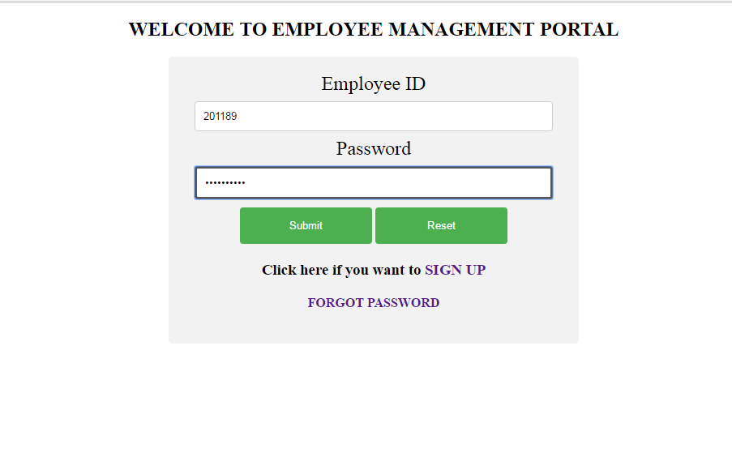

*Figure 9.1. Home Screen*

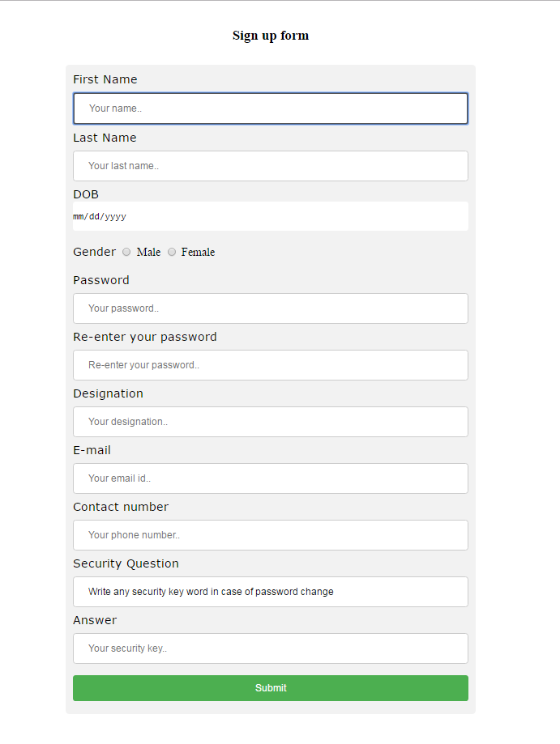

*Figure 9.2. Sign up screen*

*Figure 9.3 Home Screen*

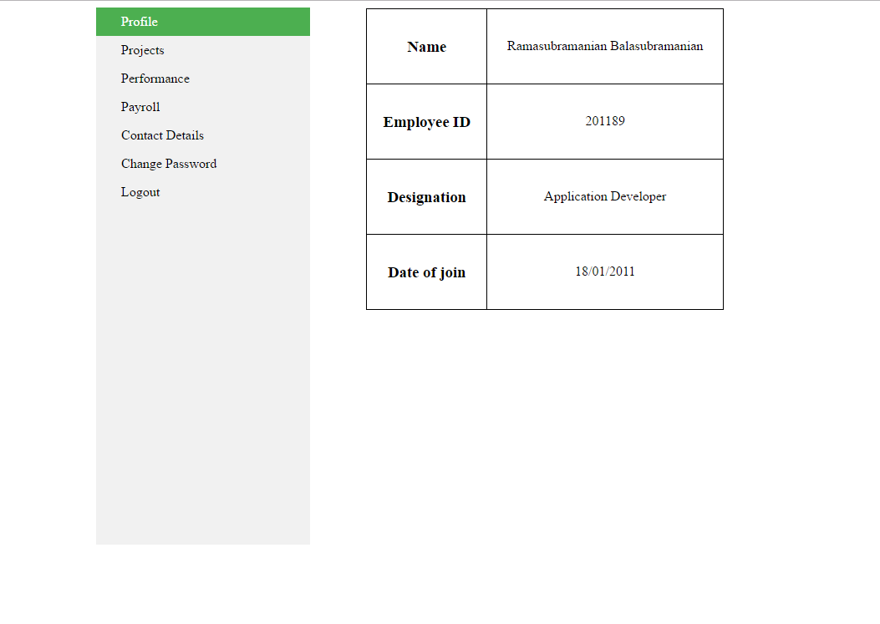

*Figure 9.4 Profile tab*

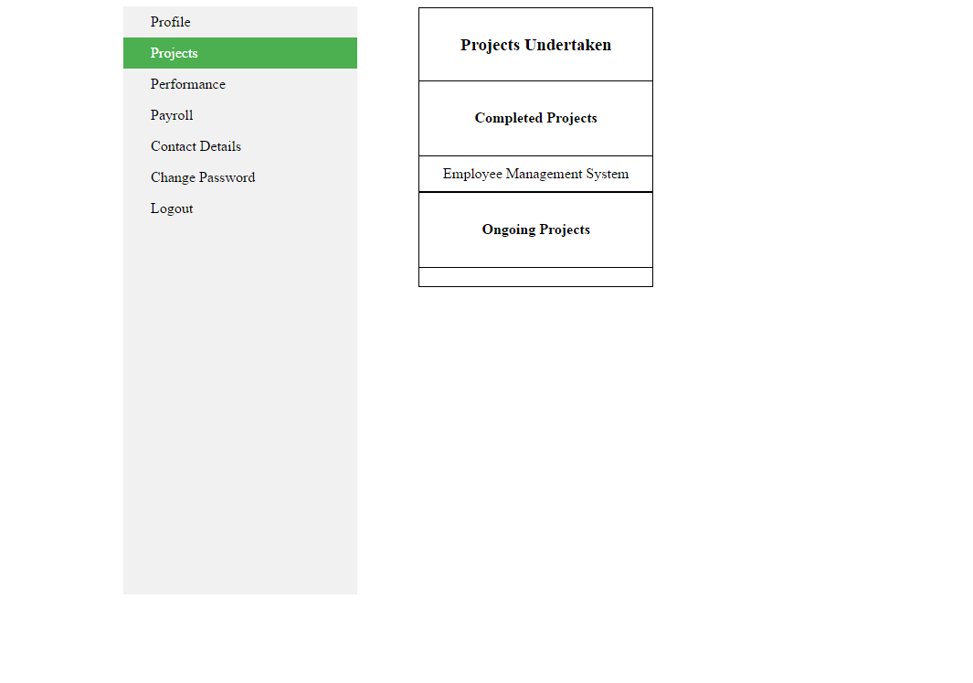

*Figure: 9.5Projects tab*

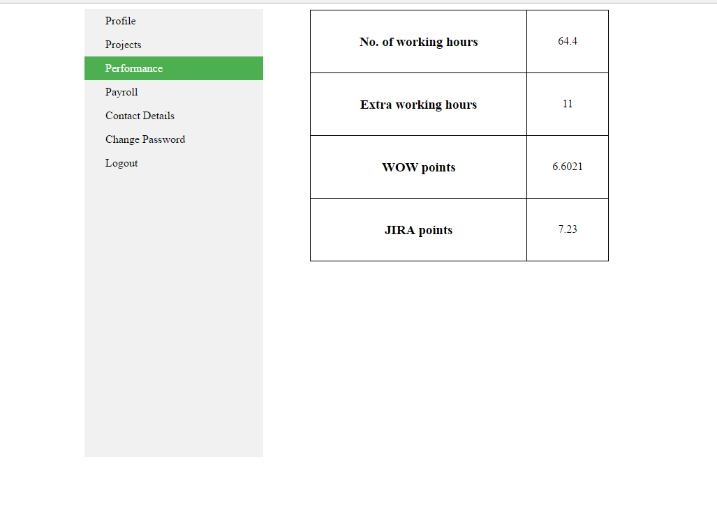*Figure 9.6 Performance tab*

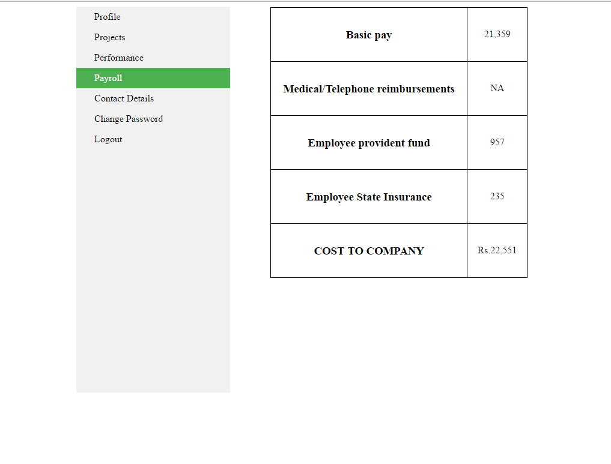

*Figure 9.6.Payroll Tab*

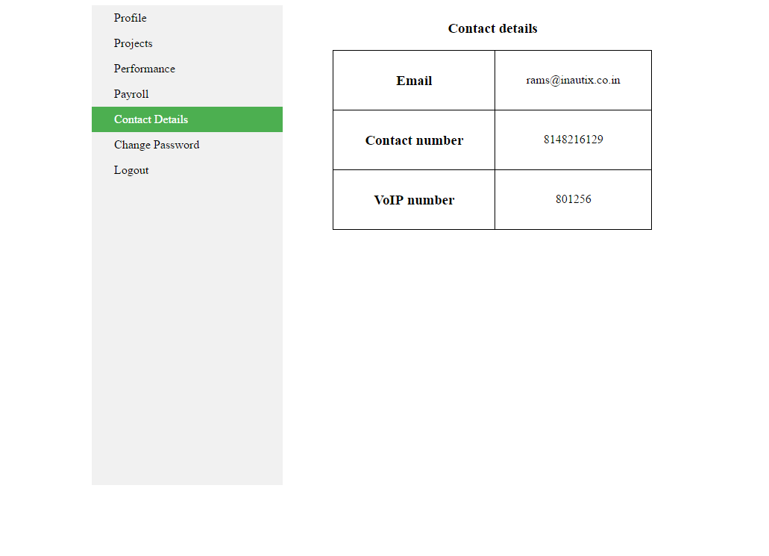

*Figure 9.7.Contact details tab*

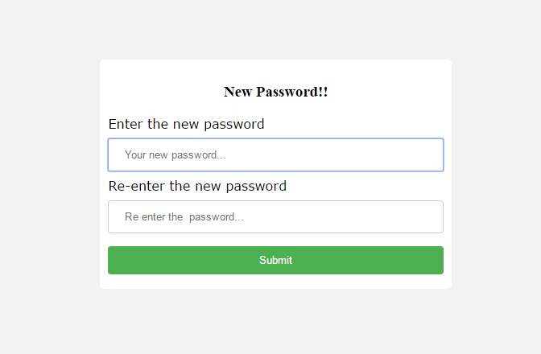

*Figure 9.8.Change Password tab*

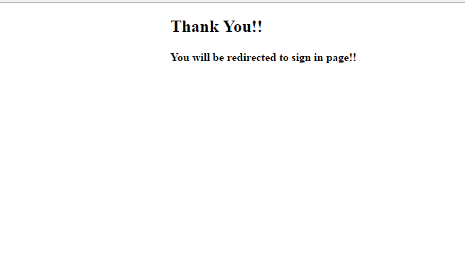

*Figure 9.9. Logout page*



*Figure 9.10. Home Screen*

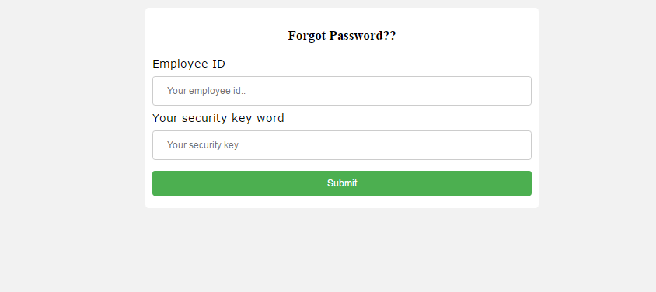

*Figure 9.11.Forgot Password*

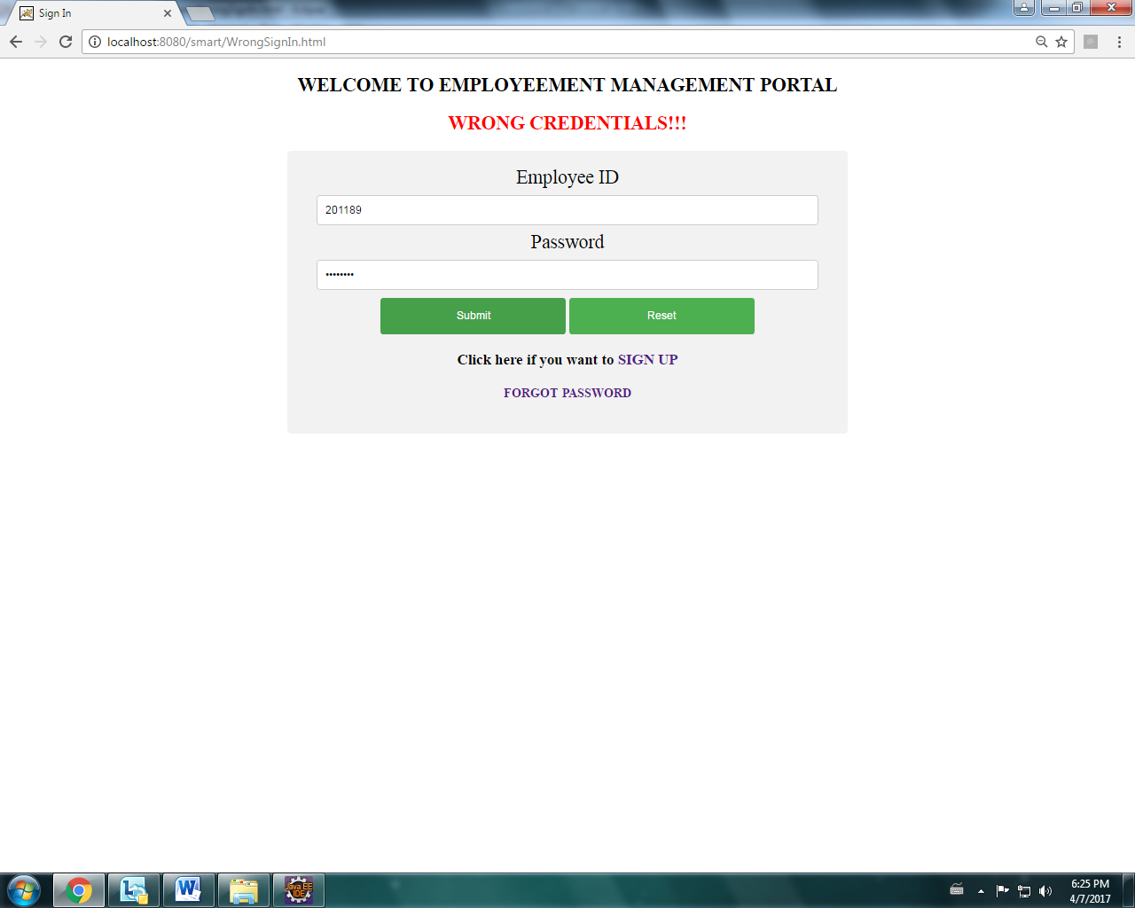

*Figure 9.12 Alert message*

10.Steps to create Spring JDBC Template:

1.Create a table with a valid tablename and required columns using My Sql,Oracle etc.

2.Create a bean class which consists of getter and settor methods

3.Create a DataAccessObject class which consists of jdbc Template along with the requried methods

Example:

import java.awt.List;

import javax.sql.DataSource;

import org.springframework.jdbc.core.JdbcTemplate;

import org.springframework.jdbc.core.ResultSetExtractor;

public class XYZ {

private DataSource dataSource;

private JdbcTemplate jdbcTemplateObject;

public void setDataSource(DataSource dataSource) {

this.dataSource = dataSource;

this.jdbcTemplateObject = new JdbcTemplate(dataSource);

}

4.The **DriverManager DataSource** is used to contain the information about the database such as driver class name, connection URL, username and password. Hence the applicationcontext.html must be updated with bean through setter injection or constructor injection.

Example:

<!-- Initialization for data source -->

<bean id="dataSource"

class="org.springframework.jdbc.datasource.DriverManagerDataSource">

<property name="driverClassName" value="oracle.jdbc.driver.OracleDriver"/>

<property name="url" value="jdbc:oracle:thin:@10.232.71.29:1521:INATP02"/>

<property name=*"*username" value="shobana"/>

<property name="password" value="shobana"/>

</bean>

<bean id=*"*classname *"*

class=*"*com.inautix.Spring*"*>

<property name=*"*dataSource" ref=*"*dataSource*"* />

</bean>

</beans>

</beans>

5.Create main class in which it gets the bean from the application.html and calls the methods present in the DataAccessObject class.

**10.1 Steps to create an Application using Spring ModelViewController(MVC):**

1. Download all the jar files which are required for spring which includes core, web, aop, mvc, j2ee, remoting, oxm, jdbc, orm etc.
2. Create a bean class which consists of getter and settor methods
3. Create a controller class using Annotations

Examples of annotations:

[**1.@RestController**](mailto:1.@RestController)**:**

It is a stereotype annotation that combines @ResponseBody and @Controller and it gives more definition to the controller class

[**2.@ResponseBody**](mailto:2.@ResponseBody)

Annotation that indicates a method should return a value which should be bound to the web response body.

[**3.@RequestBody**](mailto:3.@RequestBody)

It is one of the annotation which indicates that a parameter of the method should be bound to the body of the web request. The body of the request is passed through an HTTPMessageCoverter to resolve the argument of the method which also depends on the type of the request.

[**4.@RequestMapping**](mailto:4.@RequestMapping)

Request mapping annotation is used for mapping web request onto the particular handler class and handler methods. This annotation provides a predefined style between the servlet and prolet environments.

@RequestMapping(value=”/a proper url”,method=get/put/post/delete)

[**5.@AutoWired**](mailto:5.@AutoWired)

Auto wired annotation can be used to get rid of setter methods. This annotation marks a constructor field,config method etc.

4. Update the pom.xml with groupid and artifact id;

5. Configure the springservlet.xml as follows:

<context:component-scan base-package="com.inautix.Spring*"* />

<mvc:annotation-driven />

<! -- JSON Support -->

<bean name=*"*viewResolver" class="org.springframework.web.servlet.view.BeanNameViewResolver"/>

<bean name="jsonTemplate" class="org.springframework.web.servlet.view.json.MappingJackson2JsonView"/>

**11. Advance Rest Controller Tool:**

The only REST client that makes connection directly on socket giving full control over the connection and request/response headers.

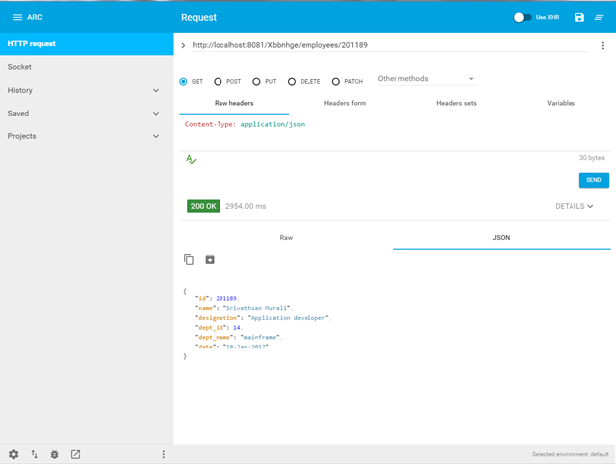

The above figure is the screen of Advance rest controller tool through which we can insert ,update delete and retrieve the records from the database.

1.It consists a section to provide the url and have to provide with the url mentioned in the main code

2.It has two bodies

1.RequestBody

2.ResponseBody

3.It provides with the methods in the form of radio buttons like GET,PUT,POST,DELETE.

The aim of creating an application using Restful API web services is to make it loosely coupled and change all the java objects to JSON Objects.

**11.1 Advance Rest Controller for POST Method**

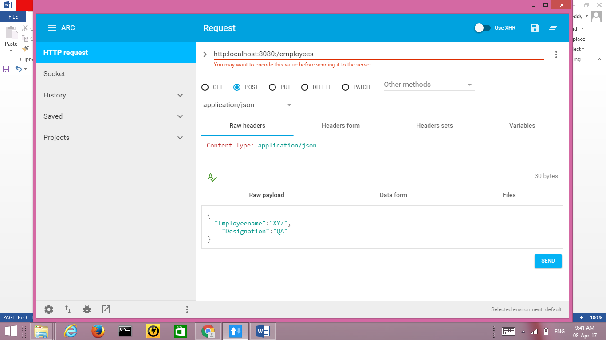

**11.2 Advance Rest Controller for PUT Method**

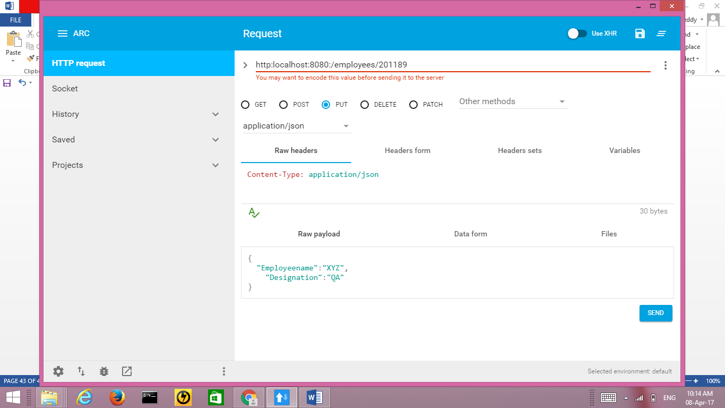

**12. CONCLUSION**

The application developed has been subjected to various tests and measures that include factors to view all the details of an employee like his projects, profile, payroll details etc. This application needs to be further integrated with the Application which updates the working hours of an employee using RHD scanner and it also to be integrated with production region. Integration is being done by adding a new tabs in the application using spring framework. A special thanks to the all the faculty members for their cooperation in successfully producing the project report.

**13. REFERENCES**

* <https://www.w3schools.com/html/>
* <https://www.tutorialspoint.com/maven/>
* <https://www.w3schools.com/css/>
* <http://www.javatpoint.com/jsp-tutorial>
* http://www.javatpoint.com/spring-tutorial