**PROJECT REPORT ON**

**EMPLOYEE MANAGEMENT SYSTEM USING SPRING FRAMEWORK AND RESTFUL API**

Submitted in partial fulfillment of the requirements for the degree of

**BACHELOR OF TECHNOLOGY IN**

**COMPUTER SCIENCE AND ENGINEERING**

**OF SASTRA UNIVERSITY**

**Submitted by**

**Kuna Praneetha(117003102)**



**Under the Guidance of**

**B.Ramasubramanian**

**i|Nautix Technologies-A BNY Mellon Company CHENNAI**

**SCHOOL OF COMPUTING**

**SHANMUGHA**

**ARTS, SCIENCE, TECHNOLOGY & RESEARCH ACADEMY**

**(SASTRA UNIVERSITY)**

**(A University Established under section 3 of the UGC Act, 1956)**

**TIRUMALAISAMUDRAM**

**THANJAVUR – 613 401**

**April 2017**

**SCHOOL OF COMPUTING**

**SHANMUGHA**

**ARTS, SCIENCE, TECHNOLOGY & RESEARCH ACADEMY**

**(SASTRA UNIVERSITY)**

**(A University Established under section 3 of the UGC Act, 1956)**

**TIRUMALAISAMUDRAM, THANJAVUR – 613401**



**BONAFIDE CERTIFICATE**

Certified that this project work entitled “Employee Management System using Spring Framework And Restful API” submitted to the Shanmugha Arts, Science, Technology & Research Academy (SASTRA University), Tirumalaisamudram- 613401 by

**Kuna.Praneetha with 117003102**

in partial fulfillment of the requirement for the award of the degree of **BACHELOR OF TECHNOLOGY IN COMPUTER** **SCIENCE AND ENGINEERING** is the original and independent work carried out under my guidance, during the period January2017 - April 2017**.**

|  |  |
| --- | --- |
| **INTERNAL GUIDE** | **ASSOCIATE DEAN** |
| **B.RAMASUBRAMANIAN,** | **Dr. A. UMAMAKESWARI** |
| **i|Nautix Technologies-A BNY Mellon Compnay,Chennai** | **SCHOOL OF COMPUTING** |

Submitted for University Examination held on___________________

**EXAMINER - I** **EXAMINER - II**

**SCHOOL OF COMPUTING**

**SHANMUGHA**

**ARTS, SCIENCE, TECHNOLOGY & RESEARCH ACADEMY**

**(SASTRA UNIVERSITY)**

**(A University Established under section 3 of the UGC Act, 1956)**

**TIRUMALAISAMUDRAM, THANJAVUR – 613401**



**DECLARATION**

We submit this project work entitled **“EMPLOYEE MANAGEMENT SYSTEM USING SPRING FRAMEWORK AND RESTFUL API”** to the Shanmugha Arts, Science, Technology & Research Academy (SASTRA) University, Tirumalaisamudram–613 401, in partial fulfillment of the requirement for the award of the degree of **BACHELOR OF TECHNOLOGY IN COMPUTER SCIENCE AND ENGINEERING** and declare that it is our original and independent work carried out under the guidance of Mr. **B.Ramasubramanian,i|Nautix Technologies-A BNY Mellon Company.**

**Date: 03/4/2017 Name: Kuna Praneetha Signature:**

**Place: Chennai Reg. No: 117003102**

**ACKNOWLEDGEMENT**

It is a great pleasure for us to present this project to all of you. We would like to acknowledge each and every one who had a role to play in making our humble efforts an out-to-out success.

We would like to thank our Honorable **Vice Chancellor (Col.) R. Sethuraman** for providing us with an opportunity and the necessary infrastructure for carrying out this project as a part of our curriculum.

We find very heartening the encouragement and strategic support offered at every step of our college life by **Dr. S. Vaidhyasubramaniam**, **Dean, Planning & Development** and **Dr. V. Badrinath, Dean, Training & Placement and School of Management** and for that we would like to thank them time and again.

We wish to express our gratitude to **Dr. A Umamakeswari**, **Associate Dean**, **and School of computing** for her foresight and guidance, to complete our project in time.

We extend our heartfelt thanks to the **Registrar**, **Dr. G. Bhalachandran**, for providing the opportunity to pursuit this project.

We are very thankful to our internal guide **B.Ramasubramanian**,i|Nautix Technologies, for encouragement, guidance and support throughout the project.

We express our sincere thanks to all the staff of School of computing, for the help throughout the project.

We express our wholehearted gratitude to our parents and friends who kept my spirits high without whose cooperation the completion of the project would not be possible.

**TABLE OF CONTENTS:**

|  |  |  |
| --- | --- | --- |
| **S. no.** | **CHAPTER** | **Page Number** |
| **1** | **Introduction** | **1** |
| **2** | **Statement of the Problem** | **3** |
| **3** | **Objectives of the study** | **5** |
| **4** | **Literature Review** | **6** |
| **5** | **Software, Hardware Requirement Specification** | **8** |
| **6** | **Conceptual Modeling** | **10** |
| **7** | **Interaction Scenario** | **13** |
| **8** | **Methodology and Approach** | **15** |
| **9** | **Output** | **21** |
| **10** | **Steps to develop application** | **27** |
| **11** | **Advance Rest Controller** | **30** |
| **12** | **Conclusion** | **34** |
| **13** | **References** | **35** |

**1. INTRODUCTION**

**1.1 About the Company**

i|Nautix Technologies India Private Limited located in Chennai and Pune in India, which is a group company of Bank of New York Mellon a leading financial services provider. The BNY is the oldest and the top most bank in the banking corporation in the United States of America, and it is one of the 20th-oldest bank in the world, which have been established by American Founding father Alexander Hamilton on June 9, 1784.

i|Nautix provides fields like technological development sectors, business sectors and technology solutions, infrastructure management services etc,for Bank of New York Mellon and its subsidiaries. It also develops and delivers wide ranging technology solutions and products for customers of Bank of New York Mellon. i|Nautix is an essential arm of client technology solutions at Bank of New York Mellon.

i|Nautix provides the following:

* Deliver service excellence and innovative solutions.
* Encourage the development of a collaborative and team work environment that values inclusion and offers associates, opportunity for growth and recognition.
* Deliver insights in shaping the future industry.
* Supports local and global communities.

i|Nautix provides Cutting Edge Technology Services, Application performance,availability,response times are important factors for success in evolving the competitive capital field markets. i|Nautix have a expertness in building a wide array of financial systems which includes broker customer management platform,asset movement systems,back processing systems,advisor platforms,retails client platforms and institutional platforms .

i|Nautix collaborates technical expertness with experience, agility, integrity, flexibility, value, integrity and also to deliver wide variety of ranging technological solutions. To make sure of a prompt service response in today’s rapidly changing market situations, the entire i|Nautix team works as a unified team whole from beginning to finish by combine their extensive domain experience and technology expertness to provide an acceptable range of service offerings like Production Validation Services, Full Life Cycle Application Development, Human Factors Engineering etc.

**Company Technologies**

***Nexen Gateway:***

BNY Mellon has always been at the leading of innovation, leading the way with new thinking as well as products and services designed to help our clients succeed.

From cloud computing platform to mobile platforms and then to big data technologies and alot Bank of New York Mellon are creating a new way of developing and delivering solutions to clients and focusing on increasing access and collaboration in the markets, improving reliability, flexibility and efficiency, for building stronger risk management and facilitating growth through access to value-added information-based services.

Bank of New York Mellon is inaugurating one of the biggest technological transformation which is called NEXENSM, which is an open source and cloud based technology platform. It has been designed in such a way that so that it can empower clients to change the way they monitor which will be more flexible, reliable, client responsive, efficient and fast. Its cutting edge technology will help clients at every stage of the investment lifecycle.

The main objective of i|Nautix is to create new and original solutions that will position our clients for success which include:

* **Cloud Based Platform:** NEXEN, is a new open-source cloud-based technology platform, which is on the cutting-edge of financial services.
* **Big Data Insights**: Digital Pulse, Digital Workplace provides data-driven insights to make evidence-based decisions faster.
* **Acquisition Strategy**: Power of advanced investment technology from BNY Mellon acquisitions like AlbridgeTM, Eagle and Hedge mark.
* Bank of New York Mellon has innovation centers at Silicon Valley, Chennai and Pune

**1.2 BACKGROUND OF THE PROJECT**

Employee management is the management of mates in an organization. Often, large organizations have many problems when storing the details of all the employees and all of these functions are organized by a special team called Human Resource, but managers are still required to supervise and administer the activities of the employees under them, and ensure the well-being, of the employee that report to them.

Many of the present day information systems are based on the Database management technology, as a collection of logical and related data, and Database Management System as a software system allowing the users of the application to define, create, maintain and control the access to the database. The process of implementing such kind of systems is not so easy and simple. This involves much of the mutual development of application program which is the role of an application developer and database. The application program is, actually the interface between the users and the database, where the data is stored. Thus, a well-developed application program and database are very important for the reliability, flexibility and functionality of the system.

The basic idea can be described from the Figure below:

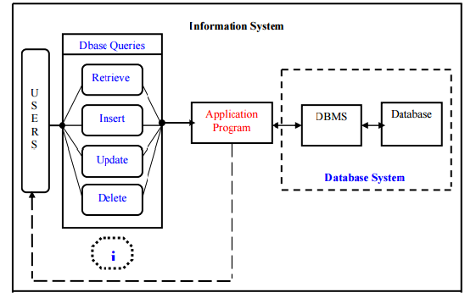

Employee management system suggests an well developed advanced technology to be used in order to provide the information to employees in an organization, for the functions like data transformation into useful information, computer hardware and software are designed and used.

A particular case is that the Human Resources Information System development. This type of systems are responsible for storing data of the employee within an organization and generating reports upon request. Such kind of system could be integrated with other modules like

* Accounting Information System(AIS) which has been developed to transform financial data information or

* Management Information System (MIS) which provides decision-oriented information to managers, etc…

Organizations depend on Information Systems in order to stay competitive in a present day market. Productivity, which is crucial factor for staying competitive, can be increased through better Information Systems.

The End users can insert, delete, update and retrieve the data from the database. The Application program acts as an interface between the database and the user.

**2. PROBLEM STATEMENT**

Management of employee information is very crucial to any organization and it is very important to every organization to have their employee detail record stored. This makes the company very easy to browse about the current employee regarding the ID, place, age and address etc.

Previously the data of the employees was maintained in a excel format but maintaining the data in a excel format will make the date prone to human errors. And such applications would be not fast and efficient in accessing the data. Hence so after the databases were developed the work became much simpler for retrieving, inserting any information about the employee of the organization

This system makes the process of scheduling much easier and computerized. By this system the manager or higher level Designated employee can view the details of any employee working under him, Thus the higher designation management can easily fix the process of assigning tasks to the employee whenever the employee is free, and also can change the appointment whenever there is a collide with the other meetings and also can avoid the direct contact with the employee..

**3. OBJECTIVE**

The objectives of the system are:

This application will reduce the complexity of employee management.

By using this system one can easily maintain all the records about all the employees of the organization

It will reduce the time to search any record of an employee.

It is easy to handle by any person who have elementary and basic knowledge of computer as it provides a user friendly environment.

**3.1 The Domain**

Employee Management System is one in which it is easy and simpler to maintain the information regarding an employee like the name, year of joining, projects etc. The traditional way of maintaining the details of an employee gets complicated when there is a lot of information to be updated often.

**3.2 Existing System**

. The Existing System is a tightly coupled java application. The Existing System uses servlets and java server page (JSP) technologies for accessing the data from the database. In case of any enhancements the entire code needs to be modified which is a time consuming process. As it is time consuming process, the existing system has been yet to be developed using spring framework and Restful API web services.

**3.3 Proposed System**

The application has been replaced with an interface much better to use and also matching with the current trends. User experience part has been increased with additional options to update any details and view any details of any employee. As the proposed system uses spring technology and if any enhancement is required in the code it can be done just by changing the bean class. Thus it had reduced the complexity and it’s not time consuming.

**4. LITERATURE REVIEW**

This application for managing the employee information uses Java for the server side code and the back end, HTML, CSS for user interface, servlets and jsp for connecting to the database and thus developed a tightly coupled java application. Spring framework and Restful API were used to enhance this application to a loosely coupled.

**4.1 Eclipse**

Eclipse is one of the open source platform which helps an application developer to create a customized development environment (IDE) from plug-in components built by Eclipse members. Eclipse provides a program (UI) model for operating with tools.  It is designed to run on multiple operating systems while providing robust integration with each underlying OS.  Plug-ins can program to the Eclipse portable APIs and run unchanged on any of the supported operating systems

**4.2Oracle Sql**

Oracle Sql developer is one of the integrated development tool which simplifies the process of storing the data in the database using simple queries. It also simplifies and manages the oracle database in the cloud platform. It offers a complete end to end development of applications and alos provides a workspace for running scripts and queries. A Database Admin console is present for managing the database, a report interface, a complete data modeling solution, and a migration platform for moving your 3rd party databases to Oracle. Oracle Sql database has been used to store the details of the employee and it does the process of inserting, retrieving and updating the records of an employee. Oracle SQL provides an easy, elegant, performant architecture for accessing, defining, and maintaining data.

**4.3Spring**

The Spring Framework is one of the simple and lightweight framework which is used for building enterprise ready applications. As spring is modular it allows to use those parts which are needed, without having to bring them to the rest. One can make use of the IOC container, with any of the web framework on top, and also can use the Hibernate integration code or the JDBC abstraction layer. Spring Framework also supports the transaction management and remote access to the logic through web services, and also provides various options for persisting data. It offers a Full-featured framework and enables to integrate the Aspect Oriented Programing ([AOP](https://docs.spring.io/spring/docs/current/spring-framework-reference/htmlsingle/#aop-introduction)) transparently into your software. The Spring Framework which is a dependent on Java platform that provides comprehensive infrastructure support for developing Java applications.

**4.4Restful API**

REST (Representational state Transfer) or RESTful web services is one of the way which allows to provide the interface between computer system on the internet. REST web services allows the systems which are requesting to access and help to change the text representations of web sources using a predefined set of stateless protocols and operations The other forms of web services are also present which are like WSDL (Web service Definition language) and SOAP(Simple Object Access Protocols) which use a set of their own arbitrary operations In a RESTful web service, all the request made to the resource URL will receive a response which may be in the format like XML,JSON,HTML etc. The response body provides if any alteration are made to the already stored record and also provide methods like GET,PUT,POSTDELETE and also provides some hypertext links to other resource bodies. By using [HTTP](https://en.wikipedia.org/wiki/HTTP), which is one of the most common type of operations available which are predefined by the [HTTP verbs](https://en.wikipedia.org/wiki/HTTP_verbs) are GET, POST, PUT, DELETE etc. By using such stateless protocols REST web services are liable to fast performance, flexibility, reliability and as they reuse the components it is easy to manage and update the system even when it is running...

**5. SOFTWARE REQUIREMENT SPECIFICATION**

**5.1 Software requirements**

The following are the minimum requirements that the target system (Employee Management System) is expected to satisfy for smooth running of this application.

Operating System: Windows 2007 or above

Eclipse: 3.4 or greater

HTML 5

CSS 3

**5.2 Hardware Requirements**

The following are the minimum hardware requirements that the target system is expected to satisfy for running this program.

Processor: 1 GHz or Higher

RAM: 1GB or higher

Storage Space: 50MB free space

**5.3 Development Specifications**

Technologies used: Java (Eclipse), spring

IDE used: Eclipse, Maven Platform

**5.4 Functional requirements**

The following functional requirements were specified

* The application checks if the entered employee number and PIN are valid.
* The application will allow the Employees to view the projects submitted by them and also the list of ongoing projects and can also view the points the employee earned.
* This application allows the manager or top level designated employee can view the details of any employee working under him, he even can check whether the employee is free in particular time or in other times

**5.5 NON FUNCTIONAL REQUREMENTS**

**5.5.1 Performance requirements**

The user should be able know the next step in the process with certain prompts. This makes the application user friendly. Care should be taken as to observe that no column is filled with erroneous or ghost data. While signing up to the application all the details get stored in the database. The application should be user friendly and it should be faster to access.

**5.5.2 Operational Requirements**

The application should be ready to be deployed in other applications with limited and easy customizations. Such as able to run on any browser and data and can be integrated as a component or plug-in. This makes the application that is to be developed behave as a component in the real world.

**5.5.3Alert Messages**

The user should know the process and must be alerted with accurate error messages and the error codes must be decoded or translated in such a way that the user should know what exactly the error is and what is supposed to be done by the user for the process to be completed successfully.

**6. CONCEPTUAL MODELLING**

**6.1 Use-Case Diagram:**



*Figure 6.1. Use case diagram for various users*

**6.2 Class Diagram**



*Figure 6.2 Class diagram*

**6.3 Activity Diagram**

*Figure* 6.3 *Activity Diagram*

**7. INTERACTION SCENARIO**

**7.1 Sequence Diagram**



*Figure 7.1. Sequence Diagram for All Users*



*Figure 7.2. Sequence Diagram for Checking performance*



*Figure 7.3 Sequence Diagram for any Feedbacks & Suggestion*

**8. METHODOLOGIES AND APPROACH**

**8.1 Design**

**8.1.1 Client-Side Design**

The user interface is kept simple and understandable. The user need not take any additional effort to understand the functionality and navigation in the application. The layouts are chosen in such a way that user can easily understand where the input has to be given. Non mandatory fields are mentioned with required descriptions to help the user in giving the correct input.

The following are the main screens and features in this application.

* Home screen
* Employee interface screen
* Signup Screen

**Home screen:**  
 This is the first screen that any user is greeted with. It is used to do two things:

* **“Employee ID”:** To enter the ID of the Employee
* **“Password”:** To enter the password of the particular ID
* **“Submit” Button:** To transit to the next page.
* **“Forgot Password”:** To regenerate the password
* **“Sign Up”:** Any new Employee can register.

**Employee interface screen:**

This is the second screen that allows Employee to view his details. This screen has the following sections:

* Profile
* Projects
* Performance
* Payments
* Contact details
* Change Password
* Logout
* **“Profile”:** On clicking this tab the employee can view his details like name, employee ID, designation etc.
* **“Projects”:** This tab navigates to the Project Details where he can view the ongoing projects and the completed projects.
* **“Performance”:** On clicking the following tab the employee can view the number of working hours ,extra working hours, the points he scored like wow points and jira points.
* **“Payroll”:** On clicking the following tab it gives all the details about the salary like the basic pay, DA, EIS etc.
* **“Contact Details”:** This tab helps to view the details like the desk number, the VoIP, email-id etc.
* **“Logout”:** This tab provides the functionality of signing out of the application.

The employee interface screen have an extra tab named as “View Peers”, this tab will be provide only to the employees of higher designation like HR Manager,Manager,Project Leads etc.

**-“View Peers”**: This tab helps the manager to view the details of an employee working under him/her.

**Signup Screen:**  
  This screen displays the necessary details required to be filled by any new employee of the organization to get registered with the website. The Screen has the following columns:

* First Name
* Last Name
* DateofBirth
* Gender
* Password
* Reenter Password
* Designation
* Personal Email-id
* Contact
* Security Question
* Answer

The new employee of the organization should provide all the following details to get registered with the website.

* **“Submit Button”:** By clicking the submit button, all the details of the employee will be stored in the database and a employee id will be assigned.
* **“Reset Button”:** The reset button helps the employee to reset the details given by him.

  .

**8.1.2 Server-Side Design**

**Activities:**

* Storing the details of the new employee when he gets signed up.
* Generating the employee ID and organization email to the employee.
* Storing the updated information of the employee

**Storing the details of the new employee when he gets signed up.**

Once the new employee enters all the information which is required for registering to the application and on clicking the submit button on the signup screen the mandatory fields are checked, if not empty the field’s values are retrieved and stored in their corresponding variables on the server side and if empty and error dialog is shown to check the mandatory fields.

**Generating the employee ID and organization email to the employee.**

After the submission of details by the employee unique ID, official email will be given to the employee. The employee can logon to the application with that id and password. And also can check all the mails within the organization with email provided to him. The application helps the employee to view all the details like his projects, working hours, points scored by him etc.

**Storing the updated information of the employee**

Whenever there is any change in the details of the employee, it can be easily updated by the HR Manager or the higher designation member of the organization .The updated information can be easily viewed by the employee by logging on to his profile..

9. OUTPUT SCREENSHOTS

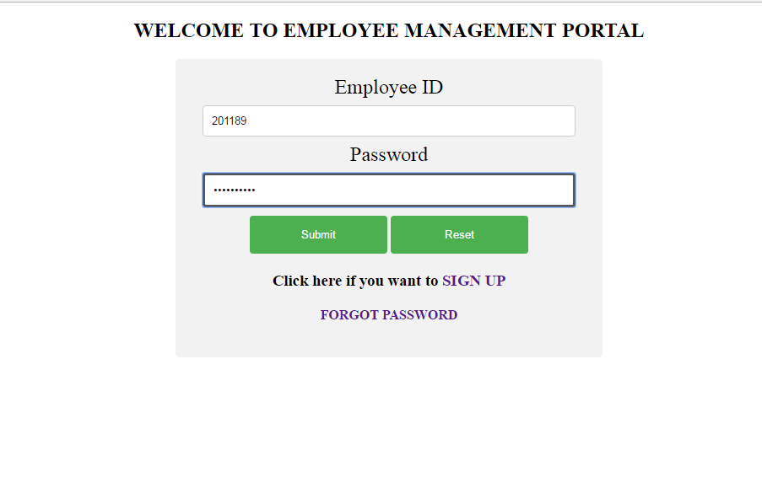

*Figure 9.1. Home Screen*

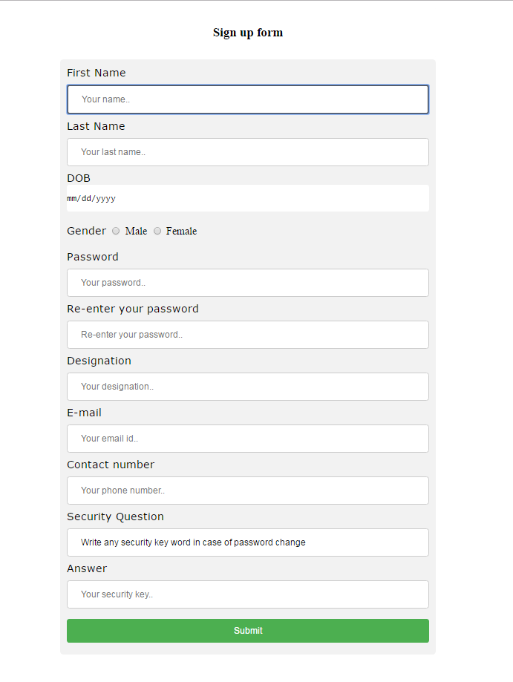

*Figure 9.2. Sign up screen*

*Figure 9.3 Home Screen*

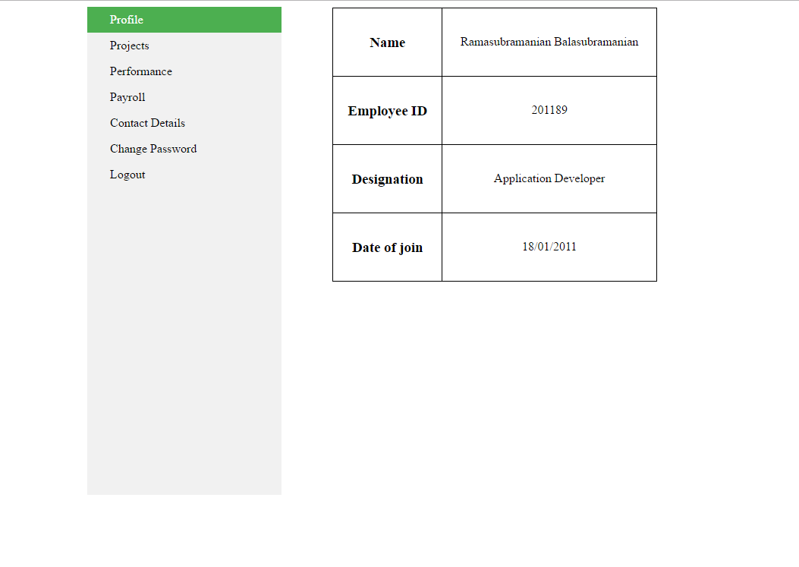

*Figure 9.4 Profile tab*

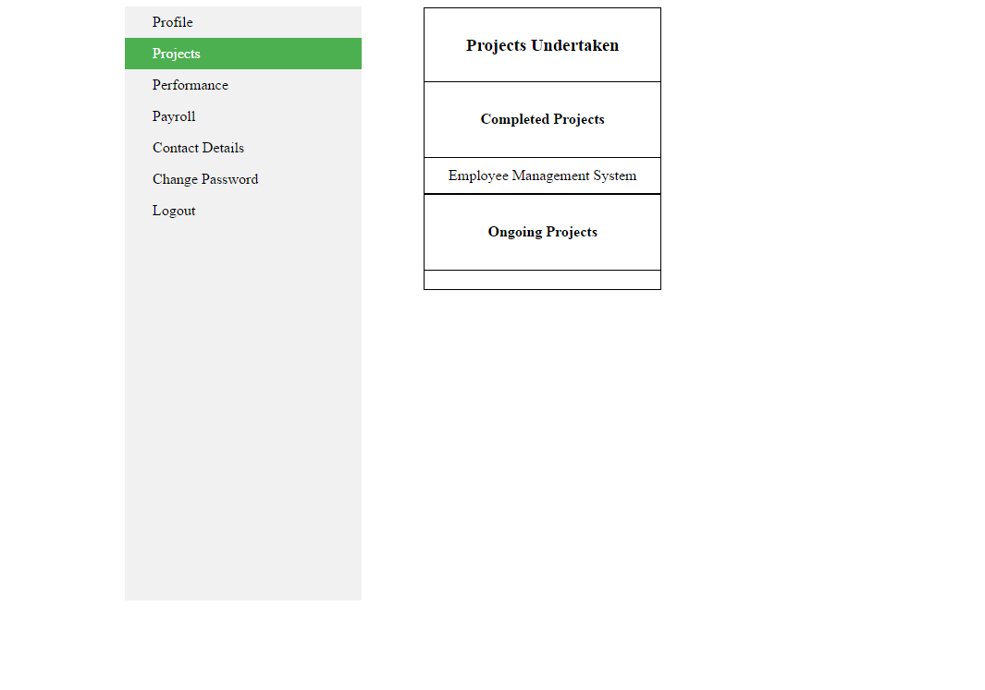

*Figure: 9.5Projects tab*

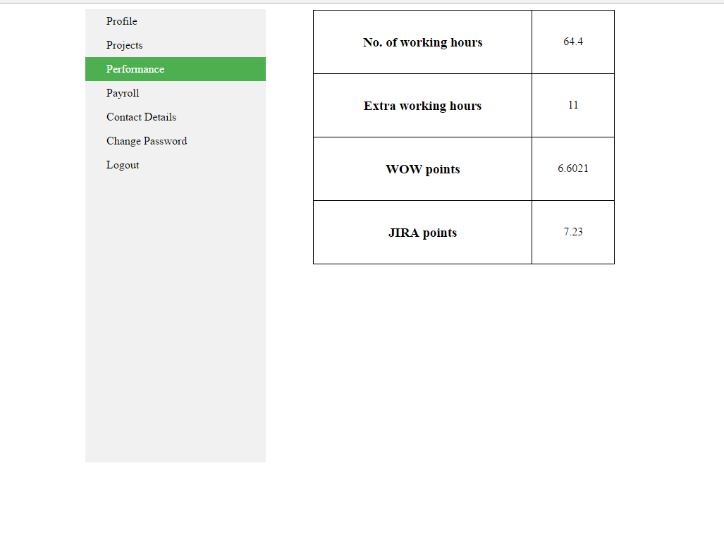*Figure 9.6 Performance tab*

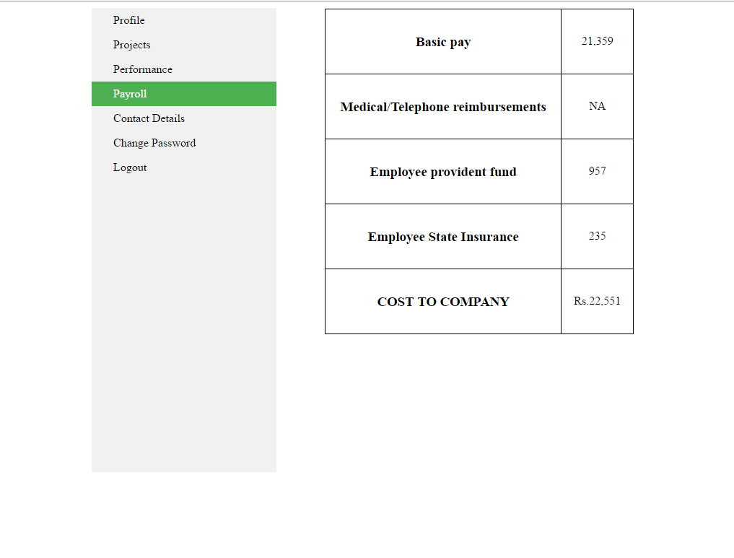

*Figure 9.6.Payroll Tab*

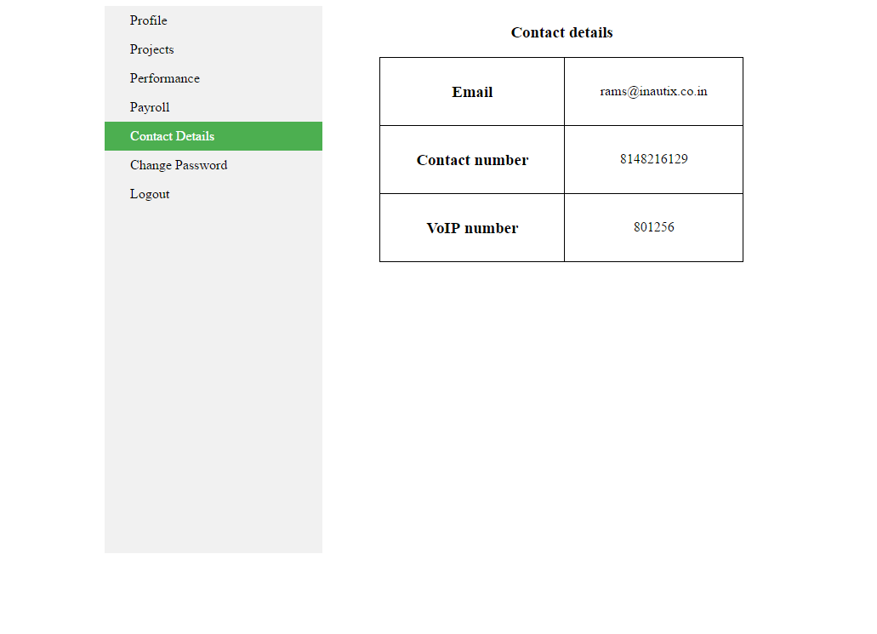

*Figure 9.7.Contact details tab*

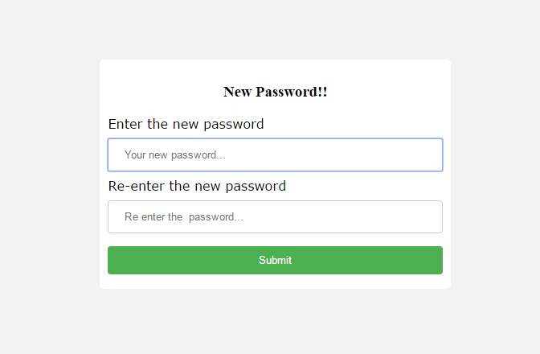

*Figure 9.8.Change Password tab*

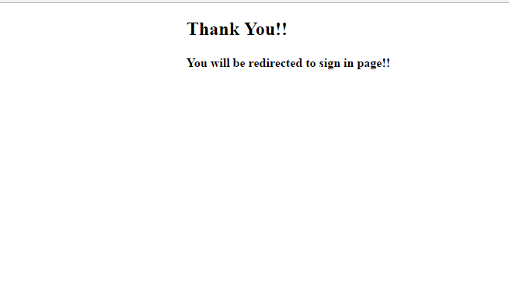

*Figure 9.9. Logout page*



*Figure 9.10. Home Screen*

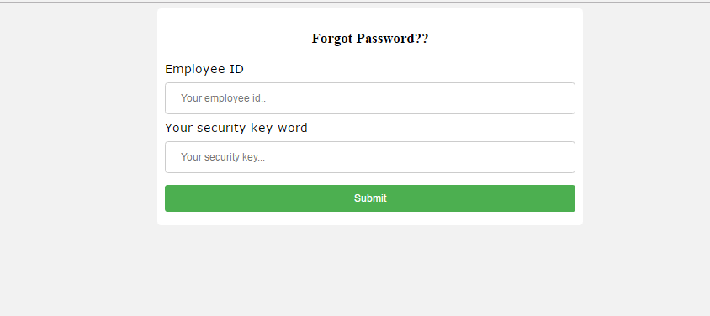

*Figure 9.11.Forgot Password*

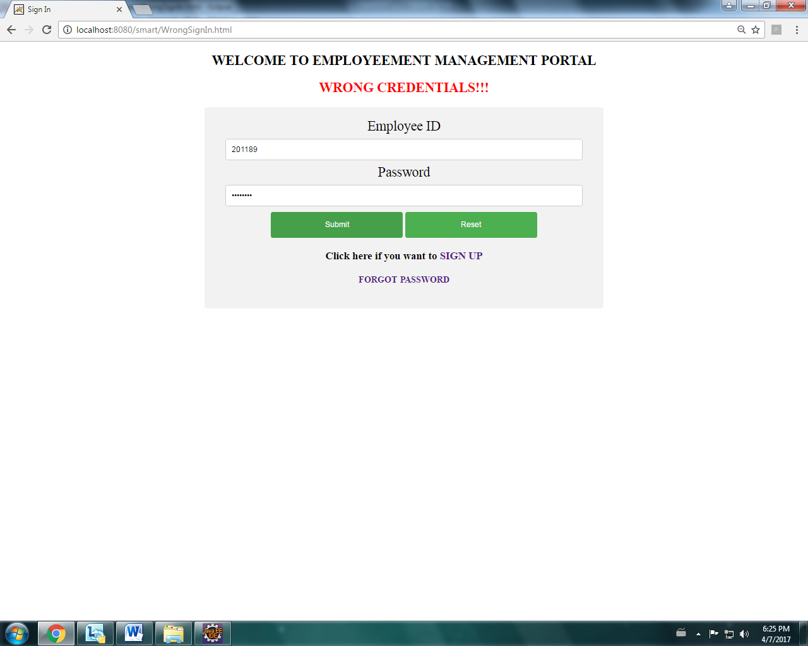

*Figure 9.12 Alert message*

10.Steps to create Spring JDBC Template:

1.Create a table with a valid tablename and required columns using My Sql,Oracle etc.

2.Create a bean class which consists of getter and settor methods

3.Create a DataAccessObject class which consists of jdbc Template along with the requried methods

Example:

import org.springframework.jdbc.core.JdbcTemplate;

import java.sql.DataSource;

private DataSource datasource;

Private jdbcTemplate jdbcTemplateObject;

Public void setDatasource(Datasource datasource)

{

this.datasource=datasource;

this.jdbcTemplate=jdbcTemplate(DataSource datasource);

}

4.The **DriverManager dataSource** is used to contain the information about the database such as driverclassname, connection URL, username and password. Hence the applicationcontext.html must be updated with bean through setter injection or constructor injection.

Example:

<beanid=”datasour”class=”org.springfarmework.jdbc.datasource.DrivermanagerDatasource”>

<bean id=”ds2” class="org.springframework.jdbc.datasource.DriverManagerDataSource">

<property name="driverClassName" value="DriverName" />

<property name="url" value="Hostaddress" />

<property name="username" value="username" />

<property name="password" value="password" />

</bean>

<bean id="jdbcTemplate" **class**="org.springframework.jdbc.core.JdbcTemplate">

<property name="dataSource" ref="ds"></property>

</bean>

<bean id="edao" **class**="com.sample">

<property name="jdbcTemplate" ref="jdbcTemplate"></property>

</bean>

</beans>

5. Create main class in which it gets the bean from the application.html and calls the methods present in the DataAccessObject class.

**10.1 Steps to create an Application using Spring ModelViewController (MVC):**

1. Download all the jar files for spring including core,web,aop,mvc,j2ee,remoting,oxm,jdbc etc.
2. Create a bean class which consists of getter and settor methods
3. Create a controller class using Annotations

Examples of annotations:

[**1.@RestController**](mailto:1.@RestController)**:**

It is a stereotype annotation that combines the @REPONSEBODY and @CONTROLLE and it gives more definition to the controller class

[**2.@ResponseBody**](mailto:2.@ResponseBody)

It is an annotation which indicates that a method should return a value which would be bound to the web response body.

[**3.@RequestBOdy**](mailto:3.@RequestBOdy)

It is an annotation indicating a method parameter should be bound to body of the web request. Body of the request is passed through an HTTPMessageConverter to resolve the method argument and also depends on the type of the request.

[**4.@RequestMapping**](mailto:4.@RequestMapping)

It is an annotation for mapping the web request onto the particular handler classes and handler methods. It provides a consistent style between the servlet and prolet environments with the semantics adapting to the environment.

@RequestMapping(value=”/a proper url”,method=get/put/post/delete)

[**5.@AutoWired**](mailto:5.@AutoWired)

It marks a constructor fiels, a setter methid or config method which is to be auto wired thorough Dependency Injections pot Setter injections using constructors.

4. Update the pom.xml with groupid and artifact id;

5. Configure the springservlet.xml as follows:

<context: component-scan base-package="package name" />

    <mvc:annotation-driven />

**<!-- JSON Support -->**

    <beanname="viewResolver" class="org.springframework.web.servlet.view"/>

    <beanname="jsonTemplate" class="org.springframework.web.servlet.view.json"/></beans>

**11. Advance Rest Controller Tool:**

The only REST client that makes connection directly on socket giving full control over the connection and request/response headers.

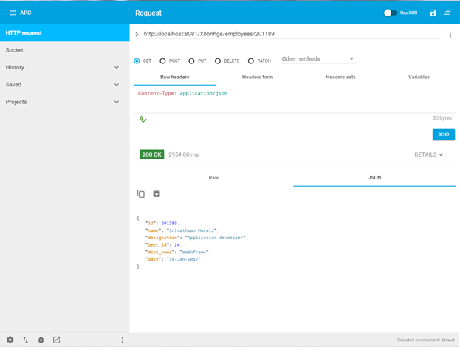

The above figure is the screen of Advance rest controller tool through which we can insert, update delete and retrieve the records from the database.

1.It consists a section to provide the url and have to provide with the url mentioned in the main code

2.It has two bodies

1.RequestBody

2.ResponseBody

3.It provides with the methods in the form of radio buttons like GET,PUT,POST,DELETE.

The aim of creating an application using Restful API web services is to make it loosely coupled and change all the java objects to JSON Objects.

**11.1 Advance Rest Controller for POST Method**

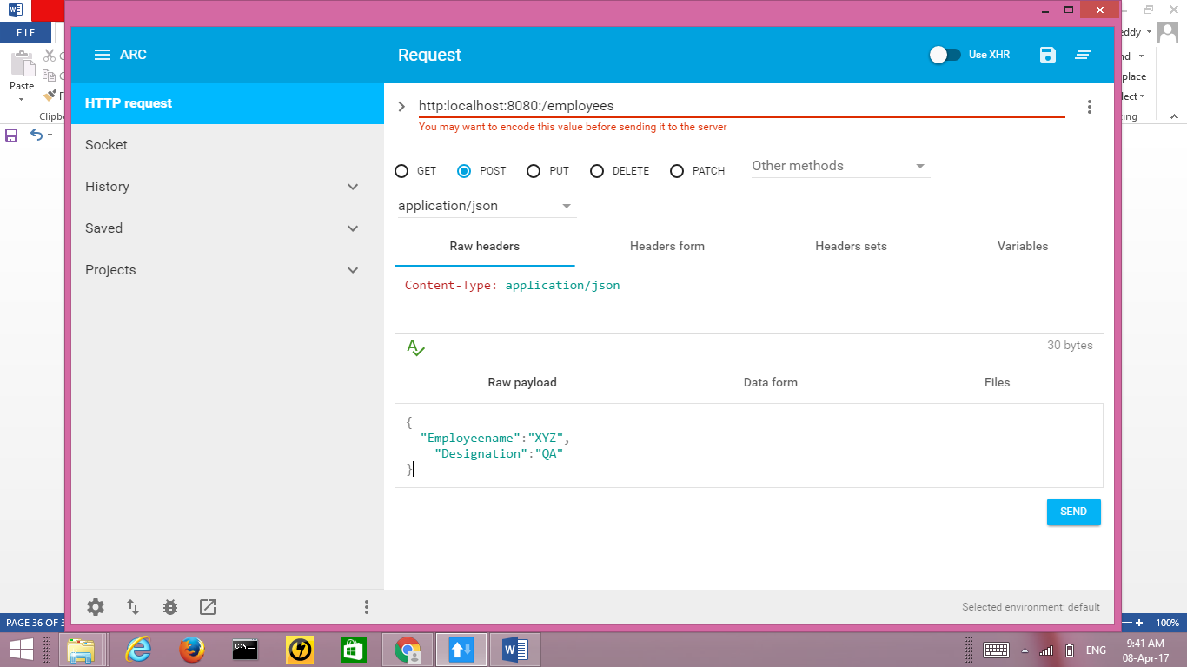

**11.2 Advance Rest Controller for PUT Method**

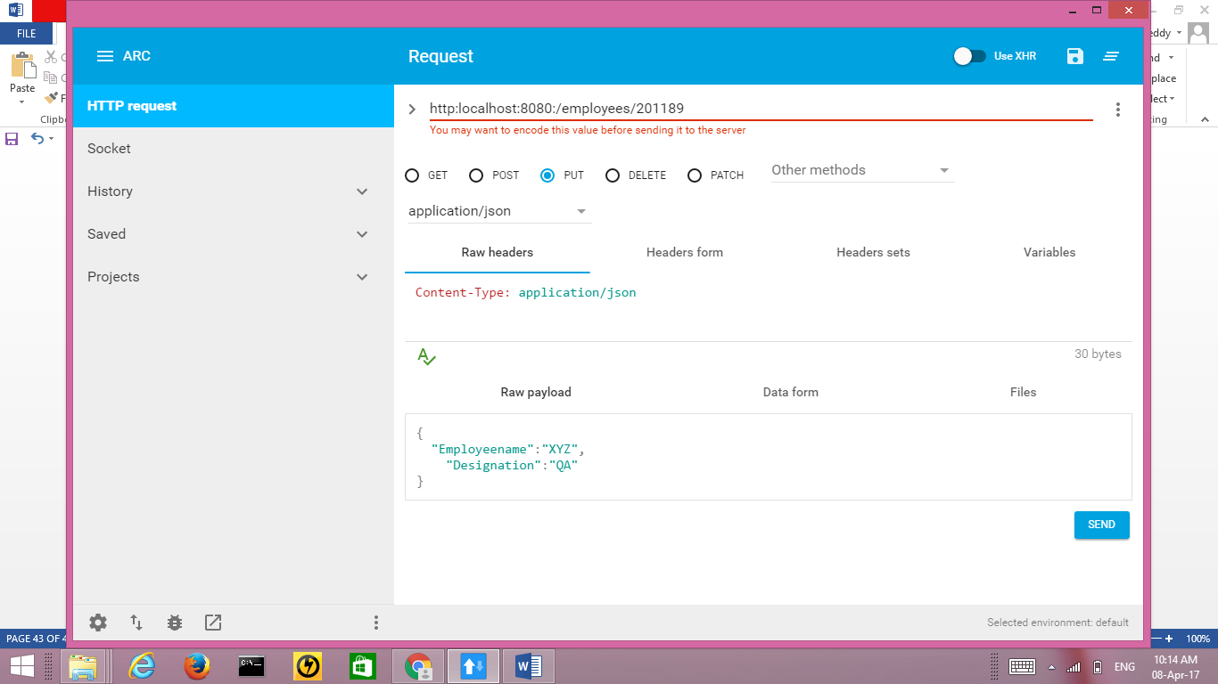

**12. CONCLUSION**

The application developed has been subjected to various tests and measures that include factors to view all the details of an employee like his projects, profile, payroll details etc. This application needs to be further integrated with the Application which updates the working hours of an employee using RHD scanner and it also to be integrated with production region. Integration is being done by adding a new tabs in the application using spring framework. A special thanks to the all the faculty members for their cooperation in successfully producing the project report.

**13. REFERENCES**

* <https://www.w3schools.com/html/>
* <https://www.tutorialspoint.com/maven/>
* <https://www.w3schools.com/css/>
* <http://www.javatpoint.com/jsp-tutorial>
* http://www.javatpoint.com/spring-tutorial