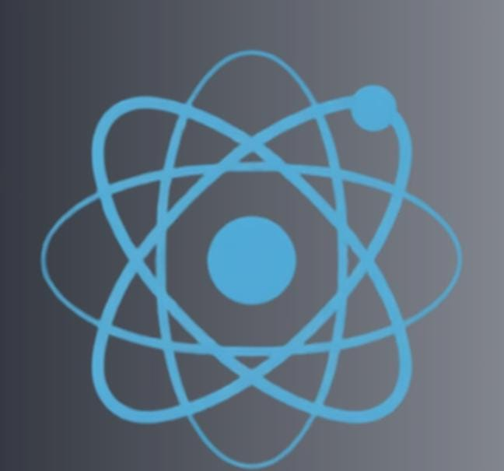
VISOR_QUANTUM
An Interactive Quantum Learning Platform
Submitted as part of the WISER Summer Program 2026 Educational Challenge
Project Report

Team Members:
- Lohitha
- Maheshwari
- P. LN Praneetha

Abstract:
Quantum computing is an emerging technology with the potential to transform fields such as cryptography, artificial intelligence, optimization, and scientific research. However, beginners often find it difficult to learn because of complex mathematics, abstract concepts, limited beginner-friendly resources, and a lack of practical learning tools.
To address these challenges, Visor Quantum was developed as a browser-based interactive educational platform that simplifies quantum computing through structured learning paths and engaging visualizations. The platform includes a 3D Bloch Sphere Simulator, Quantum Mathematics Playground, Concept Library, Interactive Quiz Module, AI Learning Assistant, and Progress Dashboard to support self-paced and hands-on learning.
Developed using HTML5, CSS3, JavaScript (ES6), and Three.js, the platform is accessible through any modern web browser without requiring additional software installation. By combining theoretical explanations with interactive simulations and assessments, Visor Quantum helps learners better understand fundamental quantum computing concepts while maintaining technical accuracy.
The primary objective of this project is to make quantum computing education more accessible, engaging, and beginner friendly. The platform serves as a valuable learning resource for students, educators, and self-learners by providing an intuitive and interactive environment that bridges the gap between theory and practical understanding. Future enhancements such as real quantum hardware integration, adaptive learning, multilingual support, and advanced simulations can further improve the platform's educational impact and scalability.
Keywords: Quantum Computing, Quantum Education, Interactive Learning, Bloch Sphere, AI Learning Assistant, Educational Platform, Quantum Visualization.

Table of Contents:
S.NO | CONTENTS | PAGENO
1 | Introduction | 1
2 | Problem Statement | 1
3 | Objectives | 2
4 | Target Audience | 2
5 | Learning Objectives | 2-3
6 | Educational Methodology | 3
7 | System Architecture | 3-4
8 | Technologies Used | 5
9 | Features | 5-14
10 | Project Workflow | 14-15
11 | Implementation | 16
12 | Results | 16
13 | Challenges Faced | 16-17
14 | Future Enhancements | 17
15 | Conclusion | 17-18
16 | References | 18

- INTRODUCTION:
Quantum computing is an emerging field that has the potential to transform industries such as cryptography, artificial intelligence, healthcare, optimization, and scientific research. Unlike classical computers, which process information using bits that exist as either 0 or 1, quantum computers use qubits that can exist in multiple states simultaneously through the principle of superposition. Quantum computers also utilize concepts such as entanglement and interference to solve certain computational problems more efficiently than classical systems.
Despite its enormous potential, quantum computing is often difficult for beginners to learn. Many educational resources assume prior knowledge of advanced mathematics and quantum mechanics, making it challenging for students to build a strong foundation. Abstract concepts, complex terminology, and limited interactive learning resources further increase the learning difficulty.
To address these challenges, we developed Visor Quantum, an interactive browser-based educational platform that simplifies quantum computing concepts through visual learning, structured educational content, interactive simulations, quizzes, and AI-assisted guidance. The platform provides learners with a clear learning path that gradually introduces quantum concepts from beginner to intermediate levels while encouraging hands-on exploration.
- PROBLEM STATEMENT:
Learning quantum computing presents several challenges, particularly for beginners. Most introductory resources require prior knowledge of mathematics topics such as linear algebra, complex numbers, and probability theory. As a result, many students struggle before they can even begin understanding quantum concepts.
Quantum mechanics introduces ideas such as superposition, entanglement, wave functions, and quantum measurement, which are significantly different from classical computing concepts. Since these ideas cannot be directly observed, learners often find them difficult to visualize and understand.
Another challenge is the lack of structured learning resources that combine theory with interactive practice. Many tutorials focus heavily on theoretical explanations while providing limited opportunities for visualization or practical experimentation. Beginners also face difficulties understanding quantum gates, multi-qubit systems, and quantum algorithms because these topics are introduced without sufficient foundational support.
Visor Quantum addresses these problems by providing an interactive educational platform that combines structured learning paths, concept explanations, Bloch Sphere visualization, mathematical tools, quizzes, and AI-assisted learning support. These features help learners build confidence gradually while improving conceptual understanding through active participation.
- OBJECTIVES:
The primary objective of Visor Quantum is to make quantum computing education accessible, interactive, and beginner friendly. The platform is designed to simplify complex quantum concepts through visual explanations and guided learning experiences.
The specific objectives of the project are:
- To simplify the learning of quantum computing fundamentals.
- To provide interactive visualizations for abstract quantum concepts.
- To help learners understand qubits, superposition, entanglement, and quantum gates.
- To offer structured learning paths that guide students from beginner to intermediate concepts.
- To provide self-assessment through interactive quizzes.
- To assist learners using an AI-powered educational assistant.
- To encourage self-paced learning through browser-based educational resources.

- TARGET AUDIENCE:
Visor Quantum has been designed primarily for learners who are beginning their journey in quantum computing. The platform is suitable for undergraduate and postgraduate students studying computer science, electronics, physics, and related disciplines. It is also useful for self-learners who wish to understand quantum computing concepts without requiring extensive prior knowledge.
The platform can also be used by educators, workshop organizers, and institutions that require an interactive teaching resource for introducing quantum computing fundamentals. By focusing on conceptual clarity and visualization, Visor Quantum supports learners from diverse educational backgrounds.

- LEARNING OBJECTIVES:
After completing the learning modules available in Visor Quantum, users will be able to understand the basic principles of quantum computing and explain the differences between classical bits and quantum bits. Learners will develop a conceptual understanding of superposition, entanglement, and quantum state representation.
The platform enables users to visualize quantum states using the Bloch Sphere, understand the operation of fundamental quantum gates such as X, Y, Z, H, S, and T, and strengthen the mathematical concepts required for quantum computing. Through quizzes and AI-assisted guidance, learners can assess their understanding and reinforce their knowledge before progressing to more advanced topics.

- EDUCATIONAL METHODOLOGY:
Visor Quantum follows a learner-centred educational methodology that combines theoretical understanding with interactive practice. The learning process is organized into a sequence of stages that encourage active participation rather than passive reading.
The educational workflow follows the sequence:
** Learn → Visualize → Practice → Assess → Improve**
Learners begin by studying the theoretical concepts presented in the Concept Library. They then interact with the Bloch Sphere Simulator to visualize quantum states and observe the effects of different quantum gates. Mathematical concepts are reinforced through the Quantum Mathematics Playground, where learners can experiment with vector normalization, matrix multiplication, and tensor products.
Interactive quizzes provide immediate feedback, allowing learners to evaluate their understanding of each topic. The AI Learning Assistant further supports the learning process by answering conceptual questions and providing simplified explanations. Finally, the Progress Dashboard enables learners to monitor their performance and identify areas for improvement.
This methodology promotes active learning, conceptual understanding, and continuous self-assessment, making quantum computing more accessible to beginners.
- SYSTEM ARCHITECTURE:
The Visor Quantum platform follows a browser-based architecture designed to provide an interactive and accessible learning experience. The system is developed using HTML, CSS, and JavaScript, with Three.js used for rendering three-dimensional quantum visualizations such as the Bloch Sphere. Since the application runs directly in a web browser, users do not need to install any additional software.
The system begins with the homepage, where users are introduced to the platform and can select an appropriate learning path. After selecting a learning path, users can access educational modules including concept explanations, simulations, quizzes, and AI-assisted guidance. The user's progress is tracked through a performance dashboard, allowing learners to monitor their improvement throughout the course.
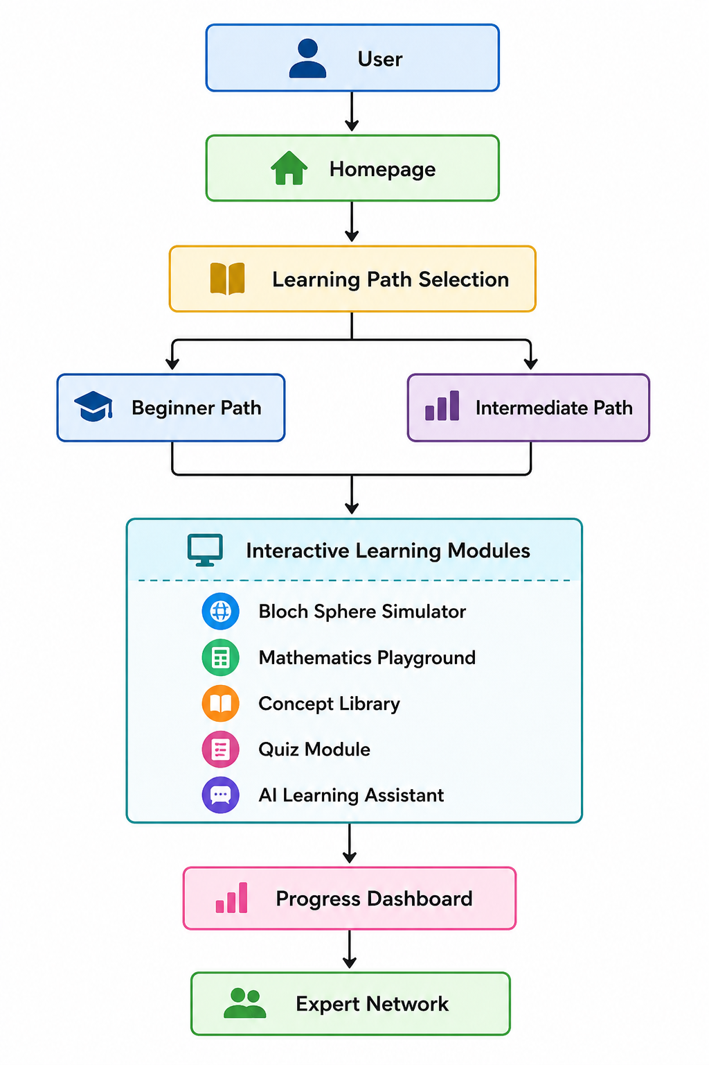
Figure 1: System Architecture

- TECHNOLOGIES USED:
The Visor Quantum platform was developed using modern web technologies to ensure responsiveness, interactivity, and ease of deployment.
Technology | Purpose
HTML5 | Creates the structure and content of web pages
CSS3 | Designs the layout, colours, animations, and responsive interface
JavaScript (ES6) | Implements interactive functionality and application logic
Three.js | Renders the interactive 3D Bloch Sphere visualization
OrbitControls.js | Allows users to rotate and explore the Bloch Sphere
GitHub | Version control and project repository management
Netlify | Website deployment and hosting
Visual Studio Code | Source code development and debugging

Table 1: Technologies
These technologies were selected because they are lightweight, open-source, and suitable for developing browser-based educational applications.

- FEATURES OF THE PLATFORM:
9.1 HOMEPAGE:
The homepage serves as the entry point of the platform. It introduces users to quantum computing and provides a clear overview of the available learning paths. The interface is designed to be visually engaging while remaining simple enough for beginners to navigate.

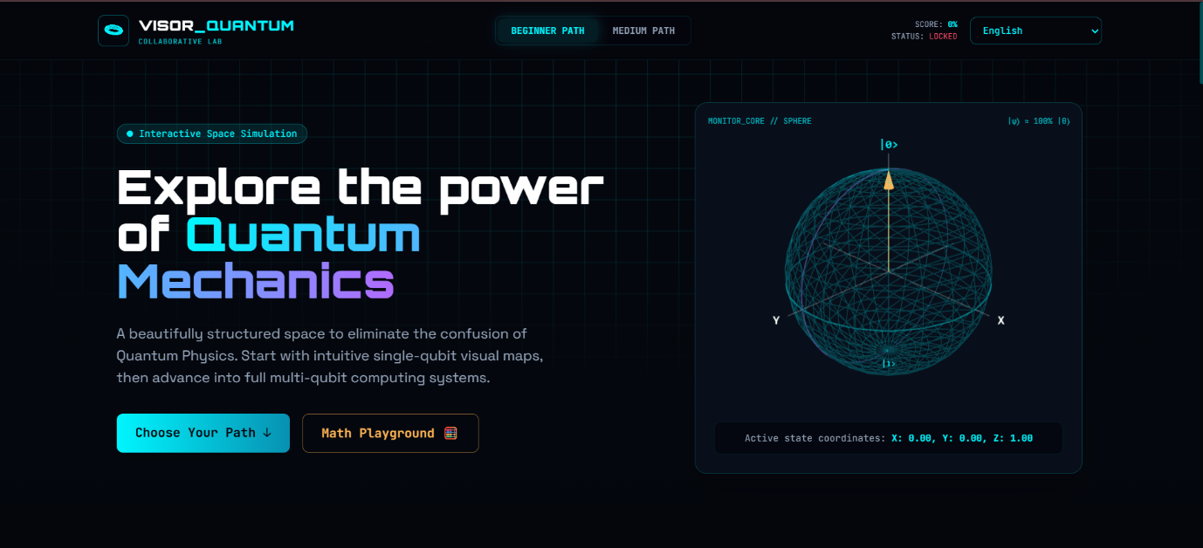
Figure 2: Home Page

  - LEARNING PATH SELECTION:
To support learners with different levels of experience, the platform provides two learning paths.
Beginner Learning Path:
This path introduces learners to the fundamentals of quantum computing. Topics include:
- Qubits
- Superposition
- Bloch Sphere
- Quantum Gates
- Basic Mathematics
- Interactive Quiz
The beginner path focuses on building a strong conceptual foundation before progressing to advanced topics.

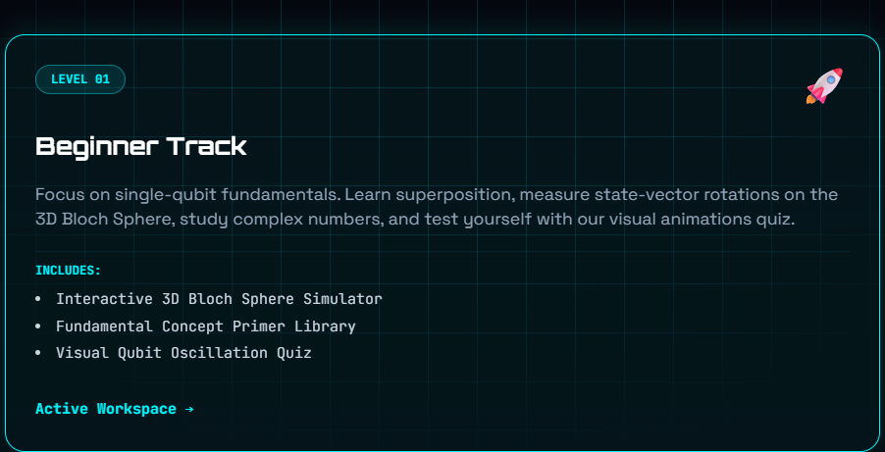
Figure 3: Beginner Path

MEDIUM LEARNING PATH:
The Medium path expands upon the beginner concepts and introduces learners to more advanced quantum computing topics such as:
- Multi-Qubit Systems
- Quantum Entanglement
- Quantum Algorithms
- Advanced Circuit Concepts
- Performance Assessment
This learning path is unlocked after learners demonstrate sufficient understanding of the beginner content.
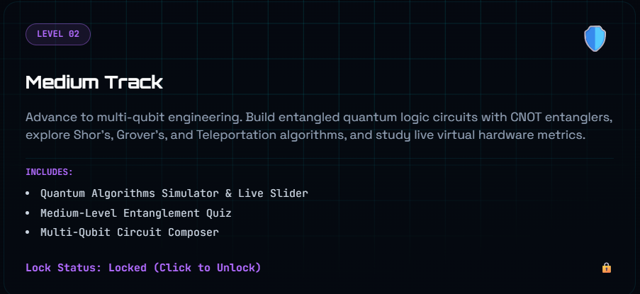
Figure 4: Medium Path

  - BLOCH SPHERE SIMULATOR:
The Bloch Sphere Simulator is one of the primary interactive components of the platform. It provides a three-dimensional representation of a single qubit and allows users to observe how quantum gates affect the qubit's state.
Learners can apply quantum gates including:
- Hadamard (H)
- Pauli-X
- Pauli-Y
- Pauli-Z
- Phase Gate (S)
- T Gate
As each gate is applied, the Bloch Sphere updates dynamically, helping learners visualize quantum state transformations.
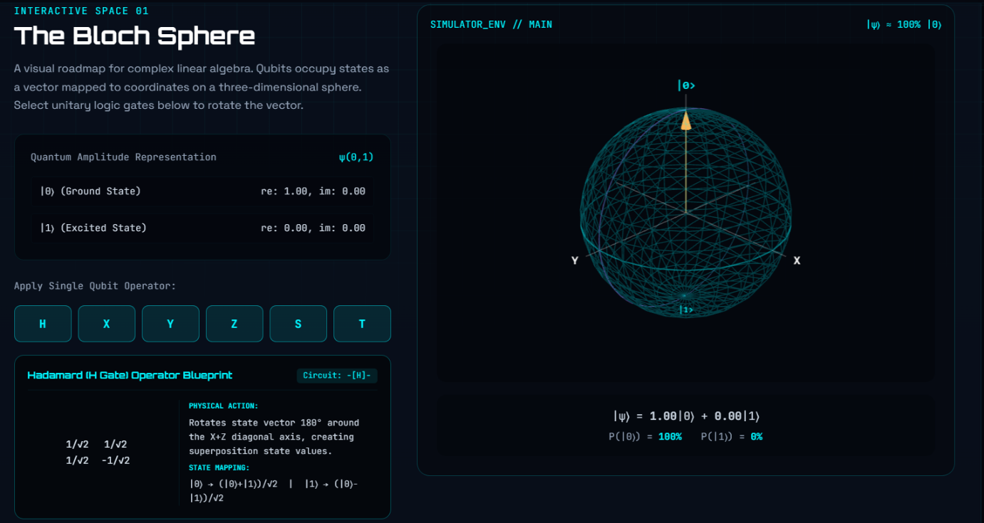
Figure 5: Bloch Sphere

9.4 QUANTUM MATHEMATICS PLAYGROUND:
Understanding quantum computing requires knowledge of several mathematical concepts. The Quantum Mathematics Playground simplifies these topics through interactive examples.
The playground includes:
- State Vector Normalization
- Matrix Multiplication
- Tensor Product Calculator
Each mathematical operation is displayed step by step, helping beginners understand the calculations involved in quantum computing.
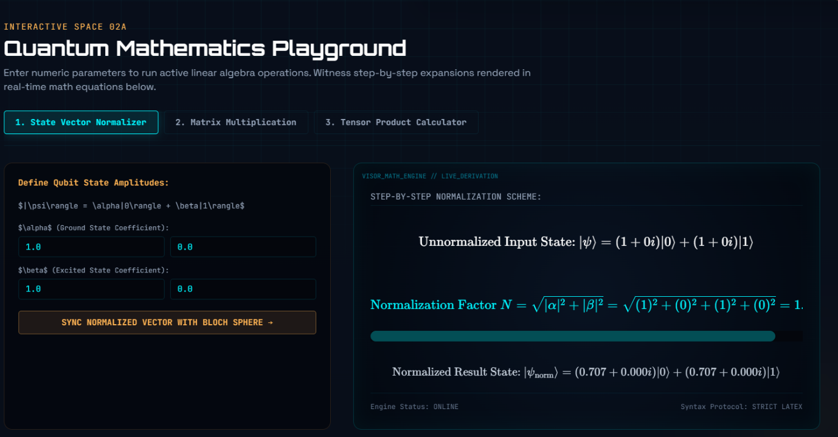
Figure 6: Mathematics Playground
9.5 CONCEPT LIBRARY:
The Concept Library provides concise explanations of the mathematical and theoretical concepts required for quantum computing.
Topics include:
- Complex Numbers
- Linear Algebra
- Tensor Products
- Bra-Ket Notation
Each topic is written using beginner-friendly language to reduce learning complexity.
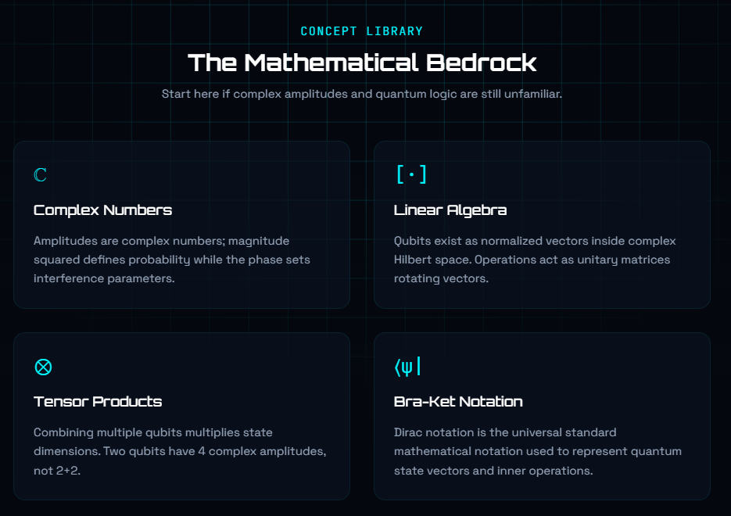
Figure 7: Concept Library
9.6 INTERACTIVE QUIZ:
The Quiz Module enables learners to assess their understanding after completing each learning section.
Features include:
- Multiple-choice questions
- Instant feedback
- Performance evaluation
- Score calculation
The quizzes reinforce conceptual understanding and encourage active learning.
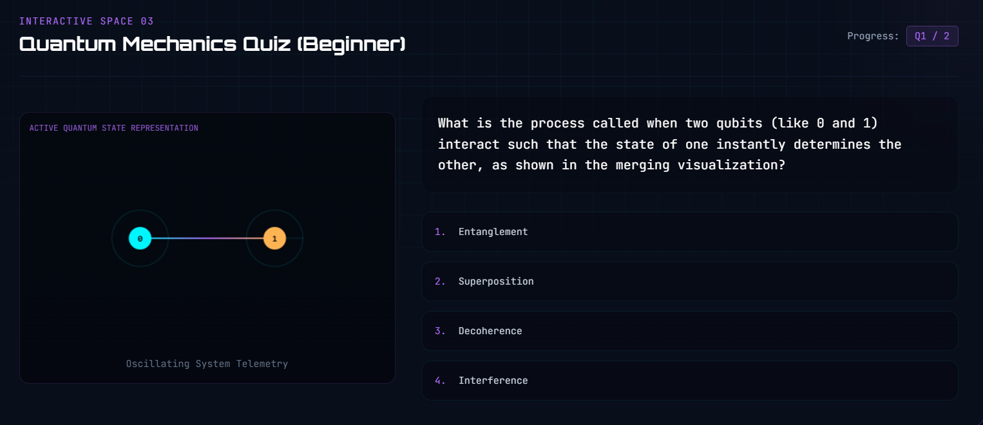
Figure 8: Quiz
9.7 AI LEARNING ASSISTANT:
The AI Learning Assistant provides AI-assisted explanations and guidance to help learners understand quantum concepts through natural language interaction. The assistant helps learners understand topics such as:
- Superposition
- Quantum Gates
- Entanglement
- Bloch Sphere
- Quantum Algorithms
This feature promotes self-paced learning and reduces dependence on external resources.
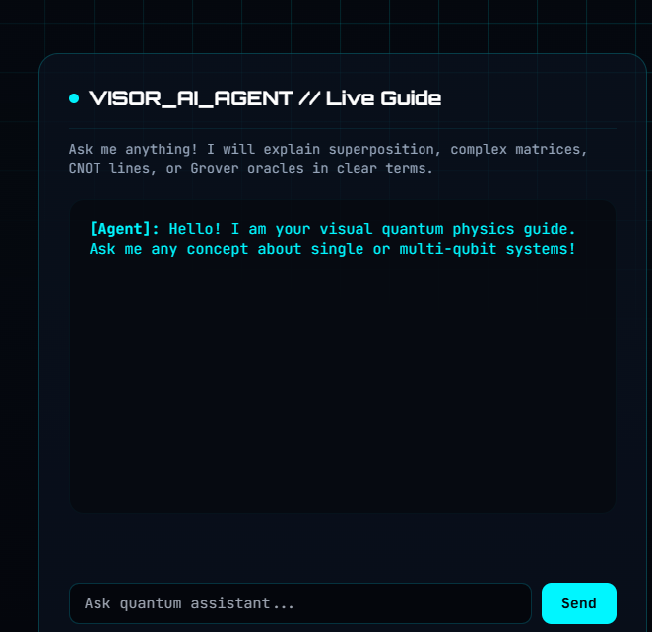
Figure 9: AI Learning Assistant
9.8 EXPERT NETWORK:
The Expert Network provides learners with access to quantum learning communities and collaboration opportunities. This feature encourages knowledge sharing and allows learners to connect with researchers and mentors interested in quantum computing.
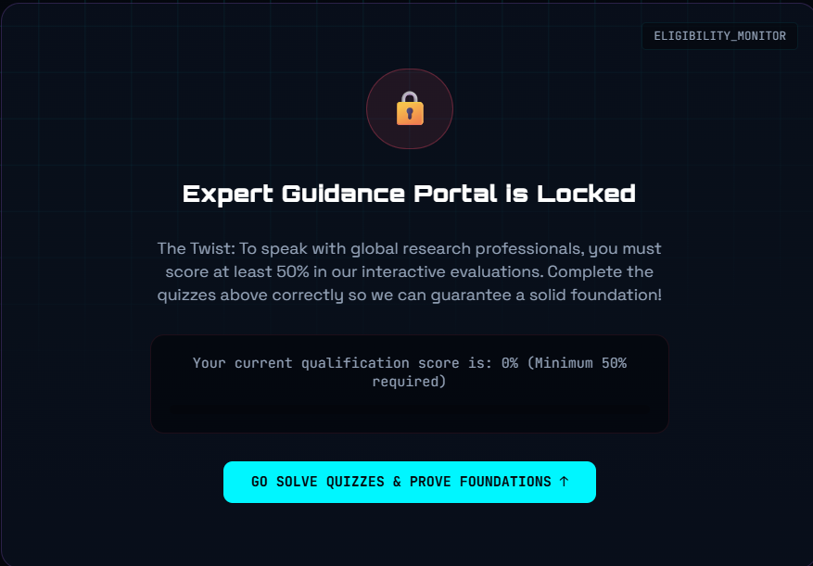
Figure 10: Expert Network
- PROJECT WORKFLOW:
The following workflow describes how users interact with the Visor Quantum platform.

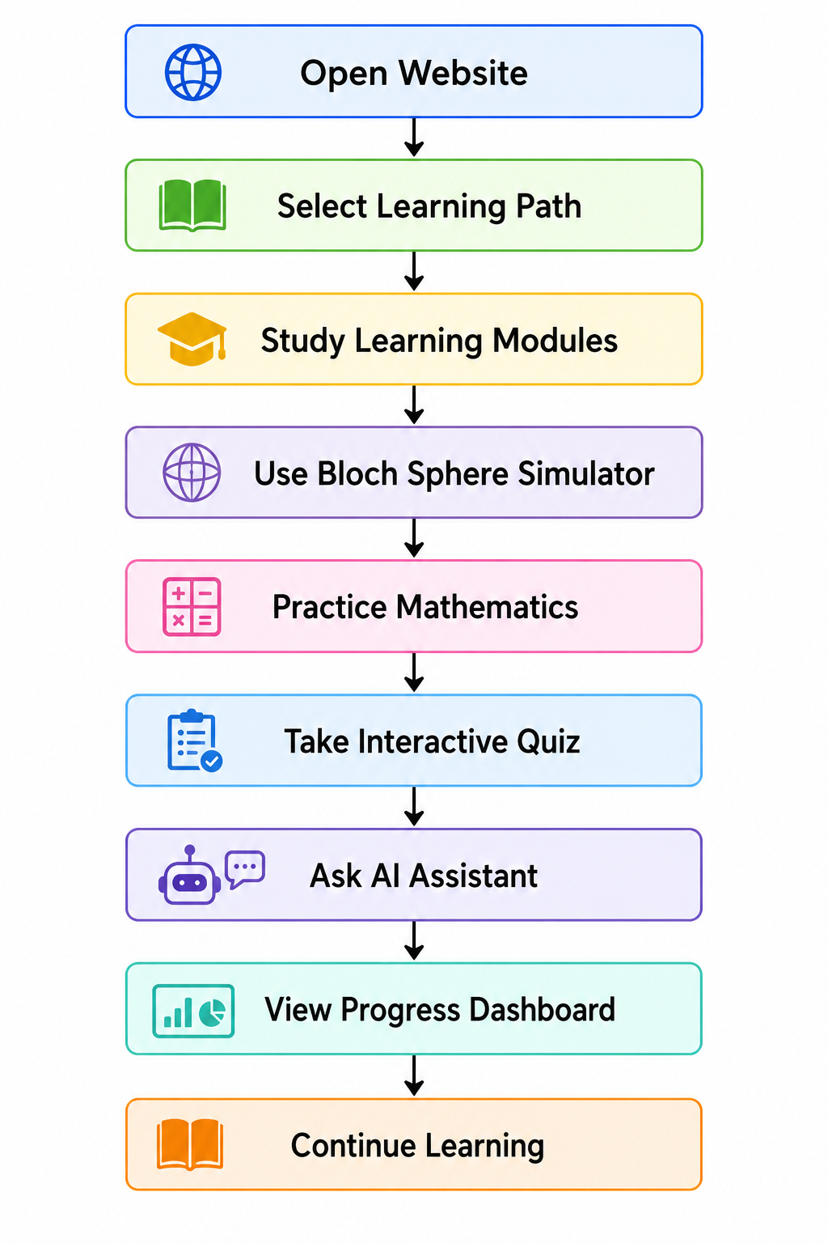
Figure 11: Workflow

- IMPLEMENTATION:
Visor Quantum was implemented as a browser-based educational platform with a focus on accessibility, responsiveness, and interactive learning. The application was developed using HTML5 for content structure, CSS3 for user interface design, and JavaScript (ES6) for implementing dynamic functionality.
The interactive Bloch Sphere visualization was developed using Three.js, enabling users to observe quantum state transformations in real time. Educational modules, quizzes, and the mathematics playground were integrated to reinforce conceptual understanding through active participation.
The project source code is maintained using GitHub, while Netlify is used to deploy the platform, making it accessible from any modern web browser without requiring software installation.

- RESULTS:
The Visor Quantum platform was successfully developed as a browser-based educational application that introduces beginners to quantum computing through interactive and engaging learning experiences. The platform integrates visualization, theoretical content, quizzes, and AI-assisted guidance into a single learning environment.
The implemented features include structured learning paths, a 3D Bloch Sphere Simulator, a Quantum Mathematics Playground, a Concept Library, an Interactive Quiz Module, an AI Learning Assistant, a Progress Dashboard, and an Expert Network section. These features work together to simplify abstract quantum concepts and promote self-paced learning.
The project demonstrates that interactive visualization and structured educational content can significantly improve conceptual understanding compared to traditional text-based learning resources. By combining theory with practical interaction, learners can better understand quantum states, quantum gates, and foundational mathematical concepts.
Overall, Visor Quantum meets its primary objective of making quantum computing education more accessible, interactive, and beginner friendly.

- CHALLENGES FACED:
Developing Visor Quantum involved several technical and educational challenges.
One of the primary challenges was simplifying complex quantum computing concepts without compromising technical accuracy. Topics such as superposition, entanglement, Bloch Sphere representation, and quantum gates are highly abstract, making it difficult to present them in a way that beginners could easily understand.
Another challenge was designing interactive visualizations that accurately represent quantum concepts while maintaining good performance within a web browser. Developing the Bloch Sphere Simulator required integrating Three.js with JavaScript to create smooth and responsive 3D interactions.
Creating educational content suitable for learners from different backgrounds was also challenging. The team focused on presenting mathematical concepts, theoretical explanations, and quizzes using simple language and a logical progression of topics.
Ensuring a responsive user interface across different screen sizes required careful implementation of HTML, CSS, and JavaScript. Additional effort was also invested in organizing the learning modules into structured beginner and intermediate learning paths to improve the overall learning experience.
- FUTURE ENHANCEMENTS:
Although Visor Quantum provides a comprehensive introduction to quantum computing, several enhancements can further improve the platform in future versions.
Future development plans include integrating IBM Quantum hardware to allow learners to execute quantum circuits on real quantum computers. Support for Qiskit-based programming exercises and live circuit execution can provide additional hands-on learning opportunities.
The platform can also be enhanced by introducing personalized learning recommendations based on learner performance. AI-driven adaptive learning paths can help users focus on topics where they need additional practice.
Additional improvements include implementing user authentication, cloud-based progress synchronization, multilingual support, instructor dashboards, advanced quantum algorithm simulations, mobile application support, achievement badges, certificates of completion, and collaborative discussion forums.
These enhancements will improve scalability, accessibility, and educational effectiveness while supporting a wider range of learners.
- CONCLUSION:
Visor Quantum was developed to address the challenges beginners face while learning quantum computing. By combining interactive visualization, structured educational content, AI-assisted guidance, mathematical tools, and self-assessment quizzes, the platform provides an engaging and effective learning experience.
The project successfully demonstrates how browser-based educational applications can simplify complex scientific concepts through visual learning and interactive exploration. Learners can progress from fundamental quantum concepts to more advanced topics using guided learning paths while continuously assessing their understanding through quizzes and performance dashboards.
Visor Quantum has the potential to serve as a valuable educational resource for students, educators, and self-learners interested in quantum computing. With future enhancements such as real quantum hardware integration and adaptive learning capabilities, the platform can continue evolving into a comprehensive quantum education ecosystem.
Overall, Visor Quantum demonstrates how interactive visualization and AI-assisted learning can simplify quantum computing education for beginners.
- REFERENCES:
[1] Peter Hu, Yangqiuting Li, Roger S. K. Mong, and Chandralekha Singh, "Student Understanding of the Bloch Sphere," 2024.
[2] Stanislav Filatov and Marcis Auzinsh, "Towards Two Bloch Sphere Representation of Pure Two-Qubit States and Unitaries," 2024.
[3] Alice Barthe, Michele Grossi, Jordi Tura, and Vedran Dunjko, "Bloch Sphere Binary Trees: A Method for the Visualization of Sets of Multi-Qubit Systems Pure States," 2023.
[4] Sarah Kaiser et al., "A Review of Quantum Computing Education and Training," 2021.
[5] Shaeema Zaman Ahmed et al., "Quantum Composer: A Programmable Quantum Visualization and Simulation Tool for Education and Research," 2020.
[6] Stefan Küchmann et al., "The Impact of an Interactive Visualization and Simulation Tool on Learning Quantum Physics," 2023.
[7] Yuhao Dan et al., "EduChat: A Large-Scale Language Model-based Chatbot System for Intelligent Education," 2023.
[8] Lasha Abadze, Maya Grigolia, and Lela Machaidze, "Role of AI Chatbots in Education: Systematic Literature Review," 2023.
[9] George Siemens and Phil Long, "Learning Analytics: Drivers, Developments and Challenges," 2011.
[10] Beverly Park Woolf, "The State of Intelligent Tutoring Systems," 2009.

GitHub Repositorymailto:https://github.com/praneethalakshmi08-max/Visor_quantum.git
Live Website (Netlify): mailto:https://earnest-pudding-acaa71.netlify.app/

