44-563 Developing Web Applications and Services

Project 02

In this project, you will use HTML and JavaScript to write a small application that computes information concerning regular polygons. For the relevant formulas, see

<http://www.mathsisfun.com/geometry/regular-polygons.html>

Here is the desired user interface:

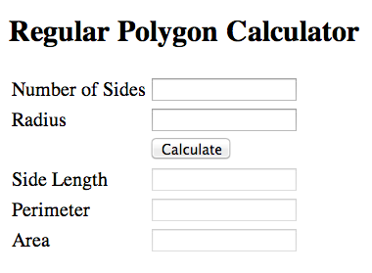

When the user enters the number of sides and the radius of a regular polygon and clicks on the Calculate button, the side length, perimeter, and area of the regular polygon must be displayed. The output values should have two digits after the decimal point.

Here is an example:

