44-563 Developing Web Applications and Services

Project 03

In this project, you will implement an order page for an on-campus ice cream store. The application allows the user to input choices, and then displays the price and the estimated delivery time. You will need an HTML file for the user interface, a JavaScript file for the event-handler, and a CSS file for any style you want to implement.

Here is the required user interface:

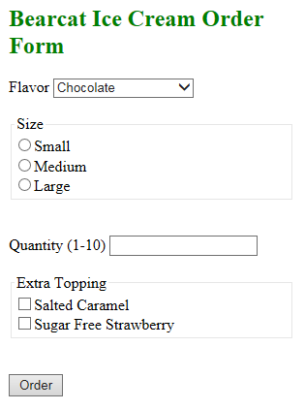

The available types of flavors are Chocolate, Mint Chocolate Chip, Strawberry, and Vanilla.

After the customer makes the selections and clicks on the Order button, a message is displayed at the bottom of the page as shown below.

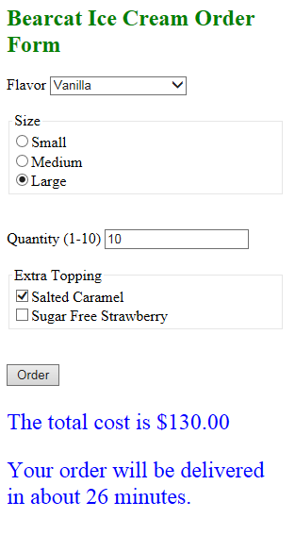

Note that the price contains a dollar sign and exactly two digits after the decimal point. The delivery time should be a random integer in the range 25-45. (Hint: Use Math.random() and Math.round().)

Price List

Small 6.00, Medium 9.00, Large 11.00

For the flavor, add 1.00 for Chocolate, 1.25 for Mint Chocolate Chip, 1.50 for Strawberry, and 1.50 for Vanilla.

Salted Caramel topping costs an additional 0.50 and Sugar Free Strawberry costs 0.70.

Example

For the ice cream order shown above, the cost is

10 \* (11.00 + 1.25+ 0.75) = 10 \* 13.00 = 130.00