44-563 Developing Web Applications and Services

Project 10

In this project, you will use JavaServer Faces to implement an application that performs calculations for regular polygons.

1. Create a new Web Application project in Netbeans. Do not forget to include the JavaServer Faces framework.

2. Create the JavaServer Faces page shown below as the start page for the application. As shown, the user enters the Number of Sides and Radius of the regular polygon.

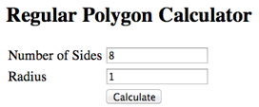

3. Create a managed bean class that has attributes for the number of sides and radius. It must also have methods to compute the side length, perimeter, and area.

4. Create a JSF page that appears after the user clicks the Calculate button. This page displays information about the rectangle as shown below:

