44-563 Developing Web Applications and Services

Project 11

In this project, you will use JavaServer Faces to implement a new user registration page for a social network called Nerd Neighborhood. You will need to create three JavaServer Faces pages, one for the start page and two for the response pages. You will also need to create a managed bean class, and a css file for styling the error message. Here is the start page:

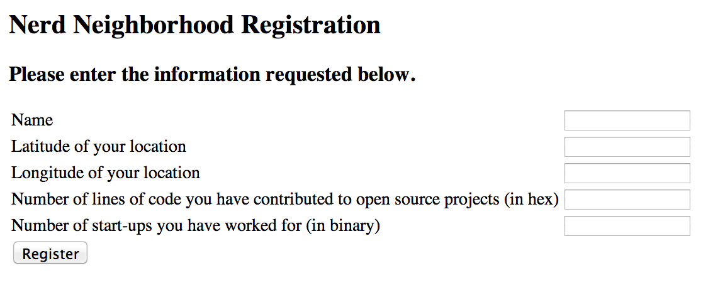

**Validation**

1. All of the fields are required.
2. The latitude must be in the range [-90.0, 90.0].
3. The longitude must be in the range [-180.0, 180.0].
4. The number of lines of code must be a string that represents a valid hexadecimal number.
5. The number of start-ups must be a string that represents a valid binary number.
6. Sample error messages are shown below.

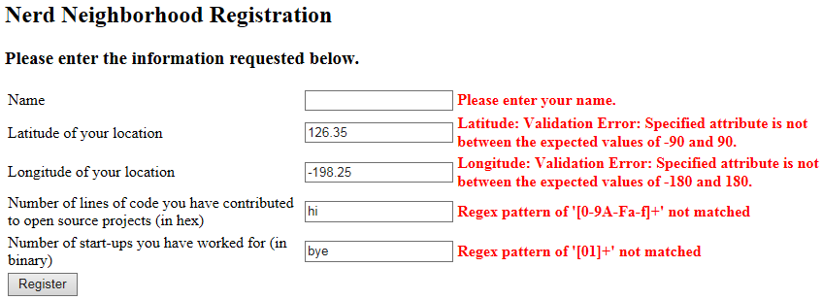

**The Managed Bean**

1. You will need an attribute for each of the input boxes on the registration page.
2. The attributes corresponding to the last two input boxes will be of type String.
3. You will need to implement a method response() that is used for dynamic page navigation. It returns a string that is the name of the response page. This method will do the following:
   1. Convert the string representing lines of code to a number using the method Integer.valueOf() with a radix of 16.
   2. Convert the string representing the number of start-ups to a number using the method Integer.valueOf() with a radix of 2.
   3. Compute the nerdScore = (linesOfCode / 1000) + numberOfStartups.
   4. If nerdScore ≥ 5, return the name of the accept response page. Otherwise, return the name of the reject response page.

**Accept Response Page**

If the user's nerdScore is sufficiently large, this is the response page:

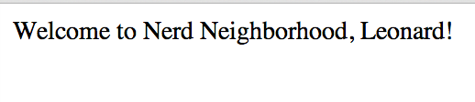

**Reject Response Page**

If the user's nerdScore is too low, the response page looks like this:

