44-563 Developing Web Applications and Services

Project 12

Write a JavaServer Faces web application that accesses the CUSTOMER table in the sample database in Netbeans. The start page allows the user to select a two-letter state code from a drop-down list. The states you must include are CA, FL, GA, MI, NY, and TX. **No other state can be included**. Here is the start page:

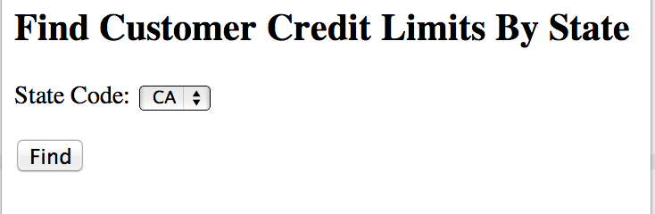

The result page displays the name of the customer from the selected state that has the highest credit limit. It also displays a list of all cities in the state that have customers.

Here is the result page if the user selects CA as the state:

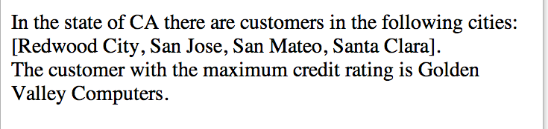

Here is the result page if the user selects MI as the state:

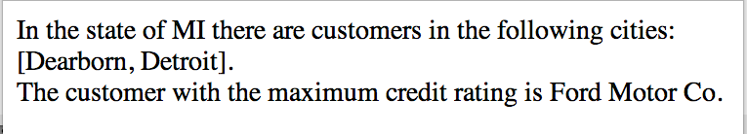

**You MUST obtain the information by doing queries on the database table. NO CREDIT if you just hardcode the results for each state.**