44-563 Developing Web Applications and Services

Project 09

In this project, you will use jQuery to send an AJAX request to a servlet. The servlet returns information represented in JSON notation.

This application enables a user to obtain information about planets in the solar system. Here is the user interface:

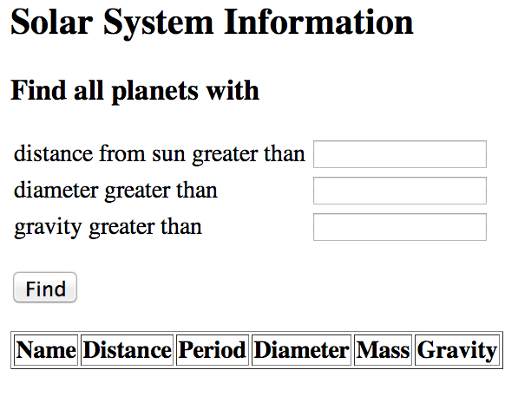

The user enters the desired minimum values in the input boxes and then clicks the Find button. The application uses jQuery to send an AJAX request to a servlet to obtain a list of planets that satisfies the criteria. The list of planets is returned in JSON format. The callback function then displays the planets in the table. Here are two examples:

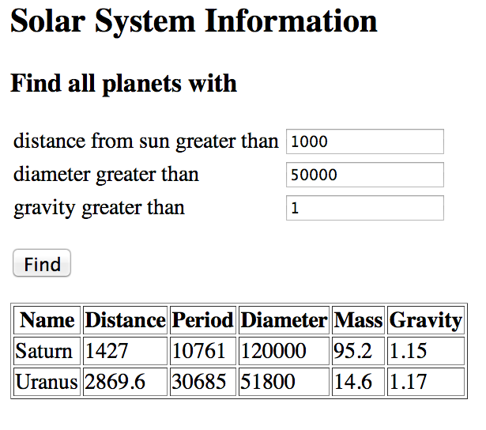

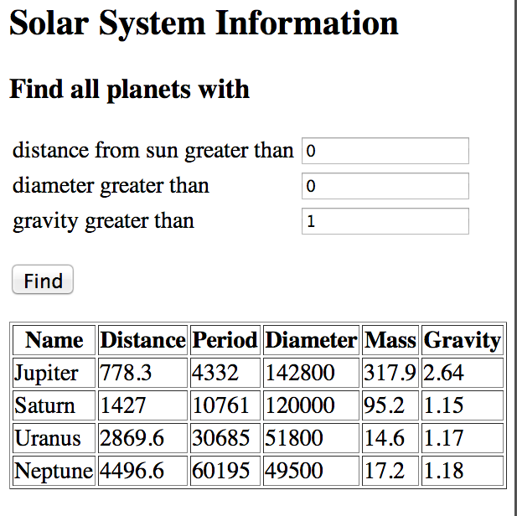

Details:

1. The planet information is provided for you in the classes Planet.java and SolarSystem.java.
2. The user interface must be designed as shown in the examples above.
3. You must use jQuery to send the AJAX request to the servlet, and you must use jQuery to implement the callback function that displays the planet information in the table.
4. The servlet must use JSON to return the list of planets that meet the criteria specified by the user.