**CSA0908 - JAVA PROGRAMMING**

**DAY-4**

1. COUNT ALL PRIME AND COMPOSITE NUMBERS

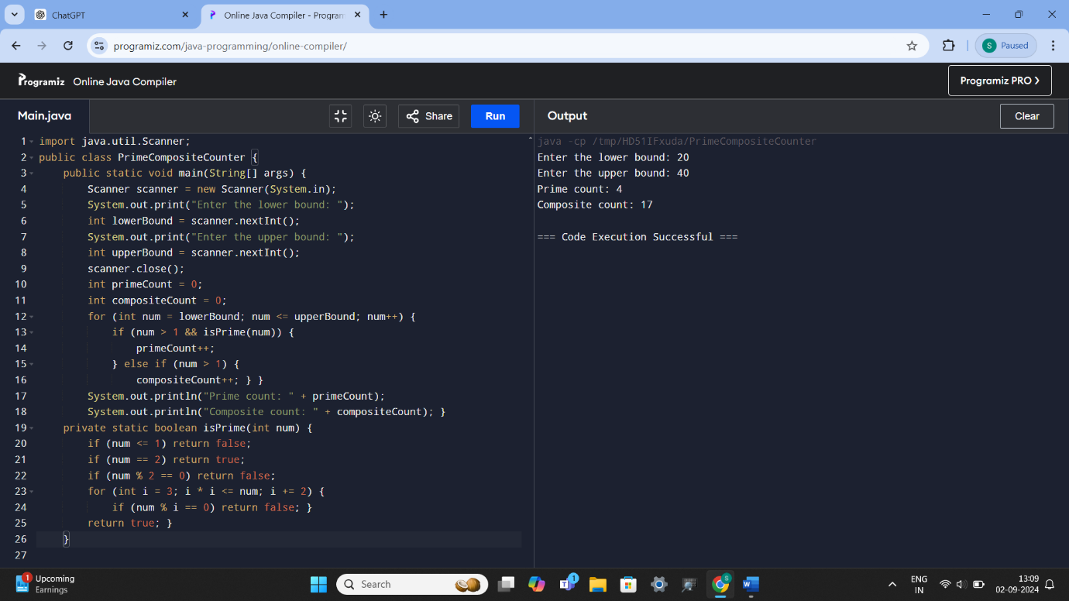

1. Mth MAX AND Nth MIN NUMBERS IN ARRAY, FIND SUM AND DIFFERENCE

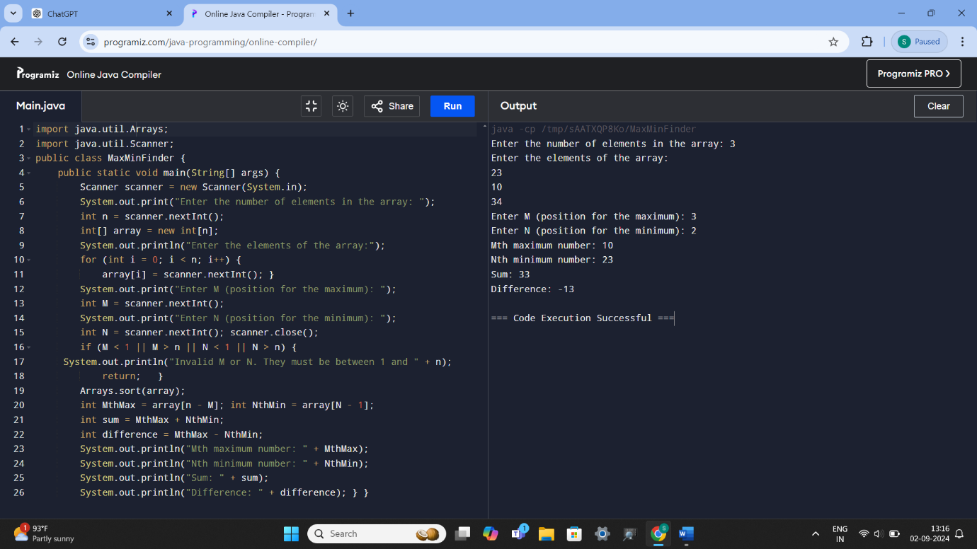

1. TOTAL AMOUNT AVAILABLE IN THE ATM MACHINE

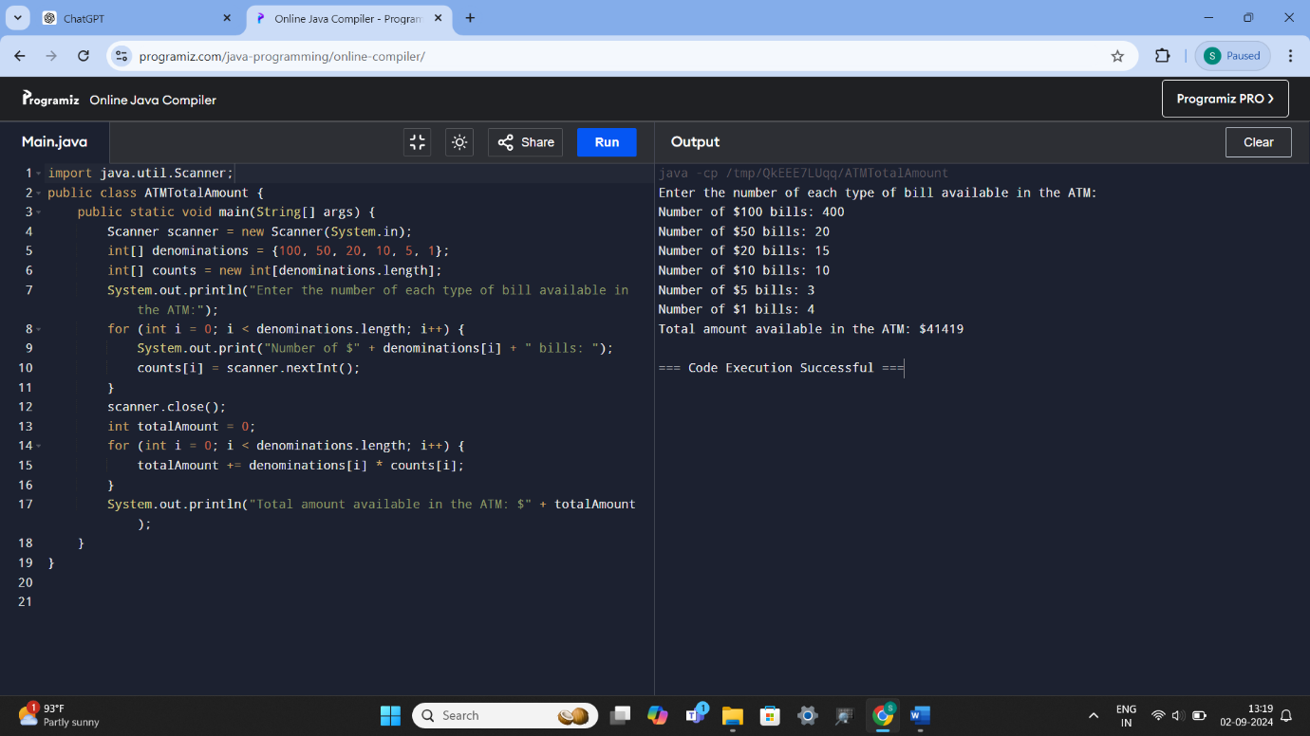

1. CHECK PALINDROME OR NOT

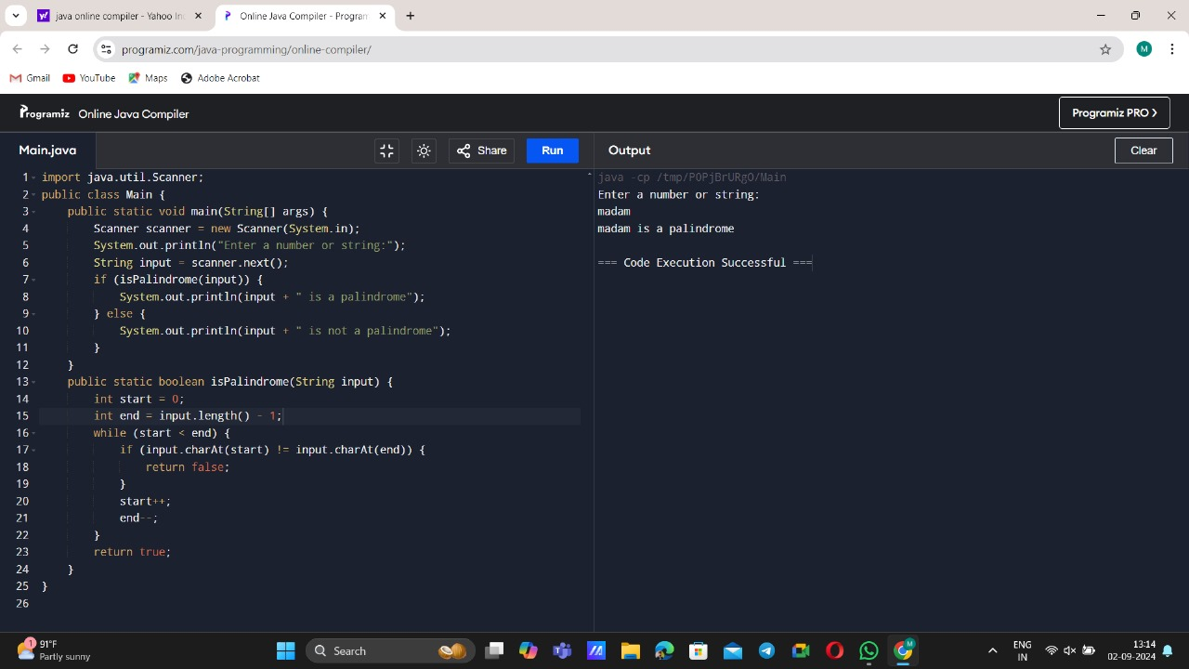

1. DECIMAL NUMBER EQUIVALENT TO BINARY AND OCTAL NUMBERS

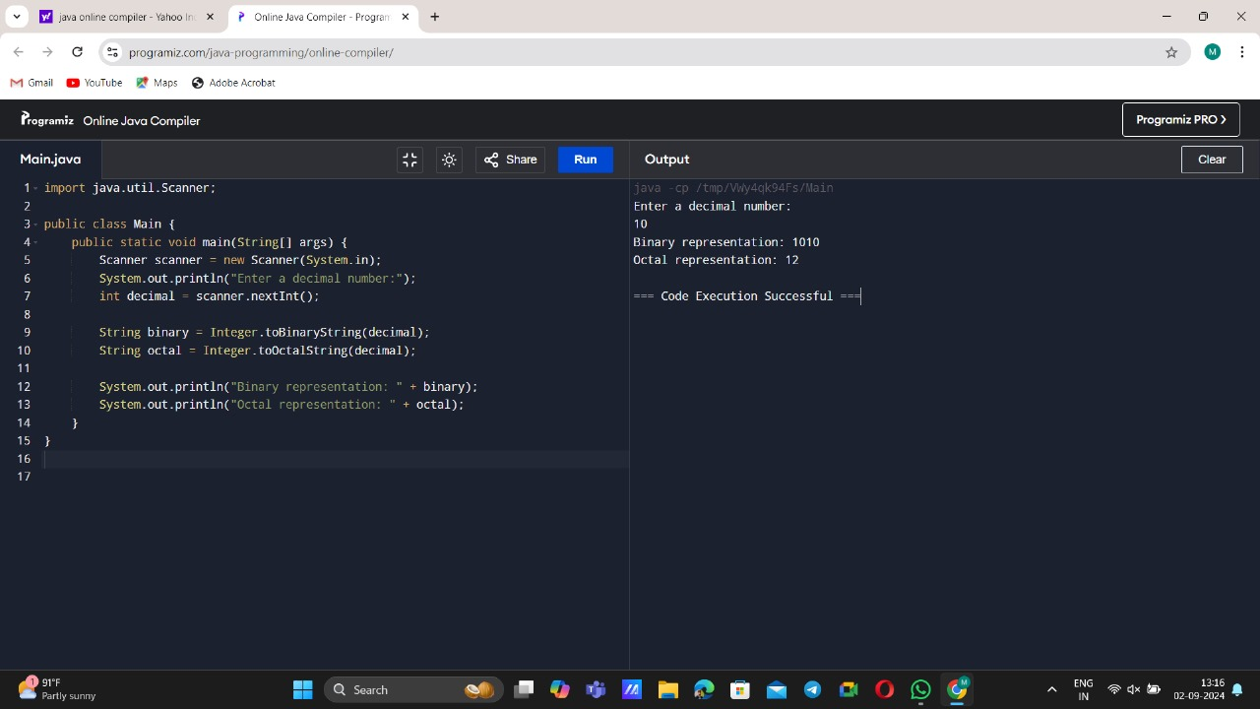

1. EMPLOYEE PROGRAM (PRINT BONUS AND SALARY)

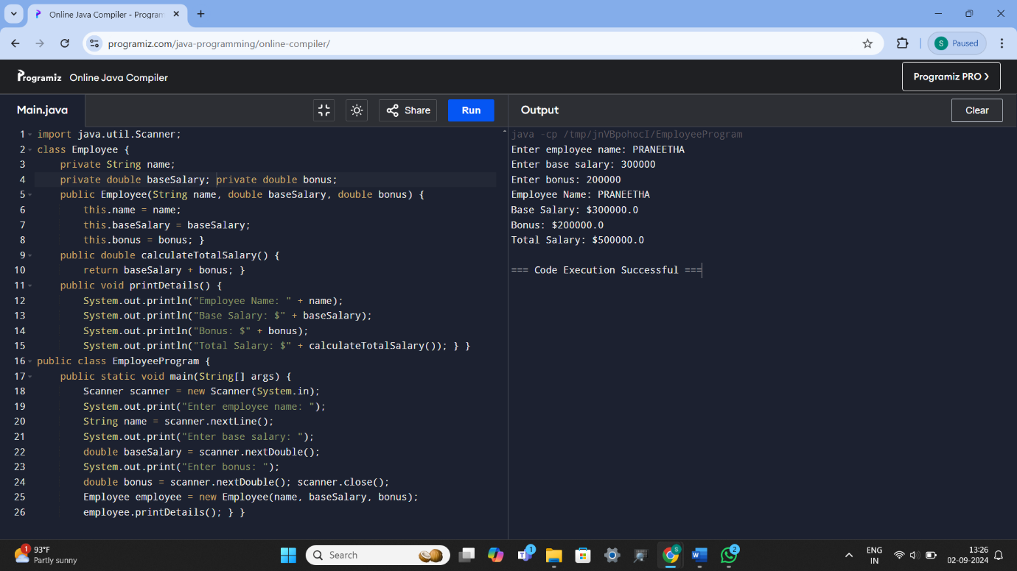

7) FIRST N PERFECT NUMBERS

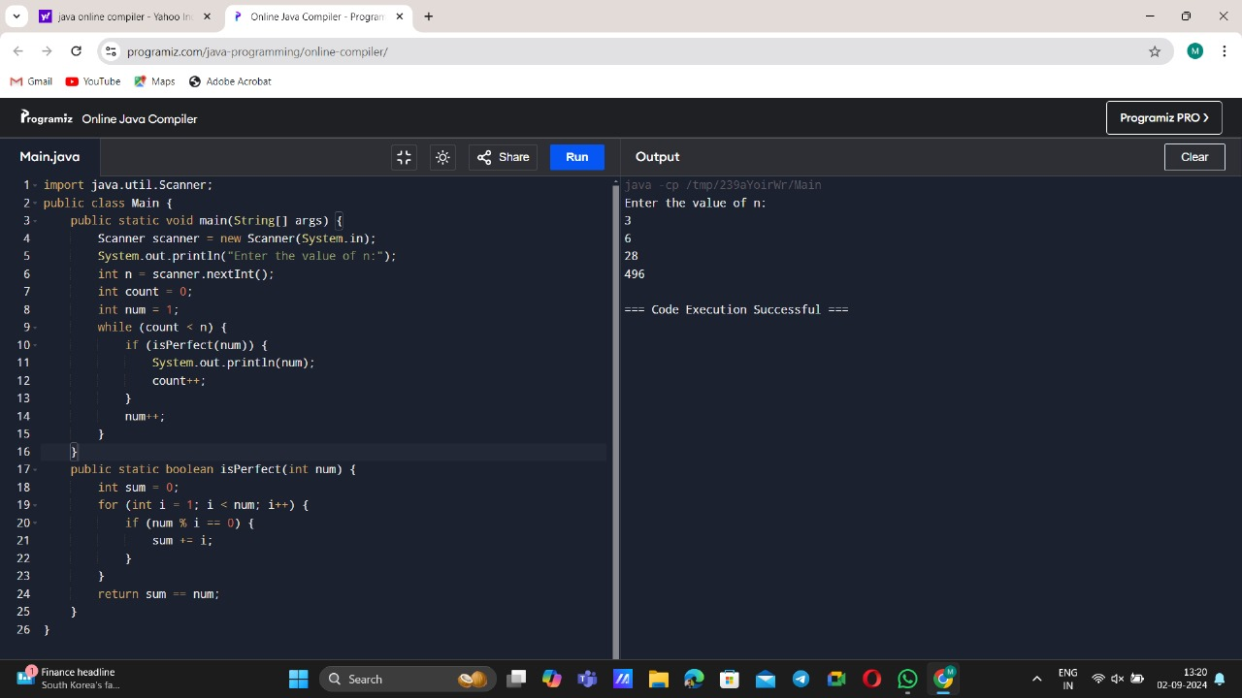

1. STUDENT PROGRAM (TOTAL, AGGREGATE AND GRADE)

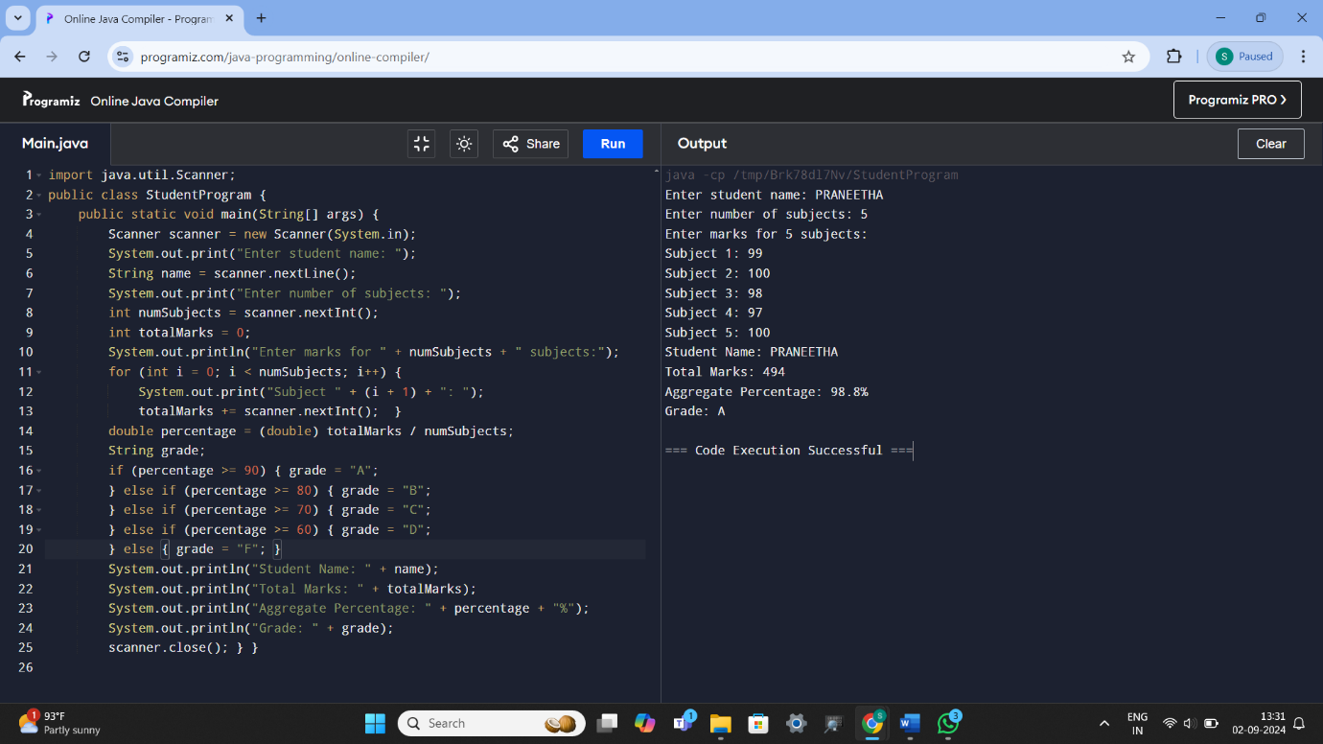

1. TO CALCULATE TAX

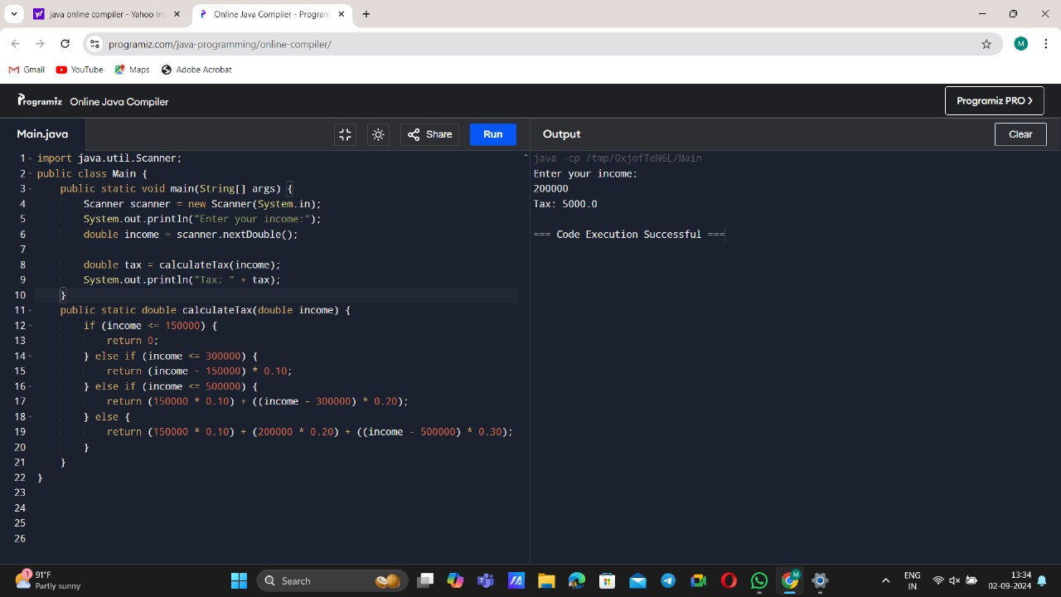

10)MULTIPLICATION TABLE OF NUMBER M UP TO N

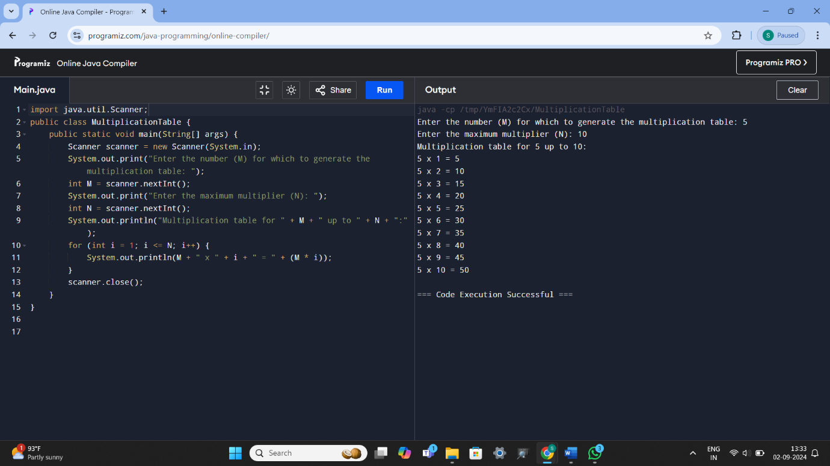

11)FIND THE AVERAGE OF +VE AND -VE NUMBERS, TO READ THE NUMBERS UNTIL -1 IS ENCOUNTERED

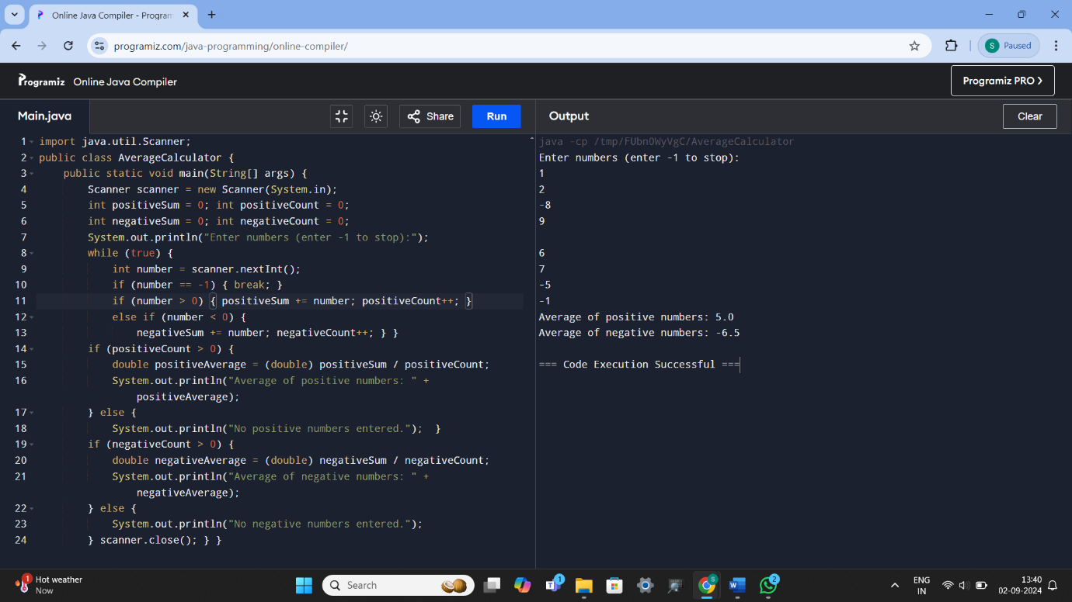

12) COUNT THE NO. OF UPPERCASES, LOWERCASES, NUMBERS AND READ A CHARACTER UNTIL A* IS ENCOUNTERED

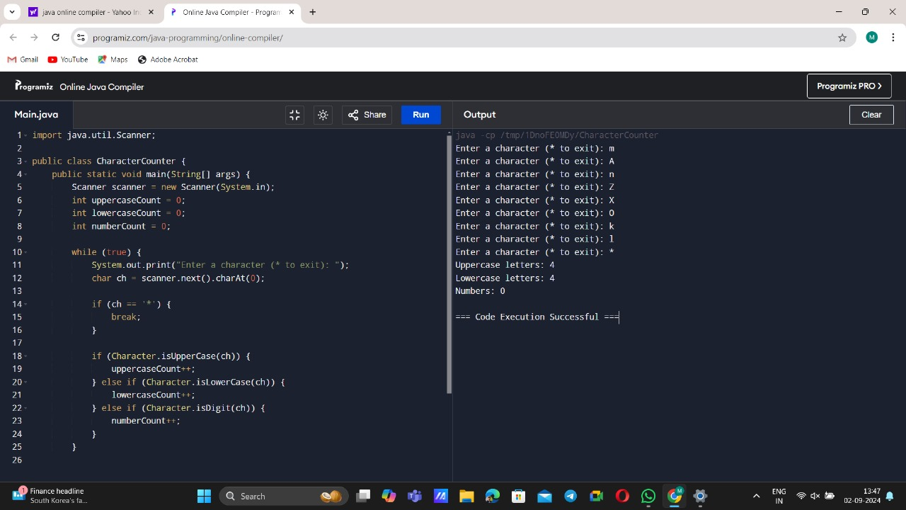

**DAY-5**

13) FACTORIAL OF A NUMBER USING RECURSION

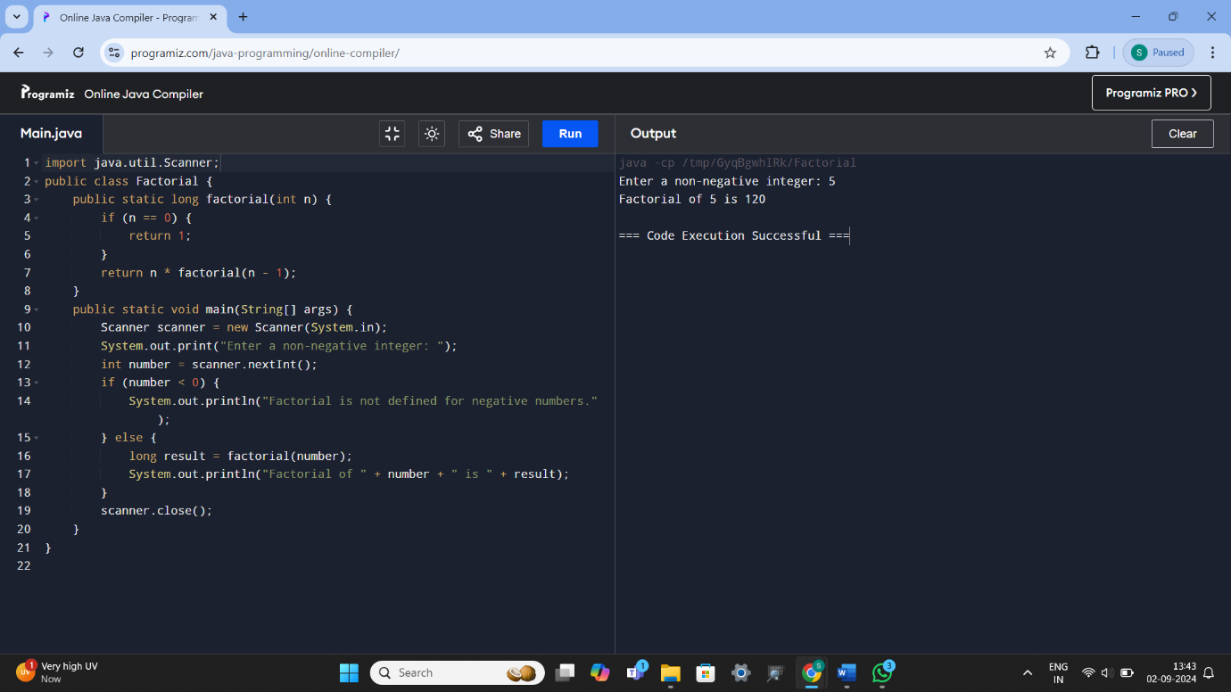

14) Nth LARGEST NUMBER IN THE ARRAY

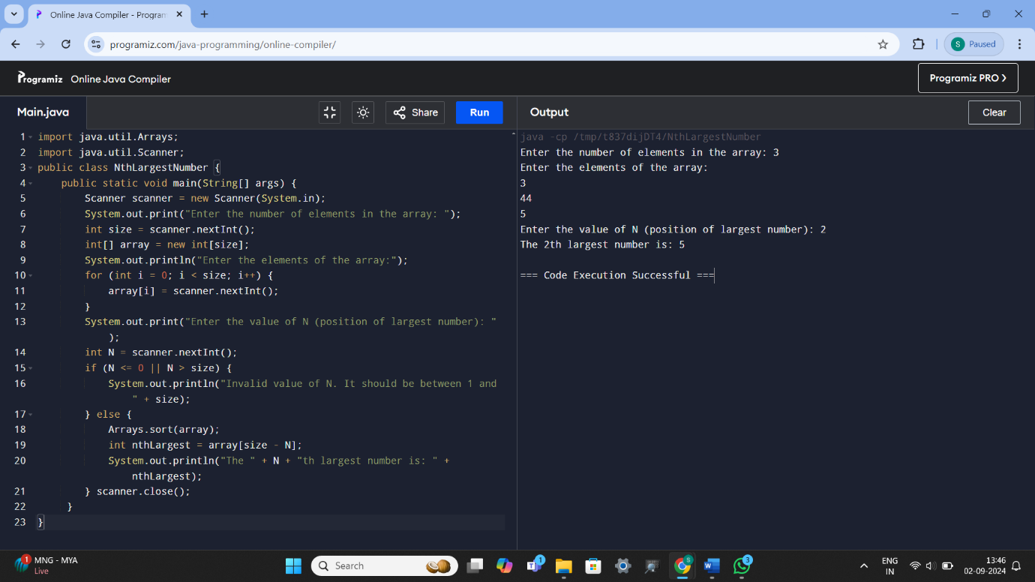

15) BINARY TO DECIMAL, OCTAL NUMBERS

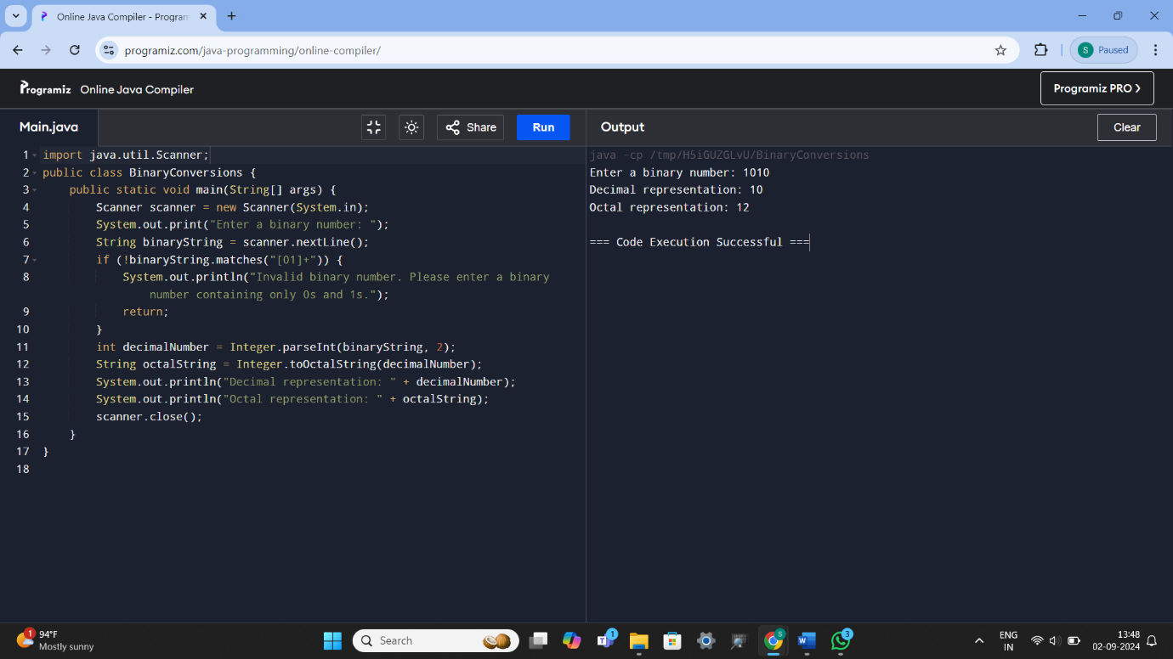

16) TO FIND NUMBER OF SPECIAL CHARACTERS

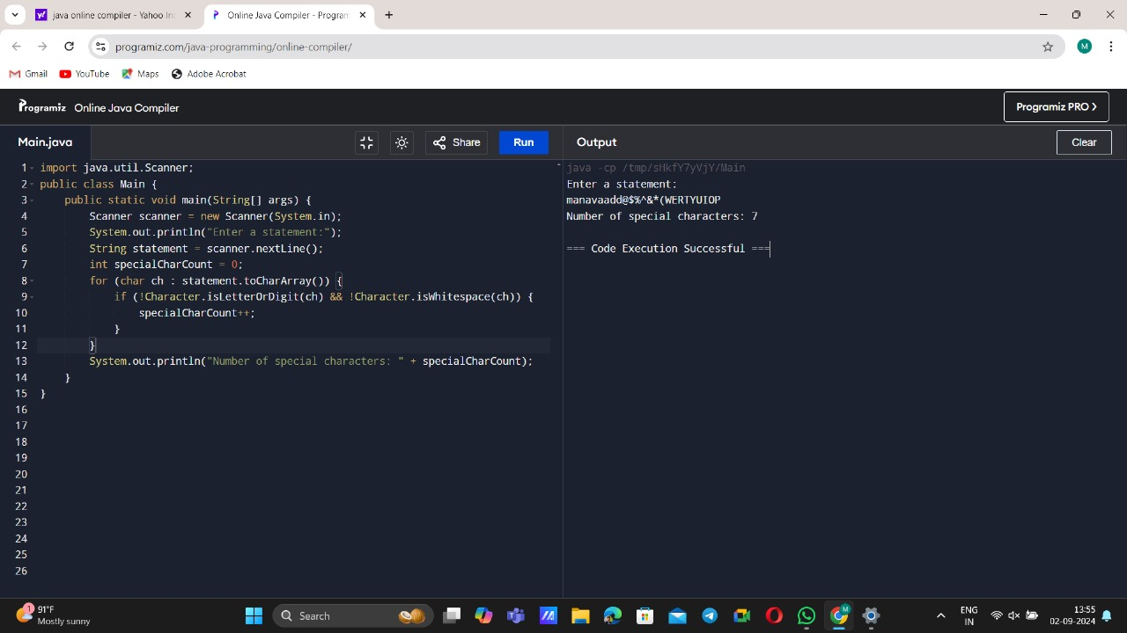

17) TO REMOVE DUPLICATES FROM THE ARRAY

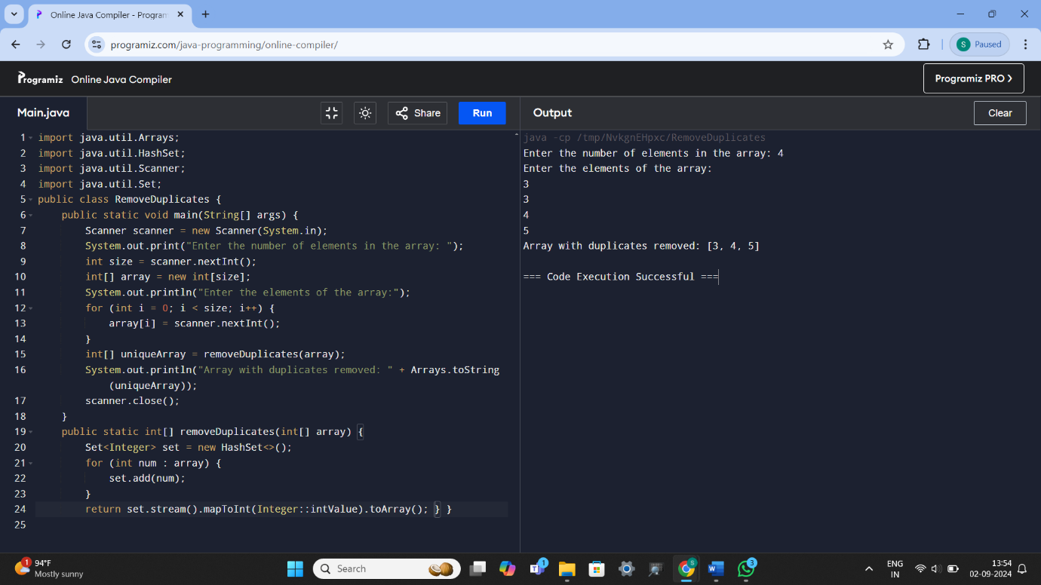

18) BANKS AND THEIR RATE OF INTEREST

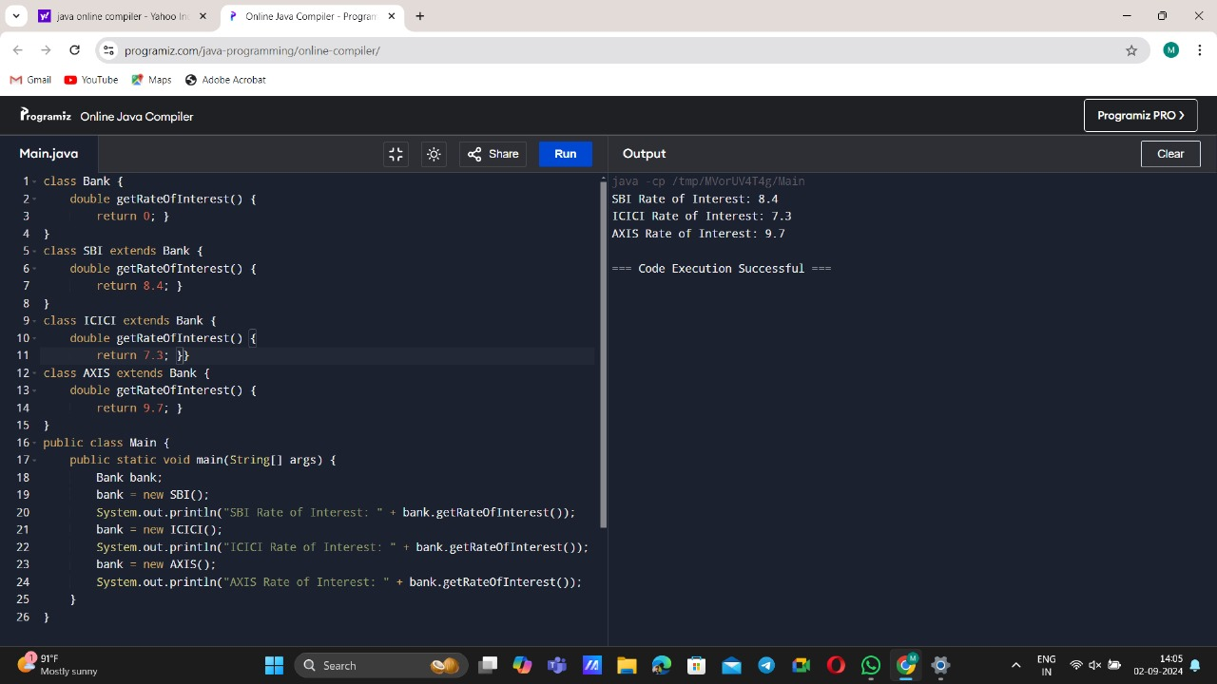

19) SUB CLASS HIDE MEMBERS BY THE SAME NAME IN THE SUPER CLASS

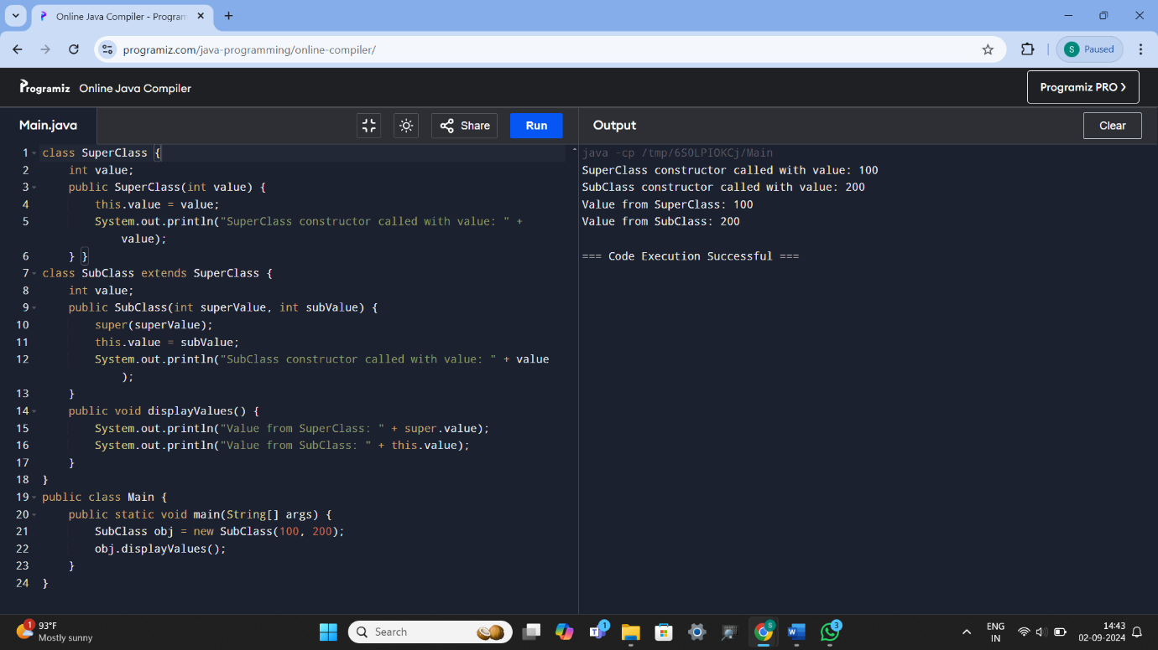

20) MULTIPLICATION TABLE FOR 5 AND 10 USING VARIOUS LIFE CYCLES

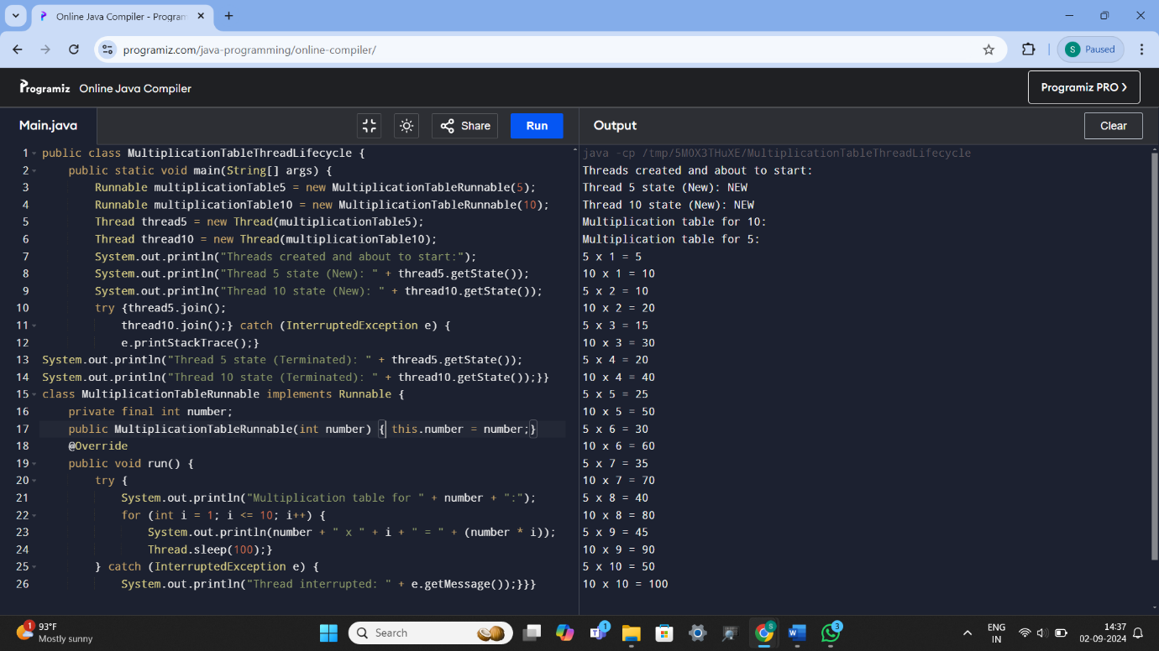

21) IMPLEMENTING R UNNABLE INTERFACE IN JAVA TO GENERATE FIBONACCI SERIES

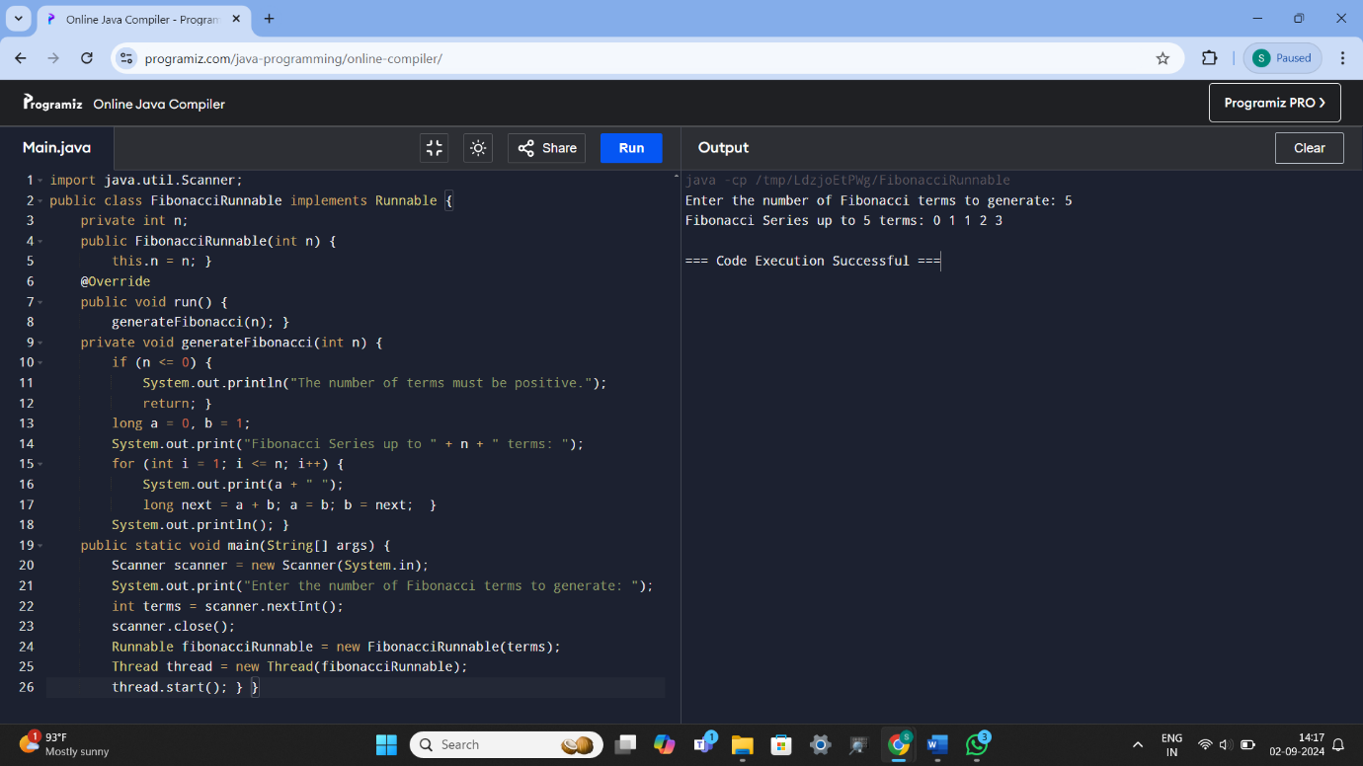

22)SUM OF N NUMBERS USING ARRAY AND THROW ARRAY INDEX OUT OF BOUNDS EXCEPTION WHEN THE LOOP VARIABLE BEYOND THE SIZE N

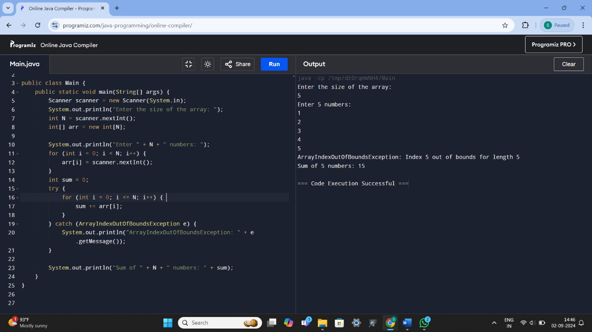

23) IMPLEMENTING R UNNABLE INTERFACE IN JAVA TO GENERATE GIVEN NUMBER IS PRIME OR NOT

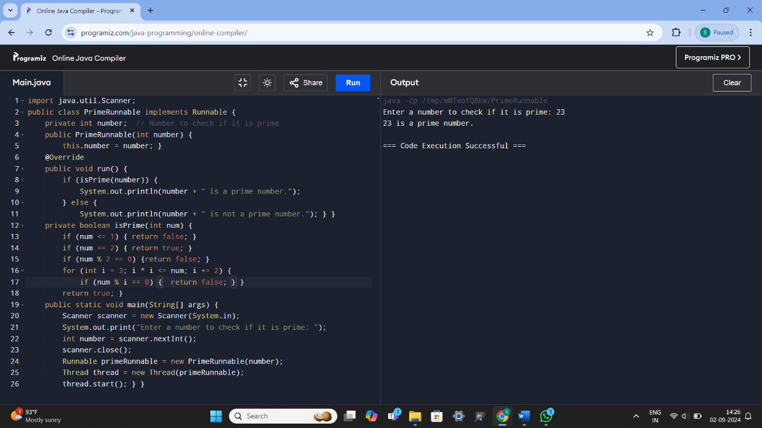

24) RETURN THE LENGTH OF THE LAST WORD IN THE STRING

