1)import java.util.Scanner;

class Book {
private int bookId;
private String title;
private String author;
private double price;
private boolean issued;

// Constructor
Book(int id, String t, String a, double p) {
bookId = id;
title = t;
author = a;
price = p;
issued = false;
}

// Getters
public int getBookId() {
return bookId;
}

public String getTitle() {
return title;
}

// Setters
public void setPrice(double p) {
price = p;
}

// Issue Book
public void issueBook() {
if (!issued) {
issued = true;
System.out.println("Book Issued Successfully.");
} else {
System.out.println("Book Already Issued.");
}
}

// Return Book
public void returnBook() {
if (issued) {
issued = false;
System.out.println("Book Returned Successfully.");
} else {
System.out.println("Book Was Not Issued.");
}
}

// Display
public void display() {
System.out.println(bookId + " " + title + " " + author + " " + price +
" " + (issued ? "Issued" : "Available"));
}
}

public class Main {
public static void main(String[] args) {

Scanner sc = new Scanner(System.in);

System.out.print("Enter number of books: ");
int n = sc.nextInt();

Book books[] = new Book[n];

for (int i = 0; i < n; i++) {
System.out.println("\nEnter Book " + (i + 1) + " Details");
System.out.print("Book ID: ");
int id = sc.nextInt();
sc.nextLine();

System.out.print("Title: ");
String title = sc.nextLine();

System.out.print("Author: ");
String author = sc.nextLine();

System.out.print("Price: ");
double price = sc.nextDouble();

books[i] = new Book(id, title, author, price);
}

while (true) {
System.out.println("\n--- MENU ---");
System.out.println("1. Display Books");
System.out.println("2. Issue Book");
System.out.println("3. Return Book");
System.out.println("4. Search Book");
System.out.println("5. Exit");
System.out.print("Enter Choice: ");

int ch = sc.nextInt();

switch (ch) {
case 1:
for (Book b : books)
b.display();
break;

case 2:
System.out.print("Enter Book ID: ");
int id = sc.nextInt();
for (Book b : books)
if (b.getBookId() == id)
b.issueBook();
break;

case 3:
System.out.print("Enter Book ID: ");
id = sc.nextInt();
for (Book b : books)
if (b.getBookId() == id)
b.returnBook();
break;

case 4:
System.out.print("Enter Book Title: ");
sc.nextLine();
String t = sc.nextLine();
boolean found = false;

for (Book b : books) {
if (b.getTitle().equalsIgnoreCase(t)) {
b.display();
found = true;
}
}

if (!found)
System.out.println("Book Not Found.");
break;

case 5:
System.exit(0);

default:
System.out.println("Invalid Choice.");
}
}
}
}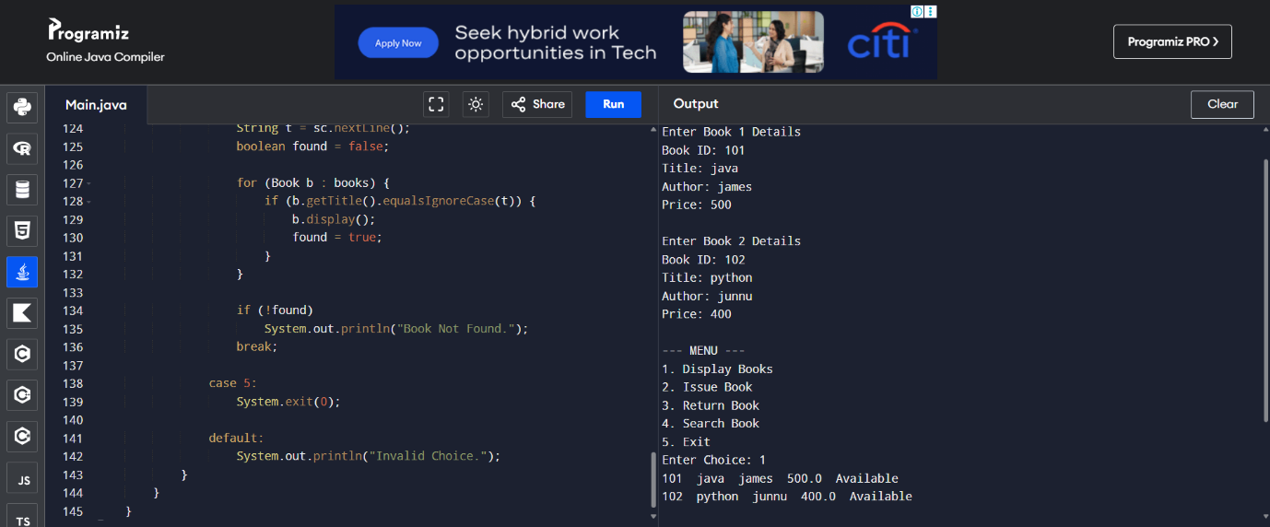
2)import java.util.Scanner;

class Employee {
int id;
String name;

Employee(int id, String name) {
this.id = id;
this.name = name;
}

void calculateSalary() {
System.out.println("Salary Calculation");
}

void display() {
System.out.println("Employee ID : " + id);
System.out.println("Employee Name : " + name);
}
}

class PermanentEmployee extends Employee {
double basic, hra, da;

PermanentEmployee(int id, String name, double basic, double hra, double da) {
super(id, name);
this.basic = basic;
this.hra = hra;
this.da = da;
}

void calculateSalary() {
double salary = basic + hra + da;
display();
System.out.println("Permanent Employee Salary = " + salary);
}
}

class ContractEmployee extends Employee {
int hours;
double rate;

ContractEmployee(int id, String name, int hours, double rate) {
super(id, name);
this.hours = hours;
this.rate = rate;
}

void calculateSalary() {
double salary = hours * rate;
display();
System.out.println("Contract Employee Salary = " + salary);
}
}

public class Main {
public static void main(String[] args) {

Scanner sc = new Scanner(System.in);
Employee e;

System.out.println("1. Permanent Employee");
System.out.println("2. Contract Employee");
System.out.print("Enter Choice: ");
int ch = sc.nextInt();

System.out.print("Enter Employee ID: ");
int id = sc.nextInt();
sc.nextLine();

System.out.print("Enter Employee Name: ");
String name = sc.nextLine();

if (ch == 1) {
System.out.print("Enter Basic Salary: ");
double basic = sc.nextDouble();

System.out.print("Enter HRA: ");
double hra = sc.nextDouble();

System.out.print("Enter DA: ");
double da = sc.nextDouble();

e = new PermanentEmployee(id, name, basic, hra, da);
} else {
System.out.print("Enter Working Hours: ");
int hours = sc.nextInt();

System.out.print("Enter Rate Per Hour: ");
double rate = sc.nextDouble();

e = new ContractEmployee(id, name, hours, rate);
}

// Runtime Polymorphism
e.calculateSalary();
}
}
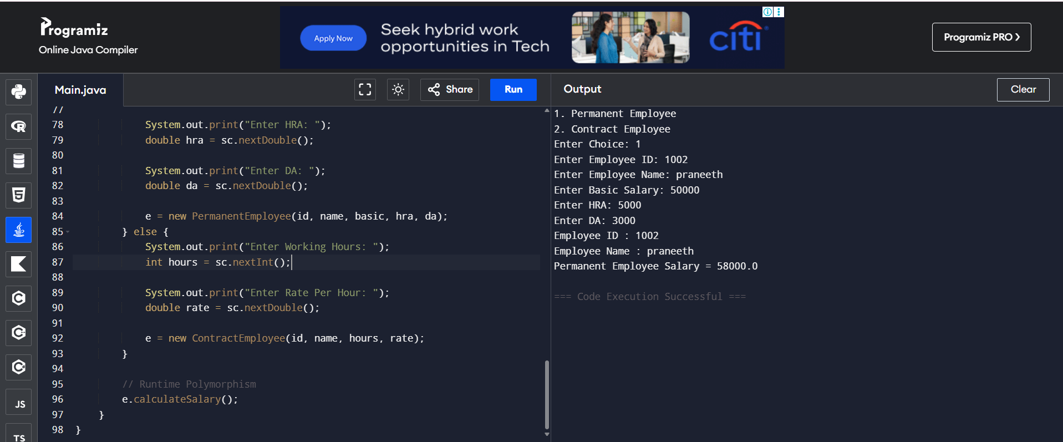
3)import java.util.Scanner;

class Vehicle {
String name;

Vehicle(String name) {
this.name = name;
}

void calculateRent(int days) {
System.out.println("Rent Calculation");
}
}

class Car extends Vehicle {
Car(String name) {
super(name);
}

void calculateRent(int days) {
System.out.println("Vehicle : " + name);
System.out.println("Rent = " + (days * 1000));
}
}

class Bike extends Vehicle {
Bike(String name) {
super(name);
}

void calculateRent(int days) {
System.out.println("Vehicle : " + name);
System.out.println("Rent = " + (days * 500));
}
}

class Bus extends Vehicle {
Bus(String name) {
super(name);
}

void calculateRent(int days) {
System.out.println("Vehicle : " + name);
System.out.println("Rent = " + (days * 2000));
}
}

public class Main {
public static void main(String[] args) {

Scanner sc = new Scanner(System.in);

Vehicle[] v = new Vehicle[3];

System.out.print("Enter Car Name: ");
sc.nextLine();
v[0] = new Car(sc.nextLine());

System.out.print("Enter Bike Name: ");
v[1] = new Bike(sc.nextLine());

System.out.print("Enter Bus Name: ");
v[2] = new Bus(sc.nextLine());

System.out.print("Enter Rental Days: ");
int days = sc.nextInt();

System.out.println("\nRental Bills");
for (Vehicle vehicle : v) {
vehicle.calculateRent(days); // Runtime Polymorphism
System.out.println();
}
}
}
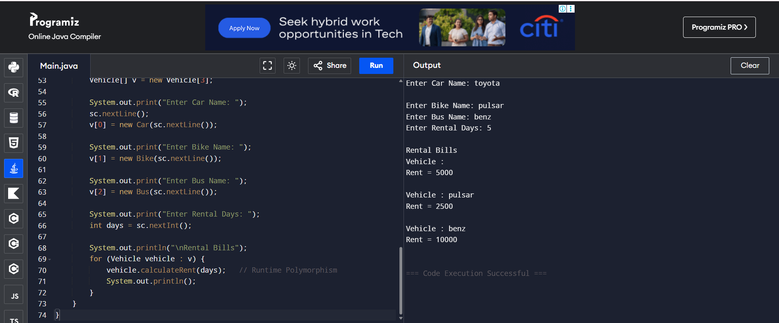
4)import java.util.Scanner;

class BankAccount {
private int accountNumber;
private String holderName;
private double balance;

// Constructor
BankAccount(int accNo, String name, double bal) {
accountNumber = accNo;
holderName = name;
balance = bal;
}

// Deposit
void deposit(double amount) {
if (amount > 0) {
balance += amount;
System.out.println("Amount Deposited Successfully.");
} else {
System.out.println("Invalid Deposit Amount.");
}
}

// Withdraw
void withdraw(double amount) {
if (amount <= balance) {
balance -= amount;
System.out.println("Amount Withdrawn Successfully.");
} else {
System.out.println("Insufficient Balance.");
}
}

// Balance Inquiry
void checkBalance() {
System.out.println("Account Number : " + accountNumber);
System.out.println("Account Holder : " + holderName);
System.out.println("Balance : " + balance);
}
}

public class Main {
public static void main(String[] args) {

Scanner sc = new Scanner(System.in);

System.out.print("Enter Account Number: ");
int accNo = sc.nextInt();
sc.nextLine();

System.out.print("Enter Holder Name: ");
String name = sc.nextLine();

System.out.print("Enter Initial Balance: ");
double bal = sc.nextDouble();

BankAccount b = new BankAccount(accNo, name, bal);

while (true) {
System.out.println("\n1. Deposit");
System.out.println("2. Withdraw");
System.out.println("3. Check Balance");
System.out.println("4. Exit");
System.out.print("Enter Choice: ");

int ch = sc.nextInt();

switch (ch) {
case 1:
System.out.print("Enter Deposit Amount: ");
b.deposit(sc.nextDouble());
break;

case 2:
System.out.print("Enter Withdraw Amount: ");
b.withdraw(sc.nextDouble());
break;

case 3:
b.checkBalance();
break;

case 4:
System.exit(0);

default:
System.out.println("Invalid Choice.");
}
}
}
}
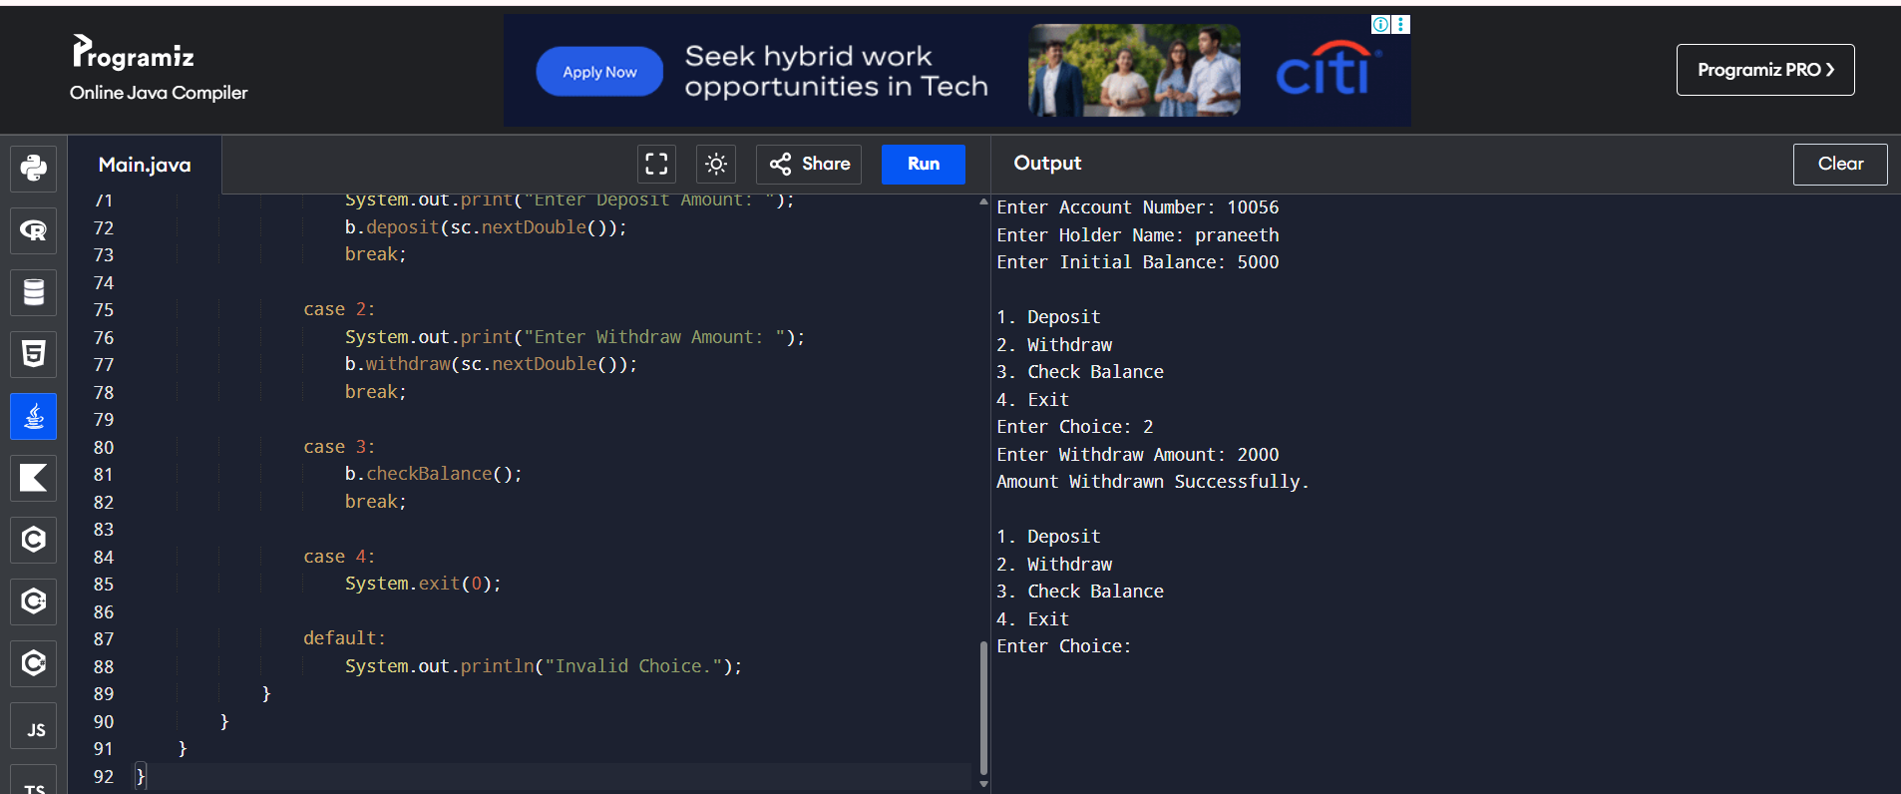
5)import java.util.Scanner;

class Admission {

// Undergraduate Fee
void calculateFee() {
System.out.println("Undergraduate Fee = Rs.50000");
}

// Postgraduate Fee
void calculateFee(String course) {
System.out.println("Postgraduate Fee = Rs.80000");
}

// Scholarship Student Fee
void calculateFee(String course, double scholarship) {
double fee = 80000 - scholarship;
System.out.println("Scholarship Student Fee = Rs." + fee);
}
}

public class Main {
public static void main(String[] args) {

Scanner sc = new Scanner(System.in);
Admission a = new Admission();

System.out.println("1. Undergraduate");
System.out.println("2. Postgraduate");
System.out.println("3. Scholarship Student");
System.out.print("Enter Choice: ");

int ch = sc.nextInt();

switch (ch) {

case 1:
a.calculateFee();
break;

case 2:
a.calculateFee("PG");
break;

case 3:
System.out.print("Enter Scholarship Amount: ");
double s = sc.nextDouble();
a.calculateFee("PG", s);
break;

default:
System.out.println("Invalid Choice");
}
}
}
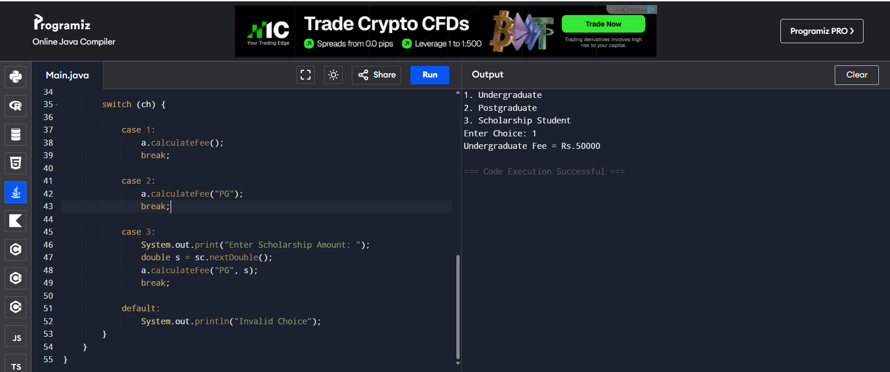
6)import java.util.Scanner;

abstract class Shape {
abstract void area();
}

class Circle extends Shape {
double r;

Circle(double r) {
this.r = r;
}

void area() {
System.out.println("Circle Area = " + (3.14 * r * r));
}
}

class Rectangle extends Shape {
double l, b;

Rectangle(double l, double b) {
this.l = l;
this.b = b;
}

void area() {
System.out.println("Rectangle Area = " + (l * b));
}
}

class Triangle extends Shape {
double base, height;

Triangle(double base, double height) {
this.base = base;
this.height = height;
}

void area() {
System.out.println("Triangle Area = " + (0.5 * base * height));
}
}

public class Main {
public static void main(String[] args) {

Scanner sc = new Scanner(System.in);

Shape[] s = new Shape[3];

System.out.print("Enter Circle Radius: ");
s[0] = new Circle(sc.nextDouble());

System.out.print("Enter Rectangle Length and Breadth: ");
s[1] = new Rectangle(sc.nextDouble(), sc.nextDouble());

System.out.print("Enter Triangle Base and Height: ");
s[2] = new Triangle(sc.nextDouble(), sc.nextDouble());

System.out.println("\nAreas of Shapes:");

for (Shape shape : s) {
shape.area(); // Runtime Polymorphism
}
}
}
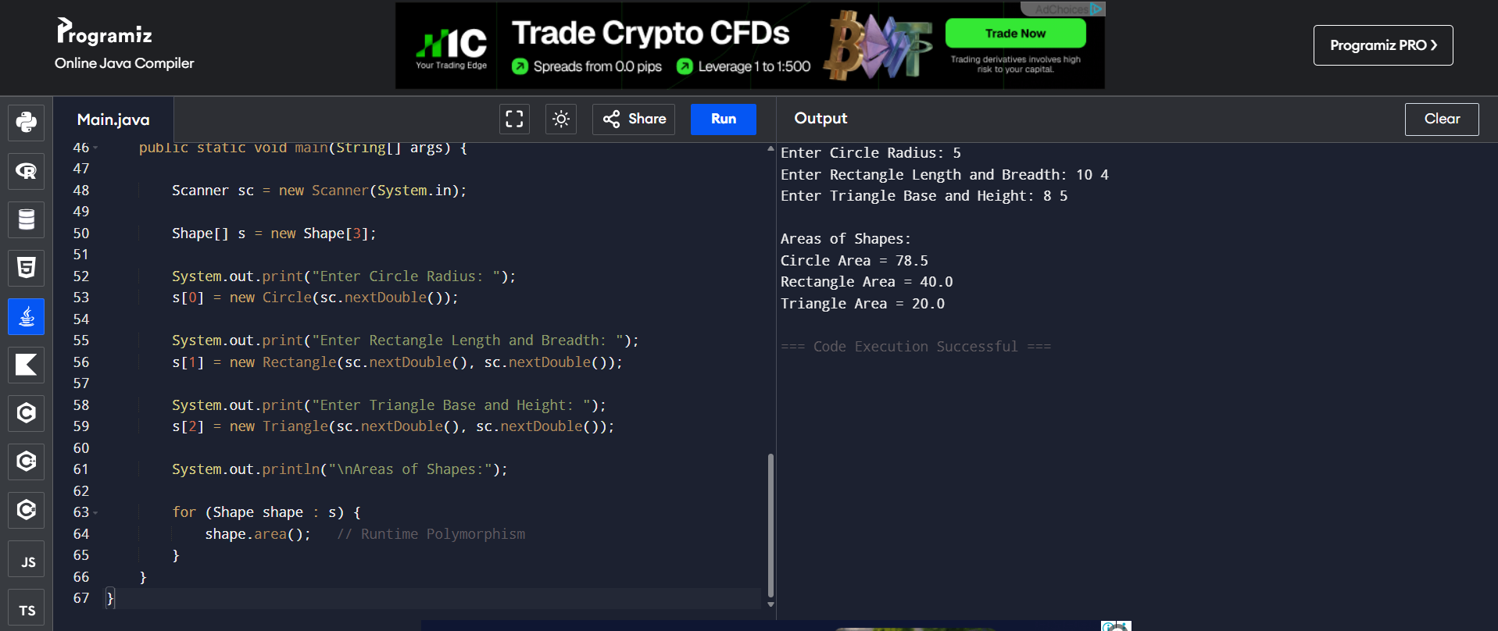
7)import java.util.Scanner;

interface MedicalRecord {
void addRecord();
void displayRecord();
}

class Patient implements MedicalRecord {
int id, age;
String name;
Scanner sc = new Scanner(System.in);

public void addRecord() {
System.out.print("Enter Patient ID: ");
id = sc.nextInt();
sc.nextLine();
System.out.print("Enter Patient Name: ");
name = sc.nextLine();
System.out.print("Enter Age: ");
age = sc.nextInt();
}

public void displayRecord() {
System.out.println("\nPatient Record");
System.out.println("ID : " + id);
System.out.println("Name : " + name);
System.out.println("Age : " + age);
}
}

class Doctor implements MedicalRecord {
int id;
String name, specialization;
Scanner sc = new Scanner(System.in);

public void addRecord() {
System.out.print("Enter Doctor ID: ");
id = sc.nextInt();
sc.nextLine();
System.out.print("Enter Doctor Name: ");
name = sc.nextLine();
System.out.print("Enter Specialization: ");
specialization = sc.nextLine();
}

public void displayRecord() {
System.out.println("\nDoctor Record");
System.out.println("ID : " + id);
System.out.println("Name : " + name);
System.out.println("Specialization : " + specialization);
}
}

public class Main {
public static void main(String[] args) {

Scanner sc = new Scanner(System.in);
MedicalRecord m;

System.out.println("1. Patient");
System.out.println("2. Doctor");
System.out.print("Enter Choice: ");
int ch = sc.nextInt();

if (ch == 1)
m = new Patient();
else
m = new Doctor();

m.addRecord();
m.displayRecord();
}
}
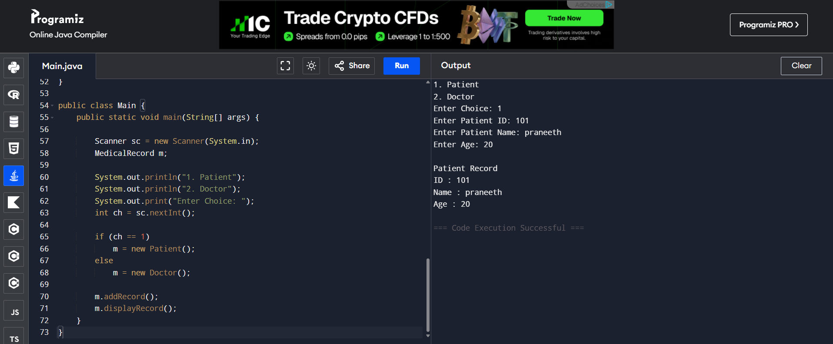
8) class Product {
int id;
String name;
double price;

Product(int id, String name, double price) {
this.id = id;
this.name = name;
this.price = price;
}
}

class Order {
Product p;
int quantity;

Order(Product p, int quantity) {
this.p = p;
this.quantity = quantity;
}

void displayBill() {
System.out.println("Product: " + p.name);
System.out.println("Price: " + p.price);
System.out.println("Quantity: " + quantity);
System.out.println("Total: " + (p.price * quantity));
}
}

public class Main {
public static void main(String[] args) {

Product p = new Product(101, "Laptop", 50000);

Order o = new Order(p, 2);

o.displayBill();
}
}
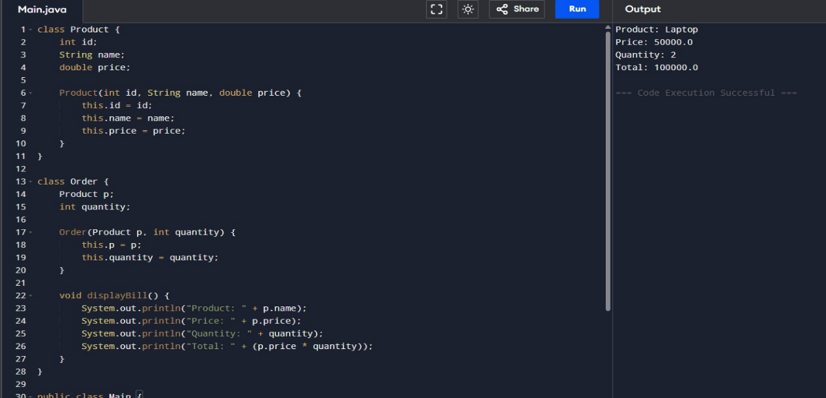
9)import java.util.Scanner;

class Student {
int rollNo;
String name;
int m1, m2, m3;
int total;
double average;
String grade;

Student(int rollNo, String name, int m1, int m2, int m3) {
this.rollNo = rollNo;
this.name = name;
this.m1 = m1;
this.m2 = m2;
this.m3 = m3;
}

void calculate() {
total = m1 + m2 + m3;
average = total / 3.0;

if (average >= 90)
grade = "A";
else if (average >= 75)
grade = "B";
else if (average >= 60)
grade = "C";
else if (average >= 40)
grade = "D";
else
grade = "F";
}

void display() {
System.out.println(rollNo + "\t" + name + "\t" + total + "\t" + average + "\t" + grade);
}
}

public class Main {
public static void main(String[] args) {

Scanner sc = new Scanner(System.in);

System.out.print("Enter Number of Students: ");
int n = sc.nextInt();

Student[] s = new Student[n];

for (int i = 0; i < n; i++) {
System.out.println("\nEnter Student " + (i + 1) + " Details");

System.out.print("Roll No: ");
int roll = sc.nextInt();
sc.nextLine();

System.out.print("Name: ");
String name = sc.nextLine();

System.out.print("Marks in 3 Subjects: ");
int m1 = sc.nextInt();
int m2 = sc.nextInt();
int m3 = sc.nextInt();

s[i] = new Student(roll, name, m1, m2, m3);
s[i].calculate();
}

System.out.println("\nRoll\tName\tTotal\tAverage\tGrade");
for (Student st : s) {
st.display();
}

Student topper = s[0];
for (int i = 1; i < n; i++) {
if (s[i].total > topper.total)
topper = s[i];
}

System.out.println("\nClass Topper");
System.out.println("Roll No : " + topper.rollNo);
System.out.println("Name : " + topper.name);
System.out.println("Total Marks : " + topper.total);
}
}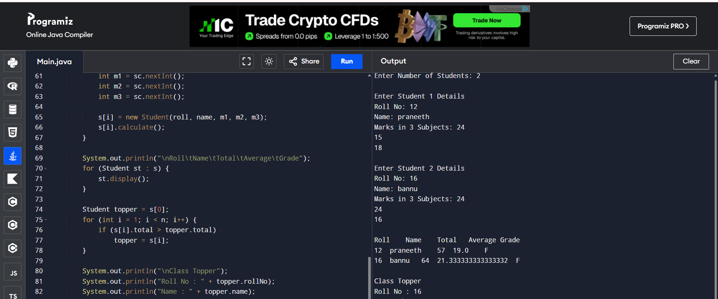
10)import java.util.Scanner;

class Device {
String name;

Device(String name) {
this.name = name;
}

void turnOn() {
System.out.println(name + " is ON");
}

void turnOff() {
System.out.println(name + " is OFF");
}

void powerConsumption() {
System.out.println("Power Consumption");
}
}

class Light extends Device {
Light(String name) {
super(name);
}

void powerConsumption() {
System.out.println(name + " Power = 20 Watts");
}
}

class Fan extends Device {
Fan(String name) {
super(name);
}

void powerConsumption() {
System.out.println(name + " Power = 75 Watts");
}
}

class AirConditioner extends Device {
AirConditioner(String name) {
super(name);
}

void powerConsumption() {
System.out.println(name + " Power = 1500 Watts");
}
}

public class Main {
public static void main(String[] args) {

Device[] d = new Device[3];

d[0] = new Light("Light");
d[1] = new Fan("Fan");
d[2] = new AirConditioner("Air Conditioner");

for (Device device : d) {
device.turnOn();
device.powerConsumption();
device.turnOff();
System.out.println();
}
}
}
