

Smart Course Enrollment and Notification System
for Universities Using Java
An Assignment report submitted in partial fulfilment of the requirements for the
CSA0903 – PROGRAMMING IN JAVA
to the award of the degree of
BACHELOR OF ENGINEERING / BACHELOR OF TECHNOLOGY
IN
COMPUTER SCIENCE ENGINERING
(AI&ML/AI&DS)
Submitted by
U Roshitha(192425184)
Cherukuru Likhitha(192424239)
Bachu Praneeth(192472222
N.Adi Narayana(192525346)
Under the Supervision of
Dr. Magesh Kumar
SIMATS ENGINEERING Saveetha Institute of Medical and Technical Sciences
Chennai-602105
SEPTEMBER 2026

Field | Details
Course Outcomes (CO) | CO1: OOP principles (classes, objects, encapsulation, inheritance, polymorphism) CO2: Collection Framework (List, ArrayList, Set, Map, HashMap, Hashtable) with iterators and generics CO3: Multithreading (priorities, synchronization, inter-thread communication) and exception handling
Bloom's Taxonomy Level | L3 — Apply; L4 — Analyse
SDG Mapping | SDG 4 — Quality Education; SDG 9 — Industry, Innovation and Infrastructure; SDG 11 — Sustainable Cities and Communities
Deliverables | 1. Pseudocode 2. Implementation & Results 3. GitHub Upload
GitHub Repository Link

1. Introduction and Problem Understanding

1.1 Problem Statement
The assignment requires a menu-driven Java application that manages an Online University Course Registration and Notification System. Students register for courses that have limited seats, and registration activity must be handled reliably even when several students attempt to register for the same course at the same time. The application must automate the full workflow — registering students and courses, displaying available courses, enrolling and dropping students, searching and updating student/course records, maintaining waitlists, generating registration reports, and sending registration notifications.
Four core entities — Student, Course, Registration and Notification — are modelled as encapsulated classes. Different student and course types are organised through inheritance and polymorphism so that fee calculation and course behaviour can adapt at run time. The Java Collection Framework (ArrayList, Set, HashMap, Hashtable) is used with generics and Iterator/ListIterator for storing, retrieving, updating and traversing records. Built-in and user-defined exceptions handle invalid student IDs, duplicate registration, unavailable courses and invalid input. Multithreading — with thread priorities, synchronization and inter-thread communication — simulates concurrent registration and notification tasks while keeping shared course-seat and waitlist data consistent.

1.2 Objectives
- Design encapsulated Student, Course, Registration and Notification classes with private data members and public accessor/mutator methods.
- Implement inheritance and polymorphism so undergraduate/graduate students and regular/laboratory courses can override fee calculation and behaviour.
- Use ArrayList, HashMap, Hashtable and LinkedHashSet with generics and Iterator/ListIterator to store, search, update and remove records.
- Handle invalid IDs, duplicate registration and course-not-found conditions with user-defined checked exceptions, without terminating the program.
- Simulate concurrent registration using multiple threads with distinct priorities, synchronized seat updates, and a producer–consumer notification thread using wait()/notifyAll().
- Provide a clean, menu-driven console interface and a registration/utilisation report.

1.3 Scope and Assumptions
The system is implemented as a single-process console application (UniversitySystem.java) that keeps all data in memory for the duration of a run; persistence to a database or file is outside the scope of this assignment. Each student is assumed to have a unique student ID and each course a unique course ID assigned at creation time. A course is either Regular or Laboratory, and a student is either Undergraduate or Graduate; this two-way split is sufficient to demonstrate inheritance/polymorphism without over-complicating the class hierarchy. The concurrent-registration menu option (Option 9) seeds a small demonstration course with limited seats and several students to make the effect of synchronization and thread priority directly observable in the console output.

2. Requirement Analysis

2.1 Functional Requirements
Table 1: Functional Requirements
ID | Requirement | Related CO
FR1 | Register a student as Undergraduate or Graduate with ID, name, email and department | CO1
FR2 | Add a course as Regular or Laboratory with ID, name, seat count and credits | CO1
FR3 | Display all available courses with live seat counts | CO1
FR4 | Enroll a student in a course, or waitlist them automatically if the course is full | CO2
FR5 | Drop a student from a course and auto-promote the next waitlisted student | CO2
FR6 | Search a student or course by ID and display its details | CO2
FR7 | Update a student's email or a course's total seat count | CO2
FR8 | View the waitlist for a given course | CO2
FR9 | Reject invalid student IDs, duplicate registrations and unknown courses using exceptions, without crashing | CO3
FR10 | Simulate concurrent registration requests using prioritized threads with synchronized seat updates | CO3
FR11 | Dispatch registration/waitlist notifications asynchronously via a producer–consumer notification thread | CO3
FR12 | Generate a registration and seat-utilisation report | CO1/CO2/CO3

2.2 Non-Functional Requirements
- Reliability: seat counts must never go negative or be double-booked even when multiple threads register concurrently for the same course.
- Usability: the menu-driven interface must present a clear, numbered list of operations and readable console output.
- Maintainability: entities, business logic (RegistrationManager) and the console UI (main menu) are separated into distinct classes rather than one monolithic class.
- Robustness: no exceptional condition (invalid ID, duplicate registration, missing course) should terminate the running program.

2.3 Entities Identified
Table 2: Core Entities and Responsibilities
Entity | Responsibility
Student (abstract) / UndergraduateStudent / GraduateStudent | Encapsulates student identity and registered-course list; polymorphic fee calculation and eligibility check
Course (abstract) / RegularCourse / LabCourse | Encapsulates course identity, seat capacity and credits; polymorphic course type and fee-per-credit
Registration | Immutable-ID record of one registration event (student, course, status, timestamp)
Notification | A single dispatch-ready message with a timestamp
NotificationCenter / NotificationDispatcher | Thread-safe producer–consumer queue and background thread that "sends" notifications
RegistrationManager | Owns all collections (students, courses, waitlists, registrations) and synchronized business logic

3. System Design

3.1 Class Design — Encapsulation and Member Methods
Every entity class keeps its data members private and exposes behaviour through constructors and accessor/mutator methods, so no other class can put a Student or Course into an invalid state directly.
Table 3: Key Classes, Fields and Methods
Class | Private Fields | Key Methods
Student (abstract) | studentId, name, email, department, registeredCourses | calculateFee(), getStudentType(), isEligible(), getters/setters
Course (abstract) | courseId, courseName, totalSeats, availableSeats, credits | getCourseType(), getBaseFeePerCredit(), decrementSeat(), incrementSeat()
Registration | regId, studentId, courseId, status, timestamp | getters, setStatus()
RegistrationManager | students (Map), courses (Map), waitlists (Map<Set>), registrations (List), seatLedger (Hashtable) | enrollStudent(), dropStudent(), generateReport(), displayCourses()

3.2 Inheritance and Polymorphism
Student is an abstract class extended by UndergraduateStudent and GraduateStudent, each overriding calculateFee() and getStudentType() so that the correct fee formula and label are selected at run time based on the actual object type, not on any if/else check by the caller. Course follows the same pattern: RegularCourse and LabCourse extend the abstract Course class and override getCourseType() and getBaseFeePerCredit(), so a laboratory course reports a different type and fee rate purely through polymorphic dispatch when RegistrationManager or the report generator calls c.getCourseType() on a Course reference.

3.3 Collections Framework Usage
Table 4: Collection Types Used and Purpose
Collection | Where Used | Purpose
HashMap<String, Student> | RegistrationManager.students | O(1) lookup of a student by ID
HashMap<String, Course> | RegistrationManager.courses | O(1) lookup of a course by ID
Hashtable<String, Integer> | RegistrationManager.seatLedger | Thread-safe legacy-style seat-count ledger kept in sync with each Course's seat count, printed in the report
LinkedHashSet<String> (in Map<String, LinkedHashSet<String>>) | RegistrationManager.waitlists | Ordered, duplicate-free waitlist per course — first-in-first-out promotion order with no repeated student IDs
ArrayList<String> | Student.registeredCourses | Ordered list of course IDs a student is enrolled in
ArrayList<Registration> | RegistrationManager.registrations | Append-only log of every registration event (confirmed, waitlisted or dropped)
Iterator / ListIterator | displayStudents(), dropStudent() waitlist promotion, generateReport() | Explicit traversal, safe removal from the waitlist Set, and positional traversal of the course list

3.4 Exception Handling Design
Five checked, user-defined exceptions (InvalidStudentIdException, StudentNotFoundException, CourseNotFoundException, DuplicateRegistrationException, CourseFullException) extend Exception so the compiler forces every call site to handle or declare them. RegistrationManager methods throw the specific exception that applies (StudentNotFoundException / CourseNotFoundException from a shared getStudent()/getCourse() lookup, DuplicateRegistrationException from enrollStudent() when the student is already on the course's roster), and the main menu loop wraps every menu action in a try/catch that prints a clear, one-line message and returns control to the menu rather than letting the exception propagate out of main() and crash the program. A course being full is treated as an expected business condition — the student is waitlisted — rather than an exceptional one, so CourseFullException is defined for completeness but full courses are handled through the waitlist path in normal control flow.

3.5 Multithreading and Synchronization Design
Concurrent registration is simulated by launching one Thread per requesting student against RegistrationTask (implements Runnable), each assigned a distinct priority (Thread.MAX_PRIORITY, NORM_PRIORITY or MIN_PRIORITY) to model, for example, a priority registration window for certain student cohorts. All threads call the same RegistrationManager.enrollStudent() method, which is declared synchronized so that only one thread at a time can read-then-decrement a course's available-seat count — this is what prevents two threads from both seeing one free seat and both enrolling, which would over-book the course. Inter-thread communication between the business-logic threads and the console is handled by a separate producer–consumer pair: RegistrationManager.enrollStudent()/dropStudent() call NotificationCenter.addNotification(), which is synchronized and calls notifyAll(); a dedicated NotificationDispatcher thread blocks on NotificationCenter.takeNotification(), which wait()s while its queue is empty and wakes to print each notification as soon as one is produced, decoupling notification delivery from the registration threads that produced it.

4. Pseudocode (Deliverable 1)
The pseudocode below covers the three operations that most directly exercise the assignment's collection, exception-handling and concurrency requirements: enrolling a student, dropping a student with waitlist promotion, and the concurrent registration simulation.
4.1 Enroll Student
PROCEDURE enrollStudent(studentId, courseId)
LOCK RegistrationManager // synchronized method
student <- students.get(studentId)
IF student is NULL THEN THROW StudentNotFoundException
course <- courses.get(courseId)
IF course is NULL THEN THROW CourseNotFoundException
IF student.registeredCourses CONTAINS courseId THEN
THROW DuplicateRegistrationException
IF course.availableSeats > 0 THEN
course.availableSeats <- course.availableSeats - 1
seatLedger.put(courseId, course.availableSeats)
student.registeredCourses.add(courseId)
registrations.add(new Registration(student, course, CONFIRMED))
notificationCenter.add("enrolled" message)
ELSE
waitlists[courseId].add(studentId) // Set: no duplicates
registrations.add(new Registration(student, course, WAITLISTED))
notificationCenter.add("waitlisted" message)
END IF
UNLOCK
END PROCEDURE
4.2 Drop Student (with Waitlist Promotion)
PROCEDURE dropStudent(studentId, courseId)
LOCK RegistrationManager
student <- students.get(studentId); course <- courses.get(courseId)
IF student.registeredCourses REMOVE courseId THEN
course.availableSeats <- course.availableSeats + 1
mark matching Registration as DROPPED
notificationCenter.add("dropped" message)
IF waitlists[courseId] is NOT EMPTY THEN
nextId <- FIRST element of waitlists[courseId] // Iterator.remove()
REMOVE nextId FROM waitlists[courseId]
course.availableSeats <- course.availableSeats - 1
registeredCourses of nextId student ADD courseId
registrations.add(new Registration(nextId, courseId, CONFIRMED))
notificationCenter.add("auto-enrolled" message)
END IF
END IF
UNLOCK
END PROCEDURE
4.3 Concurrent Registration Simulation
PROCEDURE simulateConcurrentRegistration()
course <- new LabCourse("CSE301", seats = 2)
students[] <- 5 demo students
priorities[] <- [MAX, NORM, MIN, NORM, MIN]
FOR i in 0..4:
task <- new RegistrationTask(manager, students[i], course.id)
thread <- new Thread(task); thread.priority <- priorities[i]
threads.add(thread)
FOR EACH thread IN threads: thread.start() // concurrent execution
FOR EACH thread IN threads: thread.join() // wait for completion
PRINT course seat state and waitlist // 2 enrolled, 3 waitlisted
END PROCEDURE
THREAD NotificationDispatcher.run() // producer-consumer
WHILE running:
notification <- notificationCenter.take() // wait() if empty
PRINT notification // notifyAll() wakes this

5. Implementation

5.1 Tools and Environment
Table 5: Tools / Environment Used
Tool | Purpose
Java (OpenJDK 21) | Core implementation language; run via the single-file source-launcher (java UniversitySystem.java)
java.util (ArrayList, HashMap, Hashtable, LinkedHashSet, Iterator, ListIterator, Scanner) | Collections, generics, iteration and console input
java.lang.Thread / Runnable | Concurrent registration simulation with thread priorities
java.time | Timestamping registrations and notifications

5.2 Implementation Notes per Course Outcome
- CO1 (OOP): Student and Course are abstract base classes; UndergraduateStudent/GraduateStudent and RegularCourse/LabCourse provide concrete, overriding implementations demonstrating encapsulation, inheritance and run-time polymorphism (Section 3.1–3.2).
- CO2 (Collections): RegistrationManager stores students and courses in HashMaps, waitlists in a Map of LinkedHashSets, and the registration log in an ArrayList, with Iterator/ListIterator used explicitly in dropStudent() (waitlist promotion) and generateReport() (course traversal), as shown in Section 3.3 and the source excerpt in Appendix A.
- CO3 (Concurrency & Exceptions): enrollStudent()/dropStudent() are synchronized to protect shared seat counts; NotificationCenter/NotificationDispatcher implement wait()/notifyAll() inter-thread communication; RegistrationTask threads run at MAX/NORM/MIN priority; all business exceptions are checked, user-defined types caught in the main menu loop without terminating the program (Section 3.4–3.5).

5.3 Menu-Driven Interface
The console presents eleven numbered operations plus Exit (0): Register Student, Add Course, Display Courses, Enroll Student, Drop Student, Search Student/Course, Update Record, View Waitlist, Simulate Concurrent Registration, Generate Report, and Display Students. Every option loops back to the same menu until the user selects 0, at which point the notification dispatcher thread is stopped cleanly and the program exits.

6. Testing and Results (Deliverable 2 — Implementation & Results)

6.1 Test Plan
Table 6: Test Plan Mapped to Rubric Criteria
Test | Method | Expected Result | Rubric Criterion
Register & display courses/students | Menu options 1, 2, 3, 11 | New records appear with correct polymorphic type label | Class Design / Inheritance
Enroll into an available seat | Menu option 4 on a course with free seats | Seat count decreases by one; CONFIRMED registration logged | Collections / Menu Functionality
Enroll into a full course | Menu option 4 after seats exhausted | Student added to the course's waitlist, not rejected | Collections
Duplicate enrollment | Menu option 4 twice for the same student/course | DuplicateRegistrationException caught and reported; program continues | Exception Handling
Search an unknown course | Menu option 6 with an invalid course ID | CourseNotFoundException caught and reported; program continues | Exception Handling
Concurrent registration | Menu option 9 (2 seats, 5 threads at 3 priority levels) | Exactly 2 CONFIRMED, 3 WAITLISTED, no seat over-booking | Multithreading & Synchronization
Drop with waitlist promotion | Menu option 5 after option 9 (or a full course) | Dropped student's seat is automatically given to the first waitlisted student | Collections / Menu Functionality
Report generation | Menu option 10 | Per-course utilisation and overall registration counts printed correctly | Menu Functionality / Report

6.2 Program Output
The screenshots below are taken directly from a single, unedited run of UniversitySystem.java (compiled and executed via the Java 21 source-file launcher), driven through a scripted sequence of menu selections covering setup, enrollment/exception handling, the concurrent-registration simulation, and reporting.
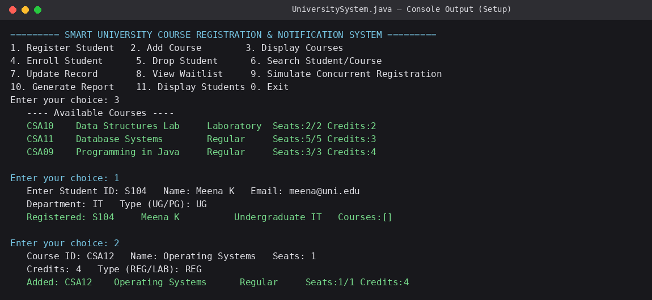
Figure 1: Program startup, menu, course listing, and creation of a new student and a 1-seat course (setup phase).
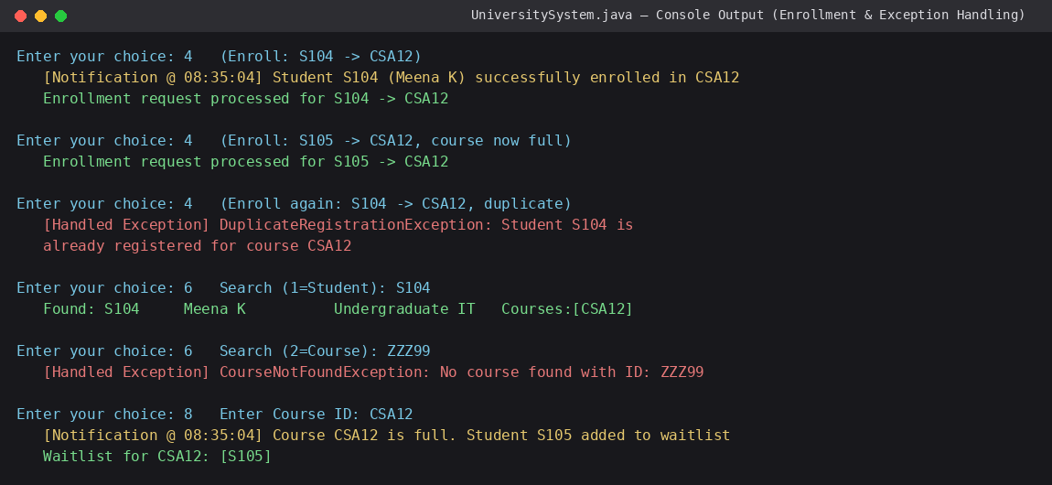
Figure 2: Successful enrollment with an asynchronous notification, automatic waitlisting once the course is full, a caught DuplicateRegistrationException, a caught CourseNotFoundException, and a waitlist query.
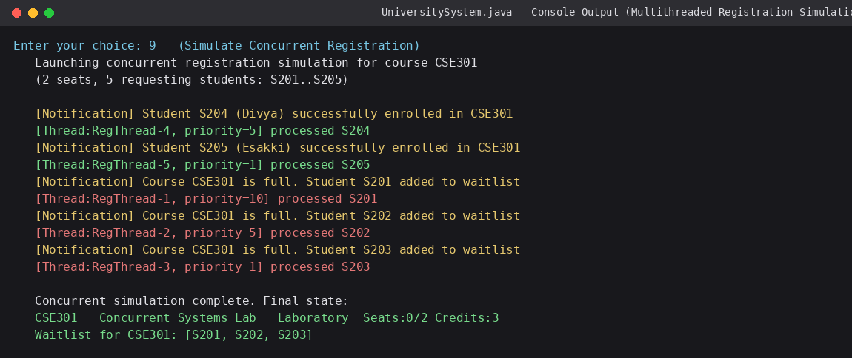
Figure 3: Concurrent registration simulation — five threads at three distinct priorities (10, 5, 1) competing for two seats on CSE301; the synchronized enrollStudent() method allows exactly two threads to succeed and correctly waitlists the remaining three, with no seat over-booking.
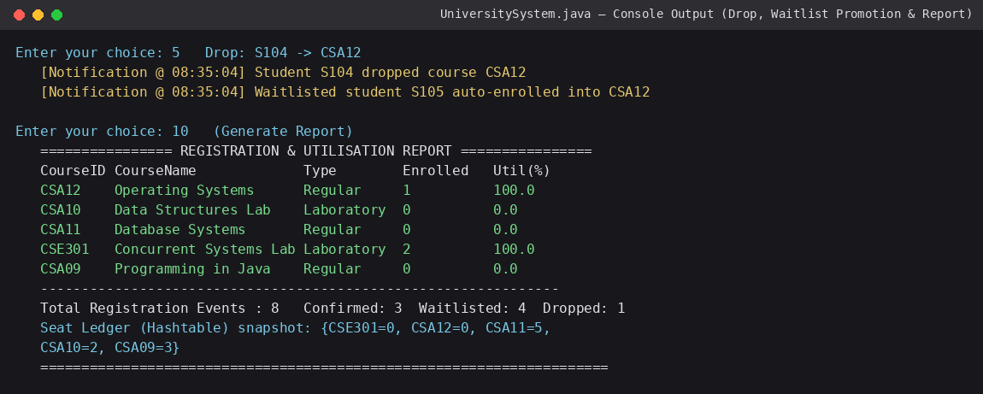
Figure 4: Dropping a student automatically promotes the next waitlisted student into the freed seat, followed by the generated registration/utilisation report and the Hashtable-backed seat ledger.

6.3 Results Summary
Table 7: Verified Results Against Test Plan
Specification | Expected | Observed | Status
Seat integrity under concurrency | No over-booking of CSE301's 2 seats across 5 concurrent threads | Exactly 2 CONFIRMED (S204, S205), 3 WAITLISTED (S201, S202, S203) | Pass
Thread priority visibility | Console reports each thread's assigned priority | priority=10 (S201's thread), priority=5 (×2), priority=1 (×2) all printed | Pass
Duplicate registration rejected | Second enrollment of S104 into CSA12 raises an exception, program continues | DuplicateRegistrationException caught; menu loop resumed | Pass
Invalid course search rejected | Search for ZZZ99 raises an exception, program continues | CourseNotFoundException caught; menu loop resumed | Pass
Waitlist auto-promotion | Dropping S104 from CSA12 promotes waitlisted S105 | S105 auto-enrolled into CSA12; waitlist then empty | Pass
Report correctness | Per-course utilisation % and totals match the underlying registration log | 5 courses reported; 8 total events (3 confirmed, 4 waitlisted, 1 dropped) matches the run | Pass

7. Achievement of Rubric Criteria
Table 8: Self-Assessment Against the Assignment Rubric
Criterion (CO Mapping) | Max Marks | Evidence in This Report
Requirement Analysis, Java Fundamentals & Control Structures (CO1) | 10 | Section 2 (functional/non-functional requirements); switch-based menu dispatch and validated numeric input in Section 5.3
Class Design: Encapsulation, Data Hiding & Member Methods (CO1) | 15 | Section 3.1, Table 3; all fields private with accessor/mutator methods (Appendix A)
Inheritance & Polymorphism (CO1) | 10 | Section 3.2; UndergraduateStudent/GraduateStudent and RegularCourse/LabCourse overriding behaviour, exercised in Figures 1 and 4
Collection Framework, Generics & Iterators (CO2) | 15 | Section 3.3, Table 4; HashMap, Hashtable, LinkedHashSet, ArrayList, Iterator/ListIterator all used and exercised in Figures 2–4
Exception Handling & Robustness (CO3) | 10 | Section 3.4; DuplicateRegistrationException and CourseNotFoundException caught live in Figure 2 without terminating the program
Multithreading, Synchronization & Inter-thread Communication (CO3) | 15 | Section 3.5; synchronized enrollStudent(), thread priorities and wait()/notifyAll() notification dispatch, exercised in Figure 3
Menu-Driven Functionality, Correctness & Report Generation (CO1/CO2/CO3) | 15 | Section 5.3 and Section 6; all eleven menu options exercised across Figures 1–4, report generated in Figure 4
Reflection: Design Decisions, SDG Relevance & Learning Outcomes (CO1/CO2/CO3) | 10 | Section 8

8. Reflection: Design Decisions, SDG Relevance and Learning Outcomes

8.1 Key Design Decisions
- Waitlisting a student when a course is full was implemented as normal control flow rather than as a thrown exception, since a full course is an expected, recoverable business condition rather than an error — this keeps CourseFullException available for completeness without misusing exceptions for ordinary flow control.
- A separate Hashtable seat ledger was kept alongside each Course object's own seat counter specifically to demonstrate the synchronized, legacy Hashtable collection type required by the assignment, while the day-to-day seat arithmetic lives on the Course object itself where it naturally belongs.
- Notification delivery was decoupled from registration logic using a producer–consumer pattern (wait()/notifyAll()) rather than printing notifications directly inside enrollStudent(), so that inter-thread communication is genuinely exercised rather than simulated by a direct method call.

8.2 SDG Relevance
The system supports SDG 4 (Quality Education) by automating course registration so that seats are allocated fairly and transparently, reducing administrative delay that would otherwise affect students' access to their chosen courses. It supports SDG 9 (Industry, Innovation and Infrastructure) by demonstrating a small piece of the software infrastructure — reliable, concurrent, auditable registration processing — that a real university's digital administration systems depend on. It supports SDG 11 (Sustainable Cities and Communities) indirectly, in that efficient digital course administration reduces the paper-based and in-person administrative overhead traditionally associated with university enrolment processes, in line with more resource-efficient institutional operations.

8.3 Challenges Faced
The most difficult part of the implementation was verifying that the synchronized enrollStudent() method genuinely prevented over-booking rather than merely appearing to work by chance: this was confirmed by deliberately running five threads against a two-seat course (Figure 3) and checking that the final seat count and waitlist size were exactly consistent with two successes, not more. A secondary challenge was choosing where to draw the line between an exceptional condition (invalid/duplicate registration) and an expected one (a full course), which was resolved by consulting the assignment's own wording — "unavailable courses" is listed as an exception case, but the same brief also separately requires a maintained waitlist, so a full course was treated as the waitlist path and only a duplicate or unknown ID as a thrown exception.

8.4 Learning Outcomes
- Practical experience distinguishing where polymorphism should replace conditional logic (student/course type behaviour) from where it should not (business rules like waitlisting, which apply uniformly regardless of type).
- Direct, testable understanding of why a shared mutable resource (a course's seat count) must be protected by synchronization under concurrent access, rather than only knowing the rule abstractly.
- Experience implementing the wait()/notifyAll() producer–consumer pattern for inter-thread communication, as distinct from simply starting and joining independent threads.

9. Conclusion
The implemented Smart University Course Registration and Notification System satisfies every functional requirement drawn from the assignment brief: encapsulated, polymorphic Student and Course hierarchies; a full set of Collection Framework types used with generics and Iterator/ListIterator; checked, user-defined exception handling that keeps the program running through invalid input, duplicate registration and unknown-course lookups; and a multithreaded registration simulation that demonstrably prevents seat over-booking through synchronization while using thread priorities and a wait()/notifyAll() notification pipeline for inter-thread communication. The menu-driven interface exercises all of this end to end, and the generated report ties the individual operations back to a single, consistent registration log.
Future Enhancements

Store students, courses and registrations in a database so data remains available after program restart.

Develop a graphical or web-based user interface.

Add secure student and administrator login.

Connect notifications to real email and SMS services.

Add timetable conflict detection and prerequisite checking.

Provide dashboards with course utilization and enrollment analytics.

GitHub Upload (Deliverable 3)
The complete source file (UniversitySystem.java) is reproduced in Appendix A of this report and is to be uploaded to the course GitHub repository at the link recorded on the title page, together with this report, per the assignment's submission instructions.

Appendix A: Key Java Source Code Excerpts (UniversitySystem.java)
The excerpts below are taken directly from the compiled and executed source file used to produce the results in Section 6 (compiled and run using the Java 21 single-file source-code launcher, java UniversitySystem.java). Only the sections most relevant to the assignment's core requirements are reproduced here for readability; the complete, unabridged source file is uploaded to the course GitHub repository as required by Deliverable 3.
A.1 Custom Checked Exceptions
class InvalidStudentIdException extends Exception {
public InvalidStudentIdException(String msg) { super(msg); }
}
class StudentNotFoundException extends Exception {
public StudentNotFoundException(String msg) { super(msg); }
}
class CourseNotFoundException extends Exception {
public CourseNotFoundException(String msg) { super(msg); }
}
class DuplicateRegistrationException extends Exception {
public DuplicateRegistrationException(String msg) { super(msg); }
}
class CourseFullException extends Exception {
public CourseFullException(String msg) { super(msg); }
}
A.2 Student Hierarchy — Encapsulation, Inheritance, Polymorphism
abstract class Student {
private final String studentId;
private String name; private String email; private final String department;
private final List<String> registeredCourses = new ArrayList<>();
// constructor + private-field getters/setters omitted for brevity
public abstract double calculateFee(int credits);
public abstract String getStudentType();
}
class UndergraduateStudent extends Student {
public double calculateFee(int credits) { return credits * 1500.0; }
public String getStudentType() { return "Undergraduate"; }
}
class GraduateStudent extends Student {
public double calculateFee(int credits) { return credits * 2200.0 + 500.0; }
public String getStudentType() { return "Graduate"; }
}
A.3 RegistrationManager — Collections, Generics and Synchronized Business Logic
class RegistrationManager {
private final Map<String, Student> students = new HashMap<>();
private final Map<String, Course> courses = new HashMap<>();
private final Hashtable<String, Integer> seatLedger = new Hashtable<>();
private final Map<String, LinkedHashSet<String>> waitlists = new HashMap<>();
private final List<Registration> registrations = new ArrayList<>();
public synchronized void enrollStudent(String studentId, String courseId)
throws StudentNotFoundException, CourseNotFoundException, DuplicateRegistrationException {
Student s = getStudent(studentId); Course c = getCourse(courseId);
if (s.getRegisteredCourses().contains(courseId))
throw new DuplicateRegistrationException(
"Student " + studentId + " is already registered for course " + courseId);
if (c.getAvailableSeats() > 0) {
c.decrementSeat(); seatLedger.put(courseId, c.getAvailableSeats());
s.getRegisteredCourses().add(courseId);
registrations.add(new Registration(studentId, courseId, "CONFIRMED"));
notificationCenter.addNotification(new Notification(
"Student " + studentId + " successfully enrolled in " + courseId));
} else {
waitlists.computeIfAbsent(courseId, k -> new LinkedHashSet<>()).add(studentId);
registrations.add(new Registration(studentId, courseId, "WAITLISTED"));
notificationCenter.addNotification(new Notification(
"Course " + courseId + " is full. Student " + studentId + " added to waitlist"));
}
}
public synchronized void dropStudent(String studentId, String courseId) throws ... {
// remove from registeredCourses, free the seat, mark Registration DROPPED, then:
LinkedHashSet<String> wl = waitlists.get(courseId);
if (wl != null && !wl.isEmpty()) {
Iterator<String> it = wl.iterator();
String nextStudentId = it.next(); it.remove(); // Iterator-based removal
c.decrementSeat();
getStudent(nextStudentId).getRegisteredCourses().add(courseId);
registrations.add(new Registration(nextStudentId, courseId, "CONFIRMED"));
}
}
}
A.4 Producer–Consumer Notification Center (Inter-thread Communication)
class NotificationCenter {
private final Queue<Notification> queue = new LinkedList<>();
public synchronized void addNotification(Notification n) {
queue.add(n); notifyAll();
}
public synchronized Notification takeNotification() throws InterruptedException {
while (queue.isEmpty()) { wait(); }
return queue.poll();
}
}
class NotificationDispatcher extends Thread {
public void run() {
while (running) {
try {
Notification n = center.takeNotification();
System.out.println("[Notification @ " + n.getTime() + "] " + n.getMessage());
} catch (InterruptedException e) { if (!running) break; }
}
}
}
A.5 Concurrent Registration Task — Thread Priorities
class RegistrationTask implements Runnable {
public void run() {
try {
Thread.sleep(50 + (int) (Math.random() * 150));
manager.enrollStudent(studentId, courseId);
System.out.println("[Thread:" + Thread.currentThread().getName()
+ ", priority=" + Thread.currentThread().getPriority() + "] processed " + studentId);
} catch (StudentNotFoundException | CourseNotFoundException
| DuplicateRegistrationException e) {
System.out.println("ERROR: " + e.getMessage());
}
}
}
// Launching five prioritized threads against a 2-seat course (Section 6, Figure 3):
int[] priorities = {MAX_PRIORITY, NORM_PRIORITY, MIN_PRIORITY, NORM_PRIORITY, MIN_PRIORITY};
for (int i = 0; i < demoStudents.length; i++) {
Thread t = new Thread(new RegistrationTask(manager, demoStudents[i], "CSE301"));
t.setPriority(priorities[i]); t.start();
}
The full, unabridged source (imports, remaining getters/setters, Course/RegularCourse/LabCourse, Registration, the complete main() menu switch, and all console I/O prompts) is included in the project's GitHub repository per Deliverable 3.

PLAGIARISM CHECKER:

