ASSIGNMENT 2 – CO2
Functions and Object-Oriented Concepts in C++
Assignment Report – Q1 to Q7 (K5 – Evaluate)
Course Data Structures and Algorithms (DSA01)
Student name B.Praneeth
Register number 192472222
Nature Individual – 50 marks
Submission date 31/10/2026
Compiler g++ 13.3.0 (Ubuntu 13.3.0-6ubuntu2~24.04.1), -std=c++17 -Wall -Wextra
GitHub repository https://github.com/praneethbacchu/DSA0103-C
CO2 coverage: function prototyping, call by reference, return by reference, inline functions, default arguments, function overloading, classes, member functions, access specifiers, arrays within a class, static data members and member functions, arrays of objects and friend functions.

Contents
Overview and results at a glance
Q1 – Call by Value, by Reference and by Pointer (6 marks)
Q2 – Return by Reference and Its Dangers (4 marks)
Q3 – Default Arguments and Function Overloading (6 marks)
Q4 – Specifying a Class with an Array Inside It (6 marks)
Q5 – Static Members and Arrays of Objects (7 marks)
Q6 – Friend Functions and Inline Functions (8 marks)
Q7 – Diagnose, Redesign and Validate (13 marks)
Appendix A – README.md
Appendix B – GitHub submission checklist and commit commands
Appendix C – Summary of complexity results

Overview and results at a glance
This report answers every task of Assignment 2. For each question the C++ programs were compiled with g++ 13.3.0 and executed; the outputs, compiler messages and timings shown are the real ones produced by those runs (terminal captures are included as figures and as files in each QN/screenshots/ folder). Predictions are recorded next to the observed results, and each question ends with the alternative-concept and complexity analysis requested.
Q | Topic | Marks | Key result
1 | Call by value / reference / pointer | 6 | Fee 45000 → unchanged by value, 40500 by reference, 36450 by pointer; chose "return the new fee" because stacked concessions depend on order (25819 vs 25820)
2 | Return by reference | 4 | highest(...) += 2 works; returning a local reference → warning + segfault; vector growth → heap-use-after-free
3 | Defaults and overloading | 6 | Ambiguity of charge(2.5) explained and removed; six predicted selections all correct
4 | Class with an array | 6 | Private circular/shifting history; shifting cost grows linearly with capacity (7.7 → 128.5 ns for k = 10 → 1000)
5 | Static members, arrays of objects | 7 | 101 103 104 4; BusTicket expected output reproduced; count survives object destruction
6 | Friend and inline functions | 8 | 205 false; 7/7 tests; inline ≈ 1.1–1.45× faster at -O2, no effect at -O0
7 | Diagnose, redesign, validate | 13 | Circular buffer: 43× faster deposits at k = 1000, identical output, but 1.8–3.5× slower reads

Method
- Predictions were written from a hand trace of the code; where the paper asks for "before running" the prediction is shown first and compared with the observed output.
- Timings use std::chrono::steady_clock, medians of 7 repetitions, results consumed through a volatile sink so the optimiser cannot delete the work. They were taken on a shared 2-core cloud machine, so absolute numbers vary by about ±10 % between runs; ratios and trends are what matter.
- Compiler diagnostics (ambiguity, private access, static-function misuse, dangling reference) were obtained by compiling deliberately faulty files that are kept in the repository next to the working versions.

Q1 – Call by Value, by Reference and by Pointer (6 marks)

1.1 Predict the output
Program from the question (Q1/predict.cpp). Prediction written by tracing the code by hand before running:
Statement | Reasoning | Predicted
change(a, b, &c) | a is a copy (stays 1); b is an alias of the caller's b (2 → 12); c is changed through its address (3 → 13). | 1 12 13
bigger(a, c) = 100; | bigger returns an int& to the larger of a (1) and c (13), i.e. to c. The call is an lvalue, so 100 is stored into c; a is untouched. | 1 100
show(1), show(1,2), show(1,2,3) | 1+5+10 = 16 (y and z defaulted); 1+2+10 = 13 (only z defaulted); 1+2+3 = 6 (no default used). Each value is followed by a space, then one newline. | 16 13 6 (trailing space)

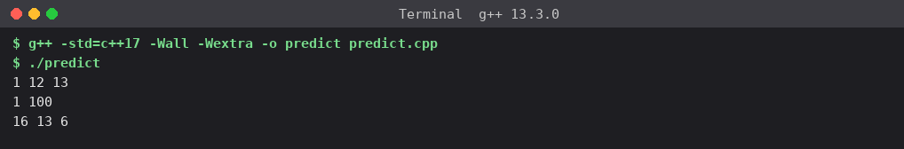
Figure 1.1 – Actual output of predict.cpp
Prediction vs actual: identical – no differences. The only subtle point is the trailing space after 6, which comes from ' ' being printed after every value inside show().
Which variables changed and why. In change() the first call changed b and c but not a: a is passed by value (a private copy on the callee's stack), b by reference (the parameter *is* the caller's b) and c by pointer (the callee dereferences the address of c). In bigger(a, c) = 100, only c changed because the function returned a reference to the larger argument. Default arguments: show(1) used both defaults (y = 5, z = 10); show(1, 2) used only z = 10; show(1, 2, 3) used none.

1.2 Complete the code
TODO 1 completed so the caller's fee changes (Q1/complete.cpp; the rest of the program is unchanged):
void applyConcession(long long& fee, int percent)
{
// TODO 1 (completed): reduce the caller's fee by percent (integer arithmetic)
fee -= fee * percent / 100;
}

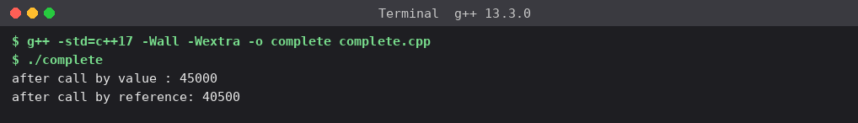
Figure 1.2 – Output matches the expected output (45000, 40500)
Why call by value leaves the fee at 45000. applyByValue(hostelFee, 10) copies the value 45000 into the parameter fee, a separate long long object in the callee's stack frame. fee -= fee * percent / 100 changes 45000 → 40500 in that copy only; the copy is destroyed when the function returns, and hostelFee in main was never touched. With integer arithmetic 45000 × 10 / 100 = 4500, so by reference 45000 − 4500 = 40500.

1.3 The concession function three ways
Q1/three_ways.cpp implements byValue(long long, int), byReference(long long&, int) and byPointer(long long*, int) (plus a return-value version and a const& preview). Predictions were made before running; each call applies 10 % to the current stored fee.
Call | Predicted stored fee | Observed | Match
byValue(fee, 10) | 45000 (inside: 40500) | 45000 (inside: 40500) | Yes
byReference(fee, 10) | 40500 | 40500 | Yes
byPointer(&fee, 10) | 36450 (40500 − 4050) | 36450 | Yes

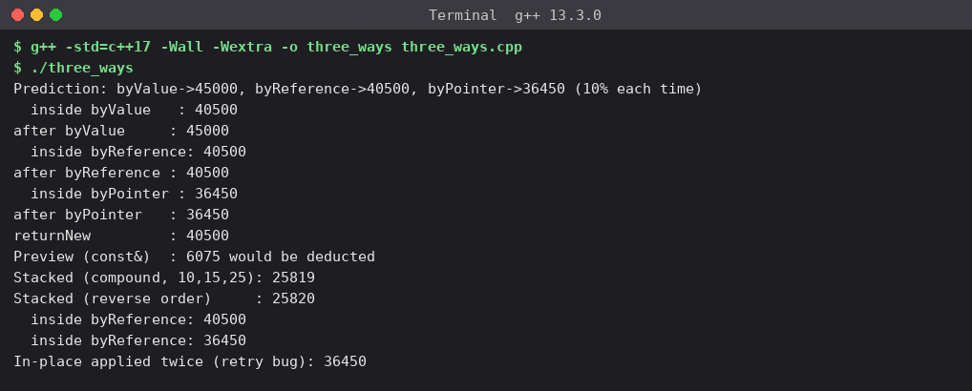
Figure 1.3 – three_ways.cpp output
void byValue(long long fee, int percent) { fee -= fee * percent / 100; }
void byReference(long long& fee, int percent) { fee -= fee * percent / 100; }
void byPointer(long long* fee, int percent) { if (!fee) return; *fee -= *fee * percent / 100; }
long long returnNew(long long fee, int percent) { return fee - fee * percent / 100; }
// full source with printing: Q1/three_ways.cpp

Inquiry – where each version stores its parameter
Version | Where the parameter lives | Can it change caller's fee?
By value | A new long long (8 bytes) in the callee's stack frame holding a copy of the value. | No – it only modifies its own copy.
By reference | No new object: fee is another name (alias) for the caller's variable (the compiler typically passes a hidden address, but semantically nothing is copied). | Yes – every use of fee is the caller's object.
By pointer | A new pointer object (8 bytes) in the callee's frame that holds the address of the caller's variable; the fee itself stays in the caller. | Yes – through *fee. (The pointer itself is a copy, so reassigning it would not affect the caller.)

Only two versions change the caller's fee because only they give the function access to the caller's object; by value gives it a copy. A `const` reference (const long long&, or const Student&) should be used when the function only reads the argument and copying would be wasteful – large objects such as a Student with strings/arrays. It avoids the copy and the compiler rejects any accidental modification. For small types such as long long plain by-value is just as cheap and simpler.

Design decision – in place or return the new fee?
Several concessions may apply to one student (merit 10 %, sports 15 %, single parent 25 %). I measured what happens when they are stacked on 45000 with integer arithmetic:
Scenario | Result
10 % → 15 % → 25 % applied one after another | 25819
25 % → 15 % → 10 % (reverse order) | 25820
In-place byReference called twice by a retry/bug | 36450 (discount applied twice)

Decision: return the new fee (a pure function long long applyConcession(long long fee, int percent)), and let the caller write fee = applyConcession(fee, p).
Reasons: (1) the result of stacking concessions depends on the order (25819 vs 25820 because of integer truncation) – a pure function makes the order explicit in the calling code or in one finalFee(fee, list) function; (2) it is composable (applyConcession(applyConcession(f, 10), 15)) and trivially testable; (3) it cannot silently double-apply when a call is retried – the in-place version did; (4) the original fee is still available for receipts and audits. An in-place (reference) version remains reasonable only for one well-defined, one-time update of a very large record.

Alternative concept and complexity analysis
Return-value solution: long long applyConcession(long long fee, int percent) { return fee - fee * percent / 100; } and in main: hostelFee = applyConcession(hostelFee, 10); – prints 40500 (verified in three_ways.cpp, line "returnNew : 40500").
Passing style | Time | Space copied per call | Large Student object (s bytes)
By value | O(1) | 8 bytes (long long) | copies all s bytes – O(s) time and space per call
By reference | O(1) | 0 bytes copied (alias, one address) | 0 bytes copied
By pointer | O(1) | 8 bytes (the pointer) | 8 bytes
By const& | O(1) | 0 bytes copied (read-only) | 0 bytes copied
Return new fee | O(1) | 8 bytes returned (usually in a register) | returned object copied/moved: O(s) unless elided

All versions do one multiplication, one division and one subtraction, so time is O(1) for the long long. The difference appears only in the space and copy cost for large objects, where by-value/return-by-value cost grows with the object size while references and pointers stay at one address.
Evidence delivered: three implementations, predictions before execution, observed results and a defended interface design (above).

Q2 – Return by Reference and Its Dangers (4 marks)

2.1 Implementation
Q2/marks.cpp contains int& highest(int[], int) (reference to the best mark), const int& highestRO(...), int highestCopy(...) and the deliberately wrong int& badReference().
// Q2 - Returning references: highest mark, const ref, copy, and the dangling-reference bug
#include <iostream>

int& highest(int marks[], int n) // reference to the array element itself
{
int best = 0;
for (int i = 1; i < n; ++i)
if (marks[i] > marks[best]) best = i;
return marks[best]; // safe: element outlives the call
}
const int& highestRO(const int marks[], int n) // read-only view of the element
{
int best = 0;
for (int i = 1; i < n; ++i)
if (marks[i] > marks[best]) best = i;
return marks[best];
}
int highestCopy(const int marks[], int n) // returns a copy of the value
{
int best = marks[0];
for (int i = 1; i < n; ++i)
if (marks[i] > best) best = marks[i];
return best;
}
int& badReference() // DANGER: returns reference to a local
{
int local = 99;
return local; // warning: reference to local variable returned
}
int main(int argc, char**)
{
int marks[] = {56, 71, 88, 64, 79};
const int n = 5;

highest(marks, n) += 2; // function call on the LEFT of an assignment
std::cout << "after highest(marks) += 2 : " << marks[2] << '\n';
highest(marks, n) = 90;
std::cout << "after highest(marks) = 90 : " << marks[2] << '\n';

int c = highestCopy(marks, n); c += 5; // copy: array unaffected
std::cout << "copy changed to " << c << ", array still " << marks[2] << '\n';

const int& r = highestRO(marks, n); // r = alias, cannot modify through r
// r += 1; // error: assignment of read-only reference
marks[2] = 91;
std::cout << "const ref sees later change: " << r << '\n';

std::cout << "address of marks[2] = " << &marks[2] << ", &highest() = " << &highest(marks, n) << '\n';

if (argc > 1) { // run with any argument to trigger the UB
int& d = badReference(); // undefined behaviour from here on
std::cout << "dangling reference d (UB): " << d << std::endl;
} else std::cout << "(run with an argument to execute the dangling-reference call)\n";
}

2.2 What the program shows
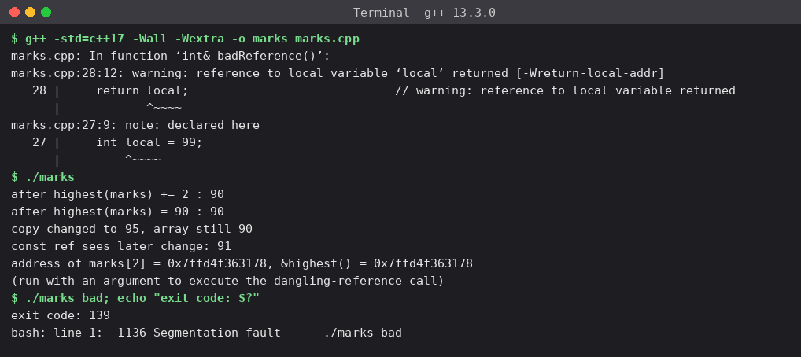
Figure 2.1 – Compiler warning, normal run, and the dangling call (segmentation fault, exit code 139)
Observation | Evidence | Explanation
Caller changes the array element | highest(marks, n) += 2 gave 90 (88+2); highest(marks, n) = 90 kept 90 | The function returns an lvalue referring to marks[2] itself, so the call can sit on the left of = or +=. Same address printed for &marks[2] and &highest(...).
Compiler warning for local reference | warning: reference to local variable 'local' returned [-Wreturn-local-addr] | local lives in the function's stack frame, which is released at return. The reference would refer to an object whose lifetime has ended.
Why it is undefined behaviour | ./marks bad → Segmentation fault, exit 139 (also at -O2 and under AddressSanitizer: SEGV on address 0x0) | The standard gives no guarantee: the slot may be reused, hold garbage, or (as GCC does here) be replaced by a null reference, which crashes. Never rely on the "it printed 99" outcome seen with other compilers.
Reference vs const reference vs copy | copy changed to 95 while array stayed 90; the const reference saw a later change to 91 | See table below.

Return type | Alias of the array element? | Caller can modify element? | Risk
int& | Yes | Yes (f() += 2, f() = 90) | Dangling if the element/object dies or moves
const int& | Yes | No – read-only view (r += 1 is a compile error); still sees later changes (printed 91) | Same dangling risk, but no accidental writes
int (copy) | No – an independent value | No – changing the copy (95) left the array at 90 | None; costs one copy and cannot be used for moderation

2.3 Changed condition – the register becomes a growing std::vector
Q2/vector_grow.cpp obtains int& top = highest(marks) from a vector with capacity 3, then calls push_back. When the size exceeds the capacity the vector allocates a bigger block, moves the elements and frees the old block, so top still refers to freed memory.
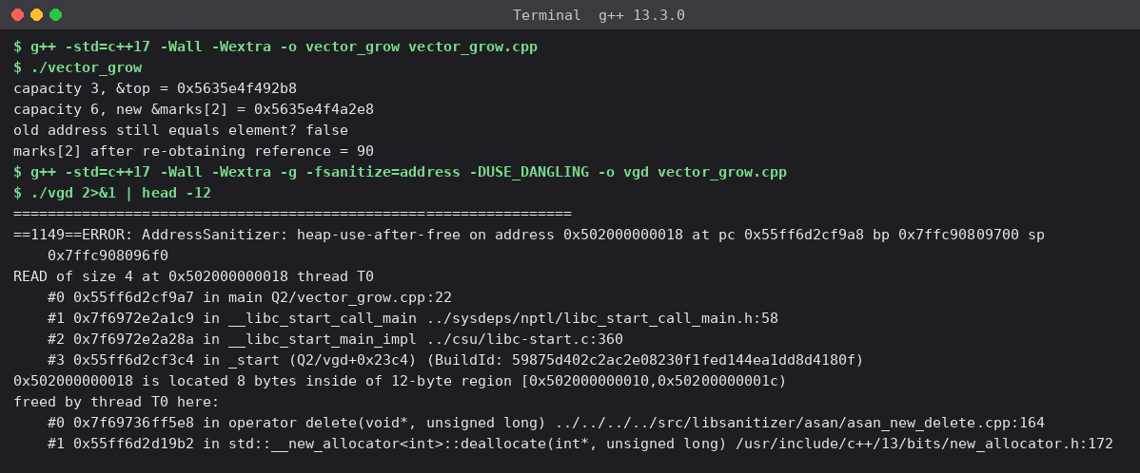
Figure 2.2 – Capacity 3 → 6, element address changes; AddressSanitizer reports heap-use-after-free
Explanation. A reference (like a pointer or iterator) into a std::vector is tied to the address of the element. Growth beyond capacity() reallocates: capacity went from 3 to 6 and the element moved from …42b8 to …52e8. The old reference still holds the old address, which has been freed, so any read/write through it is undefined behaviour (ASan: "heap-use-after-free … 8 bytes inside of 12-byte region … freed by thread T0"). Justified response: never keep a reference across an operation that can grow the container – re-obtain it after the push_back (shown: 88 → 90 correctly), reserve enough capacity in advance, or hold an index instead of a reference.

2.4 Alternative concept and complexity analysis
If the highest mark is returned as an index or a pointer (Q2/alternatives.cpp) the calling code becomes:
marks[highestIndex(marks)] += 2; // index : call site must index the container again
*highestPtr(marks) += 2; // pointer: dereference with *, may be nullptr
highestRef(marks) += 2; // reference: cleanest, cannot be null

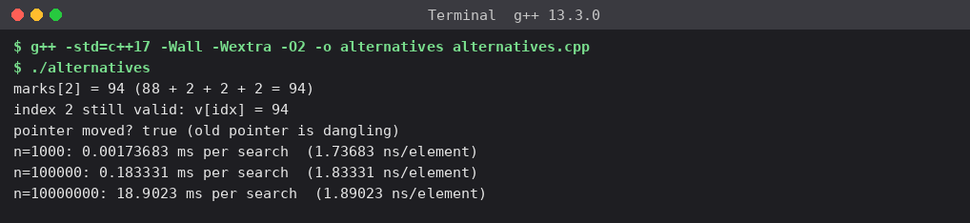
Figure 2.3 – All three call styles give 94; timing of the O(n) search
Version | Time to find highest | Extra space | Safety if array later becomes a growing vector
Reference int& | O(n) – one pass | O(1) | Dangles after reallocation; cannot signal "empty"
Pointer int* | O(n) | O(1) (one pointer) | Dangles after reallocation (observed: "pointer moved? true"); can return nullptr for empty
Index int | O(n) | O(1) | Stays valid after growth (index 2 still gave 94); only wrong if elements are erased/reordered

Measured search time grows linearly: 1.74 ns/element at n = 1,000, 1.83 at n = 100,000 and 1.89 at n = 10,000,000 (0.0017 ms, 0.18 ms, 18.9 ms) – consistent with O(n). The index is the safest design for a growing vector; the reference is the most convenient for a fixed array.

Q3 – Default Arguments and Function Overloading (6 marks)

3.1 The compiler error (ambiguous call)
// Q3 - the broken original: three overloads, one with defaults
#include <iostream>
double charge(double weight) { return 30 + 20 * weight; }
double charge(double weight, bool express) { return charge(weight) * (express ? 1.5 : 1.0); }
double charge(double weight, bool express = false, bool insured = false) { return charge(weight, express) + (insured ? 25 : 0); }

int main()
{
std::cout << charge(2.5) << '\n'; // which one? (double) or (double, bool=false, bool=false)
}

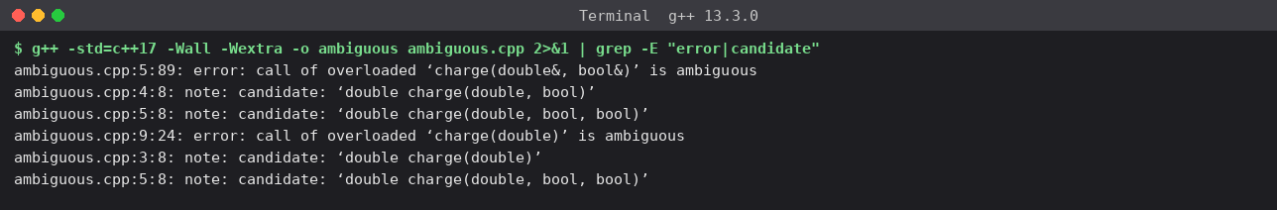
Figure 3.1 – g++ reports "call of overloaded charge(double) is ambiguous"
Explanation. For charge(2.5) two functions are viable: charge(double) and charge(double, bool = false, bool = false) (the omitted arguments are supplied by the defaults). Both take the double as an exact match and need no conversion for the missing arguments, so neither is better and the call is ambiguous. The same happens inside the third function for charge(weight, express), which matches both charge(double, bool) and charge(double, bool, bool) – the compiler reports two errors. The overloads and defaults are redundant: the default arguments already create the one- and two-argument forms.

3.2 Redesign
Rules followed: (1) default arguments live in one function per kind of input, so every short call is covered once; (2) overloads differ by the kind of input – int grams, double kilograms, Parcel object; (3) the grams and Parcel overloads delegate to the kg function, so the pricing rule exists in one place (₹30 base + ₹20/kg, express +50 %, insurance +₹25).
// Q3 - Courier charge calculator: defaults + overloading, no ambiguity
#include <iostream>
#include <iomanip>

struct Parcel { double kg; double volumeFactor; }; // volumeFactor: 1.0 normal, >1 bulky

const double BASE = 30.0, PER_KG = 20.0, EXPRESS_PCT = 50.0, INSURANCE = 25.0;

// core calculation - the ONE place with default arguments (rightmost parameters)
double charge(double kg, bool express = false, bool insured = false)
{
double c = BASE + PER_KG * kg;
if (express) c += c * EXPRESS_PCT / 100;
if (insured) c += INSURANCE;
return c;
}
// grams as int: converts and delegates (different kind of input -> overload)
double charge(int grams, bool express = false, bool insured = false)
{
return charge(grams / 1000.0, express, insured);
}
// Parcel object
double charge(const Parcel& p, bool express = false, bool insured = false)
{
return charge(p.kg * p.volumeFactor, express, insured);
}

int main()
{
std::cout << std::fixed << std::setprecision(2);
std::cout << "1. charge(2) -> int grams : " << charge(2) << '\n';
std::cout << "2. charge(2.0f) -> float->double : " << charge(2.0f) << '\n';
std::cout << "3. charge(2.5) -> double kg : " << charge(2.5) << '\n';
std::cout << "4. charge(2.5, true) -> kg + express : " << charge(2.5, true) << '\n';
std::cout << "5. charge(1500, true, true) -> grams,all : " << charge(1500, true, true) << '\n';
std::cout << "6. charge(Parcel{2.0,1.5})-> Parcel : " << charge(Parcel{2.0, 1.5}) << '\n';
}

3.3 Predict which function is selected, then run
# | Call | Candidates and ranking | Predicted selection and value
1 | charge(2) | int exact match; double needs int→double conversion | charge(int grams,…) → 2 g → 30.04
2 | charge(2.0f) | double: float→double is a promotion; int: float→int is a conversion; Parcel: not viable. Promotion beats conversion | charge(double kg,…) → 70.00
3 | charge(2.5) | double exact | charge(double kg,…) → 80.00
4 | charge(2.5, true) | double exact, true fills express | charge(double kg,…) → 120.00
5 | charge(1500, true, true) | int exact | charge(int grams,…) → 1.5 kg: 60 → ×1.5 = 90 → +25 = 115.00
6 | charge(Parcel{2.0, 1.5}) | only the Parcel overload is viable | charge(const Parcel&,…) → 3 kg: 30+60 = 90.00

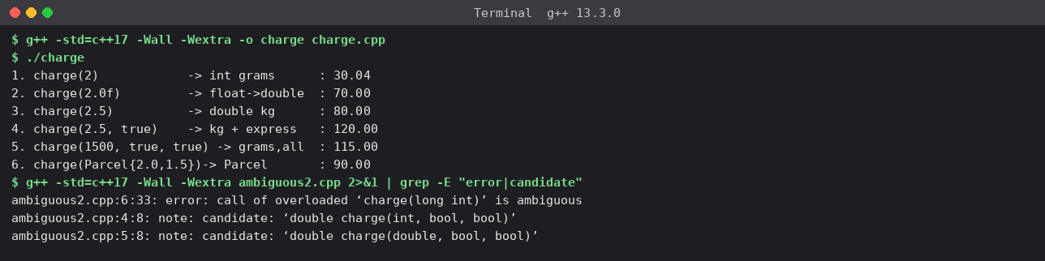
Figure 3.2 – Observed selections: all six match the predictions; no call is ambiguous (compiled with -Wall -Wextra, no warnings)
Prediction vs observation: all six values matched. Note the semantic trap in call 1: charge(2) is 2 grams (30.04), not 2 kg – a consequence of choosing an int overload for grams. This is documented in the code and is exactly why charge(2.0f) (70.00) behaves differently.
A remaining ambiguity: charge(2L) (a long) is ambiguous in this design because long→int and long→double are both *conversions* of equal rank (Q3/ambiguous2.cpp, error shown at the bottom of Figure 3.2). The fix is an explicit cast (charge(int(2L))) or a long overload; the six designed calls contain no such case.

Inquiry – how the compiler chooses among overloaded functions
- Collect all functions with that name visible at the call; drop the non-viable ones (wrong number of arguments after counting defaults, or no conversion possible).
- Rank each argument conversion: *exact match* (identity, array-to-pointer, adding const) > *promotion* (float→double, short/char→int) > *standard conversion* (int→double, double→int, long→int) > *user-defined conversion*.
- The best function must be at least as good on every argument and strictly better on one. If no function wins, the call is ambiguous and compilation fails; the return type is never considered.
- Default arguments must be given from the right because at the call site arguments are matched left-to-right and only trailing ones can be omitted. If f(int a = 1, int b) were legal, f(5) could not say whether 5 is a or b; the compiler therefore requires that once a parameter has a default, all parameters to its right have defaults too.

3.4 Alternative concept and complexity analysis
A single Parcel structure with optional (default-initialised) fields plus a function template for raw weights (Q3/alt_parcel.cpp) gives the same results for the same inputs (30.04, 80.00, 120.00, and 175.00 for a bulky, fragile, express, insured Parcel).
// Q3 alternative: one Parcel struct with optional fields + a function template for raw weights
#include <iostream>
#include <iomanip>
#include <type_traits>

struct Parcel {
double kg = 0;
bool express = false;
bool insured = false;
double volumeFactor = 1.0; // a NEW option costs one new field, no new overloads
bool fragile = false; // added later: existing calls unaffected
};
double charge(const Parcel& p)
{
double c = 30 + 20 * p.kg * p.volumeFactor;
if (p.express) c *= 1.5;
if (p.insured) c += 25;
if (p.fragile) c += 15;
return c;
}
template <class W, class = std::enable_if_t<std::is_arithmetic_v<W>>>
double charge(W weight, bool express = false, bool insured = false)
{ // grams if integral, kg if floating
double kg = std::is_integral_v<W> ? weight / 1000.0 : double(weight);
return charge(Parcel{kg, express, insured});
}
int main()
{
std::cout << std::fixed << std::setprecision(2);
std::cout << charge(2) << ' ' << charge(2.5f) << ' ' << charge(2.5, true) << ' ' << charge(Parcel{2, true, true, 1.5, true}) << '\n';
}

Aspect | Overloads + default arguments | Parcel struct / template
Overload resolution time | Done at compile time; zero run-time cost | Also compile time; a template adds instantiation time at compile time only
Run-time time | O(1) | O(1)
Space copied per call | double + 2 bool ≈ 16 bytes (or a const-ref Parcel) | A Parcel by const-ref copies nothing; by value copies ~24 bytes
Adding a new option (e.g. fragile) | New parameter in every overload or new overloads → risk of new ambiguities and long positional argument lists (charge(2.5, false, true, true)) | One new field with a default; existing calls unchanged; call sites can name the field
Readability of short calls | Best: charge(2.5, true) | Needs a Parcel to be built or the template wrapper

Conclusion: for three fixed options, overloads with defaults give the shortest calls; once options keep growing, the Parcel structure scales better because a new option does not change any function signature.

Q4 – Specifying a Class with an Array Inside It (6 marks)

4.1 Class specification
Q4/account.cpp: SavingsAccount keeps the account number, balance, a private array last[CAP] of Transaction records (CAP = 10) and a count. getBalance()/getAccNo() are defined inside the class (implicitly inline); deposit(), withdraw(), miniStatement() and the private helper record() are defined outside with the scope resolution operator SavingsAccount::.
// Q4 - SavingsAccount with a private array of the last N transactions (shifting design)
#include <iostream>
#include <string>
#include <iomanip>

struct Transaction { char type; double amount; double balanceAfter; }; // 'D' or 'W'

class SavingsAccount {
static const int CAP = 10; // one constant: change to 50 for the new requirement
long accNo;
double balance;
Transaction last[CAP]; // PRIVATE: only member functions keep count/order consistent
int count; // number of valid entries (0..CAP)

void record(char t, double amt); // declared inside, defined outside
public:
SavingsAccount(long no, double opening) : accNo(no), balance(opening), count(0) {}

// defined INSIDE the class (implicitly inline)
double getBalance() const { return balance; }
long getAccNo() const { return accNo; }

// defined OUTSIDE using the scope resolution operator
void deposit(double amt);
bool withdraw(double amt);
void miniStatement() const;
};

void SavingsAccount::record(char t, double amt)
{
if (count == CAP) { // 11th transaction: oldest is discarded
for (int i = 1; i < CAP; ++i) // shift everything left: O(CAP)
last[i - 1] = last[i];
--count;
}
last[count++] = Transaction{t, amt, balance};
}
void SavingsAccount::deposit(double amt)
{
if (amt <= 0) return;
balance += amt;
record('D', amt);
}
bool SavingsAccount::withdraw(double amt)
{
if (amt <= 0 || amt > balance) return false;
balance -= amt;
record('W', amt);
return true;
}
void SavingsAccount::miniStatement() const
{
std::cout << "Mini-statement for A/C " << accNo << " (last " << count << ")\n";
for (int i = count - 1; i >= 0; --i) // newest first
std::cout << " " << (last[i].type == 'D' ? "Deposit " : "Withdrawal")
<< std::setw(9) << last[i].amount << " bal " << std::setw(9) << last[i].balanceAfter << '\n';
std::cout << "Balance: " << balance << '\n';
}

int main()
{
SavingsAccount a(1001, 1000);
for (int i = 1; i <= 12; ++i) { // 12 transactions: first two must fall off
if (i % 3 == 0) a.withdraw(50 * i); else a.deposit(100 * i);
}
a.miniStatement();
// a.last[0] = Transaction{'D', 1e9, 1e9}; // error: 'last' is private
}

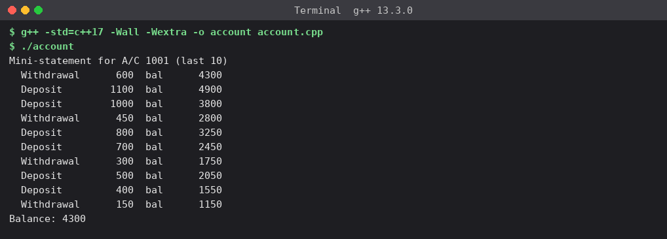
Figure 4.1 – 12 transactions are made; the mini-statement shows only the last 10 (newest first)
Hand check: transactions 1–12 are deposits of 100·i except i = 3, 6, 9, 12 which are withdrawals of 50·i. After transaction 2 the balance is 1300; transaction 3 (withdrawal 150) gives 1150 – this is the oldest line shown, so transactions 1 and 2 were discarded. The newest (12th, withdrawal 600) leaves 4300 = the printed balance.

4.2 Inquiry

Why the array must be private
The array, the count and the balance form one invariant: count ≤ CAP, entries are in time order, and each entry's balance agrees with the account balance. If last[] were public any code could write a.last[0] = …, overwrite history without changing the balance, or set count to 99 and make miniStatement() read outside the array. Making it private forces every change through deposit()/withdraw(), which keep the invariant. Evidence: uncommenting a.last[0] = … in main gives error: 'Transaction SavingsAccount::last [10]' is private within this context. Privacy also lets me change the storage strategy (Section 4.4, Q7) without touching any caller.

What happens when the 11th transaction arrives
Strategy | What happens | Cost of one add when full
Shift the array | Entries 1…9 are copied one slot to the left (overwriting the oldest at index 0), count is decremented, and the new transaction is stored at index 9. | CAP − 1 element moves → O(k), k = CAP
Circular index | A head index marks the oldest entry. The new transaction overwrites the slot at head, then head = (head + 1) % CAP. No element moves; reading starts at head and wraps around. | One write + one increment → O(1)

4.3 Design decision – last 50 transactions
Decision: change only the constant `CAP` from 10 to 50 and use the circular-index recording. Because the capacity appears in exactly one constant, the class interface (deposit, withdraw, miniStatement) and all callers do not change. With the shifting design the same one-line change works too, but the cost per transaction grows 5× (see measurements); with the circular index the per-transaction cost stays the same. A std::deque would also work but changes the data member type and allocates dynamically. I verified that both implementations give byte-identical statements at CAP = 50 (Q7).

4.4 Alternative concept and complexity analysis
Alternatives to shifting a fixed array: (a) a std::deque with push_back and pop_front when the size reaches the limit; (b) a circular buffer with a start index. Q4/bench.cpp measures the median of 7 runs of 2,000,000 additions with a full buffer.
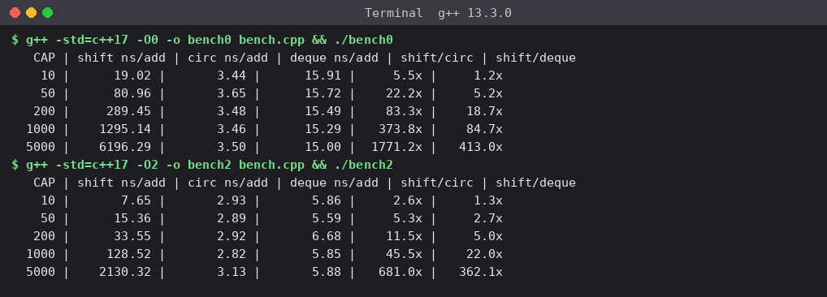
Figure 4.2 – ns per add for shifting array, circular buffer and std::deque (-O0 then -O2)
Capacity k | Shift (-O2) | Circular (-O2) | Deque (-O2) | Shift / circular
10 | 7.65 ns | 2.93 ns | 5.86 ns | 2.6×
50 | 15.36 ns | 2.89 ns | 5.59 ns | 5.3×
200 | 33.55 ns | 2.92 ns | 6.68 ns | 11.5×
1000 | 128.52 ns | 2.82 ns | 5.85 ns | 45.5×
5000* | 2130 ns | 3.13 ns | 5.88 ns | 681×

*At k = 5000 the 80 KB array no longer fits comfortably in the L1 cache, so the shift cost jumps more than linearly (cache effects); this is a measurement artefact worth noting, not a change in Big-O.
Design | Time to add | Space | Comment
Shifting array | O(k) | O(k) fixed, k·sizeof(Transaction) | Simplest; order = array order; slow when k grows (−O0: 19 → 1295 ns for k = 10 → 1000)
Circular buffer | O(1) | O(k) + one int head | Constant time (≈ 3 ns); needs modular indexing when reading
std::deque | O(1) amortised | O(k) + per-block overhead, heap allocation | Flexible and safe, but ≈ 2× slower than the hand-made circular buffer here and allocates

The measurements match the analysis: shifting grows linearly with k, the other two are flat.

Q5 – Static Members and Arrays of Objects (7 marks)

5.1 Predict the output – Token
#include <iostream>

class Token {
static int next;
int id;

public:
Token() { id = ++next; }
int get() const { return id; }
static int issued() { return next - 100; }
};

int Token::next = 100;

int main()
{
Token counter[3];
Token extra;
std::cout << counter[0].get() << ' ' << counter[2].get() << ' ' << extra.get()
<< ' ' << Token::issued() << '\n';
}

Prediction (before running): `101 103 104 4`. Reasoning: Token::next is initialised to 100. Token counter[3] runs the constructor three times, giving ids 101, 102, 103 (pre-increment: ++next first, then store). Token extra is the 4th object → id 104. counter[0].get() = 101, counter[2].get() = 103, extra.get() = 104 and Token::issued() = next − 100 = 104 − 100 = 4.
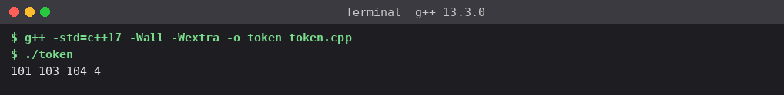
Figure 5.1 – Actual output of token.cpp
Prediction vs actual: identical, no difference. Why the counter starts at 100: the static data member is defined once, outside the class, as int Token::next = 100;; it is initialised before main starts and exists once for the whole class, not once per object, so the objects share it. The first ++next produces 101. The constructor ran 4 times (3 array elements + extra), which is why issued() = 4.

5.2 Complete the code – BusTicket
TODO 1 and TODO 2 completed in Q5/busticket.cpp (rest unchanged):
explicit BusTicket(const std::string& n) : seat(0), name(n)
{
// TODO 1: give the next seat only while seats remain
if (issued < CAPACITY) {
++issued;
seat = issued;
}
}

static int count()
{
// TODO 2: number of seats issued so far
return issued;
}

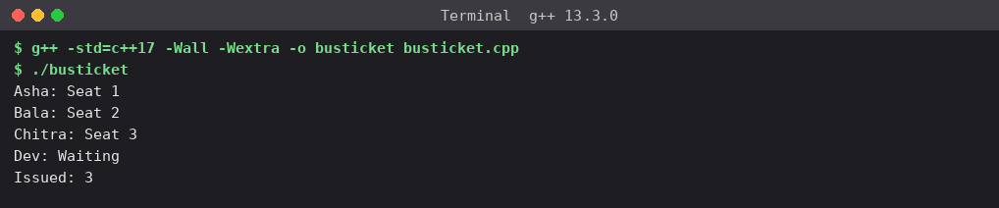
Figure 5.2 – Output equals the expected output
Expected and observed output are identical: Asha: Seat 1, Bala: Seat 2, Chitra: Seat 3, Dev: Waiting, Issued: 3 (the fourth ticket finds issued == CAPACITY, so seat stays 0 and print() shows "Waiting").

5.3 Design questions
Question | Answer
Which members must be static, and where is a static data member defined? | issued (the count of seats given out) and CAPACITY (the same for every ticket) belong to the whole class → static. count() is a static member function because the transport office must read the count without any particular ticket. seat and name stay non-static (each ticket has its own). A static data member is only *declared* inside the class; it must be defined exactly once outside the class, in one .cpp file: int BusTicket::issued = 0; (without it the linker reports an undefined reference). static const int of integral type (CAPACITY = 3) may be initialised inside the class.
Why can a static member function not use this or a non-static member? | A static function is called through the class (BusTicket::count()), not through an object, so there is no object and no this pointer. Non-static members like seat belong to a particular object and would have no object to refer to. g++ confirms: error: invalid use of member 'T::seat' in static member function and error: 'this' is unavailable for static member functions (Q5/static_err.cpp, Figure 5.3).
How is an array of BusTicket objects created and initialised? | The only constructor needs a name, so there is no default constructor and BusTicket trip[4]; would not compile. The array is initialised with an initialiser list {BusTicket("Asha"), …}; elements are constructed in index order 0…3, so the seat numbers follow the order of the list (4 constructor calls).
What happens to the count when tickets are created inside a loop or a function? | Every construction adds to the same static issued until it reaches CAPACITY. Objects that go out of scope are destroyed but nothing decrements the static, because it belongs to the class and lives for the whole program (shown in 5.4).

5.4 Test – more tickets than capacity; tickets created in a function called twice
Q5/tests.cpp creates two local tickets inside book() and calls it twice, then creates an array of 5 tickets. It also keeps a created counter to count constructions.
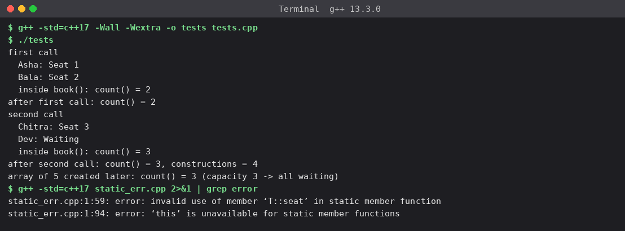
Figure 5.3 – Count is cumulative across calls; the array of 5 is all "Waiting"; static-function error messages
Observed: after the first call count() = 2 although both tickets were destroyed when book() returned; the second call continues from there – Chitra gets Seat 3 and Dev is Waiting – and count() becomes 3 with 4 constructions in total. The array of 5 created afterwards gets no seats at all (capacity exhausted). So the static count measures *seats issued over the lifetime of the program*, not the number of live objects. If "live tickets" were needed a destructor would have to decrement a separate counter.

5.5 Alternative concept and complexity analysis
Alternative: a TicketOffice object holding the counter and capacity, passed to every BusTicket (Q5/office.cpp), or a global variable. Output with two buses running at once: bus A issued 3 (Asha 1, Bala 2, Dev 3, Esha Waiting) and bus B issued 1 (Chitra Seat 1).
Aspect | Static member | Global variable | TicketOffice object
Time to issue a seat | O(1) | O(1) | O(1)
Space for counter | One int for the class | One int | One int per office (+ cap)
Extra space per ticket | 0 | 0 | a reference/pointer to the office, ≈ 8 bytes, if the ticket stores it
Encapsulation | Private to the class; only class code changes it | Any code can modify it – weakest | Private inside the office; accessed through next()
Two buses at once | No – one counter for all tickets | No | Yes – one office per bus (demonstrated)

Conclusion: the static member is the right tool when the data truly belongs to the whole class and exactly one instance of it is meaningful; as soon as the requirement becomes "several buses", the state belongs to an object (TicketOffice).

Q6 – Friend Functions and Inline Functions (8 marks)

6.1 Complete the code
TODO 1 and TODO 2 completed inside the two friend functions (Q6/time_complete.cpp). The functions use the private h and m directly; each time is converted to minutes since midnight.
int minutesBetween(const Time& a, const Time& b)
{
// TODO 1: absolute difference in minutes using private h and m
return std::abs((a.h * 60 + a.m) - (b.h * 60 + b.m));
}

bool earlier(const Time& a, const Time& b)
{
// TODO 2: true if a is earlier in the day than b
return (a.h * 60 + a.m) < (b.h * 60 + b.m);
}

6.2 Correctness check
Hand verification: 9:45 = 585 min, 13:10 = 790 min → |585 − 790| = 205; earlier(arrival, departure) asks whether 790 < 585 → false. Output 205 false = expected output. Further tests (Q6/time_tests.cpp) include the same time twice and times on either side of noon:
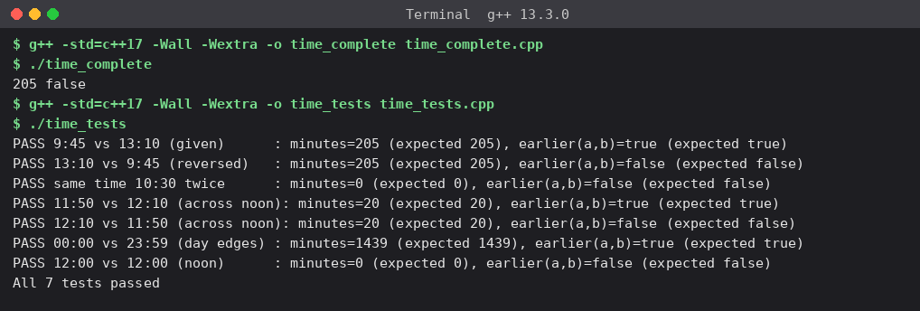
Figure 6.1 – Expected output reproduced (205 false) and 7/7 correctness tests passed
Test | Hand calculation | Result
9:45 vs 13:10 | 585 vs 790 → 205, earlier = true | PASS
13:10 vs 9:45 | 205, earlier = false | PASS
10:30 vs 10:30 (same time twice) | 0 min, earlier = false (not strictly earlier) | PASS
11:50 vs 12:10 (across noon) | 710 vs 730 → 20, earlier = true | PASS
12:10 vs 11:50 | 20, earlier = false | PASS
00:00 vs 23:59 (day edges) | 0 vs 1439 → 1439, earlier = true | PASS

6.3 Design questions
Question | Answer
Why is a friend function needed when the function works on two objects equally? | The data (h, m) is private. A non-member, non-friend function cannot read it (g++: error: 'int Time::h' is private within this context, Q6/friend_err.cpp). A member function would work but treats one object as special (a.minutesTo(b): a is *this, b an argument); for a symmetric operation on two objects a friend states the symmetry directly: minutesBetween(a, b).
How does a friend differ from a member in how it is called and what it can access? | Call: a member is invoked through an object with the dot/arrow operator and receives a hidden this; a friend is an ordinary function called with all operands as arguments and has no this. Access: both can read private members of the class, but a friend is not in the class scope (no Time:: qualifier, access specifiers do not apply to its declaration), is not inherited and the friendship is granted only by the class itself – and only to the named functions.
Should the small functions be inline, and what does inline ask the compiler to do? | inline is a request to replace the call by the function body at the call site, avoiding call/return overhead and enabling further optimisation; the compiler may ignore it (and GCC does at -O0). It also lets the definition appear in several translation units (header files) without violating the one-definition rule. These two-line functions called millions of times are ideal candidates; large functions are not, because inlining grows the code.
What would be lost if the private members were public? | Encapsulation: any code could set m = 75 or h = -3 and create an invalid time; the invariant "0 ≤ h < 24, 0 ≤ m < 60" could not be guaranteed. The representation could no longer be changed (e.g. to a single "minutes since midnight" integer) without editing every caller.

6.4 Growth investigation – 10,000,000 calls, with and without inline
Q6/inline_bench.cpp times 10,000,000 loop iterations, each making two calls (minutes and earlier) on pseudo-random times from a 1,024-element table (so the compiler cannot fold the result). Four designs are measured: friend functions declared inline; the same friend functions with __attribute__((noinline)); member functions (minutesTo, isEarlier); and free functions using public getters. Median of 7 runs.
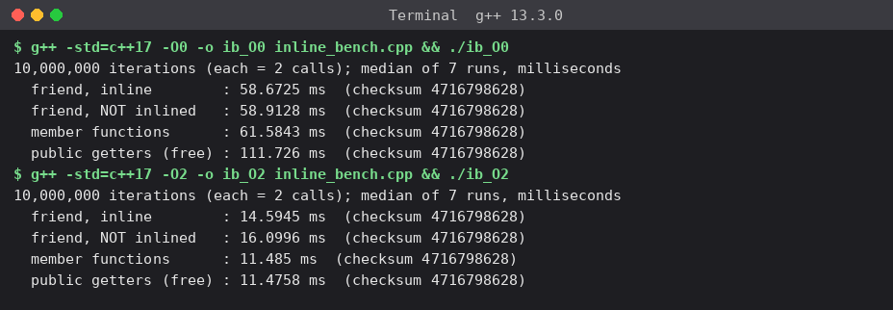
Figure 6.2 – Timings at -O0 and -O2 (identical checksum 4716798628 for all designs)
Design | -O0 (ms) | -O2 (ms)
Friend, inline | 58.7 | 14.6 *
Friend, NOT inlined (noinline) | 58.9 | 16.1
Member functions | 61.6 | 11.5
Public getters (free functions) | 111.7 | 11.5

* Run-to-run noise at -O2 is a few milliseconds on this shared 2-core machine: a second run gave 11.5 ms (inline friend) and 16.6 ms (non-inlined friend). The ranking "inlined faster than non-inlined" was stable; the three inlined designs are within noise of each other.
Explanation. (1) At -O0 the inline keyword has no effect: GCC does not inline at -O0, so inline and non-inline friends are the same (58.7 vs 58.9 ms ≈ 2.9 ns per call, dominated by unoptimised code and memory traffic). Public getters are 1.9× slower at -O0 because each getter is itself a real call (4 extra calls per comparison). (2) At -O2 the compiler inlines the small functions and the whole loop body shrinks to a few instructions: ≈ 0.6 ns per call versus ≈ 0.8 ns when a real call is forced (about 1.1–1.45× faster). The getter-based design becomes as fast as the friend version because the getters are inlined as well. Optimisation level matters far more (−O0 → −O2 is 4–5×) than the choice friend/member/getter.

6.5 Alternative concept and complexity analysis
Design | Time per call | Measured (-O0 / -O2, 20 M calls) | Encapsulation
Friend functions | O(1) | 58.7 / 14.6 ms | Private data stays private; access granted to exactly 2 named non-member functions; they must change if the representation changes
Member functions (a.minutesTo(b)) | O(1) – same after inlining | 61.6 / 11.5 ms | Strongest: only members touch the data; asymmetric call syntax
Public getters + free functions | O(1) – same after inlining, 4 extra calls at -O0 | 111.7 / 11.5 ms | Weakest of the three: h/m become readable by everyone (read-only), widening the public interface

6.6 Deployment decision
Decision: keep `minutesBetween` and `earlier` as friend functions (declared inline or defined in the header). Evidence: at -O2 friend, member and getter designs are equally fast (≈ 11.5–14.6 ms for 20 million calls), so performance gives no reason to change; at -O0 the getter design is almost twice as slow. Friends keep h and m private, add no getters to the public interface, and express the symmetric two-object operation naturally. I would switch to member functions if the number of functions needing the representation grows (a long friend list defeats the purpose), and to getters only if outside code genuinely needs to read hours and minutes anyway.
Evidence delivered: a justified friend-function design, correctness tests, measured timings at two optimisation levels and an evidence-based decision.

Q7 – Diagnose, Redesign and Validate (13 marks)
Program chosen: the SavingsAccount mini-statement of Q4 (shifting array of the last 10 transactions). The Q4 requirement already hinted at growth ("the bank now wants the last 50"), and Q4 produced the measurements needed for a diagnosis. The redesign was implemented as Q7/circular.cpp next to the unmodified Q7/original.cpp (both accept -DCAP=n).

A. Diagnose the limitation (2 marks)
Evidence from my own measurements (Q4, Figure 4.2): once the history is full, each deposit() costs (ns per add, -O2) 7.65 at k = 10, 15.4 at k = 50, 33.6 at k = 200, 128.5 at k = 1000; at -O0 19, 81, 289 and 1295 ns. The cost rises almost proportionally with the capacity k (≈ 1.3 ns per moved element at -O0, ≈ 0.12–0.15 ns at -O2), while the circular and deque versions stay flat at ≈ 3 ns and ≈ 6 ns.
Diagnosis: the design pins the logical start of the history to physical index 0 of a contiguous array. Discarding the oldest transaction therefore forces every surviving element to be moved one slot (last[i-1] = last[i]), i.e. O(k) data movement for every transaction after the buffer is full. The weakness is not the array itself but the coupling "oldest entry = element 0". It does not matter for k = 10 (a few nanoseconds) but becomes the dominant cost as the requirement grows to 50, 1000 or more.

B. Design objective (2 marks)
Objective: make the cost of recording a transaction independent of the history length k, so that at -O2 and k = 1000 a deposit() is at least 20× faster than the original and stays below 5 ns for every k from 10 to 1000, while miniStatement() output remains byte-identical to the original for the same transactions.

C. Design of the revised solution (4 marks)
What changes: the class keeps its public interface (deposit, withdraw, miniStatement, getBalance) and the private last[CAP] array, but adds one private data member head – the index of the oldest entry. Logical position *i* (0 = oldest) lives at physical index (head + i) % CAP.
SavingsAccount (class diagram)
Private data
long accNo
double balance
Transaction last[CAP] – fixed array (unchanged)
int count – valid entries, 0…CAP
int head – NEW: index of the oldest entry
Private
void record(char t, double amt) – changed: O(1) circular write
Public
SavingsAccount(long, double)
double getBalance() const
void deposit(double)
bool withdraw(double)
void miniStatement() const – changed: reads via (head + i) % CAP

record(type, amount):
e = Transaction{type, amount, balance}
if count < CAP: // still filling
last[(head + count) % CAP] = e ; count = count + 1
else: // full: 11th, 12th ... transaction
last[head] = e // overwrite the OLDEST entry
head = (head + 1) % CAP // the next-oldest becomes the oldest

miniStatement(): // newest first
for i = count-1 down to 0: print last[(head + i) % CAP]

// Q7/circular.cpp - the changed member functions
void SavingsAccount::record(char t, double amt)
{
Transaction e{t, amt, balance};
if (count < CAP) last[(head + count++) % CAP] = e; // still filling
else { last[head] = e; head = (head + 1) % CAP; } // overwrite oldest: O(1)
}
// in miniStatement(): const Transaction& t = last[(head + i) % CAP];

C++ features used: private data members and member functions (encapsulation: no caller changes), the % operator for wrap-around, and a compile-time constant CAP (the -DCAP= macro only lets me benchmark several sizes). Extra memory: one int (4 bytes plus padding) per account – no extra array; total space remains O(k). New trade-off: the history is no longer stored in order in memory, so every read needs an index calculation with a modulo; the logic is slightly harder to read and to debug than a plain array.
Note that I did not just replace the array with std::deque: the circular-index solution removes the root cause (data movement) by changing how positions are interpreted. std::deque is included in the Q4 measurements only as a comparison (≈ 5.9 ns, about twice the hand-made circular buffer).

D. Predict before implementing (1 mark)
Prediction derived from the Q4 cost model (shift cost ≈ c·(k − 1) with c ≈ 0.12–0.15 ns per element at -O2, circular cost constant ≈ 3 ns):
Capacity k | Predicted speed-up of deposit() (-O2) | Predicted read-path (checksum/statement walk)
10 | ≈ 2–3× faster | circular slower: ≈ 2–3× (modulo on every element)
50 | ≈ 5× faster | circular ≈ 2–3× slower
1000 | ≈ 40× faster; circular flat at ≈ 3 ns | circular ≈ 2–3× slower

Testable measure: ns per deposit() at k = 10, 50, 200, 1000, and ns to walk the whole history, using the same benchmark loop on both programs (bench_add.sh, bench_read.sh).

E. Implement and validate (2 marks)
Correctness first. The same scripted sequence (60 transactions mixing deposits and withdrawals) was run through both programs; the outputs are byte-identical for k = 10 and k = 50 (the diff printed nothing; MD5 sums of both outputs equal).
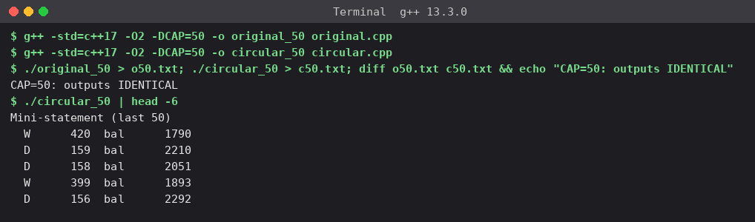
Figure 7.1 – original and circular produce identical statements at CAP = 50
Measurements (same machine, -O2, median-of-7 best ns per call, 1,000,000 deposits; reads: 2,000,000 full-history walks):
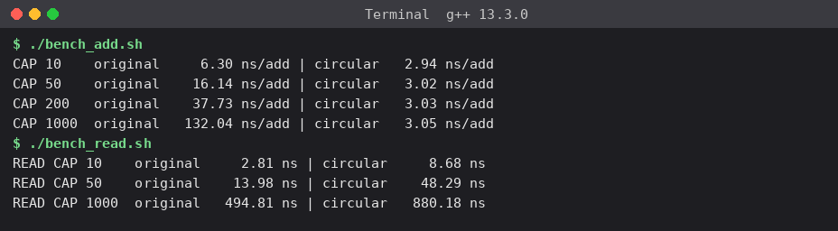
Figure 7.2 – Write path (deposit) and read path (walking the history), original vs circular
Capacity k | Original deposit | Circular deposit | Speed-up | Predicted | Original read | Circular read | Read slow-down
10 | 6.30 ns | 2.94 ns | 2.1× | 2–3× | 2.81 ns | 8.68 ns | 3.1×
50 | 16.14 ns | 3.02 ns | 5.3× | ≈ 5× | 13.98 ns | 48.29 ns | 3.5×
200 | 37.73 ns | 3.03 ns | 12.5× | – | – | – | –
1000 | 132.04 ns | 3.05 ns | 43.3× | ≈ 40× | 494.81 ns | 880.18 ns | 1.8×

The same measurements at -O0 (separate run): original 25 / 73 / 262 / 1276 ns versus circular 4.6 / 4.5 / 4.5 / 4.9 ns for k = 10 / 50 / 200 / 1000.

F. Defend the final design (2 marks)
Question | Evaluation
Was the objective achieved? | Yes for the write path. At k = 1000 the speed-up is 43× (target ≥ 20×); the cost is flat at 2.9–3.05 ns for all k (target < 5 ns); statements are byte-identical. The speed-up predictions held for the write path (≈ 2×, 5×, 43× vs predicted 2–3×, 5×, 40×). The read-path prediction (2–3× slower) was slightly off: 3.1× at k = 10, 3.5× at k = 50 and only 1.8× at k = 1000, where memory traffic rather than the modulo dominates.
What new costs were introduced? | (1) Reading the history is up to 3.5× slower (e.g. 14 → 48 ns at k = 50) because every element needs (head + i) % CAP; (2) one extra int per account; (3) more complex indexing code that is easier to get wrong (off-by-one at wrap-around) – which is why I verified identical output before measuring; (4) the data is not in chronological memory order, so e.g. a block copy of the history needs two segments. The read cost could be reduced by walking the two contiguous segments instead of using % per element.
Where may the original be preferable? | For the real ATM requirement (k = 10) the difference is only 3 ns per transaction, while printing a mini-statement through std::cout takes microseconds – the I/O dwarfs both designs. If the statement is read much more often than transactions are written, or the code must be maintained by beginners, the simple shifting array (faster reads, trivial indexing) is the better engineering choice. The redesign pays off when k grows (50 and above) and writes are frequent.
Conclusion | The redesign correctly removes the diagnosed cause (O(k) element movement) and meets its measured objective, at the price of slower reads and more complex indexing. It is not unconditionally better: I would choose the circular buffer for capacities ≥ 50 or write-heavy workloads, and keep the plain shifting array for the 10-entry mini-statement where simplicity wins.

Appendix A – README.md (as submitted in the repository)
# DSA01-192565075-Assignment2

| | |
|---|---|
| **Name** | `<YOUR NAME>` |
| **Register number** | 192565075 |
| **Course** | Data Structures and Algorithms (DSA01) – Assignment 2 (CO2) |
| **Compiler** | g++ 13.3.0 (Ubuntu 13.3.0-6ubuntu2~24.04.1) on Linux x86-64 |

## Compile command

```
g++ -std=c++17 -Wall -Wextra -o <name> <name>.cpp
```
Timing programs add `-O0` or `-O2`; Q7 programs add `-DCAP=<n>`; Q2 sanitizer runs add `-g -fsanitize=address`.

## Layout and how to run (one folder per task; output screenshots in `QN/screenshots/`)

| Task | Files | Run | Result |
|---|---|---|---|
| Q1 | `predict.cpp`, `complete.cpp`, `three_ways.cpp` | `g++ ... -o x x.cpp && ./x` | Prediction `1 12 13 / 1 100 / 16 13 6` matched. Complete-the-code prints 45000 then 40500. Value version leaves the fee unchanged; reference and pointer change it. |
| Q2 | `marks.cpp`, `vector_grow.cpp`, `alternatives.cpp` | `./marks` ; `./marks bad` (dangling call) | Reference return lets `f() += 2`. Returning a local reference gives `-Wreturn-local-addr` and a segfault (exit 139). Vector growth moves the element (ASan: heap-use-after-free). |
| Q3 | `ambiguous.cpp` (fails to compile), `ambiguous2.cpp` (fails), `charge.cpp`, `alt_parcel.cpp` | `./charge` | Six predicted overload selections all matched: 30.04, 70.00, 80.00, 120.00, 115.00, 90.00. |
| Q4 | `account.cpp`, `bench.cpp` | `./account` ; `./bench2` | 11th+ transactions discard the oldest. Shifting cost grows with capacity; circular index is constant. |
| Q5 | `token.cpp`, `busticket.cpp`, `tests.cpp`, `static_err.cpp` (fails), `office.cpp` | `./busticket` | Token prints `101 103 104 4`. BusTicket matches expected output (Seat 1-3, Dev waiting, Issued 3). |
| Q6 | `time_complete.cpp`, `time_tests.cpp`, `inline_bench.cpp`, `friend_err.cpp` (fails) | `./time_complete` | `205 false`; 7/7 tests pass; inline timings at -O0 and -O2 recorded. |
| Q7 | `original.cpp`, `circular.cpp`, `bench_add.sh`, `bench_read.sh` | `./bench_add.sh` | Circular buffer: ~3 ns per deposit for every capacity; original grows linearly (6 ns at 10 to 132 ns at 1000). Output identical. Reads are slower in the redesign. |

Files marked "(fails)" are intentional compile-error demonstrations; the error text is in the report.
Timings vary by machine and load (about +-10 %); medians of 7 runs are reported.

Appendix B – GitHub submission checklist and commit commands
The assignment requires a repository named DSA01-<RegisterNumber>-Assignment2, shared with the faculty, one folder per task, and at least one commit per task (a single upload on the last day is not accepted). The source folder supplied with this report is laid out exactly that way. Suggested commands (run on your own machine after executing every program yourself):
git init DSA01-192565075-Assignment2 && cd DSA01-192565075-Assignment2
# copy README.md and the Q1..Q7 folders in, one task at a time:
git add README.md Q1 && git commit -m "Q1: call by value/reference/pointer"
git add Q2 && git commit -m "Q2: return by reference and dangling references"
git add Q3 && git commit -m "Q3: default arguments and overloading"
git add Q4 && git commit -m "Q4: SavingsAccount class with array"
git add Q5 && git commit -m "Q5: static members and arrays of objects"
git add Q6 && git commit -m "Q6: friend and inline functions"
git add Q7 && git commit -m "Q7: diagnose, redesign and validate"
git branch -M main
git remote add origin https://github.com/<your-username>/DSA01-192565075-Assignment2.git
git push -u origin main

Then add the faculty as a collaborator (or make the repository public) and paste the link on the cover page.

Appendix C – Summary of complexity results
Task | Alternative compared | Time | Space | Own measurement
Q1 | In-place vs return new fee; by value/reference/pointer/const& | O(1) all | 8 bytes copied (by value / pointer) vs 0 (reference); O(s) for large objects by value | Outputs 45000 / 40500 / 36450 / 40500
Q2 | Reference vs index vs pointer | O(n) all | O(1) | 1.74–1.89 ns/element for n = 10³…10⁷
Q3 | Overloads+defaults vs Parcel struct/template | Compile-time resolution, O(1) run time | ≈16 bytes vs struct fields | All six predicted selections correct
Q4 | Shift vs circular vs deque | O(k) vs O(1) vs O(1) | O(k) each (+1 int / + block overhead) | -O2 k = 1000: 128.5 / 2.8 / 5.9 ns
Q5 | Static vs global vs TicketOffice | O(1) all | 1 int (+ pointer per ticket for office) | Count 2 → 3 over two calls; 4 constructions
Q6 | Friend vs member vs getters; inline vs not | O(1) all | O(1) | -O2: 11.5–14.6 ms inline vs 16.1 ms not (20 M calls)
Q7 | Original vs circular (Q4 program) | O(k) vs O(1) per add; reads O(k) both | O(k) + one int | k = 1000: 132 → 3.05 ns (43×); reads 1.8–3.5× slower

