# **Building Beowulf Cluster with Raspberry Pi**

# **August 2018**

# Abstract

This paper summarizes our project in building and setting up Beowulf cluster of Raspberry Pis. Main purpose of this project is to construct a cluster by using several small sized low power single board computers, in our case it is Raspberry Pi. Beowulf cluster is simply a collection of identical, commodity computer hardware systems, networked together and running parallel processing software which allows each nodes in the cluster to share data each other. The parallel programming which is running in the cluster is called MPI(Message Passing Interface), which uses TCP/IP along with some libraries to allow programmers to create parallel programs that can split a task into parts to run on multiple machines simultaneously.

# INTRODUCTION (HEADER 1)

Insert your introductory text here. Be sure to highlight the main point your white paper will cover. In this section, you should:

* **State the problem your white paper intends to solve**. To create added urgency, it should also touch on the consequences for not taking action.
* **Summarize the key areas your white paper will cover**. Give a high-level overview of what readers can expect from start to finish.
* **Explain the benefits of reading your white paper**. What will your reader be equipped to do after reading what you have to say?

## SUBSECTION SUB-HEADER (HEADER 2)

This is where you’ll place your first sub-point. It should tie back into your introduction. As you proceed, be sure to cover each sub-point you identified in your outline. Copy and paste this section as necessary for each sub-section in your white paper.

### Sub-point 1

You might consider placing sub-points under Heading 3-level sub-headlines. However, we recommend not using anything smaller. Too many different header levels can create an overly busy visual appearance, making your white paper harder to read.

When writing each section, consider using bulleted lists to make text easy to skim. For example:

* This is an insightful point about your topic.
* Here’s another interesting piece of data.
* Finally, here is a third important takeaway.

### Sub-point 2

See above.

### Sub-point 3

Same deal here.

## Working With Graphics, Charts, and Sidebars

If you have data you’d like to present visually, you have two choices: build graphics yourself or work with a designer (if you have a designer on staff). In general, it’s best to have a professional designer handle graphics.

Use these graphics and sidebar templates to present data for your designer:

*GRAPHIC HEADLINE*: [*Include a brief header or title for your graphic*]

*GRAPHIC COPY*: [*Include descriptive copy*]

*GRAPHIC DATA*: [*Include statistics, numbers, percentages, metrics, and so forth*]

*GRAPHIC NOTES*: [*Include other thoughts or image direction for your designer*]

## Adding One-Pagers

Large graphics and charts may work best on their own pages. Copy and paste this section onto its own page, and add your own image and copy where necessary.

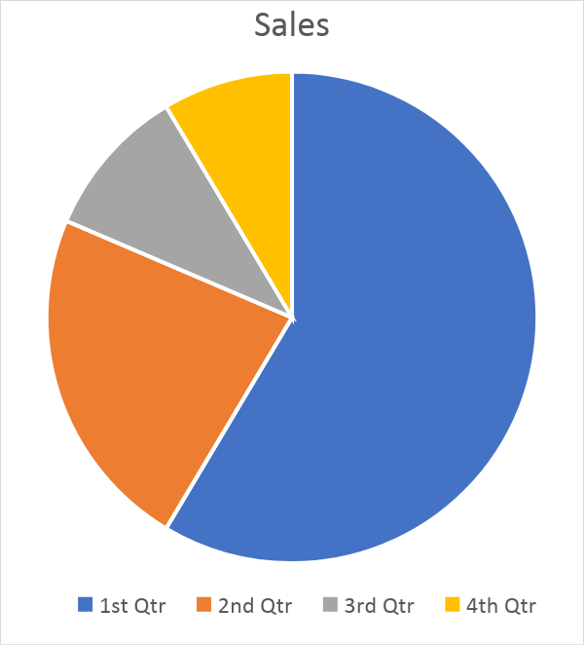

*These sales numbers indicate positive growth*.

# About [Your Company]

Include a brief description of your company. If you have a boilerplate description used for press releases or on your organization’s About page, consider repurposing it here.

# References

Cite your sources! List every source used for research and cited in your document. Use [CitationMachine.net](http://www.citationmachine.net/) to quickly generate correctly formatted citations in APA style.