WEEK 4 TASK

Testing, Evaluation and Comprehensive Documentation
Project: Online Citizen Service Portal
Student Name: Praneeth Sagar Irkulla
Roll Number: 25EU6R0703

1. Introduction
This Week 4 report presents the testing, evaluation, and final documentation of the Online Citizen Service Portal. Week 1 covered project planning and requirements, Week 2 described the proposed system architecture, and Week 3 implemented a Python prototype for submitting and tracking citizen service requests. The final phase defines test procedures, records expected outcomes, evaluates the prototype's strengths and limitations, and recommends future improvements. The prototype is an educational demonstration using in-memory sample data and is not connected to official government systems.

2. Project Objectives
- Verify that valid service requests can be submitted and assigned reference numbers.
- Check that blank or invalid input is rejected before a request is saved.
- Validate request listing, retrieval, and status-update operations.
- Evaluate reliability, maintainability, usability, and readiness for future development.
- Document testing methods, metrics, challenges, lessons learned, and recommendations.

3. Module Under Test
The prototype contains a ServiceRequest data model and a CitizenPortal class. Its main operations are submit_request(), list_requests(), get_request(), and update_status(). A valid request needs a citizen name, service type, and description of at least ten characters. A reference number is generated and the initial status is Submitted. Supported statuses include Submitted, Under Review, More Information Required, Approved, Rejected, and Completed. Data is stored in memory and is lost when the program ends.

4. Testing Strategy
Testing level | Purpose | Method
Unit testing | Check individual methods and validation rules | Use Python unittest with valid and invalid input.
Integration testing | Check that operations work together | Submit, retrieve, list, and update a request.
Negative testing | Ensure invalid input is rejected | Try blank fields, short descriptions, invalid statuses, and unknown IDs.
Regression testing | Ensure changes do not break existing features | Rerun all tests after code changes.
Usability review | Check whether the workflow is understandable | Review the steps and clarity of system messages.
Security review | Identify gaps before deployment | Review authentication, permissions, storage, and audit needs.

5. Testing Workflow
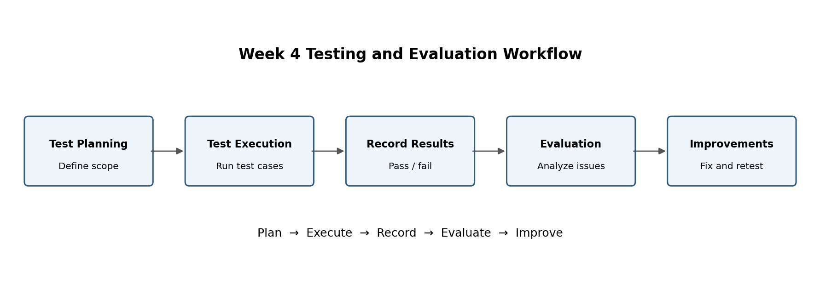
Figure 1. Testing workflow from planning to improvement.

6. Test Cases
Test ID | Scenario | Input/action | Expected result | Type
TC-01 | Valid submission | All required fields supplied | Request created with reference ID and Submitted status | Positive
TC-02 | Blank name | Name is spaces only | ValueError; no request created | Negative
TC-03 | Blank service | Service type is blank | ValueError; no request created | Negative
TC-04 | Short description | Description under 10 characters | ValueError; no request created | Negative
TC-05 | Update status | Set existing request to Under Review | Status updates successfully | Positive
TC-06 | Unsupported status | Set status to In Progress | ValueError is raised | Negative
TC-07 | Unknown reference | Update CSR-9999 | LookupError is raised | Negative
TC-08 | List requests | Submit two requests then list | Both requests are returned | Integration
TC-09 | Retrieve request | Look up an existing reference | Correct request is returned | Integration
TC-10 | Persistence check | Restart the program | Requests are lost; known limitation | Limitation

7. Test Execution Procedure
- Place the Week 3 prototype file and its test file in the same folder.
- Run the test suite using: python -m unittest test_online_citizen_portal.py
- Record the date, Python version, total tests, passed tests, failed tests, and error details.
- For every failure, reproduce the issue, correct the cause, and rerun the full suite.
- Manually run the prototype and verify the example request submission and status update.
- Report observed results honestly; expected results are not the same as executed results.

8. Results and Evaluation Metrics
The following metrics should be completed after running the test suite. The report does not claim that the tests have passed because execution results depend on the local environment.
Metric | Measurement / target
Test pass rate | Passed tests ÷ executed tests × 100; target 100% for defined tests.
Defect count | Count reproducible failures and classify severity.
Input validation | All invalid-input tests should be rejected.
Status correctness | Only supported status values should be accepted.
Response time | Measure with a timer if performance testing is performed; no benchmark claimed.
Data persistence | Not supported in the current prototype; record as a known limitation.

9. Performance Analysis
The prototype performs simple operations on an in-memory list, so request submission and lookup should be suitable for a small demonstration. However, no formal load test or measured response-time benchmark has been conducted. Lookup is linear because the program checks requests one by one; its time grows with the number of stored requests. A database with indexed reference IDs would be more suitable for larger workloads. Performance should be measured with realistic test data before making claims about production capacity.

10. Strengths
- Readable and modular Python implementation.
- Input validation prevents common incomplete submissions.
- Reference IDs help identify requests during a demonstration.
- A fixed set of statuses improves consistency.
- Separate methods make future API and database integration easier.

11. Weaknesses and Limitations
- Data disappears when the program ends.
- There is no browser-based interface or real user login.
- Role-based access control is not implemented.
- Sequential reference IDs are only unique within one program instance.
- Document uploads, notifications, monitoring, and backups are not implemented.
- Accessibility and formal performance testing have not been completed.

12. Challenges and Lessons Learned
The main challenge was limiting the prototype to a manageable feature while keeping the larger portal requirements in view. Separating request data from the operations made the code easier to understand and test. Validation and a fixed set of statuses reduce inconsistent records. The project also shows that temporary memory storage is useful for a demonstration but unsuitable for a real service. A key lesson is to distinguish expected test outcomes from actual observed results and to keep execution evidence for the final report.

13. Future Recommendations
- Connect the module to PostgreSQL or another persistent database.
- Develop a responsive citizen interface and a separate staff dashboard.
- Add secure authentication, role-based permissions, and session protection.
- Add protected document uploads with file type/size checks and malware scanning where available.
- Provide in-portal or email notifications when request status changes.
- Use collision-safe IDs and enforce uniqueness at the database level.
- Add structured logging, monitoring, alerts, automated backups, and recovery tests.
- Conduct accessibility, security, and load testing before deployment.

14. Consolidated Project Lifecycle
Week | Focus | Deliverable
Week 1 | Planning and requirements | Objectives, scope, stakeholders, requirements, risks, and timeline.
Week 2 | System design and architecture | Architecture, modules, data model, API outline, and technology stack.
Week 3 | Prototype implementation | Python request-processing module, pseudocode, and development notes.
Week 4 | Testing and final documentation | Test cases, execution procedure, metrics, evaluation, and future recommendations.

15. Conclusion
This report provides a structured testing and evaluation plan for the Online Citizen Service Portal prototype. The test cases cover valid submissions, invalid input, reference handling, request listing, retrieval, and status updates. The module demonstrates the core business flow but requires persistent storage, secure authentication, a web interface, document handling, notifications, and operational monitoring before it could be considered a more complete application. Running the test suite and recording actual outcomes will provide evidence of correctness and guide the next development phase.

16. References
- Python unittest documentation: https://docs.python.org/3/library/unittest.html
- OWASP Foundation: https://owasp.org/
- PostgreSQL documentation: https://www.postgresql.org/docs/
- Week 1 project planning and requirements report.
- Week 2 system design and architecture report.
- Week 3 prototype implementation report.

