WEEK 2 TASK

System Design and Architecture
Project: Online Citizen Service Portal
Student Name: Praneeth Sagar Irkulla
Roll Number: 25EU06R0703

1. Introduction
The Online Citizen Service Portal is a proposed digital platform that brings selected public services into one website. Week 1 defined the project objectives, scope, stakeholders, and requirements. This Week 2 document converts those requirements into a practical system architecture. It identifies the major software components, their responsibilities, communication paths, data storage, security controls, technology choices, deployment approach, and scalability considerations. The design is a proposed academic architecture and would need validation by the responsible department before use with real citizen information.

2. Requirements Review
The architecture is designed around the following key requirements:
- Citizens can register, sign in, browse services, submit applications, upload documents, and track progress.
- Authorized service officers can review applications, request corrections, and update statuses.
- Administrators can manage service content, roles, and system configuration.
- The portal provides reference numbers and notifications for important status changes.
- Personal information and documents must be protected through access controls, secure communication, and audit logging.
- The interface should be responsive, accessible, maintainable, and reliable.

3. Architectural Goals and Principles
- Separation of concerns: keep user interface, application logic, data storage, and operations responsibilities distinct.
- Security by design: authenticate users, authorize each protected action, validate inputs, and log important events.
- Maintainability: organize code into modules with clear interfaces and automated tests.
- Reliability: validate data, handle errors consistently, back up important records, and monitor system health.
- Scalability: allow application services and background notification tasks to scale as usage increases.
- Accessibility: use clear navigation, semantic page structure, keyboard support, and readable contrast.

4. High-Level System Architecture
The proposed architecture uses a layered design. Users access the portal through a browser. The presentation layer communicates with the application/API layer over HTTPS. The application layer implements business rules and calls the database, document storage, and notification service. Security and operations controls apply across all layers.
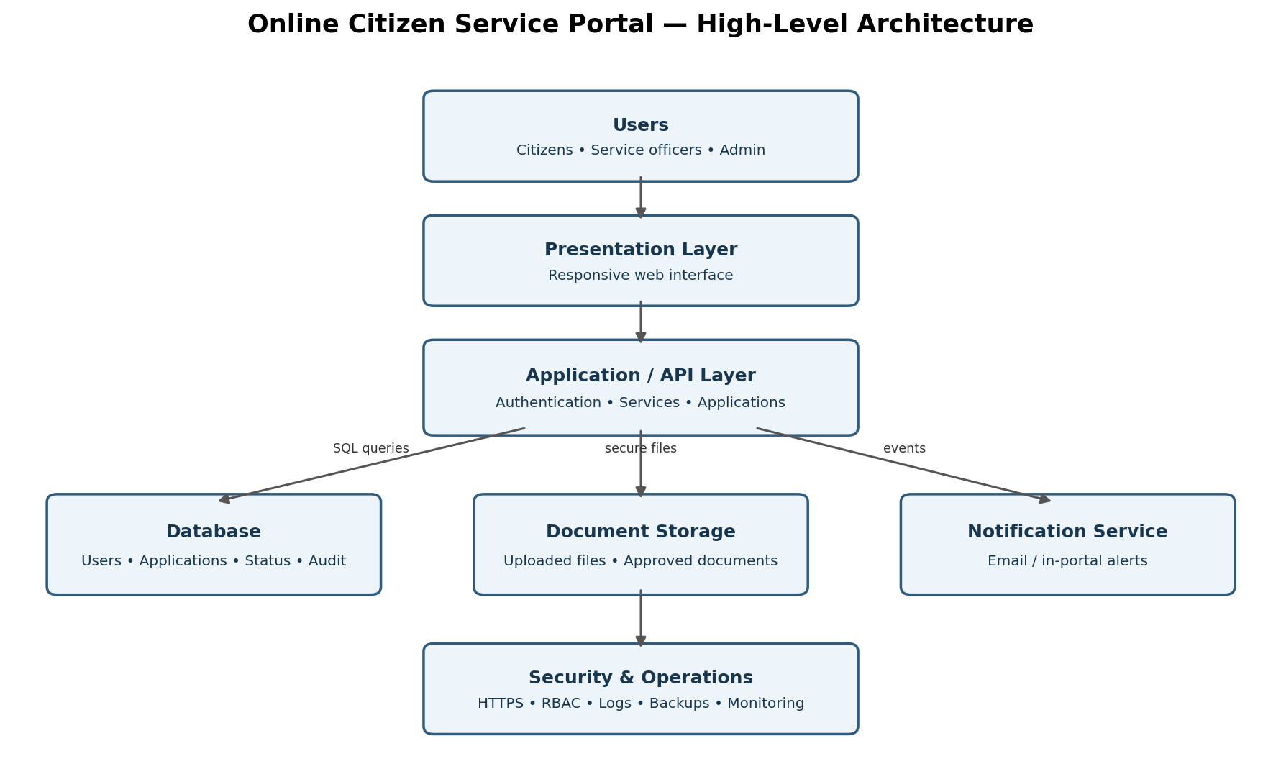
Figure 1. High-level architecture of the Online Citizen Service Portal.

5. Main System Components
5.1 Presentation Layer. Provides responsive pages for citizens, service officers, and administrators. It displays the service catalogue, forms, status information, validation messages, and dashboards. It should not contain trusted business rules or database credentials.
5.2 Authentication and Authorization. Handles sign-in, sign-out, session management, password reset, and optional multi-factor authentication. Role-based access control distinguishes citizen, officer, and administrator permissions. Each API endpoint must check authorization on the server.
5.3 Service Catalogue Module. Stores and displays service descriptions, eligibility rules, instructions, document checklists, and service categories. Administrators can update content through authorized workflows.
5.4 Application Management Module. Accepts applications, validates required fields, assigns a unique reference number, records submission time, and maintains the application status history. It supports correction requests and officer review.
5.5 Grievance Module. Allows citizens to submit complaints or requests for assistance, receive a reference number, and view progress. Access is limited to the citizen and authorized staff.
5.6 Database Layer. Stores user profiles, service metadata, application records, status history, role mappings, and audit metadata. Relational storage is suitable for structured records and transactional consistency.
5.7 Document Storage. Stores uploaded supporting documents separately from core relational records. Files should have size and type limits, malware scanning where available, private access by default, and short-lived authorized download links.
5.8 Notification Service. Sends submission confirmations and status-change alerts through email or in-portal notifications. Notification failures should be retried safely and should not silently lose the underlying application update.
5.9 Administration and Audit. Provides controlled management of service content and roles, plus audit records for important staff and administrative actions. Audit logs should be protected against unauthorized changes.
5.10 Monitoring and Backup. Collects application errors, service health metrics, and security events. Scheduled backups and recovery tests help protect availability and data integrity.

6. Module Interaction and Data Flow
1. A citizen opens the portal and selects a service from the catalogue.
2. The user signs in, and the server validates the session and role.
3. The citizen completes the application form and uploads required files.
4. The application API validates the data, checks permissions, stores the application, and creates a unique reference number.
5. The database records the application and initial status; documents are stored in private file storage.
6. A notification event is created to confirm successful submission.
7. An authorized officer opens the staff dashboard, reviews the application, and records a decision or correction request.
8. The status history is updated and the citizen is notified. The citizen can later sign in to view the current status.

7. Suggested Technology Stack
Layer / Purpose | Suggested Technology | Reason
Frontend | HTML, CSS, JavaScript; React optional | Responsive, component-based user interface.
Backend API | Python with Django REST Framework or FastAPI | Clear API design, validation, and maintainable application logic.
Database | PostgreSQL | Reliable relational storage and transaction support.
Document storage | Private object storage or protected server storage | Separates uploaded files from structured records.
Authentication | Framework-supported secure sessions; MFA where appropriate | Reduces risk from custom authentication code.
Notifications | SMTP email service or approved notification provider | Sends submission and status updates.
Version control | Git and GitHub | Tracks changes and supports collaboration.
Testing | Pytest plus API and browser tests | Checks business rules, access control, and user workflows.
Deployment | Docker with a managed cloud or approved institutional server | Repeatable deployment and easier scaling.
Monitoring | Centralized logs and service-health monitoring | Helps detect failures and investigate incidents.
These technologies are recommendations, not mandatory requirements. The final selection should consider the team's skills, hosting policy, licensing, budget, integration constraints, and the department's security standards.

8. Data Model Overview
Entity | Important fields / purpose
User | user_id, name, contact details, password hash or identity-provider ID, account status
Role | role_id, role_name, permissions
Service | service_id, title, description, eligibility, required documents, active status
Application | application_id, reference_number, user_id, service_id, submitted_at, current_status
ApplicationStatusHistory | history_id, application_id, status, changed_by, changed_at, note
Document | document_id, application_id, storage_key, file_type, size, uploaded_at
Notification | notification_id, user_id, application_id, channel, delivery_status, created_at
AuditLog | audit_id, actor_id, action, target_type, target_id, timestamp

9. API Design Overview
Example API routes are illustrative and should be documented with request fields, response formats, authorization rules, and error codes.
- POST /api/auth/login — authenticate a user.
- GET /api/services — list active services.
- GET /api/services/{service_id} — view service details.
- POST /api/applications — submit a new application.
- GET /api/applications/{reference_number} — view an application's status after authorization.
- POST /api/applications/{id}/documents — upload a permitted document.
- PATCH /api/staff/applications/{id}/status — update status for authorized staff.
- POST /api/grievances — submit a grievance.
- GET /api/admin/reports — retrieve permitted summary reports.

10. Security Architecture
- Use HTTPS for all connections and secure cookies or tokens with appropriate expiration and storage controls.
- Store passwords only as strong salted hashes using a trusted framework's password-hashing implementation.
- Enforce least privilege and role-based access on the server for every protected action.
- Validate input on the server, use parameterized database queries, and protect against common web vulnerabilities.
- Restrict uploaded file types and sizes; scan files where possible and keep them outside public web directories.
- Apply rate limiting to login and sensitive endpoints; monitor repeated failures and suspicious activity.
- Protect secrets using environment-based secret management; never commit credentials to the source repository.
- Record security-relevant events without logging passwords, session tokens, or unnecessary sensitive data.
- Define retention, deletion, backup, incident response, and access-review procedures before production launch.

11. Deployment and Scalability
For a prototype, the frontend, API, and database can run in a controlled test environment with sample data. For production, use separate application and database services, private networking where possible, managed secrets, automated deployment checks, HTTPS, monitoring, and tested backups. Containerization can make environments consistent. If traffic increases, multiple API instances can be placed behind a load balancer. Static assets can be served through a content delivery network, while notification processing can run in a background worker. Database indexes, connection pooling, caching of non-sensitive catalogue data, and performance tests can improve efficiency. Scaling should follow measured demand rather than adding complexity prematurely.

12. Reliability, Testing, and Quality Plan
- Unit tests: verify validation, reference-number generation, status transitions, and permission rules.
- Integration tests: verify API-to-database, document storage, and notification interactions.
- Security tests: test unauthorized access, role separation, file-upload controls, and common web vulnerabilities.
- Usability tests: ask representative users to locate a service, submit a sample form, and check status.
- Accessibility tests: check keyboard navigation, labels, focus order, contrast, and screen-reader semantics.
- Performance tests: measure common-page and API response times under expected usage.
- Recovery tests: verify that backups can be restored and the service can recover from common failures.

13. Architecture Risks and Mitigation
Risk | Potential effect | Mitigation
Incorrect access-control rules | Citizens may see other users' records | Centralize authorization checks and test access boundaries.
Document exposure | Private files could become publicly accessible | Use private storage, authorized access, short-lived links, and audits.
Notification outage | Users may miss status updates | Use retries, delivery tracking, and in-portal status as the source of truth.
Database failure | Applications may become unavailable | Use tested backups, monitoring, and a documented recovery plan.
Growing requirements | Architecture may become difficult to maintain | Use modular services and a formal change-control process.
Third-party integration failure | Some workflows may be delayed | Define timeouts, retries, clear error handling, and fallback procedures.

14. Estimated Timeline and Effort
Activity | Estimated hours | Deliverable
Review Week 1 requirements | 3 | Confirmed requirements
Define architecture and modules | 5 | Architecture description
Prepare architecture and workflow diagrams | 5 | Embedded diagrams
Design database entities and API routes | 5 | Data model and API outline
Select technology stack and justify choices | 4 | Technology plan
Plan security, deployment, and scaling | 5 | Security and deployment plan
Prepare test and risk strategy | 3 | Quality and risk plan
Review and finalize documentation | 3 | Final DOCX report
Total estimated effort: 33 hours. The estimate is for architecture and documentation work, not a complete production implementation.

15. Evaluation Criteria
- The architecture directly supports the requirements established in Week 1.
- Each major component has a clear responsibility and defined interactions.
- Diagrams and data flow are clear, consistent, and easy to understand.
- Technology choices are justified in terms of security, performance, maintainability, and scalability.
- Security, privacy, accessibility, deployment, and failure handling are addressed.
- The document is logically organized and can guide future implementation and testing.

16. Conclusion
This system design proposes a layered, modular architecture for the Online Citizen Service Portal. The presentation layer provides a responsive interface, the application/API layer enforces business rules, and dedicated data, document, and notification components support application processing. Security controls, audit records, backups, monitoring, and testing are essential across the system. The proposed stack is suitable for a student prototype while allowing a path toward a larger deployment if approved and properly secured. Before implementation, the requirements and design should be reviewed with stakeholders, and the architecture should be validated through prototypes, test cases, and security review.

17. References
- OWASP Foundation — Web Application Security: https://owasp.org/
- W3C — Web Accessibility Initiative: https://www.w3.org/WAI/
- NIST — Cybersecurity Framework: https://www.nist.gov/cyberframework
- PostgreSQL Documentation: https://www.postgresql.org/docs/
- Django Documentation: https://docs.djangoproject.com/

