WEEK 3 TASK

Software Development Prototype Implementation
Project: Online Citizen Service Portal
Student Name: Praneeth Sagar Irkulla
Roll Number: 25EU06R0703

1. Introduction
This Week 3 report describes a small software prototype for the Online Citizen Service Portal planned in Weeks 1 and 2. The prototype focuses on one core module: service request processing. It demonstrates input validation, reference-number generation, request storage in memory, request listing, status tracking, and staff status updates. The goal is to show the logical flow of a feature and document the implementation approach. This is an educational prototype using sample data; it is not a production government service and does not connect to official systems.

2. Selected Module and Objectives
Selected module: Service Request Processing and Status Tracking.
- Accept a citizen name, service type, and request description.
- Validate required fields and reject incomplete or invalid input.
- Generate a unique reference ID for each request during the current run.
- Store submitted requests in a simple in-memory list.
- Allow the request list to be viewed and a request status to be updated.
- Demonstrate how the module can later connect to a web interface, database, authentication, and notifications.

3. Prototype Scope and Limitations

Included
- Field validation for name, service type, and minimum description length.
- Reference ID in the format CSR-0001, CSR-0002, and so on.
- Initial status set to Submitted.
- Status updates to Under Review, More Information Required, Approved, Rejected, or Completed.
- Lookup by reference ID and listing of requests in memory.

Not Included Yet
- Real user login, password management, or role-based access.
- Persistent database storage; requests are lost when the program ends.
- Real email/SMS notifications, document upload, payment, or government-system integration.
- Production-grade logging, deployment, and security monitoring.

4. Development Plan
Stage | Activities | Output
1. Confirm requirements | Select service request processing as the core module | Module requirements
2. Design data structure | Define request fields and allowed statuses | ServiceRequest model
3. Implement validation | Check required values and description length | Input validation
4. Implement operations | Create, list, retrieve, and update requests | Working module logic
5. Test core flows | Check valid inputs, invalid inputs, and status updates | Test cases and results
6. Document and review | Record limitations and future enhancements | Final report and code

5. Workflow Diagram
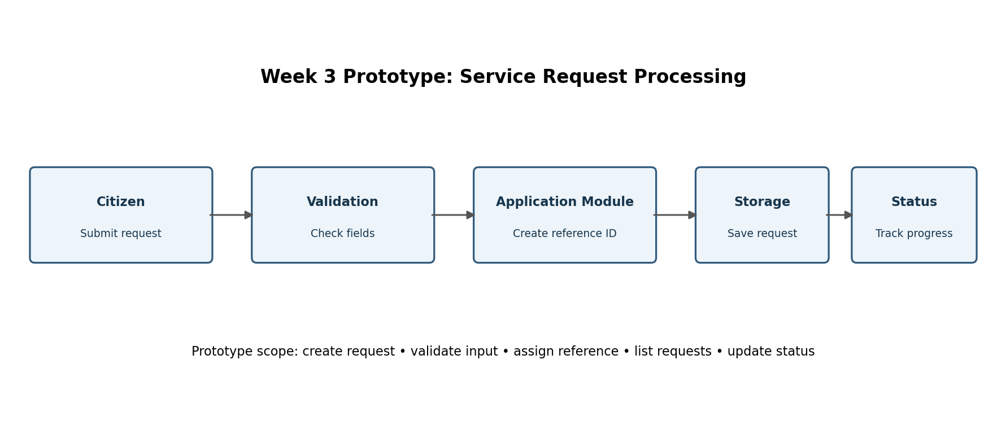
Figure 1. Request processing flow from citizen input to status tracking.

6. Implementation Approach
The prototype is written in Python because it supports clear, readable logic and built-in data structures. A ServiceRequest data class represents each request. The CitizenPortal class contains the operations for submitting, listing, retrieving, and updating requests. The submit_request method validates that the citizen name and service type are present and that the description contains at least ten characters. If validation passes, the method generates a reference number, adds a timestamp, sets the initial status to Submitted, and stores the request in memory. The update_status method accepts only a predefined list of statuses and reports an error when the reference does not exist. This design keeps business rules in one module and makes later integration with a web API easier.

7. Core Pseudocode
START
Create an empty request list and reference counter
Read citizen name, service type, and description
IF any required field is missing OR description is too short:
Display validation error
ELSE:
Generate a unique reference ID
Create request with timestamp and status = Submitted
Save request in the current session
Display reference ID
To update status, find request by reference ID
IF found and status is allowed, update status
ELSE display an appropriate error
END

8. Embedded Code Snippet
The following excerpt shows the main validation and request-creation logic. The complete Python file is provided separately.
def submit_request(self, citizen_name, service_type, description):
if not citizen_name.strip():
raise ValueError("Citizen name is required.")
if not service_type.strip():
raise ValueError("Please select a service.")
if len(description.strip()) < 10:
raise ValueError("Description must contain at least 10 characters.")
ref = f"CSR-{next(self._counter):04d}"
request = ServiceRequest(
reference_id=ref,
citizen_name=citizen_name.strip(),
service_type=service_type.strip(),
description=description.strip(),
status="Submitted",
created_at=datetime.now().strftime("%Y-%m-%d %H:%M")
)
self.requests.append(request)
return request

9. Example Run
Example input: Citizen name = Sample Citizen; Service type = Residence Certificate; Description = Requesting a residence certificate for official use. Expected output: request is created with reference CSR-0001 and status Submitted. After the update operation, the status becomes Under Review. The actual reference number starts from CSR-0001 each time a new program instance is created because the prototype uses in-memory data.

10. Testing Strategy and Test Cases
Test ID | Scenario | Expected result | Type
TC-01 | Valid name, service, and description | Request created with reference ID and Submitted status | Positive
TC-02 | Blank citizen name | Validation error; no request created | Negative
TC-03 | Blank service type | Validation error; no request created | Negative
TC-04 | Description shorter than 10 characters | Validation error; no request created | Negative
TC-05 | Update an existing reference to Under Review | Status updated successfully | Positive
TC-06 | Update using unknown reference ID | Lookup error is returned | Negative
TC-07 | Use an unsupported status value | Validation error is returned | Negative
TC-08 | List requests after two submissions | Both requests are returned | Integration
Unit tests should cover validation and status rules. Integration tests should verify that submission, lookup, listing, and status update work together. When a database is added, tests should also check persistence, duplicate submissions, authorization, and failure recovery. These are proposed test cases; they should be executed and results recorded before claiming that all tests have passed.

11. Integration with the Overall Architecture
In the Week 2 architecture, this module belongs in the application/API layer. A future web frontend would send a request to an authenticated API endpoint. The backend would validate input, apply authorization, save the record in PostgreSQL, store any documents in protected file storage, and trigger a notification. The current prototype demonstrates the business logic only; it does not yet implement the frontend, database, authentication, or notification components. Keeping the module separate makes those integrations easier to add in a later phase.

12. Challenges and Decisions
- In-memory storage was chosen to keep the first prototype simple and easy to run.
- A fixed list of valid statuses prevents accidental use of inconsistent status values.
- Reference numbers are generated in sequence for demonstration; a production system would need collision-safe IDs across multiple users and servers.
- Input validation is performed before saving so invalid requests do not enter the request list.
- Sample data is used to avoid collecting or exposing real citizen information.

13. Risks and Improvements
Limitation / risk | Future improvement
Data disappears after program exit | Use PostgreSQL or another approved persistent database.
No user identity or permissions | Add secure authentication and role-based authorization.
No file upload support | Add private document storage, file validation, and malware scanning.
No citizen notifications | Add a reliable email or in-portal notification queue.
Sequential reference IDs may collide across instances | Use database-generated IDs or UUIDs and enforce uniqueness.
Command-line interface only | Build a responsive frontend and documented REST API.
Limited observability | Add structured logs, metrics, alerts, and audit records.

14. Estimated Effort
Activity | Hours | Deliverable
Requirements and module selection | 4 | Feature scope
Pseudocode and data design | 4 | Algorithm and model
Python implementation | 9 | Prototype source code
Unit and integration test design | 6 | Test cases
Architecture integration planning | 3 | Integration notes
Documentation and review | 7 | Final report
Total planned effort: 33 hours. This is an estimate for the prototype and documentation activity.

15. Evaluation Criteria
- Clear explanation of the selected module and its role in the full system.
- Logical implementation plan and readable code snippet or pseudocode.
- Validation and request status flow are defined consistently.
- Testing plan includes positive, negative, and integration scenarios.
- Challenges, limitations, security considerations, and future improvements are documented.
- Report is organized, detailed, and consistent with the Week 1 and Week 2 project.

16. Conclusion
The Week 3 prototype demonstrates the core service-request workflow for the Online Citizen Service Portal. It validates input, creates a reference ID, records a request, and supports request lookup and status updates. The report documents the workflow, pseudocode, Python implementation excerpt, testing strategy, integration plan, and limitations. The next development phase should add persistent storage, secure authentication, a web interface, protected document handling, and notifications. These improvements would move the prototype toward the layered architecture designed in Week 2 while preserving a clear and testable module structure.

17. References
- Python documentation — https://docs.python.org/3/
- OWASP Foundation — https://owasp.org/
- PostgreSQL documentation — https://www.postgresql.org/docs/
- Week 1 project requirements and Week 2 system architecture documents.

18. Source code

"""
Online Citizen Service Portal - Week 3 prototype
A simple command-line prototype of service request processing.
Uses sample/in-memory data only; not for production use.
"""
from dataclasses import dataclass
from datetime import datetime
from itertools import count

@dataclass
class ServiceRequest:
reference_id: str
citizen_name: str
service_type: str
description: str
status: str
created_at: str

class CitizenPortal:
def __init__(self):
self.requests = []
self._counter = count(1)

def submit_request(self, citizen_name, service_type, description):
if not citizen_name.strip():
raise ValueError("Citizen name is required.")
if not service_type.strip():
raise ValueError("Please select a service.")
if len(description.strip()) < 10:
raise ValueError("Description must contain at least 10 characters.")

ref = f"CSR-{next(self._counter):04d}"
request = ServiceRequest(
reference_id=ref,
citizen_name=citizen_name.strip(),
service_type=service_type.strip(),
description=description.strip(),
status="Submitted",
created_at=datetime.now().strftime("%Y-%m-%d %H:%M")
)
self.requests.append(request)
return request

def list_requests(self):
return list(self.requests)

def update_status(self, reference_id, new_status):
allowed = {"Submitted", "Under Review", "More Information Required",
"Approved", "Rejected", "Completed"}
if new_status not in allowed:
raise ValueError("Invalid status.")
for request in self.requests:
if request.reference_id == reference_id:
request.status = new_status
return request
raise LookupError("Request reference not found.")

def get_request(self, reference_id):
for request in self.requests:
if request.reference_id == reference_id:
return request
return None

if __name__ == "__main__":
portal = CitizenPortal()
request = portal.submit_request(
"Sample Citizen",
"Residence Certificate",
"Requesting a residence certificate for official use."
)
print("Request submitted:", request.reference_id, request.status)
portal.update_status(request.reference_id, "Under Review")
print("Updated status:", portal.get_request(request.reference_id).status)

