### **Spring 2024: CS5720 Neural Networks & Deep Learning - ICP-1**

Praneeth kumar Annapureddy (700747594)

GitHub Link: <https://github.com/praneethk0910/Neural-Networks-and-Deep-Learning---ICP-2.git>

1.Write a program that takes two strings from the user: first_name, last_name. Pass these variables to

fullname function that should return the (full name).

o For example:

▪ First_name = “your first name”, last_name = “your last name”

▪ Full_name = “your full name”

Solution:

1.2.Write function named “string_alternative” that returns every other char in the full_name string.

Str = “Good evening”

Output: Go vnn

Sloution:

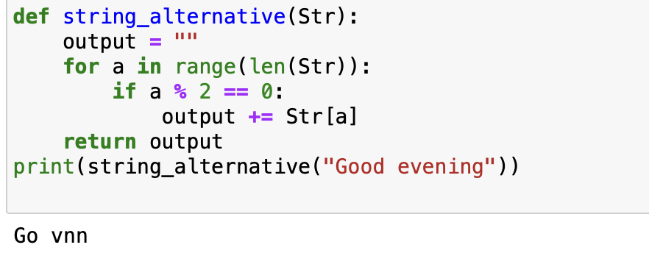

2.Write a python program to find the wordcount in a file (input.txt) for each line and then print the output.

* Finally store the output in output.txt file.

Example:

Input: a file includes two lines:

* Python Course
* Deep Learning Course

Output:

* Python Course
* Deep Learning Course
* Word_Count:
* Python: 1
* Course: 2
* Deep: 1
* Learning: 1

3. Write a program, which reads heights (inches.) of customers into a list and convert these

heights to centimeters in a separate list using:

1. Nested Interactive loop.

3.2 List comprehensions

