CryptoSteg

**Project Summary:**

This project explores the process of encrypting a file using cryptography

and then concealing it within an image using steganography tools like

Steghide. The goal is to enhance data security through multiple layers of

protection.  
  
**Project Objective:**

The primary objective of this project is to develop a secure system that leverages the strengths of cryptography and steganography to protect sensitive data. Specific objectives include:

1. To encrypt files using a strong encryption algorithm to ensure data confidentiality.
2. To embed the encrypted files within images using Steghide, thereby concealing the existence of the data.
3. To enhance the security of data transmission by adding a layer of obscurity through steganography.

**Project Solutions:**

1. **Encryption of Files:**
   * Implement a robust encryption algorithm, such as Advanced Encryption Standard (AES), to encrypt the data files. This ensures that even if the data is intercepted, it remains unreadable without the correct decryption key.
2. **Embedding Encrypted Files into Images:**
   * Use Steghide, a well-known steganography tool, to embed the encrypted files into image files. Steghide supports embedding encrypted data within various image formats, ensuring that the concealed data remains undetectable to unauthorized users.

Implementation:

A User friendly manner to access easily which option we need:

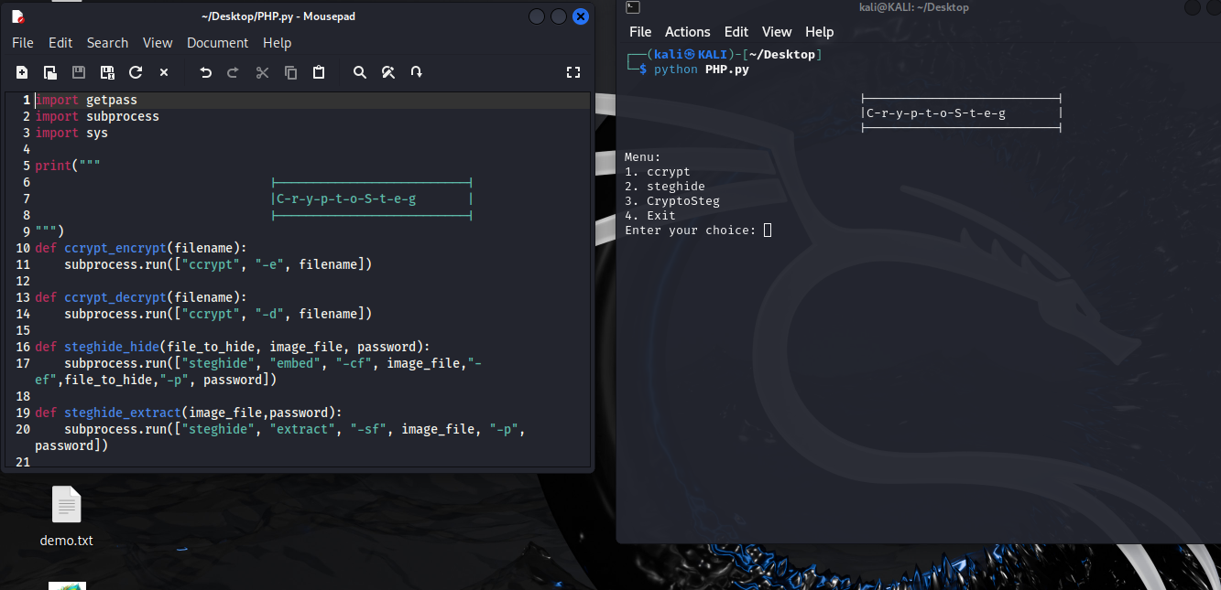  
  
2) Encrypting a file :  
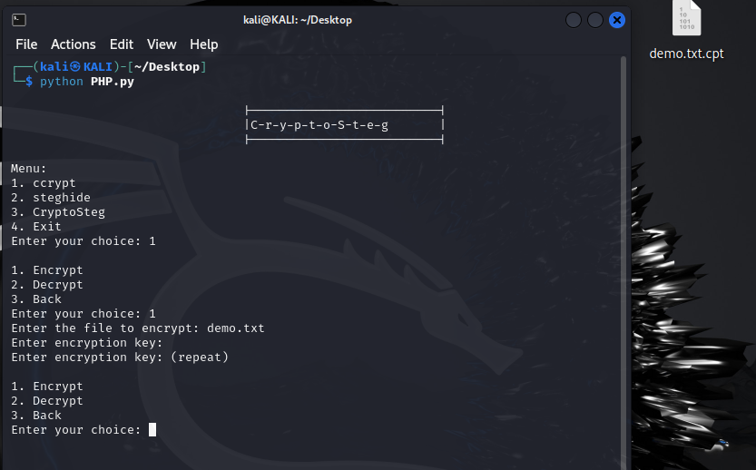

3)hiding into an image:  
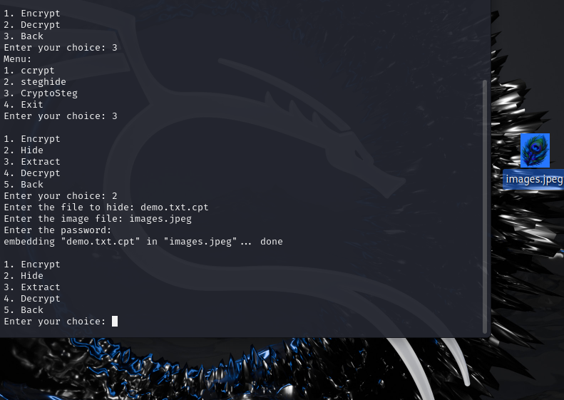

4) Extracting the data from the image 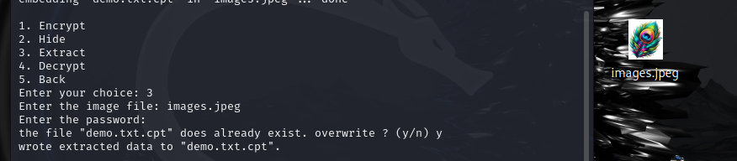

5)Decrypting the file

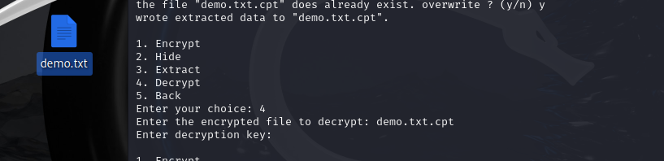

We finally achieved adding an extra layer that is combining the encrypted files into an image and then extracting the data from the image.  
  
TeamMembers:

KPNV PRANEETH  
M.PRASANNA  
U.HARSHITHA