Homework-0 MSCS630

Course- MSCS630

Name – Praneeth Manubolu

Date – 1/25/2017

1. Java (JDK) version screen shots-

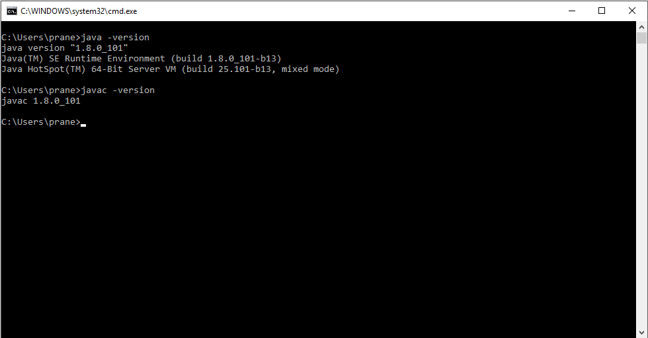

1. Git Hub repository screenshot

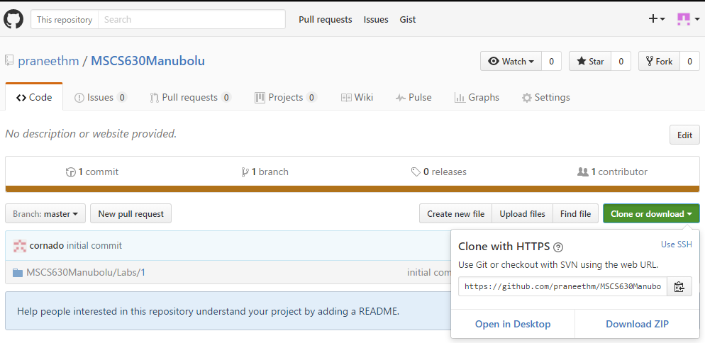

Repository link-

<https://github.com/praneethm/MSCS630Manubolu.git>

1. Git bash screen shot

