Lessons Learned:

This was my first time writing a full-fledged python program, so it was a bit difficult to complete everything mentioned in the requirement.

I now have very good understanding of basic Python functionality such as loops, functions, type conversions, sets, lists, dictionaries.

Using JSON files as input to the program helped me understand the encoding and decoding of JSON files in Python.

Issues Faced (but resolved):

Importing JSON data from a JSON file

Using dictionary to store transition function values obtained from JSON file

Reading a sequence of digits from a line and storing them in a list, line by line

Joining elements in the list again to form a string while printing Output

Traversing from one function to another based on states and inputs

Outputs:-

For 1.6b:

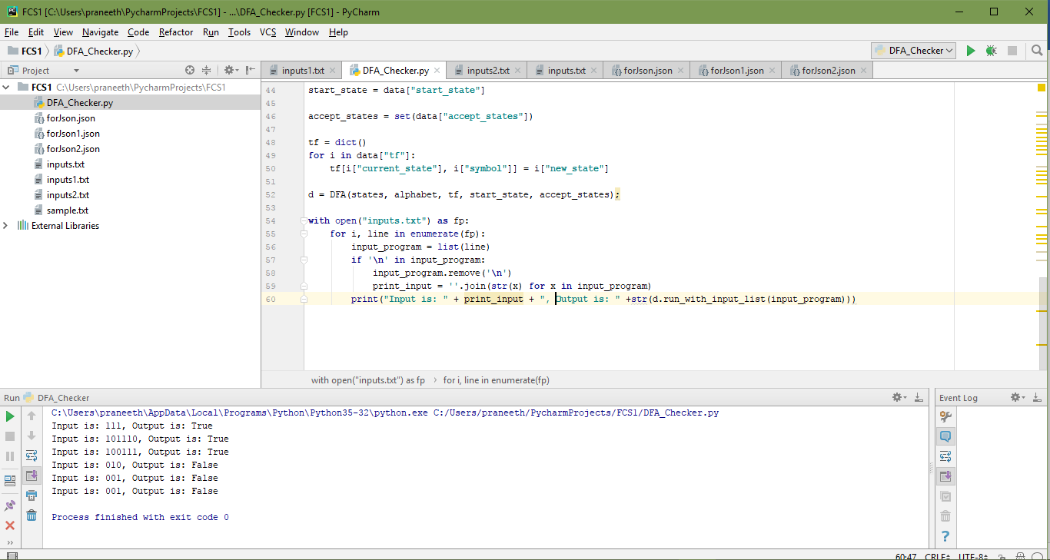

For 1.6c:

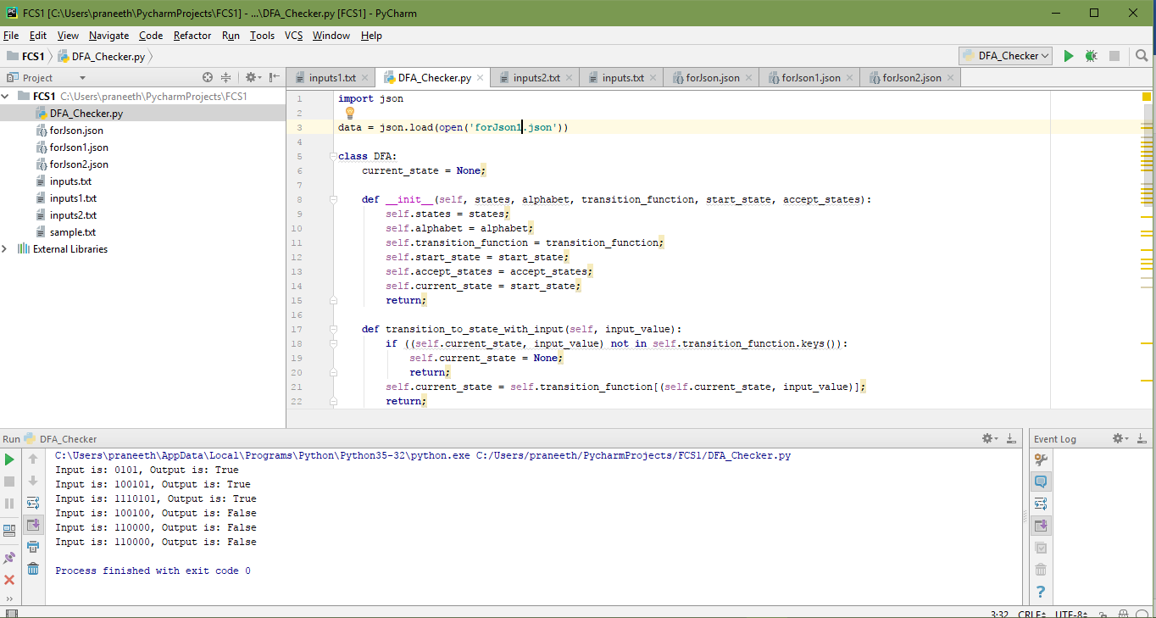

For 1.6f:

