



UiPath Automation
InvoiceProcessing

PDD: InvoiceProcessing

Table of Contents
1. PDD Version Control 3
2. Process Design Document Sign-Off 4
3. References 4
4. Introduction 5
4.1 Purpose of the Document 5
4.2 Objectives 5
4.3 Abbreviations 5
4.4 Key Roles & Contacts 6
4.5 Minimum Prerequisites for Automation 6
5. As-Is Process Description 7
5.1 Process Overview AS-IS 7
5.2 Process Business Case 8
5.3 Applications Used in the Process 9
5.4 Input and output data 9
5.5 Scheduling Requirements 10
5.5.1 Service Level Agreements 10
5.5.2 Operating Hours TO BE 10
5.6 As-Is Process Map 11
5.6.1 High level process map 11
5.7 Opportunities for improvement 12
5.8 Additional Delivery documentation 13
6. To-Be Process Description 14
6.1 Process Overview TO BE 14
6.2 To-be Functional process map 15
6.2.1 To Be Functional process map 15
6.2.2 To Be Keystroke 16
6.3 Scope to be considered for RPA automation 16
6.4 Exception Handling 16
6.5 Change Request 17
6.6 Business rules library 17
7. Reporting Requirements 19
8. Risk Mitigation plan 20
9. Other Observations 21

PDD Version Control
Version | Description | Status | Created/ Changed By | Created/ Changed Date
1.0 | Initial draft auto-generated from source code | Draft | InstaDocs | 2026-07-03

Process Design Document Sign-Off
In line with the agreed approach, the automation defined within this document must be signed off by the relevant department/ business team prior to the commencement of any development activities.

Once the Final Version of PDD is released for Sign Off, then it is recommended

Following PDD sign off, any changes to the process described within this document will be subject to Change Control Process. Any change in requirements after the Sign Off would be assessed on the urgency, impact assessment and go through approval framework defined in the RPA program before development.

Name, ID & Designation | Department | Signed-Off Date | Email Sign Off Attachment
Financial Analyst III
Manager

References

Num. | Name | Purpose
1 | Process walkthrough recording | Link to the recorded process demo (attach if available).
2 | Standard Operating Procedure (SOP) | Existing SOP / work instruction for the manual process (attach if applicable).

Introduction

Purpose of the Document
The Process Design Document outlines the “InvoiceProcessing” chosen for automation using Robotic Process Automation (RPA) technology.
The document describes the sequence of steps performed as part of the “InvoiceProcessing”, the conditions and rules of the process prior to automation and how they are envisioned to work after automating it, partly or entirely. This specifications document serves as a base for developers, providing them the details required for applying robotic automation to the selected business process.

Objectives
Objective inferred from workflow structure. Configure the UiPath LLM Gateway for a business-level narrative. Reads invoices from an inbox, validates them against an amount limit, and posts approved invoices to the finance system.

Abbreviations
Explain the terms that are used in this PDD template sample
# | Terminology | Descriptions | Remarks(optional)
1 | RPA | Robotic Process Automation
2 | PDD | Process Design Document
3 | SDD | Solution Design Document
4 | SME | Subject Matter Expert
5 | SLA | Service Level Agreement
6 | KPI | Key Performance Indicator
7 | AHT | Average Handling Time
8 | UAT | User Acceptance Testing
9 | UI | User Interface
10 | FTE | Full-Time Equivalent
11 | XAML | Workflow file format used by UiPath Studio

Key Roles & Contacts
This specifications document includes concise and complete requirements of the business process and it is built by the RPA Business Analyst / Process Owner.
The Process Owner is expected to review it and provide signoff for accuracy and completion of the process steps, context, impact and exception handling.

Role | Name & ID | Dept | Notes
Process Reviewer
Process Owner
IT POC
RPA BA
RPA Solution Architect
RPA Developer
RPA Champion
RPA PM

Minimum Prerequisites for Automation

Below are the minimum prerequisites for the automation of this process:
# | Category | Description/Assumption | Owner
1 | Access for Developer on System | Access for the bot and developer to all in-scope applications must be provisioned before development starts. | RPA BA
2 | PDD Approvals | Sign-off on this PDD from the SME and Process Owner before development commences. | RPA BA
3 | Test Data | Representative test data available in Dev/Test covering the happy path and each exception path. | SME
4 | Environment & Application | Applications, versions, file locations and access methods must match across Dev/Test/Prod. Required packages: UiPath.Excel.Activities, UiPath.Mail.Activities, UiPath.System.Activities. | IT
5 | Templates | Excel/Email templates the process depends on are finalized and available at the agreed location. | SME
6 | Potential Change | Any change to steps or applications must be notified to RPA support for maintenance of the automation. | Process Owner

As-Is Process Description
This chapter highlights the AS-IS design of the business process before improvement or automation.

Process Business Case
To be completed during Pre-automation and Post-Automation
# | Item | Description | Pre-Delivery (Discovery) | Post Delivery | Remarks
1 | Avg. Handling Time (AHT) | Average manual time to complete one transaction |  |  | To be provided by SME
2 | Annual Volume | Number of transactions handled per year |  |  | To be provided by SME
3 | Automation Potential % | Proportion of the process that can be automated
4 | Potential Time Save (Annually) | Estimated hours saved after automation
5 | RPA Capabilities/Components Used | Core RPA, Excel automation, Email |  |  | Derived from source dependencies
.
Refer this Definition Document, for the impact ratings

Process Overview AS-IS
Below some general information and metrics about the Change Summary process.
# | Item | Description
1 | Process full name | InvoiceProcessing
2 | Process area | Process
3 | Process short description | Reads invoices from an inbox, validates them against an amount limit, and posts approved invoices to the finance system.
4 | Applications used | MS Excel, Email (Outlook/SMTP), Excel, Email
5 | Dependencies: Upstream (other automations feeding this process)
6 | Dependencies: Downstream (automations that consume this output)
7 | Input data | See Input and Output Data section
8 | Output data | See Input and Output Data section
9 | Process frequency | To be provided by SME
10 | Transaction volume | To be provided by SME
11 | Average handling time (AHT) | To be provided by SME
12 | Number of FTEs | To be provided by SME
13 | Process SLAs | To be provided by SME

Note: Use “N/A” for the items that do not apply for specific business process.

Applications Used in the Process
Below is the list of applications used in the process and the technical details and requirements for accessing these applications.

No. | Application name & version | Description (Read/Write) | System Language | Thin/Thick Client | Environment / Access Method | Access POC
1 | MS Excel (UiPath.Excel.Activities 2.22.4) | Read/write the shared invoice workbook |  | Thick
2 | Email (Outlook/SMTP) (UiPath.Mail.Activities 1.19.0) | Send confirmation emails |  | Thick

Thin client: uses a remote computer for processing an application
Thick client: Apps that locally run the applications (eg. .exe, .msi, .xml, xlsx)
If test data or sandbox environment, application not present for dev, test, then please highlight that in this section
Refer the Application Access Tracker for managing the access if the scope is more than 2-3 processes.

Input and output data
Below are the inputs and outputs that need to be considered for related process steps:
# | Source/App/System/Dept | Input / Output | Description, Location, Sample
1 | Input files / source system | Input | Records the process reads at the start of each run (e.g. the pending-items workbook or queue).
2 | Business applications | Input | Live data read from the applications used during processing.
3 | Email | Output | Confirmation and exception notification emails sent per transaction / run.
4 | Execution & exception log | Output | Per-run processing log and list of exceptions for monitoring.

Scheduling Requirements

Service Level Agreements
Question | Answer
What is the SLA for this process in AS-IS
What shall be the SLA for TO BE

Operating Hours TO BE
Question | Answer
Detail process Start Time (e.g. 9am)

As-Is Process Map

High level process map
As-Is process map (grouped by application / system):
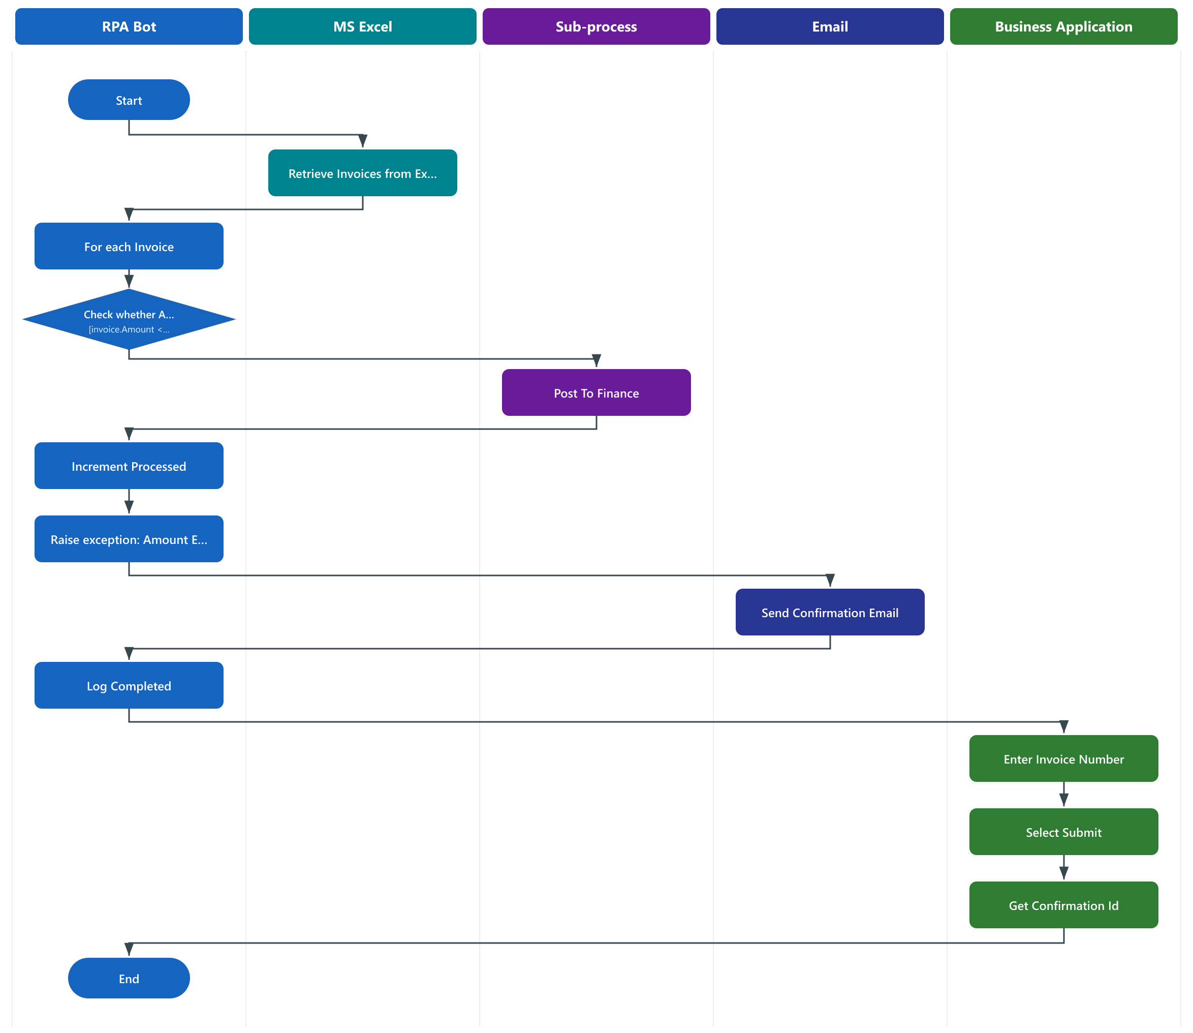

Opportunities for improvement
Below are the opportunities for improvement identified during the process review. Opportunities for improvement can be of following nature:

The following opportunities for improvement is considered in the To-Be process.
No. | Type of opportunity | Description | Comments
1
2

Additional Delivery documentation
No. | Name | Location | Description
1 | InvoiceProcessing-TestCases.xlsx | Delivered in the same output folder as this PDD | UAT test case document auto-generated by InstaDocs from the workflow logic.

To-Be Process Description
This chapter highlights the high level TO BE Summary

Process Overview TO BE
Automated process "InvoiceProcessing" built on UiPath, comprising 16 workflow activities across 1 entry point(s).

To-be Functional process map

To Be Functional process map
To-Be process flow (business view):


To Be Keystroke
- This is a sample keystroke level section
Step Ref. | Process Step | Input/Output | Description
1 | Retrieve Invoices from Excel |  | Reads or writes external data. Note: Loads pending invoices from the shared workbook.
2 | For each Invoice |  | Iterates over a collection or condition.
3 | Check whether Amount Within Limit |  | Conditional branch. Condition: [invoice.Amount <= in_MaxAmount].
4 | Post To Finance |  | Invokes another workflow.
5 | Increment Processed |  | Assigns/derives a value. Note: Counts a successfully posted invoice.
6 | Raise exception: Amount Exceeds Limit |  | Raises an exception.
7 | Send Confirmation Email |  | Reads or writes external data.
8 | Enter Invoice Number |  | Interacts with an application UI.  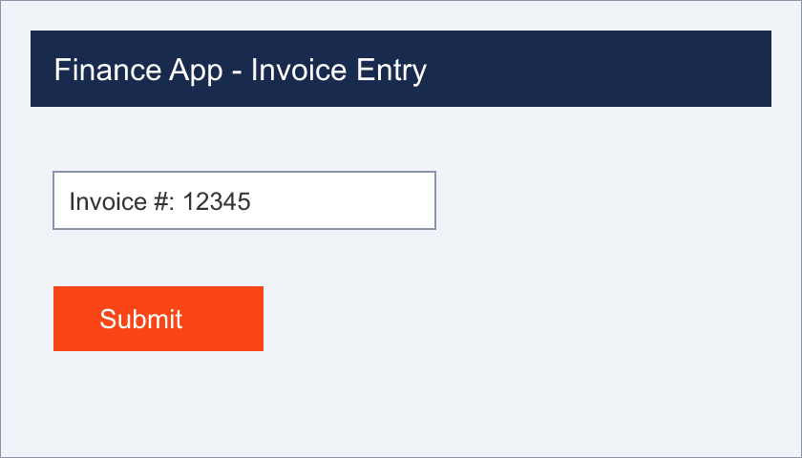
9 | Select Submit |  | Interacts with an application UI.
10 | Get Confirmation Id |  | Interacts with an application UI.

Scope to be considered for RPA automation
, clearly call out the Out of scope part clearly with the reason
# | Description | Category | In Scope for Bot | Out of Scope for bot | Remarks/Reading Criteria
1
2
3
4
5
6

Exception Handling
This section captures the comprehensive list of all exceptions, warnings or notifications with the action or workaround to be taken for each exception by the robot

Known Business exceptions
The Section explains any known business exceptions met in practice before and captured during the process evaluation.
All the Email Alerts are explained in this format
# No. | Step Name | Description | Email
1 | Throw Amount Exceeds Limit | Business-rule violation raised explicitly by the workflow. Process throws to signal the violation. | Notification email sent to the business (recipient per configuration).

Known Application / Technical exceptions
The table below reflects any known application / technical exceptions such as errors, warnings or notifications from an application or system.
All the Email Alerts are explained in this format

# No. | Step Name | Description | Email
1 | Application launch / login | MS Excel, Email (Outlook/SMTP), Excel, Email did not respond or failed to launch. The robot retries; if unresolved it logs the error and raises a system exception. | System-exception alert email sent to the support team.
2 | UI interaction | A screen element / selector could not be found (application slow or UI changed). The transaction is marked failed and logged for review.
3 | Input file access | The input file was missing, locked, or in an unexpected format. The run stops with a logged system exception.
4 | Protected step in the main process | A protected step failed at runtime; the error is caught, logged, and the item is marked as a system exception for review.

Unknown exceptions
For any unknown exceptions, the robot should perform the following:
- For business exceptions: send an e-mail to
- For Application / Technical exceptions: send an e-mail to

Change Request
This section is added just for placing the guide link here
Change Request Guidelines Link

Business rules library
Libraries / dependencies used by the process
- UiPath.Excel.Activities (2.22.4): Read/write the shared invoice workbook
- UiPath.Mail.Activities (1.19.0): Send confirmation emails
- UiPath.System.Activities (24.10.0): Core control-flow and logging
Business rules
- BR-01: When "[invoice.Amount <= in_MaxAmount]", the process branches at "If Amount Within Limit". (applies to: If Amount Within Limit)
Depending on the complexity of the process, an additional business rules library may need to be documented and referenced here(for DU/Forms Cases). Any deviation from the AS-IS will be documented here. For e.g., if UiPath Forms is being used to obtain missing data for creating a Sales Order in SAP and this form is being sent to the business for their input, then this section can be used for documenting the parameters to be available in the UiPath Forms and all functional details pertaining to it

Step Ref. | Process Step | Input/Output | Description
1

Reporting Requirements
By default, Insights Reporting Dashboard would be comprised of the following tiles, which can be edited, adding Process Tile table here for reference:
BA to study the Reporting Guide for more information & update this section accordingly for Type of report, frequency
Program level Reporting should be discussed before even PDD, and can be refined during PDD with granular information
Dashboard Name | Report Name | Report Type | Description | Insights OOB or Custom?
Process
Process
Process
Process
Process
Process
Process

# Processes Ran, Success Rate, Average Run Time:

Top 10 Processes by # Run and Status, Top 10 Processes with Faulted Jobs, Weekly Runs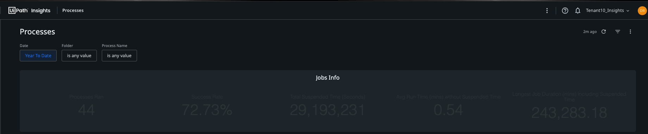
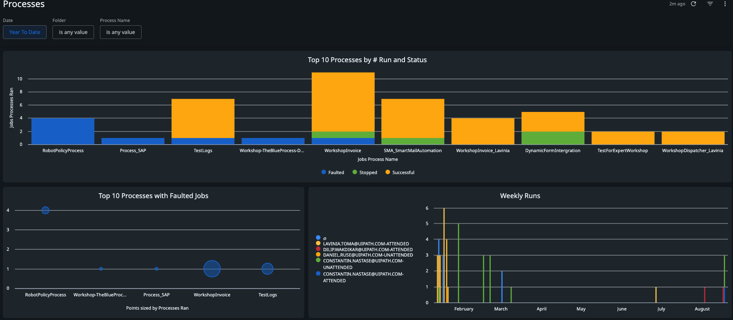

Error Details
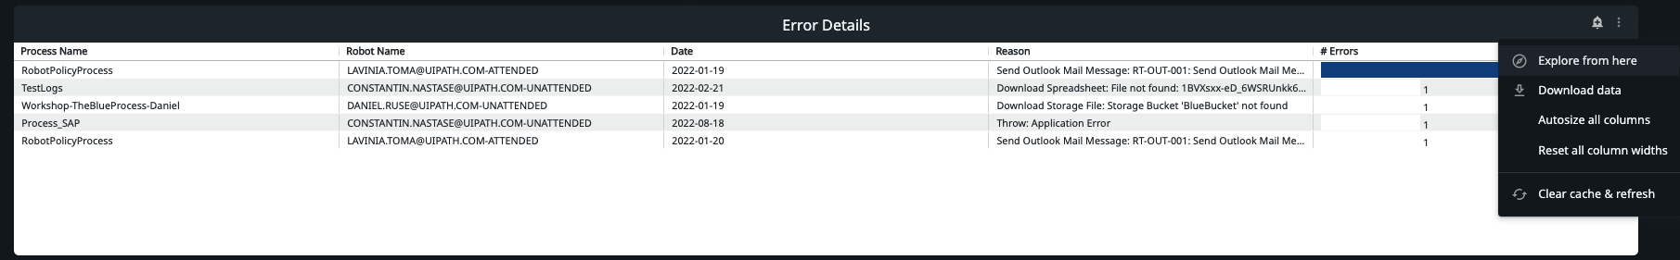

Risk Mitigation plan
This section includes the changes in Operations in Disclosure Review process

Business / Process changes
No. | Process Step | Change description | Change impact on RPA and estimate of cost | Due date | Status*
1
2
3
4
*Status: Registered, Rejected, Accepted

Application / Infrastructure changes (Not Applicable)
No. | Process Step | Change description | Change impact on RPA and estimate of cost | Due date | Status*
1
2
3
*Status: Registered, Rejected, Accepted

Other Observations
Add any observations or pending topics that are under discussion and could have an impact on the automation of the to-be process

Intentionally left blank

