

A Project Report

On

**“Oil Spill Detection”**

Batch Details

|  |  |  |
| --- | --- | --- |
| Sl. No. | Roll Number | Student Name |
| 1 | 20211CAI0169 | P V SAI PRANEETH |
| 2 | 20211CAI0171 | BACHHU SATYA CHARAN |
| 3 | 20211CAI0163 | TATIKONDA BHARGAV NAIDU |
| 4 | 20211CAI0172 | HARI PRADHAN S D |

**School of**

**Computer Science and Engineering**

**Presidency University Bengaluru.**

Under the guidance of,

Dr. MURALI PARAMESWARAN

School of Computer Science and Engineering

Presidency University, Bengaluru

**CONTENTS**

1. Introduction about Project
2. Literature Review
3. Objectives

## Methodology

1. Timeline for Execution of Project
2. Expected Outcomes
3. Conclusion
4. References

**INTRODUCTION**

Oil spill detection is a critical environmental concern, as spills cause severe ecological damage and economic losses. This project focuses on predicting oil spills using satellite imagery data, leveraging machine learning techniques to classify image patches as either containing an oil spill or not. The dataset, consists of various spectral and spatial features extracted from satellite images. The proposed approach employs Support Vector Machine (SVM), Random Forest, and XG Boost algorithms to achieve high-accuracy classification. The system is developed using Python for backend processing, with a user-friendly front-end interface built using HTML, CSS, and JavaScript. The implementation aims to enhance real-time monitoring and detection capabilities, aiding in quick response measures for oil spill containment. The project contributes to environmental sustainability by providing an automated, efficient, and scalable solution for oil spill detection in maritime ecosystems.

**LITERATURE REVIEW**

The paper **"Oil Spill Detection from Synthetic Aperture Radar (SAR) Earth Observations: A Meta-Analysis and Comprehensive Review"** explores the effectiveness of SAR technology in detecting oil spills. It reviews methods such as threshold-based detection, texture analysis, and machine learning approaches, highlighting their strengths and limitations. The paper also discusses challenges like false positives and environmental factors affecting detection accuracy. It emphasizes the potential of data fusion (e.g., SAR with AIS) and deep learning to enhance oil spill detection and reduce response times.

The paper **"Deep Learning-Based Approaches for Oil Spill Detection: A Bibliometric Review of Research Trends and Challenges"** reviews the use of deep learning methods in oil spill detection. It highlights popular techniques such as Convolutional Neural Networks (CNNs) and transfer learning for classifying SAR images. The study identifies key challenges, including limited labeled datasets, false positives, and environmental variations. It also discusses research trends and the growing focus on real-time, accurate spill detection using integrated deep learning models.

The paper **"Developing a Comprehensive Oil Spill Detection Model for Marine Environments"** presents a holistic approach to detecting oil spills using integrated data sources like Synthetic Aperture Radar (SAR) images and Automatic Identification System (AIS) data. It explores traditional and machine learning methods for anomaly detection and emphasizes combining vessel movement data with satellite observations to improve accuracy. The study also addresses challenges like false positives and environmental noise, proposing a model that balances detection speed with reliability for real-time marine monitoring.

The paper **"Oil Spill Detection Based on Machine Learning and Deep Learning: A Review"** discusses various machine learning and deep learning techniques used for detecting oil spills in SAR images. It covers methods such as Support Vector Machines (SVMs), Random Forests, and Convolutional Neural Networks (CNNs), highlighting their accuracy and effectiveness. The paper also reviews challenges like false positives and data scarcity. It emphasizes the need for hybrid approaches and data fusion to improve detection performance and reduce environmental impact.

The paper **"Multi-Source Knowledge Graph Reasoning for Ocean Oil Spill Detection from Satellite SAR Images"** proposes using knowledge graphs to enhance oil spill detection accuracy. By integrating data from multiple sources like SAR images, AIS data, and environmental information, the model leverages graph reasoning to identify spills and reduce false positives. The study highlights how knowledge graphs can improve the interpretation of complex relationships between vessel activities and ocean conditions, offering a more reliable and robust approach for real-time oil spill detection.

The paper **"The Application of Satellite Image Analysis in Oil Spill Detection"** explores the use of satellite imagery, particularly Synthetic Aperture Radar (SAR), for identifying oil spills. It reviews common image analysis methods such as thresholding and texture analysis, emphasizing their role in detecting dark patches on the ocean surface. The study discusses challenges like false positives caused by environmental factors and highlights the potential of combining image analysis with auxiliary data sources (e.g., AIS data) to improve detection accuracy and reliability.

The paper **"A Novel Deep Learning Method for Marine Oil Spill Detection from Satellite Synthetic Aperture Radar Imagery"** introduces a new deep learning approach to improve the accuracy of oil spill detection in SAR images. It leverages Convolutional Neural Networks (CNNs) to automatically extract features and classify oil spills from background noise. The study emphasizes the model’s ability to reduce false positives caused by environmental factors and highlights its potential for real-time marine monitoring. This method demonstrates enhanced detection accuracy compared to traditional threshold-based techniques.

The paper **"Marine Oil Spill Detection Using Synthetic Aperture Radar over Indian Ocean"** focuses on detecting oil spills in the Indian Ocean using SAR imagery. It discusses the effectiveness of SAR technology in identifying oil slicks under varying environmental conditions. The study applies image processing techniques, such as thresholding and texture analysis, to distinguish oil spills from natural phenomena like low-wind areas. It highlights the region-specific challenges and the potential of integrating SAR data with auxiliary information (e.g., AIS) for more accurate and reliable detection.

The paper **"Utilizing Deep Learning Algorithms for Automated Oil Spill Detection in Medium Resolution Optical Imagery"** explores the application of deep learning techniques, particularly Convolutional Neural Networks (CNNs), to detect oil spills in medium-resolution optical satellite images. It highlights the challenges of optical imagery, such as varying light conditions and cloud cover, and demonstrates how deep learning can improve detection accuracy. The study emphasizes automated feature extraction and classification, showing the potential for faster, more reliable oil spill detection in real-time monitoring systems.

The paper **"GreyWolfLSM: An Accurate Oil Spill Detection Method Based on Level Set Method from Synthetic Aperture Radar Imagery"** introduces GreyWolfLSM, a novel detection approach that combines the Grey Wolf Optimization algorithm with the Level Set Method (LSM). This hybrid model is designed to accurately segment oil spills from SAR images by refining the boundaries of dark patches associated with oil slicks. The method improves spill detection accuracy while reducing false positives caused by environmental factors, offering a more reliable tool for marine oil spill monitoring.

**OBJECTIVES**

Multi-Source Data Integration and Preprocessing:  
Multi-Source Data Integration and Preprocessing involves developing a unified framework that seamlessly combines satellite SAR imagery with AIS vessel data. This process begins with the acquisition of high-quality SAR images, which provide detailed radar observations of the ocean surface, and AIS data, which offers real-time information about vessel positions, speeds, and trajectories. Once collected, the data undergoes rigorous cleaning to remove noise, correct errors, and address missing values, ensuring that each dataset is reliable and consistent. This integration facilitates the correlation of vessel movements with potential oil spill indicators observed in the SAR imagery, thereby creating a robust and synchronized dataset that serves as a reliable foundation for further analysis and detection algorithms.

**Robust Detection Algorithm Development:**  
Designing and implementing advanced machine learning and deep learning models for oil spill detection from SAR images involves a comprehensive approach that starts with curating a diverse and representative dataset of SAR images under various environmental conditions. The focus is on developing algorithms to automatically extract and learn critical features such as dark patches and subtle texture variations that are characteristic of oil spills. This process requires sophisticated feature engineering, where the models are trained to discern between genuine oil spill signatures and other similar-looking phenomena caused by natural oceanic variations. Additionally, extensive model training and validation are conducted using labeled datasets, employing techniques like data augmentation to improve robustness and reduce overfitting. The ultimate goal is to fine-tune these models to minimize false positives while enhancing detection accuracy, ensuring that the system reliably identifies oil spills even under challenging and variable environmental conditions.

**Real-Time Monitoring and Alert System:**  
Establishing a real-time monitoring and alert system involves continuously processing data streams from satellite SAR imagery and AIS sources to maintain an up-to-date picture of marine conditions. This dynamic system is designed to analyze incoming data nearly instantaneously, identifying any anomalies that could indicate the presence of an oil spill. Integrated automated alert mechanisms, such as email, SMS, or in-app notifications, ensure that relevant stakeholders are immediately informed of potential spill events. This rapid notification capability is essential for enabling swift, coordinated response efforts that can mitigate environmental damage. Additionally, the system's real-time dashboard offers a clear, visual representation of current conditions, supporting informed decision-making during critical situations

**METHDOLOGY**

1. Data Acquisition and Preprocessing:  
   Collect satellite SAR imagery alongside AIS vessel data from reliable sources. The gathered data is then processed using Python to remove noise, correct errors, and normalize formats and coordinate systems, ensuring consistency and enabling seamless integration across sources.
2. Feature Extraction and Data Fusion:  
   Extract critical spectral and spatial features from SAR images—such as dark patches and textural variations indicative of oil spills—using advanced image processing techniques. Concurrently, fuse this with AIS data to correlate vessel movements with potential spill indicators, thereby enriching the dataset for robust analysis.
3. Machine Learning Classification:  
   Employ machine learning algorithms like Support Vector Machine, Random Forest, and XGBoost to classify image patches as oil spills or non-oil spills. The models are trained on labeled datasets, leveraging the extracted features to enhance detection accuracy and minimize false positives under various environmental conditions.
4. Real-Time Monitoring and Alert System:  
   Develop a dynamic backend in Python that continuously processes incoming SAR and AIS data in near real-time. Integrate automated alert mechanisms that notify stakeholders immediately upon detection of potential oil spills, thus enabling rapid and coordinated response to marine pollution events.
5. Visualization and End-to-End Integration:  
   Create an interactive front-end interface using HTML, CSS, and JavaScript to visualize detection results, offering a user-friendly dashboard for real-time monitoring. This complete system not only supports timely decision-making but also ensures scalability, efficiency, and environmental sustainability throughout its operation.

**OUTCOMES**

**Enhanced Detection Accuracy:** The system is designed to significantly improve oil spill detection accuracy by integrating advanced machine learning and deep learning models with multi-source data. This integration leverages detailed spectral and spatial features from SAR imagery and AIS vessel data, ensuring that subtle indicators of oil spills are captured while minimizing false positives.

**Real-Time Monitoring and Rapid Response:** By processing incoming data in near real-time, the proposed framework enables immediate identification of potential oil spills. This outcome facilitates timely alerts and coordinated responses, which are critical for mitigating environmental damage and effectively managing marine pollution incidents.

**Scalable and User-Friendly Platform:** The development of an interactive front-end interface combined with a robust Python-based backend creates a scalable system for continuous marine monitoring. This user-friendly platform not only supports efficient visualization and decision-making but also promotes sustainable management of marine ecosystems through automated, data-driven insights.

**TIMELINE OF THE PROJECT/ PROJECT EXECUTION PLAN**

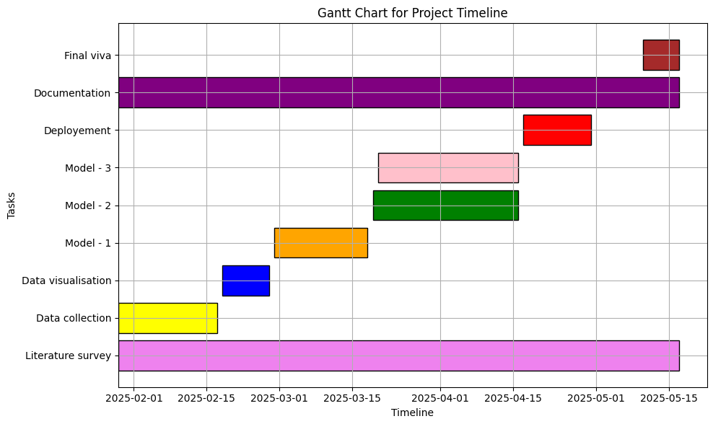

**CONCLUSION**

The proposed system represents a significant advancement in automated marine monitoring by effectively integrating satellite SAR imagery with AIS vessel data. By leveraging sophisticated machine learning and deep learning algorithms, the framework accurately identifies oil spill incidents, even in challenging environmental conditions, while minimizing false positives. The real-time monitoring and alert components enable immediate stakeholder notification, facilitating swift response actions that are crucial for mitigating environmental damage. Furthermore, the user-friendly interface ensures that the system is accessible and scalable, promoting sustainable marine ecosystem management. Overall, this integrated approach sets a new benchmark for efficient, data-driven oil spill detection and rapid intervention in marine pollution scenarios.

**REFERENCES**

1. Jafarzadeh, Hamid, Masoud Mahdianpari, Saeid Homayouni, Fariba Mohammadimanesh, and Mohammed Dabboor. "Oil spill detection from Synthetic Aperture Radar Earth observations: A meta-analysis and comprehensive review." *GIScience & Remote Sensing* 58, no. 7 (2021): 1022-1051.
2. Vasconcelos, Rodrigo N., André T. Cunha Lima, Carlos AD Lentini, José Garcia V. Miranda, Luís FF de Mendonça, José M. Lopes, Mariana MM Santana et al. "Deep learning-based approaches for oil spill detection: A bibliometric review of research trends and challenges." *Journal of Marine Science and Engineering* 11, no. 7 (2023): 1406.
3. Akhmedov, Farkhod, Rashid Nasimov, and Akmalbek Abdusalomov. "Developing a Comprehensive Oil Spill Detection Model for Marine Environments." *Remote Sensing* 16, no. 16 (2024): 3080.
4. Huby, Alaa Akram, Rafid Sagban, and Raaid Alubady. "Oil spill detection based on machine learning and deep learning: a review." In *2022 5th International Conference on Engineering Technology and its Applications (IICETA)*, pp. 85-90. IEEE, 2022.
5. Liu, Xiaojian, Yongjun Zhang, Huimin Zou, Fei Wang, Xin Cheng, Wenpin Wu, Xinyi Liu, and Yansheng Li. "Multi-source knowledge graph reasoning for ocean oil spill detection from satellite SAR images." *International Journal of Applied Earth Observation and Geoinformation* 116 (2023): 103153.
6. Tysiąc, Paweł, Tatiana Strelets, and Weronika Tuszyńska. "The application of satellite image analysis in oil spill detection." *Applied Sciences* 12, no. 8 (2022): 4016.
7. Huang, Xudong, Biao Zhang, William Perrie, Yingcheng Lu, and Chen Wang. "A novel deep learning method for marine oil spill detection from satellite synthetic aperture radar imagery." *Marine Pollution Bulletin* 179 (2022): 113666.
8. Naz, Saima, Muhammad Farooq Iqbal, Irfan Mahmood, and Mona Allam. "Marine oil spill detection using synthetic aperture radar over indian ocean." *Marine Pollution Bulletin* 162 (2021): 111921.
9. Sun, Zhen, Qingshu Yang, Nanyang Yan, Siyu Chen, Jianhang Zhu, Jun Zhao, and Shaojie Sun. "Utilizing deep learning algorithms for automated oil spill detection in medium resolution optical imagery." *Marine Pollution Bulletin* 206 (2024): 116777.
10. Aghaei, Nastaran, Gholamreza Akbarizadeh, and Abdolnabi Kosarian. "GreyWolfLSM: An accurate oil spill detection method based on level set method from synthetic aperture radar imagery." *European Journal of Remote Sensing* 55, no. 1 (2022): 181-198.