**PREDICTING THE OIL SPILL**

**ABSTRACT**

Oil spill detection is a critical environmental issue that has gained significant attention due to the devastating impact it has on marine ecosystems, wildlife, and local economies. Oil spills can lead to long-lasting ecological damage, disrupt aquatic habitats, and result in extensive economic losses, particularly in the fishing and tourism industries. Timely and accurate detection of oil spills is essential for minimizing the extent of the damage and enabling quick response measures for containment and cleanup.

This project focuses on utilizing satellite imagery data to predict and identify oil spills, leveraging advanced machine learning techniques to analyze and classify image patches. The dataset used for this project, sourced from Kaggle, consists of various spectral and spatial features extracted from satellite images of maritime regions. These features provide rich information about the surface characteristics of the water, allowing for accurate detection of potential oil spills.

The proposed methodology employs several robust machine learning algorithms, including Support Vector Machine (SVM), Random Forest, and XGBoost, to classify image patches as either containing an oil spill or not. These algorithms are chosen for their ability to handle complex data patterns and provide high-accuracy classifications. The system processes satellite imagery in real-time, providing rapid analysis of large datasets. The implementation is developed using Python, a popular language for machine learning, data processing, and analysis. The backend processing of image data is seamlessly integrated with a user-friendly front-end interface built with HTML, CSS, and JavaScript. The interface allows users to interact with the system easily, upload satellite images, and view the results of oil spill detection in an intuitive manner.

The proposed oil spill detection system aims to enhance the real-time monitoring and detection capabilities for maritime ecosystems, helping to address oil spill incidents more efficiently. By automating the detection process, the system facilitates quicker response measures, reducing the environmental and economic impact of such incidents. Furthermore, the system’s scalable nature ensures that it can be applied across different maritime regions, providing a valuable tool for governments, environmental organizations, and other stakeholders in combating oil spills. This project contributes to environmental sustainability by offering an effective and automated solution to one of the most pressing challenges facing global ecosystems today.

**Keywords:** oil spill detection, satellite imagery, machine learning, SVM, Random Forest, XGBoost, Python, HTML, CSS, JavaScript.

**OBJECTIVE OF PROJECT:**

The primary objective of this project is to develop an automated and efficient oil spill detection system using satellite imagery and machine learning techniques. The system aims to accurately classify image patches as either containing an oil spill or not by extracting spectral and spatial features from satellite images. By leveraging Support Vector Machine (SVM), Random Forest, and XGBoost classifiers, the project seeks to enhance detection accuracy and optimize predictive performance. Additionally, the implementation of a user-friendly web interface using HTML, CSS, and JavaScript enables real-time visualization and monitoring. The ultimate goal is to provide a scalable, reliable, and rapid detection solution that aids in environmental protection, facilitates quick response measures, and minimizes ecological and economic impacts of oil spills in maritime ecosystems.

**PROBLEM STATEMENT:**

Oil spills pose significant environmental and economic risks, leading to the destruction of marine ecosystems, loss of biodiversity, and severe economic losses in industries such as fishing and tourism. Detecting oil spills promptly and accurately is crucial for effective response and mitigation. However, traditional methods of oil spill detection, such as manual observation or sensor-based techniques, are often slow, costly, and limited in scope. This project aims to address the need for a more efficient and scalable solution by using satellite imagery data for automated oil spill detection. The challenge is to develop a machine learning model capable of accurately classifying satellite image patches into two categories: oil spill or no oil spill. The dataset, sourced from Kaggle, includes various spectral and spatial features, which will be used to train models like Support Vector Machine (SVM), Random Forest, and XGBoost. The solution aims to enhance real-time detection, providing a rapid, automated response mechanism for oil spill containment and environmental protection.

### **EXISTING SYSTEM**

Traditional oil spill detection systems rely on manual analysis, basic image processing, and classical machine learning techniques. These systems use image segmentation, thresholding, and edge detection methods, which often result in high false positives due to confusion between oil spills and natural ocean phenomena like algae blooms, cloud shadows, or floating debris. The accuracy of such methods is generally low, often ranging between **60-75%,** depending on the dataset and environmental conditions.

Some existing systems employ **machine learning models such as Logistic Regression, k-Nearest Neighbors (KNN), and Decision Trees,** but these models struggle with complex spatial and spectral variations in satellite images, leading to suboptimal classification performance. Additionally, deep learning-based approaches, such as CNNs, have been explored but require extensive labeled datasets and high computational power, making them less feasible for real-time applications. The lack of automated real-time processing and scalable frameworks in these existing methods significantly impacts their effectiveness in detecting oil spills quickly and accurately.

**Disadvantages of the Existing System**

* **Low Accuracy** – Traditional methods, such as thresholding and edge detection, struggle with distinguishing oil spills from similar oceanic features, resulting in accuracy levels around **60-75%**.
* **High False Positives** – Natural phenomena like algae blooms, cloud shadows, and floating debris often get misclassified as oil spills, leading to incorrect detections.
* **Manual Dependency** – Many existing systems rely on expert analysis of satellite images, which **is time-consuming, labor-intensive, and prone to human error.**
* **Limited Scalability** – Traditional image processing techniques are **not scalable** for analyzing large datasets from satellite imagery in real-time.
* **Slow Detection & Response Time** – Delays in analyzing and interpreting satellite images can result in **slow response times**, increasing environmental damage.

**Proposed System**

The proposed system utilizes machine learning algorithms to develop an automated oil spill detection framework based on satellite imagery data. It employs support vector machine, random forest, and XGBoost to classify image patches as oil spills or non-oil spills. Spectral and spatial features from satellite images enhance classification accuracy. The backend, developed in Python, processes the data, while the front-end interface using HTML, CSS, and JavaScript enables visualization. The system allows real-time monitoring, aiding in rapid response to marine pollution. It is scalable, efficient, and environmentally sustainable, offering an automated solution for oil spill detection and maritime ecosystem protection.

**Advantages of the Proposed System**

The proposed system offers several advantages:

* **Higher Accuracy** – Utilizes **Support Vector Machine (SVM), Random Forest, and XGBoost**, which improve classification accuracy compared to traditional methods.
* **Automated Detection** – Eliminates the need for manual analysis **by automatically identifying oil spills** from satellite images.
* **Enhanced Feature Extraction** – Uses **spectral and spatial features** from satellite imagery to enhance model performance and minimize false positives.
* **Real-Time Monitoring** – Allows for **instant detection and response**, helping authorities take quick action to mitigate environmental damage.
* **Scalable System** – Can process large-scale satellite datasets efficiently, making it **suitable for global maritime monitoring**.

**PROJECT FLOW**

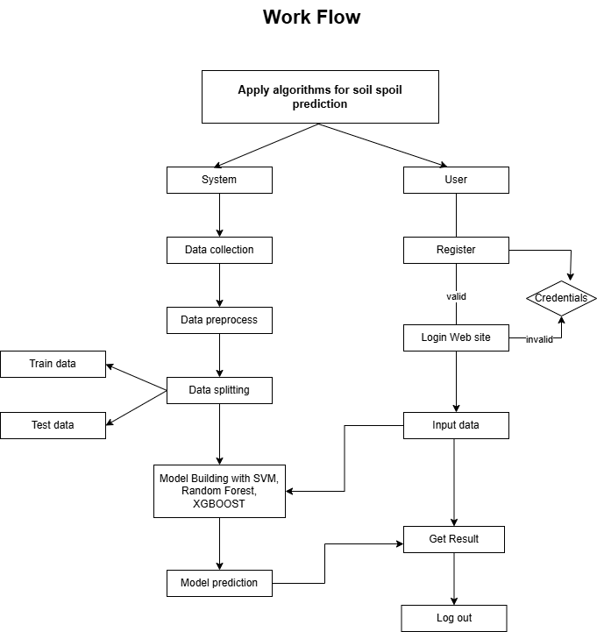

**ARCHITECTURE**:

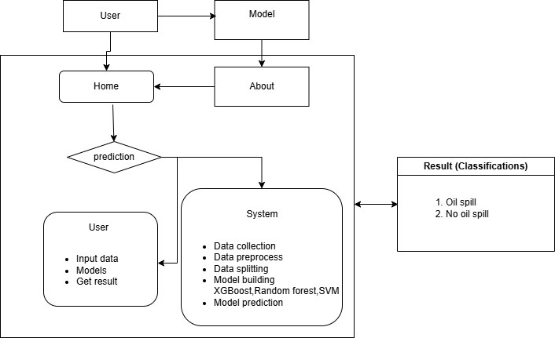

**IMPLEMENTATION AND RESULTS**

**Modules**

**1. System**

**1. 1 Data Preprocessing**

An essential step in getting the datasets ready for analysis is data preparation. It includes preprocessing the data, addressing any missing values, and converting the data into a format appropriate for machine learning algorithms.

**1.2 Handling Missing Values**

Both datasets might have missing or incomplete records, which can greatly affect the accuracy of machine learning models. To address this, Numerical data is handled using imputation techniques such as mean or median, while mode estimation is used to fill in the blanks in categorical data. If the data is significantly incomplete, those records may be excluded to avoid skewing the results.

**1.3 Data Cleaning**

This step involves removing duplicates, correcting inconsistent data entries, and filtering out irrelevant information. For instance, erroneous timestamps or negative energy volumes need to be corrected or removed to ensure data quality.

**1.4 Normalization and Scaling**

To guarantee that numerical attributes equally enhance the model's learning procedure, normalization or scaling techniques are applied. Methods like Min-Max Scaling or Standardization adjust all characteristics within a comparable range, which can enhance the model's execution and aid in faster convergence.

#### 1.5 **Model Training**

* **Objective:** Train machine learning models to classify whether a given data row corresponds to an oil spill or not.
* **Details:**
  + **Algorithms:**
    - **Support Vector Machine (SVM):** Fine-tune an SVM model for binary classification (oil spill vs. no oil spill).
    - **Random Forest:** Use Random Forest to handle non-linear relationships in the data and manage complex feature interactions.
    - **XGBoost:** Apply XGBoost for better handling of imbalanced data and for improving classification accuracy.
    - **Training Process:** Split the dataset into training, validation, and test sets , and fit into model.

#### 1.4 **Model Evaluation**

* **Objective:** Evaluate the model’s performance to ensure generalization to unseen data.
* **Details:**
  + **Metrics:** Use classification metrics like accuracy, precision, recall, F1-score to evaluate model performance.
  + **Confusion Matrix:** Assess the confusion matrix to evaluate true positives, false positives, true negatives, and false negatives.

#### 1.5 **Model Saving**

* **Objective:** Serialize the trained models for future use and deployment.
* **Details:**
  + **Serialization:** Save the trained models using formats like .joblib, .pkl, or .h5 for machine learning models.
  + **Versioning:** Implement model versioning to track changes and updates in the models over time.

#### 1.6 **Model Integration**

* **Objective:** Integrate the models into the overall system for oil spill detection.
* **Details:**
  + **System Integration:** Develop a backend system (e.g., using Flask) to host the trained models and allow them to process new CSV data inputs.
  + **Prediction Pipeline:** Create an API endpoint where new data can be input as CSV files, processed through the model, and returned with predictions.

### **2. User Interaction**

#### **2.1 Register**

* **Objective:** Allow users to create an account and access the system.
* **Details:**
  + **User Information:** Collect details like username, email, and preferred notification settings for oil spill alerts.

#### **2.2 Login**

* **Objective:** Secure access to the system.
* **Details:** Implement authentication to allow users to log in and manage their accounts securely.

#### **2.3 Upload Data**

#### **Objective:** Allow users to upload new satellite imagery feature data for oil spill detection.

#### **2.4 View Detection Results**

* **Objective:** Display the model’s prediction results for the uploaded data.
* **Details:**
  + Show whether the uploaded data contains an oil spill or not.