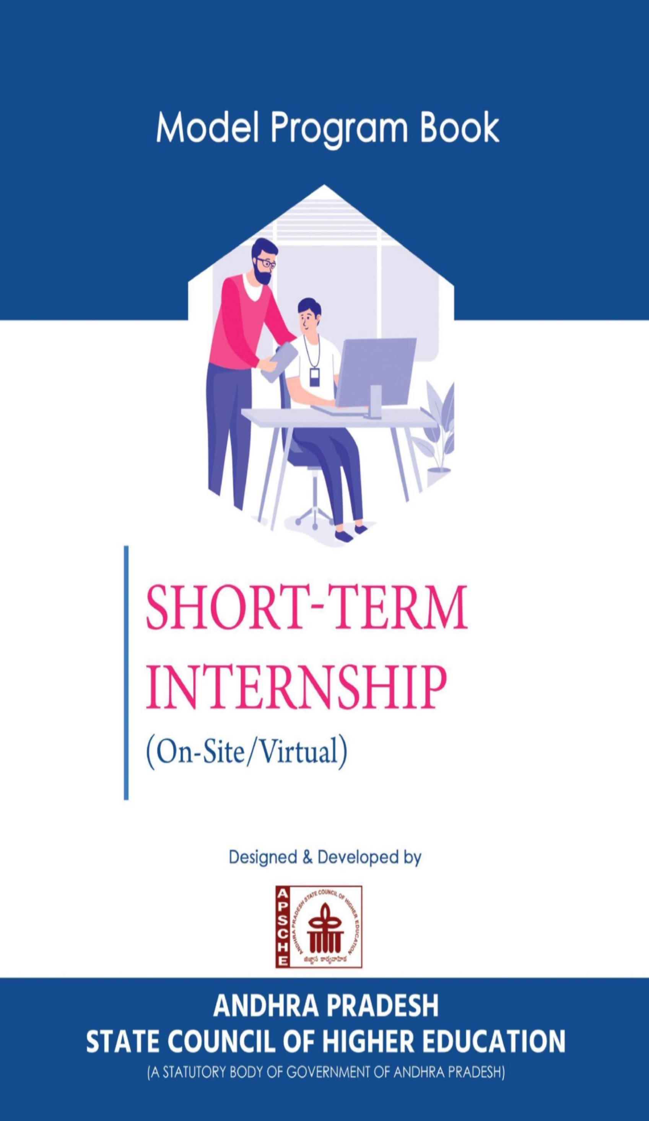

**PROGRAM BOOK FOR**

**SHORT-TERM INTERNSHIP**

# (Onsite)

Name of the Student: T. Naga Lakshmi

Name of the College: Aditya College of Engineering and Technology

Registration Number: 21P31A0540

Period of Internship: 8 Weeks

From: 15/05/2023 To: 08/07/2023

Name & Address of the Intern Organization: Technical Hub, Surampalem

**JNTUK University**

**AN INTERNSHIP REPORT ON**

# PROBLEM-SOLVING AND JAVA

An Internship Report submitted in partial fulfilment of the Requirements

for the award of the degree of

# BACHELOR OF TECHNOLOGY

in

# COMPUTER SCIENCE & ENGINEERING

Submitted by

**THOTA NAGA LAKSHMI**

**Regd. No: 21P31A0540**

Under the esteemed supervision of

**Mr. Amanulla MohammedM. Tech, (Ph. D)**

**Duration From: 15-05-2023 To: 08-07-2023**

**Department of Computer Science And Engineering**

**ADITYA COLLEGE OF ENGINEERING & TECHNOLOGY**

**Approved by AICTE, New Delhi & Affiliated to JNTUK, Kakinada & Accredited by NAAC ‘A+’ Grade**

**Recognized by UGC under the sections 2(f) and 12(B) of the UGC act 195 Aditya Nagar, ADB Road-Surampalem, Kakinada District, Andhra Pradesh - 533 437.**

**2023-2024**

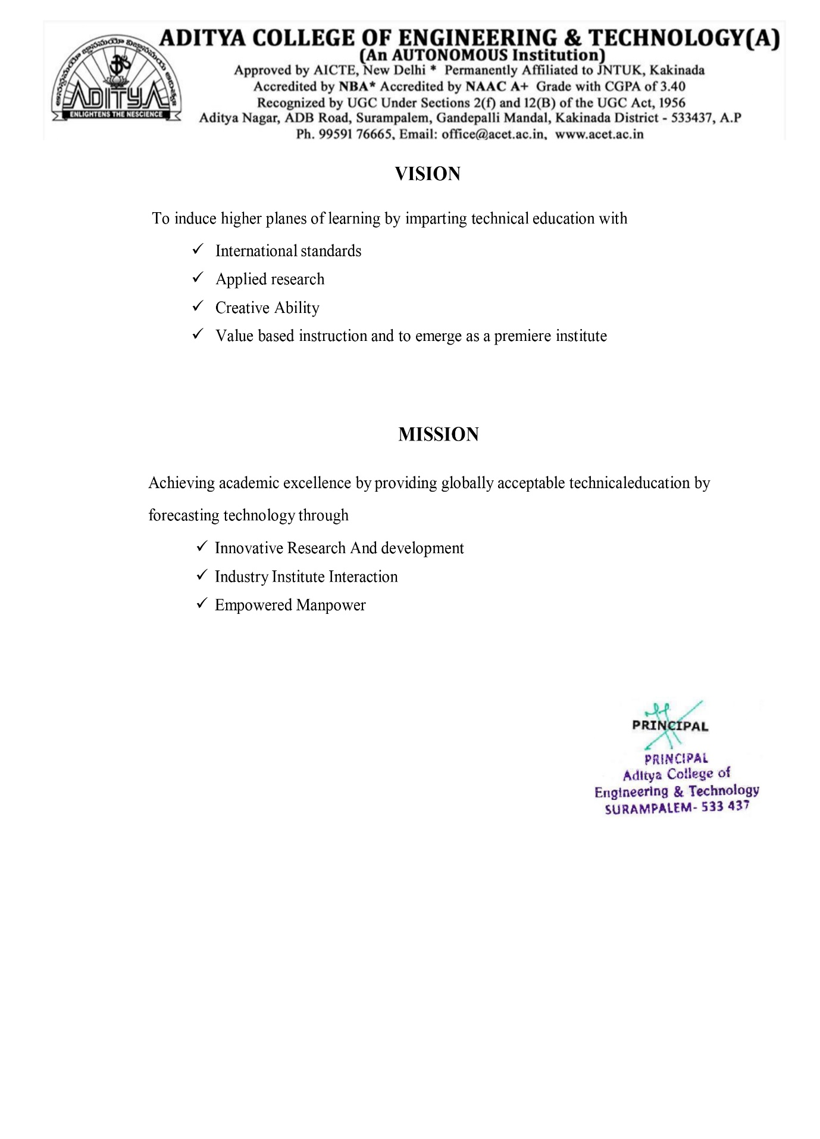

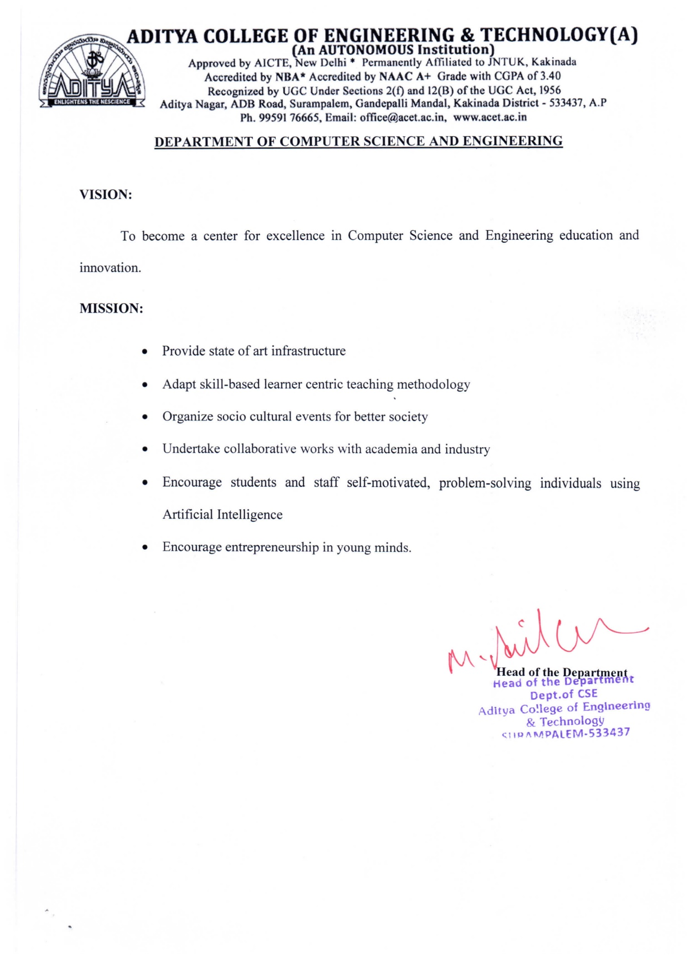

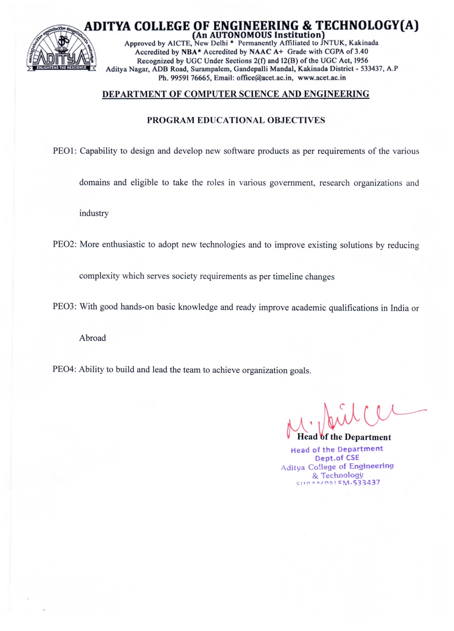

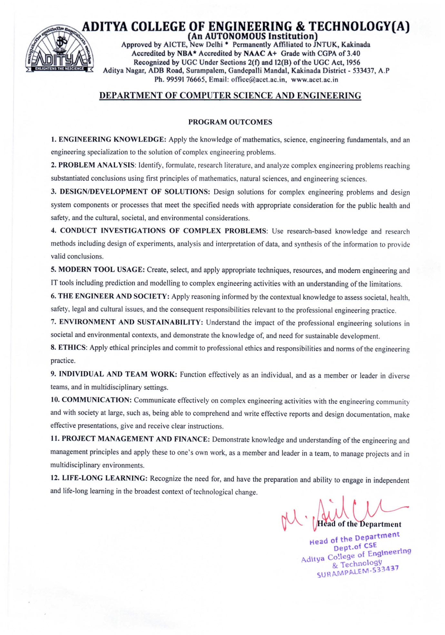

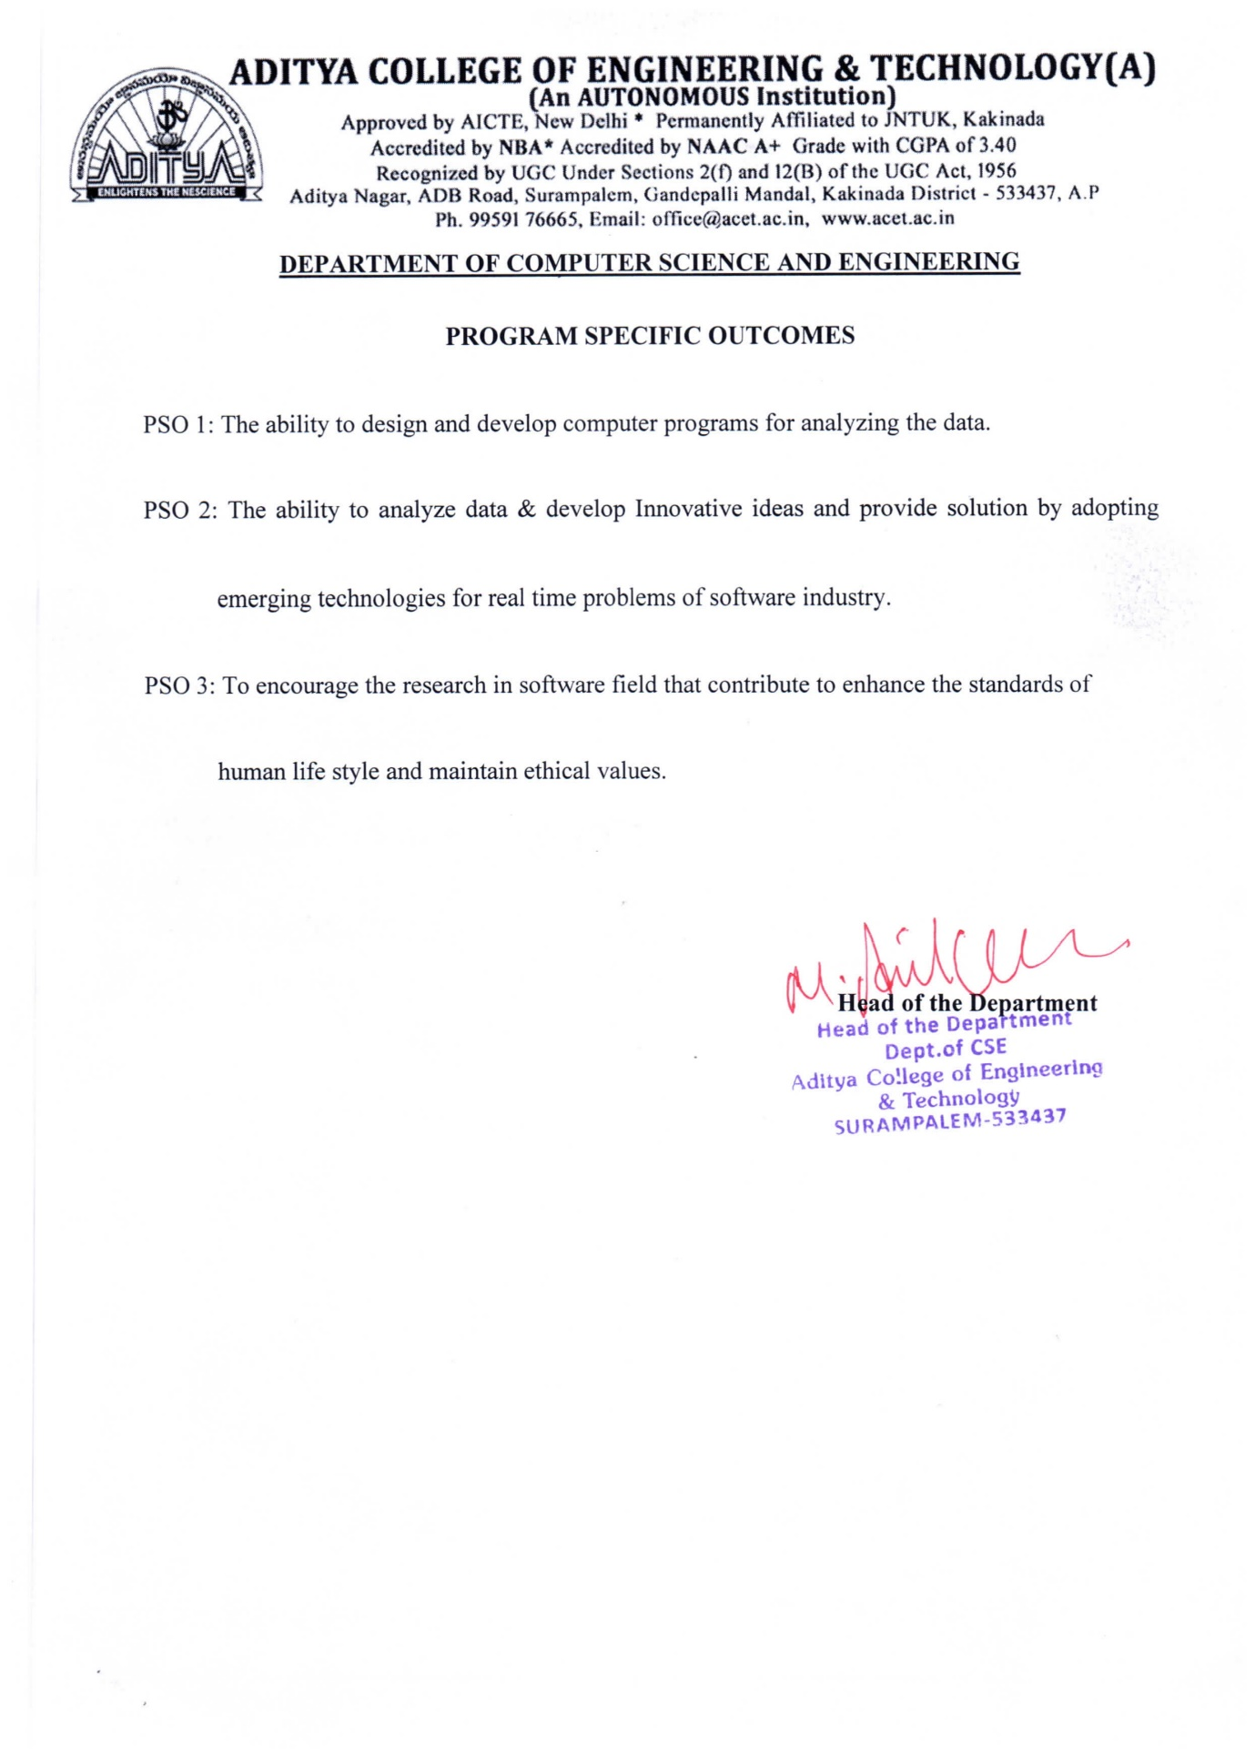

# 

# CERTIFICATE

**Department of Computer Science and Engineering**



This is to certify that the Internship report entitled **“PROBLEM-SOLVING AND JAVA”** is being submitted by **THOTA NAGA LAKSHMI (21P31A0540)**. In partial fulfillment of the requirements for award of the degree of **Bachelor of Technology in Information Technology** in Computer Science And Engineering from Aditya College of Engineering & Technology, Surampalem, during the academic year 2023-2024.

**Internship Coordinator Head of the Department**

**Mr. J.S. Narendra Kumar M. Tech (Ph. D) Dr. M. ANIL KUMAR M. Tech., (Ph. D)**

**Sr Assistant Professor** **Professor**

**EXTERNAL EXAMINER**

**Acknowledgement**

First I would like to thank the Director of **Technical Hub Pvt. Ltd**., **Surampalem** for giving me the opportunity to do an internship within the organization. I also would like all the people that worked along with me in **Technical Hub Pvt. Ltd., Surampalem** with their patience and openness they created an enjoyable working environment.

It is with immense pleasure that I would like to express our indebted gratitude to our Internship coordinator **Mr. Jagatha Satya Narendra Kumar M. Tech (Ph. D)**, who has guided us a lot and encouraged us in every step of the intern project work, his valuable moral support and guidance throughout the Internship project helped us to a greater extent.

It gives us immense pleasure to express a deep sense of gratitude to my guide

**Mr. Amanulla Mohammed M. Tech (Ph. D),** throughout the project work. Without her sustained and sincere effort, this project work would not have taken this shape. He/she encouraged and helped us to overcome various difficulties that I have faced at various stages of our project work.

I would like to sincerely thank our Head of the department **Dr. M. ANIL KUMAR M. tech., Ph.D.**, for providing all the necessary facilities that led to the successful completion of my internship.

I would like to take this opportunity to thank our beloved Principal **Dr. Dola Sanjay****M. Tech, Ph.D**., for providing all the necessary facilities and a great support to us in completing the Internship. I would like to thank all the faculty members and the non-teaching staff of the Department of **Computer Science Engineering** for their direct or indirect support in helping us in the completion of this project work.

We feel elated to thank **Dr. CH. RAGHAVENDHRAN M. Tech (Ph. D)**, **Dean (Academics & Administration)** of Aditya College of Engineering and Technology for his cooperation in completion of our internship work.

Finally, we would like to thank all our friends and family members for their continuous help and encouragement.

**THOTA NAGA LAKSHMI**

**(21P31A0540)**

**Instructions to Students**

Please read the detailed Guidelines on Internship hosted on the website of AP State Council of Higher Education [***https://apsche.ap.gov.in***](https://apsche.ap.gov.in)

1. It is mandatory for all the students to complete 2 months (180 hours) of short- term internship either physically or virtually.
2. Every student should identify the organization for internship in consultation with the College Principal/the authorized person nominated by the Principal.
3. Report to the intern organization as per the schedule given by the College. You must make your own arrangements for transportation to reach the organization.
4. You should maintain punctuality in attending the internship. Daily attendance is compulsory.
5. You are expected to learn about the organization, policies, procedures, and processes by interacting with the people working in the organization and by consulting the supervisor attached to the interns.
6. While you are attending the internship, follow the rules and regulations of the intern organization.
7. While in the intern organization, always wear your College Identity Card.
8. If your College has a prescribed dress as uniform, wear the uniform daily, as you attend to your assigned duties.
9. You will be assigned a Faculty Guide from your College. He/She will be creating a WhatsApp group with your fellow interns. Post your daily activity done and/or any difficulty you encounter during the internship.
10. Identify five or more learning objectives in consultation with your Faculty Guide. These learning objectives can address:
    1. Data and Information you are expected to collect about the organization and/or industry.
    2. Job Skills you are expected to acquire.
    3. Development of professional competencies that lead to future career success.
11. Practice professional communication skills with team members, co-interns, and your supervisor. This includes expressing thoughts and ideas effectively through oral, written, and non-verbal communication, and utilizing listening skills.
12. Be aware of the communication culture in your work environment. Follow up and communicate regularly with your supervisor to provide updates on your progress with work assignments.
13. Never be hesitant to ask questions to make sure you fully understand what you need to do your work and to contribute to the organization.
14. Be regular in filling up your Program Book. It shall be filled up in your own handwriting. Add additional sheets wherever necessary.
15. At the end of internship, you shall be evaluated by your Supervisor of the intern organization.
16. There shall also be evaluation at the end of the internship by the Faculty Guide and the Principal.
17. Do not meddle with the instruments/equipment you work with.
18. Ensure that you do not cause any disturbance to the regular activities of the intern organization.
19. Be cordial but not too intimate with the employees of the intern organization and your fellow interns.
20. You should understand that during the internship programme, you are the ambassador of your College, and your behavior during the internship programme is of utmost importance.
21. If you are involved in any discipline related issues, you will be withdrawn from the internship programme immediately and disciplinary action shall be initiated.
22. Do not forget to keep up your family pride and prestige of your College.

# Student’s Declaration

I, **THOTA NAGA LAKSHMI** a student of **B. Tech Program**, Regd. No: **21P31A0540** of the Department of **Computer Science Engineering**, College do hereby declare that I have completed the mandatory Internship from **15/05/2023** to **08/07/2023** in **Technical Hub Pvt Ltd.,** under the Faculty Guideship of Department of **Computer Science Engineering, ADITYA COLLEGE OF ENGINEERING AND TECHNOLOGY**

*(Signature and Date)*

**Official Certification**

This is to certify that **THOTA NAGA LAKSHMI** Reg. No**. 21P31A0540** has completed his Internship in **TECHNICAL HUB** on **PROBLEM-SOLVING AND JAVA** INTERNSHIP under my supervision as a part of partial fulfilment of the requirement for the Degree of B. Tech in the Department of **Computer Science and Engineering, ADITYA COLLEGE OF ENGINEERING & TECHNOLOGY.**

This is accepted for evaluation.

(Signatory with Date and Seal)

**Endorsements**

Faculty Guide

Head of the Department

Principal

**Certificate of Internship**

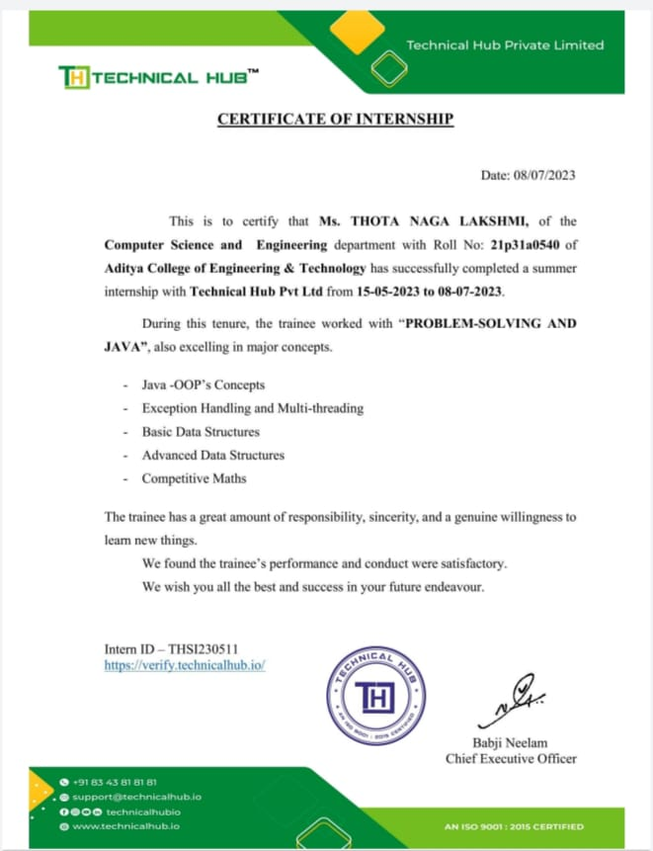

## **Certificate from Intern Organization**

This is to certify that **THOTA NAGA LAKSHMI**Reg. No: **21P31A0540** of **ADITYA COLLEGE OF ENGINEERING & TECHNOLOGY** underwent internship in **TECHNICAL HUB Pvt Ltd.**from **15/05/2023** to **08/07/2023.**The overall performance of the intern during his/her internship is found to be *________________*(Satisfactory/Not Satisfactory).

*Authorized Signatory with Date and Seal*

**Contents**

|  |  |  |
| --- | --- | --- |
| **CHAPTERS** | | **Pg. No.** |
| **INSTRUCTIONS TO STUDENTS** | |  |
| **CHAPTER 1: EXECUTIVE SUMMARY** | | **1-1** |
| 1.1 | A brief description of the intern organization | 1 |
| 1.2 | Learning objective of organization internship | 1 |
| 1.3 | Learning outcome of organization internship | 1 |
| **CHAPTER 2: OVERVIEW OF THE ORGANIZATION** | | **2-3** |
| 2.1 | Organization vision | 2 |
| 2.2 | Organization mission | 3 |
| **CHAPTER 3: INTERNSHIP PART** | | **4-21** |
| 3.1 | Activities taken place in internship | 4 |
|  | 3.1.1 Activity log for the First week | 6 |
|  | 3.1.2 Weekly Report of Week-1 | 7 |
|  | 3.1.3 Activity log for the Second week | 8 |
|  | 3.1.4 Weekly Report of Week-2 | 9 |
|  | 3.1.5 Activity log for the Third week | 10 |
|  | 3.1.6 Weekly Report of Week-3 | 11 |
|  | 3.1.7 Activity log for the Fourth week | 12 |
|  | 3.1.8 Weekly Report of Week-4 | 13 |
|  | 3.1.9 Activity log for the Fifth week | 14 |
|  | 3.1.10 Weekly Report of Week-5 | 15 |
|  | 3.1.11 Activity log for the Sixth week | 16 |
|  | 3.1.12 Weekly Report of Week-6 | 17 |
|  | 3.1.13 Activity log for the Seventh week | 18 |
|  | 3.1.14 Weekly Report of Week-7 | 19 |
|  | 3.1.15 Activity log for the Eighth week | 20 |
|  | 3.1.16 Weekly Report of Week-8 | 21 |
| **CHAPTER 4: OUTCOME DESCRIPTION** | | **22-29** |
| 4.1 | Describe the real time technical skills you have acquired | 23 |
| 4.2 | Describe the managerial skills you have acquired | 24 |
| 4.3 | Describe how you could improve your communication skills | 25 |
| 4.4 | Describe the technological developments you have observed and relevant to the subject area of training | 27 |
| **STUDENT SELF-EVALUATION OF THE SHORT-TERM INTERNSHIP** | | **30** |
| **EVALUATION BY THE GUIDE OF THE INTERN ORGANIZATION** | | **31** |
| **PHOTOS & VIDEO LINKS** | | **32** |
| **INTERNAL ASSESSMENT STATEMENT** | | **37** |
| **EXTERNAL ASSESSMENT STATEMENT** | | **38** |

### **CHAPTER 1:**

### **EXECUTIVE SUMMARY**

### **A Brief Description of Intern Organization**

I had done Internship in Technical hub Pvt ltd which was part of our college which provides quality technical skills and students were able to acquire knowledge in different programming languages as well as different technologies like Artificial Intelligence and Machine learning, Full stack, Cloud, Sales force, and also programming languages like C, C++, Python, Java etc.

* 1. **Learning Objective of Organization Internship**
* To make Students aware of the Upcoming new technologies and increase their skills set
* Provide opportunity to become active in recruitments.
* Enables to acquire like skills and knowledge, and use their technical knowledge on the real time problem statements.
* Sensitize the students to present technologies around them.
  1. **Learning outcome of Organization Internship**
* Learning new technologies which help them enlighten.
* Improves student’s ability to apply what they have learned in “the real world”.
* Greater interpersonal development, particularly the ability to work well with others, and build leadership and communication skills.

**CHAPTER-2**

**OVERVIEW OF THE COMMUNITY**

Technical Hub was started in the year 2016 at Aditya Group of Engineering Colleges, Surampalem, East Godavari Dist., Andhra Pradesh with a motto to impart quality and skilled technical knowledge to the Engineering students to excel in their careers. In-house industry skilled trainers of scripted software such as SAP, Salesforce, Java and networking technologies as Cisco, Red hat and Microsoft. Provide free training to the students from different branches of engineering throughout the year. They conduct learning Sessions, Workshops, Hackathons, Learnathons, Ideathons and Gameathons regularly to inculcate interest among the students to think out of box.

**Figure-1: Technical hub**

Technical Hub trains 2000+ students from various branches and customize the training programs as per the needs of departments. They now train and encourage certifications for the students on disruptive technologies such as Machine Learning, AR-VR, Blockchain, Robotics, 3D gaming. They have signed Learning and Development MOUs with SAP, Sales force, Comptia and setup laboratories with latest Software & hardware equipment to train the students in real-time environment. Our Industry-Connect program is organized once in a month to know latest technology happenings and updates by Industry experts’ interaction with the students. Project Space is organized twice a year to provide customized solutions by the students to the real problems in the society. T-shaped Engineer is one of its kind in technical training arena, the agenda of the program is to prepare and skill train a student to be readily employed by the industry. They trained and deployed handful of students in the software companies with highest salary package.

Technical Hub is a one stop solution for the career loving students to excel in technology and software related roles. Our Open-door policy encourages the students to approach Technical Hub and enrol themselves for the trainings.

To complete the internship, the organization makes sure we have attended classes properly that we should have 80% of attendance and pass the assignments conducted by the organization. They evaluate our knowledge and provide training accordingly. Our performance report is also sent to our mail. It also takes about students’ discipline and behaviour. Immediate disciplinary actions will be taken for any mischief. Thub provides real time working experience for the interns. The trainees are very interactive and available whenever the intern needs help and show special care towards the trainees.

It provides training for students for learning new technologies that are currently in trend and also based on student interest. The demand-supply gap scenario, exponential opportunities and dynamic challenges in the 21st-century call for a change in our thinking on engineering practice and education. A transformation in the current engineering education is the need of hour, Growth of new knowledge together with rapidly evolving technological skills, the skill to communicate across disciplines, the availability to lead team-centered projects, contextualized problem formulation, and hands-on experience to meet the current industry needs due to the growing gap between engineering practice, education and research which requires a lot of concern. As a timely response, it is the concern for the student that has led Aditya to initiate Technical Hub: a perfect launch pad to the job world. Technical Hub trains students in various disciplines beyond technological labels besides equipping them with the skills and creativity required for advancement in their careers. Through its various programs technical hub provides adequate opportunities for an unmatched knowledge base by imparting all necessary skills to students and makes them job ready. Aditya founded Technical Hub as a timely reaction to his concern for students. Technical Hub educates students in a variety of subjects that go beyond technology labels, as well as providing them with the skills and creativity needed to advance in their jobs.

**CHAPTER-3**

**INTERNSHIP PART**

**3.1 Activities taken place in Internship**

During the internship I got trained in Java and problem-solving. At first, I started learning about introduction of java and worked on Java topics like:

* Java fundamentals
* Control statements
* Arrays
* Strings

After that, I started learning OOPs concept. It is used to implement many projects with the help of classes and objects. The topics on which I worked with OOPs are:

* Introduction to OOPS
* Polymorphism
* Inheritance
* Abstract classes
* Interface

After OOPs I’ve learned the key concepts in Java .The Topics on which I’ve worked are:

* Packages
* Exception handling
* Multithreading
* JDBC

After successfully completed topics in java , I started learning Problem solving in CPP. CPP is widely used in problem solving because of its availability of multiple resources and libraries. The Topics on which I worked in Problem solving are:

* Introduction
* Bit manipulation
* Searching Algorithms
* Sorting Algorithms
* Introduction to competitive math

After completing necessary topics in Problem-solving I have started learning Key concepts related to problem solving. The Topics included in that are:

* Introduction to STL
* Introduction to data structures
* Linked Lists
* Stacks
* Queue

After completing all the concepts, I have practiced all the above concepts in the platforms like related to problem solving are:

* Leet Code
* Geeks for Geeks
* Hacker Rank
* Code chef

**3.1.1 ACTIVITY LOG FOR FIRST WEEK**

|  |  |  |  |
| --- | --- | --- | --- |
| **Day**  **&**  **Date** | **Brief description of the daily activity** | **Learning Outcome** | **Person In-Charge Signature** |
| **Day – 1** | Learnt about Fundamentals of Java | Learned Java Fundamentals |  |
| **Day – 2** | Learnt about Applications of Java | Learned Java Fundamentals and applications |  |
| **Day – 3** | Learnt about Control Statements in Java | Learned concept of Control Statements |  |
| **Day – 4** | Solved Problems on Control Statements | Learned concept of Control Statements |  |
| **Day – 5** | Learnt Concept of Arrays | Learned about Arrays |  |
| **Day – 6** | Solved some array problems | Learned about Arrays |  |

**WEEKLY REPORT**

**3.1.2 WEEK -1 (From Dt 15/05/23 to Dt 20/05/23)**

**Objective of the Activity Done:**

In this week I have gained knowledge in the basics of Java and started about Control Statements.

**Detailed Report:**

In this week, I have learned the Fundamentals of Java and also learned about the Applications related to Java. And after that moved forward to learn about the concept of

Control Statements and started solving problems on the concepts that I have learned. Also, I have learnt the concept of Arrays, Strings and String classes in Java Programming Language and solved various problems related to strings on different coding platforms. I have gained knowledge and some practical experience on the concepts that I have learned so far.

**3.1.3 ACTIVITY LOG FOR SECOND WEEK**

|  |  |  |
| --- | --- | --- |
| **Day**  **&**  **Date** | **Brief description of the daily activity** | **Learning Outcome** |
| **Day – 1** | Learnt about Strings in Java | Learned concept of Strings |
| **Day – 2** | Learnt about string classes in Java | Learned concept of Strings |
| **Day – 3** | Introduction to Object Oriented Programming in Java | Learned about OOPs |
| **Day – 4** | Applications of ObjectOriented Programming in Java | Learned about OOPs |
| **Day – 5** | Learned the concept about Polymorphism in Java | Learned about Polymorphism |
| **Day - 6** | Learned about different types of Polymorphism | Learned about Polymorphism |

**WEEKLY REPORT**

**3.1.4 WEEK – 2 (From Dt 22/05/23 to Dt 27/05/23)**

**Objective of the Activity Done:**

In this week I have gained knowledge in the basics of Java and started learning Object Oriented Programming.

**Detailed Report:**

In this week I have learnt about the concept called Strings. And I have also learned the concept related to string classes. I started learning about a crucial concept in Java called as ObjectOriented Programming where I gained knowledge in different topics like classes, Objects and I also learned the concepts like Polymorphism by solving problems.

I have solved some problems in these areas that have increased my problem solving experience.

**3.1.5** **ACTIVITY LOG FOR THIRD WEEK**

|  |  |  |  |
| --- | --- | --- | --- |
| **Day**  **&**  **Date** | **Brief description of the daily activity** | **Learning Outcome** | **Person In-Charge Signature** |
| **Day – 1** | Learnt the concept of Inheritance in Java | Learned concept of Inheritance |  |
| **Day – 2** | Learnt the applications of Inheritance in Java | Learned concept of Inheritance |  |
| **Day – 3** | Learnt about Abstract Classes in Java | Learned concept of Abstract Classes |  |
| **Day – 4** | Solved some problems about Abstract Classes in Java | Learned concept of Abstract Classes |  |
| **Day – 5** | Learnt about Interfaces in Java | Learned concept of Interfaces |  |
| **Day – 6** | Learnt about Applications of Interfaces in Java | Learned concept of Interfaces |  |

**WEEKLY REPORT**

**3.1.6 WEEK – 3 (From Dt 29/05/23 to Dt 03/06/23**)

**Objective of the Activity Done:**

In the 3rd week, I started learning some more OOP’s concepts and topics like Inheritance, Interfaces.

**Detailed Report:**

In this week, I have dived deep into the concepts of Object Oriented Programming and learnt various concepts. The topics related to Inheritance, Applications of Inheritance, Abstract classes and I also learned the concepts regarding interfaces and its applications.

I have explored many coding problems regarding these concepts in many coding platforms, and solved some of them. Here I have learnt that direct support for multiple inheritance is not allowed in Java. This multiple inheritance is implemented indirectly by using interfaces. So, next I have started learning interfaces and its applications.

**3.1.7 ACTIVITY LOG FOR FOURTH WEEK**

|  |  |  |  |
| --- | --- | --- | --- |
| **Day**  **&**  **Date** | **Brief description of the daily activity** | **Learning Outcome** | **Person In-Charge Signature** |
| **Day – 1** | Learnt about Packages in Java | Learned concept of Packages |  |
| **Day – 2** | Learnt about types of Packages in Java | Learned concept of Packages |  |
| **Day – 3** | Learnt about user-defined packages in Java | Learned concept of Packages |  |
| **Day – 4** | Learnt about Exception Handling in Java | Learned concept of Exception Handling |  |
| **Day – 5** | Learnt about Exception Handling in Java | Learned concept of Exception Handling |  |
| **Day - 6** | Learnt about Java Database Connectivity (JDBC) | Learned about JDBC |  |

**WEEKLY REPORT**

**3.1.8 WEEK-4 (From Dt 05/06/23 to Dt 10/06/23)**

**Objective of the Activity Done:**

In the Fourth week, I started learning some more OOPs concepts and topics like Exception Handling, JDBC

**Detailed Report:**

In this week, I have learned concepts about Packages. I have learned declaration of packages and importing of statements using import. And moving forward I have also learned about different types of Packages and also included how to work with user-defined packages practically and also learned creating some user-defined packages. After these I have started learning the concept called Exception handling. Types of Exceptions like checked and unchecked exceptions. Checked exceptions must be caught or declared in the method signature using the “Throws” keyword. Unchecked exceptions do not need explicit handling. And a small intro on JDBC.

**3.1.9 ACTIVITY LOG FOR FIFTH WEEK**

|  |  |  |  |
| --- | --- | --- | --- |
| **Day**  **&**  **Date** | **Brief description of the daily activity** | **Learning Outcome** | **Person In-Charge Signature** |
| **Day – 1** | Got an idea about different Problem solving approaches | Introduction to Problem-Solving |  |
| **Day – 2** | Practiced problems on the learned concepts | Problem-Solving Session |  |
| **Day – 3** | Learnt about Bit Manipulation | Learned concept of Bit Manipulation |  |
| **Day – 4** | Practiced problems on Bit Manipulation | Problem-Solving Session |  |
| **Day – 5** | Learnt about Different Searching Algorithms | Learned various Searching Algorithms |  |
| **Day – 6** | Practiced problems on different Searching Algorithms | Problem-Solving Session |  |

**WEEKLY REPORT**

**3.1.10 WEEK – 5 (From Dt 12/06/23 to Dt 17/06/23)**

**Objective of the Activity Done:**

In fifth week, I have started learning Problem-Solving Techniques and various kinds of Algorithms.

**Detailed Report:**

I have got to know some basic understanding of Problem-Solving and started learning few Algorithms. The first concept I have learned is Bit Manipulation. Then I learned various Searching and Sorting Algorithms and analyzed their Time and Space complexities. Then I have solved various problems related to the above learned concepts on different Coding Platforms. That makes me learn various algorithms related to searching.

**3.1.11 ACTIVITY LOG FOR SIXTH WEEK**

|  |  |  |  |
| --- | --- | --- | --- |
| **Day**  **&**  **Date** | **Brief description of the daily activity** | **Learning Outcome** | **Person In-Charge Signature** |
| **Day – 1** | Learnt about Different Sorting Algorithms | Learned various Sorting Algorithms |  |
| **Day – 2** | Practices problems on the sorting Algorithms | Problem-Solving Session |  |
| **Day – 3** | Learnt some Basic concepts of Competitive Math like Number Theory | Learned concept of Number Theory |  |
| **Day – 4** | Practices problems on the Number Theory. | Problem-Solving Session |  |
| **Day – 5** | Learnt about concepts related to Competitive Math like Permutations. | Learned concept of permutations. |  |
| **Day – 6** | Practices problems on the learned concepts | Problem-Solving Session |  |

**WEEKLY REPORT**

**3.1.12 WEEK – 6 (From Dt 19/06/23 to Dt 24/06/23)**

**Objective of the Activity Done:**

In sixth week, I have started learning About Number theory and its related algorithms.

**Detailed Report:**

I have learned various Searching and Sorting Algorithms and analyzed their Time and Space complexities. I have learned some basic competitive math concepts like Number Theory which covers Algorithms like GCD, LCM and Prime Numbers. I then solved various problems related to the above learned concepts on different Coding Platforms.

**3.1.13 ACTIVITY LOG FOR SEVENTH WEEK**

|  |  |  |  |
| --- | --- | --- | --- |
| **Day**  **&**  **Date** | **Brief description of the daily activity** | **Learning Outcome** | **Person In-Charge Signature** |
| **Day – 1** | Learnt about Standard Template Library and different containers. | Learned concept of STL |  |
| **Day – 2** | Practices problems on the Standard Template Library | Problem-Solving Session |  |
| **Day – 3** | Learnt about different Data Structures | Learned concept of Data Structures |  |
| **Day – 4** | Practices problems on the learned concepts. | Problem-Solving Session |  |
| **Day – 5** | Learnt about a concept called  Linked Lists | Learned concept of Linked Lists |  |
| **Day – 6** | Practices problems on the learned concepts. | Problem-Solving Session |  |

**WEEKLY REPORT**

**3.1.14 WEEK–7 (From Dt 26/06/23 to Dt 01/07/23)**

**Objective of the Activity Done:**

In seventh week, I have learned various Data Structures and their Implementation.

**Detailed Report:**

I have learned about Standard Template Library and the working mechanism of different Containers available in STL. I further moved to learn Data Structures and got a basic idea about different Data Structures like Linked Lists. I have also learned about the applications of Linked lists. I then solved various problems on different Online Coding Platforms with the knowledge I have on Data Structures and Algorithms.

**3.1.15 ACTIVITY LOG FOR EIGTH WEEK**

|  |  |  |  |
| --- | --- | --- | --- |
| **Day**  **&**  **Date** | **Brief description of the daily activity** | **Learning Outcome** | **Person In-Charge Signature** |
| **Day – 1** | Learnt about a concept called  Stacks | Learned concept of Stacks |  |
| **Day – 2** | Practiced some Problems on stacks. | Problem-Solving Session |  |
| **Day – 3** | Learnt about a concept called  Queues | Learned concept of Queues |  |
| **Day – 4** | Practiced some Problems on queues. | Problem-Solving Session |  |
| **Day – 5** | Learnt about a concept called  Trees. | Learned concept of Trees. |  |
| **Day – 6** | Practiced some Problems on Trees. | Problem-Solving Session |  |

**WEEKLY REPORT**

**3.1.16 WEEK–8 (From Dt 03/07/23 to Dt 08/07/23)**

**Objective of the Activity Done:**

In 8th week I have learned various Data Structures and their Implementation.

**Detailed Report:**

I have learned working mechanism of different Containers available in STL. I further moved to learn Data Structures and got a basic idea about different Data Structures like Stacks, Queues and their functionalities. I have also learned about their various applications. I then solved various problems on different Online Coding Platforms with the knowledge I have on Data Structures and Algorithms.

###### **CHAPTER-4:**

###### **OUTCOMES DESCRIPTION**

I had done my internship on “Problem Solving and Java” at Technical Hub Pvt ltd, located at Aditya Nagar, Surampalem. In the view of this short-term internship, I had a great learning experience with the people that I have been trained by and with my fellow interns. We had shared our knowledge together and strengthened skills day by day. We have been provided with highspeed internet and had a good physical infrastructure that made us feel very comfortable throughout the internship period. I have been scheduled 6 days a week for internship training. I had recognized the importance of Java and its dominance in present world scenario.

I had developed interpersonal, communication, and other important skills before in time that are very much required for a job and a job interview. I can determine, document, and fulfil performance goals associated with their job assignment that I had mutually agreed upon by the business the MCC experimental learning supervisor, and the study of every domain that had been related to the internship that I chose.

I had a great time with my fellow interns in various zones including having fun time with then other than training. There are few employees present to monitor our actions and performance of the training and to clarify our doubts in the concepts that we have been thought during the Internship. The atmosphere of the training place is very workaholic where all the interns and staff are engaged in either learning something or exploring something that could help them to make themselves a better person tomorrow.

**4.1 Real-time technical skills acquired during Internship**

I gained a wide range of practical technical skills throughout the internship, which really aided in my career development. My practical expertise with java helped me to become proficient in developing real time projects like Employee management system, pizza ordering system etc.

Moreover, the internship taught how to build a code in systematic manner because while writing code we all have face some issues like indentations, syntax errors, etc to overcame this type of things we build a clean and effective code. I also gained knowledge on how oops concepts can be used in real time projects and also how Exceptions are caught.

In addition, the internship gave me hands-on experience creating and building real time projects. where I used java concepts to solve realistic problems. I was able to understand the complexities writing code, passing parameters, and compiling the code thanks to this experience. Exercises including pizza ordering system, bank management system implementing this kind of projects I had gained experience on some concepts of java and highlighting the significance of ongoing development. In summary, the internship offered a stimulating and dynamic learning atmosphere that enabled me to gain and utilize technical skills in practical situations, equipping me for the difficulties and intricacies of the rapidly developing fields.

**4.2 Managerial Skills acquired during Internship**

I had earned much more during an internship than just a pay check or college credits. The internship skills, lessons, and insights That I had gained are invaluable for both life and our future career. Here are some of the many benefits/skills an internship had thought me

* Punctuality is as much about courtesy and respect as it is about timeliness. Internship taught me how to fix my schedule and leave extra cushion time to allow for unexpected delays like traffic or long coffee lines.
* Whether through emails, phone calls, or face-to-face meetings, the internship had seen my communicating with others in the organization that I had worked. Communication is often one of the underappreciated internship skills and one that greatly affects the working world.
* Through the internship, I had gained an understanding and appreciation for clear business communication through meetings, messages, and training.
* From conducting comprehensive competitor analysis research, to designing a marketing and communication plan, my knowledge of business and marketing theories was transformed into a series of practical techniques and skills that I can now implement in real-life business scenarios.
* I learned that every company or organisation has its own culture. It’s essential to observe others and learn how they engage and interact with co-workers, or help them with projects and tasks. I quickly learned that whenever something is unclear for me, or I don’t understand, it’s fine to ask for clarification.
* As an intern, I discovered it’s essential to be enthusiastic and open to learning new skills, asking for more work and being curious to learn and ask questions. This attitude will show that you enjoy being part of the team and that you're keen to help. Having curiosity and enthusiasm also means that, as an intern, you get a lot out of what you’re doing, which opens lots of opportunities.
* Asking for and receiving professional feedback is very important. It is essential to take note of both the positive and negative points for the future, so you can grow and excel in your career. I learned that sometimes asking for feedback or receiving feedback is difficult to hear, but it will have a significant impact on your future career and success.

**4.3 Describe how you could improve your communications Skills**

Internships are an ideal way to observe and learn. It had offered the opportunity to discover new technical skills, explore my career path and expanded my network with professionals. However, one key area which I had really been developed through the internship is my communication skills.

Anecdotal feedback from some of the companies that appear for the placements in my college tells us that there is still a need for students to develop their communication skills once in their placement

* As a fresh face with in an organisation I had been in an ideal position to observe and learn. I had a few seminars/presentations at the mid-way point of my internship the new skills that I had learnt till that date and on which I had worked on. Not only that demonstrated my initiative and enthusiasm for the role but also, I had the ideal opportunity to practice my presentation skills in the real-time work experience.
* We likely have a weekly meeting/discussion at the end of every week. I had involved in every discussion and explored the ideas that I had in my mind and helped me in feeling more confident in speaking in front of my fellow interns and other staff. As the days passed by, I had become an active speaker that one can face the higher/fellow individuals in any organization.
* Actively seek feedback from my peers to ensure my constant learning and improving my communication skills. I had rectified my speaking skills by interacting with my fellow interns and the trainees, corrected my language grammar and developed a good vocabulary.
* The easiest and quickest way that I had found to improve my communication skills is to practice. And then practice some more! I used my internship as an ideal way to speak with my fellow interns and trainees and learn from their experiences.
* Become involved with group and company events such as special occasions and social activities performed by the company. I put my every effort to explore myself in opportunity that could improve mu communication skills. AI had been always curious about their experience and engage in a conversation with them. This had helped a lot to improve my language skills.
* I asked the mentors / trainees for any tips and guidance could share. I felt that was a great way to not only build your professional relationships, that was also an invaluable method of gaining first hand tips from people who have been in a similar situation. I could able to grasp strategies and methods to improve my communication skills as well as build a connection with my mentors/trainees.

The development of my communication skills needs to be an ongoing part of my professional learning and development. As I start my career, I will be learning many new technical skills which are incredibly important for my development. However, effective communication skills will really help me go to the next level of my career. I might want to consider extra training or classes to perfect my business communication.

**4.4 Describe how could you could your abilities in group discussions, participation in teams, contribution as a team member, leading a team/activity.**

Group members need to act cohesively in order to operate well together. My fellow members had a great willing to get to know one another, particularly those with different interests and backgrounds. We are always been open to new ideas, diverse viewpoints, and the variety of individuals present within the group. I always listen to others and elicit their ideas. I know how to balance the need for cohesion within a group with the need for individual expression. We trusted one another enough to share our own ideas and feelings. A sense of mutual trust developed only to the extent that everyone had shown their willing to self-disclose and be honest yet respectful. We demonstrated personal accountability for the tasks we have been assigned in the form of activity.

We demonstrated support for one another as we accomplish our goals. We exemplified a sense of team loyalty and both cheer on as a whole and help others who had experienced difficulties. We viewed one another not as competitors (which is common within a typically individualistic educational system) but as collaborators to explore and innovate ideas in our learning. We communicated our opinions in a way that respects other opinion, focusing on “What can we learn?” rather than “Who is to blame?” seen constructive feedback in the process section for more details.

Besides knowing how to develop a healthy group climate, we also need to know how to function so that we can be productive and accomplish our tasks effectively.  We all were agreed on what needs to be done and by whom when it’s come to any activity to be done. We determined what he or she needs to be done and took responsibility in completing the task(s). We held accountable to each other for the work done by us to others. We were able to give and receive feedback about the ideas. Giving constructive feedback required for using on ideas and behaviours, instead of individuals, being as positive as possible, and offered suggestions for improvement. Receiving feedback required listening well, asked for clarification if the comment is unclear, and being open to change and other ideas if the ideas was better than the present one.

We help each other to develop and used strategies centralize the goals. As such, we facilitated others decision-making and deal productively without any conflict if the idea was better than any other. In extreme cases, we approached the mentor for additional advice and help. We planned and managed tasks and our time for our other works we had like academics, etc. We got to know which roles can be filled within us (e.g., facilitator, idea-generator, summarizer, evaluator, mediator, encourager, recorder) and were aware of which role(s) we were best suited for. We also showed our willingness to rotate roles to maximize our own and others ’learning experience. That makes us experience the roles of team lead and a team member.

**4.5 Describe the technological developments you have observed and relevant to the subject area of training**

As many know, technology is becoming increasingly more valuable over time. With that increasing importance comes a higher demand for jobs. One of those job demands specifically deals with Java-related positions. What is Java? It is a popular programming language with widespread applications and usability. There are many advantages to going into a technology-based career—specifically one that relies heavily on the use of Java—including income, job security, and benefits.

However, there is one obstacle that everyone looking into a technology field must overcome, and that obstacle is experience. Companies looking to hire up and coming tech candidates will be looking for more than a degree from an accredited college or coding boot camp. They are also looking for hands-on work experience. This is where internships come into play.

This internship will help demonstrate my ability to work and prove to your possible future employer what work I can produce. This is important as it highlights the skills you learned to code with java. There are many benefits to a Java internship that we will go into further detail about, including gaining knowledge, networking, and finding future success in the tech industry.

### Gain Java knowledge and experience in real-life situations

### Establish your tech network through internship

1. Become a team player

***Student Self Evaluation of the Short-Term Internship***

**Name of the Organization & Address:** Technical Hub Pvt. Ltd

**Organization Name & Address:**

|  |  |  |
| --- | --- | --- |
| **Student Name: T. Naga Lakshmi** |  | **Registration No: 21P31A0540** |
| **Term of Internship: Short term** | **From: 15 – 05 - 2023** | **To: 08 – 07 - 2023** |
| **Date of Evaluation:** |  |  |

###### **Please rate your performance in the following areas:**

**Rating Scale: Letter grade of CGPA calculation to be provided**

|  |  |  |  |  |  |  |
| --- | --- | --- | --- | --- | --- | --- |
| 1 | Oral communication | 1 | 2 | 3 | 4 | 5 |
| 2 | Written communication | 1 | 2 | 3 | 4 | 5 |
| 3 | Proactiveness | 1 | 2 | 3 | 4 | 5 |
| 4 | Interaction ability with community | 1 | 2 | 3 | 4 | 5 |
| 5 | Positive Attitude | 1 | 2 | 3 | 4 | 5 |
| 6 | Self-confidence | 1 | 2 | 3 | 4 | 5 |
| 7 | Ability to learn | 1 | 2 | 3 | 4 | 5 |
| 8 | Work Plan and organization | 1 | 2 | 3 | 4 | 5 |
| 9 | Professionalism | 1 | 2 | 3 | 4 | 5 |
| 10 | Creativity | 1 | 2 | 3 | 4 | 5 |
| 11 | Quality of work done | 1 | 2 | 3 | 4 | 5 |
| 12 | Time Management | 1 | 2 | 3 | 4 | 5 |
| 13 | Understanding the Community | 1 | 2 | 3 | 4 | 5 |
| 14 | Achievement of Desired Outcomes | 1 | 2 | 3 | 4 | 5 |
| **15** | **OVERALL PERFORMANCE** | **1** | **2** | **3** | **4** | **5** |

**Date: Signature of the Student**

#### **Evaluation by the Supervisor of the Intern Organization**

**Organization Name & Address: Technical Hub Pvt. Ltd**

**Name & Address of the Supervisor with Mobile Number:**

|  |  |  |
| --- | --- | --- |
| **Student Name: T. Naga Lakshmi** |  | **Registration No: 21P31A0540** |
| **Term of Internship: Short term** | **From: 15 – 05 –2023** | **To: 08 – 07 - 2023** |
| **Date of Evaluation:** |  |  |

Please rate the student’s performance in the following areas:

Please note that your evaluation shall be done independent of the student’s self- evaluation

Rating Scale: 1 is lowest and 5 is highest rank

|  |  |  |  |  |  |  |
| --- | --- | --- | --- | --- | --- | --- |
| 1 | Oral communication | 1 | 2 | 3 | 4 | 5 |
| 2 | Written communication | 1 | 2 | 3 | 4 | 5 |
| 3 | Pro activeness | 1 | 2 | 3 | 4 | 5 |
| 4 | Interaction ability with community | 1 | 2 | 3 | 4 | 5 |
| 5 | Positive Attitude | 1 | 2 | 3 | 4 | 5 |
| 6 | Self-confidence | 1 | 2 | 3 | 4 | 5 |
| 7 | Ability to learn | 1 | 2 | 3 | 4 | 5 |
| 8 | Work Plan and organization | 1 | 2 | 3 | 4 | 5 |
| 9 | Professionalism | 1 | 2 | 3 | 4 | 5 |
| 10 | Creativity | 1 | 2 | 3 | 4 | 5 |
| 11 | Quality of work done | 1 | 2 | 3 | 4 | 5 |
| 12 | Time Management | 1 | 2 | 3 | 4 | 5 |
| 13 | Understanding the Community | 1 | 2 | 3 | 4 | 5 |
| 14 | Achievement of Desired Outcomes | 1 | 2 | 3 | 4 | 5 |
| **15** | **OVERALL PERFORMANCE** | **1** | **2** | **3** | **4** | **5** |

**Date: Signature of the Supervisor**

## **PHOTOS OF ONLINE CODING PROFILES**

**Different Activities Performed During this Summer Internship**

**Geeks for Geeks Profile:**

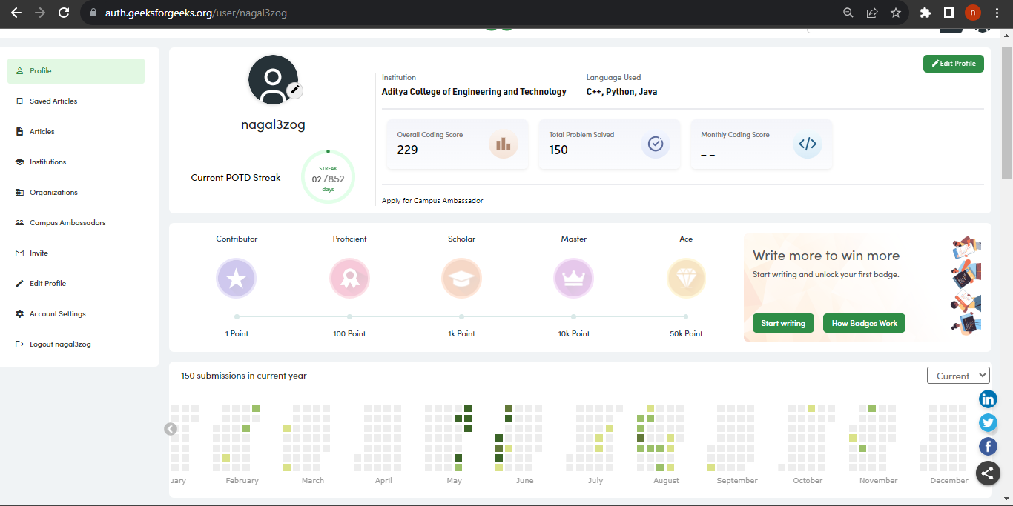

**Hacker rank Profile:**

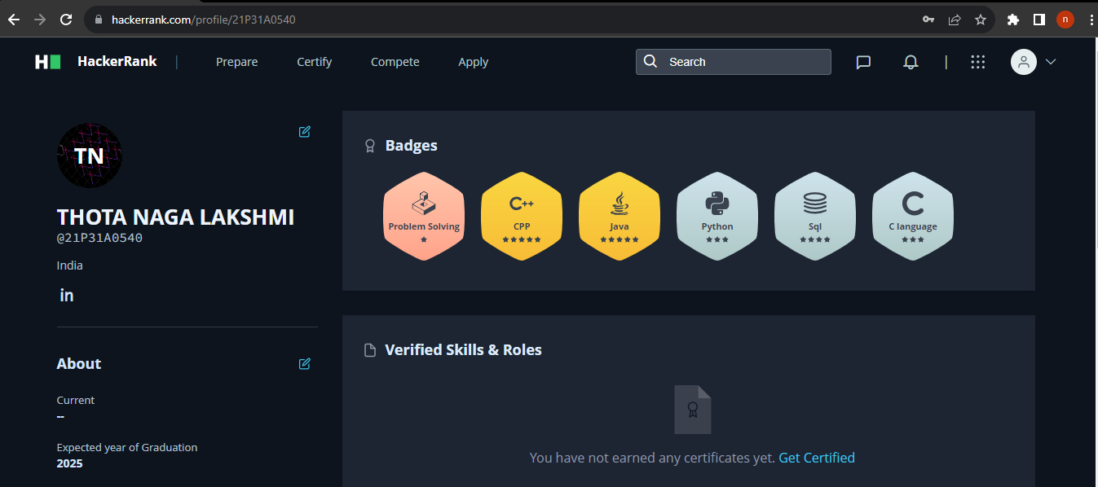

**Code chef Profile:**

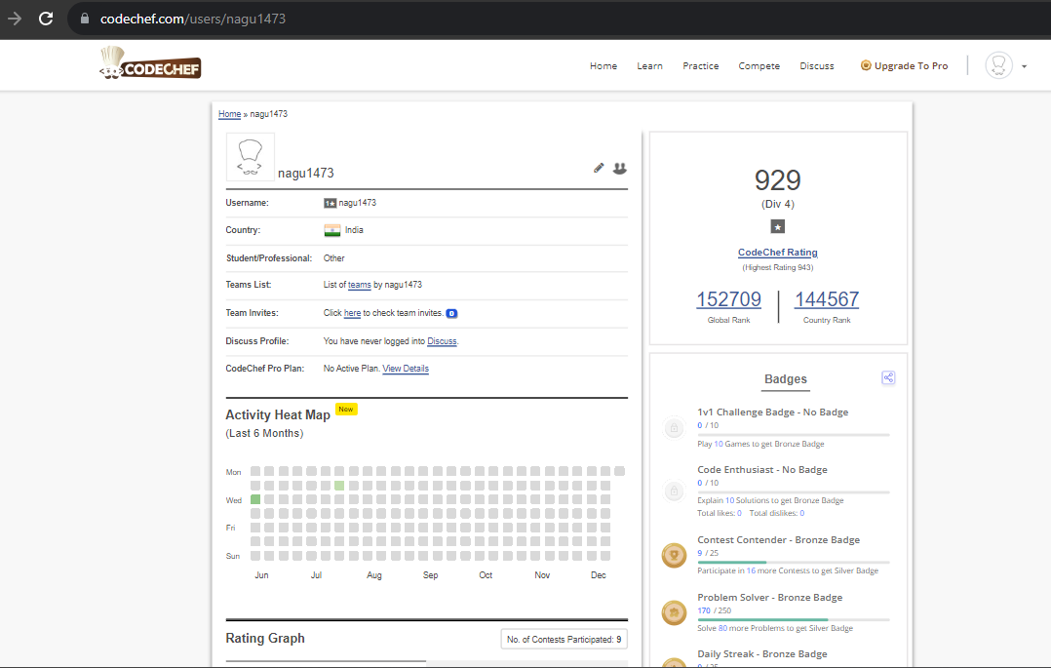

### **External Evaluation for Short Term Internship (On-site/Virtual)**

###### **Objectives:**

* To integrate theory and practice.
* To learn to appreciate work and its function towards the future.
* To develop work habits and attitudes necessary for job success.
* To develop communication, interpersonal and other critical skills in the future job.
* To acquire additional skills required for the world of work.

###### **Assessment Model:**

* There shall only be internal evaluation.
* The Faculty Guide assigned is in-charge of the learning activities of the students and for the comprehensive and continuous assessment of the students.
* The assessment is to be conducted for 100 marks.
* The number of credits assigned is 4. Later the marks shall be converted into grades and grade points to include finally in the SGPA and CGPA.
* The weightings shall be:
  + Activity Log 25 marks
  + Internship Evaluation 50marks
  + Oral Presentation 25 marks
* Activity Log is the record of the day-to-day activities. The Activity Log is assessed on an individual basis, thus allowing for individual members within groups to be assessed this way. The assessment will take into consideration the individual student’s involvement in the assigned work.
* While evaluating the student’s Activity Log, the following shall be considered –
  1. The individual student’s effort and commitment.
  2. The originality and quality of the work produced by the individual student.
  3. The student’s integration and co-operation with the work assigned.
  4. The completeness of the Activity Log.
* The Internship Evaluation shall include the following components and based on Weekly Reports and Outcomes Description

1. Description of the Work Environment.
2. Real Time Technical Skills acquired.
3. Managerial Skills acquired.
4. Improvement of Communication Skills.
5. Team Dynamics
6. Technological Developments recorded.

**MARKS STATEMENT**

**(To be used by the Examiners)**

###### **INTERNAL ASSESSMENT STATEMENT**

**Name of the student:**

**Program of study:**

**Year of Study:**

###### **Group:**

**Register No/H.T .No:**

**Name of the College:**

**University:**

|  |  |  |  |
| --- | --- | --- | --- |
| **S. No** | **Evaluation Criterion** | **Maximum Marks** | **Marks Awarded** |
| 1. | Internship Evaluation | 20 |  |
| 2. | Presentation | 30 |  |
|  | **GRAND TOTAL** | **50** |  |

###### **Date: Signature of the Head of the Department with seal**

**Signature of Internship Mentor:**

**Signature of External:**

