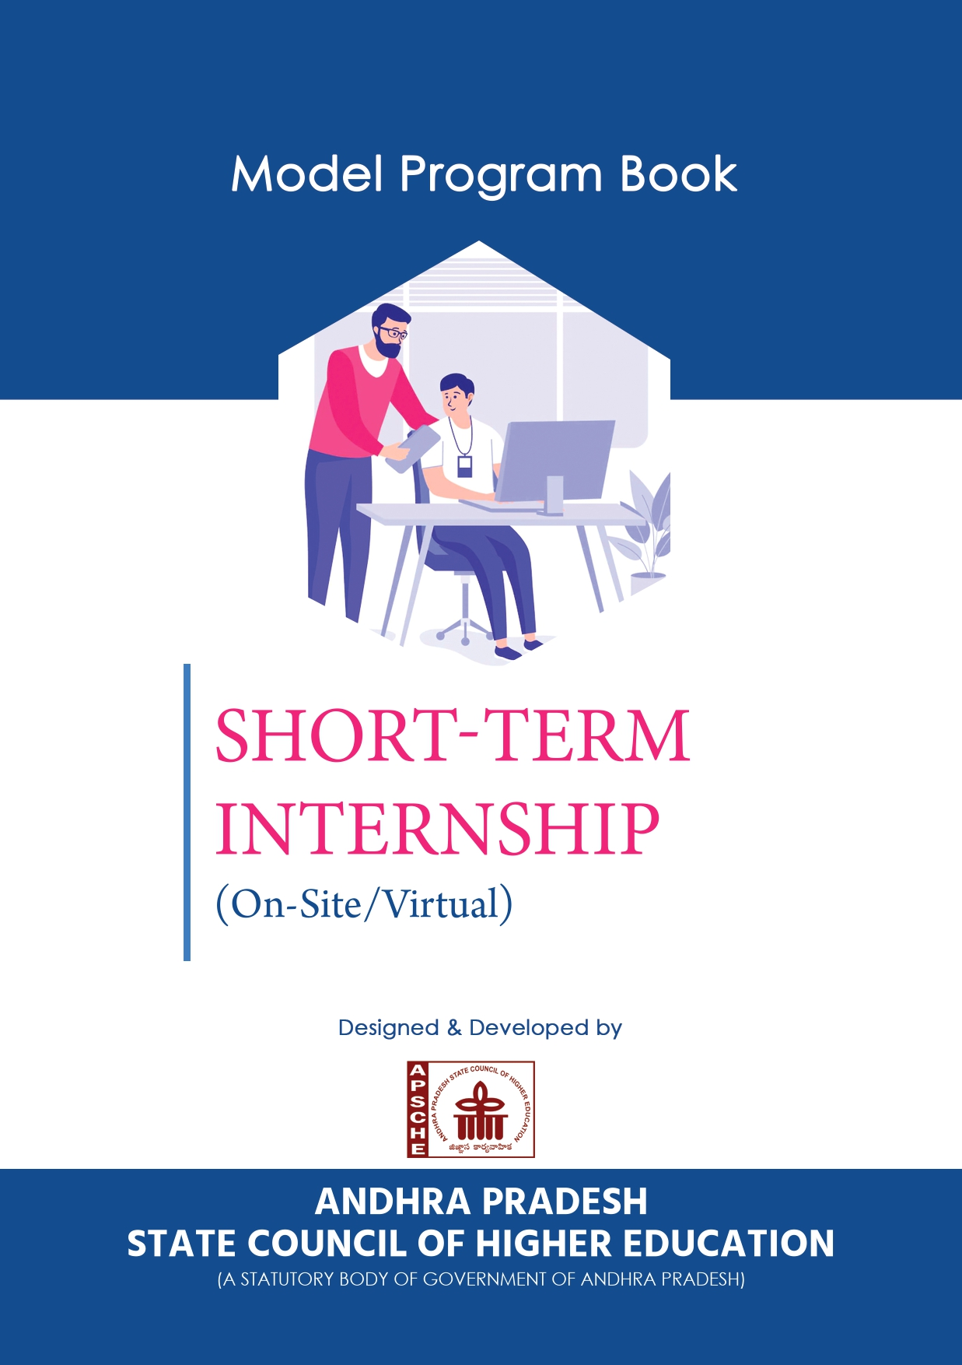

**PROGRAM BOOK FOR**

**SHORT-TERM INTERNSHIP**

**(Onsite / Virtual)**

Name of the Student: Pinapatruni Chandra Praneeth

Name of the College: Aditya College of Engineering and Technology

Registration Number: 21P35A0503

Period of Internship: 8 Weeks From: 26-08-2023 To: 25-10-2023

Name & Address of the Intern Organization: YBI Foundation, Delhi

**JNTUK University**

2023-2024

An Internship Report on

**Data Science & Machine Learning**

Submitted in partial fulfilment of the requirements for the award of the degree of

**BACHELOR OF TECHNOLOGY**

in

**COMPUTER SCIENCE AND ENGINEERING**

Submitted by

**Pinaoatruni Chandra Praneeth (21P35A0503)**

**Under the faculty guideship of**

**Mrs. Ch.Sujana M.Tech.,(Ph.D)**

**Assistant Professor**



**ADITYA COLLEGE OF ENGINEERING & TECHNOLOGY**

**Approved by AICTE, New Delhi & Affiliated to JNTUK, Kakinada**

**Accredited by NAAC (A+) and NBA**

**Surampalem, Kakinada District, Andhra Pradesh - 533 437**

**2020-2024**

**Aditya College of Engineering & Technology**

The dreams of its bounding fathers took shape in 2004 in the form of Sri Sai Aditya Institute of Science and Technology which is now renamed as Aditya College of Engineering and Technology under G.O.RT.NO:92 with approval of AICTE in the aegis of Sarojini Educational Society, Kakinada and permanently affiliated to JNTU Kakinada. The college has two academic buildings apart from two boy’s hostels and one girl’s hostel buildings.

The campus is centrally located between Kakinada and Rajahmundry. It is situated in a eco-friendly area with thick greenery at Surampalem, Gandepalli Mandal, East Godavari District, AP. ACET offers various under graduate and post graduate courses in engineering, science and management and has state of laboratories and well stocked library and one of the best computing facilities. With an ideal teacher-taught ratio we strive for academic excellence through personalized attention. Since its inception ACET has achieved national standing in terms of academic performance, co-curricular and extra-curricular activities. Known for its creative dynamism and flexibility the college offers varied programs blending skill development and value orientation to shape the career of students.

The college proudly offers 6 UG and 8 PG programs in engineering, MCA, MBA with 15 years of rich standing in the educational era. Besides, the college has added many feathers in its cap which include AA+ Grade by Careers 360, South India 4th rank by Digital Mailers, South India 6th rank by Silicon India, 13th rank out of top 25 engineering colleges by 4Ps, a niche in Asia top 100 colleges by WCRC leaders, Best Placement Award by ASSOCHAM, All India 98th rank-DQ CMR top T-School survey by DATA Quest and 13th position in Top 20 colleges of India by the Sunday Indian. These distinct recognitions speak volumes of the institute’s objective to promote engineering excellence. The total student strength is 5052 with faculty strength of 355 thus giving rise to healthy faculty student ratio.

It is approved by AICTE, recognized by Govt. of Andhra Pradesh, Permanently affiliated to Jawaharlal Nehru Technological University Kakinada (JNTUK) and is accredited by National Assessment and Accreditation Council (NAAC) with ‘B’ Grade. The college also received UGC recognition under Sections 2(f) & 12(B) of the UGC Act.

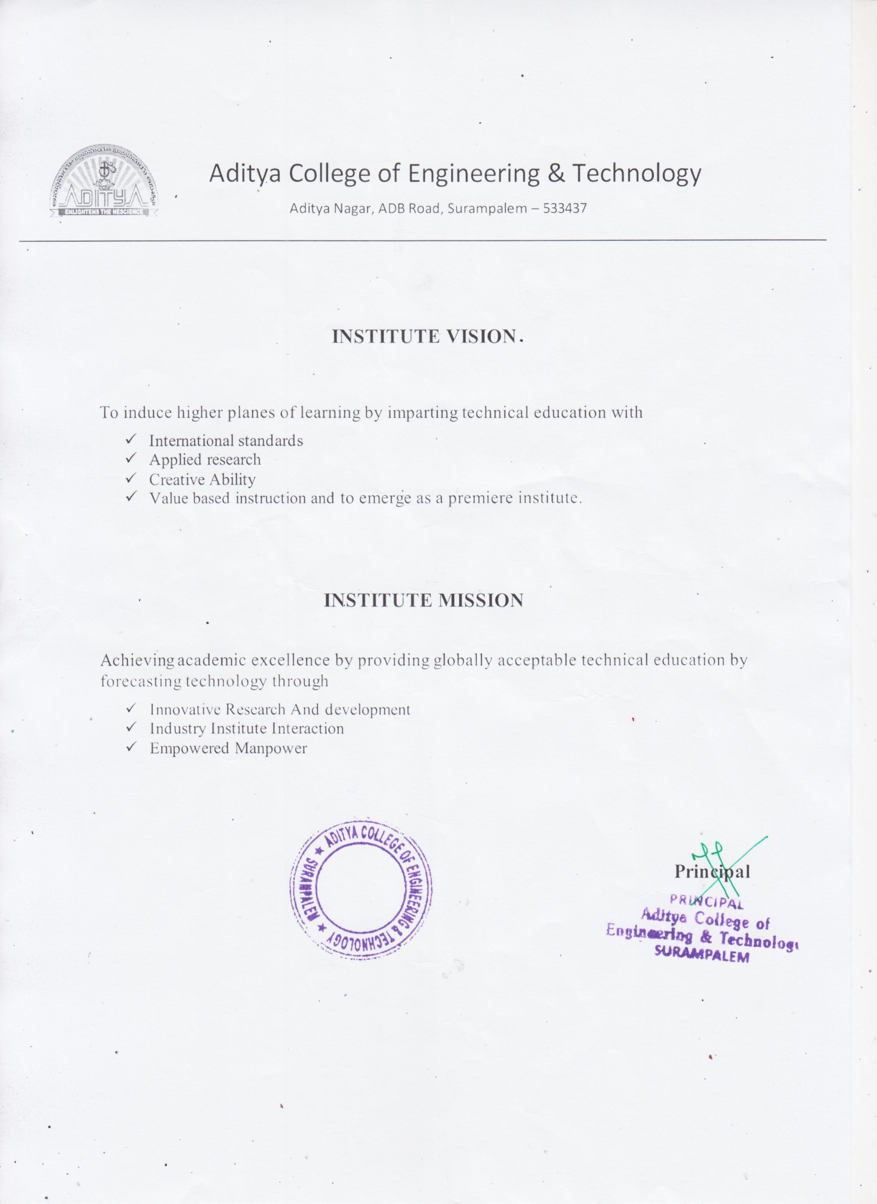

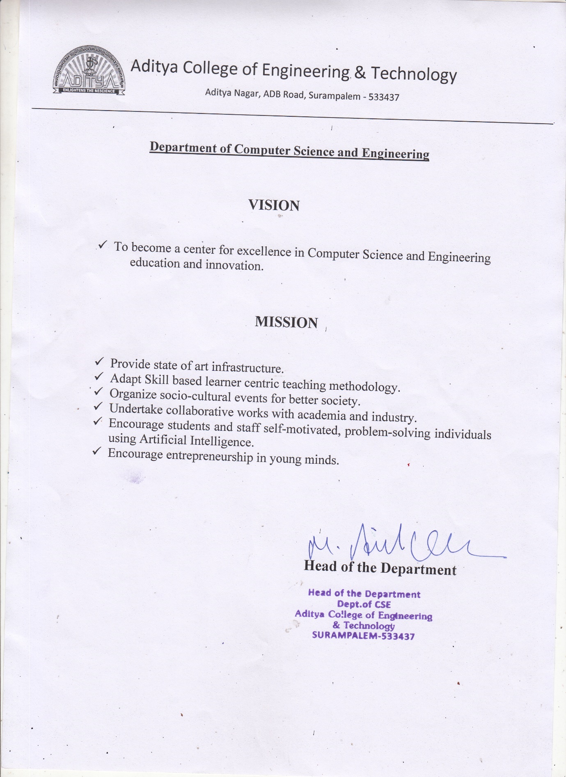

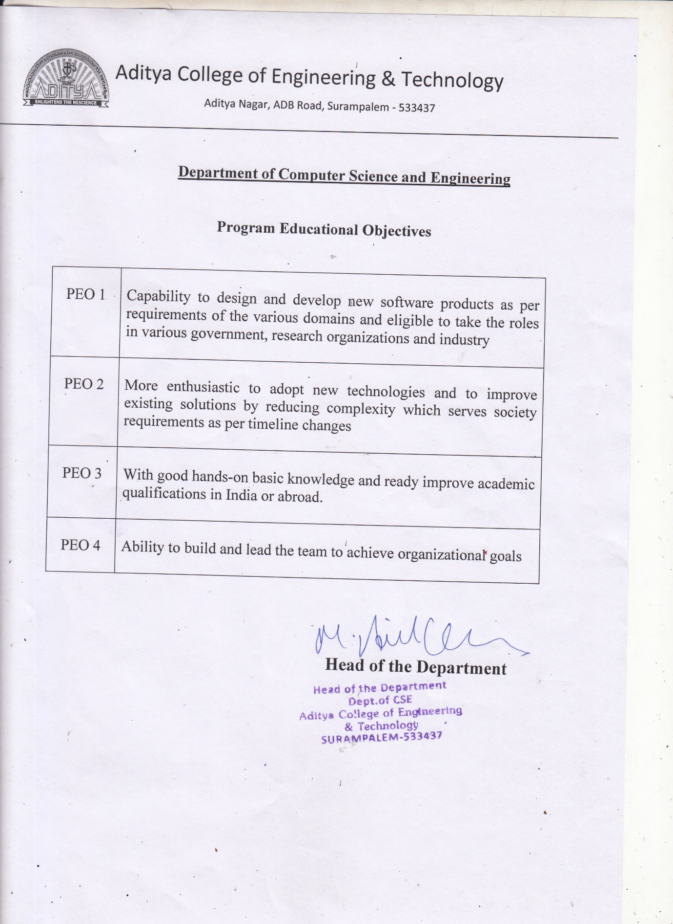

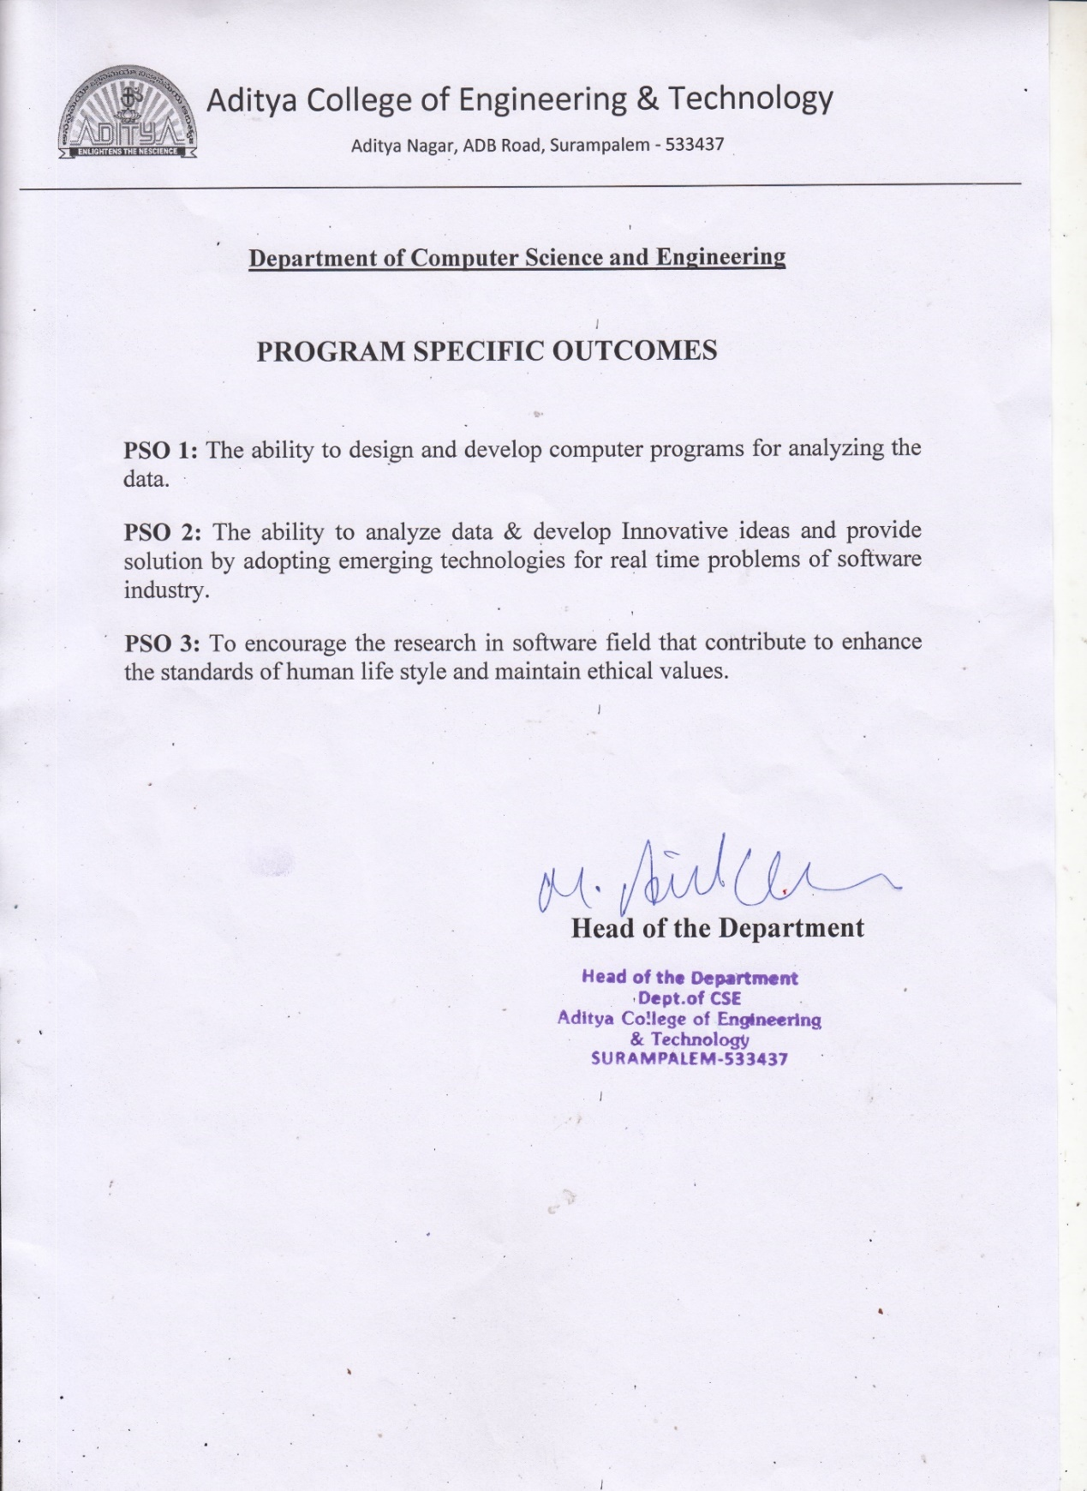

**ADITYA COLLEGE OF ENGINEERING & TECHNOLOGY**

Approved by AICTE, New Delhi & Affiliated to JNTUK, Kakinada

Accredited by NAAC (A+) and NBA

**DEPARTMENT OF COMPUTER SCIENCE AND ENGINEERING**



**CERTIFICATE**

This is to certify that the Internship work entitled, **"Data Science and Machine Learning",** is a bonafide work carried out by  **Pinapatruni Chandra Praneeth(21P35A0503)** in partial fulfilment of the requirements for the award of the degree of **BACHELOR OF TECHNOLOGY** in **COMPUTER SCIENCE AND ENGINEERING** from **Aditya College of Engineering and Technology**, Surampalem, during the academic year 2023-2024.

This Internship work has not been submitted in full or part to any other University or Educational Institute for the award of any Degree or Diploma.

|  |  |  |
| --- | --- | --- |
| **INTERNSHIP**  **GUIDE**  **Mrs. Ch.Sujana, M.Tech,( Ph.D)** |  | **HEAD OF THE DEPARTMENT**  Dr. M. Anil Kumar, M.Tech., Ph.D.  Professor |

**EXTERNAL EXAMINER**

**Instructions to Students**

Please read the detailed Guidelines on Internship hosted on the website of AP State Council of Higher Education **https://apsche.ap.gov.in**

1. It is mandatory for all the students to complete Semester internship either in V Semester or in VI Semester.
2. Every student should identify the organization for internship in consultation with the College Principal/the authorized person nominated by the principal.
3. Report to the intern organization as per the schedule given by the College. You must make your own arrangements for transportation to reach the organization.
4. You should maintain punctuality in attending the internship. Daily attendance is compulsory.
5. You are expected to learn about the organization, policies, procedures, and processes by interacting with the people working in the organization and by consulting the supervisor attached to the interns.
6. While you are attending the internship, follow the rules and regulations of the intern organization.
7. While in the intern organization, always wear your College Identity Card.
8. If your college has a prescribed dress as uniform, wear the uniform daily, as you attend to your assigned duties.
9. You will be assigned a Faculty Guide from your College. He/she will be creating a WhatsApp group with your fellow interns. Post your daily activity on and/or any difficulty you encounter during the internship.
10. Identify five or more learning objectives in consultation with your Faculty Guide. These learning objectives can address:
11. Data and Information you are expected to collect about the organization and/or industry.
12. Job Skills you are expected to acquire.
13. Development of professional competencies that lead to future career success.
14. Practice professional communication skills with team members, co-interns, and your supervisor. This includes expressing thoughts and ideas effectively through oral, written, and non-verbal communication, and utilizing listening skills.
15. Be aware of the communication culture in your work environment. Follow up and communicate regularly with your supervisor to provide updates on your progress with work assignments.

Never be hesitant to ask questions to make sure you fully understand what you need to do your work and to contribute to the organization.

1. Be regular in filling up your Program Book. It shall be filled up in your own handwriting. Add additional sheets wherever necessary.
2. At the end of internship, you shall be evaluated by your Supervisor of the intern the organization.
3. There shall also be evaluation at the end of the internship by the Faculty Guide and the Principal.
4. Do not meddle with the instruments/equipment you work with.
5. Ensure that you do not cause any disturbance to the regular activities of the intern organization.
6. Be cordial but not too intimate with the employees of the intern organization and your fellow interns.
7. You should understand that during the internship programme, you are the ambassador of your college, and your behaviour during the internship programme is of utmost importance.
8. If you are involved in any discipline-related issues, you will be withdrawn from the internship programme immediately and disciplinary action shall be initiated.
9. Do not forget to keep up your family pride and prestige of your college.

**Student’s Declaration**

I, **Pinapatruni Chandra Praneeth**, a student of B.Tech Program, Reg. No. 21P35A0503 of the Department of Computer Science and Engineering, Aditya College of Engineering and Technology College do hereby declare that I have completed the mandatory Internship program from 26/08/2023 to 25/10/2023 in YBI Foundation under the Faculty Guideship of Mrs. Ch.Sujana, Department of Computer Science and Engineering, Aditya College of Engineering and Technology.

*(Signature and Date)*

**Official Certification**

This is to certify that Pinapatruni Chandra Praneeth Reg. No. 21P35A0503 has completed his/her Internship in YBI Foundation Organization on Data Science and Machine Learning under my supervision as a part of partial fulfillment of the requirement for the Degree of B.Tech in the Department of Computer Science and Engineering, Aditya College of Engineering and Technology.

This is accepted for evaluation.

*(Signatory with Date and Seal)*

**Endorsements**

*Faculty Guide*

*Head of the Department*

*Principal*

**Certificate from Intern Organization**

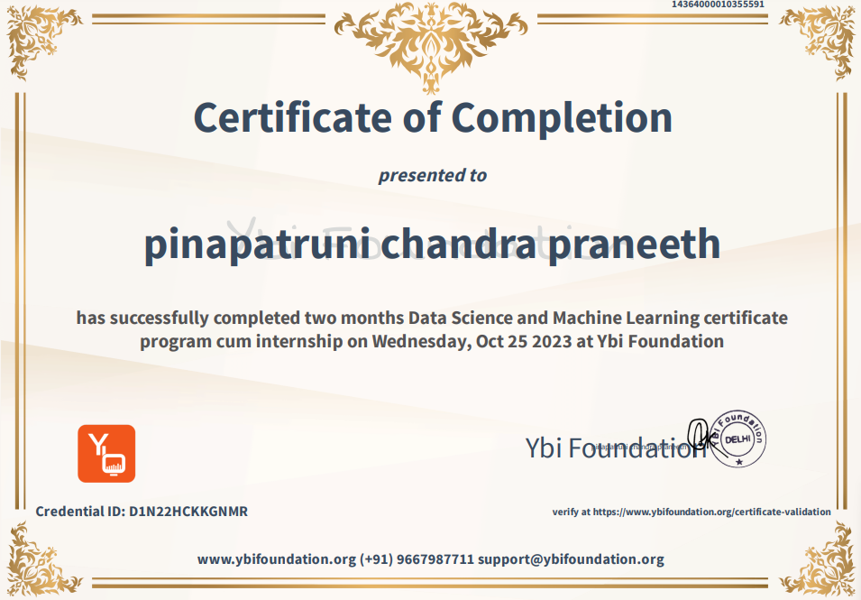

**Acknowledgements**

It is with immense pleasure that we would like to express our indebted gratitude to my

**Internship Guide**, **Mrs. Ch.Sujana, M.Tech,( Ph.D)** who has guided us a lot and encouraged us in every step of internship work, his valuable moral support and guidance has been helpful in successful completion of this work.

We wish to express our sincere thanks to **Dr. M. ANIL KUMAR** M.Tech., Ph.D., **Head of the Department of CSE**, for his valuable guidance given to us throughout the period of the internship work.

We feel elated to thank **Principal**, **Dr. DOLA SANJAY S** M.Tech., Ph.D., of Aditya College of Engineering and Technology for his cooperation in completion of our internship and throughout our course.

We feel elated to thank  **Dr.CH RAGHAVENDRAN** M.Tech., Ph.D., **Dean (Academics & Administration)** of Aditya College of Engineering and Technology for his cooperation in completion of our internship work.

We wish to express our sincere thanks to all faculty members, and lab programmers for their valuable guidance given to us throughout the period of the Internship Program.

We avail this opportunity to express our deep sense and heart full thanks to the **Management** of **Aditya College of Engineering & Technology** for providing a great support for us by arranging the trainees, and facilities needed to complete our internship program and for giving us the opportunity for doing this work.

|  |
| --- |
| **STUDENT NAME** |
| **Pinapatruni Chandra Praneeth**  **(21P35A0503)** |

**Contents**

|  |  |  |
| --- | --- | --- |
| **CHAPTERS** | | **Pg. No.** |
| **INSTRUCTIONS TO STUDENTS** | |  |
| **CHAPTER 1: EXECUTIVE SUMMARY** | |  |
| 1.1 | A brief description of the intern organization |  |
| 1.2 | learning objective of organization internship |  |
| 1.3 | Learning outcome of organization internship |  |
| **CHAPTER 2: OVERVIEW OF THE ORGANIZATION** | |  |
| 2.1 | Organization vision |  |
| 2.2 | Organization mission |  |
| **CHAPTER 3: INTERNSHIP PART** | |  |
| 3.1 | Activities taken place in internship |  |
|  | 3.1.1 Activity log for the First week |  |
|  | 3.1.2 Weekly Report of Week-1 |  |
|  | 3.1.3 Activity log for the Second week |  |
|  | 3.1.4 Weekly Report of Week-2 |  |
|  | 3.1.5 Activity log for the Third week |  |
|  | 3.1.6 Weekly Report of Week-3 |  |
|  | 3.1.7 Activity log for the Fourth week |  |
|  | 3.1.8 Weekly Report of Week-4 |  |
|  | 3.1.9 Activity log for the Fifth week |  |
|  | 3.1.10 Weekly Report of Week-5 |  |
|  | 3.1.11 Activity log for the Sixth week |  |
|  | 3.1.12 Weekly Report of Week-6 |  |
|  | 3.1.13 Activity log for the Seventh week |  |
|  | 3.1.14 Weekly Report of Week-7 |  |
|  | 3.1.15 Activity log for the Eighth week |  |
|  | 3.1.16 Weekly Report of Week-8 |  |
| **CHAPTER 4: OUTCOME DESCRIPTION** | |  |
| 4.1 | Describe the real time technical skills you have acquired |  |
| 4.2 | Describe the managerial skills you have acquired |  |
| 4.3 | Describe how you could improve your communication skills |  |
| 4.4 | Describe the technological developments you have observed and relevant to the subject area of training |  |
| **STUDENT SELF-EVALUATION OF THE SHORT-TERM INTERNSHIP** | |  |
| **EVALUATION BY THE GUIDE OF THE INTERN ORGANIZATION** | |  |
| **PHOTOS & VIDEO LINKS** | |  |
| **INTERNAL ASSESSMENT STATEMENT** | |  |
| **EXTERNAL ASSESSMENT STATEMENT** | |  |

**CHAPTER 1: EXECUTIVE SUMMARY**

The Data Science and Machine Learning Internship is provided by YBI Foundation through AICTE and APSCHE portal.

## Learning Objectives of YBI Foundation Internship

* + - Machine Learning Proficiency
    - Data Preparation and Cleaning
    - Data Visualization and Communication
    - Real-World Project Experience

## Learning Outcomes of YBI Foundation Internship

* + - Team Collaboration and Communication
    - Understanding Business Context
    - Ethical and Responsible Data Practices
    - Continuous Learning and Adaption

## A Brief Description of the Intern Organization

YBI Foundation is a non-profit educational technology organization based in Delhi, dedicated to empowering young individuals to thrive in the realm of emerging technologies. They employ a blend of digital and in-person strategies to offer fresh knowledge, education, and cutting-edge technologies to students, educators, and professionals. They emphasize a flexible, 24/7 learning model to cater to a diverse audience. The platform delivers complimentary live instructor-led courses, enabling students to excel in fields such as data science, business analytics, machine learning, cloud computing, and big data. Their core values revolve around fostering innovation, imagination, technological expertise, and staying attuned to the latest industry demands. Their mission is to assist learners in realizing their utmost potential in both their academic pursuits and careers.

**CHAPTER 2: OVERVIEW OF THE ORGANIZATION**

YBI Foundation is a Delhi-based not-for-profit Edutech company that aims to enable the youth to grow in the world of emerging technologies. They offer a mix of online and offline approaches to bring new skills, education, technologies for students, academicians and practitioners. They believe in the learning anywhere and anytime approach to reach out to learners. The platform provides free online instructor-led classes for students to excel in data science, business analytics, machine learning, cloud computing and big data. They aim to focus on innovation, creativity, technology approach and keep themselves in sync with the present industry requirements. They endeavour to support learners to achieve the highest possible goals in their academics and professions.

YBI Foundation is an unlisted private company incorporated on 22 October, 2020. It is classified as a not for profit company and is located in West Delhi, Delhi. It's authorized share capital is INR 10.00 lac and the total paid-up capital is INR 10.00 lac.

## YBI Foundation has two directors – Alok Yadav and Arushi Yadav.

## Vision of the Organization

Young Business Innovators (YBI) is an organization with a clear and ambitious mission. Their commitment is evident in their dedication to fostering entrepreneurship, promoting technology commercialization, encouraging technology adoption, and actively engaging with their community. Furthermore, YBI seeks to improve its financial position to ensure long-term viability and growth, demonstrating a keen awareness of the need for sustainable development.

One of YBI's primary commitments is to entrepreneurship. This commitment likely involves supporting startups and small businesses by providing them with resources, mentorship, and education. They recognize that entrepreneurship is a vital engine for economic growth, job creation, and innovation. By nurturing and guiding aspiring entrepreneurs, YBI contributes to the development of a thriving entrepreneurial ecosystem.

## Mission of the Organization

Our mission is straightforward yet profound: to champion diversity in ideas, technologies, and leadership to forge a brighter future. We are committed to nurturing a dynamic and inclusive ecosystem that celebrates innovation, welcomes novel ideas, and empowers visionary leaders.

The core of our mission lies in recognizing that the world's most promising opportunities emerge from the convergence of diverse perspectives. By fostering a platform where a rich tapestry of ideas can flourish, we aim to fuel the engines of progress, ensuring that no potential is left untapped.

We firmly believe in the power of technology as a catalyst for change. Through technology, we can address critical challenges, improve lives, and reshape industries. Our mission drives us to support and amplify those technological solutions that hold the promise of a more sustainable, inclusive, and prosperous future.

Leadership is a linchpin of our mission. We strive to identify, mentor, and elevate leaders who embody the spirit of innovation and the values of diversity and inclusion. It is through these visionary leaders that we can steer the course toward a brighter and more equitable future.

.

**CHAPTER 3: INTERNSHIP PART**

As a part of a short-term internship, I have done my internship in the YBI Foundation.

Young Business Innovators (YBI) is a dynamic and forward-thinking organization dedicated to catalyzing positive change through entrepreneurship, technology, and community engagement. Established with a visionary mission, YBI is committed to providing inclusive economic programs for young entrepreneurs, setting a global standard in the realm of economic development.

At the core of YBI's mission is a resolute belief in the transformative power of youth-led entrepreneurship. YBI recognizes that young entrepreneurs possess the innovation, energy, and potential to shape the future. By fostering their growth and providing them with resources and mentorship, YBI seeks to be the catalyst for a new generation of successful and socially conscious business leaders.

YBI is more than an organization; it's a movement that champions diversity and inclusion. The organization is dedicated to supporting a diverse array of ideas and technologies, recognizing that innovation flourishes in an environment that embraces differences. By empowering leaders who embody these principles, YBI envisions a world where opportunities are not bound by traditional barriers but are accessible to all.

## DATA SCIENCE AND MACHINE LEARNING CATALYST

**Able to explain Machine Learning concepts such as training and testing models and various regressions**. Identify common use cases for declarative versus programmatic customization. Use programmatic techniques to prevent security vulnerabilities.

**ACTIVITY LOG FOR THE FIRST WEEK**

|  |  |  |  |
| --- | --- | --- | --- |
| **Day & Date** | **Brief description of the daily activity** | **Learning outcomes** | **Person In-Charge Signature** |
| Day-1 | This is my first day to the internship. I enrolled “Data Science and Machine Learning” internship in YBI Foundation. I listened to the live class conducted by YBI Foundation | Learned Instructions to  complete Internship. |  |
| Day-2 | On the second day of the internship I browsed about the importance and job opportunities in Data Science. | 1)Importance of Data Science  2)Job Opportunities in Data Science |  |
| Day-3 | Learnt about the basic definitions of Data Science, Machine Learning, Python and their concepts. | Basic definitions of various  concepts. |  |
| Day-4 | Learnt about the advanced definitions of Data Science, Machine Learning and their concepts. | Advanced definitions of various concepts. |  |
| Day-5 | Scope of Data Science exits in the real world and how it is useful in the future. | Scope of Data Science |  |
| Day-6 | Revised all the topics that I learnt on this day. | Revision of topics |  |

**WEEKLY REPORT**

**WEEK–1 (From Dt 17/09/23 to Dt 22/09/23)**

**Objective of the Activity Done:**

I introduced myself to the new course “DATA SCIENCE AND MACHINE LEARNING”. In 1st week I learnt key concepts of DATA SCIENCE AND MACHINE LEARNING.

**Detailed Report:**

In the course, I had the opportunity to learn new terms and acquire a solid understanding of the fundamental definitions in the realms of data science and machine learning. These definitions laid the groundwork for my journey into these fields, and they provided me with the necessary vocabulary to navigate the intricacies of data analysis and predictive modeling. As I delved into the coursework, I realized the significance of grasping these definitions, as they formed the building blocks of my data science and machine learning education.

One of the most enlightening aspects of this course was gaining insights into the real-world applications of data science and machine learning. These technologies are not just theoretical concepts but have far-reaching use cases in our daily lives. From recommendation systems that suggest our next favorite movie to the personalized healthcare recommendations that keep us healthy, the impact of data science and machine learning is omnipresent. These revelations made me appreciate the omnipresence and utility of these fields in our interconnected, data-driven world.

Furthermore, I also had the privilege to learn about the expansive scope of data science and how it's set to shape the future. With the exponential growth of data and the increasing importance of data informed decision-making, data science is poised to play a pivotal role in countless industries. Its applications are boundless, from business analytics and finance to healthcare and autonomous vehicles. The realization of this vast scope ignited my enthusiasm for the field and solidified my belief in its relevance in the years to come.

.

**ACTIVITY LOG FOR THE SECOND WEEK**

|  |  |  |  |
| --- | --- | --- | --- |
| **Day & Date** | **Brief description of the daily activity** | **Learning outcomes** | **Person In-Charge Signature** |
| Day-1 | On the 1st day of this week I decided to cover all the topics from Python which are useful in Machine Learning, Data Science topics. | Introduction to Python. |  |
| Day-2 | Learned about Classifications, Features, Applications, Factors of Python. | Classifications, Features,  Applications,Factors of Python. |  |
| Day-3 | Introduced to Google Colab Platform where Python code can be written. | Introduction of Google Colab. |  |
| Day-4 | Learnt and practiced all the Python Libraries that are useful for Data  Science and Machine Learning | Python Libraries for Machine Learning and Data Science |  |
| Day-5 | Explored Data Frames which is  main useful in DS&ML | Data Framing. |  |
| Day-6 | Did exercises on Data Framing on using various examples. | Exercises on Data Framing. |  |

**WEEKLY REPORT**

**WEEK–2 (From Dt 23/09/23 to Dt 28/09/23)**

|  |
| --- |
| **Objective of the Activity Done:**  In this week I covered all the topics from Python and did some hands on exercises for experience. |
| **Detailed report:**  In my journey to acquire proficiency in data science and machine learning, I was introduced to the powerful platform called Google Colab. This cloud-based environment provided a seamless and efficient way to write Python code, enabling me to access various libraries essential for data analysis and machine learning. Through Google Colab, I not only learned but also practiced extensively with these libraries, solidifying my understanding of their applications in data science  One fundamental aspect I delved into during my exploration was the concept of data framing. Data frames are pivotal structures that enable efficient data organization and manipulation. Through Google Colab, I conducted numerous exercises and hands-on projects, leveraging data frames to analyze and process data. These practical experiences gave me a strong foundation in working with real-world data, enhancing my ability to extract meaningful insights and patterns from it.  Incorporating my newfound knowledge, I tackled a variety of examples and case studies. These examples covered a wide range of scenarios, from data cleaning and preprocessing to complex data analysis and predictive modeling. Google Colab's collaborative and versatile nature allowed me to experiment and iterate with different data science techniques, making it an invaluable tool in my journey to become proficient in data science and machine learning. |

**ACTIVITY LOG FOR THE THIRD WEEK**

|  |  |  |  |
| --- | --- | --- | --- |
| **Day & Date** | **Brief description of the daily activity** | **Learning outcomes** | **Person In-Charge Signature** |
| Day-1 | Created Kaggle account, It is home for Data Science in this platform we can create and develop many projects related to Data Science. | Creation of Kaggle Account. |  |
| Day-2 | Learnt about how to split Testing and Training of Data in the projects. | Testing, Training of  Data |  |
| Day-3 | Learnt about how to split Testing and Training of Data in the projects. | Train & Test Split Data in Machine Learning |  |
| Day-4 | I did some tasks for hands on experience of testing and training Data. | Hands-on-experience of Testing and  Training of Data |  |
| Day-5 | Learnt about how Machine Learning came into existence and how it is useful for further existence. | Focused on Machine Learning existence. |  |
| Day-6 | Deployed data for training and testing on different applications | Deploying raw data. |  |

**WEEKLY REPORT**

**WEEK–3 (From Dt 29/09/23 to Dt 04/10/23)**

|  |
| --- |
| **Objective of the Activity Done:**  I learned Testing and Training concepts in Machine Learning and creation of Kaggle account. |
| **Detailed report:**  During my journey into the realm of machine learning, I delved into the critical concepts of testing and training. Understanding these concepts is fundamental to building robust and accurate machine learning models. I learned that the process of training a model involves using a portion of the available data to teach the model how to make predictions or classifications. This training data allows the model to learn patterns and relationships within the data, enabling it to make informed decisions. On the other hand, testing involves evaluating the model's performance using a separate set of data that it has never seen before. This testing data helps us assess how well the model generalizes to new, unseen data. This essential concept of splitting data into training and testing sets ensures that the model is both knowledgeable and capable of making accurate predictions.  Another significant aspect of my learning journey was the creation of a Kaggle account. Kaggle is a renowned platform in the data science and machine learning community, known for hosting competitions, sharing datasets, and fostering collaboration among data enthusiasts worldwide. By creating a Kaggle account, I gained access to a wealth of resources, including real-world datasets, kernels, and forums where data scientists and machine learning practitioners share their knowledge and experiences. This platform has become an invaluable resource for me, enabling me to apply what I've learned in realworld projects and learn from others in the field. |

**ACTIVITY LOG FOR THE FORTH WEEK**

|  |  |  |  |
| --- | --- | --- | --- |
| **Day & Date** | **Brief description of the daily activity** | **Learning outcomes** | **Person In-Charge Signature** |
| Day – 1 | Learnt about different forms of Learning in ML where every algorithm are used by these forms. | 1)Supervised Learning  2)Unsupervised Learning  3)Reinforcement Learning |  |
| Day – 2 | I completed some tasks to examine Supervised and Unsupervised learning and noted some important points on how data works. | Exercise on Supervised and Unsupervised Learning |  |
| Day – 3 | I completed some tasks to examine Reinforcement learning and noted some important points on how data works. | Exercise on Reinforcement Learning |  |
| Day – 4 | I concentrated on Linear  Regression Model which focuses on the development of algorithms and statistical models that can learn from and make predictions on data. | Linear Regression  Model |  |
| Day – 5 | I learnt about Logistic Regression Model mainly used for classification tasks where the goal is to predict the probability that an instance belonging to a given class or not. | Logistic Regression Model |  |
| Day – 6 | I learnt about the basic Linear Algebra techniques that are used in Machine Learning | Linear Algebra Techniques. |  |

**WEEKLY REPORT**

**WEEK–4(From Dt 05/10/23 to Dt 10/10/23)**

**Objective of the Activity Done:**

I understood the concepts of different forms of learning in Machine Learning and I learned some Linear Algebra Techniques and Regression Models.

**Detailed Report:**

I had the opportunity to grasp the fundamental concepts surrounding the various forms of learning. Machine learning encompasses a spectrum of learning types, each designed to tackle different problems. These include supervised learning, unsupervised learning, and reinforcement learning. In supervised learning, models are trained using labeled data, making predictions based on input-output pairs. Unsupervised learning, on the other hand, explores patterns in unlabeled data, such as clustering similar data points or dimensionality reduction. And in reinforcement learning, models learn to make sequential decisions by interacting with an environment and receiving feedback. Understanding these different forms of learning provided me with a comprehensive perspective on the versatility of machine learning, allowing me to choose the most suitable approach for specific tasks.

Additionally, I delved into the realm of linear algebra techniques, a foundational component of machine learning. Linear algebra provides the mathematical underpinning for many machine learning algorithms and concepts. I learned about vectors, matrices, and matrix operations, which are essential for manipulating and transforming data. These techniques enable the representation and manipulation of data in a format suitable for various machine learning models, such as regression and neural networks.

Furthermore, I gained knowledge about regression models, a critical component of supervised learning. Regression is a predictive modelling technique used to establish relationships between independent variables and a dependent variable. I explored linear regression, a straightforward yet powerful model that seeks to find the best-fitting linear relationship between variables. This foundation in regression models not only laid the groundwork for more complex modelling techniques but also equipped me with a practical tool for making predictions based on data.

**ACTIVITY LOG FOR THE FIFTH WEEK**

|  |  |  |  |
| --- | --- | --- | --- |
| **Day & Date** | **Brief description of the daily activity** | **Learning outcomes** | **Person In-Charge Signature** |
| Day – 1 | I revised all the topics of Machine Learning which I learnt in the last week it helped me to recall all the topics for better understanding. | Revision of Machine Learning topics |  |
| Day – 2 | Today I learnt a new topic on how data should be represented in various data sets. | Data representation |  |
| Day – 3 | I did hands on practices with data representation which helped me create my own tables and raw data. | Exercises on Data representation. |  |
| Day – 4 | I learnt some theories in machine learning and learnt about Data Warehouses. | Theories in Machine  Learning and Data Warehouses. |  |
| Day – 5 | I started to learn Data Science, Firstly I have learnt some basic definitions. | Introduction to Data  Science |  |
| Day – 6 | I learnt different data types in  Data Science | Data types in Data  Science |  |

**WEEKLY REPORT**

**WEEK–5 (From Dt 11/10/23 to Dt 16/10/23)**

**Objective of the Activity Done:**

I covered how to represent data in various data sets and concept of Data Warehouses in Machine Learning. I started to learn basic topics in Data Science such as Data types.

**Detailed Report:**

In my pursuit of knowledge within the field of machine learning, I embarked on a journey that included the fundamental concepts of representing data in various datasets. The ability to represent data is at the core of any data-driven discipline, and in machine learning, it's no different. I learned how to structure data effectively, considering different types of data and their respective formats. This foundational understanding allowed me to prepare data for analysis and model training, ensuring the accuracy and reliability of the results.

In addition to data representation, I delved into the intriguing realm of data warehouses. Data warehouses serve as central repositories for storing and managing large volumes of data from diverse sources. They are critical for businesses and organizations seeking to harness the power of data for informed decision-making. Learning about data warehouses illuminated their pivotal role in machine learning and data science, as they provide a structured and efficient way to access, manage, and analyze data, ultimately driving insights and value.

As I continued my exploration in the field of data science, I embarked on the path to understanding different data types. Data types form the bedrock of data science, influencing how data is stored, processed, and analyzed. I covered the basics of various data types, such as numerical, categorical, and text data, and their significance in the context of data analysis. This foundational knowledge equipped me with the skills to handle and manipulate data effectively, a crucial skill set for any data scientist.

**ACTIVITY LOG FOR THE SIXTH WEEK**

|  |  |  |  |
| --- | --- | --- | --- |
| **Day & Date** | **Brief description of the daily activity** | **Learning outcomes** | **Person In-Charge Signature** |
| Day – 1 | I came into deep dive topics from this week, I learnt about different  types of API’s | API’s |  |
| Day – 2 | I explored about the fixing data which is also known as Data Cleaning from Raw Data. | Data Cleaning |  |
| Day – 3 | I started to learn about  Statistics & Probabilities,  Applied Mathematics which is a huge concept in DS&ML | Statistics & Probabilities,  Applied Mathematics. |  |
| Day – 4 | On this I learnt about the various concepts that I leftover | 1)Data Visualization  2)Data Preprocessing  3)Feature Engineering  4)Data Acquisition. |  |
| Day – 5 | I continued to learn the leftover topics | 1)Predictive Analysis  2)Clustering  3)Cross-Validation  4)Overfitting. |  |
| Day – 6 | I took revision of all the above topics and made some practices on them | Revision and practicing |  |

**WEEKLY REPORT**

**WEEK–6 (From Dt 17/10/23 to Dt 22/10/23)**

**Objective of the Activity Done:**

I spent more time in this week to know about API’s, Data Cleaning, Statistics in Machine Learning and Data Processing, Data Visualization, Feature Engineering, Data Acquisition, Predictive Analysis, Clustering, Overfitting, Cross-Validation concepts.

**Detailed Report:**

I dedicated time to comprehending the significance of Application Programming Interfaces (APIs). APIs serve as the bridge between diverse software systems, enabling seamless data exchange and functionality integration. This knowledge was instrumental in connecting and leveraging external resources in my projects, thus expanding the horizons of what I could achieve.

In my pursuit of data analysis excellence, I recognized the pivotal importance of data cleaning, statistics, and data processing. Data is often messy and noisy, and understanding how to preprocess it, remove outliers, and fill in missing values is foundational to accurate model training. Equipped with statistical knowledge, I honed my ability to extract insights, conduct hypothesis testing, and make data driven decisions. Data visualization and feature engineering became powerful tools in my arsenal, enabling me to communicate complex information effectively and transform data into meaningful features that enhance model performance.

Furthermore, I devoted time to understanding data acquisition and predictive analysis, gaining insights into gathering data from various sources and harnessing it to make informed predictions. Clustering, a key unsupervised learning technique, allowed me to discover patterns and group similar data points. Overfitting and cross-validation concepts were essential in optimizing my models, ensuring they generalize well to new data. This comprehensive exploration has not only broadened my knowledge but also equipped me with the skills to tackle diverse data science and machine learning challenges.

.

**ACTIVITY LOG FOR THE SEVENTH WEEK**

|  |  |  |  |
| --- | --- | --- | --- |
| **Day & Date** | **Brief description of the daily activity** | **Learning outcomes** | **Person In-Charge Signature** |
| Day – 1 | I decided to think do a beginner project where I can build my skills and my visualization and started to search the best topic to do it | Browsing for best project in the Internet |  |
| Day – 2 | I decided to “Cancer Prediction” project and the same day I collected some raw data and my own prepared data | Decided to do a project and collected required data. |  |
| Day – 3 | On this day I cleaned the data and did Feature Engineering on the required data. | Data preprocessing and Feature Engineering is done on the data taken. |  |
| Day – 4 | I have chosen some algorithms based on the requirements and tuned data hyperparameters using the validation set to optimize model performance | Algorithms chosen and data is tuned to optimize the performance. |  |
| Day – 5 | On this day I trained and tested data where I fed up with some errors and some how I completed the process. | Model Training and  Model Testing |  |
| Day – 6 | I evaluated the data with some clauses and finally completed my beginner project | Evaluation and project completion. |  |

**WEEKLY REPORT**

**WEEK–7 (From Dt 23/10/23 to Dt 28/10/23)**

|  |
| --- |
| **Objective of the Activity Done:**  I decided to do a beginner project entitled - “Cancer Prediction” successfully completed with many troubles. |
| **Detailed report:**  Undertaking a beginner project titled "Cancer Prediction" marked a significant milestone in my journey through data science and machine learning. While the endeavor was challenging, it was also immensely rewarding. I initially selected this project to apply the skills and knowledge I had acquired throughout my learning process. However, the journey was fraught with obstacles, from data quality issues to the complexity of the predictive models involved. These challenges pushed me to expand my problem-solving capabilities, research diligently, and seek help from the supportive online data science community.  Despite the hurdles I encountered, the completion of the "Cancer Prediction" project was a testament to my determination and growing expertise. The project encompassed the critical task of using data to predict cancer cases, a mission that holds substantial real-world significance. I learned the importance of data preprocessing, feature engineering, model selection, and thorough evaluation. The experience not only deepened my understanding of machine learning but also allowed me to appreciate the practical implications of these techniques in healthcare, where early diagnosis can save lives.  This project has been a stepping stone in my journey toward becoming a proficient data scientist and machine learning practitioner. It highlighted the importance of perseverance, resilience, and continuous learning. The obstacles I encountered have become valuable learning experiences, equipping me with the skills and knowledge needed to take on more complex projects in the future. The "Cancer Prediction" project, though challenging, marked the beginning of my contributions to the field of data science and machine learning, and I look forward to embarking on more ambitious projects in the future. |

**ACTIVITY LOG FOR THE EIGTH WEEK**

|  |  |  |  |
| --- | --- | --- | --- |
| **Day & Date** | **Brief description of the daily activity** | **Learning outcomes** | **Person In-Charge Signature** |
| Day – 1 | As this is the last week I concentrated on some advanced topics like ensemble methods. | Introduction to Ensemble Learning |  |
| Day – 2 | On this day I covered Bagging and Random Forest concepts in ML and Boosting. | Bagging  Radom Forest  ADA Boosting  Gradient Boosting |  |
| Day – 3 | I learnt about the NLP, Text  Preprocessing and  Tokenization and how to build an NLP Model . | Text Preprocessing  Building an NLP Model |  |
| Day – 4 | I did some research on Time Series Data and Time Series Forecasting and later I did Time Series Analysis with Python. | 1)Basics of Time Series  Data  2)Time Series Forecasting 3)Time Series Analysis with Python |  |
| Day – 5 | On this day I learnt about  Cloud Services and  Distributed Data Processing with Hadoop and Spark. | 1)Cloud Services  2)Distributed Data  Processing with Hadoop and  Spark |  |
| Day – 6 | On this final day I keep on revision on all the topics that I’m doubt in. | Revision and Completion of the Internship. |  |

**WEEKLY REPORT**

**WEEK–8 (From Dt 29/10/23 to Dt 03/11/23)**

|  |
| --- |
| **Objective of the Activity Done:**  I spent this week learning advanced concepts like Ensemble learning, Bagging, Random Forest, Bagging, Text Preprocessing, how to build an NLP model, Basics of Time Series Data. Time Series Forecasting, Time Series Analysis with Python and Cloud Services and I finally completed my internship course module. |
| **Detailed report:**  This week was a culmination of intense learning and achievement as I delved into advanced concepts that have significantly enhanced my expertise in data science and machine learning. I dedicated time to mastering ensemble learning, a technique that involves combining multiple models to improve predictive accuracy. The intricacies of bagging and the powerful capabilities of Random Forest were among the highlights, providing me with a deeper understanding of ensemble methods. Additionally, I delved into the world of natural language processing (NLP) by acquiring essential skills in text preprocessing and building NLP models. Understanding the basics of time series data, its forecasting, and analysis with Python opened up a new dimension of data manipulation and forecasting techniques.  In the midst of these advanced learnings, I reached a momentous milestone by completing my internship course module. This marked a significant achievement in my journey towards becoming a proficient data scientist and machine learning practitioner. The module encompassed a wide range of topics, from advanced machine learning techniques to practical skills like cloud services utilization. The newfound knowledge and the successful completion of the internship have reinforced my confidence and enthusiasm to apply these skills in real-world projects and challenges, and I'm excited to continue pushing the boundaries of what I can achieve in this dynamic field. |

**CHAPTER 5: OUTCOMES DESCRIPTION**

## Work Environment I have Experienced

Foundations, such as the YBI Foundation, serve as catalysts for change, often supporting and empowering grassroots initiatives, social entrepreneurs, and community-driven projects. Their work is not solely defined by the financial assistance they provide but also by the expertise, knowledge, and networks they bring to the table. Foundations create an environment where innovation, research, and solutions can flourish.

One of the most remarkable aspects of nonprofit work is the dedication and passion of those involved. People choose to work in these organizations not for personal gain but for the fulfilment of their mission. They are motivated by a shared sense of purpose, and it is this dedication that often leads to innovative solutions, partnerships, and an unwavering commitment to social and environmental causes.

They are the embodiment of what's possible when individuals and communities unite in the pursuit of a better world. The work of organizations like the YBI Foundation reminds us that even in the face of daunting global issues, positive change is not only possible but is actively being pursued by passionate individuals and organizations committed to making a difference.

**Real-time technical skills acquired during Internship**

In my YBI Internship focusing on data science and machine learning, I've likely gained a valuable set of real-time technical skills that are highly relevant in the field. Here's an overview of some of the technical skills I have acquired or enhanced during my internship:

**Data Analysis:** The process of inspecting, cleaning, transforming, and visualizing data to extract insights.

**Machine Learning:** A field of artificial intelligence (AI) focused on developing algorithms that enable systems to learn and make predictions or decisions without explicit programming.

**Feature Engineering:** The process of selecting, creating, or transforming features from data to improve machine learning model performance.

**Model Evaluation:** Assessing the performance of machine learning models using metrics such as accuracy, precision, recall, F1-score, and ROC curves.

**Hyperparameter Tuning:** The optimization of model hyperparameters to improve its performance and generalization

**Data Preprocessing:** The preparation of data for analysis or modeling, which may include handling missing values, scaling features, and encoding categorical variables.

**Time Series Analysis:** Analyzing data points collected or recorded over time to identify patterns and make forecasts.

**Natural Language Processing (NLP):** A field of AI that deals with the interaction between computers and human language, including tasks like sentiment analysis and text classification.

**Big Data and Distributed Computing:** Handling and processing large datasets across distributed computing environments, often using tools like Apache Spark.

**Data Visualization:** Presenting data in visual formats to facilitate understanding and insights.

**Version Control:** Managing and tracking changes in code and collaborative projects using tools like Git and GitHub.

**Jupyter Notebooks:** Interactive documents that combine code, visualizations, and narrative text for documenting and sharing data analysis and workflows.

**Cloud Computing:** Using remote servers and resources, typically from cloud providers like AWS, Google Cloud, or Azure, for data storage, computing, and model deployment.

**Model Deployment:** Making machine learning models accessible for use in applications or systems, often through cloud platforms, containerization (e.g., Docker), or web frameworks (e.g., Flask).

**Collaborative Tools:** Software and platforms used for team communication, task management, and project coordination, including tools like Slack and Trello.

**Managerial Skills acquired during Internship**

I had earned much more during an internship than just a pay check or college credits. The internship skills, lessons, and insights That I had gained are invaluable for both life and our future career. Here are some of the many benefits/skills an internship had thought me

* Punctuality is as much about courtesy and respect as it is about timeliness. Internship taught me how to fix my schedule and leave extra cushion time to allow for unexpected delays like traffic or long coffee lines.
* Whether through emails, phone calls, or face-to-face meetings, the internship had seen my communicating with others in the organization that I had worked. Communication is often one of the underappreciated internship skills and one that greatly affects the working world.
* Through the internship, I had gained an understanding and appreciation for clear business communication through meetings, messages, and training.
* From conducting comprehensive competitor analysis research, to designing a marketing and communication plan, my knowledge of business and marketing theories was transformed into a series of practical techniques and skills that I can now implement in real-life business scenarios.
* I learned that every company or organisation has its own culture. It’s essential to observe others and learn how they engage and interact with co-workers, or help them with projects and tasks. I quickly learned that whenever something is unclear for me, or I don’t understand, it’s fine to ask for clarification.
* As an intern, I discovered it’s essential to be enthusiastic and open to learning new skills, asking for more work and being curious to learn and ask questions. This attitude will show that you enjoy being part of the team and that you're keen to help. Having curiosity and enthusiasm also means that, as an intern, you get a lot out of what you’re doing, which opens lots of opportunities.
* Asking for and receiving professional feedback is very important. It is essential to take note of both the positive and negative points for the future, so you can grow and excel in your career. I learned that sometimes asking for feedback or receiving feedback is difficult to hear, but it will have a significant impact on your future career and success.
* I likely had a number of responsibilities when it comes to my internship. I had learnt how to prioritize my tasks by order of importance or workload, as well as juggle a few different tasks at once. This is key for both life and work.

**Describe how you could improve your communications kills**

Internships are an ideal way to observe and learn. It had offered the opportunity to discover new technical skills, explore my career path and expanded my network with professionals. However, one key area which I had really been developed through the internship is my communication skills.

Anecdotal feedback from some of the companies that appear for the placements in my college tells us that there is still a need for students to develop their communication skills once in their placement

* As a fresh face with in an organisation I had been in an ideal position to observe and learn. I had a few seminars/presentations at the mid-way point of my internship the new skills that I had learnt till that date and on which I had worked on. Not only that demonstrated my initiative and enthusiasm for the role but also, I had the ideal opportunity to practice my presentation skills in the real-time work experience.
* We likely have a weekly meeting/discussion at the end of every week. I had involved in every discussion and explored the ideas that I had in my mind and helped me in feeling more confident in speaking in front of my fellow interns and other staff. As the days passed by, I had become an active speaker that one can face the higher/fellow individuals in any organization.
* Actively seek feedback from my peers to ensure my constant learning and improving my communication skills. I had rectified my speaking skills by interacting with my fellow interns and the trainees, corrected my language grammar and developed a good vocabulary.
* The easiest and quickest way that I had found to improve my communication skills is to practice. And then practice some more! I used my internship as an ideal way to speak with my fellow interns and trainees and learn from their experiences.
* Become involved with group and company events such as special occasions and social activities performed by the company. I put my every effort to explore myself in opportunity that could improve mu communication skills.This had helped a lot to improve my language skills.
* The development of my communication skills needs to be an ongoing part of my professional learning and development. As I start my career, I will be learning many new technical skills which are incredibly important for my development. However, effective communication skills will really help me go to the next level of my career. I might want to consider extra training or classes to perfect my business communication.

**Describe how could you could your abilities in group discussions, participation in teams, contribution as a team member, leading a team/activity.**

Group members need to act cohesively in order to operate well together. My fellow members had a great willing to get to know one another, particularly those with different interests and backgrounds. We are always been open to new ideas, diverse viewpoints, and the variety of individuals present within the group. I always listen to others and elicit their ideas. I know how to balance the need for cohesion within a group with the need for individual expression. We trusted one another enough to share our own ideas and feelings. A sense of mutual trust developed only to the extent that everyone had shown their willing to self-disclose and be honest yet respectful. We demonstrated personal accountability for the tasks we have been assigned in the form of activity.

We demonstrated support for one another as we accomplish our goals. We exemplified a sense of team loyalty and both cheer on as a whole and help others who had experienced difficulties. We viewed one another not as competitors (which is common within a typically individualistic educational system) but as collaborators to explore and innovate ideas in our learning. We communicated our opinions in a way that respects other opinion, focusing on “What can we learn?” rather than “Who is to blame?” seen constructive feedback in the process section for more details.

Besides knowing how to develop a healthy group climate, we also need to know how to function so that we can be productive and accomplish our tasks effectively.  We all were agreed on what needs to be done and by whom when it’s come to any activity to be done. We determined what he or she needs to be done and took responsibility in completing the task(s). We held accountable to each other for the work done by us to others. We were able to give and receive feedback about the ideas. Giving constructive feedback required for using on ideas and behaviors, instead of individuals, being as positive as possible, and offered suggestions for improvement. Receiving feedback required listening well, asked for clarification if the comment is unclear, and being open to change and other ideas if the ideas was better than the present one.

We help each other to develop and used strategies centralize the goals. As such, we facilitated others decision-making and deal productively without any conflict if the idea was better than any other. In extreme cases, we approached the mentor for additional advice and help. We planned and managed tasks and our time for our other works we had like academics, etc. We got to know which roles can be filled within us (e.g., facilitator, idea-generator, summarizer, evaluator, mediator, encourager, recorder) and were aware of which role(s) we were best suited for. We also showed our willingness to rotate roles to maximize our own and others’ learning experience.

**Describe the technological developments you have observed and relevant to the subject area of training**

In the ever-evolving landscape of training, particularly in the fields of data science and machine learning, a series of transformative technological developments have significantly impacted the learning experience. One of the most notable advancements is the rapid progress in deep learning, with the emergence of increasingly sophisticated neural network architectures like GPT-3 and GPT-4. These models have reshaped the way we approach natural language understanding and generation, offering new possibilities for text analysis in training materials.

Another substantial shift is the integration of artificial intelligence (AI) into learning management systems and e-learning platforms. AI-driven algorithms can now personalize training content, adapting its content, pace, and complexity to each learner's unique needs. This customization optimizes the learning experience and enhances knowledge retention.

The convergence of edge AI and mobile learning has made training more accessible and convenient. Learners can now access training materials, conduct machine learning experiments, and participate in training sessions from their smartphones and tablets, empowering remote and on-the-go learning.

Furthermore, cloud computing services have become indispensable in data science and machine learning, providing learners with on-demand access to extensive computational resources for training complex models and processing large datasets, all without the need for specialized hardware.

Ethical considerations in AI and machine learning have gained prominence, influencing the content of training materials. Concepts of fairness, accountability, and transparency have become integral to the curriculum, ensuring that learners comprehend the ethical implications of their work and how to mitigate bias in their models.

Explainable AI techniques have arisen as a response to the need for transparency in model decision-making. These methods enable learners to understand and communicate the inner workings of complex models, a crucial skill in an environment where transparency and interpretability are increasingly valued.

Real-time collaboration tools, such as Slack, Microsoft Teams, and Google Workspace, have become essential for remote learning and collaborative data science projects. They facilitate seamless communication and the sharing of code, data, and insights among learners.

Finally, automated machine learning (Auto-ML) tools and platforms have simplified model- building processes, allowing learners to create machine learning models with minimal manual intervention. These tools streamline the journey, enabling learners to concentrate on fundamental concepts and problem-solving.

These technological advancements have reshaped the training landscape in data science and machine learning, making it more accessible, efficient, and ethically responsible. Staying attuned to these developments is imperative for both educators and learners, ensuring they remain competitive in these rapidly evolving fields.

***Student Self Evaluation of the Short-Term Internship***

**Student Name:Pinapatruni Chandra praneeth Registration No: 21P35A0503**

**Term of Internship: From: 26/08/2023 To: 25/10/2023**

**Date of Evaluation:**

**Organization Name & Address: YBI Foundation, Delhi, India**

Please rate your performance in the following areas:

Rating Scale: Letter grade of CGPA calculation to be provided

|  |  |  |  |  |  |  |
| --- | --- | --- | --- | --- | --- | --- |
| 1 | Oral communication | 1 | 2 | 3 | 4 | 5 |
| 2 | Written communication | 1 | 2 | 3 | 4 | 5 |
| 3 | Proactiveness | 1 | 2 | 3 | 4 | 5 |
| 4 | Interaction ability with community | 1 | 2 | 3 | 4 | 5 |
| 5 | Positive Attitude | 1 | 2 | 3 | 4 | 5 |
| 6 | Self-confidence | 1 | 2 | 3 | 4 | 5 |
| 7 | Ability to learn | 1 | 2 | 3 | 4 | 5 |
| 8 | Work Plan and organization | 1 | 2 | 3 | 4 | 5 |
| 9 | Professionalism | 1 | 2 | 3 | 4 | 5 |
| 10 | Creativity | 1 | 2 | 3 | 4 | 5 |
| 11 | Quality of work done | 1 | 2 | 3 | 4 | 5 |
| 12 | Time Management | 1 | 2 | 3 | 4 | 5 |
| 13 | Understanding the Community | 1 | 2 | 3 | 4 | 5 |
| 14 | Achievement of Desired Outcomes | 1 | 2 | 3 | 4 | 5 |
| **15** | **OVERALL PERFORMANCE** | **1** | **2** | **3** | **4** | **5** |

**Date: Signature of the Student**

***Evaluation by the Guide of the Intern Organization***

**Student Name Pinapatruni Chandra Praneeth Registration No: 21P35A0503**

**Term of Internship: From: To:**

**Date of Evaluation:**

**Organization Name & Address: YBI Foundation, Delhi, India**

**Name & Address of the Guide with Mobile Number**

Please rate the student’s performance in the following areas:

Please note that your evaluation shall be done independent of the student’s self-evaluation

Rating Scale: 1 is lowest and 5 is highest rank

|  |  |  |  |  |  |  |
| --- | --- | --- | --- | --- | --- | --- |
| 1 | Oral communication | 1 | 2 | 3 | 4 | 5 |
| 2 | Written communication | 1 | 2 | 3 | 4 | 5 |
| 3 | Proactiveness | 1 | 2 | 3 | 4 | 5 |
| 4 | Interaction ability with community | 1 | 2 | 3 | 4 | 5 |
| 5 | Positive Attitude | 1 | 2 | 3 | 4 | 5 |
| 6 | Self-confidence | 1 | 2 | 3 | 4 | 5 |
| 7 | Ability to learn | 1 | 2 | 3 | 4 | 5 |
| 8 | Work Plan and organization | 1 | 2 | 3 | 4 | 5 |
| 9 | Professionalism | 1 | 2 | 3 | 4 | 5 |
| 10 | Creativity | 1 | 2 | 3 | 4 | 5 |
| 11 | Quality of work done | 1 | 2 | 3 | 4 | 5 |
| 12 | Time Management | 1 | 2 | 3 | 4 | 5 |
| 13 | Understanding the Community | 1 | 2 | 3 | 4 | 5 |
| 14 | Achievement of Desired Outcomes | 1 | 2 | 3 | 4 | 5 |
| **15** | **OVERALL PERFORMANCE** | **1** | **2** | **3** | **4** | **5** |

**Date: Signature of the Guide**

**PHOTOS & VIDEO LINK**

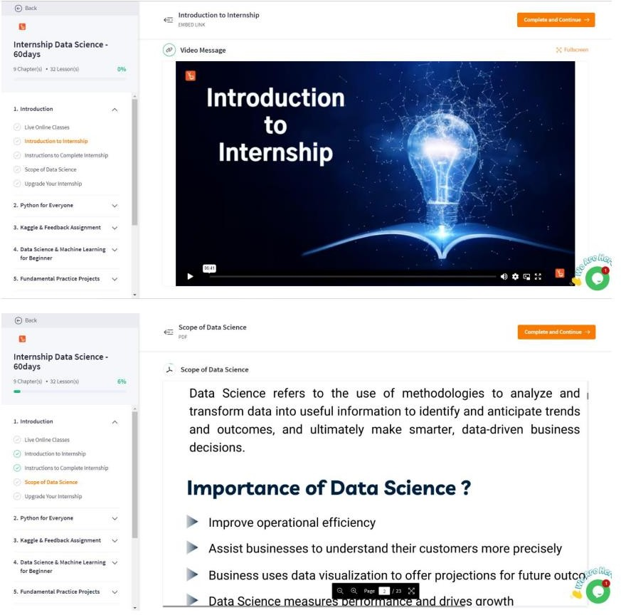

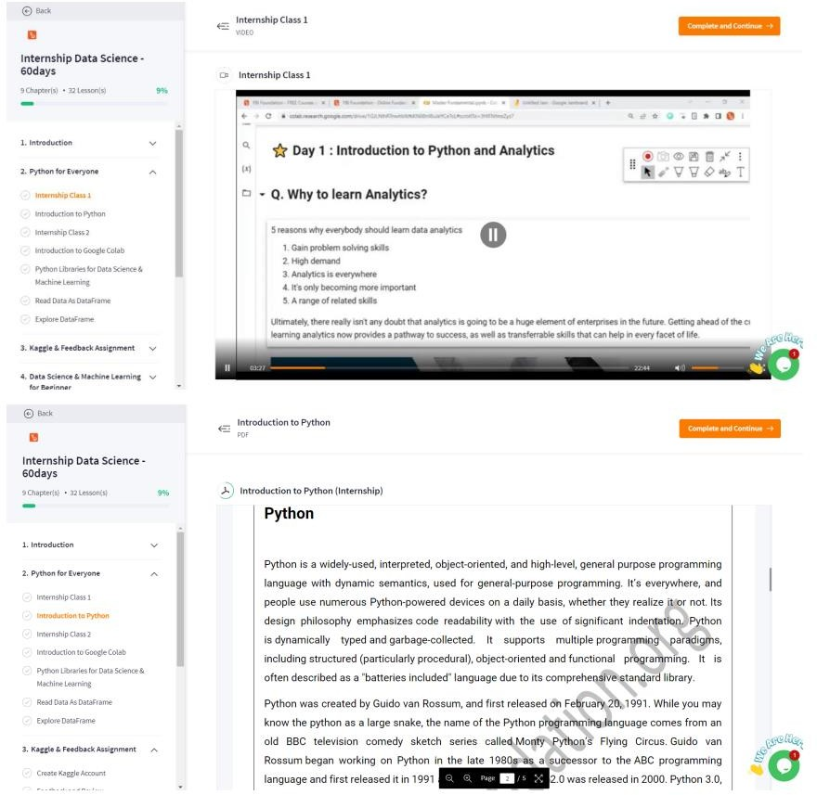

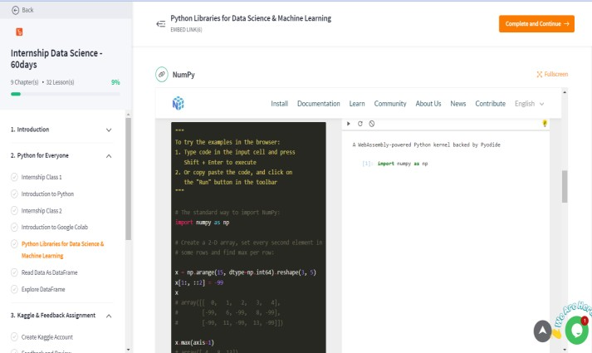

YBI FOUNDATION URL

**https://www.ybifoundation.org/#/profile/edit-profile**

**Internal Evaluation for Short Term Internship**

**(On-site/Virtual)**

**Objectives:**

* To integrate theory and practice.
* To learn to appreciate work and its function towards the future.
* To develop work habits and attitudes necessary for job success.
* To develop communication, interpersonal and other critical skills in the future job.
* To acquire additional skills required for the world of work.

**Assessment Model:**

* There shall only be internal evaluation.
* The Faculty Guide assigned is in-charge of the learning activities of the students and for the comprehensive and continuous assessment of the students.
* The assessment is to be conducted for 100 marks.
* The number of credits assigned is 4. Later the marks shall be converted into grades and grade points to include finally in the SGPA and CGPA.
* The weightings shall be:
  + Activity Log 25 marks
  + Internship Evaluation 50marks
  + Oral Presentation 25 marks
* Activity Log is the record of the day-to-day activities. The Activity Log is assessed on an individual basis, thus allowing for individual members within groups to be assessed this way. The assessment will take into consideration the individual student’s involvement in the assigned work.
* While evaluating the student’s Activity Log, the following shall be considered –

1. The individual student’s effort and commitment.
2. The originality and quality of the work produced by the individual student.
3. The student’s integration and co-operation with the work assigned.
4. The completeness of the Activity Log.

* The Internship Evaluation shall include the following components and based on Weekly Reports and Outcomes Description

1. Description of the Work Environment.
2. Real Time Technical Skills acquired.
3. Managerial Skills acquired.
4. Improvement of Communication Skills.
5. Team Dynamics
6. Technological Developments recorded

**MARKS STATEMENT**

**(To be used by the Examiners)**

**INTERNAL ASSESSMENT STATEMENT**

**Name Of the Student: Pinapatruni Chandra Praneeth**

**Programme of Study: B.Tech**

**Year of Study: 4th Year**

**Group: Computer Science and Engineering**

**Register No/H.T. No: 21P35A0503**

**Name of the College: Aditya College of Engineering and Technology**

**University: JNTUK**

|  |  |  |  |
| --- | --- | --- | --- |
| ***Sl. No*** | ***Evaluation Criterion*** | ***Maximum Marks*** | ***Marks Awarded*** |
| 1. | Internship Evaluation | 20 |  |
| 2. | Presentation | 30 |  |
|  | GRAND TOTAL | 50 |  |

Date: **Signature of the Faculty Guide**

**Certified by**

Date: **Signature of the Head of the Department/Principal**

Seal:

