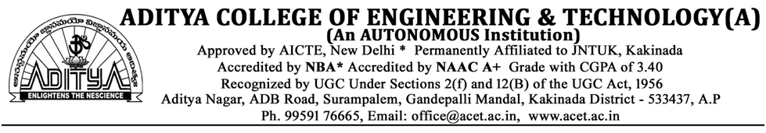

**ASSIGNMENT-1**

1. What is value education? Why there is a need of value education?
2. Explain the process of value education?
3. Explain the process of self-exploration with a diagram
4. What is the meaning of prosperity? How can you say that you are prosperous?
5. What is meaning of justice in human relationships? How does it follow from family to world family?

**Answers**

**1)ans)** Character oriented education that instils basic values and ethnic values in one’s psyche is called ‘Value Based Education’. The subject that enables us to understand ‘what is valuable’ for human happiness is called value education. Value education is important to help everyone in improving the value system that he/she holds and puts it to use. Once, one has understood his/ her values in life he/she can examine and control the various choices he/she makes in his/ her life. Value education enables us to understand our needs and visualize our goals correctly and also helps to remove our confusions and contradictions and bring harmony at all levels. It also helps remove our confusions and contradictions and enables us to rightly utilize the technological innovations.

Values form the basis for all our thoughts, behaviours and actions. Once we know what is valuable to us, these values becomes the basis, the anchor for our actions. We also need to understand the universality of various human values, because only then we can have a definite and common program for value education. Then only we can be assured of a happy and harmonious human society.

The subject that enables us to understand ‘what is valuable’ for human happiness is called value education. Need for value education is:

•      **Correct identification of our aspirations.**The subject which enables us to understand ‘what is valuable’ for human happiness is called ‘value education’ (VE). Thus, VE enables us to understand our needs and visualize our goals correctly and also indicate the direction for their fulfilment. It also helps to remove our confusions and contradictions and bring harmony at all levels.

•      **Understanding universal human values to fulfil our aspirations in continuity.**Values form the basis for all our thoughts, behaviours and actions. Once we know what is valuable to us, these values becomes the basis, the anchor for our actions. We also need to understand the universality of various human values, because only then we can have a definite and common program for value education. Then only we can be assured of a happy and harmonious human society.

•      **Complimentarity of values and skills.**To fulfil our aspirations both values and skills are necessary. When we identify and set the right goals and produced in right direction. This is known as **value domain**, the domain of wisdom, and when we learn and practices to actualize this goal to develop the techniques to make this happen in real life, in various dimensions of human endeavour (struggle). This is known as **domain of skills**.

Hence, there is an essential complementarity between values and skills for the success of any human endeavour. For example, I want to lead a healthy life. Only wishing for good health will not help me keep my body fit and healthy and without having understood the meaning of health, I will not be able to choose things correctly to keep my body fit and healthy.

•      **Evaluation of our beliefs.**Each one of us believes in certain things and we base our values on these beliefs, be they false or true which may or may not be true in reality. These believes come to us from what we read, see, hear, what our parents tells us, our friends talk about, what the magazines talk of, what we see from TV etc. Value Education helps us to evaluate our beliefs and assumed values.

•      **Technology and human values.**The present education system has become largely skill-based. The prime emphasis is on science and technology. However, science and technology can only help to provide the means to achieve what is considered valuable. It is not within the scope of science and technology to provide the competence of deciding what really is valuable. Value Education is a crucial missing link in the present education system. Because of this deficiency, most of our efforts may prove to be counterproductive and serious crises at the individual, societal and environmental level are manifesting.

**2)ans)**

The process for value education has to be that of self-exploration, which includes two things: verification at the level of natural acceptance and experiential validation in living. Self exploration is the process to find out what is valuable to me by investigating within myself, what is right for me, true for me, has to be judged within myself.

Through self exploration we get the value of ourself. Various aspects of reality facilitating the understanding of human values will be presented as proposals. We need to verify these proposals for our self and examine our living in this light.

The subject that enables us to understand ‘what is valuable’ for human happiness is called value education. In order to qualify for any course on value education, the following guidelines for the content of the course are important:

•      **Universal:**It needs to be applicable to all the human beings irrespective of cast, creed, nationalities, religion, etc., for all times and regions.

•      **Rational:**It has to appeal to human reasoning. It has to be amenable to reasoning and not based on dogmas or blind beliefs.

•      **Natural and verifiable:**It has to be naturally acceptable to the human being who goes through the course and when we live on the basis of such values it leads to our happiness. It needs to be experientially verifiable, and not based on dogmas, beliefs or assumptions.

•      **All encompassing:**Value education is aimed at transforming our consciousness and living. Hence, it needs to cover all the dimensions (thought, behaviour, work and realization) and levels (individual, family, society, nature and existence) of human life and profession.

•      **Leading to harmony:**The value education ultimately is targeted to promote harmony within the individual, among human beings and with nature.

**3)ans)**

Self exploration is the process to find out what is valuable to me by investigating within myself, what is right for me, true for me, has to be judged within myself. Through self exploration we get the value of ourself. The process of self exploration is a follows:

First of all we have to keep in mind that,

Whatever is being presented is a PROPOSAL.

•      Don’t assume it to be true immediately, nor reject it without proper exploration.

•      Verify it in your own right, on the basis of it being naturally acceptable to you,

o Not just on the basis of scriptures

o Not on the basis of equipment/instrument data

o Not on the basis of the assertion by other human beings.

Therefore, it is essential to carefully ponder over these on your own right. Neither accept these as true immediately nor reject them prematurely without proper exploration.

Don’t just accept / reject these only on the basis of the following:

•      Because something like this/ different from this, has been mentioned in scriptures,

•      Or, because it has been preached/ denied by some great men,

•      Or, a large number of people possess such a view / a different view,

•      Or it is claimed to have been verified through some physical instrument or, claimed that this is beyond the domain of verifiability by physical instruments.

Then what to do

•      Verify on the basis of your natural acceptance

•      Live accordingly to validate it experientially

o   If the proposal is true in behaviour with humanleads to >  mutual happiness

o   If the proposal is true in work with rest of thenature  leads to >       mutual prosperity

Remember, it is a process of self- exploration, therefore, it has to be authenticated by us alone by means of verification at the level of natural acceptance and experiential validation. The process is shown in the diagram below:

[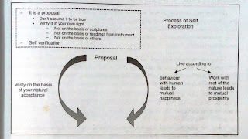](https://3.bp.blogspot.com/-RUCLHKnYqzo/WgFwKluVEUI/AAAAAAAABhY/ZvTkNj57d-0W8nEVWGWPF1JVkpyObfgdwCLcBGAs/s1600/IMG_20171107_123806241.jpg)

But this process is not complete. It will be completed when on verification on the basis of natural acceptance and testing in our living ultimately results in ‘realization’ and ‘understanding’ in us.

•      Verify on the basis of your natural acceptance

•      Live accordingly to validate it experientially

o   If the proposal is true in behaviour with humanleads to >   mutual happiness

o   If the proposal is true in work with rest of thenature  leads to >  mutual prosperity

•      Results in realization and understanding

On having realization and understanding we get

o Assurance

o Satisfaction

o Universality (Applies to all time, space and individual)

[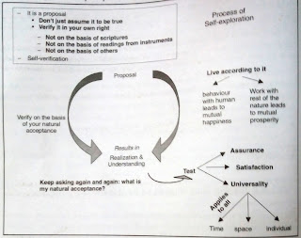](https://1.bp.blogspot.com/-U1an-U0SzzQ/WgFwYnNdmvI/AAAAAAAABhc/h4IJPr1kz_40x6kbMy_iYxnKqLL1ZMHngCLcBGAs/s1600/IMG_20171107_123828824.jpg)

Take for example: a proposal- ‘respect’ is a value in human relation. When I verify at the level of natural acceptance, I find that it is naturally acceptable to me. Similarly, when I behave with respect, it is mutually fulfilling to me and to the other.

Thus the proposal is ‘True’. If it fails on any of the two tests, it is untrue.

This verification leads to realization of the truthfulness of the proposal and it becomes part and parcel of my understanding. It is reflected in my thoughts and in my behaviour.

**4)ans)**

Happiness may be defined as being in harmony/synergy in the state/ situation that I live in. “A state or situation in which I live, if there is harmony in it then I like to be in that state / situation. The state of liking is happiness.” Whereas, prosperity is the “feeling of having or making available more than required physical facilities”.

In the current scenario, we are generally trying to achieve happiness and prosperity by maximizing accumulation and consumption of physical facilities. This is an attempt to achieve happiness through pleasant sensory interactions. The physical facilities are not seen in terms of fulfilling bodily needs but as a means of maximizing happiness.

This has resulted in wrong assessment of wants for physical facilities as being unlimited. But this pursuit is self-defeating. Neither can we hope to achieve continuous happiness through sensory interactions nor can we have prosperity, as it amounts to trying to fulfil unlimited wants through limited resources. This effort is engendering problems at all the levels. It is becoming anti-ecological and anti-people, and threatening the human survival itself. Some of the consequences of such a trend are summarised below:

**1 At the level of the individual**– Rising problems of depression, psychological disorders, suicides, stress, insecurity, psycho-somatic diseases, loneliness etc.

**2 At the level of the family –**Breaking of joint families, mistrust, conflict between older and younger generations, insecurity in relationships, divorce, dowry tortures, family feuds, wasteful expenditure in family functions etc.

**3 At the level of the Society –**Growing incidences of terrorism and naxalism, rising communalism, spreading casteism, racial and ethnic struggle, wars between nations, attempts of genocide, fear of nuclear and genetic warfare, etc.

**4 At the level of nature –**Global warming, water, air, soil, noise, etc. pollution, resource depletion of minerals and mineral oils, sizeable deforestations, loss of fertility of soil.

It therefore, calls for an urgent need for human beings to correctly understand happiness and prosperity as well as the sustainable way to achieve these.

**5)ans)**

Mutual fulfilment is the hallmark of justice. And justice is essential in all relationships. Justice starts from the family and slowly expands to the world family. The child gets an understanding of justice in the family. With this understanding, he goes out into society and interacts with people.

 Justice is the recognition of values (the definite feelings in a relationship, their fulfilment, the right evaluation of the fulfilment resulting in mutual happiness. Justice concerns itself with the proper ordering of things and people within a society. There are four elements: Recognition of values, fulfilment, evaluation and mutual happiness ensured. When all the four are ensured, justice is ensured. Mutual fulfilment is the hallmark of justice. And justice is essential in all relationships. Justice starts from the family and slowly expands to the world family. The child gets an understanding of justice in the family. With this understanding, he goes out into society and interacts with people.

If the understanding of justice is ensured in the family, there will be justice in all the interactions we have in the world at large. If we do not understand the values in relationships, we are governed by our petty prejudices and conditionings. We may treat people as high or low based on their body (particular caste, or sex or race or tribe), on the basis of wealth one possesses or the belief systems that one follows. All this is a source of injustice and leads to a fragmented society while our natural acceptance is for an undivided society and universal human order. Having explored the harmony in human beings, we are able to explore the harmony in the family. This enables us to understand the harmony at the level of society and nature/existence. And this is the way the harmony in our living grows. We slowly get the competence to live in harmony with all human beings.

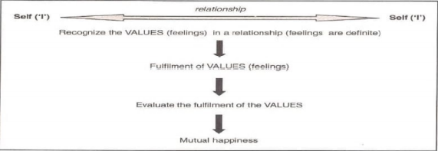

**THE-END**