Our co-living space project aims to create a vibrant and inclusive community where individuals can live, work, and connect with like-minded people. We believe that living together in a shared environment fosters collaboration, reduces isolation, and enhances the overall quality of life.

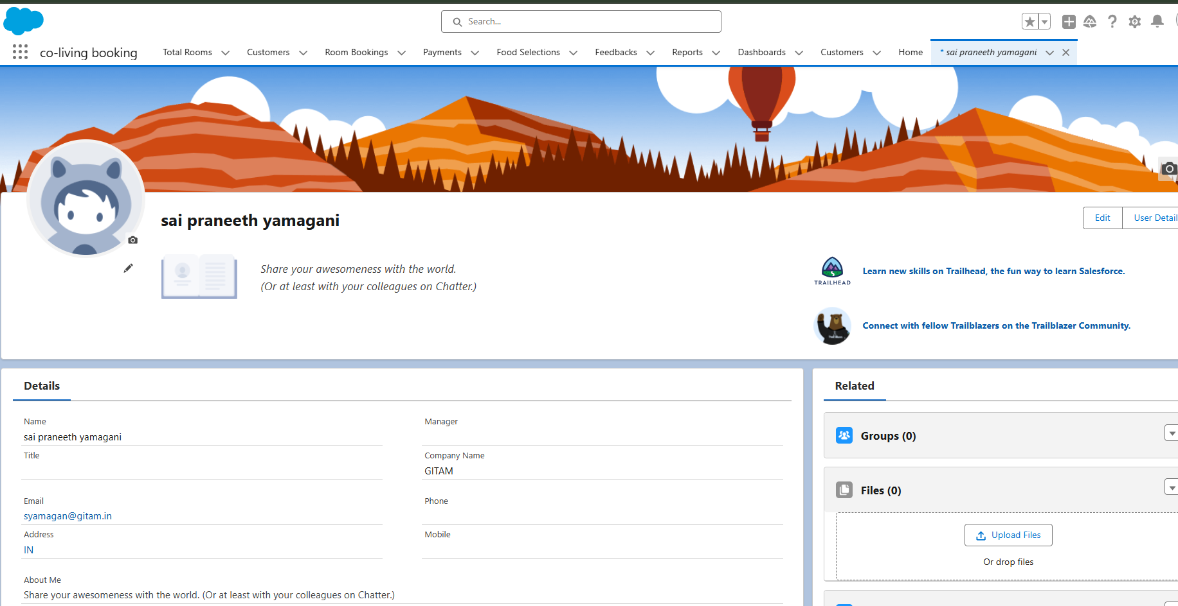

What Is an Object?   
Salesforce objects are database tables that permit you to store data that is specific to an organization. What are the types of Salesforce objects   
Salesforce objects are of two types:   
  
1. Standard Objects: Standard objects are the kind of objects that are provided by salesforce.com such as users, contracts, reports, dashboards, etc.   
2. Custom Objects: Custom objects are those objects that are created by users. They supply information that is unique and essential to their organization. They are the heart of any application and provide a structure for sharing data.

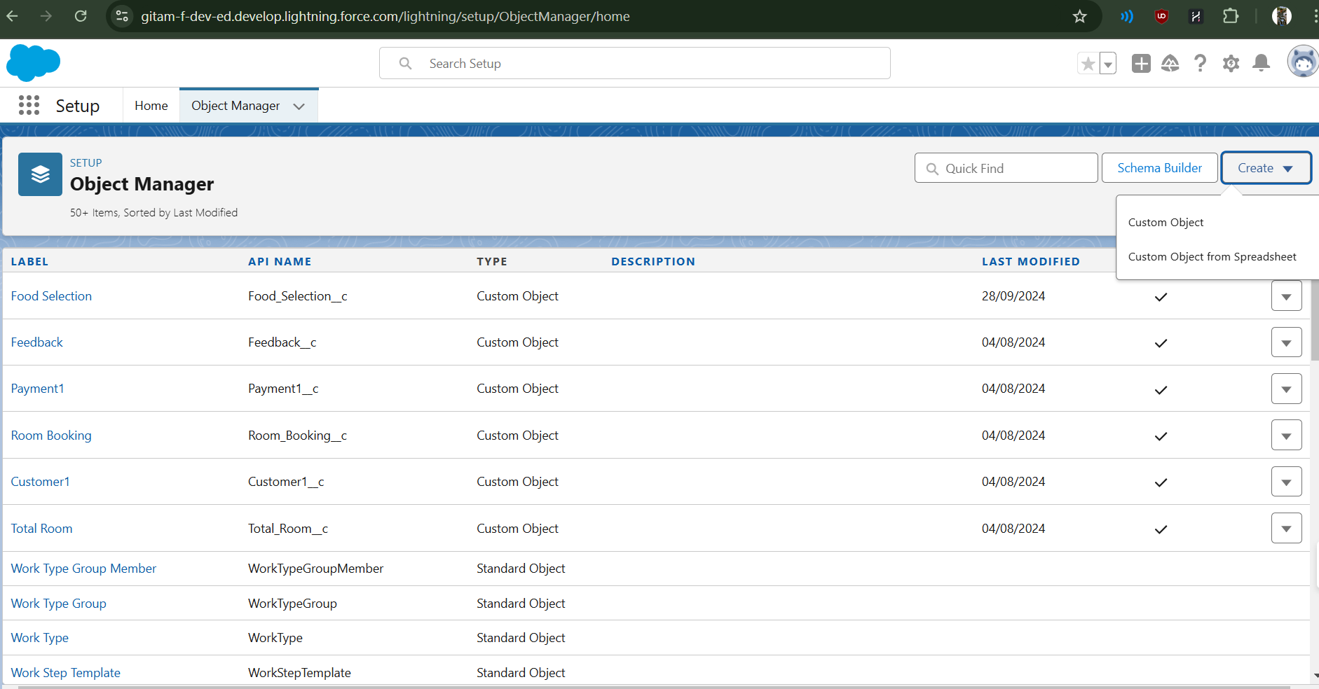

**What is Tab:** A tab is like a user interface that is used to build records for objects and to view the records in the objects.

**Types of Tabs:**

1. **Custom Tabs**

Custom object tabs are the user interface for custom applications that you build in salesforce.com. They look and behave like standard salesforce.com tabs such as accounts, contacts, and opportunities.

1. **Web Tabs**

Web Tabs are custom tabs that display web content or applications embedded in the salesforce.com window. Web tabs make it easier for your users to quickly access content and applications they frequently use without leaving the salesforce.com application.

1. **Visualforce Tabs**

Visualforce Tabs are custom tabs that display a Visualforce page. Visualforce tabs look and behave like standard salesforce.com tabs such as accounts, contacts, and opportunities.

1. **Lightning Component Tabs**

Lightning Component tabs allow you to add Lightning components to the navigation menu in Lightning Experience and the mobile app.

1. **Lightning Page Tabs**

Lightning Page Tabs let you add Lightning Pages to the mobile app navigation menu.

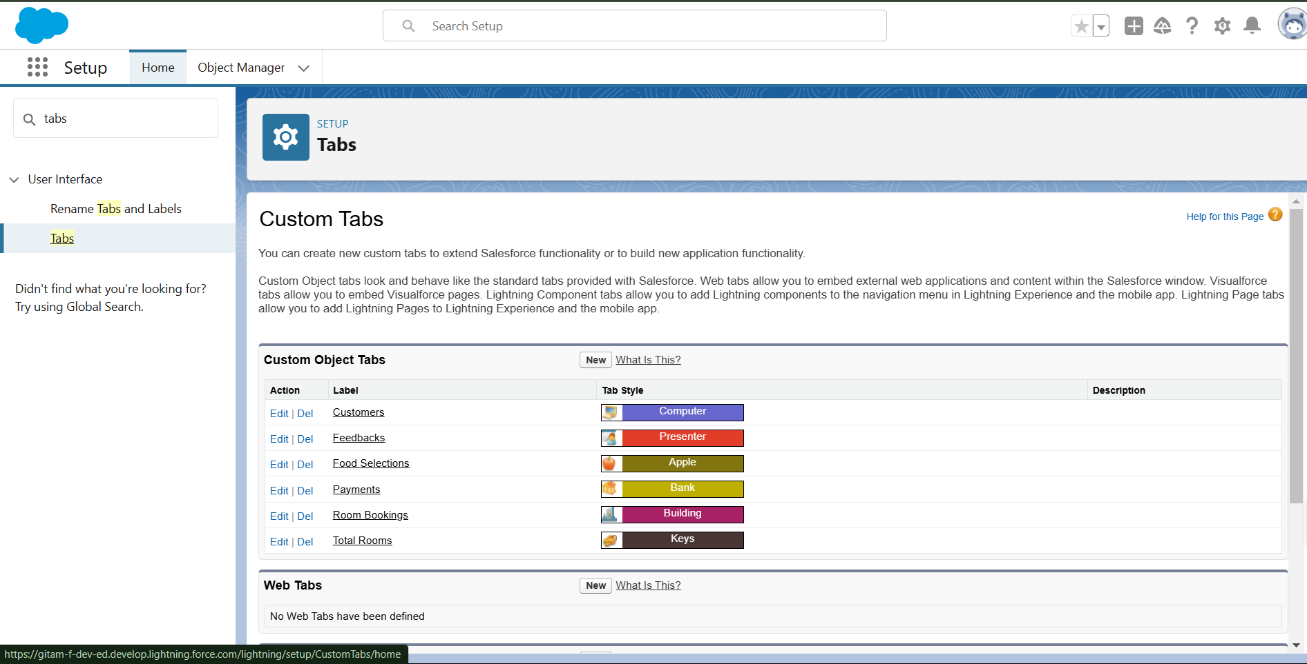

The Lightning App

An app is a collection of items that work together to serve a particular function. In Lightning Experience, Lightning apps give your users access to sets of objects, tabs, and other items all in one convenient bundle in the navigation bar.

Lightning apps let you brand your apps with a custom color and logo. You can even include a utility bar and Lightning page tabs in your Lightning app. Members of your org can work

more efficiently by easily switching between apps.

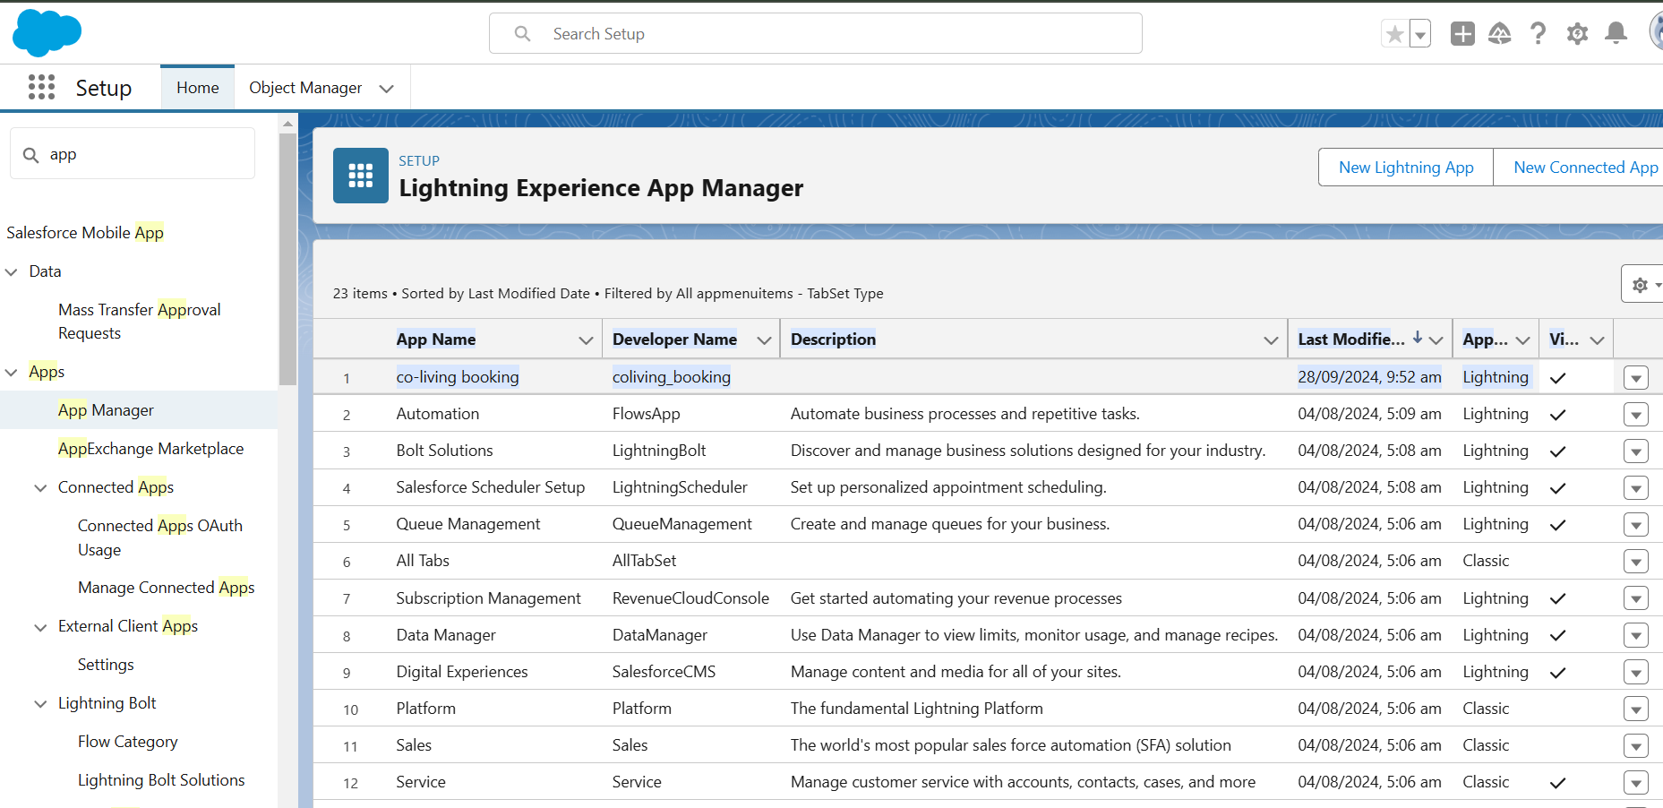

When we talk about Salesforce, Fields represent the data stored in the columns of a relational database. It can also hold any valuable information that you require for a specific object. Hence, the overall searching, deletion, and editing of the records become simpler and quicker.

Types of Fields

1. Standard Fields
2. Custom Fields

Standard Fields:

As the name suggests, the Standard Fields are the predefined fields in Salesforce that perform a standard task. The main point is that you can’t simply delete a Standard Field until it is a non-required standard field. Otherwise, users have the option to delete them at any point from the application freely. Moreover, we have some fields that you will find common in every Salesforce application. They are,

1. Created By

2. Owner

3. Last Modified

4. Field Made During object Creation

Custom Fields:

On the other side of the coin, Custom Fields are highly flexible, and users can change them according to requirements. Moreover, each organizer or company can use them if necessary. It means you need not always include them in the records, unlike Standard fields. Hence, the final decision depends on the user, and he can add/remove Custom Fields of any given form.

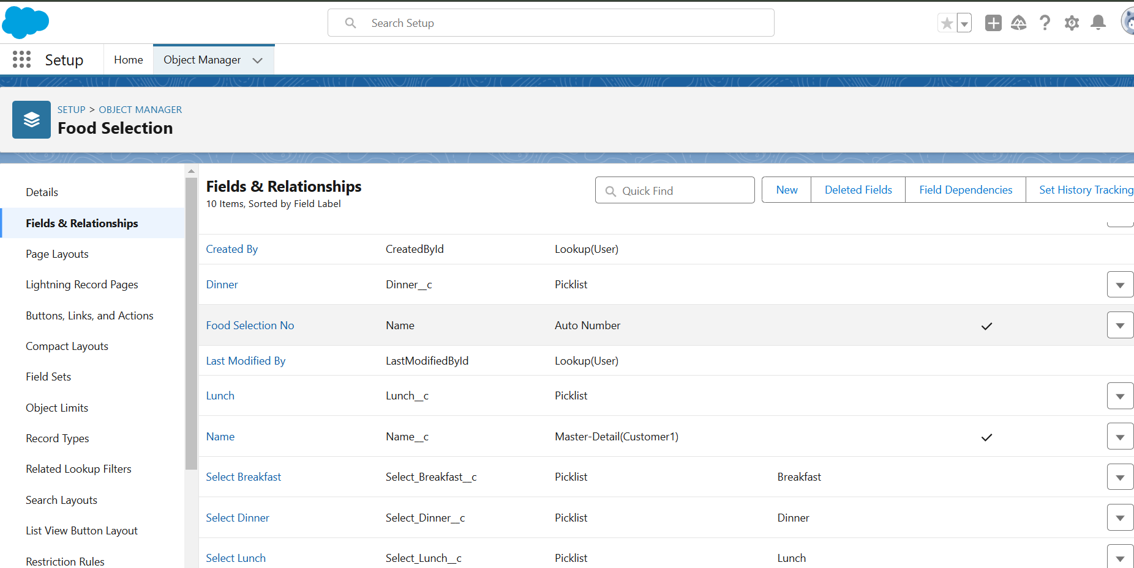

Validation rule

Validation rules are applied when a user tries to save a record and are used to check if the data meets specified criteria. If the criteria are not met, the validation rule triggers an error message and prevents the user from saving the record until the issues are resolved.

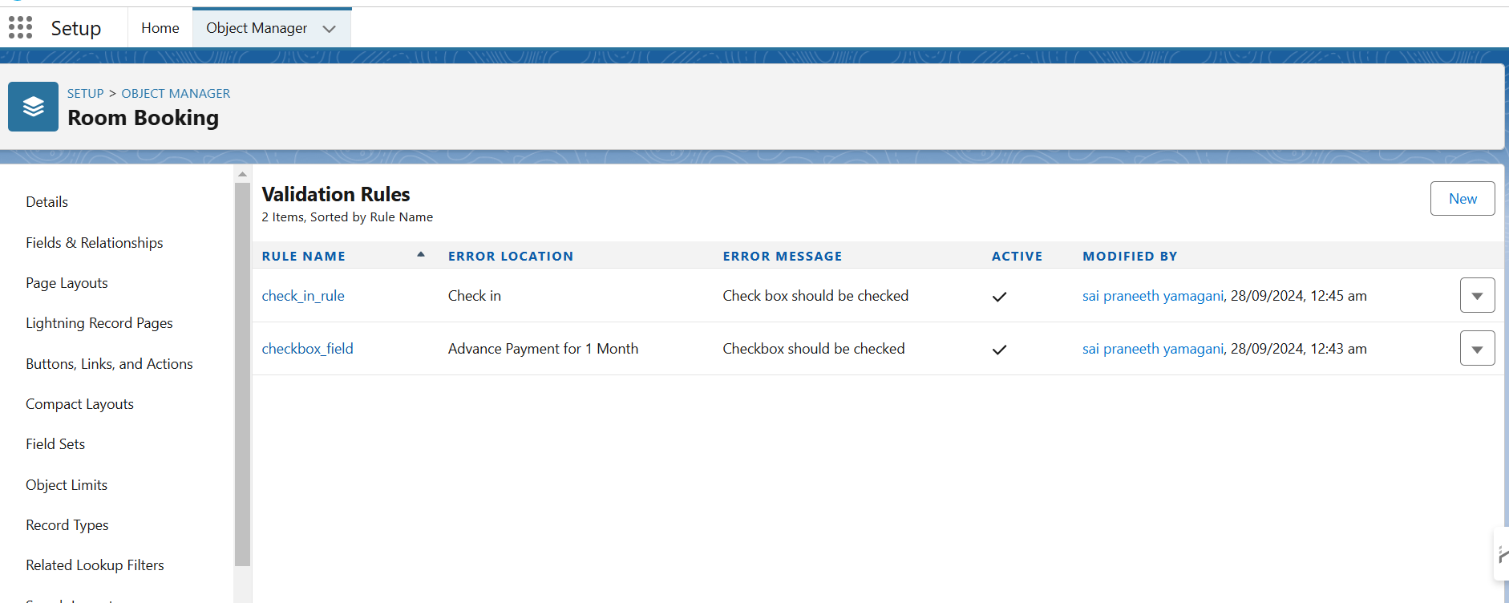

A profile is a group/collection of settings and permissions that define what a user can do in salesforce. Profile controls “Object permissions, Field permissions, User permissions, Tab settings, App settings, Apex class access, Visualforce page access, Page layouts, Record Types, Login hours & Login IP ranges. You can define profiles by the user's job function. For example System Administrator, Developer, Sales Representative.

Types of profiles in salesforce

1. Standard profiles:

By default salesforce provides below standard profiles.

* Contract Manager
* Read Only
* Marketing User
* Solutions Manager
* Standard User
* System Administrator.

We cannot deleted standard ones

Each of these standard ones includes a default set of permissions for all of the standard objects available on the platform.

2. Custom Profiles:

Custom ones defined by us.

They can be deleted if there are no users assigned with that particular one.

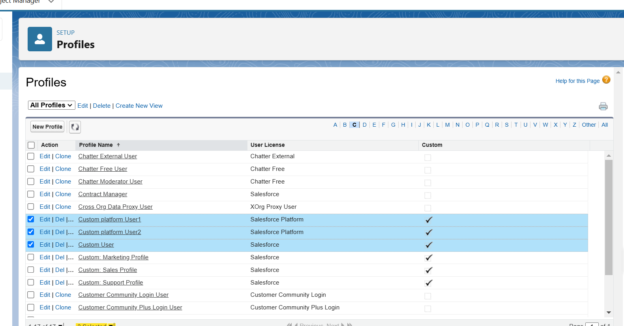

### Roles

A role in Salesforce defines a user's visibility access at the record level. Roles may be used to specify the types of access that people in your Salesforce organization can have to data. Simply put, it describes what a user could see within the Salesforce organization.

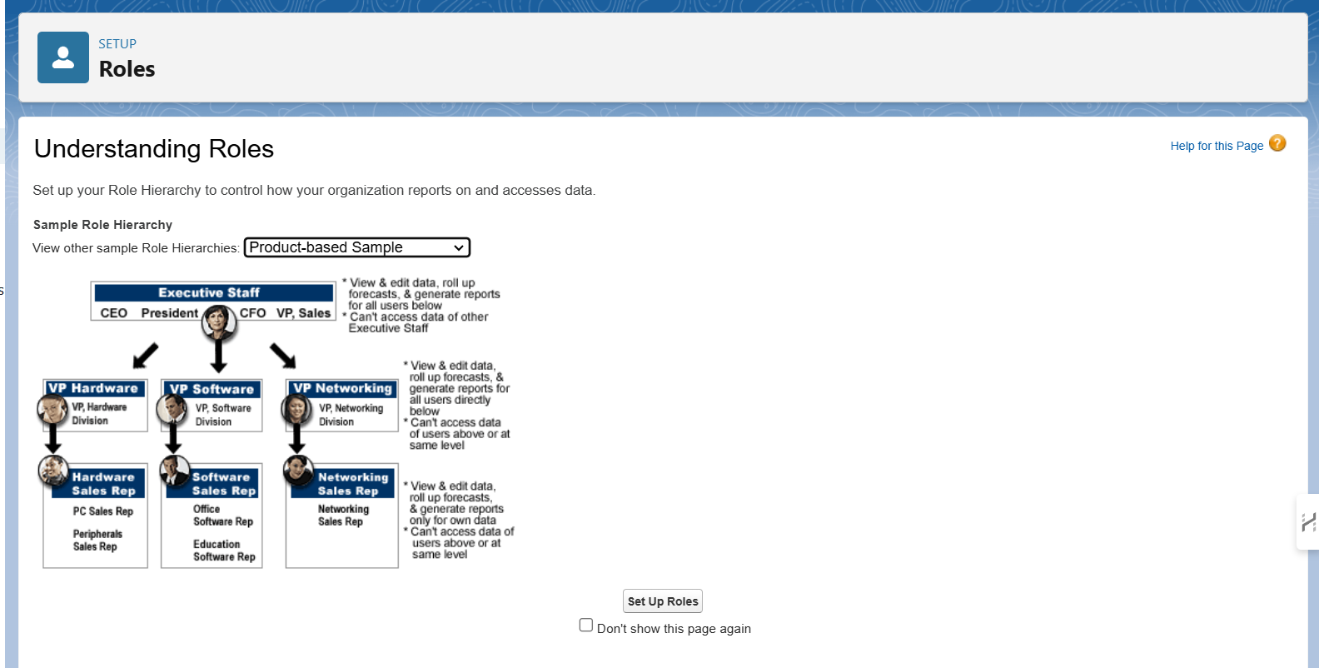

Users

A user is anyone who logs in to Salesforce. Users are employees at your company, such as sales reps, managers, and IT specialists, who need access to the company's records. Every user in Salesforce has a user account. The user account identifies the user, and the user account settings determine what features and records the user can access.

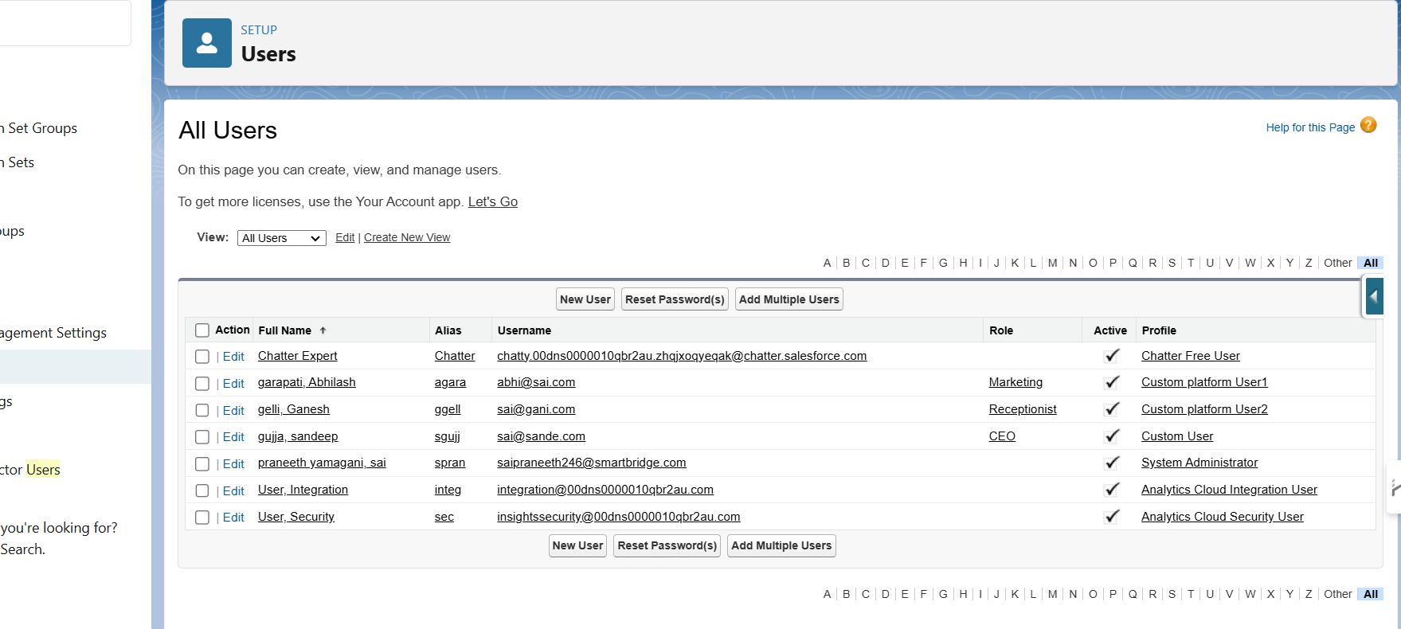

Reports

Reports give you access to your Salesforce data. You can examine your Salesforce data in almost infinite combinations, display it in easy-to-understand formats, and share the resulting insights with others. Before building, reading, and sharing reports, review these reporting basics.   
  
Types of Reports in Salesforce

1. Tabular
2. Summary
3. Matrix
4. Joined Reports

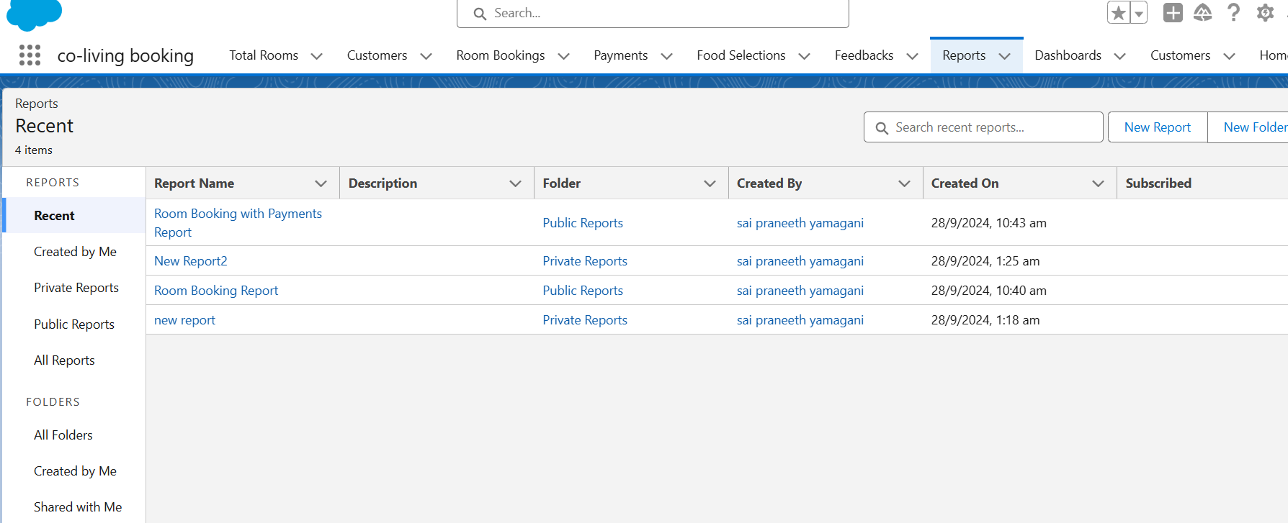

Dashboards

Dashboards help you visually understand changing business conditions so you can make decisions based on the real-time data you’ve gathered with reports. Use dashboards to help users identify trends, sort out quantities, and measure the impact of their activities. Before building, reading, and sharing dashboards, review these dashboard basics.

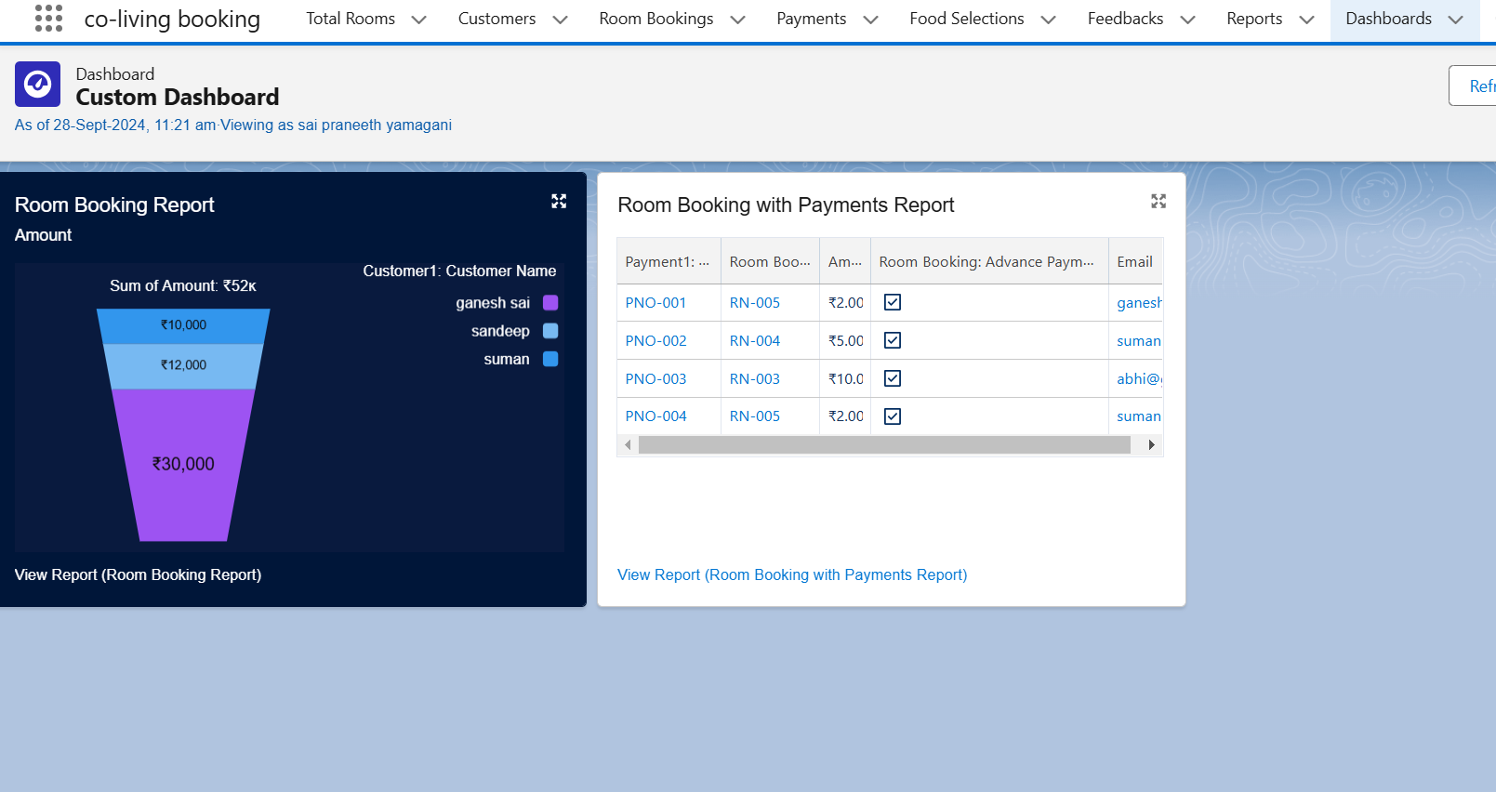

Flows

In Salesforce, a flow is a powerful tool that allows you to automate business processes, collect and update data, and guide users through a series of screens or steps. Flows are built using a visual interface and can be created without any coding knowledge.

Why do we need to create a flow:

To get the Amount Field automatic by the selection of the Room sharing and Ac fields the Amount is generated Automatically in the amount field.

## final project done with flow testing

## 

## thank you