A

MAJOR PROJECT REPORT ON

“QUANTICO”

Submitted in partial fulfilment of the requirement for the award of the degree of

BACHELOR OF TECHNOLOGY
IN
COMPUTER SCIENCE & ENGINEERING

BY

Y.KESHAV 12K81A05H9

Y.PRANEETH 12K81A05J0

L.ESWAR REDDY 12K81A05E8

G.VAMSHI KRISHNA 12K81A05D9

Under the Guidance of

PADMA RAJANI
Assistant Professor, CSE Dept.



DEPARTMENT OF COMPUTER SCIENCE AND ENGINEERING

St. MARTIN’S ENGINEERING COLLEGE

(Affiliated to JNTU, Hyderabad)

DHULAPALLY (V), QUTBULLAPUR (M), SECUNDERABAD

2012-2016

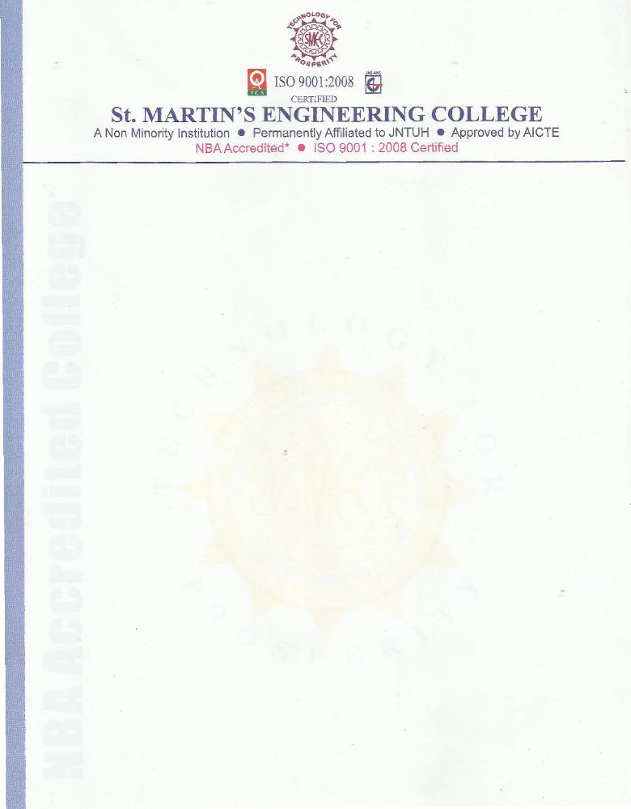

CERTIFICATE

This is to certify that the Mini Project report titled “Quantico” that is being submitted by Y.Keshav (12K81A05H9), Y.Praneeth (12K81A05J0), L.Eswar Reddy (12K81A05E8) and G.Vamshi Krishna (12K81A05D9) students of B.Tech (CSE) fourth year at ST.MARTIN'S ENGINEERING COLLEGE, Dhulapally, Secunderabad, in partial fulfilment of the requirements for the award of the degree of Bachelor of Technology in Computer Science & Engineering is a record of bonafide work carried out by them.
The result of investigation enclosed in this report have been verified and found satisfactory.

INTERNAL GUIDE HEAD OF THE DEPT. Mrs. PADMA RAJANI Mr.A.PRAKASH

EXTERNAL EXAMINER

ACKNOWLEDGEMENT

The satisfaction and euphoria that accompanies the successful completion of any task would be incomplete without the mention of the people who made it possible and whose encouragement and guidance have crowned my efforts with success.

We extend my deep sense of gratitude to PRINCIPAL, Dr KANCHA SAMMAIAH,

St. Martin’s Engineering College, Dhulapally for permitting me to undertake this Project.

We are indebted to Mr.A.PRAKASH, HOD, Computer Science & Engineering, St.Martins’s Engineering College, Dhulapally, for his support and guidance throughout our project.

We would like to thank our project guide Mrs. PADMA RAJANI, ASSISTANT PROFESSOR, for her constant motivation and valuable help throughout the project work.

Finally, we express thanks to one and all who have helped us in successfully completing this project. Furthermore we would like to thank our family and friends for their moral support and encouragement.

Y.KESHAV (12K81A05H9)

Y.PRANEETH (12K81A05J0)

L.ESWAR REDDY (12K81A05E8)

G.VAMSHI KRISHNA (12K81A05D9)

