1.<!DOCTYPE html>

<html>

<head>

<title>body</title>

</head>

<body style="background-color: #e8e1a9;">

<center><h2>STUDENT DETAILS</h2></center>

<center><img src="praneet.JPEG" width="20%"></center>

<center><h2>Registration no:-121810304018</h2></center>

</body>

</html>

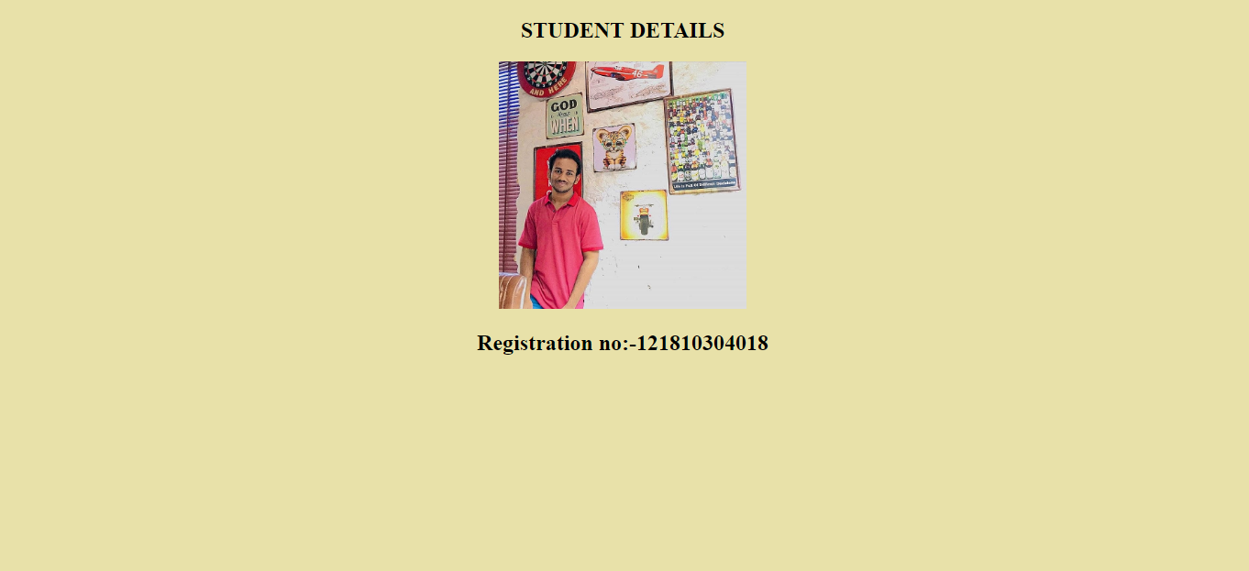

2.<!DOCTYPE html>

<html>

<head>

<title>header</title>

</head>

<body style="background-color: #b2ede5;">

<table>

<tr>

<td><img src="GITAM.JPEG" width="30%"></td>

<td><h3>GITAM UNIVERSITY</h3></td>

<td style="padding-left: 400px;"><input type="text" placeholder="🔍Search.." name="search"></td>

</tr>

</table>

</body>

</html>

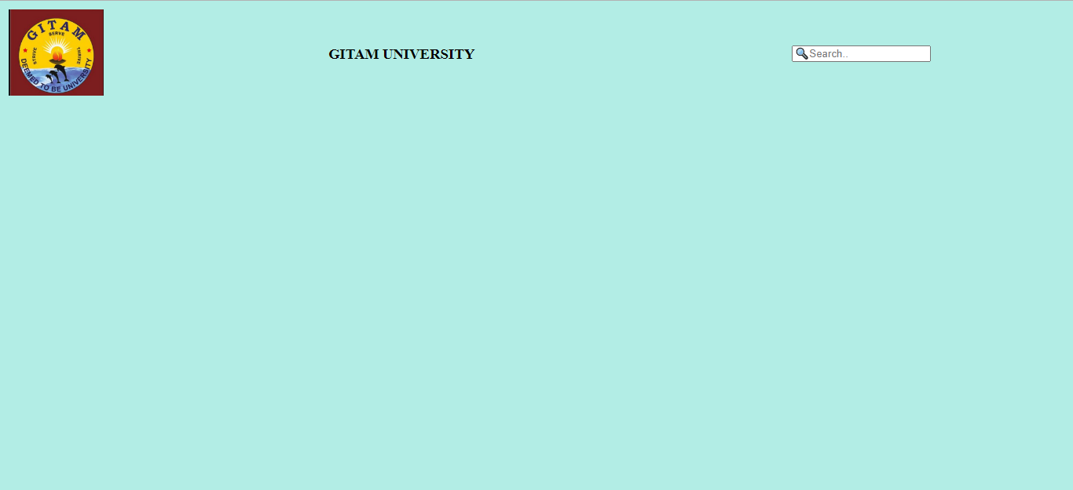

3. <!DOCTYPE html>

<html>

<head>

<title>left frame</title>

</head>

<body style="background-color: #f2ca99;">

<div style="padding-top: 350px;padding-left: 10px;">

<marquee behavior="scroll" direction="top" scrollamount="12">Social links</marquee>

<a style="text-decoration: none;" href="https://www.linkedin.com/feed/">Linkedin</a><br><br><br>

<a style="text-decoration: none;" href="https://login.gitam.edu/login.aspx" target="frame4">GITAM</a>

</div>

</body>

</html>

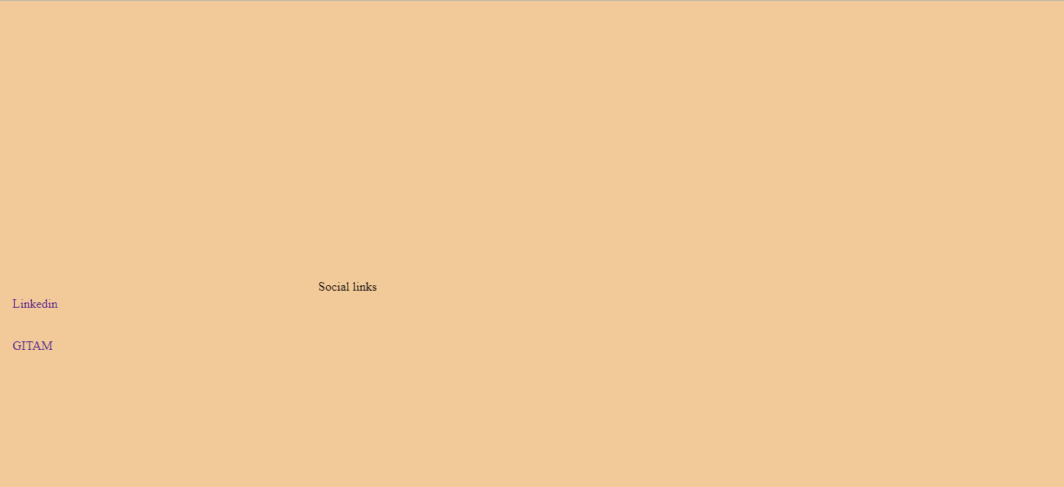

4. <!DOCTYPE html>

<html>

<head>

<title>footer</title>

</head>

<body style="background-color: #86b4ba;">

<center><h4>@copyrights.designed by Praneet kandregula</h4></center>

</body>

</html>

Capture 4.PNG

OverAll

5. <!DOCTYPE html>

<html>

<head>

<title>K.Praneet-B4-18(04-02-2021)</title>

</head>

<FRAMESET COLS="10%,80%, 10%">

<FRAME SRC="frame3.html" NAME=left>

<frameset rows = "6%,50%,6%">

<frame name="frame2" src="frame2.html" />

<frame name="frame4" src="frame4.html" />

<frame name="frame1" src="frame1.html" />

</frameset>

<frame name="frame4" src="frame5.html" />

</html>

