Javascript Masterclass Coding Excercises (From Udemy course)

02nd Sep 2019 | Tuesday

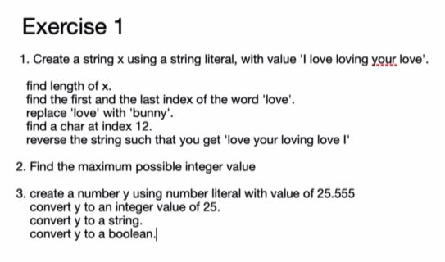

Solution-

1.

|  |
| --- |
| let x='I love loving your love';  //find length of x  console.log("Length="+ x.length);    // find the first and the last index of the word 'love'  console.log('First index of word `love`= ' + x.indexOf('love'));  console.log('Last index of word `love`= ' + x.lastIndexOf('love'));  //replace 'love' with 'bunny'  //console.log(x.replace('love','bunny')); //replaces only first occurance.  console.log(x.replace(/love/g,'bunny'));  // find a char at index 12  console.log(x.charAt(12));  // Reverse a string such that you you get 'love your loving love I'  let arr= x.split(' ');  //console.log(arr.__proto__);  let reverseString=arr.reverse().join(' ');  console.log(reverseString); |

|  |
| --- |
| //Excercise 1  //2. Find maximum possible integer value  //console.dir(Number);  console.log(Number.MAX_SAFE_INTEGER);  console.log(Number.MAX_VALUE);  //3.  let y=25.555;  y=parseInt(y); //alternative to Math function to get integer  y=Math.floor(y);  console.log(typeof(y));  console.log(y);  y=y.toString();  console.log(typeof(y));  console.log(y);  y=Boolean(y);  console.log(typeof(y));  console.log(y); |

Excercise 2-

//Check the number is prime number using for loop.

//Check the number is prime number using while loop.

|  |
| --- |
| let input=151;  let input=151;  let isPrime=null;  let count=0;  if (input%2===0){  isPrime=false;  count++;  }  else{  for (let i=3;i<Math.sqrt(input);i+2)  {  count++;  if (input%i===0){  isPrime=false;  break;  }  }  }  if (isPrime===null){  count++;  console.log("The number is a Prime number");  }  else{  console.log("The number is not a Prime number");  }  console.log("Iterations check: " + count);  console.log(Math.sqrt(input)); |