MongoDB for NoSQL

- Uploading the cleaned data to the database
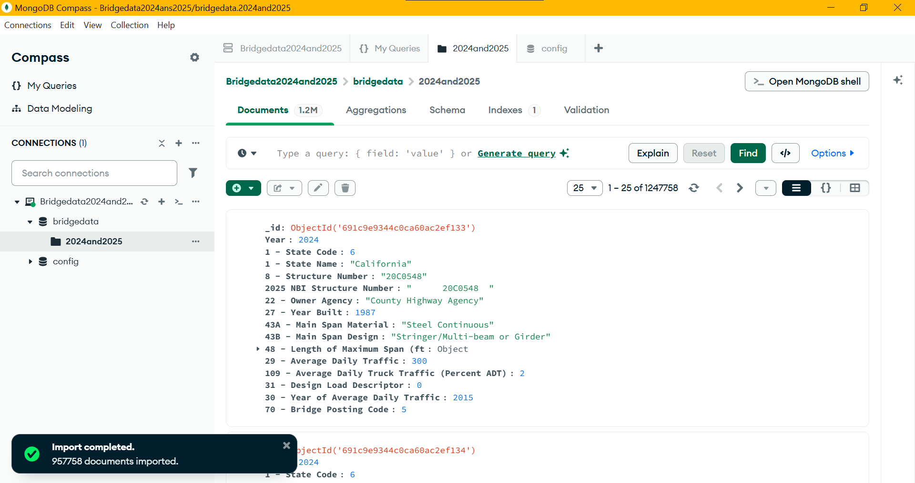

- Filter Bridges by State
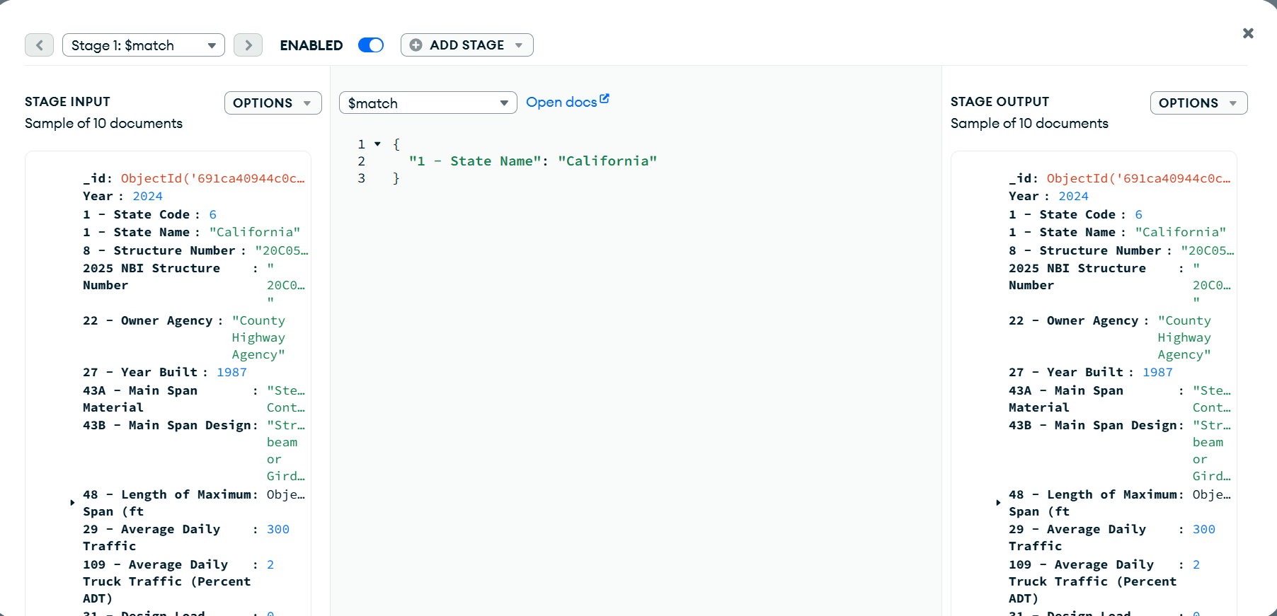

- Aggregate Bridges by Main Span Material
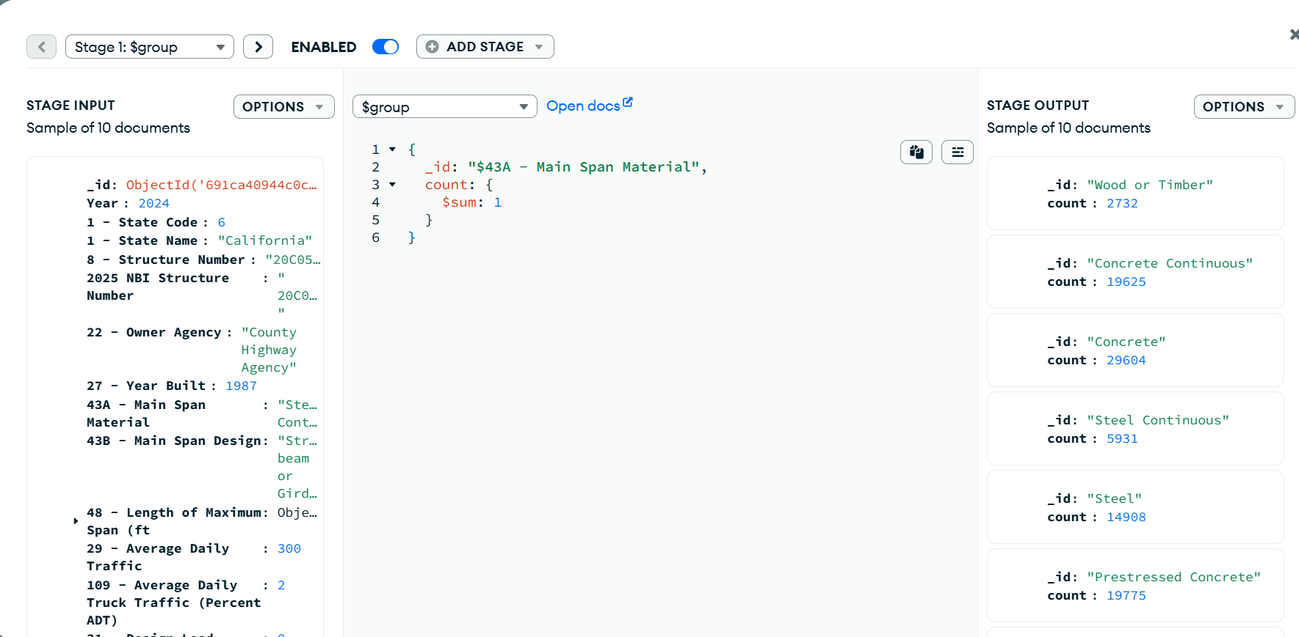

- Find Bridges with High Average Daily Traffic
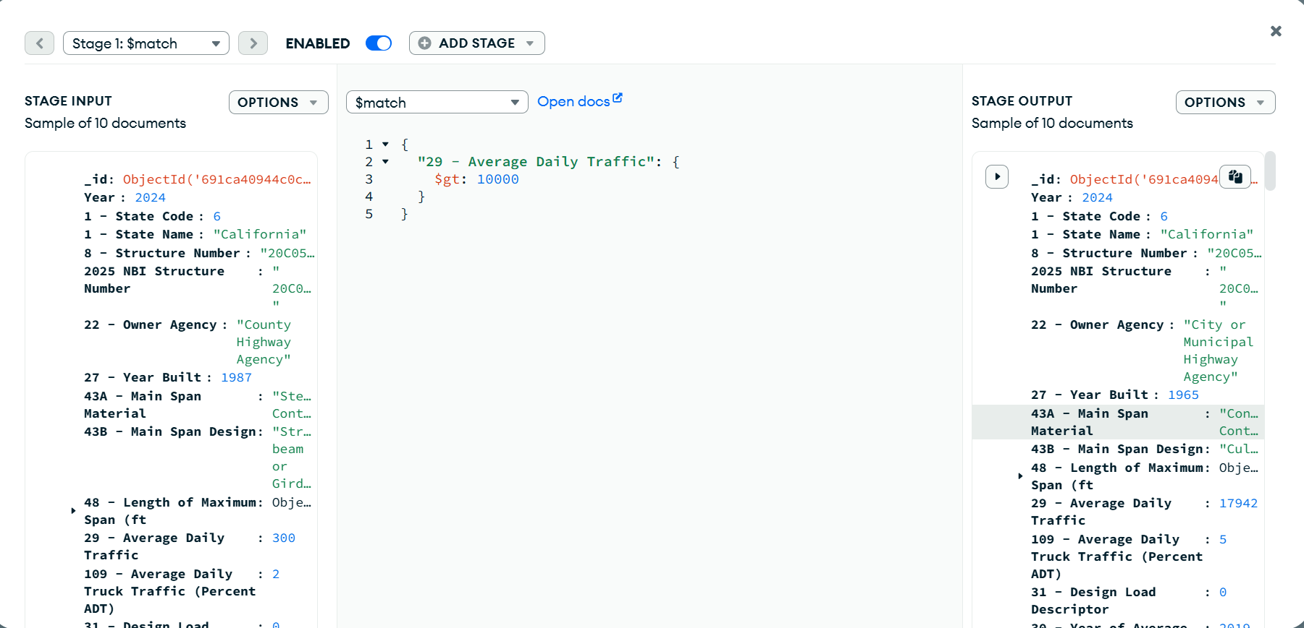

- Bridges that were built before 1980


