;l

Foundations of Programming

Assignment No. : 4
- PROBLEM STATEMENT: Write a C Program to calculate the salary of an employee given his basic pay (taken as input from the user). Calculate gross salary of employee. Let HRA be 10 % of basic pay and TA be 5% of basic pay. Let employees pay professional tax as 2% of total salary. Calculate net salary payable after deductions.

OBJECTIVE:

- To understand the importance of flowchart for any programming model.
- To learn simple flowchart symbols and arrows to define relationships.
- To understand and develop visual representations of flow of data.

THEORY:
- Define Algorithm.
- What are the different characteristics of an algorithm.
PLATFORM: Linux
FLOWCHART:
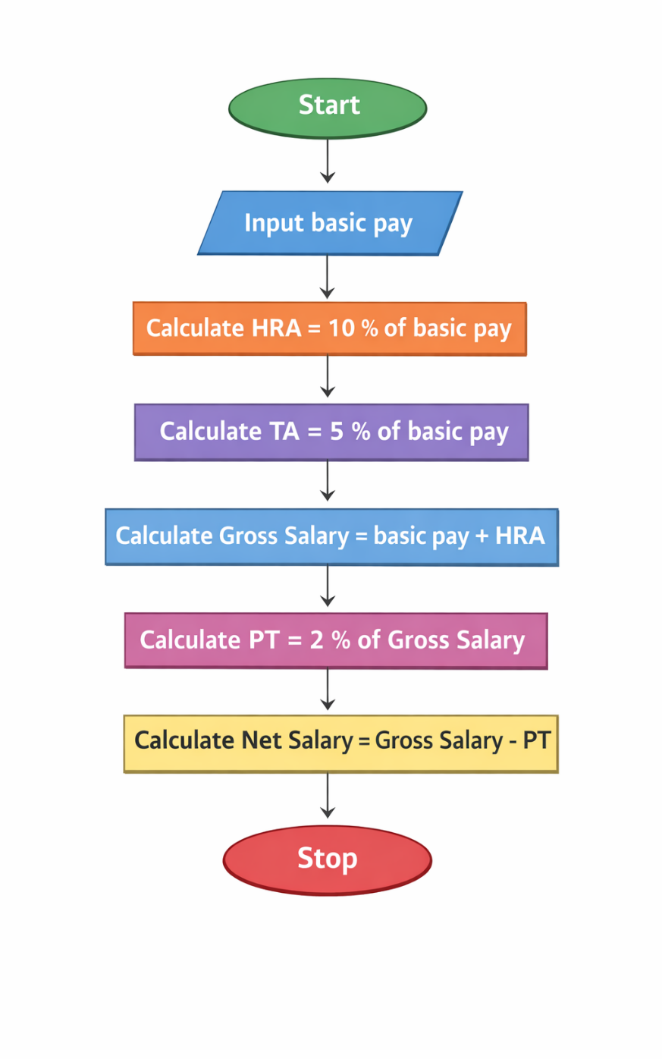
ALGORITHM:
- Start
- Declare variables: basicPay, HRA, TA, grossSalary, PT, netSalary
- Input basicPay from the user
- Calculate HRA = 10% of basicPay
- Calculate TA = 5% of basicPay
- Calculate grossSalary = basicPay + HRA + TA
- Calculate professional tax (PT) = 2% of grossSalary
- Calculate netSalary = grossSalary - PT
- Display HRA, TA, grossSalary, PT, and netSalary
- Stop

CODE:
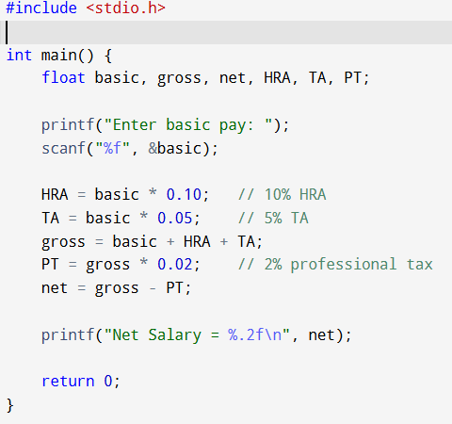

INPUT:
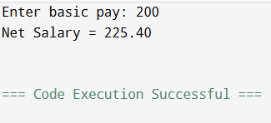
OUTPUT:
CONCLUSION: Thus, we have learned to write algorithms and to draw its representation in terms of flowchart.

FAQs:
- Describe various symbols and their use in flowchart.
- Difference between Algorithm and Flowchart.

