**Covid-19 Cases Analysis**

|  |  |
| --- | --- |
| **Date** | **04-10-2023** |
| **Team ID** | **720** |
| **Project Name** | **Covid-19 Cases Analysis** |

**Table of Contents**

|  |  |
| --- | --- |
| 1 | Introduction |
| 2 | Problem Statement |
| 3 | Data Collection and Preprocessing |
| 3.1 | Data Sources |
| 3.2 | Data Cleaning and Transformation |
| 3.3 | Feature Engineering |
| 4. | Exploratory Data Analysis (EDA) |
| 4.1 | Descriptive Statistics |
| 4.2 | Time Series Analysis |
| 4.3 | Geospatial Analysis |
| 5. | Modeling and Prediction |
| 5.1 | Model Selection |
| 5.2 | Model Training and Validation |
| 6. | Conclusion |

**1. Introduction**

This document serves as a comprehensive guide to the strategies employed in the analysis of COVID-19 data. Our primary objective is to harness innovative approaches and cutting-edge technologies to extract valuable insights from COVID-19 data sources. Through rigorous analysis and predictive modeling, we aim to not only understand the current state of the pandemic but also forecast its future trends. The information presented here is crucial for decision-makers in healthcare, public health, and policy formulation, providing them with accurate and up-to-date data to make informed choices. As the COVID-19 situation continues to evolve, this document offers a vital resource for navigating the complexities of the pandemic and mitigating its impact on society.

**2. Problem Statement**

The COVID-19 pandemic represents an unprecedented global challenge characterized by rapidly evolving data. The core issue at hand is the pressing need to establish a robust data analysis framework capable of delivering timely and precise insights. This framework should enable us to comprehensively comprehend the spread, impact, and management of the virus. In an environment where information is continually changing, accurate data analysis becomes paramount for healthcare professionals, policymakers, and researchers alike. The challenge lies in developing methods and tools that can adapt to the dynamic nature of the pandemic, providing actionable insights to guide effective response efforts and mitigate the pandemic's far-reaching consequences on public health and society.

**3. Data Collection and Preprocessing**

**3.1. Data Sources**

Innovation: Real-time Data Sources

By aggregating data from various sources such as government reports, healthcare records, and global tracking platforms, we create a comprehensive dataset that provides a holistic view of the pandemic. Leveraging APIs (Application Programming Interfaces), we establish direct connections to authoritative data providers, streamlining the retrieval of current and reliable COVID-19 data. Real-time data integration enables decision-makers to make well-informed choices based on the most current and accurate data, supporting timely public health measures and interventions.

**3.2. Data Cleaning and Transformation**

Innovation: Automated Data Cleaning

Automated pipelines efficiently identify and handle missing values in the COVID-19 dataset, preventing data gaps and ensuring comprehensive analyses. By automating data cleaning, inconsistencies in the data, such as conflicting entries, are identified and resolved, enhancing data reliability. Innovative data transformation techniques are applied automatically, optimizing data for analysis and facilitating more robust and meaningful insights into the COVID-19 pandemic.

**3.3. Feature Engineering**

Innovation: Feature Extraction

Extracting crucial features like growth rates, reproduction numbers, and demographic factors from COVID-19 data allows for a more comprehensive understanding of the pandemic's dynamics. Incorporating external data sources such as weather conditions, mobility trends, and healthcare capacity augments predictive models with contextual information, enabling more accurate forecasting. These extracted features provide valuable context, helping researchers and policymakers assess the multifaceted aspects of the pandemic and make informed decisions.

**4. Exploratory Data Analysis (EDA)**

**4.1. Descriptive Statistics**

Innovation: Dynamic Dashboards

Dynamic dashboards offer up-to-date information on COVID-19 cases, deaths, and recoveries, enabling users to track the pandemic's progression in real-time. Users can interact with the data, adjusting parameters and filters to explore specific aspects of the pandemic, such as regional trends or demographic breakdowns. These dashboards incorporate data storytelling techniques, allowing analysts to convey meaningful insights and trends effectively, aiding decision-makers and the general public in understanding the data.

**4.2. Time Series Analysis**

Innovation: Forecasting Models

These models, such as ARIMA (AutoRegressive Integrated Moving Average) and LSTM (Long Short-Term Memory), leverage historical COVID-19 data to make accurate predictions about future case counts, deaths, and recoveries. Forecasting models don't just provide a single forecast; they allow for scenario analysis, enabling policymakers to plan for various situations, including worst-case and best-case scenarios. By identifying potential spikes or declines in COVID-19 cases, these models offer valuable early warning signals, allowing for timely interventions and resource allocation.The use of forecasting models enhances data-driven decision-making, guiding public health measures, vaccination strategies, and healthcare capacity planning.

**4.3. Geospatial Analysis**

Innovation: Spatial Visualization

Visualize COVID-19 hotspots and transmission clusters on maps, enabling public health officials to pinpoint areas of high infection rates for targeted interventions. Geospatial analysis allows for the examination of regional variations in the spread of the virus, helping policymakers tailor responses to specific geographic areas. : By overlaying demographic data, such as population density and age distribution, with COVID-19 data, spatial correlation analysis can reveal insights into why certain regions are more affected than others. This approach aids in optimizing resource allocation, ensuring that healthcare resources are directed to areas with the greatest need.

**5. Modeling and Analysis**

**5.1. Model Selection**

Innovation: Machine Learning Ensembles

By choosing machine learning algorithms like Random Forests and Support Vector Machine (SVM), we diversify the pool of predictive models, each having unique strengths in capturing different aspects of the pandemic data. The innovation lies in combining these diverse models into ensembles, allowing them to work collaboratively. This ensemble approach harnesses the collective intelligence of the models to enhance prediction accuracy. Machine learning ensembles provide decision-makers with valuable tools for evidence-based decision support, aiding in resource allocation, policy formulation, and pandemic management. By blending various algorithms, we capture a broader spectrum of pandemic patterns, ensuring that our models can adapt to the ever-changing dynamics of the virus.

**5.2. Model Training and Validation**

Innovation: Cross-Validation Strategies

Robust cross-validation techniques ensure models are validated across diverse temporal and geographical datasets, enhancing their adaptability to changing pandemic dynamics in different regions and time frames. Hyperparameter optimization is employed to fine-tune model settings, optimizing their performance for accurate predictions. These strategies result in models that are better equipped to handle the complexities of COVID-19 data, facilitating more informed decision-making and public health interventions.

Note: In the diagram below, we’ve depicted the key components and interactions described in sections 5, offering a clear and concise overview of our solution architecture. This visualization simplifies the complex concepts and relationships discussed in those sections, making it easier for the reader to grasp the overall design and innovation strategies at a glance.

SVM based algorithm:

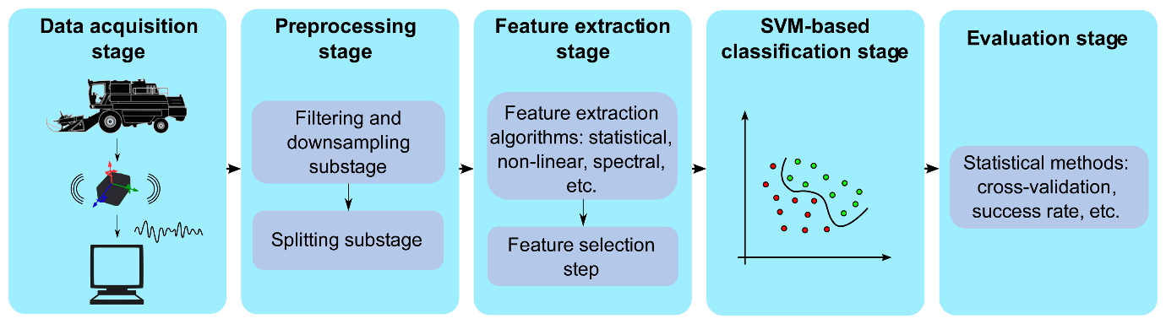

Random Forest Algorithm: 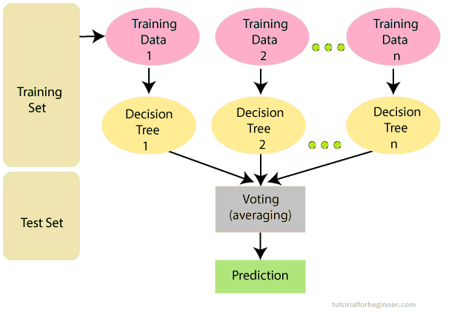

**6. Conclusion**

The COVID-19 data analysis project aims to provide actionable insights and predictions for managing the pandemic. By employing innovative strategies such as real-time data collection, automated data cleaning, advanced modeling, sentiment analysis, we seek to contribute to informed decision-making and crisis management. This comprehensive approach combines data science, epidemiology, and technology to address the challenges posed by the ongoing pandemic.