**COVID -19 ANALAYSIS**

**DEVELOPMENT PART 1**

|  |  |
| --- | --- |
| **Date** | **10-10-2023** |
| **Team ID** | **720** |
| **Project Name** | **Covid-19 Cases Analysis** |

**Table of Contents**

|  |  |
| --- | --- |
| 1 | Introduction |
| 2 | Problem Statement |
| 3 | Steps involved in model evaluation |
| 3.1 | Data collection |
| 3.2 | Load the dataset |
| 3.3 | Data preprocessing |
| 3.4 | Data visualisation using Cognos |
| 4 | Conclusion |

**1. Introduction**

This document serves as a comprehensive guide to the strategies employed in the analysis of COVID-19 data. Our primary objective is to harness innovative approaches and cutting-edge technologies to extract valuable insights from COVID-19 data sources. Through rigorous analysis and predictive modeling, we aim to not only understand the current state of the pandemic but also forecast its future trends. The information presented here is crucial for decision-makers in healthcare, public health, and policy formulation, providing them with accurate and up-to-date data to make informed choices. As the COVID-19 situation continues to evolve, this document offers a vital resource for navigating the complexities of the pandemic and mitigating its impact on society.

**2. Problem Statement**

The COVID-19 pandemic represents an unprecedented global challenge characterized by rapidly evolving data. The core issue at hand is the pressing need to establish a robust data analysis framework capable of delivering timely and precise insights. This framework should enable us to comprehensively comprehend the spread, impact, and management of the virus. In an environment where information is continually changing, accurate data analysis becomes paramount for healthcare professionals, policymakers, and researchers alike. The challenge lies in developing methods and tools that can adapt to the dynamic nature of the pandemic, providing actionable insights to guide effective response efforts and mitigate the pandemic's far-reaching consequences on public health and society.

**3. Steps involved in model evaluation**

**3.1. Data collection:**

The dataset is intended for the analysis of COVID-19 data, focusing on the months of March, April, and May in the year 2021. It comprises columns for date, cases, deaths, and information about countries and regions within the European Union (EU) and the European Economic Area (EEA).

**3.2. Load the dataset.**

Import the necessary dependencies and load the dataset.

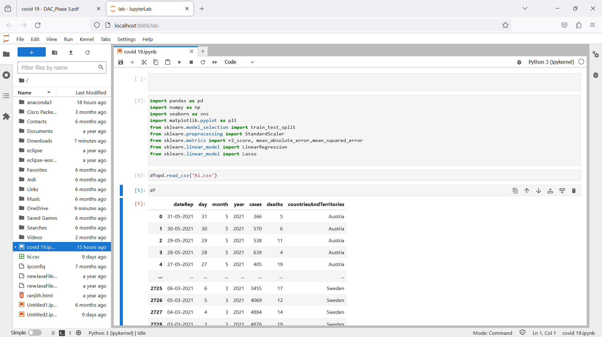

**3.3. Explore the dataset using jupyter notebook.**

**Step 1:**

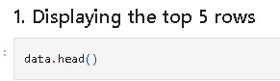

**Step 2:**

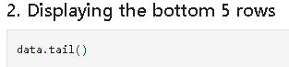

**Step 3:**

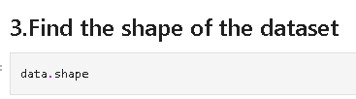

**Step 4:**

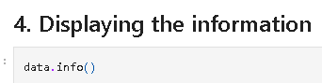

**Step 5:**

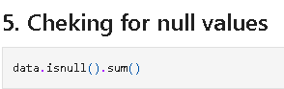

**Step 6:**

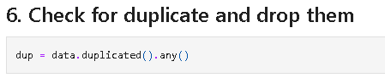

**Step 7:**

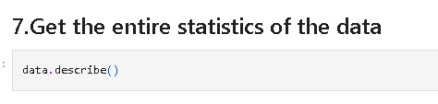

**3.4 Visualisation using Cognos:** 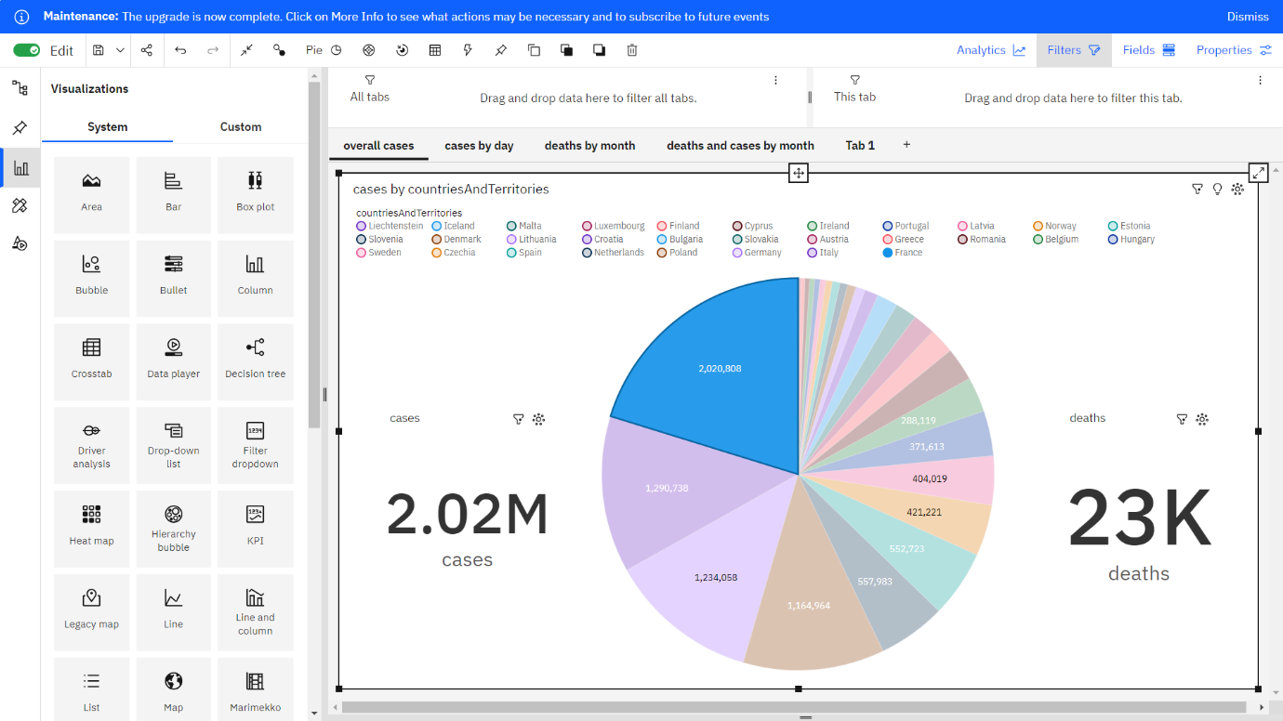

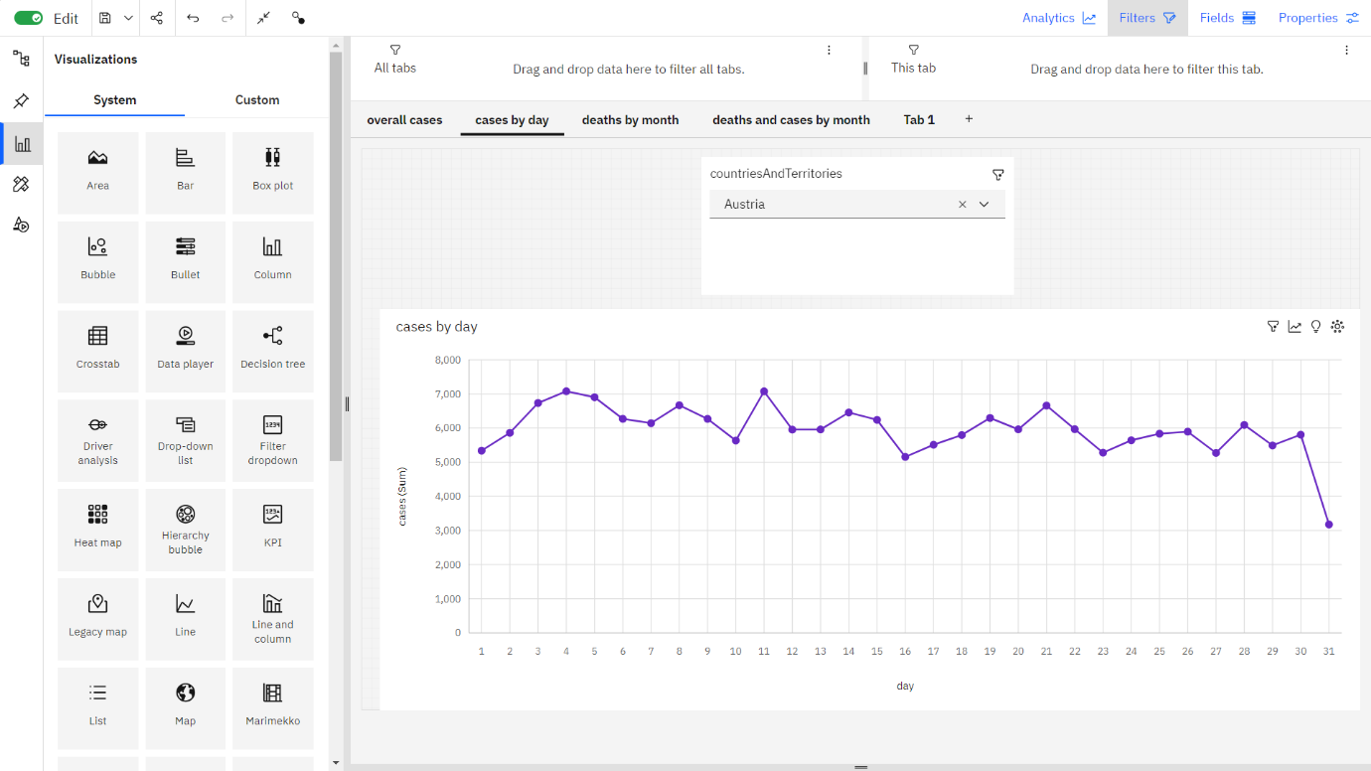

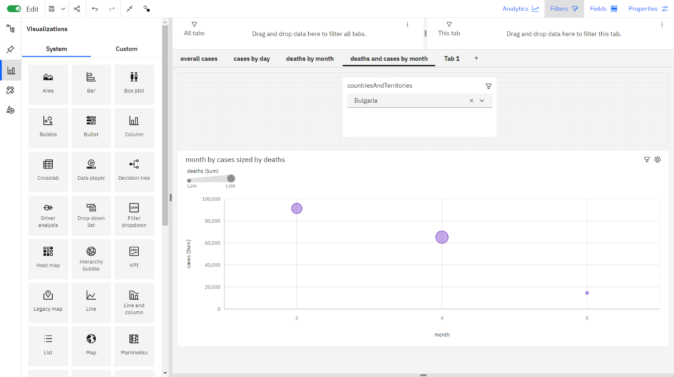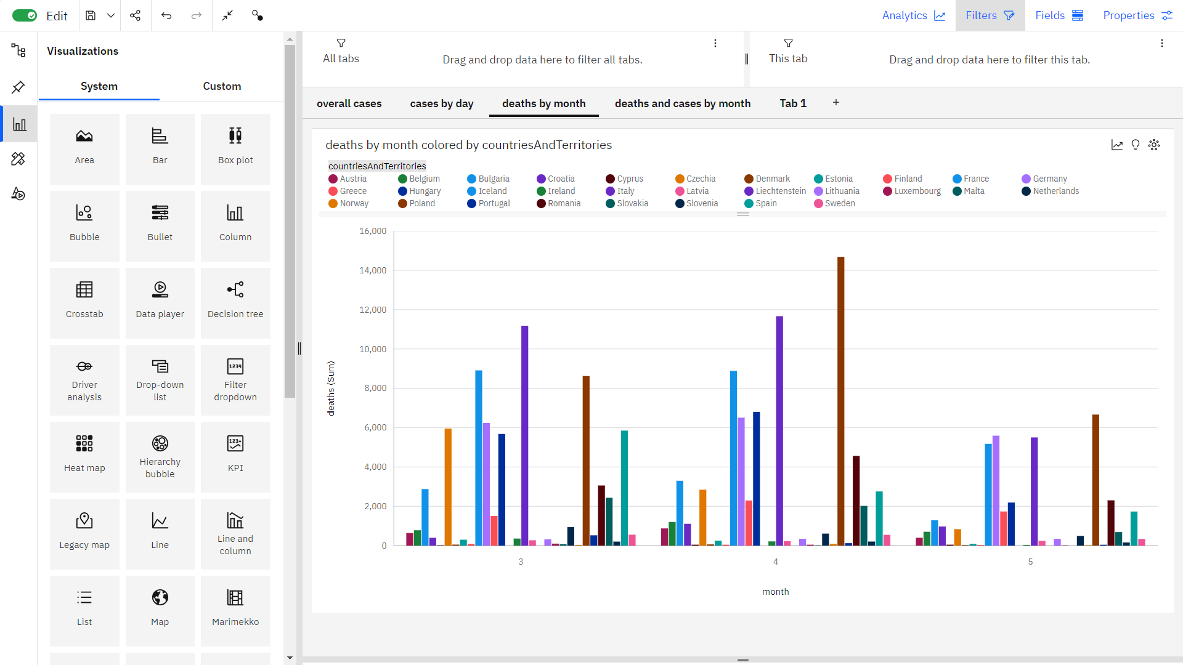

**4. Conclusion**

The COVID-19 data analysis project aims to provide actionable insights and predictions for managing the pandemic. By employing innovative strategies such as real-time data collection, automated data cleaning, advanced modeling, sentiment analysis, we seek to contribute to informed decision-making and crisis management. This comprehensive approach combines data science, epidemiology, and technology to address the challenges posed by the ongoing pandemic.