**COVID -19 ANALAYSIS**

**DEVELOPMENT PART II**

|  |  |
| --- | --- |
| **Date** | **10-10-2023** |
| **Team ID** | **720** |
| **Project Name** | **Covid-19 Cases Analysis** |

**Table of Contents**

|  |  |
| --- | --- |
| 1 | Introduction |
| 2 | Problem Statement |
| 3 | Visualisation using IBM Cognos and insights |
| 3.1 | Home |
| 3.2 | Visualisation for overall cases and analyses |
| 3.3 | Visualisation for total Mean and Standard Deviation to analysis cases and deaths |
| 3.4 | Visualisation for standard Deviation of cases and deaths by months |
| 3.5 | Visualisation for standard Deviation of cases and deaths by months |
| 3.6 | Visualisation for Mean of cases and deaths by countries |
| 3.7 | Visualisation for cases and deaths by months |

**1. Introduction:**

This document serves as a comprehensive guide to the strategies employed in the analysis of COVID-19 data. Our primary objective is to harness innovative approaches and cutting-edge technologies to extract valuable insights from COVID-19 data sources. Through rigorous analysis and predictive modeling, we aim to not only understand the current state of the pandemic but also forecast its future trends. The information presented here is crucial for decision-makers in healthcare, public health, and policy formulation, providing them with accurate and up-to-date data to make informed choices. As the COVID-19 situation continues to evolve, this document offers a vital resource for navigating the complexities of the pandemic and mitigating its impact on society.

**2. Problem Statement**

The COVID-19 pandemic represents an unprecedented global challenge characterized by rapidly evolving data. The core issue at hand is the pressing need to establish a robust data analysis framework capable of delivering timely and precise insights. This framework should enable us to comprehensively comprehend the spread, impact, and management of the virus. In an environment where information is continually changing, accurate data analysis becomes paramount for healthcare professionals, policymakers, and researchers alike. The challenge lies in developing methods and tools that can adapt to the dynamic nature of the pandemic, providing actionable insights to guide effective response efforts and mitigate the pandemic's far-reaching consequences on public health and society.

**3.Visualisation using IBM Cognos and insights :**

**3.1.Home**

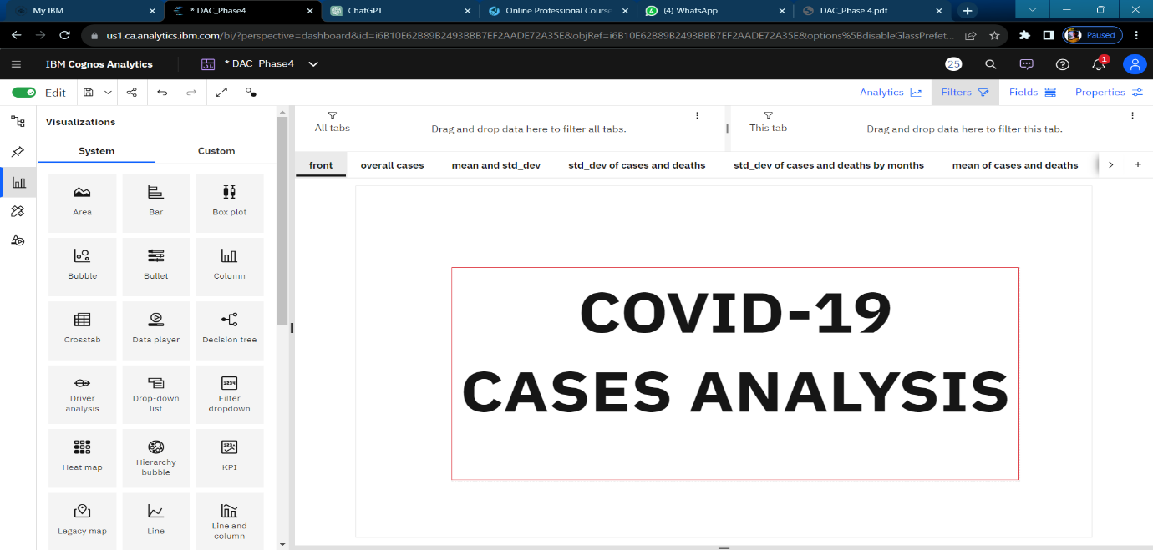

**3.2.Visualisation for overall cases and analyses:**

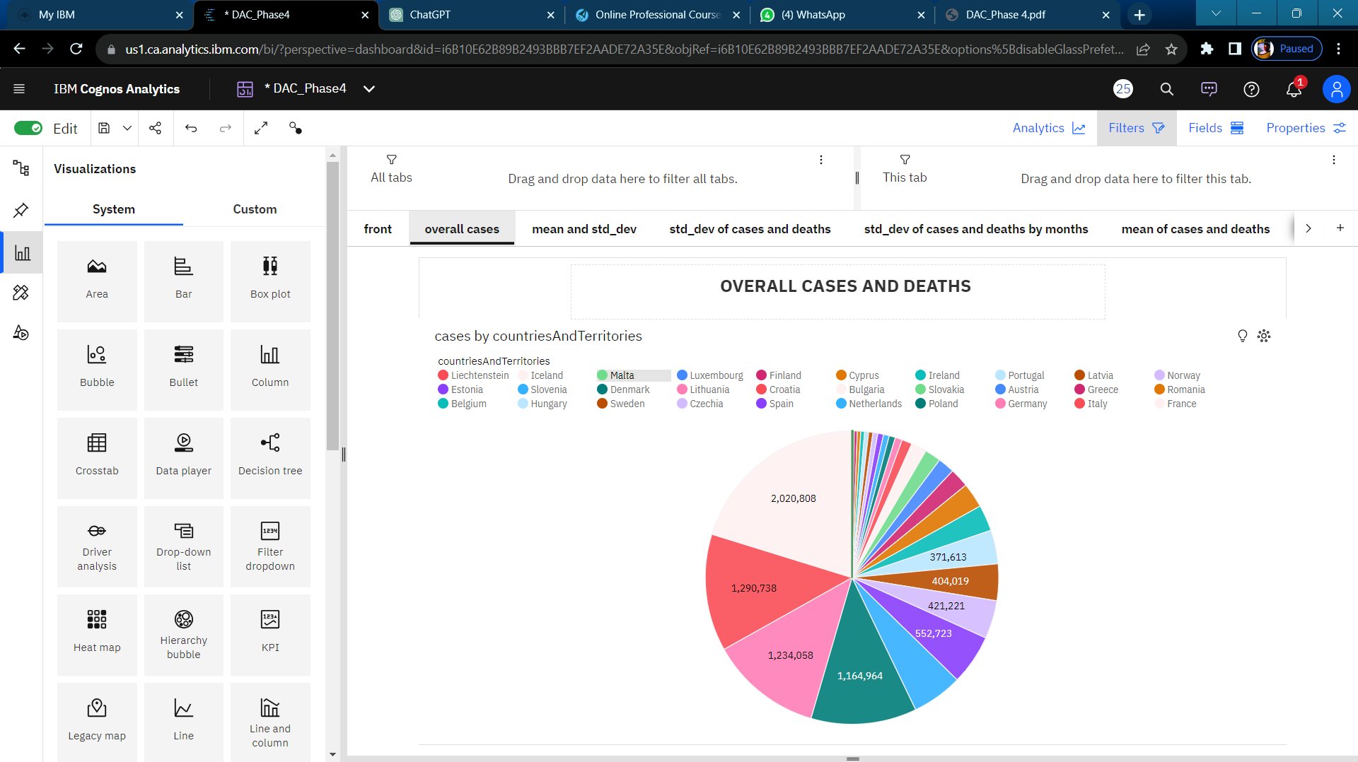

In this piechart, various countries and territories, the total number of cases of COVID-19 is significantly high, with France having the highest number of cases, exceeding 2.0 million, while Liechtenstein has the lowest, with 437 cases. Notably, on 2021-03-29 to 2021-03-30, France experienced a staggering 937% increase in cases, indicating a significant surge in infections within a short timeframe. It is projected that by 2021-06-19, France will surpass Germany in cases by more than 14 thousand, highlighting the severity of the situation in France. Overall, the cumulative cases across all countries and territories are nearing 10.0 million, underscoring the global impact of the pandemic.

**3.3.Visualisation for total Mean and Standard Deviation to analysis cases and deaths:**

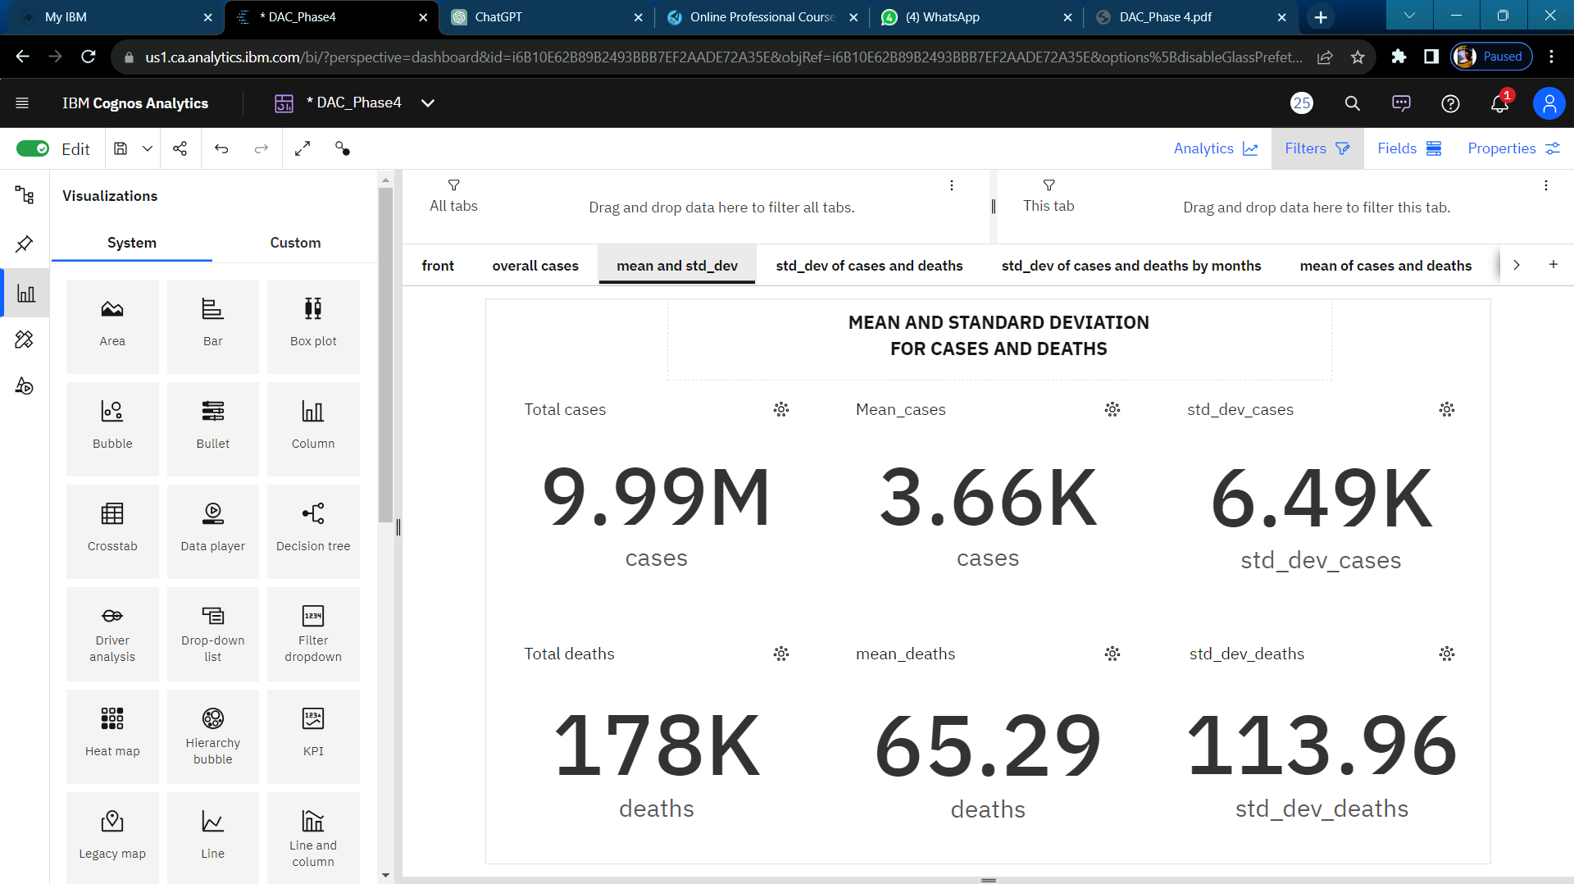

**For Cases:**

For cases, there is a noticeable strong weekly trend, with the highest values typically occurring on Thursdays and the lowest on Mondays. Additionally, there is a moderate downward trend in the number of cases. Notably, on 2021-04-06 and 2021-04-07, there were unusual spikes in cases, with a 69% increase in just one day. The lowest average cases were reported on 2021-05-25 at 953.87 and 2021-05-26 at 989.0, while the highest average cases were observed on 2021-04-01 at 6467.87 and 2021-03-26 at 6438.93. According to current forecasts, cases are expected to reach almost 1500 by 2021-06-19, and the dataset contains over 2500 results for cases.

**For Deaths:**

As for deaths, there is also a strong weekly trend, with the highest values tending to occur on Wednesdays and the lowest on Mondays. However, there is a weak downward trend in the number of deaths. On 2021-04-08, an unusually high value was reported. The lowest average deaths were recorded on 2021-05-31 at 11.87 and 2021-05-30 at 18.07, while the highest average deaths were observed on 2021-04-09 at 111.83 and 2021-04-08 at 109.77. Current forecasts suggest that deaths may reach 13.27 by 2021-06-19, and the dataset contains over 2500 results for deaths.

**For Standard Deviation:**

In the context of standard deviation, the number of cases has a deviation of 6.49k from the mean value, which is 3.66k. This indicates a relatively high variability in the number of cases. Similarly, the number of deaths shows a deviation of 113.96 from the mean of 65.29, suggesting a significant spread in the data. These values suggest that there is considerable variation in both cases and deaths, which may have implications for analyzing and managing the situation they represent.

**3.4.Visualisation for Standard Deviation of cases and deaths by months:**

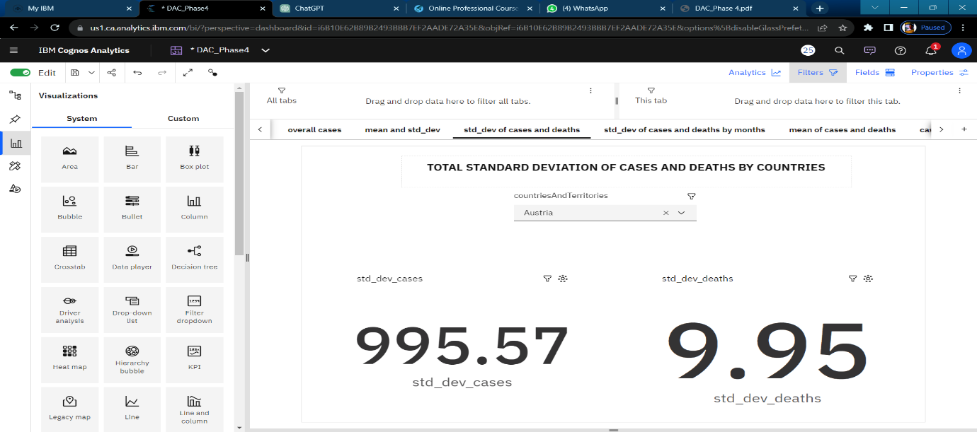

In Australia, the standard deviation for COVID-19 cases is 995.97, indicating a relatively high degree of variability in case numbers. In contrast, the standard deviation for deaths in Australia is much lower at 9.95, suggesting less variability in mortality figures. Similarly, in France, there were 13.1k cases with a standard deviation of 995.97 and 122.02 deaths with a standard deviation of 9.95, reflecting differing patterns in the spread of the virus and its impact on these two countries. Utilizing IBM Cognos, we can create a comprehensive visualization to explore and compare these statistics across various countries and territories, offering valuable insights into the COVID-19 situation worldwide.

**3.5.Visualisation for standard Deviation of cases and deaths by months:**

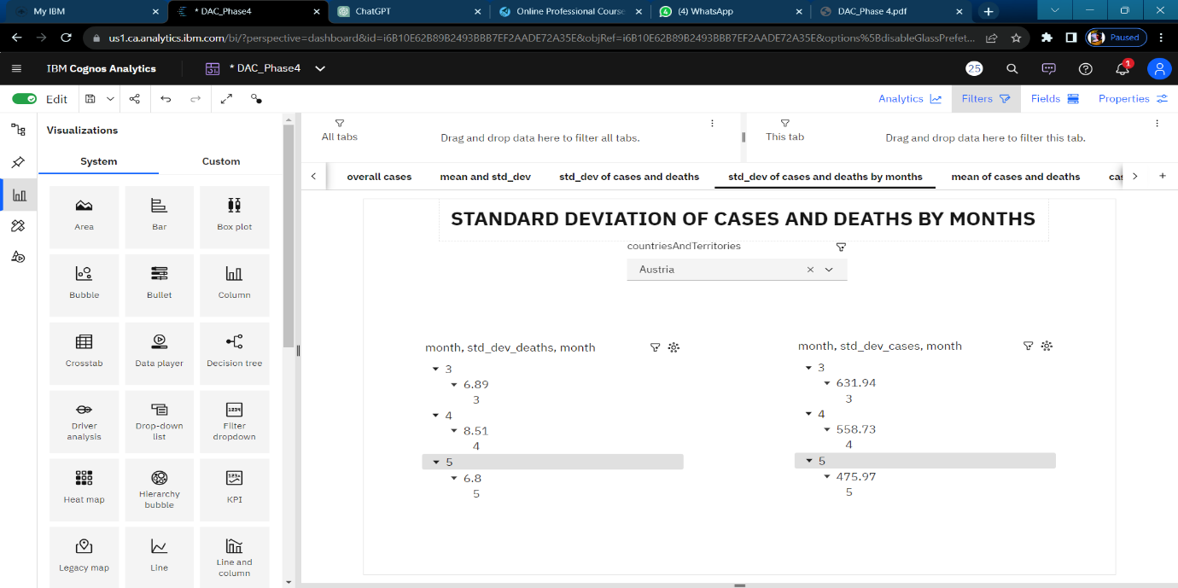

In this visualization, we can leverage IBM Cognos to conduct a detailed analysis of the standard deviation for both COVID-19 cases and deaths on a monthly basis for every country and territory. By breaking down the data into monthly increments, we gain a more granular understanding of the fluctuations in case numbers and mortality rates over time. This approach allows for the identification of trends, anomalies, and patterns that might not be apparent when examining aggregate data. Such insights can be invaluable for policymakers, healthcare professionals, and researchers in tailoring strategies and responses to the evolving dynamics of the pandemic worldwide.

**3.6.Visualisation for Mean of cases and deaths by countries:**

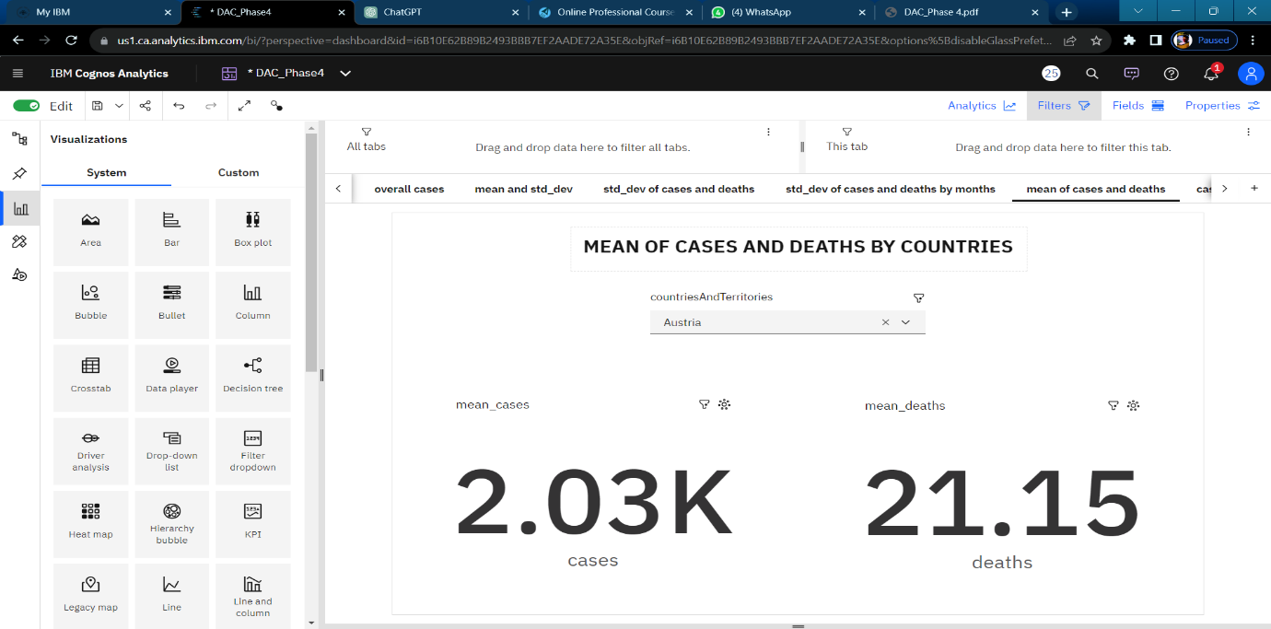

In the IBM Cognos visualization, a comprehensive analysis of COVID-19 cases and deaths reveals intriguing insights. Cases exhibit a strong weekly trend, with the highest values typically observed on Tuesdays and the lowest on Mondays. Additionally, there's a weak downward trend in cases. Notably, the dateRep for May 25, 2021, records the lowest average cases at just over 2,000, while April 7, 2021, has the highest average cases at almost 54,000.

For deaths, a moderate weekly trend is observed, with the largest values occurring on Wednesdays and the smallest on Mondays. Similar to cases, deaths also exhibit a weak downward trend. Remarkably, March 27, 2021, stands out with the highest average deaths at 897, and April 20, 2021, follows with an average of 447.

The forecasting data suggests that both cases and deaths may increase by June 19, 2021, with cases reaching over 18,000 and deaths potentially rising to 68.47. Several unusual data points are noted, particularly on March 27, 2021, for deaths and May 25, 2021, for cases. Moreover, during the period from March 27 to March 28, deaths dropped by 79%.

Overall, the IBM Cognos visualization provides comprehensive insights based on 91 data points for both cases and deaths, offering a valuable tool for understanding the dynamics of the COVID-19 pandemic.

**3.7.Visualisation for cases and deaths by months:**

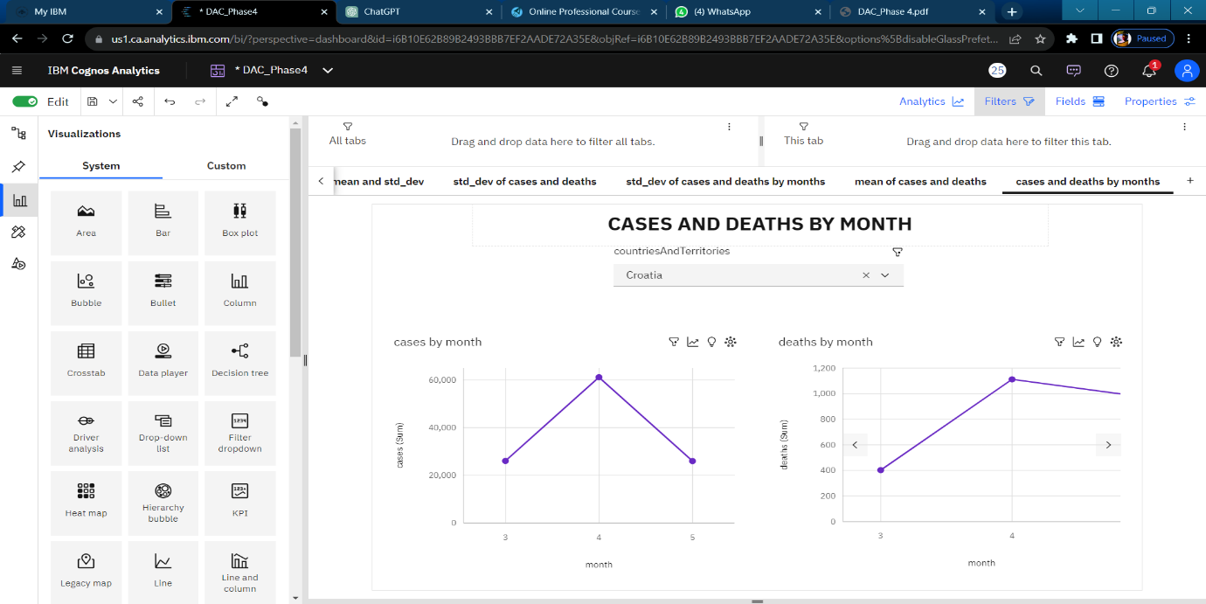

In the IBM Cognos analysis, intriguing patterns emerge when comparing monthly data for COVID-19 cases and deaths. Month 4 holds the highest total deaths but is ranked second in total cases, indicating a discrepancy between case severity and mortality. Similarly, month 3 boasts the highest total cases but is ranked second in total deaths, highlighting variations in the impact of the virus.

Across all months, the cumulative sum of cases exceeds 288,000, underscoring the significance of the pandemic's reach. Cases fluctuate, with the lowest occurring in month 5 at over 69,000, and the highest in month 3 at over 114,000. Months 3 and 4 stand out significantly in terms of cases, contributing to nearly 76% of the total.

For deaths, the collective sum across all months surpasses 2,500. Deaths range from 708 in month 5 to over a thousand in month 4, revealing variations in mortality trends. This comprehensive analysis provides valuable insights into the dynamics of COVID-19 cases and deaths across different months.

**4. Conclusion**

The COVID-19 data analysis project aims to provide actionable insights and predictions for managing the pandemic. By employing innovative strategies such as real-time data collection, automated data cleaning, advanced modeling, sentiment analysis, we seek to contribute to informed decision-making and crisis management. This comprehensive approach combines data science, epidemiology, and technology to address the challenges posed by the ongoing pandemic.