Invention Disclosure Form

Choose one: Only publication or (publication + Examination process)

1.) Please fill in your personal and contact details

The details required are for the person completing this Invention Disclosure Form. This person will be the primary contact in relation to this disclosure. It should ideally be the Principal Inventor.

Title | ResQ-Land
First Name | Dr. Pranshu
Last name | Pranjal
Institution/organization (If Organisation is Applicant) | Manipal University Jaipur
Department | B.Tech CSE (AI & ML)
Position held
Tel no. (Ext No) | -
Cell no. | +91 8979609032
Email | pranshu.pranjal@jaipur.manipal.edu

2.) How would you classify the invention?

An “invention” encompasses a new product, a new process, the composition of new material, product or process both, a machine assembly, software code, a system or an improvement of existing technology.
Software system + process innovation: A blockchain-powered land record management platform integrating smart contracts, GIS mapping, on-chain spatial collision detection, cryptographic document/boundary anchoring, and a multi-party consent transfer protocol with a time-locked challenge window.

3.) Title for the invention

The title should be broad enough to encompass both methods and compositions. The title should be short and usually contain no more than about five to ten words.
ResQ-Land: Blockchain-Based Secure Land Record Management System with On-Chain Boundary Verification and Cryptographic Anchoring

4.) Please describe the problem being solved by this invention

Please describe what challenge/problem the inventors intend to solve with this invention. Is there any alternative solution available?

Persistent problems in traditional systems:
Manual, paper-based records prone to loss, damage, and tampering
Fraudulent transactions and title disputes due to lack of reliable verification
Boundary conflicts from outdated surveys and inaccurate data
Slow, complex transfer processes (weeks or months)
Corruption risks from bribery, fake documents, and opaque procedures

Gaps in current government initiatives:
Fragmented rollout with uneven state-level adoption and poor interoperability
Legal enforceability gap: blockchain records not yet fully recognized under Registration Act, 1908
Limited GIS integration: current systems lack robust spatial verification
Court admissibility issues with digital records in litigation
Multi-stakeholder disconnect between banks, legal firms, and revenue departments
Centralization risks even in digitized systems
5.) Provide a brief description of the invention and how it works?

What is the purpose of the invention?
How does it work? (This can include the construction, the principles involved, the details of operation, and alternative methods of construction and operation, if known). Please provide results, data, flow chart, diagrams or other evidence demonstrating how the invention works.

Discuss all additional forms that you can foresee for this invention, whether or not you have evaluated them to date.

Purpose: ResQ-Land digitizes land parcels as blockchain assets and prevents duplicate registration, deed substitution, and unauthorized ownership transfers through technical mechanisms enforced at the blockchain consensus layer.

Process:
1. Boundary drawing & spatial fingerprinting: Registrant draws the parcel boundary on a GIS interface (Leaflet.js). The frontend decomposes the polygon into geohash cells using ngeohash and Turf.js, creating a spatial fingerprint.
2. Document hashing: The uploaded deed is hashed with SHA-256 in-browser before storage.
3. Boundary anchor: The frontend computes keccak256(keccak256(geohashes), documentHash, landId, ownerAddress). This anchor cryptographically binds the boundary geometry, deed, parcel ID, and owner.
4. On-chain verification: The smart contract receives the metadata, document hash, boundary anchor, and geohash array. It verifies the anchor, checks each geohash against the occupiedGeohashes mapping, and rejects on collision.
5. Multi-party transfer: Seller initiates (0.01 ETH deposit) → Buyer accepts (0.01 ETH deposit) → Verifier approves → 7-day challenge window → Ownership transfers atomically once the challenge window expires without a successful challenge.
6. Audit trail: Every registration, verification, rejection, and transfer event is emitted by the smart contract and indexed by a subgraph, providing an immutable, court-ready history.

Supporting diagrams (transfer flow and system architecture):
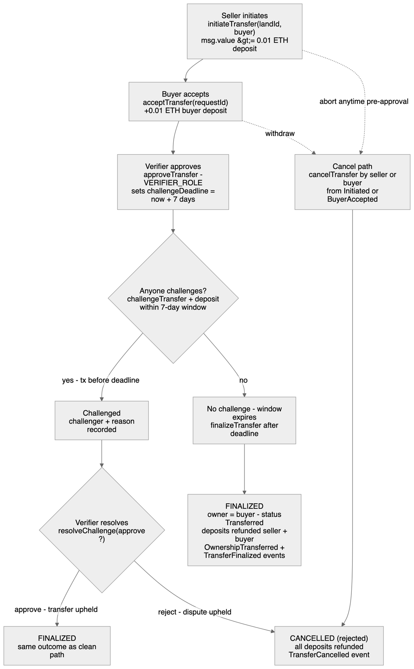
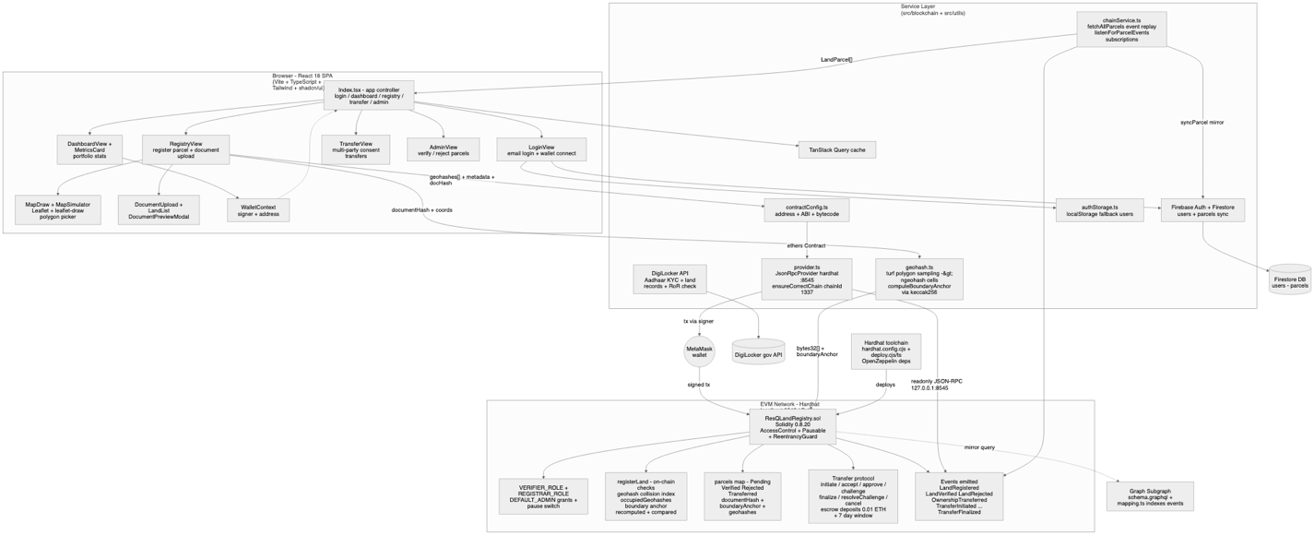

6.) Please provide a short description of the various components of the invention.

The components need to be described to disclose the type of device, material, composition, dimensions, alignments, adjustments, etc. along with the available/prospective alterations.

Blockchain network: Ethereum-compatible (Hardhat local testnet / Polygon Amoy testnet).
Smart contracts: ResQLandRegistry.sol (Solidity) — geohash collision detection, cryptographic boundary anchors, role-based access control, multi-party transfer state machine.
GIS map interface: Leaflet.js with polygon drawing; Turf.js for area calculation; ngeohash for spatial fingerprinting.
Web portal: React + TypeScript frontend, Vite build system, shadcn/ui components.
Hybrid storage: On-chain metadata/hashes/anchors; off-chain documents with cryptographic integrity checks.
Authentication: MetaMask wallet-based identity with role-based access control.
Indexing: TheGraph-compatible subgraph for event indexing and audit trails.
7.) What is a novel about the invention?

What are the new and unusual features and benefits of the invention? What makes it different from anything else?
What advantages does this invention have over existing technology (cheaper, faster, more efficient, breakthrough)?
Is the invention easy for buyers to adopt?

Novel Features:
1. On-chain geohash collision detection: The system decomposes the boundary into geohash cells and stores the mapping inside the smart contract. Any registration transaction occupying an already-used cell is rejected at the consensus layer.
2. Cryptographic boundary anchor: The frontend computes a hash binding the geohash root, deed document hash, land identifier, and owner address. The smart contract recomputes and rejects mismatches, making deed substitution and boundary tampering detectable on-chain.
3. Multi-party consent transfer with time-locked challenge window: Ownership transfer is governed by a smart-contract state machine requiring seller initiation, buyer acceptance, verifier approval, and a 7-day public challenge period before finalization.

Advantages over existing technology:
Security: Boundary conflicts prevented at the consensus layer.
Integrity: Cryptographic linkage of deed, boundary, land ID, and owner.
Trust minimization: Multi-party consensus and public challenge period required.
Admissibility: Immutable event logs provide court-ready audit trails.
8.) Are you aware of any existing methods, apparatus, or developments relating to this invention?

Provide a complete description of the closest known methods and apparatus in existence. Discuss the disadvantages or problems of each and how the present invention solves these. How is the problem that this invention addresses currently solved i.e. describe known technologies that accomplish the same or similar purpose as this invention, and/or the closest similar technology known?

US Patent 11,593,901 (Feb 2023): Smart-contract property transfer. Lacks on-chain boundary non-overlap enforcement. ResQ-Land solves this with on-chain geohash collision detection.
ISPRS Annals (Dec 2025): GIS + blockchain land records. Verification is visual/off-chain. ResQ-Land enforces the spatial index on-chain.
MDPI (Sept 2025): Hybrid on-chain/off-chain storage using IPFS. Lacks a cryptographic boundary anchor and multi-party consent protocol. ResQ-Land provides both.
Georgia Pilot (Bitfury): Bitcoin anchoring without full integration or on-chain spatial enforcement. ResQ-Land provides complete registration/verification/transfer logic with spatial enforcement.
Sweden Pilot (Lantmäteriet): Blockchain-assisted transactions with limited rollout, no challenge-period protocol. ResQ-Land adds a public challenge window with deposits.
Propy: NFT-based transfers on public chains. Privacy concerns and no on-chain boundary collision detection. ResQ-Land uses permissioned roles and on-chain spatial verification.
9.) What is the technical impact of the invention?

Does the invention represent a marginal development or a significant change? Is it revolutionary? Is it creating a new field?

This invention represents a significant change in land record validation and transfer. It is not merely a marginal digitization improvement because it moves fraud-prevention mechanisms from administrative procedure to blockchain consensus.
Specific Impacts:
Transforms manual, fragmented systems into a tamper-proof, auditable digital registry.
Bridges the gap between government digitization efforts and legal enforceability with cryptographic proofs and immutable audit trails.
Creates a new technical approach to blockchain-based land governance where boundary disputes are prevented at the consensus layer.
Enables interoperability across multiple stakeholders while preserving privacy through hash-based commitments..
Reduces fraud vectors in ownership transfer with a deposit-backed, time-locked, multi-party protocol.
10.) What are the invention’s limitations or disadvantages?

Describe any problems, limitations or disadvantages that you have already encountered or anticipate encountering in the future (These may include problems with the technology, e.g. design issues, regulatory issues, bottlenecks in the development cycle, etc. or commercialization issues, e.g. costly to implement, difficult to manufacture, small market etc.). Can they be overcome? If so, how?

Legal recognition: Blockchain records not yet fully recognized under Indian property law. Mitigation: pilot testing with local authorities and parallel registration.Initial costs: Infrastructure setup and stakeholder training may be resource-intensive. Mitigation: cloud deployment and incremental rollout.
Survey data dependency: Accuracy depends on reliable GIS and survey inputs. Mitigation: integration with government survey datasets and ground-truthing.
Scalability: Nationwide rollout requires government collaboration and phased integration. Mitigation: state-by-state pilots and interoperability standards.
Gas costs: On-chain geohash storage and the multi-step transfer protocol incur fees. Mitigation: deployment on low-cost L2s or permissioned sidechains.
Geohash approximation: Small/irregular parcels may require higher precision, increasing storage cost. Mitigation: adjustable precision with a maximum 200 geohash cap per parcel.
11.) What is the present stage of technical development?

Describe the invention’s development status.
- Is it theoretical i.e. just an idea (initial concept of invention, with no supporting data)?
- Has there been proof of concept (sufficient experimental data to show that your idea is valid)?
- Is it at design stage?
- Is it prototype ready?
- Has a prototype been produced?
- Has it been laboratory tested?
- Is it ready for testing / trial?

1. Proof of concept: Smart contract compiles; frontend builds successfully
2. Design stage: Architecture, data flow, and state machine finalized
3. Prototype ready & produced: Functional prototype developed and tested on local Hardhat Ethereum testnet
4. Laboratory tested: Solidity contract compiled; React/TypeScript frontend built; individual functions implemented and ready for integration testing
5. Ready for testing/trial: Prototype ready for deployment on Polygon Amoy testnet for user acceptance testing with local authorities
Overall Development Status: Technology Readiness Level 4-5 (technology validated in a relevant environment)
12.) Prior Art Assistance*
Please provide the key inventive features with their attributes/limitations.
Please suggest keywords for search.
Please mention if there are certain specific values attributable to the invention [for example: process is feasible at 70-80 degree Celsius; the angle of inclination in optical invention is 34-45 degree is feasible; dosage of novel formulation is 10mg/day against 15mg/day in other formulation]
Key Inventive Features:
1. On-chain geohash collision detection (geohash precision 8; max 200 cells/parcel) — prevents double-registration at the consensus layer
2. Cryptographic boundary anchor (keccak256; binds geohash root + document hash + land ID + owner address) — verifiable on-chain
3. Multi-party consent transfer with challenge window (7-day window; 0.01 ETH deposit per party) — state-machine protocol with seller, buyer, verifier, challenger roles

Suggested Keywords for Prior Art Search:
geohash collision detection smart contract, on-chain spatial index land registry, cryptographic boundary anchor blockchain, deed hash boundary polygon ancho, multi-party consent transfer smart contract, challenge window ownership transfer blockchain, time-locked land transfer Ethereum, blockchain land registry Section 3(k) India

Specific Technical Values:
Geohash precision: 8 characters per cell
Maximum geohashes per parcel: 200 cells
Challenge window duration: 7 days
Required deposit per active party: 0.01 ETH
Document hash algorithm: SHA-256
Anchor hash algorithm: keccak256
Smart-contract language: Solidity 0.8.20
Blockchain target: Ethereum-compatible (Hardhat local / Polygon Amoy)
Signatures
Each inventor must sign below.

Each inventor named must sign and print his/her full name and the date in the space provided. The first signature should be that of the person completing this Invention Disclosure.

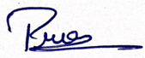
Signature.......................................... Print name: Pranesh Nikhar Date: 11/09/26

Signature.......................................... Print name: Date: Pranshu Pranjal Date: 11/09/26

Signature.......................................... Print name: Bhupathiraju Vijaya Bhaskarraju Date: 11/09/26
Signature.......................................... Print name: Virat Ghatge Date: 11/09/26

APPLICANT | MANIPAL UNIVERSITY JAIPUR
INVENTOR |  | Name | Gender | Nationality | Address
INVENTOR | 1st | Pranshu Pranjal | Male | Indian
 | 2nd | Pranesh Nikhar | Male | Indian | Mumbai, Maharashtra
 | 3rd | Virat Ghatge | Male | Indian | Pune, Maharashtra
 | 4th | Bhupathiraju Vijaya Bhaskarraju | Male | Indian | Visakhapatnam,Andhra Pradesh

