DIODE WATCH
Passive, One-Way Threat Detection for Critical-Infrastructure Enclaves
Presentation Content — Pages 1 to 4
PAGE 1

Proposed Solution

1. Detailed Explanation of the Proposed Solution
Diode Watch is a working prototype of an AI/ML pipeline that watches one-way network traffic through a data diode and detects cyber-attacks — without ever sending a single packet back.
Critical infrastructure — power grids, water systems, banks, hospitals, telecoms — is monitored at its gateway through a hardware data diode: a one-way mirror for network traffic. It copies everything crossing the link into a secure monitoring enclave, but nothing can ever be sent back through it. This removes an entire class of attack in which a compromised monitoring computer becomes a ladder back into the real network, and it preserves a clean, tamper-proof record of evidence for forensic investigation.
Diode Watch lives entirely inside that monitoring enclave and does its whole job using only what it can passively see: flow records (NetFlow/IPFIX/sFlow), DNS query metadata, and TLS handshake metadata. It cannot ping a host, complete a handshake, or block anything — it can only observe, reason, and report. The pipeline ingests a one-directional stream of IP flow records in near real time and detects, classifies, and scores six families of cyber threats:
- Volumetric / protocol DDoS attacks (SYN floods, UDP amplification, spoofed floods)
- Botnet command-and-control (C2) beaconing
- DGA-generated domains and DNS tunnelling
- Malware hidden inside encrypted (TLS/QUIC) traffic
- Reconnaissance and port scanning
- Data exfiltration
Every detection is emitted as a standardized, versioned JSON alert — threat class, severity, confidence score, and supporting evidence — and streamed live to a React dashboard, so a human analyst can act on the intelligence. This division of labour is deliberate: Diode Watch produces intelligence, humans produce action.

2. How It Addresses the Problem
The brief calls for a prototype that ingests a one-directional stream, detects and scores six threat families in near real time, uses only passively collected data with no return path, outputs labelled alerts with evidence, and meets a stated and measured throughput target. Diode Watch satisfies every one of these constraints structurally, not just procedurally:
- Read-only ingest — the engine never opens a socket toward any observed IP; there is no code path capable of sending traffic back.
- No payload decryption — TLS/QUIC sessions are analysed purely from metadata (JA3 fingerprints, message sizes, certificate depth, timing); the codebase contains no decryption logic at all.
- Streaming, not batch — a single asyncio loop processes flows incrementally with sliding windows and bounded, sub-millisecond latency — there are no end-of-run reports.
- Standardized, evidence-carrying alerts — every alert is a versioned record with timestamp, threat class, severity, confidence, and the exact features that fired, auditable by a forensic analyst.
Because the one-way guarantee is enforced in code — the only outbound call anywhere in the system is an optional internal webhook to n8n — it is structurally impossible for the enclave to “ping back,” rather than merely a design intention.

3. Innovation and Uniqueness of the Solution
- Self-verifying evaluation — the simulator writes ground-truth labels to a stream the detection engine never reads. An independent evaluator matches alerts against real attack episodes and computes precision, recall, and F1 live on the dashboard. The system's accuracy is proven by construction, not claimed.
- Hybrid heuristics + ML by design — classical thresholds carry precision on known attack shapes; three trained models (a logistic-regression DGA classifier and two unsupervised IsolationForest anomaly detectors) add coverage for novel attacks; a drift monitor auto-retrains the models — a complete MLOps loop running entirely inside a network that is deliberately cut off from the internet.
- Malware detection without decryption — encrypted-session malware is caught using only JA3 TLS fingerprints and handshake metadata, never the payload.
- Engineering judgement over benchmark-chasing — logistic regression was deliberately chosen over a higher-scoring LightGBM model because it is roughly five times faster per call in a streaming loop that cannot batch inference — a measured latency-versus-accuracy trade-off, documented rather than hidden.
- Fully self-contained and reproducible — 100% open-source (MIT), runs with a single Docker Compose command on free-tier tools, and ships with 32 passing unit tests.
Figure 1 — The one-way constraint: traffic mirrors into the enclave; nothing can travel back.

PAGE 2

Technologies to Be Used

1. Technology Stack
Programming languages, frameworks and infrastructure, and the reasoning behind each choice:
Component | Technology / Choice | Why it was chosen
Languages | Python 3.12 (engine, simulator, ML) · JavaScript/TypeScript (frontend) | Fast async I/O for streaming; rich ML ecosystem; component-based UI for a live dashboard
Transport | Redis Streams + consumer groups | Durable, ordered delivery; XREADGROUP/XACK give at-least-once semantics; lets engine workers scale horizontally with zero code changes
ML / stats | scikit-learn (Logistic Regression, IsolationForest), LightGBM + SHAP (offline reference) | Sub-millisecond inference for streaming; LightGBM kept offline for feature-importance analysis only
Alert storage | TimescaleDB (PostgreSQL 16) hypertable | Time-series optimised; fast indexed queries on (threat_class, time) and (severity, time)
Backend API | FastAPI + WebSockets | Typed, async, and the built-in event loop matches the streaming nature of the problem
Frontend | React + Vite + Recharts | Fast to build; live-updating charts; easily demonstrable to judges
Orchestration | n8n | Visual, importable JSON workflows for alert routing and scheduled/drift-triggered retraining — no custom scheduler code
Observability | Prometheus + Grafana | Standard scrape-based metrics; engine exposes /metrics for live throughput and drift values
Packaging | Docker Compose | One command brings up the entire stack; fully reproducible demo

Hardware / Deployment Context
- Designed to run on the monitoring-enclave side of a hardware data diode, alongside the production data-diode appliance.
- Horizontally scalable: Redis consumer groups allow additional engine workers to be added with zero code changes, and TimescaleDB hypertables scale alert storage by time — giving the prototype a credible path to production hardware scale.

2. Methodology and Process for Implementation
The pipeline follows a clear, verifiable sequence from traffic generation to live-scored evaluation:
- Step 1 — Simulation Lab: generates realistic, labelled synthetic traffic (benign flows plus eight attack campaigns) and writes ground-truth labels to a side-channel stream.
- Step 2 — One-way ingest: flows travel over Redis Streams into the Detection Engine; the ground-truth stream travels separately and is never read by the engine.
- Step 3 — Warmup: the engine observes ~180 seconds of benign-only traffic to learn its own baseline for the unsupervised models — no labels, no internet, fully self-contained.
- Step 4 — Detection: every flow updates a shared sliding-window store and is scored in the same pass by six stateful heuristic detectors and three ML models.
- Step 5 — Alerting: alerts are deduplicated and fanned out to TimescaleDB, the live dashboard (via WebSocket), and n8n for CRITICAL/HIGH-severity routing.
- Step 6 — Drift & retrain: a Population Stability Index (PSI) monitor watches the DGA feature distribution and automatically retrains in under a second when real-world drift is detected.
- Step 7 — Evaluation: an independent evaluator compares alerts against the hidden ground-truth stream and computes live precision, recall and F1 on the dashboard.
Current status: a working end-to-end prototype, all six threat families implemented and covered, 32/32 automated unit tests passing, and the full stack reproducible with one Docker Compose command.
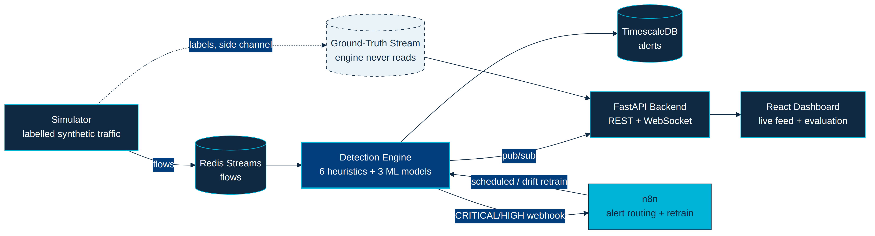
Figure 2 — End-to-end architecture and data flow, including the isolated ground-truth side channel.

PAGE 3

Feasibility, Challenges and Risk Mitigation

1. Analysis of Feasibility
- Proven, not theoretical — this is a working end-to-end prototype that runs live end-to-end, not a concept diagram. It processes real streaming flows and passes 32 automated unit tests covering detectors, features, windows, alerts and the simulator.
- Self-contained by construction — all three ML models train from bundled corpora or the engine's own warmup traffic in under a second, with no external services, internet access, or vendor feeds required — essential for a network deliberately cut off from the outside world.
- Verifiable, not asserted — because ground truth is isolated on a stream the engine never reads, the live precision/recall/F1 numbers shown on the dashboard are evidence the detector cannot have cheated to produce.
- Performance is measured, not assumed — sustained throughput of ~1,300–1,600 flows/sec against a stated target of 2,000 flows/sec, with the current bottleneck already identified and a documented path to closing the gap.

2 & 3. Potential Challenges and Strategies for Overcoming Them
Challenge / Risk | Mitigation Strategy
Legitimate periodic traffic (NTP, keepalives) can resemble C2 beaconing | SYN-only exclusion added to the beacon pre-filter so floods and simple periodic protocols cannot masquerade as C2
DGA classifier flagged rare-but-valid domains as malicious | Kept all observed benign trigrams and raised the alert threshold from 0.65 to 0.80 — eliminating false positives while keeping ~99.6% DGA recall
Sustained throughput (~1,500 flows/sec) is below the 2,000 flows/sec target | Bottleneck identified as per-flow IsolationForest scoring on TLS traffic; Redis consumer groups already allow horizontal scaling with zero code changes
Real-world DGA families and traffic will drift from the synthetic training data | Built-in PSI drift monitor auto-triggers in-process retraining (under 1 second) the moment real distribution shift is detected
Slow-rotating spoofed sources / slow scans below detection windows | Documented as a known edge case in the project's own threat model; thresholds are tunable per deployment scale
Chunky legitimate uploads (backups, sync) resemble exfiltration signatures | A per-source EWMA baseline learns each host's normal transfer size online, reducing false positives from bulk-but-benign transfers

The team's approach to risk is transparency-first: every known limitation is documented in the project's own threat model rather than hidden, and a measured number (“we sustain ~1,500 flows/sec against a 2,000 target”) is treated as more credible — and more fixable — than an unverified claim.
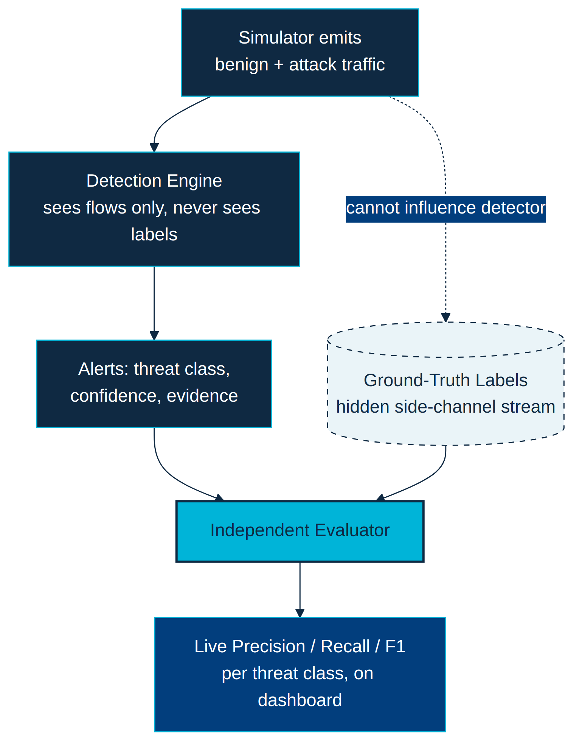
Figure 3 — The honest-evaluation loop that makes the feasibility claim verifiable rather than asserted.

PAGE 4

Potential Impact and Benefits

1. Potential Impact on the Target Audience
The target audience is security operations teams and analysts protecting critical infrastructure — power grids, water treatment, transport, financial networks, hospitals and telecoms — that already rely on data-diode architectures for their monitoring enclaves.
- From blind-but-safe to intelligent-and-safe — Diode Watch turns a monitoring enclave that previously produced only a tamper-proof but uninterpreted packet/flow archive into one that actively raises labelled, evidence-backed alerts with confidence scores in near real time.
- Human analysts stay in control — because the output is intelligence rather than automated blocking, the human analyst remains the one who acts — matching the operational and regulatory reality of critical-infrastructure teams, which require human sign-off before any response action.

2. Benefits of the Solution
Category | Benefit
Social | Earlier detection of attacks on power, water, healthcare and financial systems reduces the risk of service outages that directly endanger public wellbeing and safety.
Economic | 100% open-source (MIT) and built entirely on free-tier tools in Docker Compose, so smaller utilities and operators who cannot afford commercial intrusion-detection suites can deploy credible AI-assisted monitoring at near-zero licensing cost.
Security & Resilience | Preserves the core security guarantee of the data diode — no return path, tamper-proof chain of custody for forensic and legal use — while adding the missing piece: actual intelligence, without weakening the one-way isolation operators depend on.
Trust & Transparency | Accuracy is proven live against hidden ground truth rather than asserted; every alert carries a full evidence trail, supporting forensic and regulatory review.
Educational | A fully documented architecture, model cards, and an honest account of failures and fixes make the project a reusable reference for other teams building ML systems inside constrained, network-isolated environments.
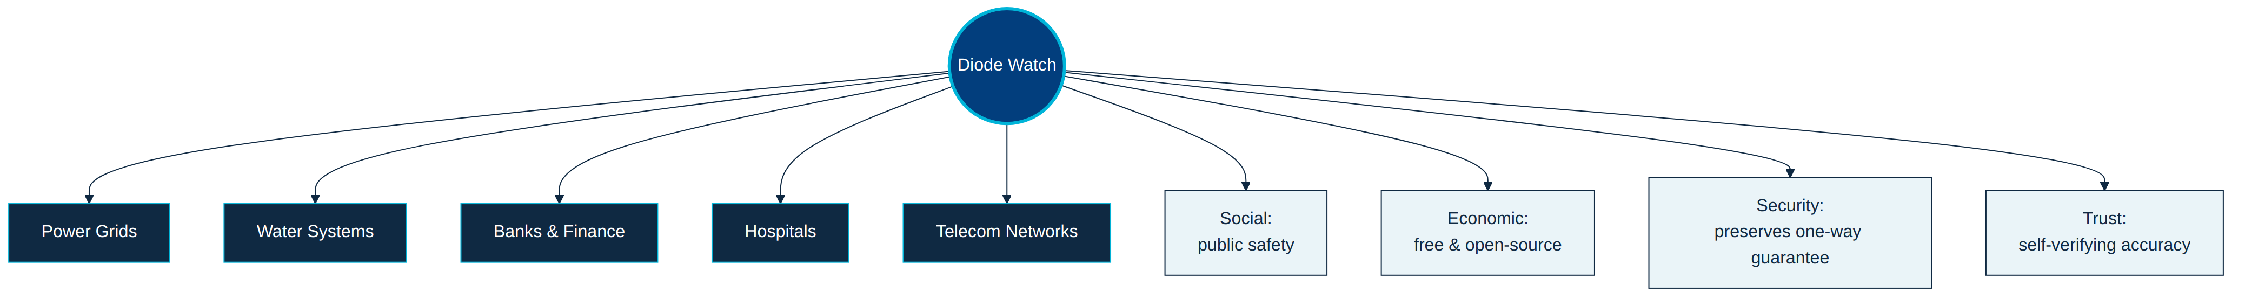
Figure 4 — Diode Watch's reach across critical-infrastructure sectors and benefit categories.

