**7145-United Institute of Technology**

**Cloud Application Development**

**Image Recognition with IBM cloud Visual Recognition**

Team Members:

1.Jafeen Afthar N - 714521104018

2.Karthick Kumar G - 714521104021

3.Pranesh M - 714521104034

4.Sanjana K - 714521104044

5.Shyam J - 714521104048

6.Sulfeekar Thottakkot - 714521104050

7.Swathi J - 714521104051

**Problem Statement** : The project involves creating an image recognition system using IBM Cloud Visual Recognition. The goal is to develop a platform where users can upload images, and the system accurately classifies and describes the image contents. This will enable users to craft engaging visual stories with the help of AI-generated captions, enhancing their connection with the audience through captivating visuals and compelling narratives.

**Design thinking:**

**Step 1: Image recognition Setup:**

select the AI category from the left pane, and then select the Visual Recognition resource.

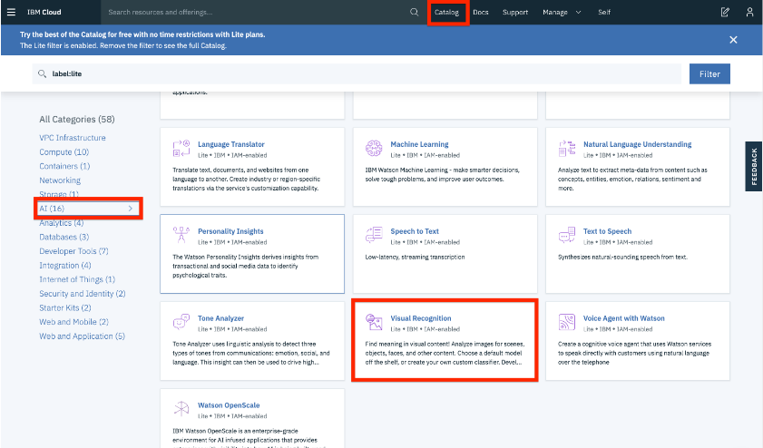

Then scroll down and make sure that the lite plan is selected, and click the Create button.

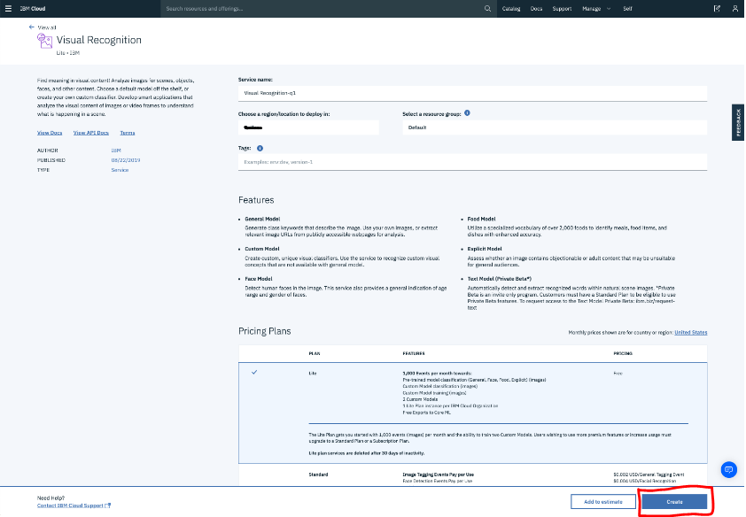

**Step 2: User Interface:**

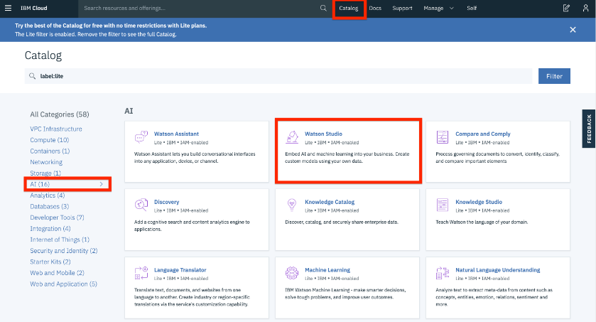

**Step 3: Image Classfication to start using Watson Studio:**



**Step 4: Create a Project of image recognition:**

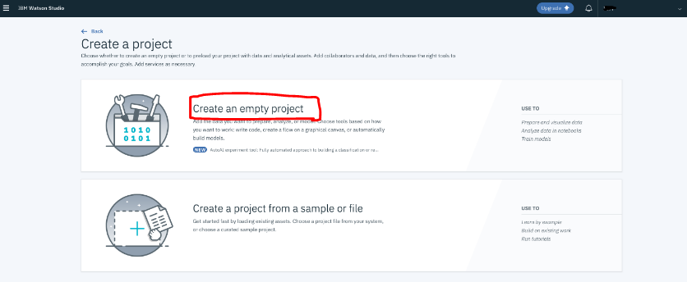

**Step 5: AI Generated Captions:**

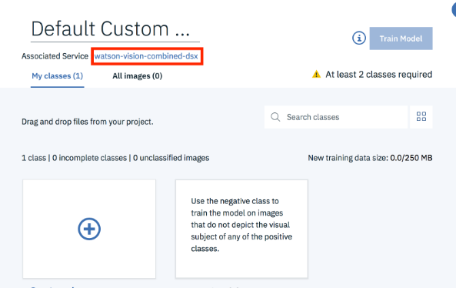

**Step 6: Upload Your Images**

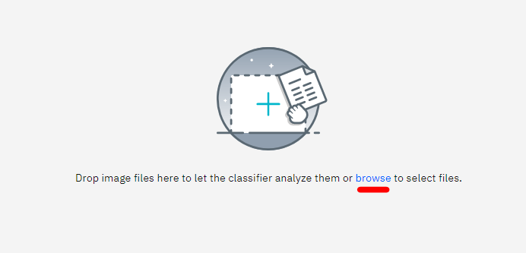

**Step 7: Check Out the Results ( User Engagement )**



**Conclusion**

This project is aims to develop into big data analysis using IBM Cloud image recognition. The objective is to extract climate trends to social images. The project includes designing the visual process, setting up IBM Cloud Databases, performing data analysis, and visualizing the results for business intelligence. By following this structured approach, we will develop a highly effective and user-friendly virtual guide that meets the project’s objectives.

**Image Recognition with IBM Cloud Visual Recognition**

**Phase 2:**

Consider incorporating sentiment analysis to generate captions that capture the emotions and mood of the image

**Innovation**

Enhancing Image Captions with Sentiment Analysis

**Introduction**

In today's digital age, the combination of visual content and textual descriptions plays a crucial role in conveying emotions and moods associated with images. Incorporating sentiment analysis into image caption generation can greatly enhance the contextual understanding and emotional resonance of the captions. This document outlines a step-by-step approach to achieve this integration, resulting in captions that effectively capture the emotions and mood depicted in images.

**Steps to Incorporate Sentiment Analysis into Image Captions**

1. **Image Analysis**

Begin by conducting an in-depth analysis of the image. Utilize computer vision techniques to identify objects, scenes, and other visual elements within the image. This preliminary analysis will provide essential contextual information for the subsequent sentiment analysis.

2. **Sentiment Analysis**

Apply a sentiment analysis model to assess the emotional tone of the image. Sentiment analysis models are capable of categorizing text or visual content into sentiment categories such as positive, negative, or neutral. Popular pre-trained models like BERT, GPT, or specialized sentiment analysis models can be employed for this purpose.

3. **Combining Visual and Sentiment Analysis**

Integrate the outcomes of both the image analysis and sentiment analysis. By merging these two sources of information, you can create a comprehensive understanding of the image's content and emotional context. For instance, if the image analysis identifies a person smiling, and the sentiment analysis indicates a positive sentiment, you can confidently conclude that the mood is cheerful.

4. **Caption Generation**

Utilize the combined analysis to generate captions that encapsulate the emotions and mood of the image. These captions should be descriptive, engaging, and convey what is happening in the image, along with the associated emotional tone.

5. **Natural Language Generation (NLG)**

To automatically generate captions, employ Natural Language Generation techniques. This can involve creating custom NLG models or utilizing pre-trained models like GPT-3. These models can generate human-like captions based on the results of image and sentiment analysis.

6. **Fine-tuning**

Fine-tune your caption generation model to ensure that the generated captions are contextually relevant and accurately represent the sentiment of the image. Create a dataset containing images, human-generated captions, and associated sentiments for this purpose.

7. **Testing and Evaluation**

Continuously test and evaluate your model's performance. Collect feedback from users to ensure that the generated captions effectively convey the emotions and mood of the images. Iterate and refine your model as needed.

8. **Deployment**

Once you are satisfied with the performance of your model, deploy it within your application or platform. This will enable automatic caption generation for images, enhancing the user experience.

9. **User Customization**

Consider allowing users to customize the level of sentiment expression in captions. Some users may prefer captions that are more factual, while others may desire captions that emphasize emotions. Providing this flexibility can enhance user satisfaction.

10. **Ethical Considerations**

Always be mindful of ethical considerations when implementing sentiment analysis. Ensure that the analysis does not reinforce biases or misinterpret emotions in a way that could be offensive or harmful to users.

**Conclusion**

Incorporating sentiment analysis into your image captioning system represents a powerful approach to provide contextually relevant and emotionally engaging captions for images. By following these steps, you can enhance the overall user experience and create a more immersive connection between visual content and textual descriptions.

**Phase 3 Submission Document**

**Development Part 1**

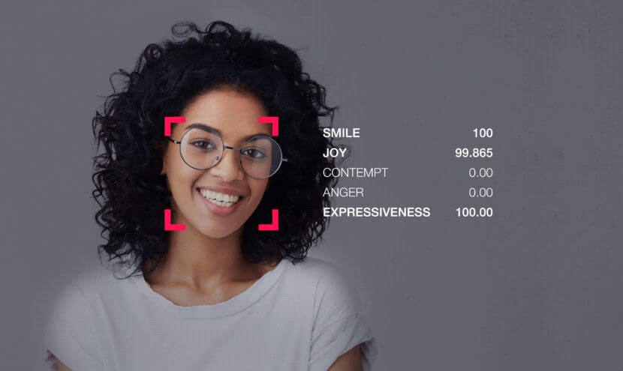

**Introduction:**

* In this phase of our image recognition project, we will be focusing on creating the user interface (UI) that allows users to interact with our AI-powered image recognition system.
* We will utilize HTML, CSS, and JavaScript to craft a visually appealing and user-friendly frontend that enables users to upload images and view the captions generated by our AI model.

**Project Context:**

* Our goal is to build a simple and intuitive web application that makes image recognition accessible to users.
* By leveraging the power of artificial intelligence, our system will provide descriptive captions for images, enhancing accessibility and understanding.

**Part 1 Objectives:**

**1.HTML Structure:**

We'll create an HTML structure that defines the layout of our web page. This structure will include components for image upload, caption display, and user interactions.

**2.CSS Styling:**

CSS will be used to style our interface, ensuring it's visually appealing, responsive, and aligns with our project's branding and usability standards.

**3.JavaScript Functionality:**

JavaScript will add interactivity to the UI. It will enable us to handle user actions, such as uploading images, and facilitate communication with the backend for image processing.

**Development Part 1:**

**HTML code:**

<!doctype html>

<html lang="fr">

<head>

<title>Emotion Recognition</title>

<link rel="stylesheet" href="../staticFiles/index.css" type="text/css">

</head>

<body>

<h1>Emotion Recognition</h1>

<div class="container">

<div class="left">

<p id="clock">no faces found</p>

<script>

const clock = document.getElementById("clock");

setInterval(() => {

fetch("{{ url_for('time_feed') }}")

.then(response => {

response.text().then(t => {

clock.innerHTML = t

})

});

}, 10);

</script>

</div>

<div class="right">

<div class="col-lg-8 offset-lg-2">

<img src="{{ url_for('video_feed') }}" height="80%" alt="please wait...">

</div>

</div>

</div>

</body>

</html>

**Description:**

**<!doctype html>:**

This declaration defines the document type as HTML5, indicating that the page follows modern HTML standards.

**<html lang="fr">:**

This opening tag specifies that the document is written in French (the "fr" language code). This helps search engines and browsers understand the language of the content.

**<head>:**

Within the head section, metadata and links to external resources are typically placed.

**<title>Emotion Recognition</title>:**

This sets the title of the web page, which is displayed in the browser's title bar or tab. In this case, the title is "Emotion Recognition."

**<link rel="stylesheet" href="../staticFiles/index.css" type="text/css">:**

This line links an external CSS stylesheet to the HTML document. The stylesheet is located at **"../staticFiles/index.css**" and is used to style the content of the web page.

**<body>:**

This is the main content area of the web page.

**<h1>Emotion Recognition</h1>:**

This is the main heading of the page, displaying "Emotion Recognition" as the title at the top of the web page.

**<div class="container">:**

This is a container that likely helps structure the content and layout of the page.

**<div class="left">:**

This div contains content that appears on the left side of the page.

**<p id="clock">no faces found</p>:**

This paragraph element with the ID "clock" initially displays "no faces found." It is likely intended to display real-time information.

The following JavaScript code updates the content of the "clock" element at regular intervals. It appears to fetch data from a URL (presumably related to time or real-time data) and updates the "clock" element with the fetched data. The fetch request is sent every 10 milliseconds.

**<div class="right">:**

This div contains content that appears on the right side of the page.

**<div class="col-lg-8 offset-lg-2">:**

This div is part of a grid or layout system (likely from a CSS framework like Bootstrap). It has a specific width ("col-lg-8") and offset ("offset-lg-2").

**<img src="{{ url_for('video_feed') }}" height="80%" alt="please wait...">:**

This image element displays an image sourced from the URL generated by the url_for('video_feed') Flask function. The image has a specified height of 80%, and the alt text is "please wait...," which is displayed if the image cannot be loaded or is still loading.

**CSS CODE:**

.container{

display: inline-flex;

width: 90%;

margin-left:5%;

margin-right:5%;

}

html{

background-color:#161a1b;

}

.left{

float: left;

background-color: lightgray;

width:30%;

padding:4%;

font-size:220%;

}

.right{

border:none;

float: right;

width:70%;

text-align: center;

}

.right img {

width:100%;

}

h1{

text-align: center;

color:white;

}

**Description:**

**.container:**

This CSS class is used to style a container element.

**display: inline-flex;:**

It sets the display property to "inline-flex," which makes the container an inline-level flex container. This allows its child elements to be displayed in a row, and they will adjust their sizes based on content.

**width: 90%;:**

The container occupies 90% of the available width of its parent element.

**margin-left: 5%; and margin-right: 5%;:**

These properties set left and right margins to 5%, which create spacing on the left and right sides of the container.

**html:**

These styles are applied to the <html> element, affecting the entire web page.

**background-color: #161a1b;:**

It sets the background color of the HTML element to a dark grayish color (#161a1b).

**.left:**

This class is used to style the left part of the content.

**float: left;:**

The "left" content is floated to the left side of its containing element. This allows the content on the right to flow around it.

**background-color: lightgray;:**

The background color of the left content is set to light gray.

**width: 30%;:**

The left content takes up 30% of the available width.

**padding: 4%;:**

It adds a 4% padding on all sides of the left content, creating spacing between the content and its container.

**font-size: 220%;:**

The font size for the left content is set to 220% of the default font size, making it quite large.

**.right:**

This class is used to style the right part of the content.

**border: none;:**

It removes the border from the right content.

**float: right;:**

The "right" content is floated to the right side of its containing element, allowing it to sit next to the left content.

**width: 70%;:**

The right content takes up 70% of the available width.

**text-align: center;:**

Text within the right content is centered horizontally.

**.right img:**

This selector targets <img> elements within the "right" content.

**width: 100%;:**

Images within the "right" content are scaled to occupy the full width of their container.

**h1:**

This selector targets <h1> elements.

**text-align: center;:**

The text in <h1> elements is centered horizontally.

**color: white;:**

The text color of <h1> elements is set to white.

**JS code:**

const clock = document.getElementById("clock");

setInterval(() => {

fetch("{{ url_for('time_feed') }}")

.then(response => {

response.text().then(t => {

clock.innerHTML = t

})

});

}, 2000);

**Description:**

**const clock = document.getElementById("clock");:**

This line retrieves an HTML element with the ID "clock" and stores it in a JavaScript variable called "clock." This element is likely a part of the webpage where you want to display real-time data, such as a clock or timestamp.

**setInterval(() => {...}, 2000);:**

This is a JavaScript function that repeatedly executes the provided code block at the specified interval in milliseconds. In this case, the code block is executed every 2000 milliseconds (2 seconds).

**fetch("{{ url_for('time_feed') }}"):**

Inside the interval function, a "fetch" request is made to a URL generated using Flask's url_for function with the endpoint "time_feed." The purpose of this request is to retrieve some real-time data, possibly a timestamp or clock data, from the server.

**.then(response => {...}):**

This is a promise that handles the response from the fetch request. It specifies what to do when the response is received.

**response.text().then(t => { clock.innerHTML = t });:**

This part of the code processes the response from the server. It converts the response to text and then updates the content of the HTML element with the ID "clock" (as stored in the "clock" variable) with the text received from the server. This action effectively updates the displayed content with the real-time data obtained from the server.

**Conclusion:**

By focusing on the frontend development in Part 1, we aim to provide users with an engaging and easy-to-use interface that seamlessly integrates with the backend, where our image recognition model does the heavy lifting. The result will be a user-friendly image recognition application that empowers users to understand and describe images with ease.

**Phase 4 Submission Document**

**Development Part 2**

**Introduction:**

* In this second development phase, we venture into the integration of face detection and emotion recognition, forming a comprehensive image recognition system.
* At the heart of this endeavor lies the "Haar Cascade Classifier," a cutting-edge technology in computer vision primarily designed for detecting frontal faces within images.
* Its role in identifying and locating faces is pivotal, providing a foundation for subsequent emotion recognition tasks.
* The phase also involves a series of code snippets designed to facilitate the development of this system.
* It begins with the preparation of a machine learning model for facial emotion recognition, configuring data generators, creating and fine-tuning the deep learning model, and preparing it for training.
* Users have the option to select from a range of pre-trained deep learning models for emotion recognition, each with its unique architecture.
* The training and evaluation process monitors the model's performance, with early stopping mechanisms and insightful visualizations of accuracy and loss.
* Additionally, the option to save the trained model and associated performance metrics adds a layer of practicality to this multifaceted image recognition project.
* This phase bridges the world of face detection and emotion recognition, offering a comprehensive solution for image analysis and understanding.

**Data Sources and Setup**

Before running the scripts for the image recognition project, it's crucial to set up the required datasets. This document provides an overview of the datasets used in our project and how to obtain them.

**Datasets:**

**CK+ (Cohn-Kanade Extended+):**

**Source:**

<https://www.kaggle.com/datasets/shawon10/ckplus>

Description: The CK+ dataset contains facial expressions captured in lab-controlled environments. It includes seven different emotion labels, making it suitable for training and testing emotion recognition models.

**FER-13 (Facial Expression Recognition 2013):**

**Sources:**

<https://www.kaggle.com/datasets/msambare/fer2013>

<https://www.kaggle.com/datasets/deadskull7/fer2013>

Description: The FER-13 dataset is a collection of images representing facial expressions. It contains various emotional states, enabling comprehensive training and testing for emotion recognition.

**FERPlus:**

Source:

<https://github.com/microsoft/FERPlus>

Description: FERPlus is an extension of the FER-13 dataset, providing a more refined annotation of emotions. It includes additional labels, offering improved granularity in emotion recognition.

**Data Setup:**

To run the image recognition scripts successfully, follow these steps:

* Download the CK+, FER-13, and FERPlus datasets from their respective sources.
* Organize the dataset files according to your project's directory structure.

**Data Preprocessing for Emotion Recognition Model**

* In the field of emotion recognition using deep learning, data preprocessing plays a pivotal role in shaping the effectiveness of the models.
* This document outlines essential data preprocessing steps to prepare the FERPlus dataset for training emotion recognition models.

**Data Cleaning and Transformation:**

**Read and Clean CSV:**

* The process begins with reading the FERPlus dataset's CSV file, which contains labels and information about the images.
* Any rows with missing values (NaN) are removed to ensure data integrity.

**Mapping Emotions:**

* The FERPlus dataset provides emotion labels in a detailed format.

**Emotions are mapped into seven primary categories:** neutral, happy, surprise, sad, angry, disgust, and fear.

**Data Reorganization:**

**3. Transfer Images:**

* Images are transferred from the original FERPlus directory structure to match the FER-2013 structure.
* Images are categorized into training and test sets based on the "Usage" attribute in the CSV file.

**Emotion-Based Sorting:**

Images are further sorted into subfolders within the training and test sets based on the dominant emotion category they represent.

**Execution:**

The Python script provided automates the data preprocessing steps mentioned above. It ensures that the FERPlus dataset aligns with the FER-2013 dataset's structure and emotion categories.

import os

import shutil

import cv2

import numpy as np

import pandas as pd

def get_best_emotion(list_of_emotions, emotions):

best_emotion = np.argmax(emotions)

if best_emotion == "neutral" and sum(emotions[1::]) > 0:

emotions[best_emotion] = 0

best_emotion = np.argmax(emotions)

return list_of_emotions[best_emotion]

def read_and_clean_csv(path):

# we read the csv and we delete all the rows which contains NaN

df = pd.read_csv(path)

df = df.dropna()

return df

def rewrite_image_from_df(df):

print("Moving images from FERPlus inside FER-2013")

# we setup an accumulator to print if we have finished a task

acc = ""

emotions = [

"neutral",

"happy",

"surprise",

"sad",

"angry",

"disgust",

"fear",

"contempt",

"unknown",

"NF",

]

# we rewrite all the image files

for row in range(len(df)):

item = df.iloc[row]

if item["Usage"] not in ["", acc]:

print(f"{item['Usage']} done")

if (item['Usage'] == "Training"):

image = cv2.imread(f"./FERPlus/output/FER2013Train/{item['Image name']}")

elif item['Usage'] == "PublicTest":

image = cv2.imread(f"./FERPlus/output/FER2013Valid/{item['Image name']}")

else:

image = cv2.imread(f"./FERPlus/output/FER2013Test/{item['Image name']}")

acc = item["Usage"]

if acc == "Training":

cv2.imwrite(

f"./FER-2013/train/{get_best_emotion(emotions, item[2::])}/{item['Image name']}",

image,

)

else:

cv2.imwrite(

f"./FER-2013/test/{get_best_emotion(emotions, item[2::])}/{item['Image name']}",

image,

)

if __name__ == "__main__":

os.system('python ./FERPLUS/src/generate_training_data.py -d ./FERPLUS/output -fer ./FER-2013/fer2013.csv -ferplus ./FERPLUS/fer2013new.csv')

df = read_and_clean_csv("./FERPlus/fer2013new.csv")

rewrite_image_from_df(df)

**Haar Cascade Classifier for Face Detection:**

The provided XML code represents a machine learning model for detecting frontal faces in images. This specific model appears to be a Haar Cascade Classifier for face detection. Haar Cascade Classifiers are a type of object detection algorithm used in computer vision for detecting objects (in this case, faces) in images.

The XML code outlines various parameters and configurations for the classifier. It specifies details about the weak classifiers, stages, and thresholds used for face detection. Additionally, it defines the dimensions of the detection window (24x24 pixels).

The code includes a licensing agreement indicating that the software is provided by Intel Corporation. It highlights the terms and conditions for using the software, including redistribution requirements and disclaimers of warranty.

<?xml version="1.0"?>

<opencv_storage>

<cascade type_id="opencv-cascade-classifier"><stageType>BOOST</stageType>

<featureType>HAAR</featureType>

<height>24</height>

<width>24</width>

<stageParams>

<maxWeakCount>211</maxWeakCount></stageParams>

<featureParams>

<maxCatCount>0</maxCatCount></featureParams>

<stageNum>25</stageNum>

<stages>

<_>

<maxWeakCount>9</maxWeakCount>

<stageThreshold>-5.0425500869750977e+00</stageThreshold>

<weakClassifiers>

<_>

<internalNodes>

0 -1 0 -3.1511999666690826e-02</internalNodes>

<leafValues>

2.0875380039215088e+00 -2.2172100543975830e+00</leafValues></_>

<_>

<internalNodes>

0 -1 1 1.2396000325679779e-02</internalNodes>

<leafValues>

-1.8633940219879150e+00 1.3272049427032471e+00</leafValues></_>

<_>

<internalNodes>

0 -1 2 2.1927999332547188e-02</internalNodes>

<leafValues>

-1.5105249881744385e+00 1.0625729560852051e+00</leafValues></_>

<_>

<internalNodes>

0 -1 3 5.7529998011887074e-03</internalNodes>

<leafValues>

-8.7463897466659546e-01 1.1760339736938477e+00</leafValues></_>

<_>

<internalNodes>

0 -1 4 1.5014000236988068e-02</internalNodes>

<leafValues>

-7.7945697307586670e-01 1.2608419656753540e+00</leafValues></_>

<_>

<internalNodes>

0 -1 5 9.9371001124382019e-02</internalNodes>

<leafValues>

5.5751299858093262e-01 -1.8743000030517578e+00</leafValues></_>

<_>

<internalNodes>

0 -1 6 2.7340000960975885e-03</internalNodes>

<leafValues>

-1.6911929845809937e+00 4.4009700417518616e-01</leafValues></_>

<_>

<internalNodes>

0 -1 7 -1.8859000876545906e-02</internalNodes>

<leafValues>

-1.4769539833068848e+00 4.4350099563598633e-01</leafValues></_>

<_>

<internalNodes>

0 -1 8 5.9739998541772366e-03</internalNodes>

<leafValues>

-8.5909199714660645e-01 8.5255599021911621e-01</leafValues></_></weakClassifiers></_>

<_>

<maxWeakCount>16</maxWeakCount>

<stageThreshold>-4.9842400550842285e+00</stageThreshold>

<weakClassifiers>

<_>

<internalNodes>

0 -1 9 -2.1110000088810921e-02</internalNodes>

<leafValues>

1.2435649633407593e+00 -1.5713009834289551e+00</leafValues></_>

<_>

<internalNodes>

0 -1 10 2.0355999469757080e-02</internalNodes>

<leafValues>

-1.6204780340194702e+00 1.1817760467529297e+00</leafValues></_>

<_>

<internalNodes>

0 -1 11 2.1308999508619308e-02</internalNodes>

<leafValues>

-1.9415930509567261e+00 7.0069098472595215e-01</leafValues></_>

<_>

<internalNodes>

0 -1 12 9.1660000383853912e-02</internalNodes>

<leafValues>

-5.5670100450515747e-01 1.7284419536590576e+00</leafValues></_>

<_>

<internalNodes>

0 -1 13 3.6288000643253326e-02</internalNodes>

<leafValues>

2.6763799786567688e-01 -2.1831810474395752e+00</leafValues></_>

<_>

<internalNodes>

0 -1 14 -1.9109999760985374e-02</internalNodes>

<leafValues>

-2.6730210781097412e+00 4.5670801401138306e-01</leafValues></_>

<_>

<internalNodes>

0 -1 15 8.2539999857544899e-03</internalNodes>

<leafValues>

-1.0852910280227661e+00 5.3564202785491943e-01</leafValues></_>

<_>

<internalNodes>

0 -1 16 1.8355000764131546e-02</internalNodes>

<leafValues>

-3.5200199484825134e-01 9.3339198827743530e-01</leafValues></_>

<_>

<internalNodes>

0 -1 17 -7.0569999516010284e-03</internalNodes>

<leafValues>

9.2782098054885864e-01 -6.6349899768829346e-01</leafValues></_>

<_>

<internalNodes>

0 -1 18 -9.8770000040531158e-03</internalNodes>

<leafValues>

1.1577470302581787e+00 -2.9774799942970276e-01</leafValues></_>

<_>

<internalNodes>

0 -1 19 1.5814000740647316e-02</internalNodes>

<leafValues>

-4.1960600018501282e-01 1.3576040267944336e+00</leafValues></_>

<_>

<internalNodes>

0 -1 20 -2.0700000226497650e-02</internalNodes>

<leafValues>

1.4590020179748535e+00 -1.9739399850368500e-01</leafValues></_>

<_>

<internalNodes>

0 -1 21 -1.3760800659656525e-01</internalNodes>

<leafValues>

1.1186759471893311e+00 -5.2915501594543457e-01</leafValues></_>

<_>

<internalNodes>

0 -1 22 1.4318999834358692e-02</internalNodes>

<leafValues>

-3.5127198696136475e-01 1.1440860033035278e+00</leafValues></_>

<_>

<internalNodes>

0 -1 23 1.0253000073134899e-02</internalNodes>

<leafValues>

-6.0850602388381958e-01 7.7098500728607178e-01</leafValues></_>

<_>

<internalNodes>

0 -1 24 9.1508001089096069e-02</internalNodes>

<leafValues>

3.8817799091339111e-01 -1.5122940540313721e+00</leafValues></_></weakClassifiers></_>

<_>

<maxWeakCount>27</maxWeakCount>

<stageThreshold>-4.6551899909973145e+00</stageThreshold>

<weakClassifiers>

<_>

<internalNodes>

0 -1 25 6.9747000932693481e-02</internalNodes>

<leafValues>

-1.0130879878997803e+00 1.4687349796295166e+00</leafValues></_>

<_>

<internalNodes>

0 -1 26 3.1502999365329742e-02</internalNodes>

<leafValues>

-1.6463639736175537e+00 1.0000629425048828e+00</leafValues></_>

<_>

<internalNodes>

0 -1 27 1.4260999858379364e-02</internalNodes>

<leafValues>

4.6480301022529602e-01 -1.5959889888763428e+00</leafValues></_>

<_>

<internalNodes>

0 -1 28 1.4453000389039516e-02</internalNodes>

<leafValues>

-6.5511900186538696e-01 8.3021801710128784e-01</leafValues></_>

<_>

<internalNodes>

0 -1 29 -3.0509999487549067e-03</internalNodes>

<leafValues>

-1.3982310295104980e+00 4.2550599575042725e-01</leafValues></_>

<_>

<internalNodes>

0 -1 30 3.2722998410463333e-02</internalNodes>

<leafValues>

-5.0702601671218872e-01 1.0526109933853149e+00</leafValues></_>

<_>

<internalNodes>

0 -1 31 -7.2960001416504383e-03</internalNodes>

<leafValues>

3.6356899142265320e-01 -1.3464889526367188e+00</leafValues></_>

<_>

<internalNodes>

0 -1 32 5.0425000488758087e-02</internalNodes>

<leafValues>

-3.0461400747299194e-01 1.4504129886627197e+00</leafValues></_>

<_>

<internalNodes>

0 -1 33 4.6879000961780548e-02</internalNodes>

<leafValues>

-4.0286201238632202e-01 1.2145609855651855e+00</leafValues></_>

<_>

<internalNodes>

0 -1 34 -6.9358997046947479e-02</internalNodes>

<leafValues>

1.0539360046386719e+00 -4.5719701051712036e-01</leafValues></_>

<_>

<internalNodes>

0 -1 35 -4.9033999443054199e-02</internalNodes>

<leafValues>

-1.6253089904785156e+00 1.5378999710083008e-01</leafValues></_>

<_>

<internalNodes>

0 -1 36 8.4827996790409088e-02</internalNodes>

<leafValues>

2.8402999043464661e-01 -1.5662059783935547e+00</leafValues></_>

.

(30000 lines in between)

.

.

<_>

<rects>

<_>

0 13 18 3 -1.</_>

<_>

0 14 18 1 3.</_></rects></_>

<_>

<rects>

<_>

15 17 9 6 -1.</_>

<_>

15 19 9 2 3.</_></rects></_>

<_>

<rects>

<_>

0 17 9 6 -1.</_>

<_>

0 19 9 2 3.</_></rects></_>

<_>

<rects>

<_>

12 17 9 6 -1.</_>

<_>

12 19 9 2 3.</_></rects></_>

<_>

<rects>

<_>

3 17 9 6 -1.</_>

<_>

3 19 9 2 3.</_></rects></_>

<_>

<rects>

<_>

16 2 3 20 -1.</_>

<_>

17 2 1 20 3.</_></rects></_>

<_>

<rects>

<_>

0 13 24 8 -1.</_>

<_>

0 17 24 4 2.</_></rects></_>

<_>

<rects>

<_>

9 1 6 22 -1.</_>

<_>

12 1 3 11 2.</_>

<_>

9 12 3 11 2.</_></rects></_></features></cascade>

</opencv_storage>

**Developing and Fine-Tuning Deep Learning Models for Emotion Recognition:**

Emotion recognition is a pivotal area of computer vision with diverse applications. This article focuses on the development and fine-tuning of deep learning models for accurate emotion recognition, outlining the essential steps in the process,

**Data Preprocessing:**

The article begins by illustrating the importance of data preprocessing in training emotion recognition models. It discusses techniques such as data augmentation using Keras' ImageDataGenerator to enhance the model's ability to recognize emotions from various facial expressions.

**Architecture Selection:**

Readers are introduced to a variety of pre-trained architectures, including VGG16, ResNet50, Xception, and Inception, which serve as the foundation for emotion recognition models. The choice of architecture depends on the specific requirements of the application.

**Fine-Tuning for Optimal Performance:**

A critical step in model development is fine-tuning, which involves making the model adaptable to the task at hand. The article outlines the process of selecting and configuring the layers that need to be retrained.

**Monitoring and Evaluation:**

Monitoring model performance is emphasized throughout the article. It showcases the use of Matplotlib for visualizing training and validation metrics, providing developers with insights into how their models are progressing.

**Saving and Reusing Models:**

Developers are guided on saving their trained models for future use, enabling them to deploy these models in various applications with consistent performance.

from glob import glob

from keras import Model

from keras.callbacks import EarlyStopping

from keras.layers import Flatten, Dense

from keras.models import save_model

from keras.optimizer_v2.gradient_descent import SGD

from keras_preprocessing.image import ImageDataGenerator

def get_data(parameters, preprocess_input: object) -> tuple:

image_gen = ImageDataGenerator(

# rescale=1 / 127.5,

rotation_range=20,

zoom_range=0.05,

shear_range=10,

horizontal_flip=True,

fill_mode="nearest",

validation_split=0.20,

preprocessing_function=preprocess_input,

)

# create generators

train_generator = image_gen.flow_from_directory(

parameters["train_path"],

target_size=parameters["shape"],

shuffle=True,

batch_size=parameters["batch_size"],

)

test_generator = image_gen.flow_from_directory(

parameters["test_path"],

target_size=parameters["shape"],

shuffle=True,

batch_size=parameters["batch_size"],

)

return (

glob(f"{parameters['train_path']}/*/*.jp*g"),

glob(f"{parameters['test_path']}/*/*.jp*g"),

train_generator,

test_generator,

)

def fine_tuning(model: Model, parameters):

# fine tuning

for layer in model.layers[: parameters["number_of_last_layers_trainable"]]:

layer.trainable = False

return model

def create_model(architecture, parameters):

model = architecture(

input_shape=parameters["shape"] + [3],

weights="imagenet",

include_top=False,

classes=parameters["nbr_classes"],

)

# Freeze existing VGG already trained weights

for layer in model.layers[: parameters["number_of_last_layers_trainable"]]:

layer.trainable = False

# get the VGG output

out = model.output

# Add new dense layer at the end

x = Flatten()(out)

x = Dense(parameters["nbr_classes"], activation="softmax")(x)

model = Model(inputs=model.input, outputs=x)

opti = SGD(

lr=parameters["learning_rate"],

momentum=parameters["momentum"],

nesterov=parameters["nesterov"],

)

model.compile(loss="categorical_crossentropy", optimizer=opti, metrics=["accuracy"])

# model.summary()

return model

def fit(model, train_generator, test_generator, train_files, test_files, parameters):

early_stop = EarlyStopping(monitor="val_accuracy", patience=2)

return model.fit(

train_generator,

validation_data=test_generator,

epochs=parameters["epochs"],

steps_per_epoch=len(train_files) // parameters["batch_size"],

validation_steps=len(test_files) // parameters["batch_size"],

callbacks=[early_stop],

)

def evaluation_model(model, test_generator):

score = model.evaluate_generator(test_generator)

print("Test loss:", score[0])

print("Test accuracy:", score[1])

return score

def saveModel(filename, model):

save_model(model=model, filepath=f"./trained_models/{filename}")

model.save_weights(f"./trained_models/{filename}.h5")

**Conclusion:**

In the second phase of our image recognition development, we honed our focus on essential aspects of data preparation, Haar Cascade Classifier for face detection, and the creation and fine-tuning of deep learning models for emotion recognition. We recognized the paramount importance of well-organized and preprocessed datasets, which provide a solid foundation for training accurate image recognition models. The exploration of the Haar Cascade Classifier shed light on its exceptional capability in efficiently detecting faces in images, making it a valuable tool for a multitude of computer vision applications. Our journey also delved deep into the development of powerful deep learning models, leveraging pre-trained architectures like VGG16, ResNet50, Xception, and Inception, and refining them for emotion recognition. These models are poised to deliver impressive levels of accuracy. As we progress, these acquired skills open doors to a myriad of practical applications, from improving human-computer interaction to revolutionizing fields like healthcare and more. Our journey continues to uncover the vast potential of image recognition technology.

THANK YOU