DevOps — Unit 1 Mini Project Report
Enterprise Student Record and Academic Management Platform
Design Thinking & Product Planning Report

Name : Pranav Gaikwad
PRN : 2125UMLM1041
Department : SY AIML
Subject : DevOps

Careertiq Training & Engineering Division
Academic Year 2026

Table of Contents
1. Introduction & Objective
2. Business Understanding: Academic Management
3. Design Thinking Methodology
4. IBM Design Thinking
5. Stakeholder Analysis Report
6. User Persona Report
7. Requirements Engineering Specification
8. Product Vision & Minimum Viable Product (MVP) Scope
9. Product / Engineering Roadmap
10. Initial System Architecture & Repository Structure
11. Project Charter & Milestone Plan
12. Student Deliverables Checklist

1. Introduction & Objective
Modern educational institutions manage a large volume of academic operations — admissions, course registration, attendance, examinations, and result processing. When handled manually, these processes are slow, error-prone, and offer administrators no real-time visibility. This project applies structured software product engineering practices, rather than ad-hoc coding, to plan a solution for this domain.
The objective of this Unit 1 Mini Project is to independently apply the Design Thinking methodology to design a software solution — the “Enterprise Student Record and Academic Management Platform” — for managing student records and academic information within a higher education institution. The focus is on understanding the educational domain, identifying stakeholders, analysing user needs, defining requirements, and preparing a product vision and roadmap before any coding begins.

1.1 Programming vs. Software Product Engineering
Coding is only one execution phase within a larger engineering lifecycle that spans research, architecture, user experience design, quality assurance, automated deployment, and continuous monitoring. The table below contrasts simple programming with full software product engineering.
Dimension | Programming / Coding | Software Product Engineering
Primary Goal | Translating logic/algorithms into executable code. | Building scalable, maintainable, valuable systems for end users.
Scope | Isolated functions, micro-tasks, or single scripts. | Full lifecycle (SDLC), architecture, CI/CD, database design, security.
Success Metric | Code compiles and passes basic test inputs. | User adoption, high availability, performance, business outcomes.
Mindset | Technology-centric — “How do I write this function?” | Product-centric — “What core problem are we solving for users?”

2. Business Understanding: Academic Management
Before writing code or provisioning infrastructure, engineers must master the business operations of the target environment. This section documents the core operations of an academic institution's student-record and examination workflow.

2.1 Core Academic Operations
- Admissions & Enrollment: Verifying eligibility, capturing personal/academic data, and allotting enrollment numbers.
- Course Registration: Allowing students to enrol in semester-wise subjects and electives.
- Attendance Management: Recording day-wise / period-wise presence and computing attendance percentage.
- Examination Management: Scheduling internal & external exams, hall-ticket generation, and invigilation planning.
- Result Processing: Marks entry, grade computation, and transcript / mark-sheet generation.
- Administrative Reporting: Compliance reports, attendance-shortage lists, and academic audit trails.

2.2 Academic Lifecycle — Current Process Flow
The diagram below illustrates the end-to-end manual academic lifecycle that the platform must digitise and automate.
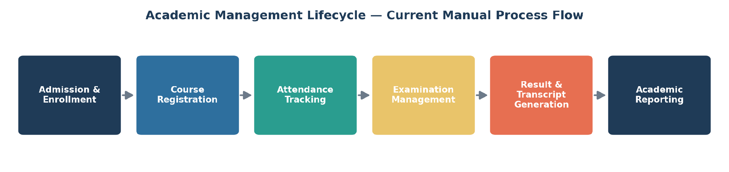
Figure 1: Academic Management Lifecycle — Manual Process Flow

2.3 Manual Process Challenges vs. Automated Solution
Manual Operational Bottleneck | Automated Platform Solution | Business Outcome Metric
Paper-based registration forms and long queues | Online self-service registration portal | Registration time reduced from days to minutes
Manual attendance registers per class | Digital attendance capture with real-time sync | Attendance accuracy improved to 99%+
Manual marks tabulation and result compilation | Automated result & grade computation engine | Result publishing time reduced by 70%
No centralised visibility for administrators | Real-time academic analytics dashboard | Compliance reporting time reduced from days to minutes

3. Design Thinking Methodology
Design Thinking is an iterative, human-centred problem-solving framework that prioritises deep empathy for users before evaluating technological constraints. It was applied across five stages to shape the platform's requirements.
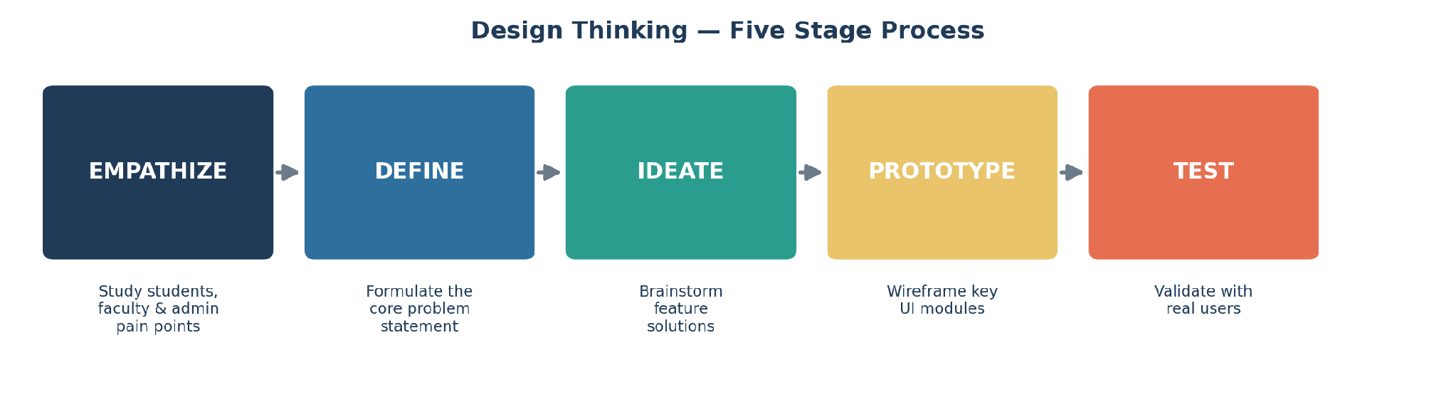
Figure 2: Design Thinking — Five Stage Process

3.1 Stage 1 — Empathize
Engineers and designers study users in their natural academic workflow. Key user categories analysed include Students, Faculty Members, Academic Administrators, Examination Cell Staff, and IT Support Personnel.

3.2 Stage 2 — Define
Data collected during empathy building is organised into a definitive core problem statement:
“Students, faculty, and academic administrators experience significant delays and errors in registration, attendance tracking, examination management, and result generation due to fragmented manual record-keeping. Concurrently, administrators lack centralised, real-time visibility into academic data, resulting in reporting delays, compliance risk, and reduced student satisfaction.”

3.3 Stage 3 — Ideate
Unconstrained feature brainstorming yielded high-value capabilities:
- Automated email / SMS alerts for attendance shortage, exam schedules, and results.
- Digital ID / QR-based student verification for exams and library access.
- Mobile self-service portal for registration and result viewing.
- Live academic analytics dashboard for administrators.
- Automated attendance-shortage and grade-computation engines.

3.4 Stage 4 — Prototype
Low-fidelity wireframing was planned for the core UI modules: Student Login & Dashboard, Course Registration Portal, Faculty Attendance & Marks Entry Screen, and Admin Analytics Panel.

3.5 Stage 5 — Test
Paper / clickable prototypes are to be demonstrated to students, faculty, and administrative staff to evaluate navigation flow, layout clarity, and task-completion speed prior to frontend engineering.

4. IBM Design Thinking
IBM Design Thinking scales human-centred design for large-scale enterprise delivery through three core pillars.
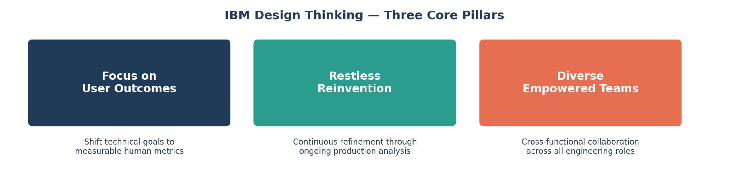
Figure 3: IBM Design Thinking — Three Core Pillars

4.1 Focus on User Outcomes
Technical goals are re-framed as measurable human outcomes.
- Feature Goal: “Build a student attendance database module.”
- Outcome Focus: “Enable faculty to mark attendance for an entire class in under 60 seconds.”

4.2 Restless Reinvention
Continuous deployment (CD) is treated as an ongoing refinement cycle — constantly analysing production usage to improve UI layout and backend response speed.

4.3 Diverse Empowered Teams
Cross-functional collaboration spans Product Managers, UX Designers, Software Engineers, QA, Database Administrators, and DevOps Engineers.

4.4 The IBM Loop Engine
The platform is engineered using the continuous cycle of Observe → Reflect → Make.
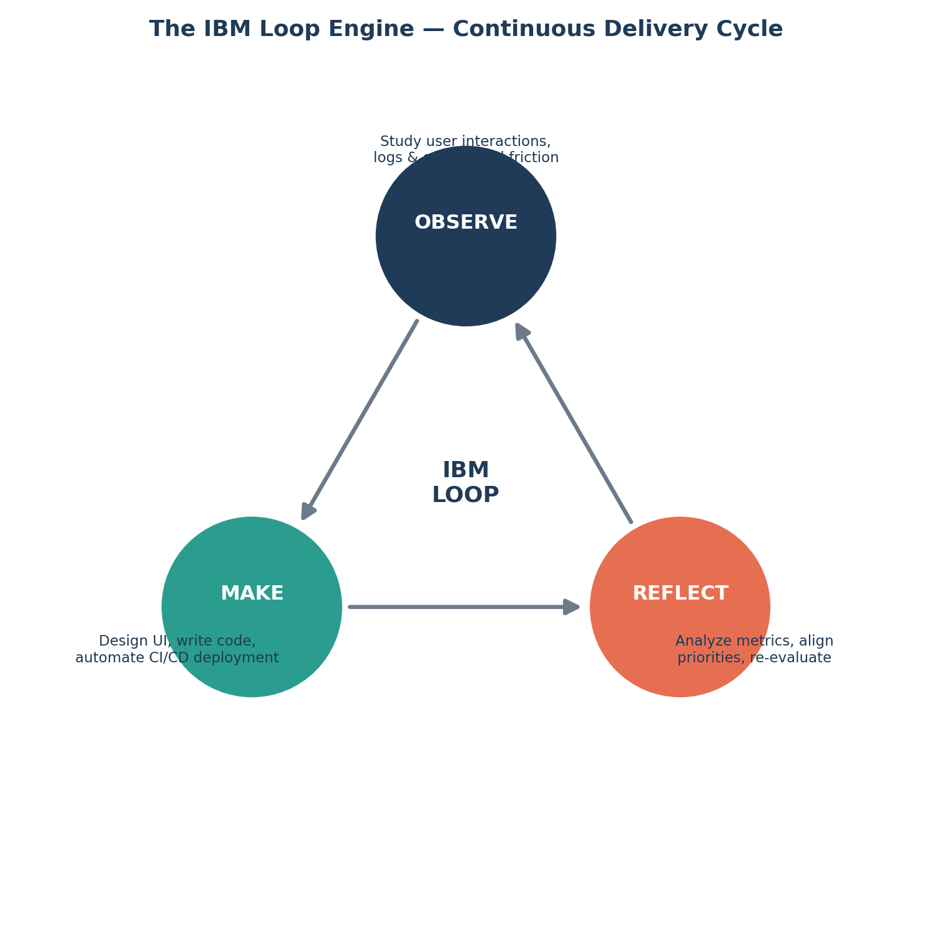
Figure 4: The IBM Loop — Observe, Reflect, Make

5. Stakeholder Analysis Report
Stakeholders were grouped into three categories based on their role and expectations from the project.
Stakeholder Group | Key Roles | Responsibilities & Project Expectations
Business Stakeholders | College Management, Academic Administrators, Students, Faculty, Exam Cell | Define business vision, validate functional usability, ensure academic-compliance.
Engineering Stakeholders | Software Developers, UI/UX Designers, QA Engineers | Architect the codebase, build responsive frontends, write automated tests.
Operations Stakeholders | DevOps Engineers, Database Administrators, IT Support / Security Team | Provision cloud infrastructure, maintain database integrity, automate CI/CD pipelines.

6. User Persona Report
Representative personas were developed for the platform's three primary user groups, capturing their goals, frustrations, and required features.
User Persona | Primary Objectives | Key Frustrations & Pain Points | Target Platform Feature
Ananya (Student) | Register for courses quickly; track attendance & results in real time. | Long registration queues; delayed result publishing; no attendance visibility. | Mobile self-service portal, live attendance & result tracker.
Prof. Mehta (Faculty) | Mark attendance and enter exam marks with minimal effort. | Manual attendance registers; error-prone manual marks tabulation. | Digital attendance & marks-entry interface with auto-validation.
Mrs. Deshmukh (Academic Administrator) | Monitor institution-wide academic performance and compliance. | Lack of real-time data; manual report generation taking days. | Executive analytics dashboard with 1-click compliance reports.

7. Requirements Engineering Specification

7.1 Functional Requirements (FRS)
ID | Requirement | Description
FR-01 | Authentication | Secure Role-Based Access Control (RBAC) for Admin, Faculty, Student, and Exam Cell.
FR-02 | Student Registration | Full CRUD for student profiles, academic history, and enrollment records.
FR-03 | Course Registration Engine | Semester-wise subject/elective enrollment with seat-availability checks.
FR-04 | Attendance Engine | Digital attendance capture with automatic percentage & shortage computation.
FR-05 | Examination & Result Engine | Exam scheduling, marks entry, and automated grade / result computation.
FR-06 | Reporting Module | Transcript, mark-sheet, attendance and administrative compliance reports.
FR-07 | Notification System | Triggered email/SMS alerts for attendance shortage, exam schedules, and results.

7.2 Non-Functional Requirements (NFRS)
ID | Requirement | Description
NFR-01 | Security | Password hashing (Bcrypt/Argon2), JWT session management, and HTTPS encryption.
NFR-02 | Performance | Sub-500ms API response time for search/report queries under concurrent load.
NFR-03 | Availability & Scalability | Containerized deployment targeting 99.9% uptime with horizontal pod autoscaling.
NFR-04 | Usability | Intuitive, accessible UI usable by students, faculty, and administrators alike.
NFR-05 | Maintainability | Infrastructure as Code (IaC) modularity and clear codebase separation.
NFR-06 | Reliability | Automated backups and disaster recovery for academic data integrity.

8. Product Vision & Minimum Viable Product (MVP) Scope

8.1 Vision & Mission Statement
Vision: “To deliver a modern, automated, cloud-native Student Record and Academic Management Platform that eliminates manual administrative overhead, streamlines registration and examination workflows, and gives every stakeholder real-time academic visibility.”
Mission: “To empower academic institutions with a reliable, secure, and scalable digital platform that reduces administrative effort and improves the academic experience for students and faculty.”

8.2 Success Criteria & Business Objectives
- Reduce course registration time from days to under 5 minutes per student.
- Achieve 99%+ attendance and result data accuracy.
- Cut administrative report-generation time by over 70%.
- Reach 99.9% platform uptime post-deployment.
- Achieve adoption by 90% of students and faculty within the first academic term.

8.3 MVP Release Scope (Sprint 1–4)
To maintain agility, non-essential capabilities (such as AI-based performance prediction or alumni-network modules) are deferred to later releases. The MVP includes:
- User Login & Profile RBAC (Student, Faculty, Admin)
- Student Registration & Course Enrollment
- Basic Attendance Capture & Tracking
- Basic Examination Marks Entry & Result Generation
- Basic Administrative Reporting

9. Product / Engineering Roadmap
The roadmap is phased to align with course progression, moving from domain analysis through to production deployment and monitoring.
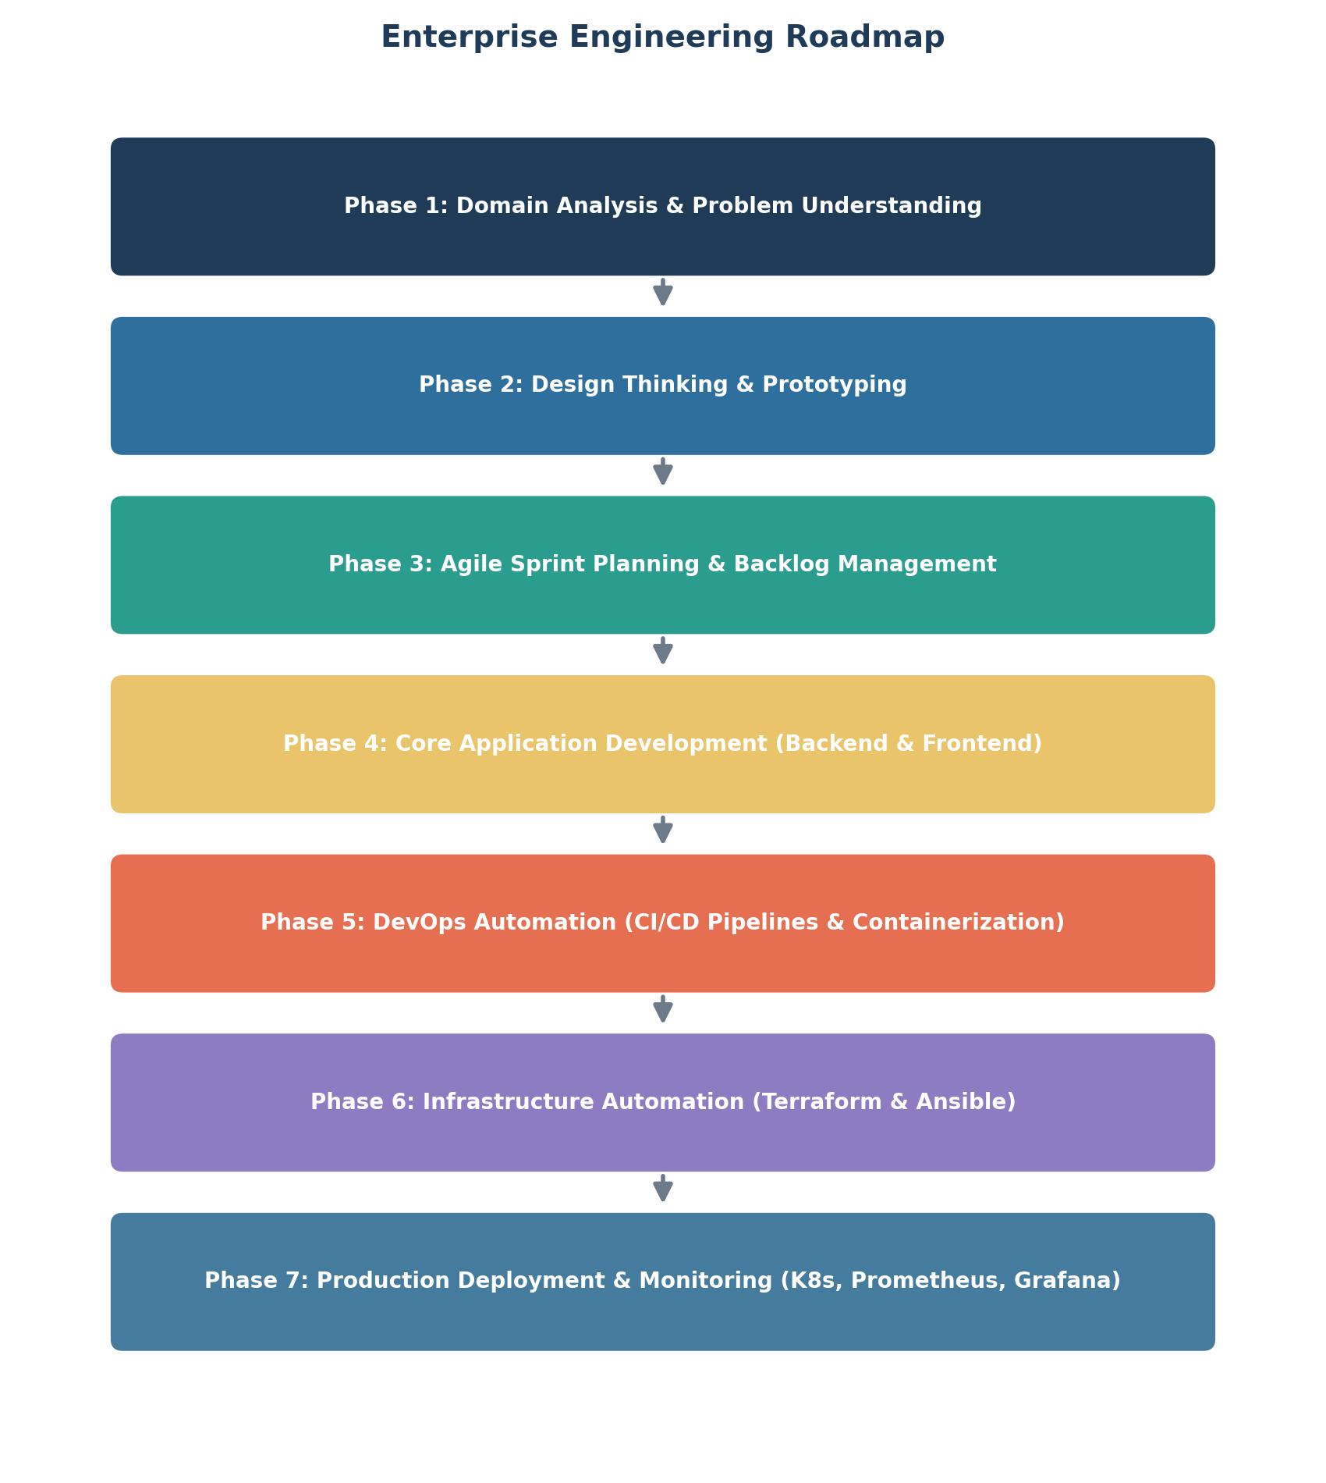
Figure 5: Enterprise Engineering Roadmap

10. Initial System Architecture & Repository Structure
The platform follows a layered, containerised microservices architecture that separates client applications, the API gateway, business-logic services, data storage, and DevOps infrastructure.
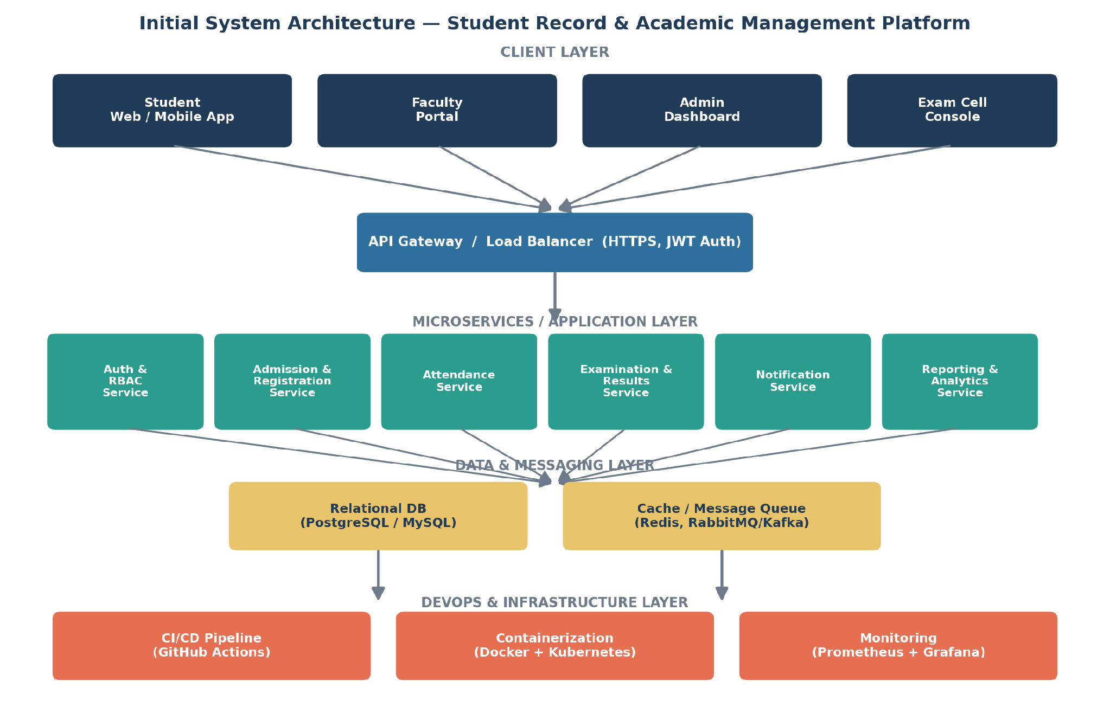
Figure 6: Initial System Architecture Diagram

10.1 Project Repository Structure
The repository is initialised with a standardised folder architecture, ready for Git version control and CI/CD pipeline integration in subsequent units.
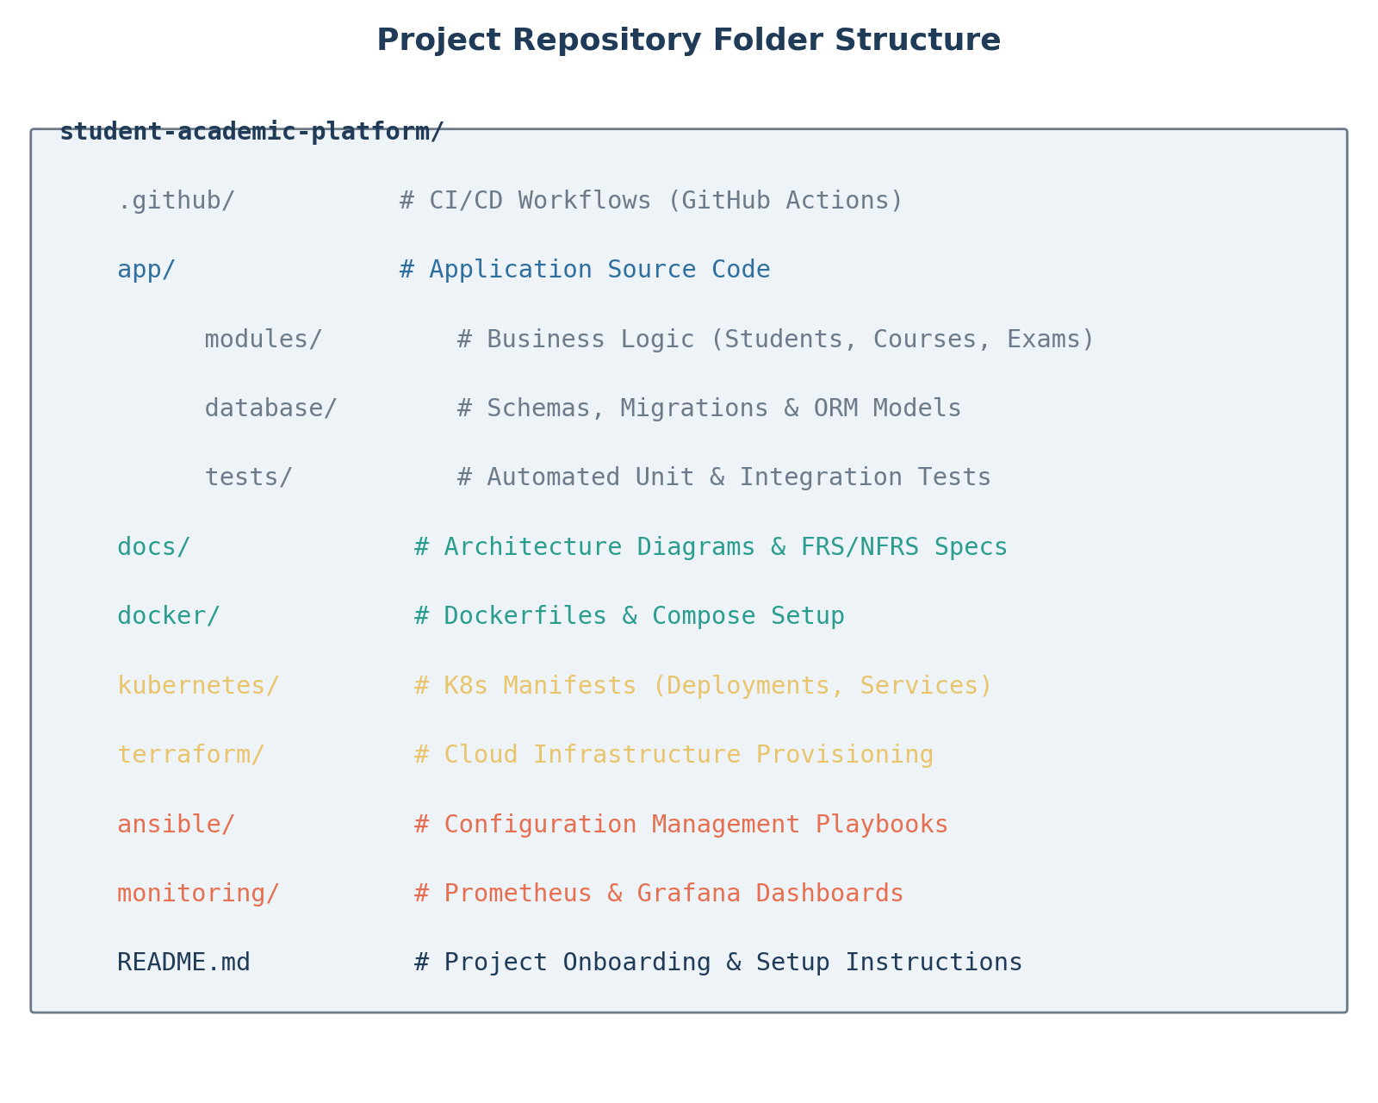
Figure 7: Project Repository Folder Structure

11. Project Charter & Milestone Plan

11.1 Project Charter
Field | Details
Project Name | Enterprise Student Record and Academic Management Platform
Prepared By | Pranav Gaikwad (PRN: 2125UMLM1041)), SY AIML
Objective | Design a Design-Thinking-led software product plan for automating academic record management.
Scope | Admissions, course registration, attendance, examinations, result processing, and reporting.
Out of Scope (MVP) | AI-based analytics, alumni network, third-party payment gateways.
Timeline | Unit 1 (Weeks 1–4) — Design Thinking & Product Planning phase.
Success Criteria | Approved BRD, FRS/NFRS, product vision, roadmap, and initialised repository.
Key Risks | Incomplete stakeholder input; scope creep beyond MVP; unclear NFR targets.

11.2 Milestone Plan
Milestone | Target Week | Deliverable
M1: Domain & Business Understanding | Week 1 | Business Requirements Document (BRD)
M2: Design Thinking Completion | Week 2 | Design Thinking Report, Problem Statement
M3: Stakeholder & Persona Analysis | Week 2 | Stakeholder Analysis Report, User Persona Report
M4: Requirements Finalisation | Week 3 | FRS & NFRS Documents
M5: Vision, MVP & Roadmap | Week 3 | Product Vision Document, MVP Definition, Roadmap
M6: Architecture & Repo Setup | Week 4 | System Architecture Diagram, Initialised Git Repository

12. Student Deliverables Checklist
The following deliverables, as specified in the Unit 1 Mini Project brief, have been prepared as part of this report.
# | Deliverable | Status
1 | Business Requirements Document (BRD) | ✓ Completed
2 | Product Vision Document | ✓ Completed
3 | Stakeholder Analysis Report | ✓ Completed
4 | User Persona Report | ✓ Completed
5 | Functional Requirements Specification (FRS) | ✓ Completed
6 | Non-Functional Requirements Specification (NFRS) | ✓ Completed
7 | Design Thinking Report | ✓ Completed
8 | IBM Design Thinking Report | ✓ Completed
9 | IBM Loop Documentation | ✓ Completed
10 | MVP Definition | ✓ Completed
11 | Product Roadmap | ✓ Completed
12 | Initial System Architecture Diagram | ✓ Completed
13 | Project Charter | ✓ Completed
14 | Project Repository Initialization (Structure Planned) | ✓ Completed
15 | Product Discovery Documentation | ✓ Completed

