Table of Contents

MedBuddy

A WhatsApp-Based Medication Adherence & Drug-Interaction Assistant
Project Design Document — for review by the Faculty Guide
Institution | Kalinga Institute of Industrial Technology (KIIT University)
Course | Minor Project (5 credits)
Team | Prangshu [Roll No. ____] · Arundhati [Roll No. ____]
Faculty Guide | [Prof. ____]
Duration | 1 month
Status | Proof-of-Concept
Date | August 2026
Disclaimer: MedBuddy is an academic proof-of-concept built for learning and demonstration. It is not a certified medical device and must not be used for real clinical decision-making. All drug information is drawn from a small, curated, static dataset. Every user-facing message carries this disclaimer.

Executive Summary
For readers short on time — this section summarises the entire project.
MedBuddy is a proof-of-concept WhatsApp assistant that turns a photo of a prescription into three things: plain-language explanations of each medicine, drug-drug interaction warnings, and automated dose reminders with adherence tracking — all with zero app installation.
Aspect | Summary
What it is | A WhatsApp bot for medication adherence and drug-interaction safety
Target users | Patients — especially those for whom installing a dedicated health app is a barrier
Why it matters | ≈50% of patients do not take long-term medicines as prescribed (WHO); dangerous interactions often go unnoticed
Key ideas | (1) Meet patients on WhatsApp — no install, no learning curve; (2) AI explanations are grounded in a curated dataset and never invented
Core flow | Photo → OCR → structured extraction → brand→generic normalization → interaction check → plain-language reply → scheduled reminders
Architecture | Two designs are evaluated in §7. Recommended: Hybrid — a deterministic, safety-critical core wrapped in a conversational AI agent; a fully agentic design is proposed as a stretch goal
Tech stack | FastAPI · Twilio WhatsApp · Tesseract + vision LLM · LLM extraction + Pydantic · Python rule engine · APScheduler · PostgreSQL
Team / timeline | 2 members (Prangshu, Arundhati) · 1 month · KIIT 5-credit minor project
Deliverables | A working WhatsApp demo and an evaluation report (extraction accuracy, interaction correctness, delivery rate, latency)
Status | Proof-of-concept — not for clinical use
Bottom line: a focused, achievable one-month project with a strong safety guarantee (the AI never invents drug information) and a clear primary deliverable, plus an ambitious agentic stretch goal.

1. Abstract
Medication non-adherence and unnoticed drug-drug interactions are among the most common and preventable causes of treatment failure. MedBuddy is a proof-of-concept assistant, delivered entirely over WhatsApp, that lets a patient photograph a prescription and, in return, receive: (a) the medicines extracted and explained in plain language, (b) warnings about dangerous interactions between those medicines, and (c) automated dose reminders with adherence tracking — all with no app installation required.
This document presents the project’s motivation, objectives, scope, and technology stack, and then examines two candidate system architectures — a hybrid design (a deterministic safety-critical core wrapped in a conversational agent) and a fully agentic design (an LLM that autonomously decides which operations to run). A comparative analysis and a recommendation follow.

2. Problem Statement & Motivation
- Non-adherence is widespread. The World Health Organization has noted that adherence to long-term therapies averages around 50% in developed countries, and is often lower in resource-constrained settings. Missed and mistimed doses reduce treatment effectiveness and increase avoidable complications.
- Prescriptions are hard for patients to understand. Medical shorthand, brand vs. generic naming, and handwriting make it difficult for a patient to know what they are taking and why.
- Interactions go unnoticed. Patients frequently take multiple medicines (and over-the-counter drugs) without any check for dangerous combinations.
- Existing apps create friction. Dedicated medication apps require installation, sign-up, and a degree of digital literacy — a real barrier for elderly and first-time smartphone users.
- WhatsApp removes that friction. WhatsApp is already installed and familiar for the vast majority of users in India. Meeting patients on a channel they already use — with zero install — is the core design bet of this project.

3. Objectives
Primary objectives 1. Extract structured medication details (drug name, dosage, frequency, duration) from a photograph of a prescription. 2. Explain each medicine in plain, non-technical language. 3. Detect and flag drug-drug interactions, classified by severity (minor / moderate / major). 4. Schedule and deliver dose reminders over WhatsApp, and log the patient’s “taken / missed / snooze” responses.
Secondary objectives 5. Send a follow-up nudge when a dose reminder goes unanswered. 6. Maintain a per-patient log of prescriptions, conversations, and adherence. 7. (Optional) Provide a simple web dashboard reporting extraction accuracy and interaction statistics for evaluation.

4. Scope
In scope - Single patient per WhatsApp number (no multi-tenant authentication). - A static, curated drug-interaction dataset and a brand→generic mapping dataset (≈150–200 entries each). - Proof-of-concept accuracy, with disclaimers throughout.
Out of scope - Live FDA / WHO API integration — the interaction data is curated and static by design. - Clinical-grade accuracy claims. - Multi-tenant authentication or user-account management. - A doctor-facing dashboard — MedBuddy is patient-facing only.

5. System Overview — Core User Flow
- The patient messages the bot (“Hi”) and registers a name and age.
- The patient sends a photo of their prescription.
- OCR extracts the raw text (Tesseract as the primary engine; a vision-capable LLM as a fallback for handwriting).
- Structured extraction pulls drug name, dosage, frequency, and duration into a validated JSON record.
- Normalization maps brand names to generics via fuzzy matching against the curated dataset (e.g. Crocin → Paracetamol).
- The interaction engine checks every pair of drugs against the interaction dataset and flags severity.
- The patient receives a plain-language explanation of each medicine plus any interaction warnings — grounded strictly in the dataset, never invented.
- The reminder scheduler parses frequency strings (“twice daily”, “every 8 hrs”) into concrete send times and pushes reminders over WhatsApp.
- The patient replies “taken” / “missed” / “snooze”, which is logged with a timestamp.
- If no reply arrives within a set window, a missed-dose follow-up is sent.
- All prescriptions, chats, and interactions are logged per patient.

6. Technology Stack
Layer | Technology
Messaging | Twilio WhatsApp Sandbox API
Backend | FastAPI (Python)
OCR | Tesseract (primary); vision-capable LLM (handwriting fallback)
Extraction / NLP | LLM structured output + Pydantic validation
Interaction engine | Python rule engine over a curated JSON/CSV dataset
Scheduler | APScheduler
Database | PostgreSQL (SQLite acceptable for local development)
Optional dashboard | Plain HTML / React served from a FastAPI endpoint
Deployment (optional) | Docker, Render free tier
Planned database tables: patients, prescriptions, medications, interactions, reminders, adherence_logs.

7. System Architecture
A key design decision for this project is how the individual processing steps are orchestrated. The steps themselves are common to both approaches; what differs is who decides the order in which they run — fixed application code, or the language model itself.

7.1 Common building blocks
Regardless of the approach chosen, the system is built from the same capabilities:
Capability | Nature
OCR / text extraction | Tesseract, with a vision-LLM fallback
Structured extraction | A single LLM call, schema-validated
Drug normalization | Deterministic fuzzy matching
Interaction check | Deterministic Python rule engine
Explanation generation | A single LLM call, grounded to matched dataset rows
Reminder scheduling | Deterministic (APScheduler)
An essential safety principle applies throughout: the LLM is never the source of drug facts. Drug identity and interaction data always come from the curated datasets; the LLM only reads (extraction) and rephrases (explanation). Drugs that cannot be matched to the dataset are flagged and routed to a disclaimer, never described from the model’s own knowledge.
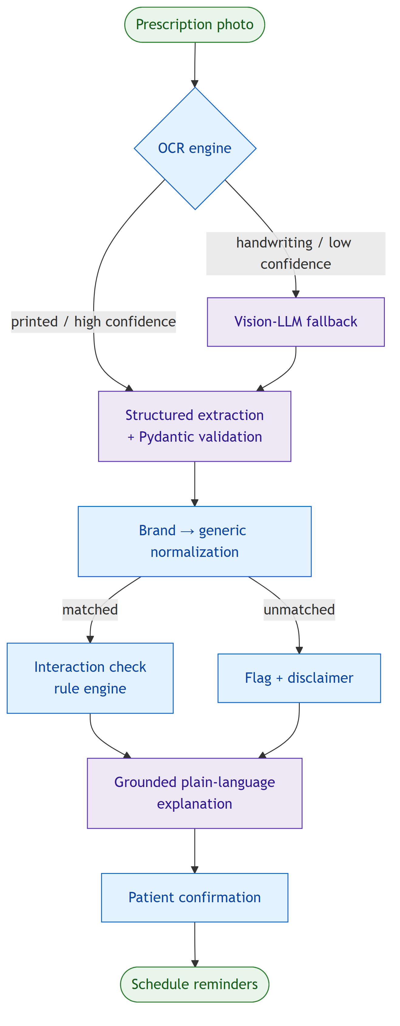
Figure 1 — The MedBuddy intake pipeline. Green nodes are start/end points, blue nodes are deterministic (rule-based) steps, and purple nodes are LLM-powered steps. The two branch points — OCR confidence, and whether a drug matches the curated dataset — are where the safety-critical routing happens.

7.2 Approach A — Hybrid (deterministic core + conversational agent)
The prescription-processing path is a fixed, deterministic pipeline — the order of steps is written into the application code and is identical on every run. This pipeline is exposed as a single operation. Around it sits a conversational agent that handles everything which does not fit a rigid sequence: free-form questions, clarifications, adherence coaching, and regimen queries. The agent may call the deterministic pipeline, plus a set of read-only lookup tools, but the safety-critical computation stays fixed.
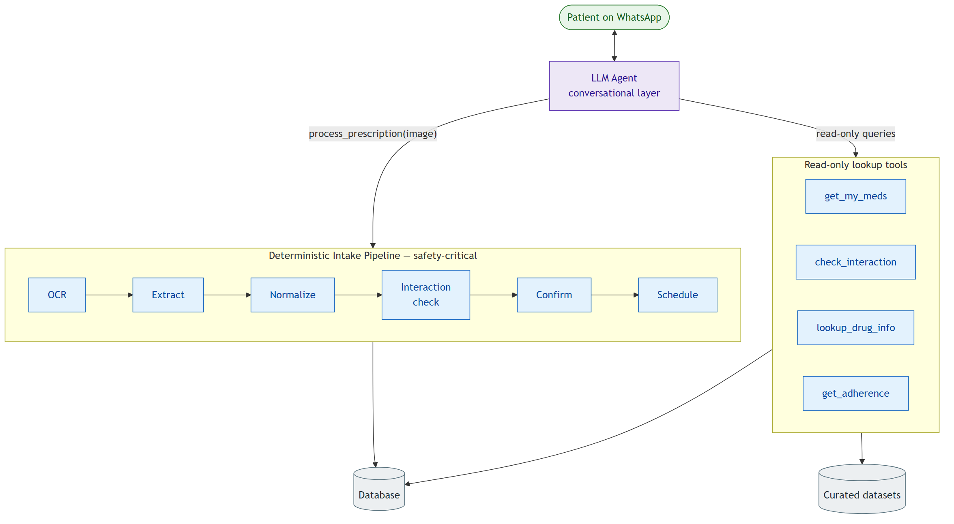
Figure 2 — Approach A (Hybrid). A conversational agent handles free-form dialogue and read-only lookups, but the safety-critical intake work runs as one fixed, deterministic pipeline that the agent invokes as a single operation.
Characteristics - The safety-critical path (extraction → interaction check → scheduling) is fully deterministic, reproducible, and unit-testable. - The interaction check cannot be skipped or hallucinated for the intake path. - The agent layer adds a natural, conversational experience for the patient. - Evaluation is clean: each pipeline stage and each tool can be tested in isolation against a labelled test set.

7.3 Approach B — Fully Agentic (LLM-orchestrated)
Here there is no fixed pipeline. Each capability is exposed to the LLM as a tool, and the model itself decides which tools to call, and in what order, based on the incoming message and the conversation so far.
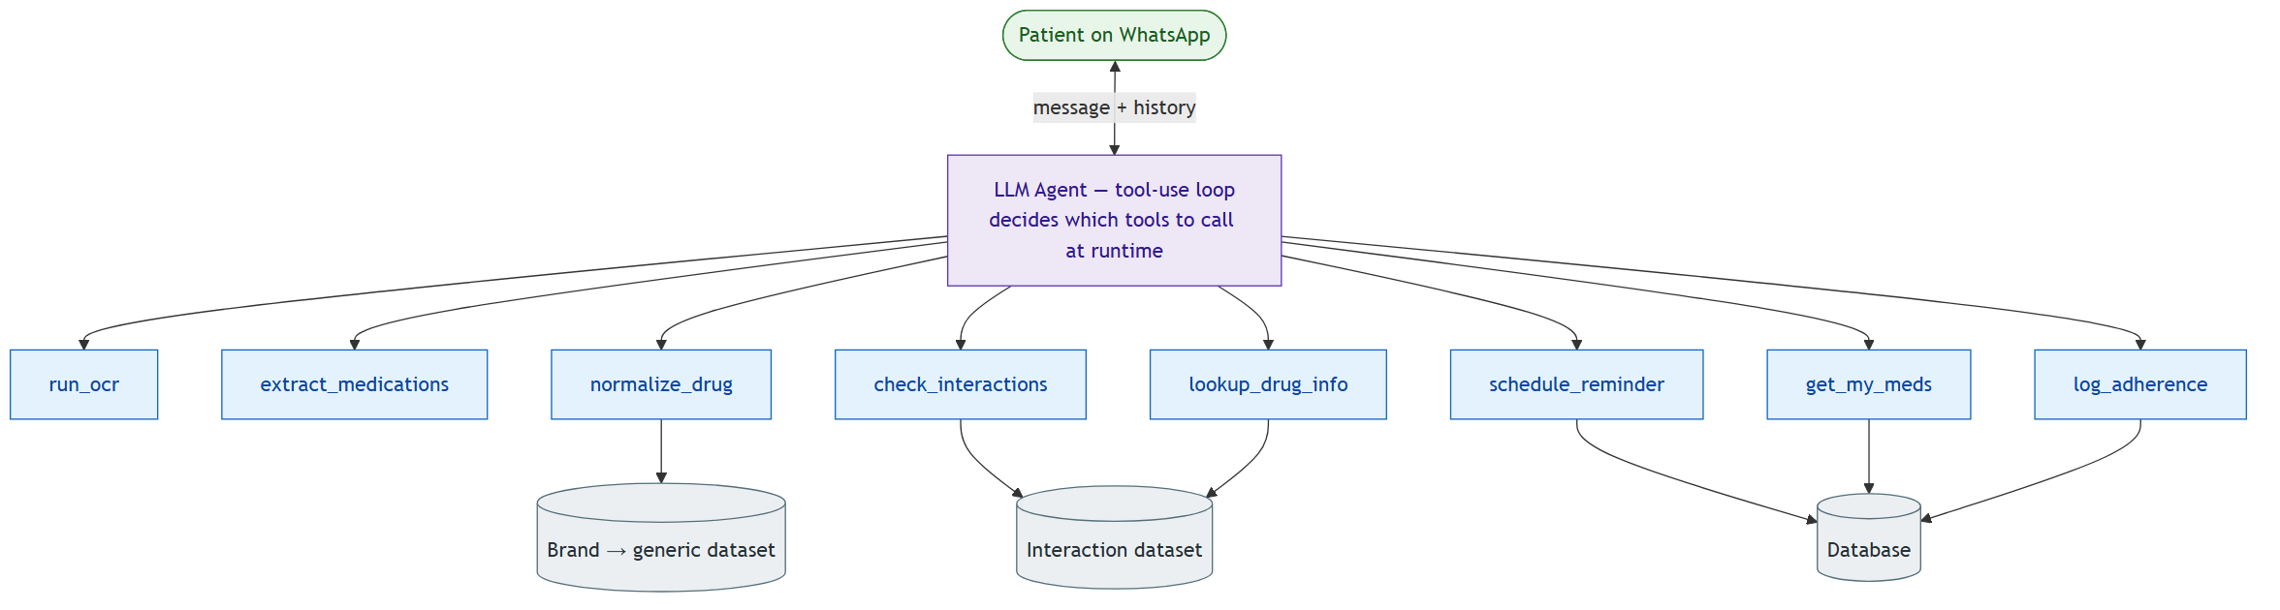
Figure 3 — Approach B (Fully Agentic). Every capability is exposed as a tool, and the LLM decides at runtime which tools to call and in what order. There is no fixed pipeline; grounding and safety depend on prompt guardrails and confirmation gates.
Characteristics - Maximum flexibility: naturally handles multi-intent messages, out-of-order inputs, and arbitrary follow-up questions. - The control flow is not fixed — the same input may be handled via different tool sequences on different runs. - Requires explicit guardrails to preserve grounding (e.g. system-prompt rules forbidding any drug statement not derived from a tool result, and confirmation gates on state-changing tools). - Higher latency and cost (multiple LLM round-trips per prescription) and lower reproducibility, which complicates quantitative evaluation.

7.4 Comparative Analysis
Dimension | A — Hybrid | B — Fully Agentic
Control flow | Fixed pipeline + agent shell | Entirely LLM-decided
Safety / grounding | Strong — critical path is deterministic | Weaker — depends on prompt guardrails
Reproducibility & evaluation | Clean, per-stage metrics | Noisy, path-dependent
Latency & cost | Low (1–3 LLM calls per intake) | Higher (multiple round-trips)
Flexibility / conversational ability | High (agent shell) | Highest
Implementation effort (1 month) | Moderate | High
Debuggability & explainability | High | Lower

7.5 Recommendation
For a one-month proof-of-concept in a drug-safety domain, evaluated by a formal report, we recommend Approach A (Hybrid). It preserves a strong, provable safety guarantee — the interaction check on the intake path is deterministic and cannot be hallucinated — while still delivering the conversational experience that makes the demo compelling. Critically, it keeps the evaluation metrics clean and reproducible, because each stage can be tested in isolation.
Approach B remains a valuable extension: once the hybrid system is stable, selected conversational features can be handed to the agent to demonstrate autonomous, tool-using behaviour. This gives the project a clear, low-risk primary deliverable with an ambitious stretch goal, rather than betting the whole project on the harder architecture.

8. Evaluation Methodology
- OCR / extraction accuracy — precision and recall on drug name, dosage, and frequency, measured against a manually labelled test set of prescription images.
- Interaction-detection correctness — accuracy against a set of known drug-combination test cases.
- Reminder delivery success rate — the percentage of scheduled reminders delivered on time.
- End-to-end latency — elapsed time from photo upload to explanation delivered.

9. Constraints & Known Limitations
The project is built on Twilio’s WhatsApp Sandbox, which imposes real constraints that shape the design and are documented as limitations in the final report:
- The sandbox is for testing only, not production, and uses a shared Twilio number.
- Trial messaging is limited (≈100 free messages), so integration testing is deliberately deferred until the pipeline is validated offline, to conserve credits.
- Sandbox sessions expire 3 days after a number joins, which affects multi-day reminder testing — test numbers must periodically rejoin.
- A rate limit (~1 message per 3 seconds) requires bursty sends to be queued.
- Business-initiated messages outside a 24-hour window are restricted to pre-approved templates, which constrains how reminders are delivered.
The interaction dataset is small and curated, so coverage is limited by design. MedBuddy is a proof-of-concept and is not suitable for clinical use.

10. Project Plan (4 Weeks)
Week | Focus
1 — Foundation & data | Repository, database schema, Twilio sandbox wiring; curate the interaction and brand→generic datasets; collect 15–20 sample prescription images.
2 — Core pipelines | Interaction engine, OCR pipeline, LLM structured extraction, normalization, and grounded explanation — validated offline as an isolated pipeline.
3 — Integration & reminders | Reminder scheduler, adherence logging, missed-dose escalation; wire the full pipeline into the WhatsApp webhook; end-to-end testing.
4 — Evaluation, polish & report | Accuracy / precision-recall evaluation, delivery-rate testing, optional dashboard/deployment, joint report, and demo.

11. Team & Responsibilities
Member | Primary responsibilities | Secondary
Prangshu | Backend architecture, database schema, interaction rule engine, scheduler/reminder logic, WhatsApp webhook integration | Testing, deployment
Arundhati | OCR + LLM extraction pipeline, drug normalization, grounded explanation generation, evaluation metrics | Dataset curation, report writing
Both | Dataset curation, end-to-end integration testing, report and demo preparation

12. Expected Outcomes
- A working WhatsApp proof-of-concept demonstrating the full flow: prescription photo → extraction → interaction check → plain-language explanation → dose reminders with adherence logging.
- A labelled evaluation dataset and a report quantifying extraction accuracy, interaction-detection correctness, delivery success rate, and latency.
- A written analysis of the architectural trade-offs (hybrid vs. fully agentic) and the design decisions made.
- (Optional) A simple evaluation dashboard and a containerised deployment on Render.

MedBuddy — academic proof-of-concept. Not a certified medical tool; not for clinical use.

